USER

MANUAL

A step by step user guide to how to getting started with

**ECOWAS Balance & Emission Sankey**

**KarakoramX**

Technologies

# INDEX

1. Introduction **1**
2. Sign in **2**
3. Sign up **3**
4. Forget Password **4**
5. Dashboard **5**
   1. Navigation Bar **6**
   2. Countries **7**
   3. Color Legend **8**
   4. Balance Sankey **9**
   5. Download **10**
   6. Help **11**
   7. Timeline **12**
6. User Profile **13**
   1. Edit Profile **14**

INTRODUCTION

This user manual is about “ECOWAS (Economic Community of West African States)”.

ECOWAS is a group of 15-member regional group with a mandate of promoting economic integration in all fields of activity of the constituting countries. It was established on 28 May 1975 via the treaty of Lagos, ECOWAS is a 15-member regional group with a mandate of promoting economic integration in all fields of activity of the constituting countries.

The user manual will serve as a handbook with detailed information about ECOWAS, guiding the user about how it works. It contains the evaluation structure, the methodology of data collation, and the criteria by which data collected will be assessed.

# SIGN IN

Sign-in requires the email and password of an individual to gain system access by verifying themselves as they already have an account in the system.

## Steps to Sign in:

1. You have to write your **Email Address** here to get access to the system.
2. You must enter the **Password** you used in signing up for the system.
3. Enabling by ticking the checkbox “**Keep me signed in**” keeps you signed in and gives the access to the system until you signed out manually.
4. If you don’t remember the password, “**Forgot Password**” will let you change the password effectively.
5. **Sign-in** button allows interaction with the website or system.
6. **Sign-up** option is to get registered if you don’t have an account.

# RESET PASSWORD

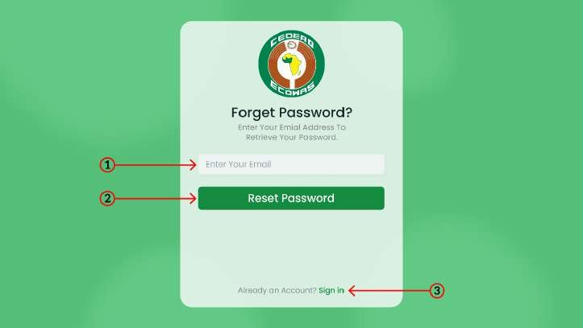When the sign-in password is forgotten, the reset password is used to change the password to a new one.

## Steps to Reset Password:

1. Type an **Email Address** with which you’ve already actived or your account.
2. **Reset Password** button allows interaction with the website or system.
3. **Sign-in** option is to get registered if you already have an account.

# SIGN UP

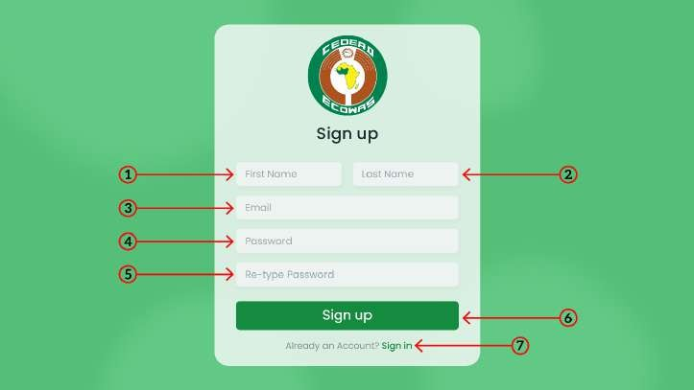Sign-up requires details i.e. First_name, Last_name, Email, and Pass- word to save the information to register the individual for the first time.

## Steps to Sign up:

1. Write the **First Name** which is a personal name given at birth.
2. Enter the **Last Name** which is one’s surname or family name.
3. Type an **Email Address** that is active or in use.
4. Write a **Password** with at least 1 uppercase letter, lowercase letters, numbers, and special characters.
5. **Re-write** the above **Password** to confirm the password.
6. **Sign-up** button allows interaction with the website or system.
7. **Sign-in** option is to get registered if you already have an account.

# DASHBOARD

A dashboard is a type of graphic user interface that provides performance guides. ECOWAS dashboard includes a user profile, navigation bar, Sankey graph, and timeline.

## Steps to Use Dashboard:

1. This option opens a list of **15-Member Countries** included in ECOWAS.
2. By clicking the color legend**,** a list of the energy resources appears where you can see and change the color of links by **Color Picker**.
3. This option enables two types of graph **Emission Sankey and Balance Sankey**. Balance Sankey shows the inflows and outflows of energy resources whereas Emission Sankey shows the inflows and outflows of energy resources highlighting the CO2 emission.
4. By clicking, the entire record is **Downloaded in SVG format** keep the file for offline use or any other purpose.
5. This option Helps you provide a manual to **Assist** you in how the website works.
6. The **Play Button** beside Timeline will show the resource flow from 2007 to the present year.
7. **Timeline** shows the graph of energy resources and their utilization on yearly basis.

# COUNTRIES

## Steps to Change Country:

1. In the navigation bar first element is **Countries**. By clicking it, a list of countries appears.
2. This option opens a list of **15-member countries** included in ECOWAS i.e. Benin, Burkina Faso, Cape Verde, Cote d’ Ivoire, The Gambia, Ghana, Guinea, Guinea Bissau, Liberia, Mali, Niger, Nigeria, Sierra Leone, Senegal, and Togo.

# COLOR LEGENDS

## Steps to Change Color Legend:

1. In the navigation bar the second element is **Color Legend**. By clicking it, a list of energy resources appears.
2. A **list** of energy resources appears where you can see the color of the respective resources.
3. A color picker will appear from where you can **Change the Color.**

# USER PROFILE

## Steps to See User Proﬁle:

1. User profile is an easy way to know you are signed in. Besides the image, there is a **Dropdown Menu** where profile edit and logout options are given.
2. **Edit Profile** provides the option to change personal information i.e. First_name, last_name, and password.
3. **Logout** removes your authentication/verification token.

# EDIT USER PROFILE

## Steps to Edit User Proﬁle:

1. This option enables the option to add or **Change the Image**.
2. Write the **First Name** which is a personal name given at birth.
3. Enter the **Last Name** which is one’s surname or family name.
4. Write the **Password** you used to sign in to the website.
5. Add a **New Password** with at least 1 uppercase letter, lowercase letters, a number, and one special character.
6. **Save Profile** button is to save the changes you did in the profile.