Web Pages Collection

01 Hello World

HTML Code
<!DOCTYPE html><html><head><title>Hello World Page</title></head><body><h1>Hello World!</h1><p>Welcome to my first HTML page.</p></body></html>

Screenshot
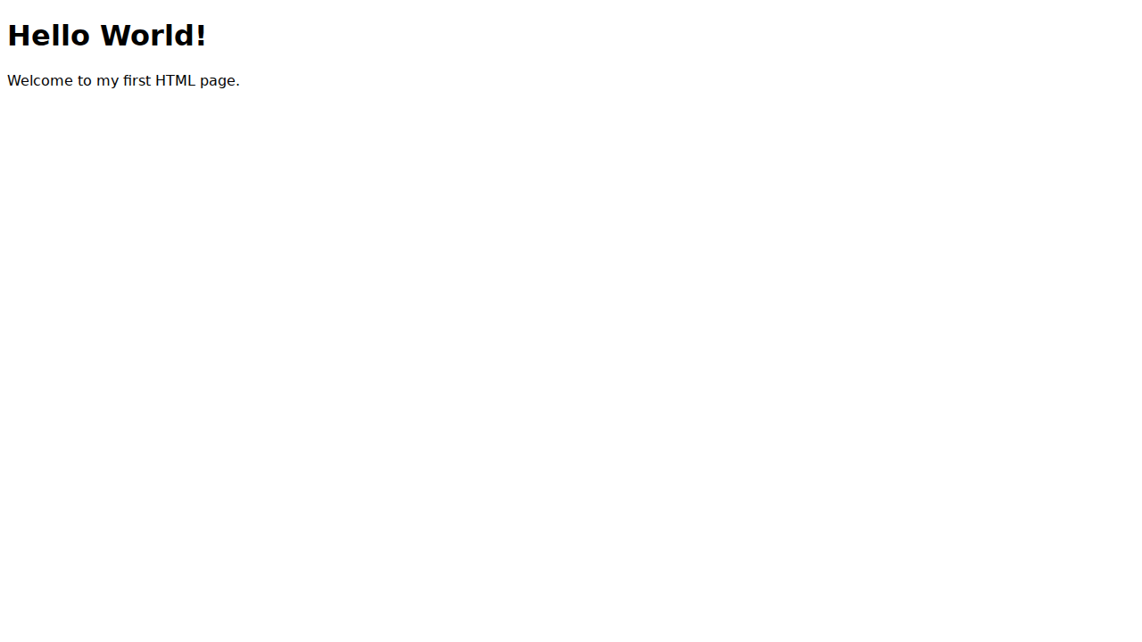

02 Resume

HTML Code
<!DOCTYPE html><html><head><title>Simple Resume Page</title></head><body><h1>John Doe</h1><p>Software Engineer</p><h2>Experience</h2><ul><li>Company A - Dev</li><li>Company B - Intern</li></ul></body></html>

Screenshot


03 Favorites

HTML Code
<!DOCTYPE html><html><head><title>Favorite Books or Movies List</title></head><body><h1>My Favorites</h1><h2>Movies</h2><ul><li>Inception</li><li>The Matrix</li></ul><h2>Books</h2><ul><li>1984</li><li>The Great Gatsby</li></ul></body></html>

Screenshot
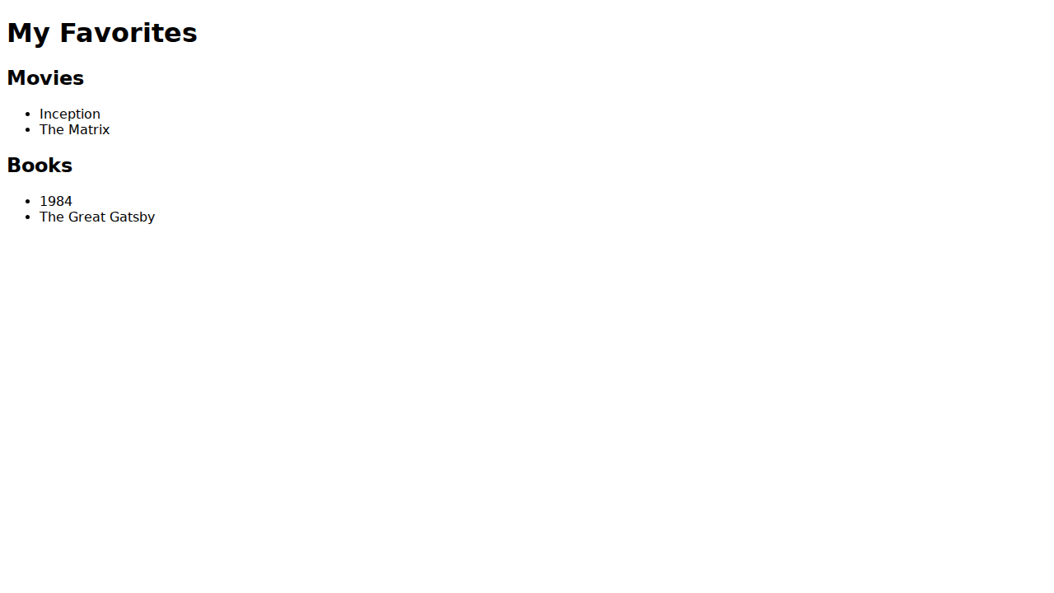

04 Contact

HTML Code
<!DOCTYPE html><html><head><title>Basic Contact Info Page</title></head><body><h1>Contact Me</h1><p>Email: john@example.com</p><p>Phone: 123-456-7890</p></body></html>

Screenshot
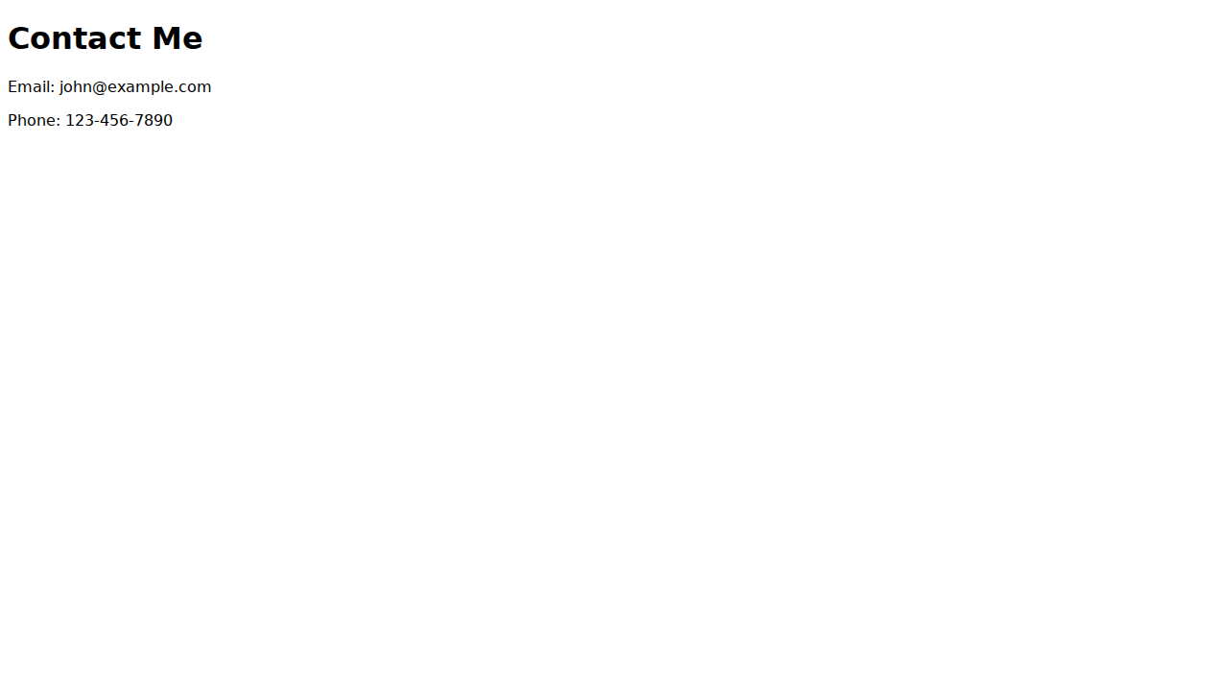

05 Grades

HTML Code
<!DOCTYPE html><html><head><title>HTML Table with Student Grades</title></head><body><h1>Student Grades</h1><table border='1'><tr><th>Student</th><th>Grade</th></tr><tr><td>Alice</td><td>A</td></tr><tr><td>Bob</td><td>B</td></tr></table></body></html>

Screenshot
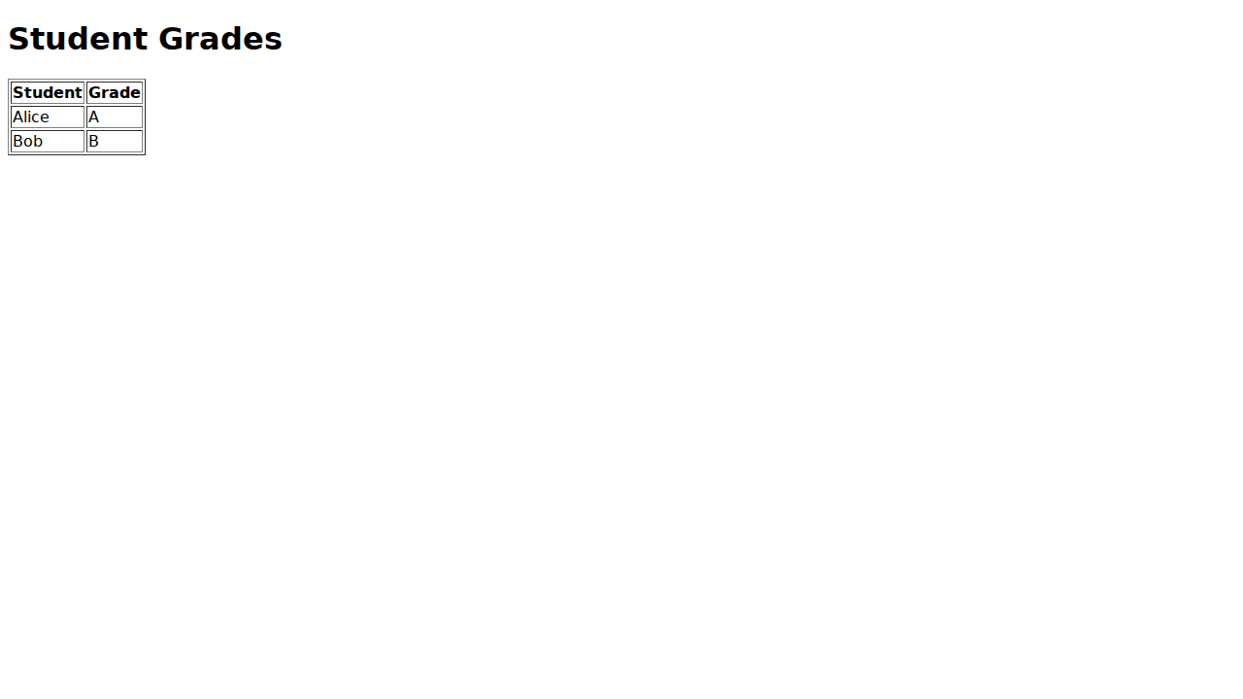

06 Blog Post

HTML Code
<!DOCTYPE html><html><head><title>Simple Blog Post Page</title></head><body><h1>My First Blog Post</h1><p>Published on: Oct 1, 2023</p><p>This is the content of my blog post. It is very interesting.</p></body></html>

Screenshot


07 Product Landing

HTML Code
<!DOCTYPE html><html><head><title>Product Landing Page</title></head><body><h1>Super Widget</h1><p>The best widget in the world. Buy now!</p><button>Buy Now</button></body></html>

Screenshot
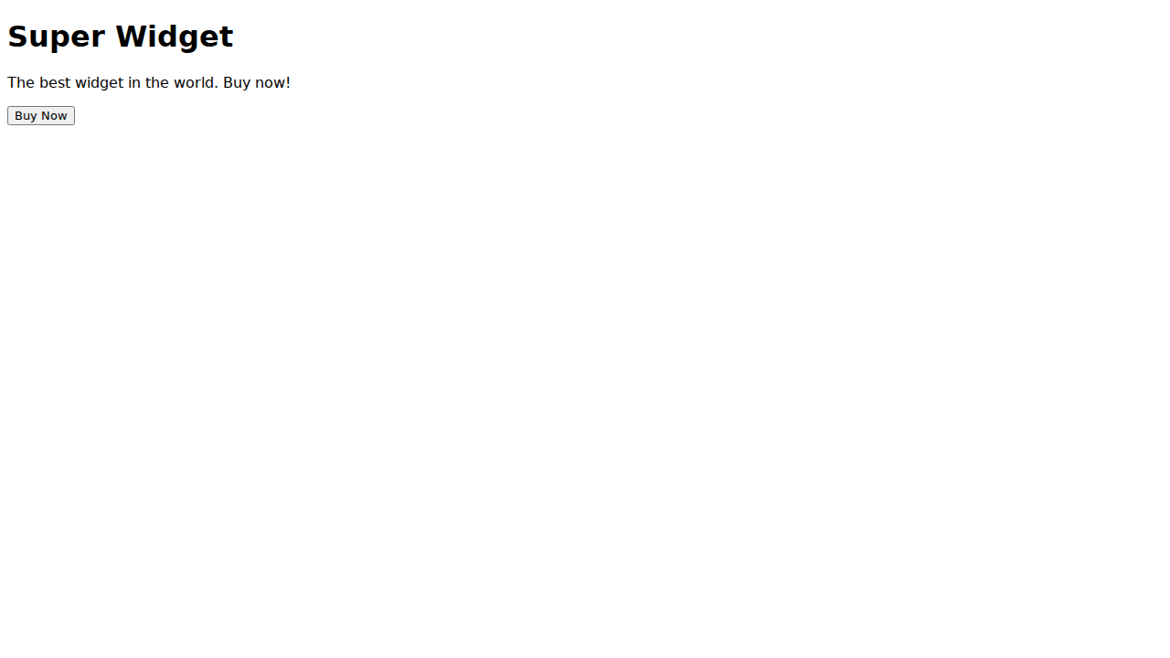

08 Tribute

HTML Code
<!DOCTYPE html><html><head><title>Tribute Page</title></head><body><h1>Tribute to Ada Lovelace</h1><p>The first computer programmer.</p><img src='https://upload.wikimedia.org/wikipedia/commons/a/a4/Ada_Lovelace_portrait.jpg' alt='Ada Lovelace' width='200'></body></html>

Screenshot
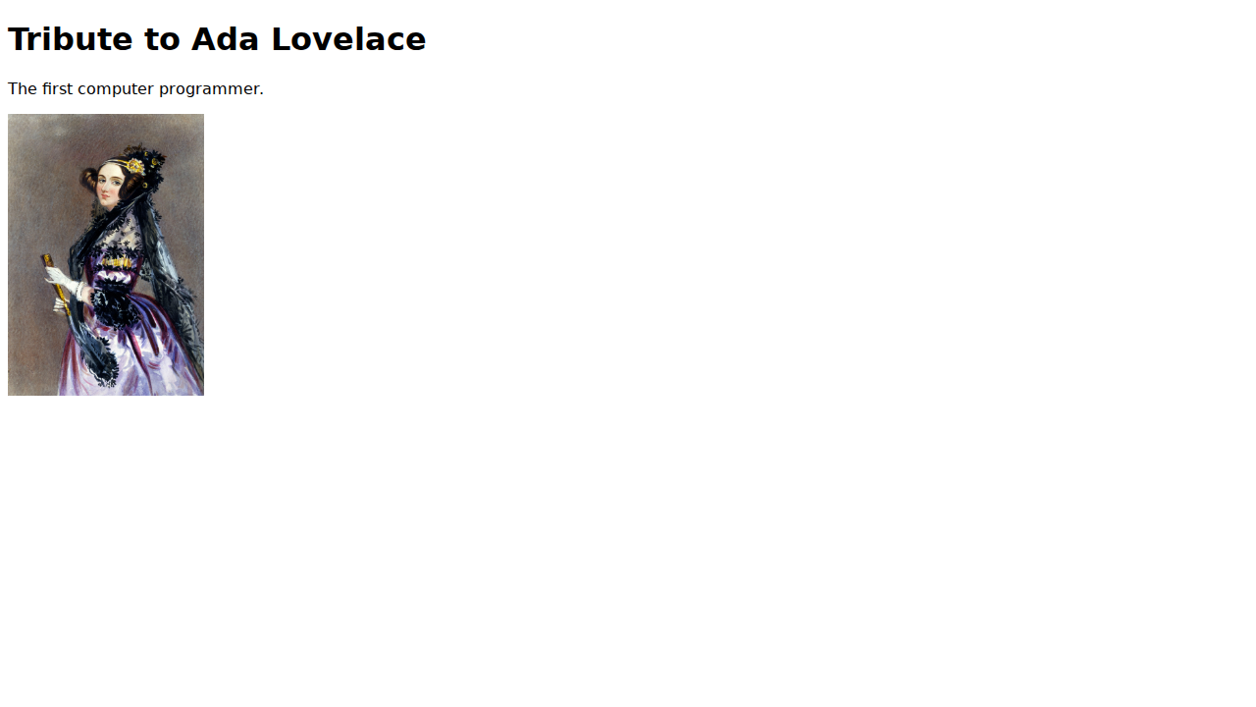

09 Gallery

HTML Code
<!DOCTYPE html><html><head><title>Photo Gallery Page</title></head><body><h1>My Photo Gallery</h1><div style='display:flex;'><div style='margin:10px; border:1px solid #ccc; padding:5px;'>Photo 1</div><div style='margin:10px; border:1px solid #ccc; padding:5px;'>Photo 2</div></div></body></html>

Screenshot
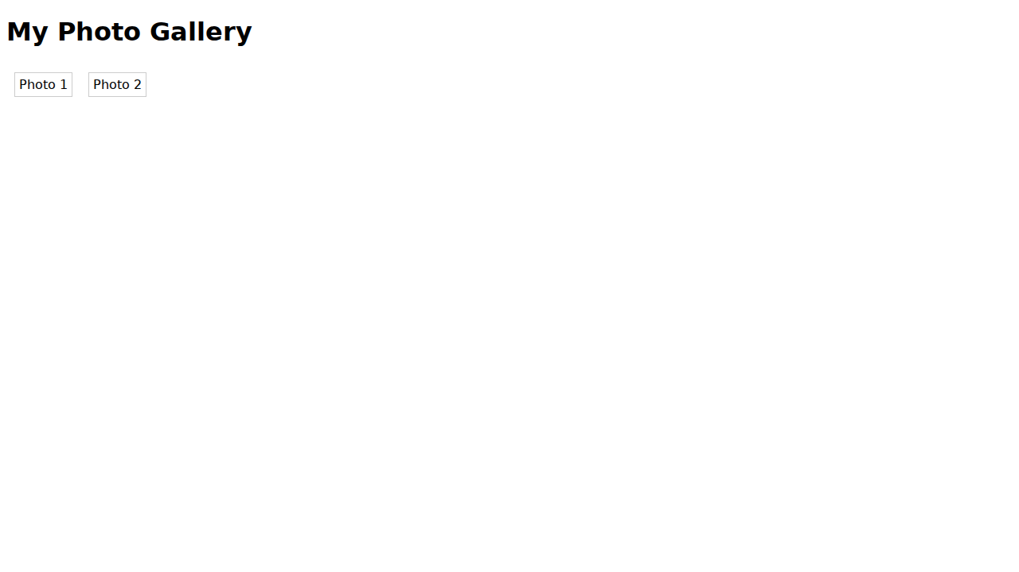

10 Portfolio

HTML Code
<!DOCTYPE html><html><head><title>Personal Portfolio Page</title></head><body><h1>My Portfolio</h1><p>Check out my projects below.</p><ul><li>Project 1</li><li>Project 2</li></ul></body></html>

Screenshot
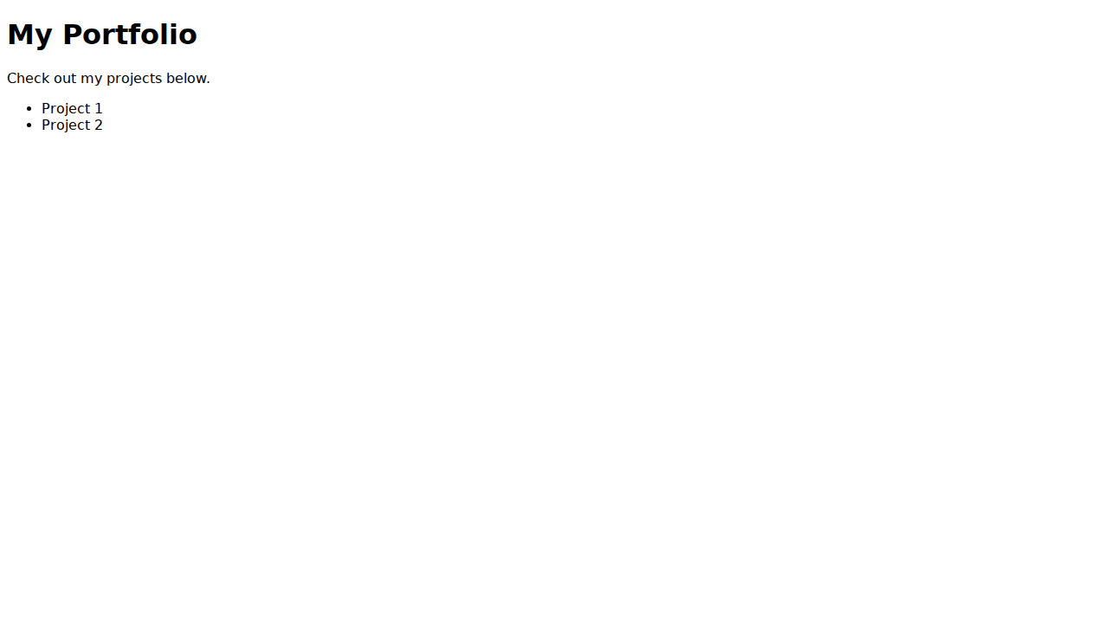

11 Survey

HTML Code
<!DOCTYPE html><html><head><title>Survey or Feedback Form</title></head><body><h1>Feedback Form</h1><form><label>Name:</label><input type='text'><br><label>Comments:</label><textarea></textarea><br><input type='submit'></form></body></html>

Screenshot
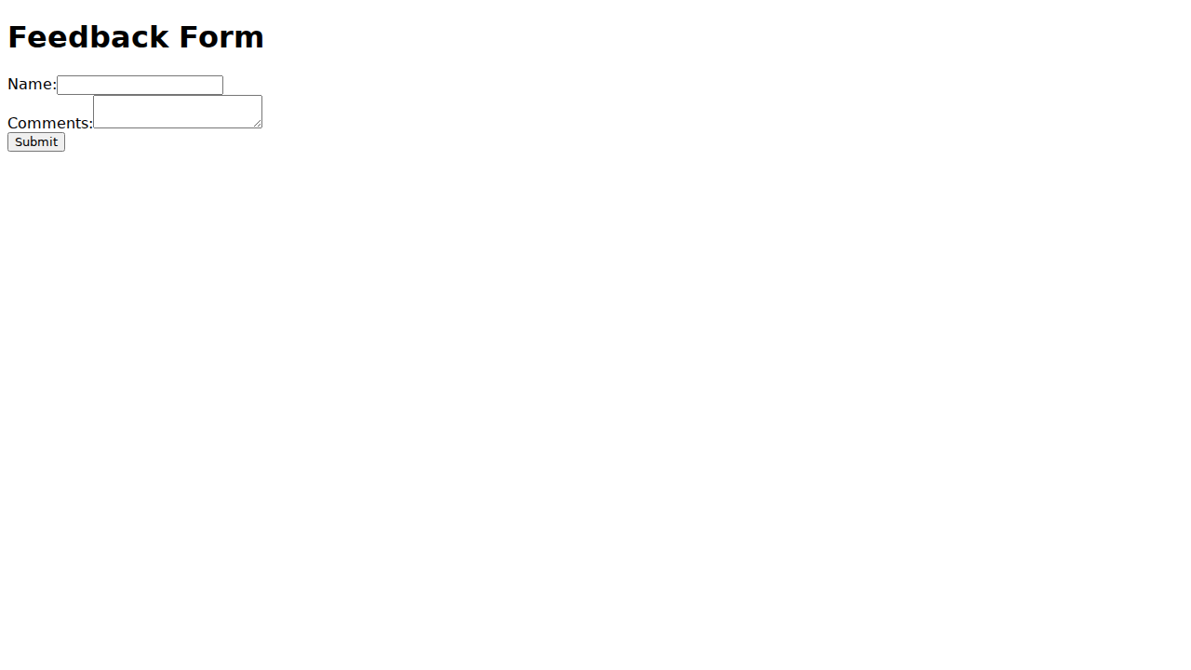

12 Newsletter

HTML Code
<!DOCTYPE html><html><head><title>Newsletter Signup Form</title></head><body><h1>Newsletter Signup</h1><form><label>Email:</label><input type='email'><button>Subscribe</button></form></body></html>

Screenshot
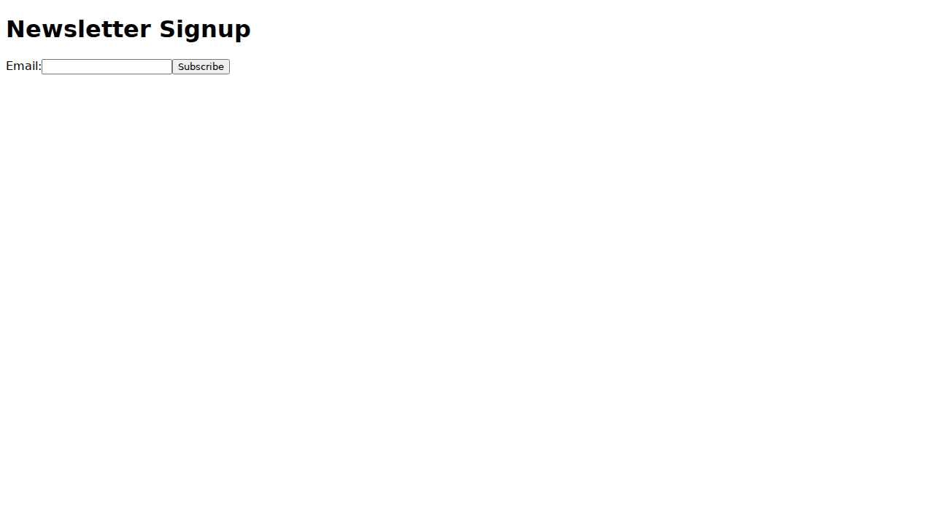

13 Event Invitation

HTML Code
<!DOCTYPE html><html><head><title>Simple Event Invitation Page</title></head><body><h1>Birthday Party!</h1><p>You are invited to my party on Friday.</p><p>Location: My House</p></body></html>

Screenshot
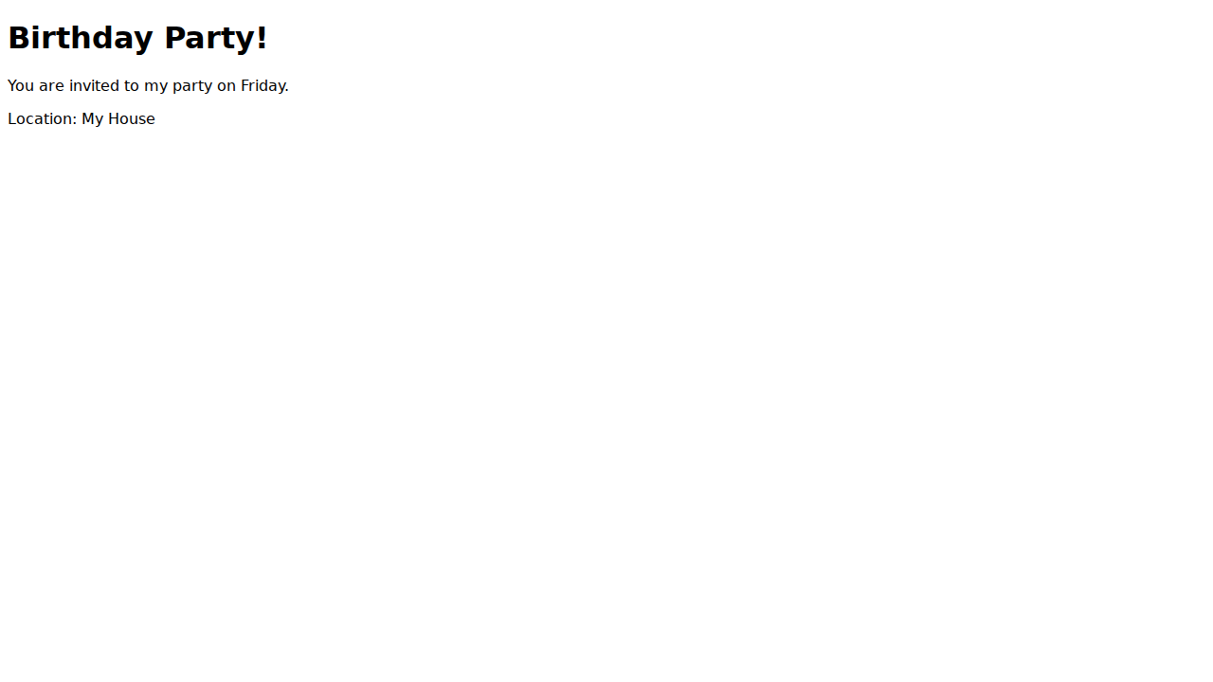

14 Recipe

HTML Code
<!DOCTYPE html><html><head><title>Recipe Page</title></head><body><h1>Pancake Recipe</h1><h2>Ingredients</h2><ul><li>Flour</li><li>Milk</li><li>Eggs</li></ul><h2>Steps</h2><ol><li>Mix</li><li>Fry</li></ol></body></html>

Screenshot
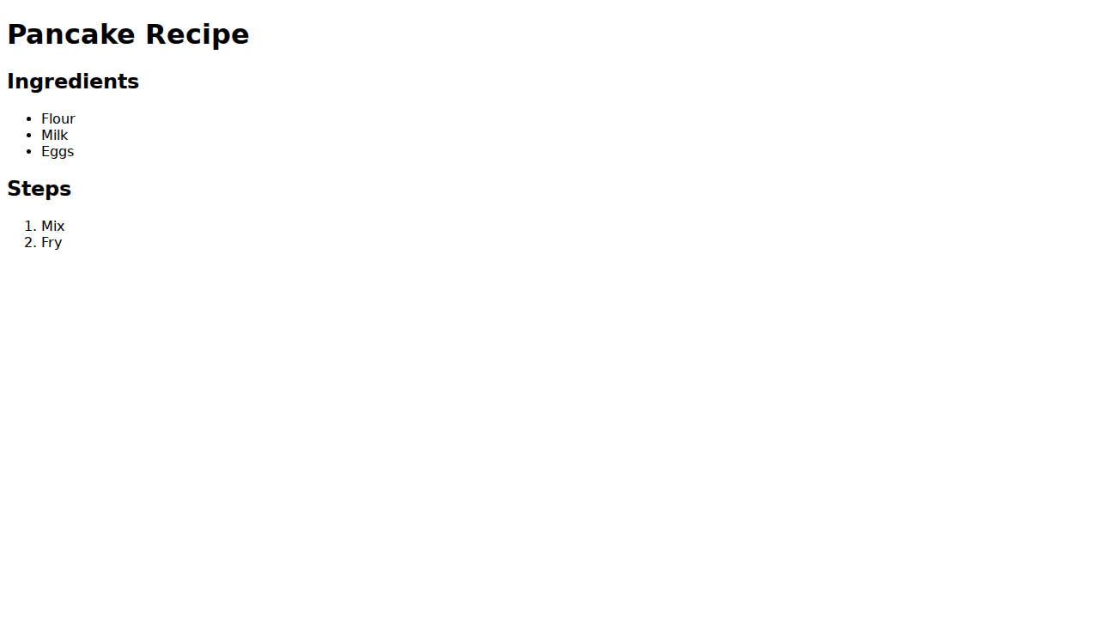

15 Schedule

HTML Code
<!DOCTYPE html><html><head><title>Event Schedule Page</title></head><body><h1>Conference Schedule</h1><table border='1'><tr><th>Time</th><th>Event</th></tr><tr><td>9:00 AM</td><td>Keynote</td></tr><tr><td>10:00 AM</td><td>Workshop</td></tr></table></body></html>

Screenshot
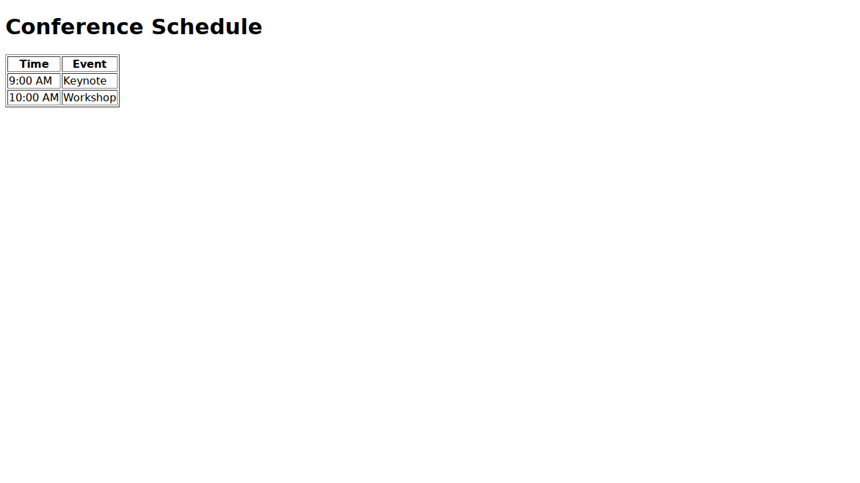

16 Login

HTML Code
<!DOCTYPE html><html><head><title>Simple Login Page (Front-End Only)</title></head><body><h1>Login</h1><form><label>Username:</label><input type='text'><br><label>Password:</label><input type='password'><br><button>Login</button></form></body></html>

Screenshot
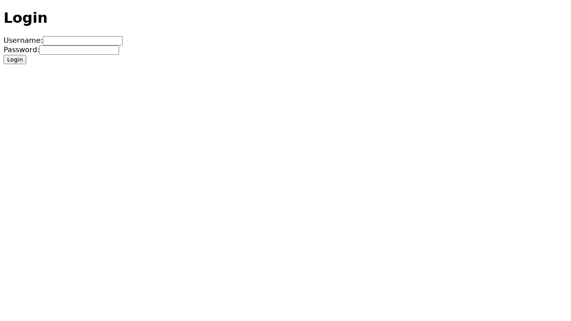

17 Registration

HTML Code
<!DOCTYPE html><html><head><title>Basic Registration Form</title></head><body><h1>Register</h1><form><label>Name:</label><input type='text'><br><label>Email:</label><input type='email'><br><label>Password:</label><input type='password'><br><button>Register</button></form></body></html>

Screenshot
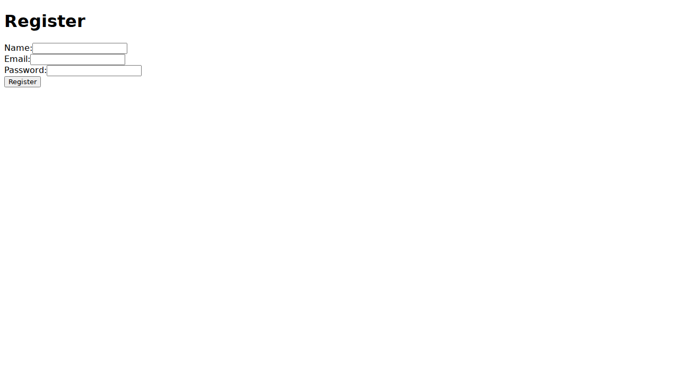

18 Youtube

HTML Code
<!DOCTYPE html><html><head><title>HTML Page with Embedded YouTube Video</title></head><body><h1>Watch this video</h1><iframe width='560' height='315' src='https://www.youtube.com/embed/dQw4w9WgXcQ' frameborder='0' allowfullscreen></iframe></body></html>

Screenshot
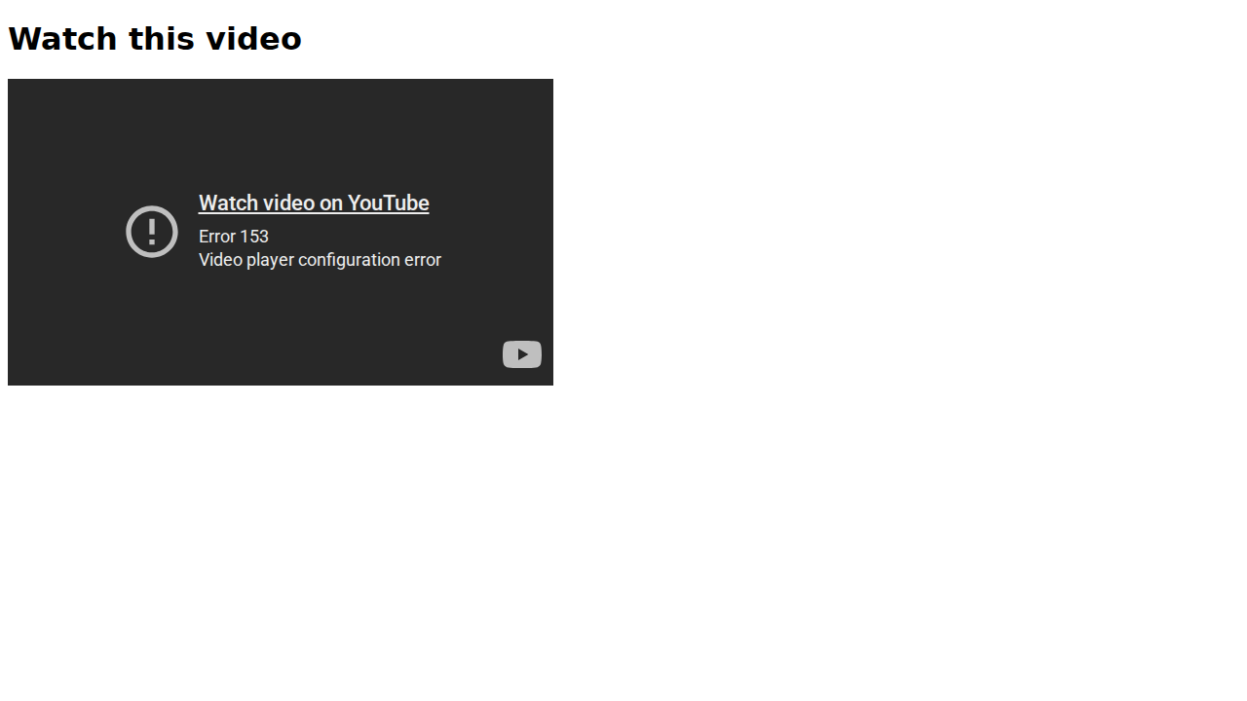

19 Coming Soon

HTML Code
<!DOCTYPE html><html><head><title>Coming Soon Landing Page</title></head><body><h1>Coming Soon</h1><p>We are working hard to launch our new site. Stay tuned!</p></body></html>

Screenshot
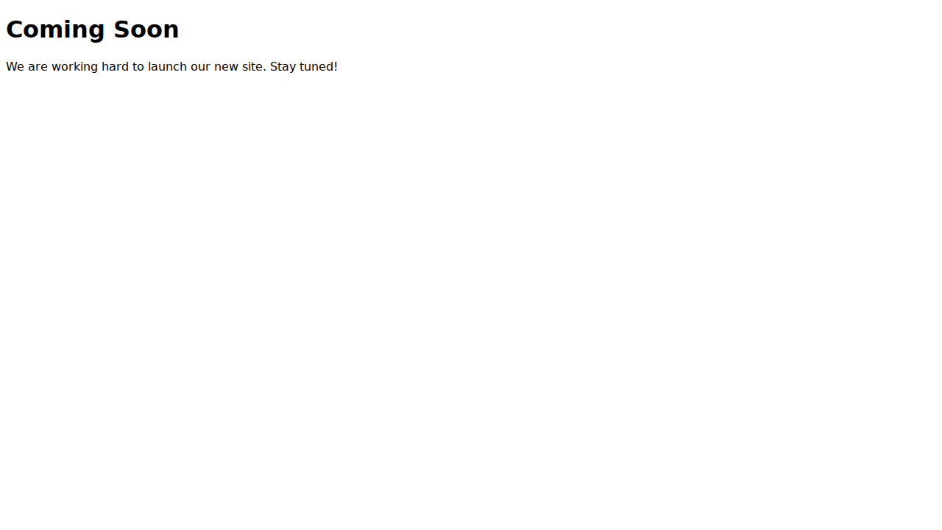

20 Faq

HTML Code
<!DOCTYPE html><html><head><title>HTML FAQ Page</title></head><body><h1>Frequently Asked Questions</h1><h3>Q: What is this?</h3><p>A: This is a collection of HTML pages.</p><h3>Q: How do I use it?</h3><p>A: Just open the files.</p></body></html>

Screenshot
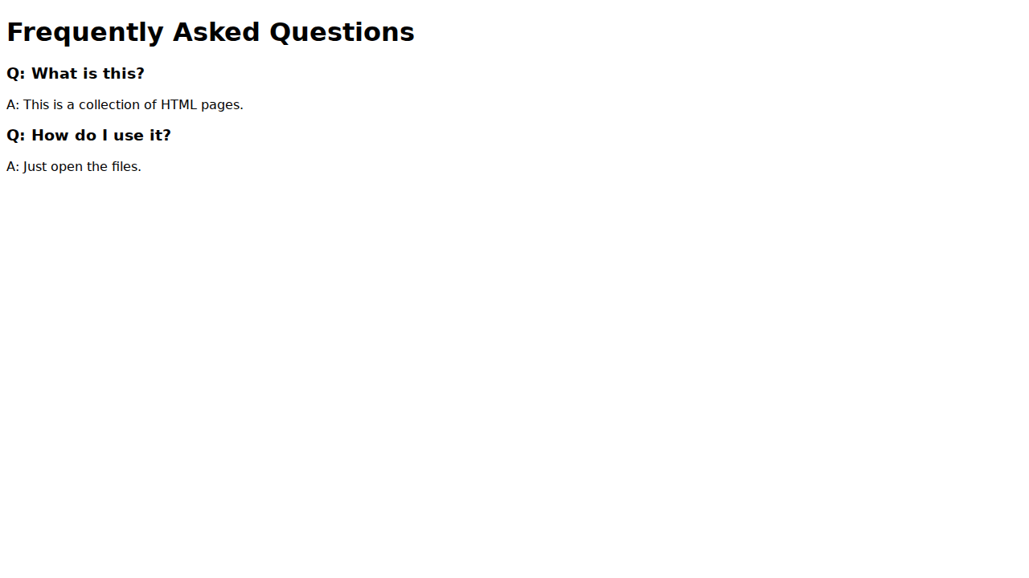

21 Audio Player

HTML Code
<!DOCTYPE html><html><head><title>Basic HTML Page with Audio Player</title></head><body><h1>Audio Player</h1><audio controls><source src='horse.ogg' type='audio/ogg'>Your browser does not support the audio element.</audio></body></html>

Screenshot
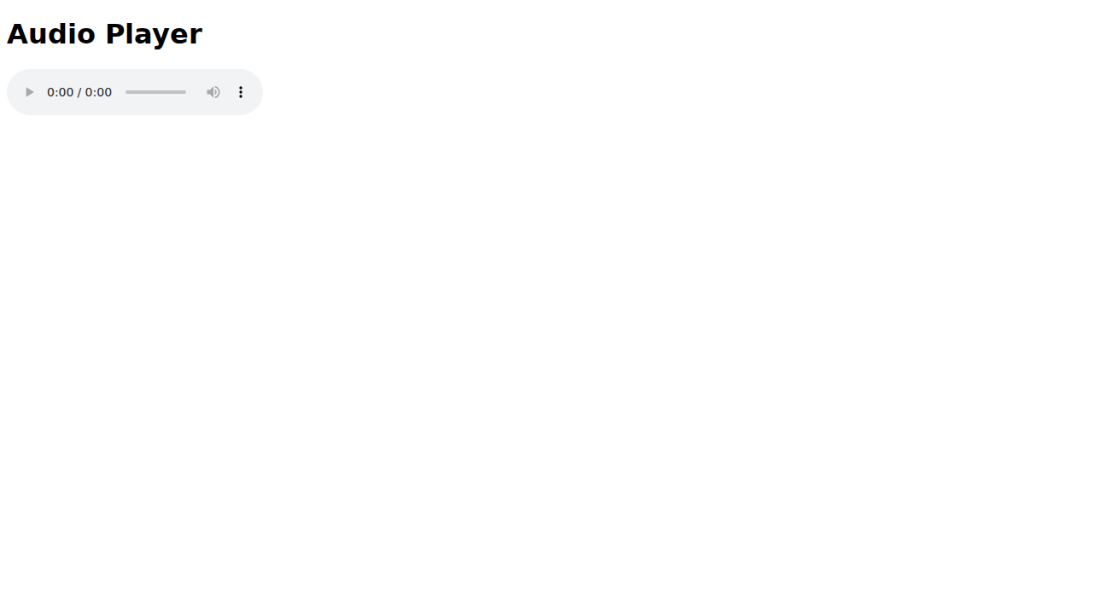

22 Google Maps

HTML Code
<!DOCTYPE html><html><head><title>Simple HTML Page with Google Maps Embed</title></head><body><h1>Our Location</h1><iframe src='https://www.google.com/maps/embed?pb=!1m18!1m12!1m3!1d3151.8354345093647!2d144.9537353153166!3d-37.816279742021234!2m3!1f0!2f0!3f0!3m2!1i1024!2i768!4f13.1!3m3!1m2!1s0x6ad642af0f11fd81%3A0xf577d1b74b1d8e1c!2sFederation%20Square!5e0!3m2!1sen!2sau!4v1614131580000!5m2!1sen!2sau' width='600' height='450' style='border:0;' allowfullscreen='' loading='lazy'></iframe></body></html>

Screenshot
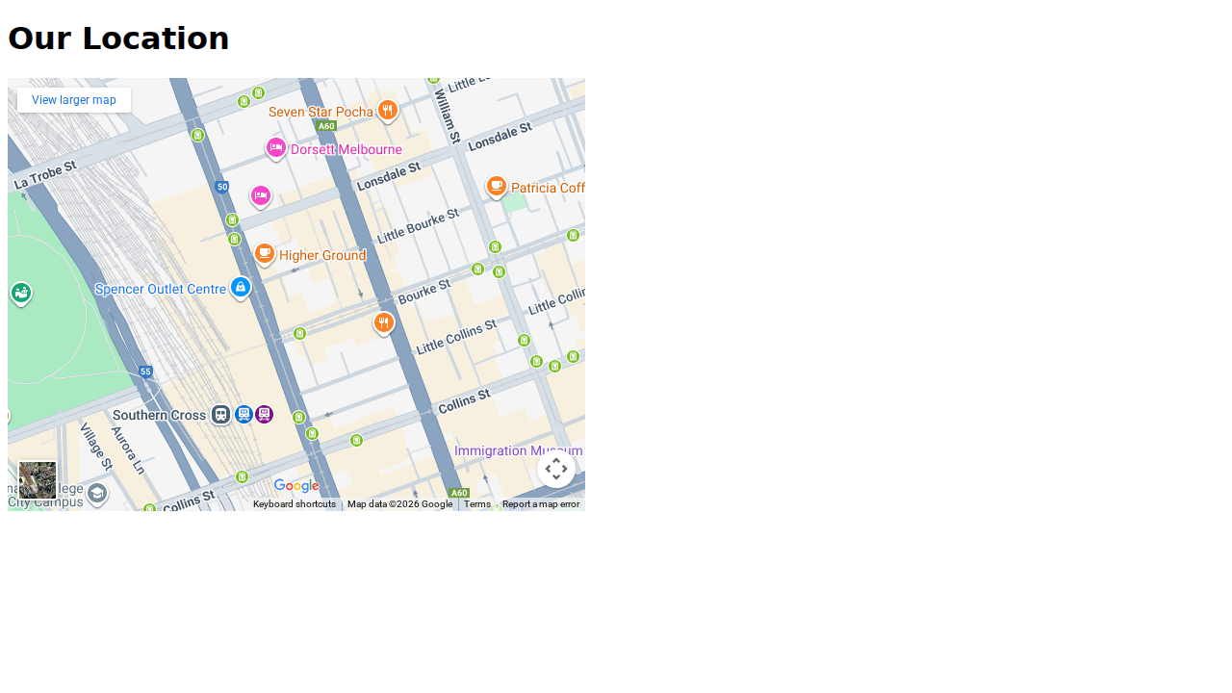

23 404

HTML Code
<!DOCTYPE html><html><head><title>404 Error Page</title></head><body><h1>404 - Not Found</h1><p>Sorry, the page you are looking for does not exist.</p><a href='01_hello_world.html'>Go Home</a></body></html>

Screenshot
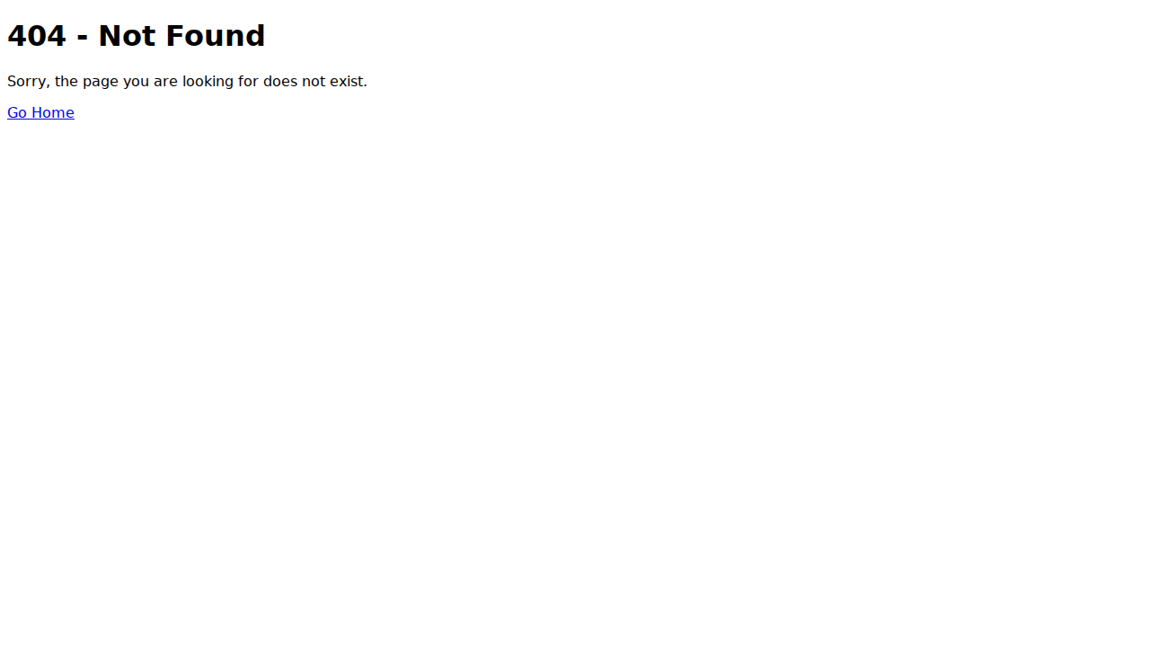

24 Toc

HTML Code
<!DOCTYPE html><html><head><title>HTML Page with Table of Contents</title></head><body><h1>Table of Contents</h1><ul><li><a href='#sec1'>Section 1</a></li><li><a href='#sec2'>Section 2</a></li></ul><h2 id='sec1'>Section 1</h2><p>Content of section 1.</p><h2 id='sec2'>Section 2</h2><p>Content of section 2.</p></body></html>

Screenshot
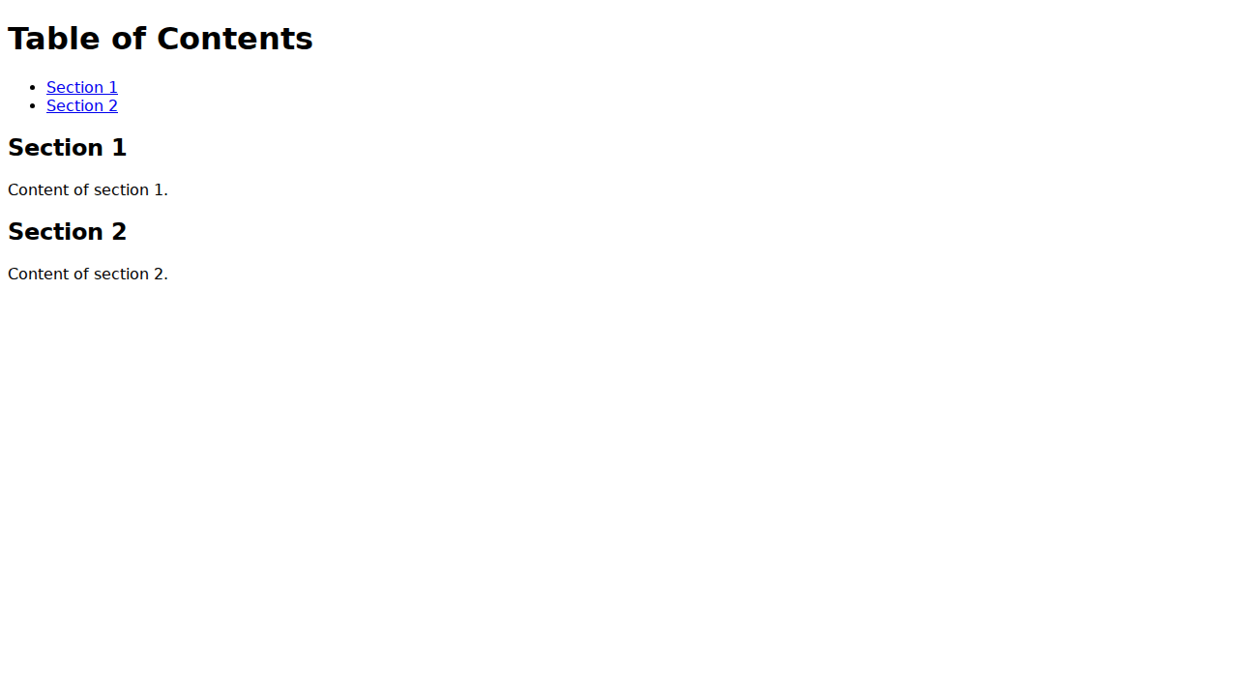

25 Slider

HTML Code
<!DOCTYPE html><html><head><title>Simple Image Slider (Manual HTML Version)</title></head><body><h1>Image Slider</h1><div style='width:300px; height:200px; overflow:hidden; border:1px solid black;'><div style='width:900px; display:flex;'><div style='width:300px;'>Slide 1</div><div style='width:300px;'>Slide 2</div><div style='width:300px;'>Slide 3</div></div></div><p>Manual slider (scroll horizontally or imagine buttons here).</p></body></html>

Screenshot
