C++ Practicals Report

Practical 1: Data members & member functions

Source Code:
#include <iostream>
using namespace std;
class Rectangle
{
public:
int length;
int breadth;
int area()
{
return length * breadth;
}
int perimeter()
{
return 2 * (length + breadth);
}
};
int main()
{
Rectangle rect;
cout << "Length of rectangle: ";
cin>> rect.length;
cout << "\nBreadth of rectangle: ";
cin>>rect.breadth;
cout << "Area of rectangle: " << rect.area() << endl;
cout << "Perimeter of rectangle: " << rect.perimeter() << endl;
return 0;
}

Output Screenshot:
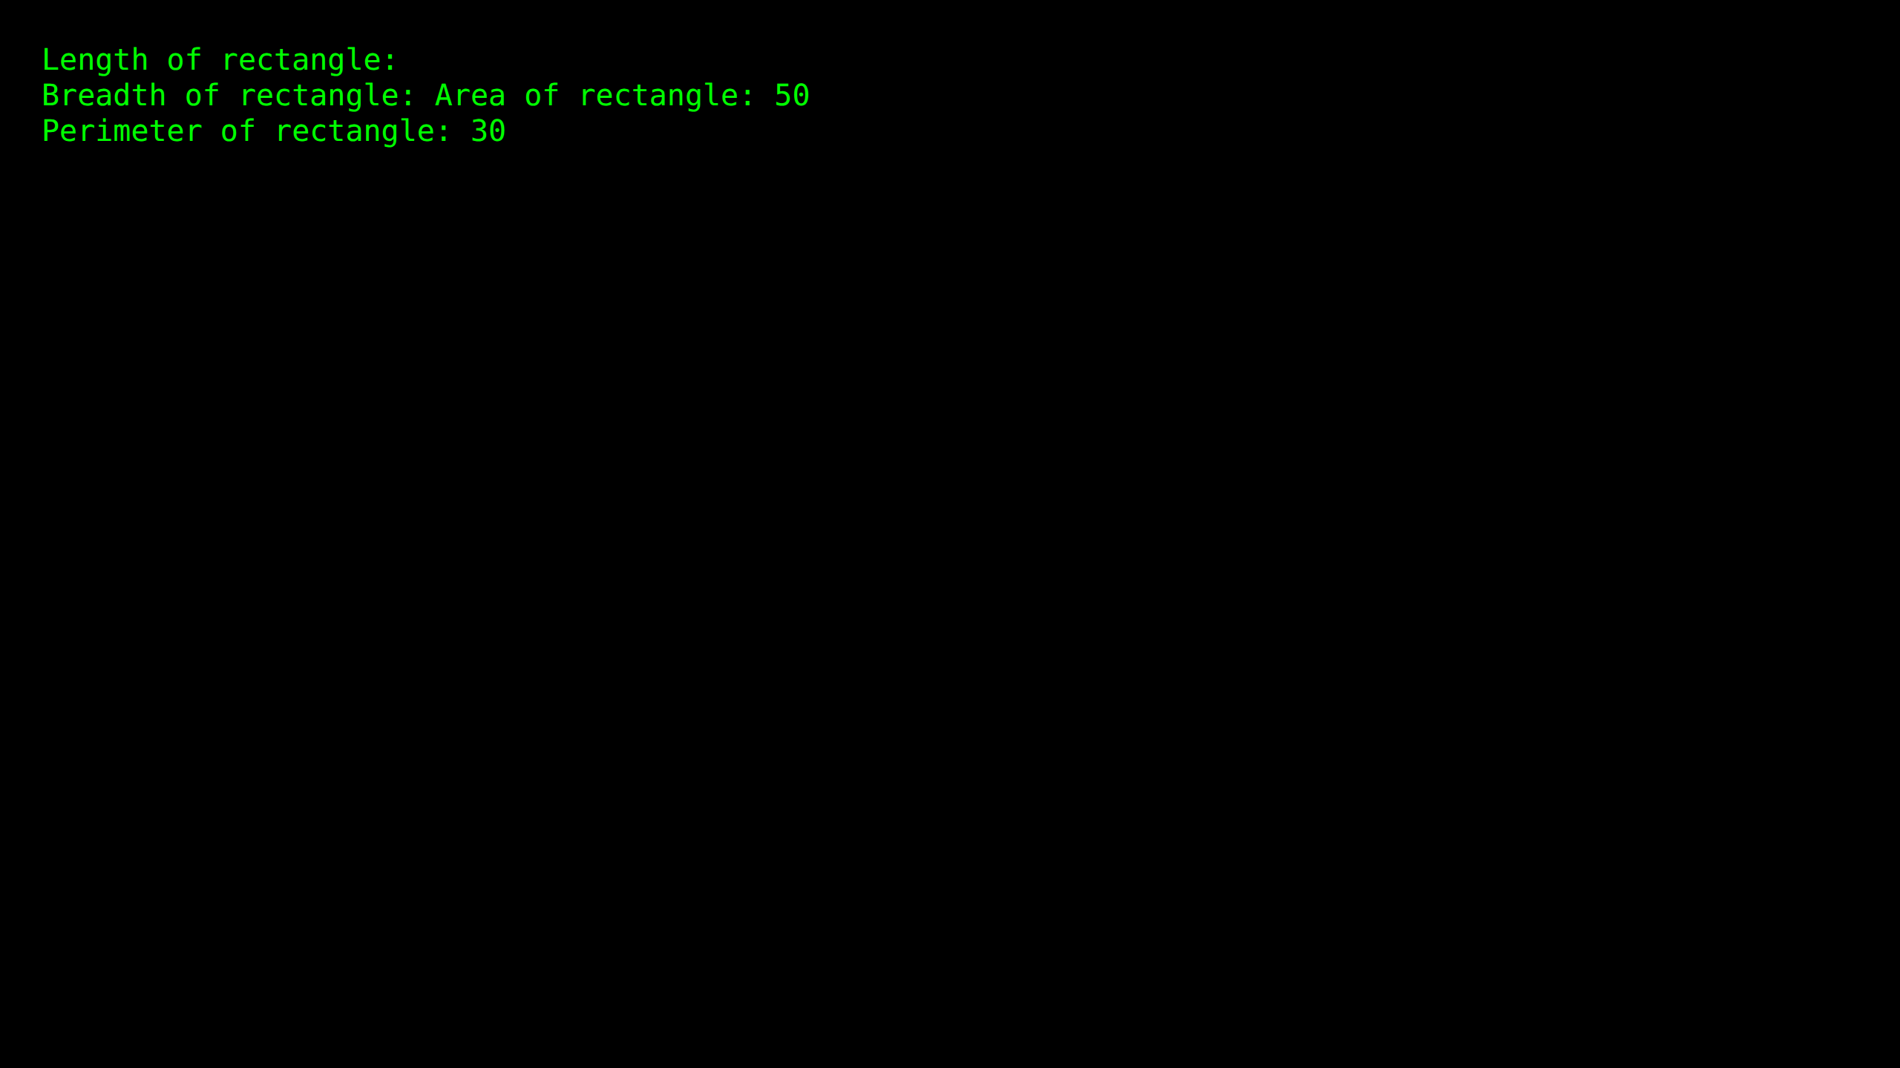

Practical 2: Branching and looping statements

Source Code:
#include <iostream>
using namespace std;
class Student
{
public:
int marks;
void getMarks()
{
cout << "Enter marks: ";
cin >> marks;
}
void calculateGrade()
{
if (marks >= 90) {
cout << "Grade: O - Outstanding " << endl;
}
else if (marks >= 85 && marks<90) {
cout << "Grade: A++" << endl;
}
else if (marks >= 80 && marks<85) {
cout << "Grade: A+" << endl;
}
else if (marks >= 75 && marks<80) {
cout << "Grade: A" << endl;
}
else if (marks >= 70 && marks<75) {
cout << "Grade: B+" << endl;
}
else if (marks >= 65 && marks<70) {
cout << "Grade: B" << endl;
}
else if (marks >= 60 && marks<65) {
cout << "Grade: C" << endl;
}
else if (marks >= 50 && marks<60) {
cout << "Grade: D" << endl;
}
else if (marks >= 40 && marks<50) {
cout << "Grade: E" << endl;
}
else
{
cout << "Grade: F" << endl;
}
}
};
int main() {
Student student;
student.getMarks();
student.calculateGrade();
return 0;
}

Output Screenshot:
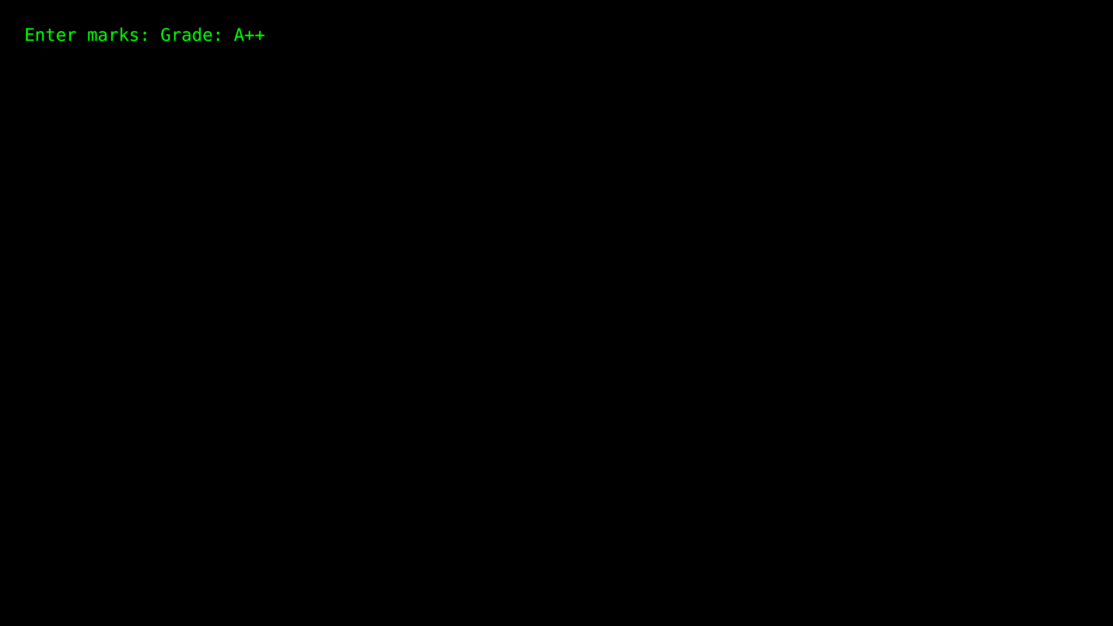

Practical 3.1: Sum of 'n' natural numbers

Source Code:
#include <iostream>
using namespace std;
int main()
{
int arr[100],i,size,sum=0,n;
cout<<"Enter the number of elements: ";
cin>>size;//Accepting array size
cout<<"Enter the value of elements: "<<endl;
n=size;
for(i=0;i<n;i++)
{
cin>>arr[i]; //Accepting values
}
for(i=0;i<n;i++)
{
sum=sum+arr[i];//Calculating sum
}
cout<<"Sum of elements in an array is: "<<sum << endl;
return 0;
}

Output Screenshot:
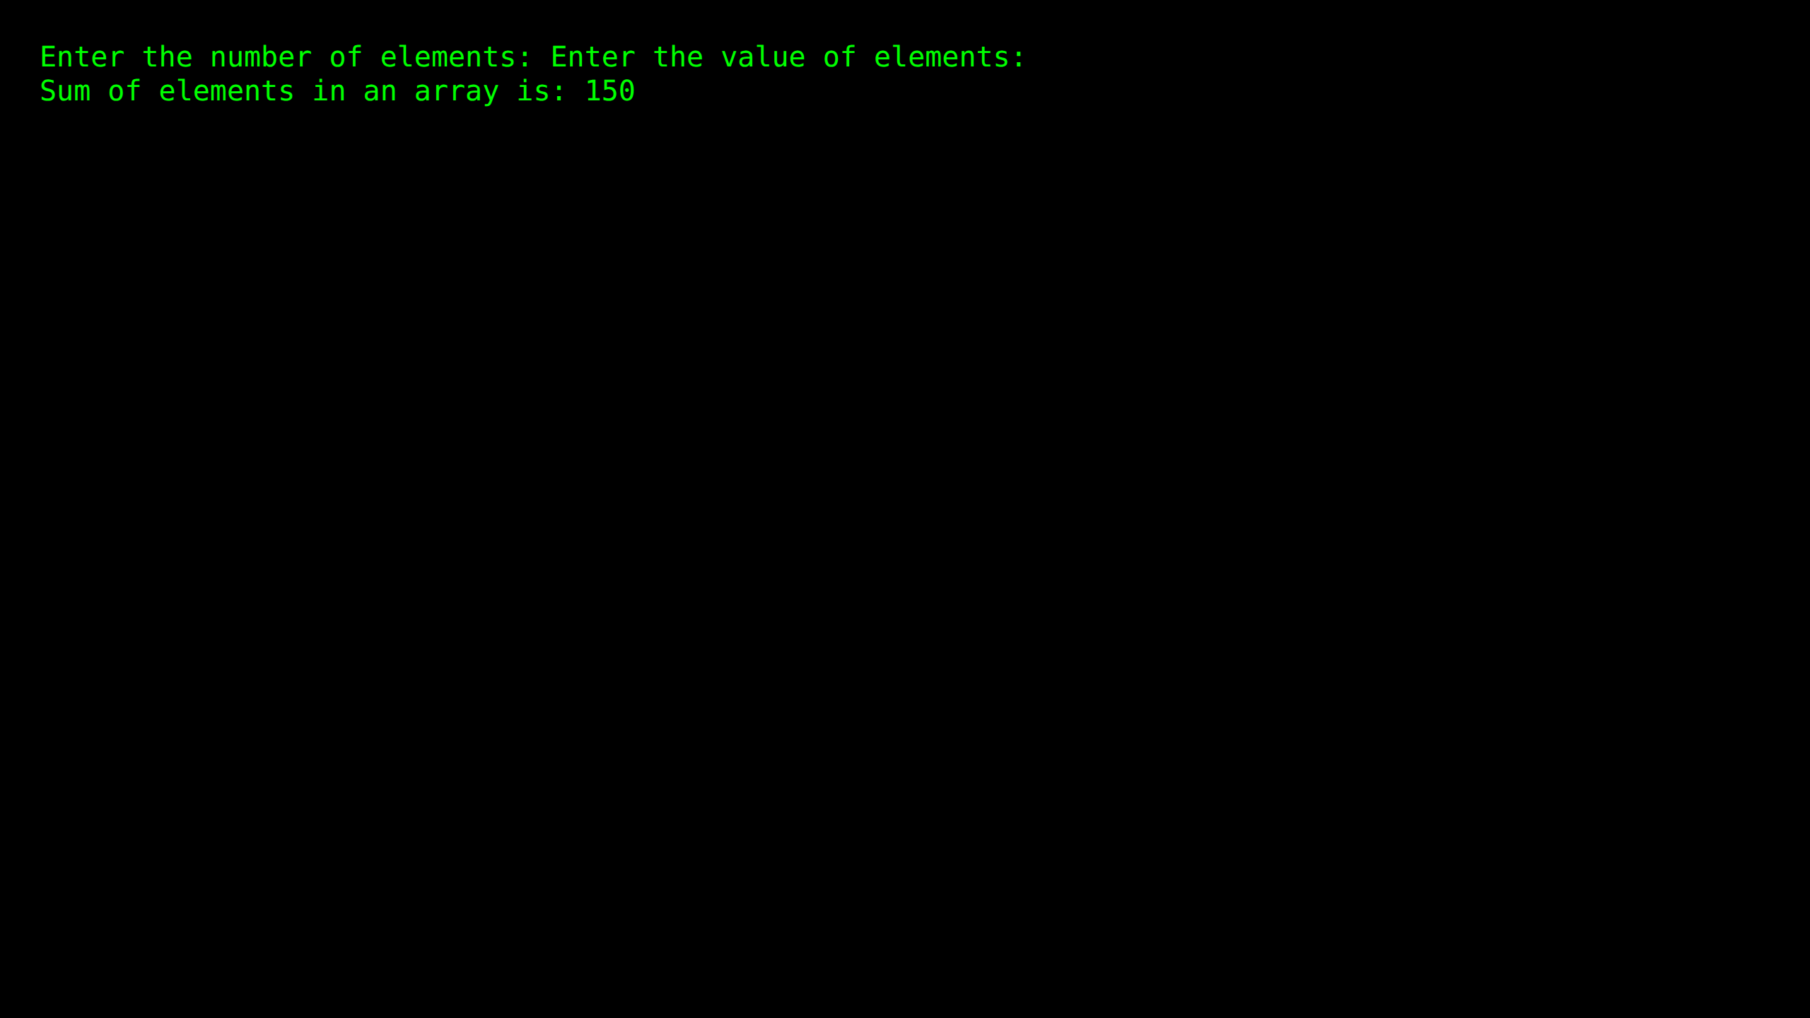

Practical 3.2: Sum of two matrices

Source Code:
#include<iostream>
using namespace std;
int main()
{
int m1[5][5], m2[5][5], m3[5][5];
int i, j, r, c;
cout<<"Enter the no.of rows of the matrices to be added(max 5):";
cin>>r;
cout<<"Enter the no.of columns of the matrices to be added(max 5):";
cin>>c;
cout<<"\n1st Matrix Input:\n";
for(i=0;i<r;i++)
{
for(j=0;j<c;j++)
{
cout<<"\nmatrix1["<<i<<"]["<<j<<"]= ";
cin>>m1[i][j];
}
}
cout<<"\n2nd Matrix Input:\n";
for(i=0;i<r;i++)
{
for(j=0;j<c;j++)
{
cout<<"\nmatrix2["<<i<<"]["<<j<<"]= ";
cin>>m2[i][j];
}
}
cout<<"\nAdding Matrices...\n";
for(i=0;i<r;i++)
{
for(j=0;j<c;j++)
{
m3[i][j]=m1[i][j]+m2[i][j];
}
}
cout<<"\nThe resultant Matrix is:\n";
for(i=0;i<r;i++)
{
for(j=0;j<c;j++)
{
cout<<"\t"<<m3[i][j];
}
cout<<endl;
}
return 0;
}

Output Screenshot:
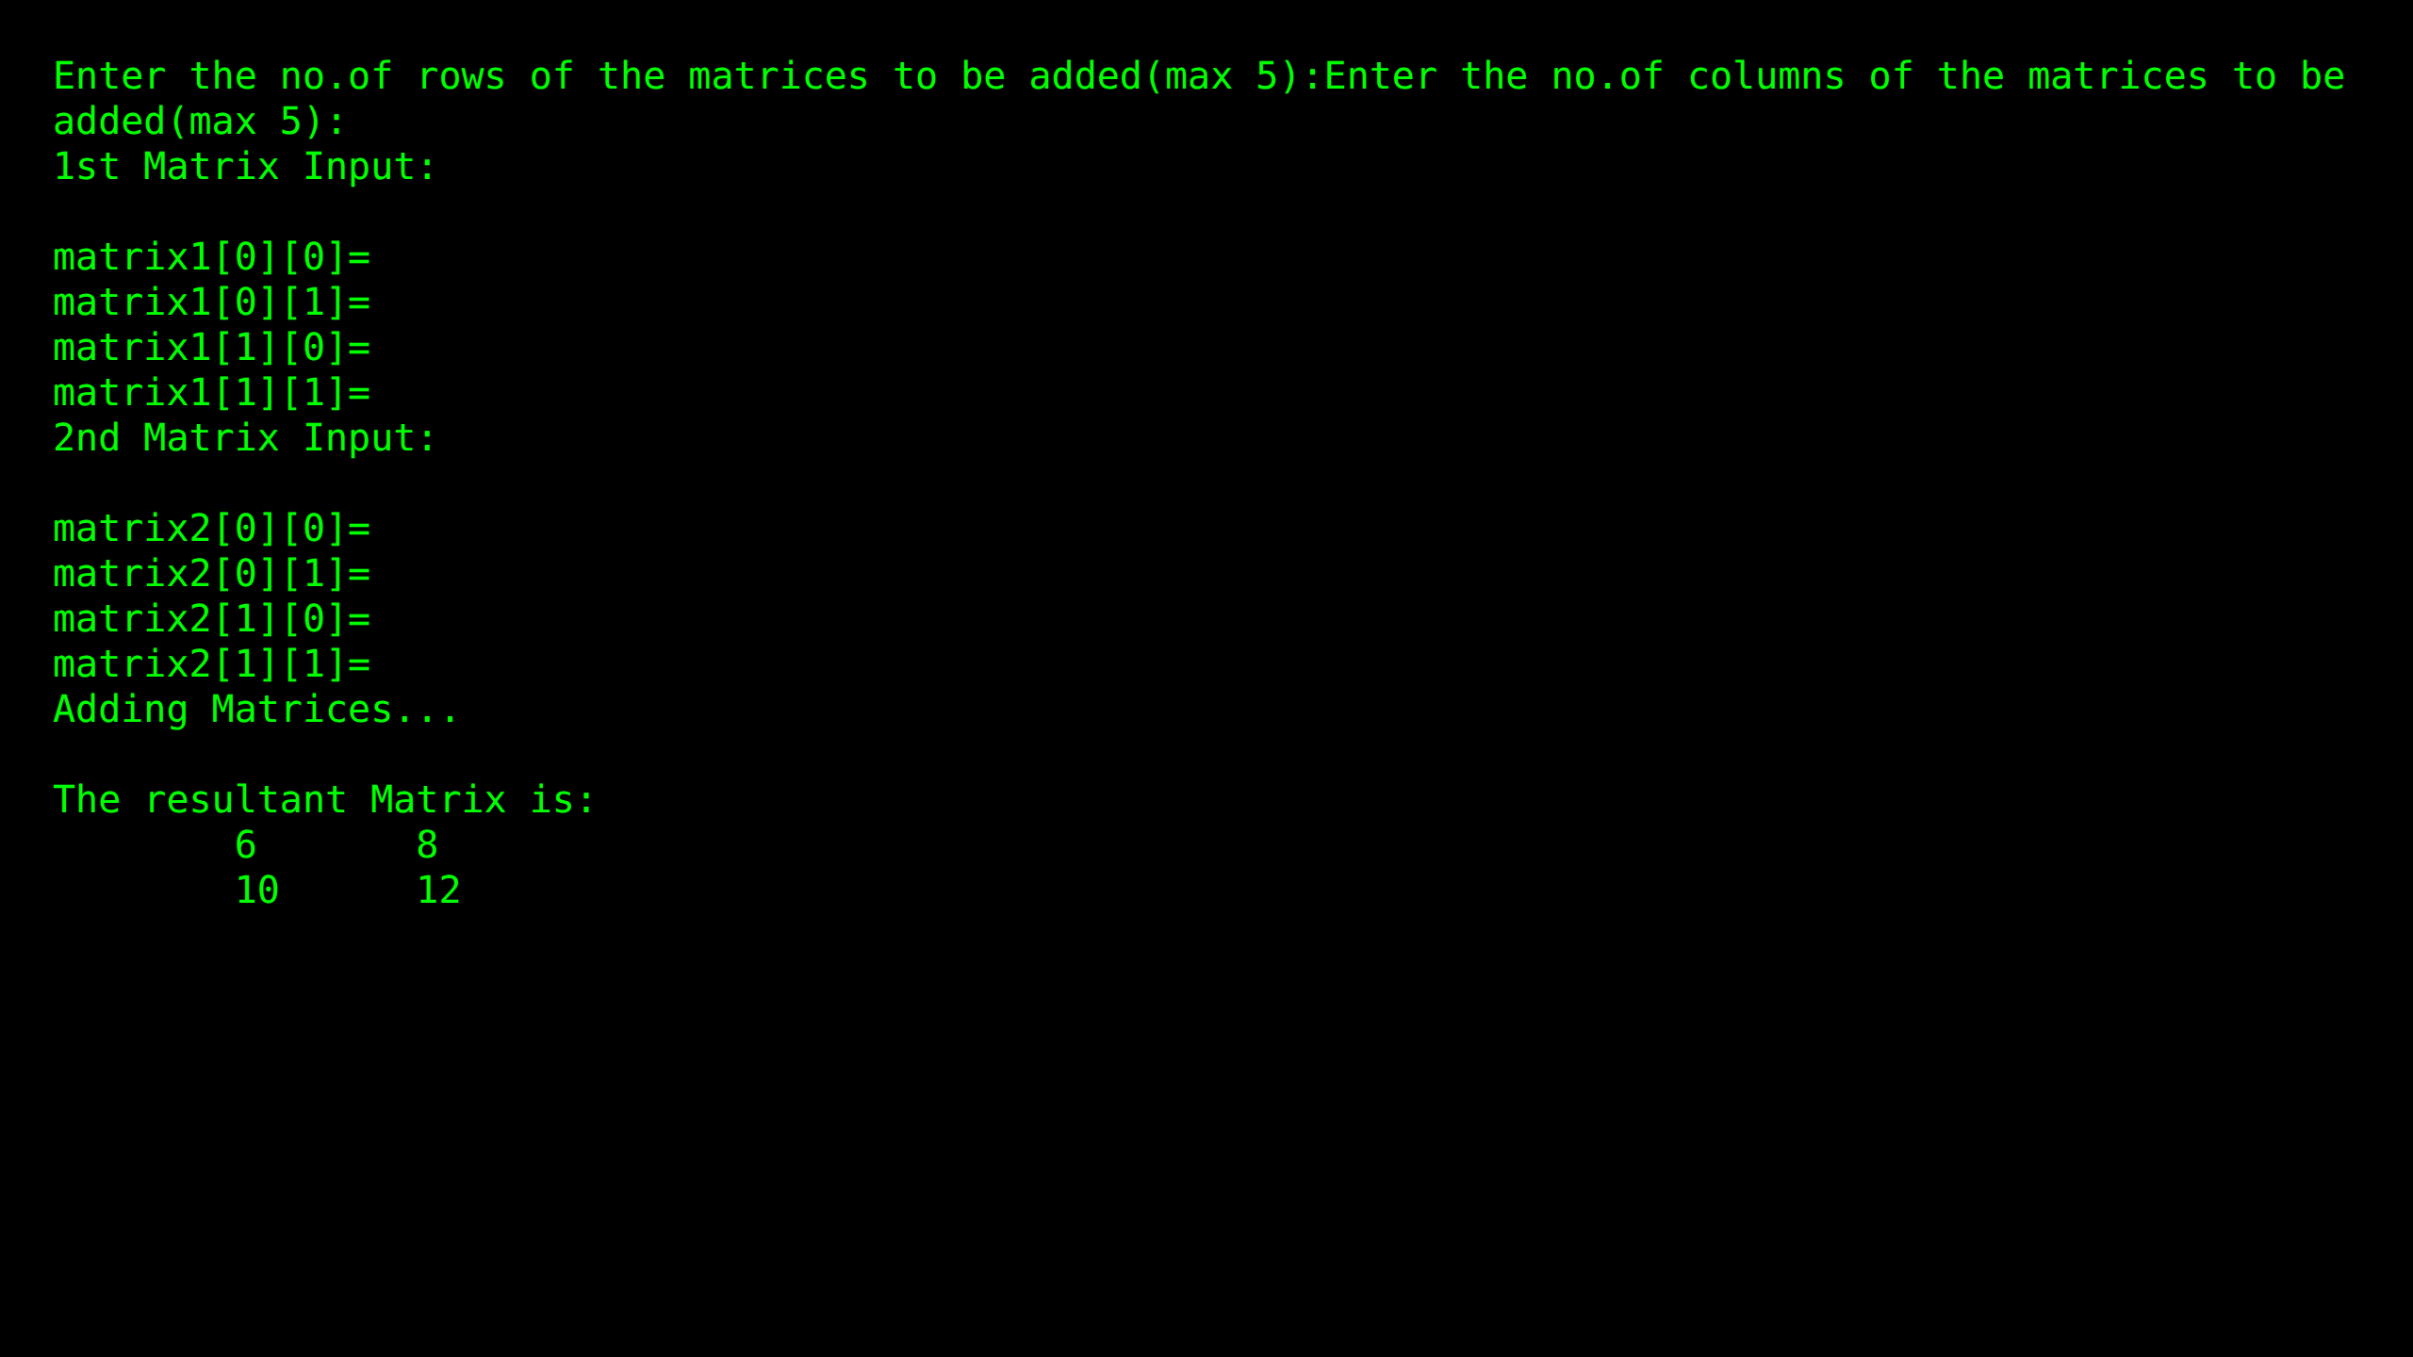

Practical 4: Scope resolution operator

Source Code:
#include <iostream>
using namespace std;
int i = 10;
void localScopeFunction()
{
int i = 5;
cout << "Inside localScopeFunction - Global Variable: " << ::i << endl;
cout << "Inside localScopeFunction - Local Variable: " << i << endl;
}
int main() {
cout << "Inside main - Global Variable: " <<i << endl;
localScopeFunction();
int i = 20;
cout << "Inside nested block - Global Variable: " << ::i << endl;
cout << "Inside nested block - Nested Variable: " << i << endl;
return 0;
}

Output Screenshot:
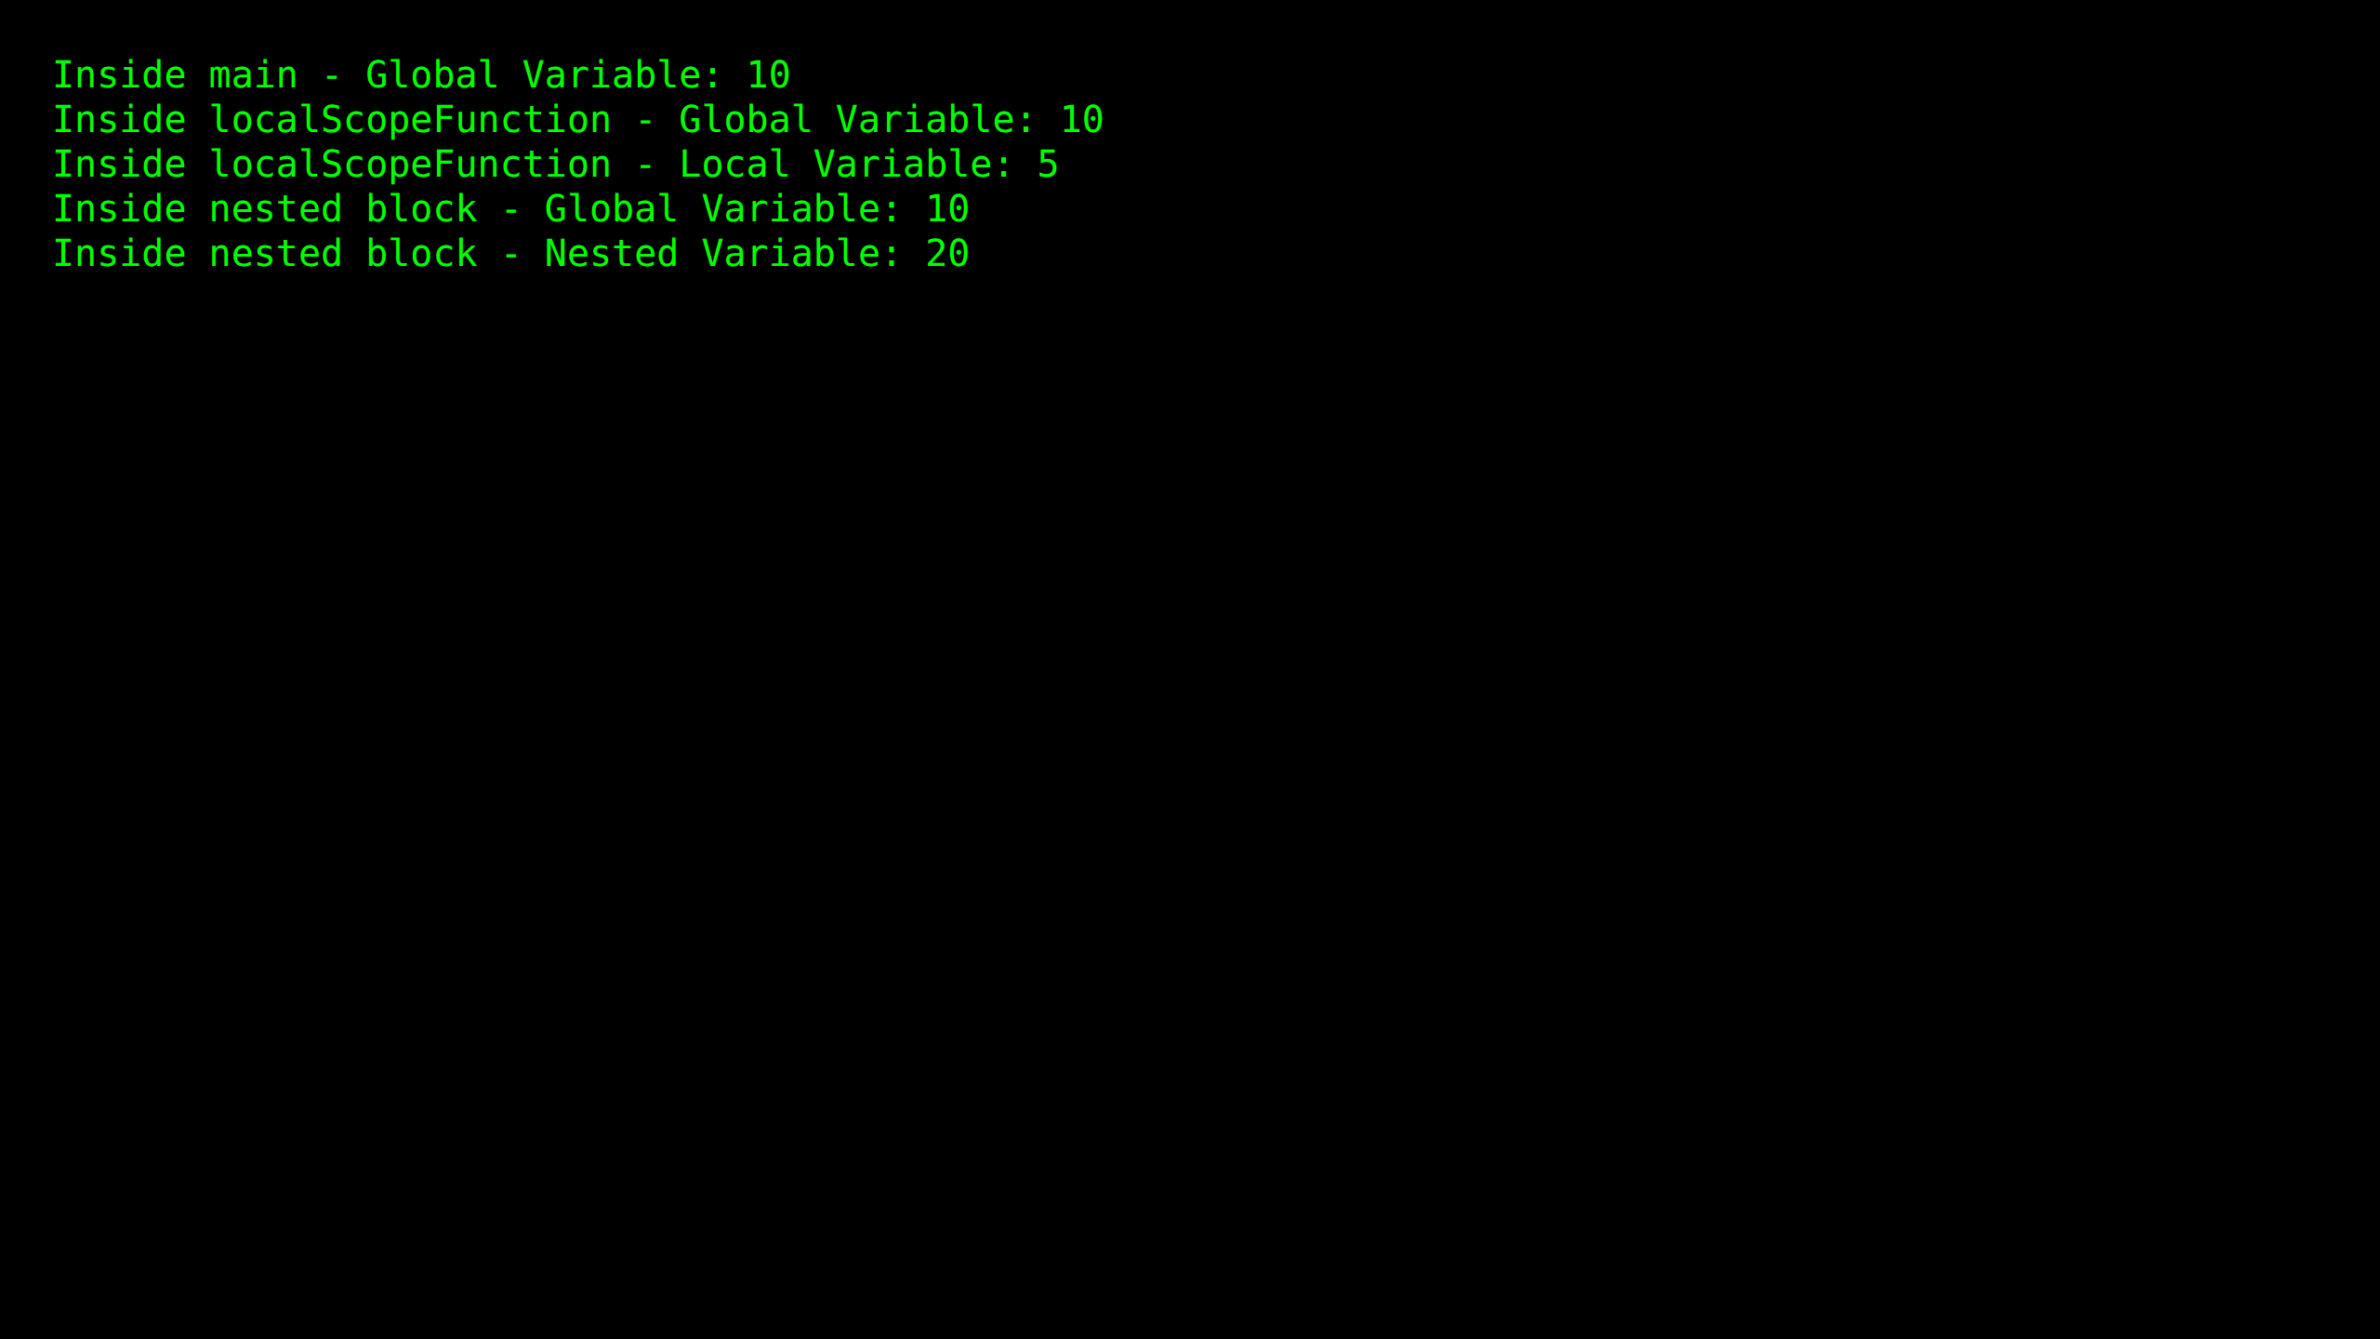

Practical 5: Constructors and destructors

Source Code:
#include <iostream>
using namespace std;
class MyClass
{
public:
MyClass()
{
value = 0;
cout << "Default Constructor called" << endl;
}
MyClass(int value)
{
this->value = value;
cout << "Parameterized Constructor called with value: " << value << endl;
}
MyClass(const MyClass &other)
{
this->value = other.value;
cout << "Copy Constructor called with value: " << value << endl;
}
~MyClass()
{
cout << "Destructor called for value: " << value << endl;
}
private:
int value;
};
int main()
{
MyClass obj1;
MyClass obj2(42);
MyClass obj3 = obj2;
MyClass *dynamicObj1 = new MyClass;
MyClass *dynamicObj2 = new MyClass(99);
delete dynamicObj1;
delete dynamicObj2;
return 0;
}

Output Screenshot:
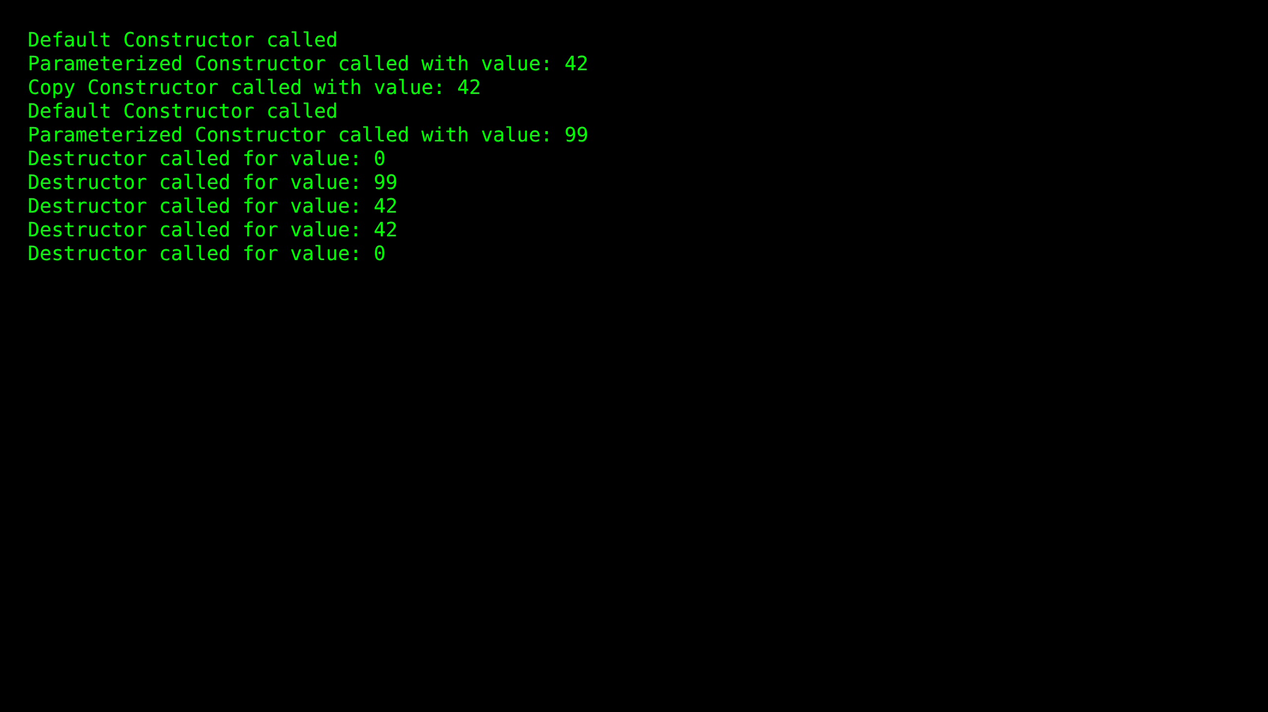

Practical 6: Access specifiers

Source Code:
#include <iostream>
using namespace std;
class BaseClass
{
public:
int publicVar;
void publicFunction(void)
{
cout << "Inside public Function of Base Class" << endl;
}
protected:
int protectedVar;
void protectedFunction(void)
{
cout << "Inside protected Function of Base Class" << endl;
}
private:
int privateVar;
void privateFunction()
{
cout << "Inside private Function of Base Class" <<endl;
}
};
int main()
{
BaseClass obj;
obj.publicVar = 5;
cout <<"Public variable value: "<< obj.publicVar<<endl;
obj.publicFunction();
return 0;
}

Output Screenshot:
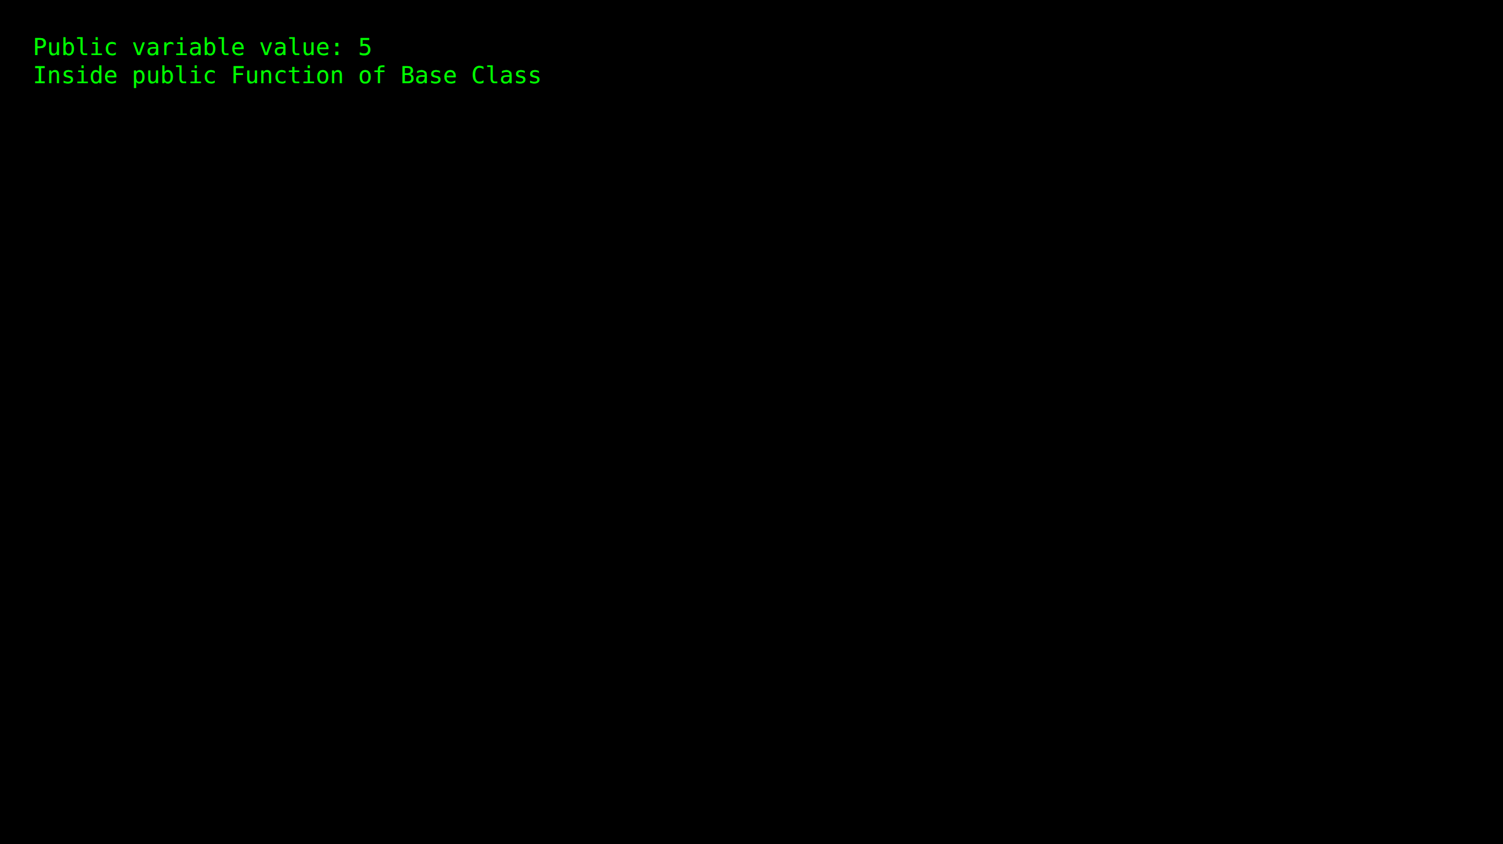

Practical 7.1: Single Level Inheritance

Source Code:
#include <iostream>
using namespace std;
class Account
{
public:
float salary = 60000;
};
class Programmer: public Account
{
public:
float bonus = 5000;
};
int main(void)
{
Programmer p1;
cout<<"Salary: "<<p1.salary<<endl;
cout<<"Bonus: "<<p1.bonus<<endl;
return 0;
}

Output Screenshot:
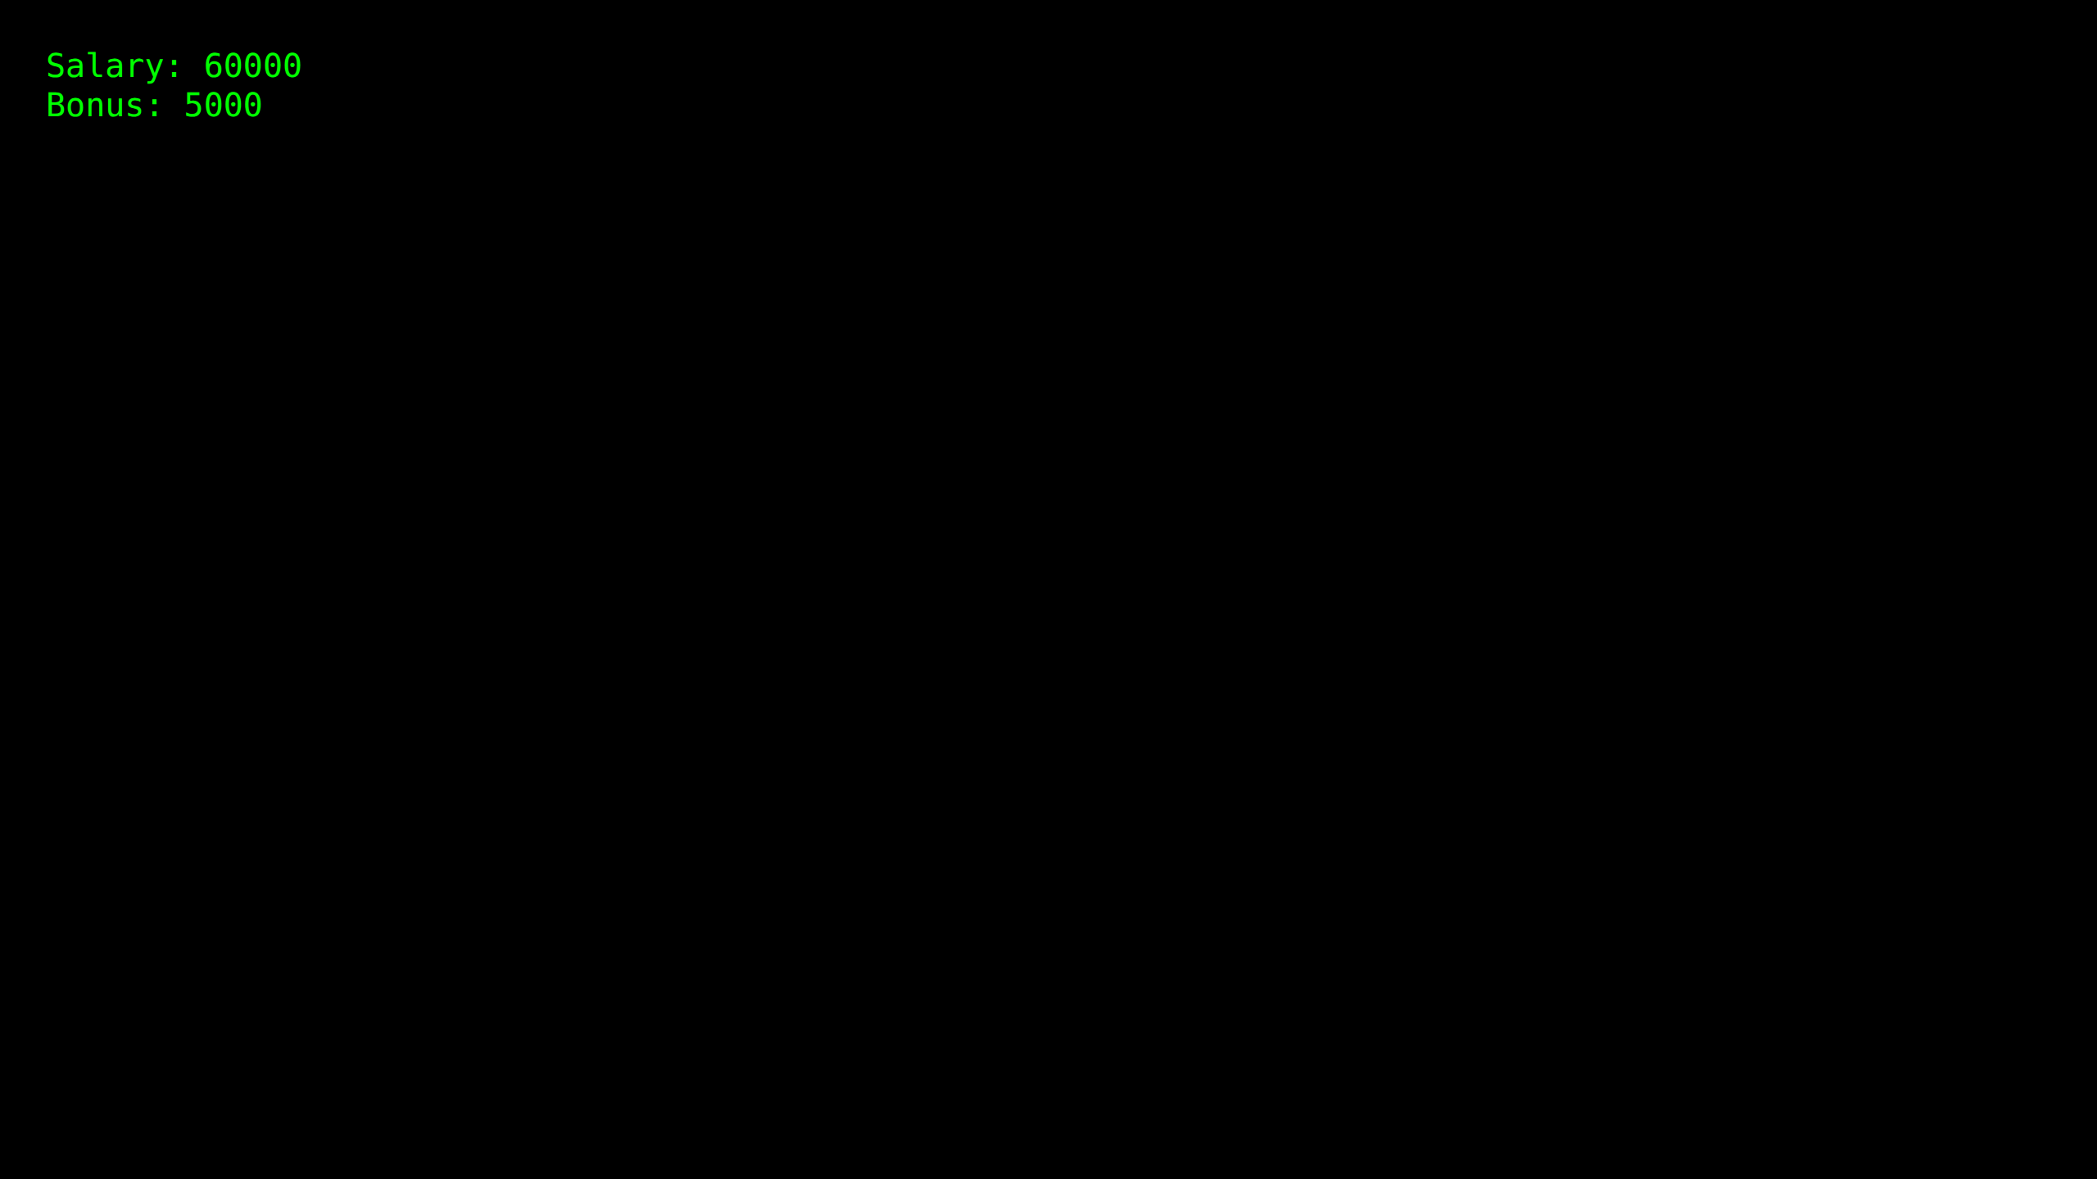

Practical 7.2: Multi Level Inheritance (A)

Source Code:
#include <iostream>
using namespace std;
class Vehicle
{
public:
Vehicle()
{
cout << "This is a Vehicle" << endl;
}
};
class fourWheeler: public Vehicle
{ public:
fourWheeler()
{
cout<<"Objects with 4 wheels are vehicles"<< endl;
}
};
class Car: public fourWheeler{
public:
Car()
{
cout<<"Car has 4 Wheels"<<endl;
}
};
int main()
{
Car obj;
return 0;
}

Output Screenshot:
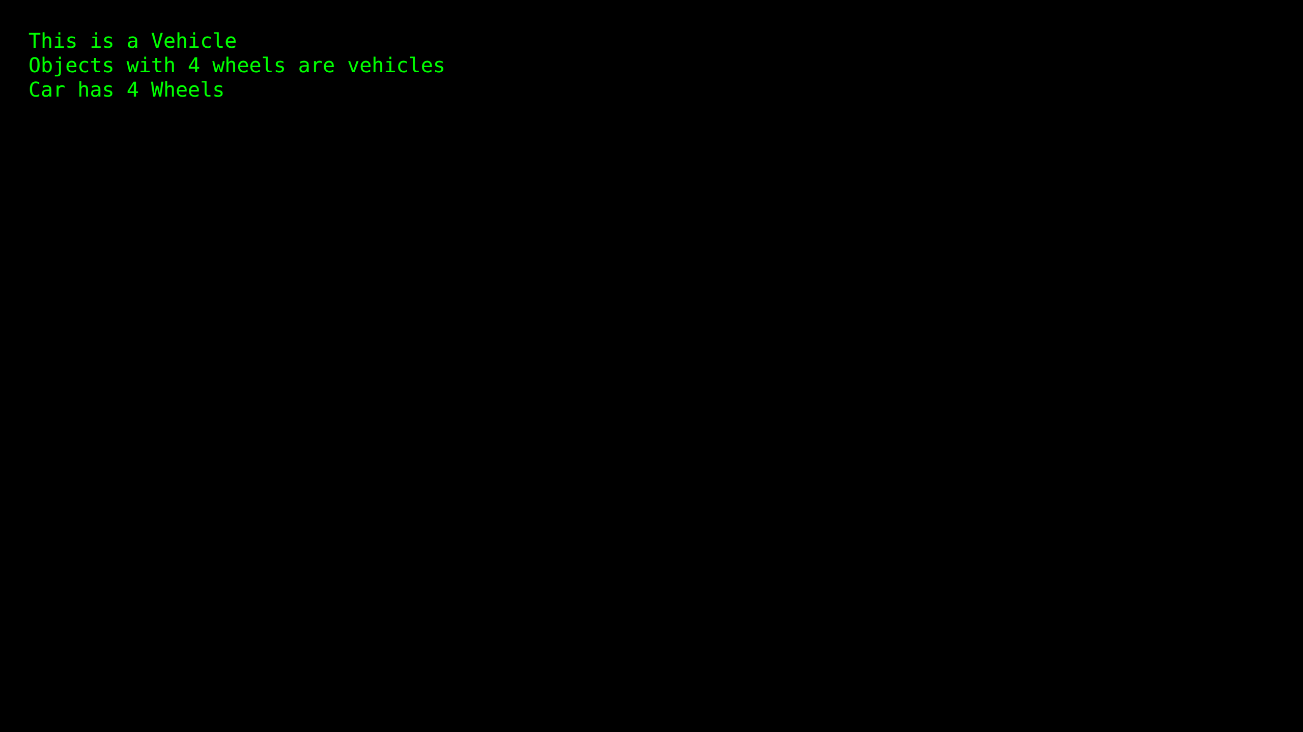

Practical 7.3: Multi Level Inheritance (B)

Source Code:
#include <iostream>
using namespace std;
class Animal
{
public:
void eat()
{
cout<<"Eating...base class"<<endl;
}
};
class Dog: public Animal
{
public:
void bark()
{
cout<<"Barking...first level derived class"<<endl;
}
};
class BabyDog: public Dog
{
public:
void weep()
{
cout<<"Weeping...second level derived class" << endl;
}
};
int main(void)
{
BabyDog d1;
d1.eat();
d1.bark();
d1.weep();
return 0;
}

Output Screenshot:
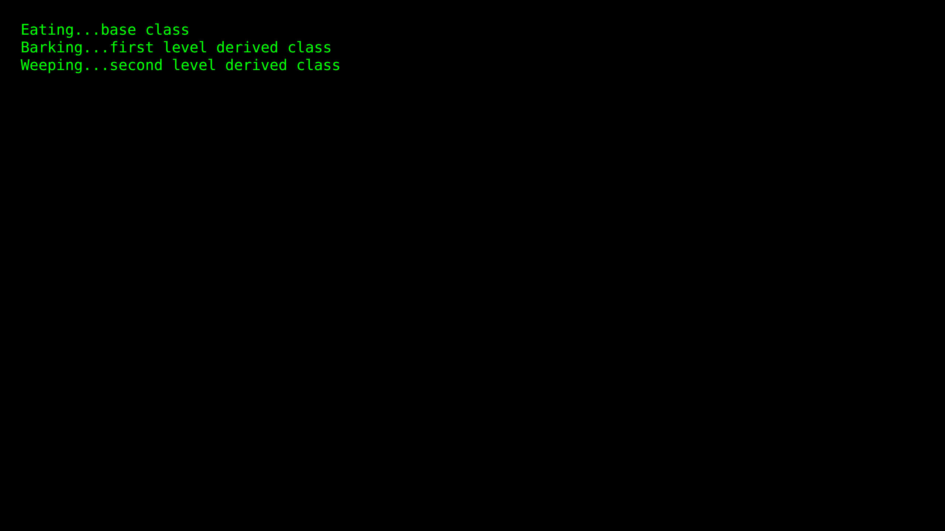

Practical 8.1: Multiple Inheritance

Source Code:
#include <iostream>
using namespace std;
class A
{
protected:
int a;
public:
void get_a(int n)
{
a = n;
}
};
class B
{
protected:
int b;
public:
void get_b(int n)
{
b = n;
}
};
class C : public A,public B
{
public:
void display()
{
cout << "The value of a is : " <<a<< endl;
cout << "The value of b is : " <<b<< endl;
cout<<"Addition of a and b is : "<<a+b << endl;
}
};
int main()
{
C c;
c.get_a(10);
c.get_b(20);
c.display();
return 0;
}

Output Screenshot:
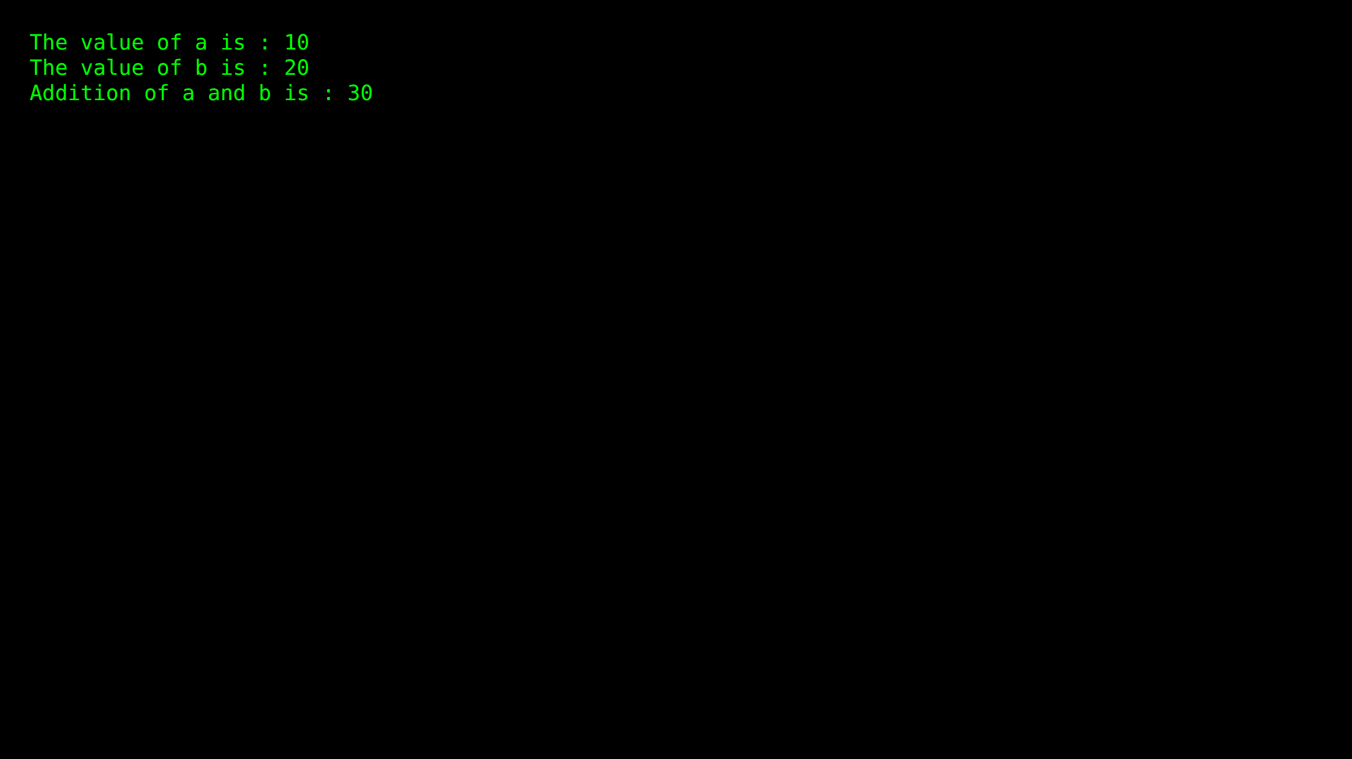

Practical 8.2: Hierarchical Inheritance

Source Code:
#include <iostream>
using namespace std;
class Shape
{
public:
int a;
int b;
void get_data(int n,int m)
{
a= n;
b = m;
}
};
class Rectangle : public Shape
{
public:
int rect_area()
{
int result = a*b;
return result;
}
};
class Triangle : public Shape
{
public:
int triangle_area()
{
float result = 0.5*a*b;
return (int)result;
}
};
int main()
{
Rectangle r;
Triangle t;
int length,breadth,base,height;
cout << "Enter the length of a rectangle: " << endl;
cin>>length;
cout << "Enter the breadth of a rectangle: " << endl;
cin>>breadth;
r.get_data(length,breadth);
int m = r.rect_area();
cout << "Area of the rectangle is : " <<m<<endl;
cout << "Enter the base of the triangle: " << endl;
cin>>base;
cout << "Enter the height of the triangle: " << endl;
cin>>height;
t.get_data(base,height);
float n = t.triangle_area();
cout <<"Area of the triangle is : " << n<<endl;
return 0;
}

Output Screenshot:
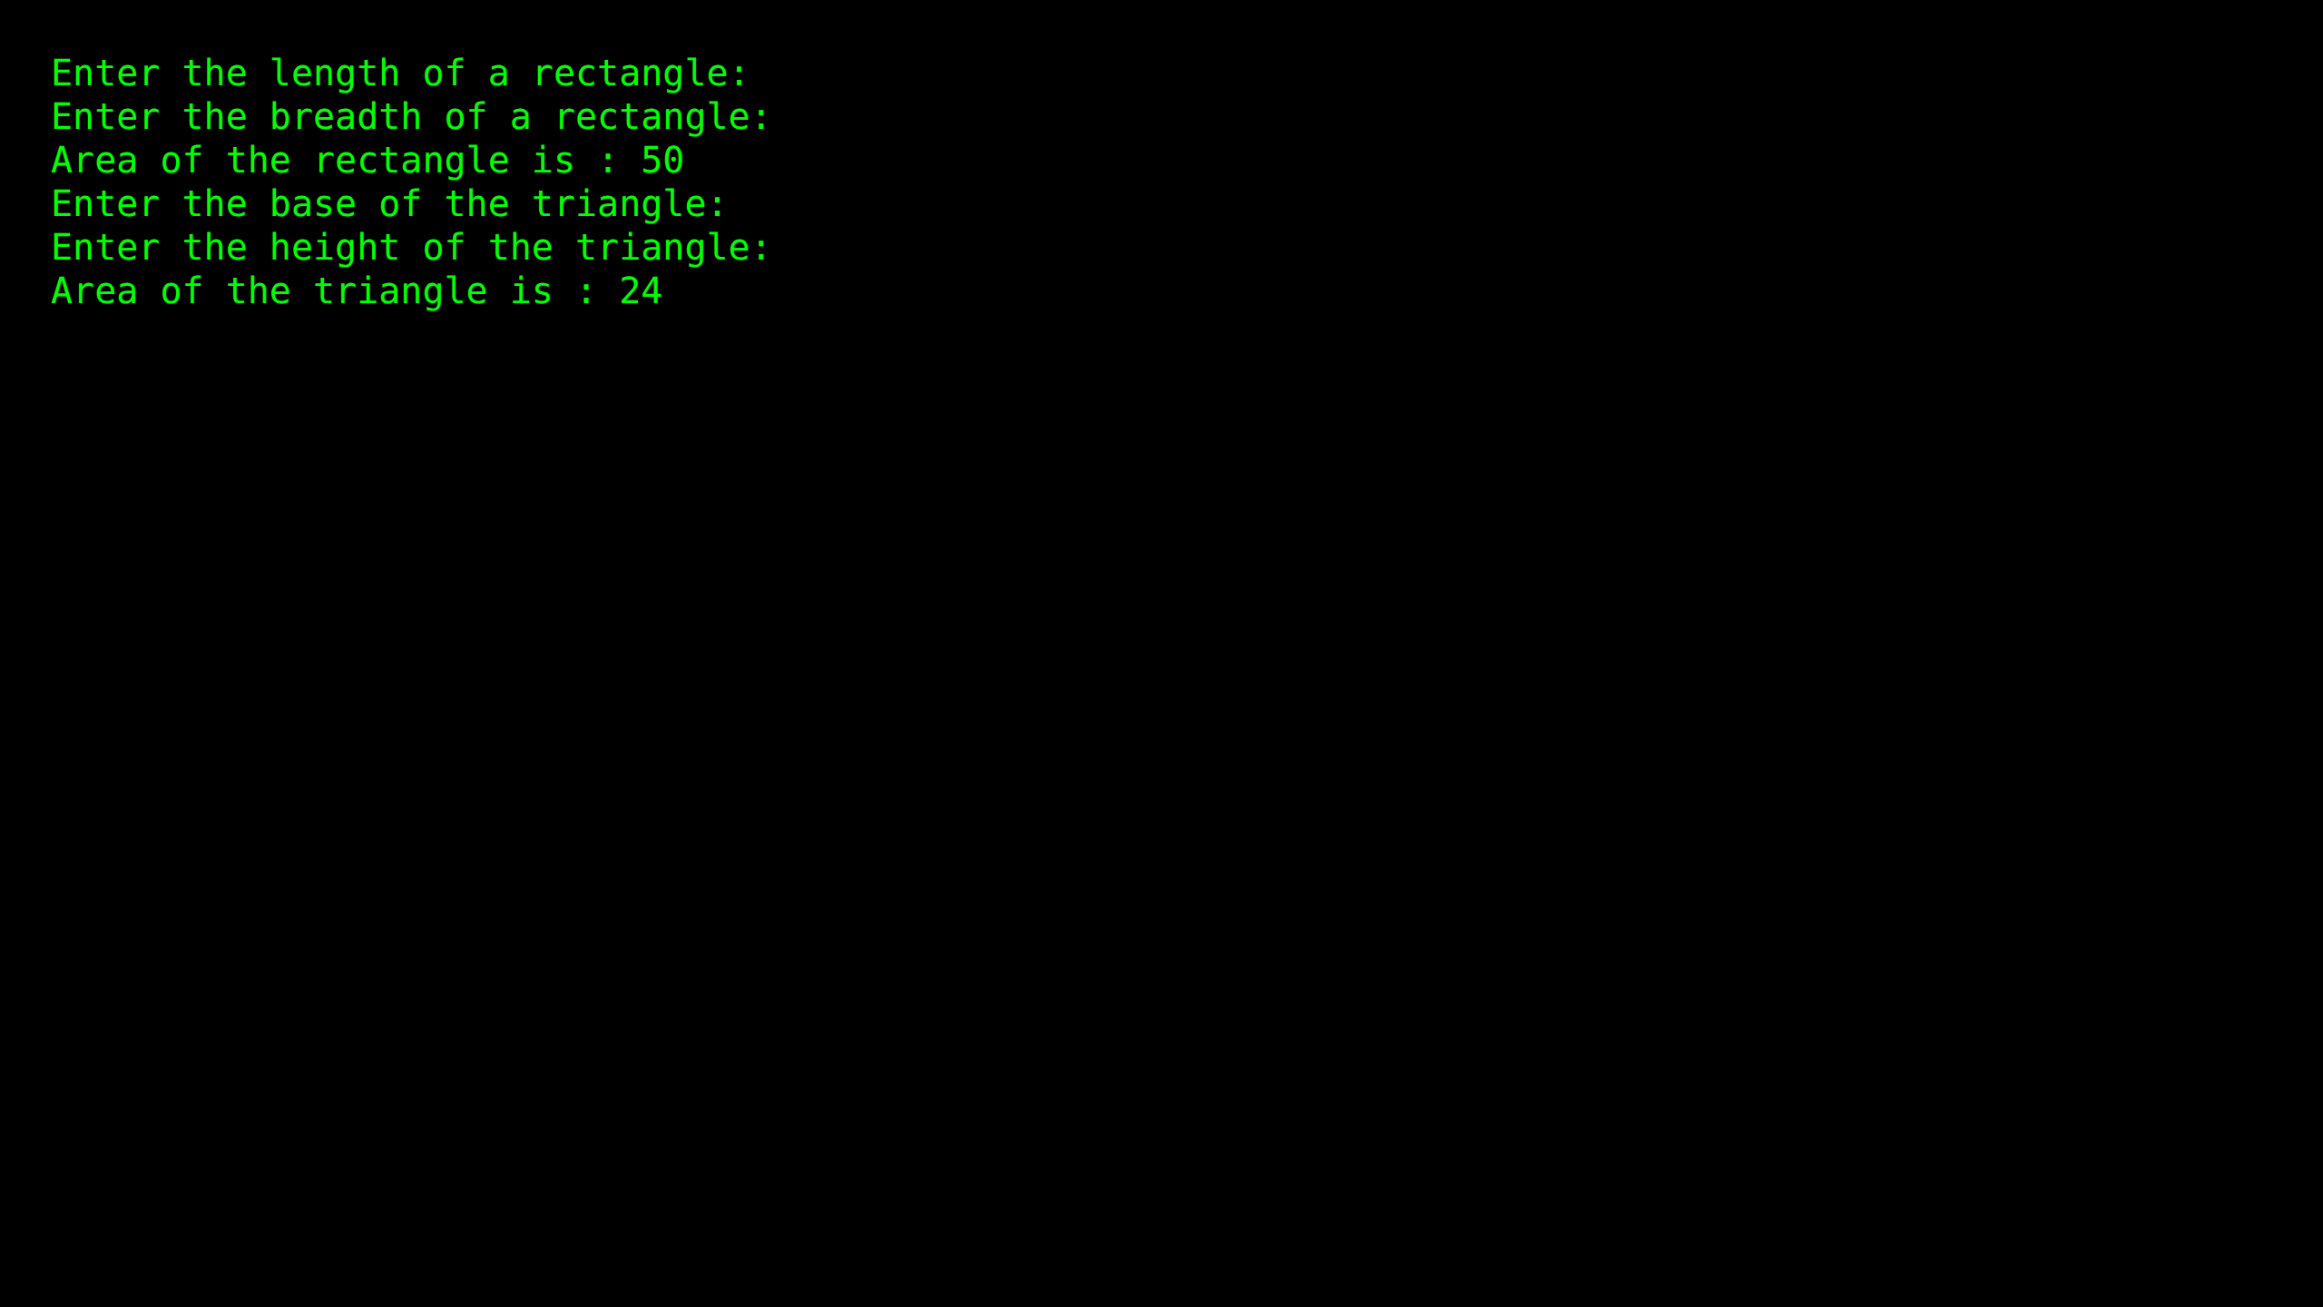

Practical 8.3: Hybrid Inheritance (A)

Source Code:
#include <iostream>
using namespace std;
class Vehicle {
public:
Vehicle()
{
cout << "This is a Vehicle" << endl;
}
};
class Fare{
public:
Fare()
{
cout<<"Fare of Vehicle\n";
}
};
class Car: public Vehicle
{
};
class Bus: public Vehicle, public Fare
{
};
int main()
{
Bus obj2;
Car obj1;
return 0;
}

Output Screenshot:
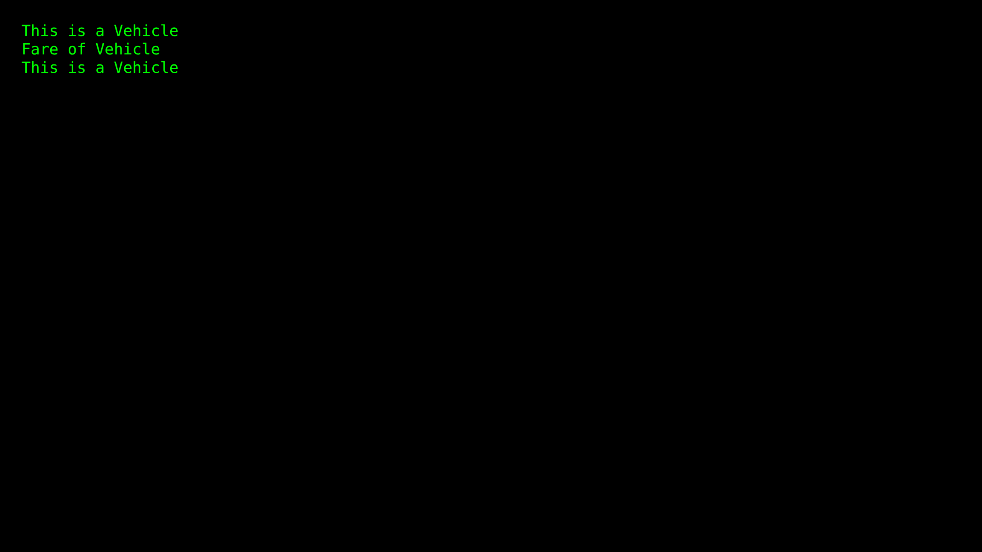

Practical 8.4: Hybrid Inheritance (B)

Source Code:
#include <iostream>
using namespace std;
class A
{
protected:
int a;
public:
void get_a()
{
cout << "Enter the value of 'a' : " << endl;
cin>>a;
}
};
class B : public A {
protected:
int b;
public:
void get_b()
{
cout << "Enter the value of 'b' : " << endl;
cin>>b;
}
};
class C
{
protected:
int c;
public:
void get_c()
{
cout << "Enter the value of c is : " << endl;
cin>>c;
}
};
class D : public B, public C
{
protected:
int d;
public:
void mul()
{
get_a();
get_b();
get_c();
cout << "Multiplication of a,b,c is : " <<a*b*c<< endl; }
};
int main()
{
D d;
d.mul();
return 0;
}

Output Screenshot:
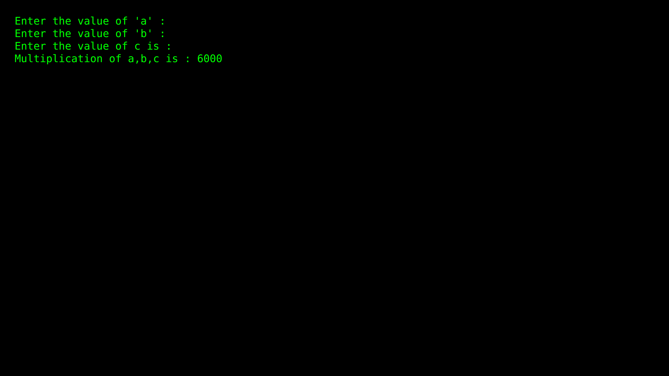

Practical 9: Derived class constructors

Source Code:
#include <iostream>
using namespace std;
class Base {
public:
int x;
Base(int a) : x(a) {
cout << "Base class constructor invoked." << endl;
}
};
class Derived : public Base {
public:
int y;
Derived(int a, int b) : Base(a), y(b) {
cout << "Derived class constructor invoked." << endl;
}
void display() {
cout << "x = " << x << ", y = " << y << endl;
}
};
int main() {
Derived d(10, 20);
d.display();
return 0;
}

Output Screenshot:
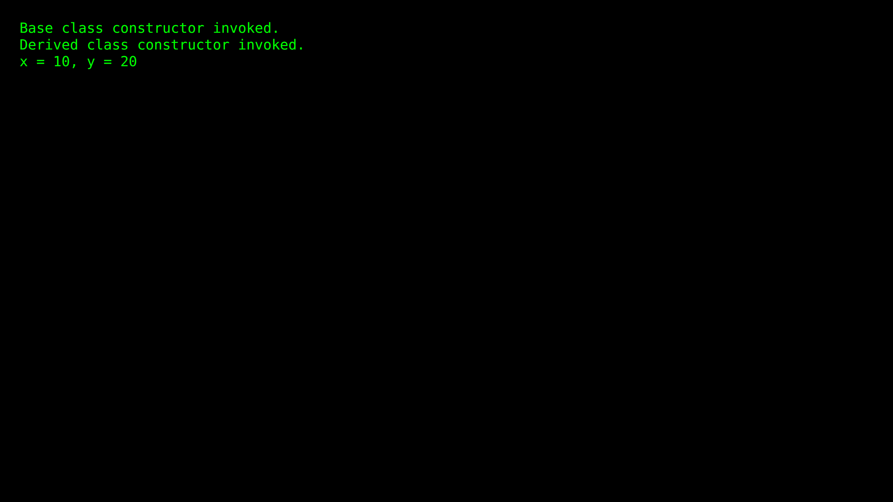

Practical 10.1: Friend Function (1)

Source Code:
#include <iostream>
using namespace std;
class Distance {
private:
int meter;
friend int addFive(Distance);
public:
Distance() : meter(0) {}
};
int addFive(Distance d) {
d.meter += 5;
return d.meter;
}
int main() {
Distance D;
cout << "Distance: " << addFive(D) << endl;
return 0;
}

Output Screenshot:
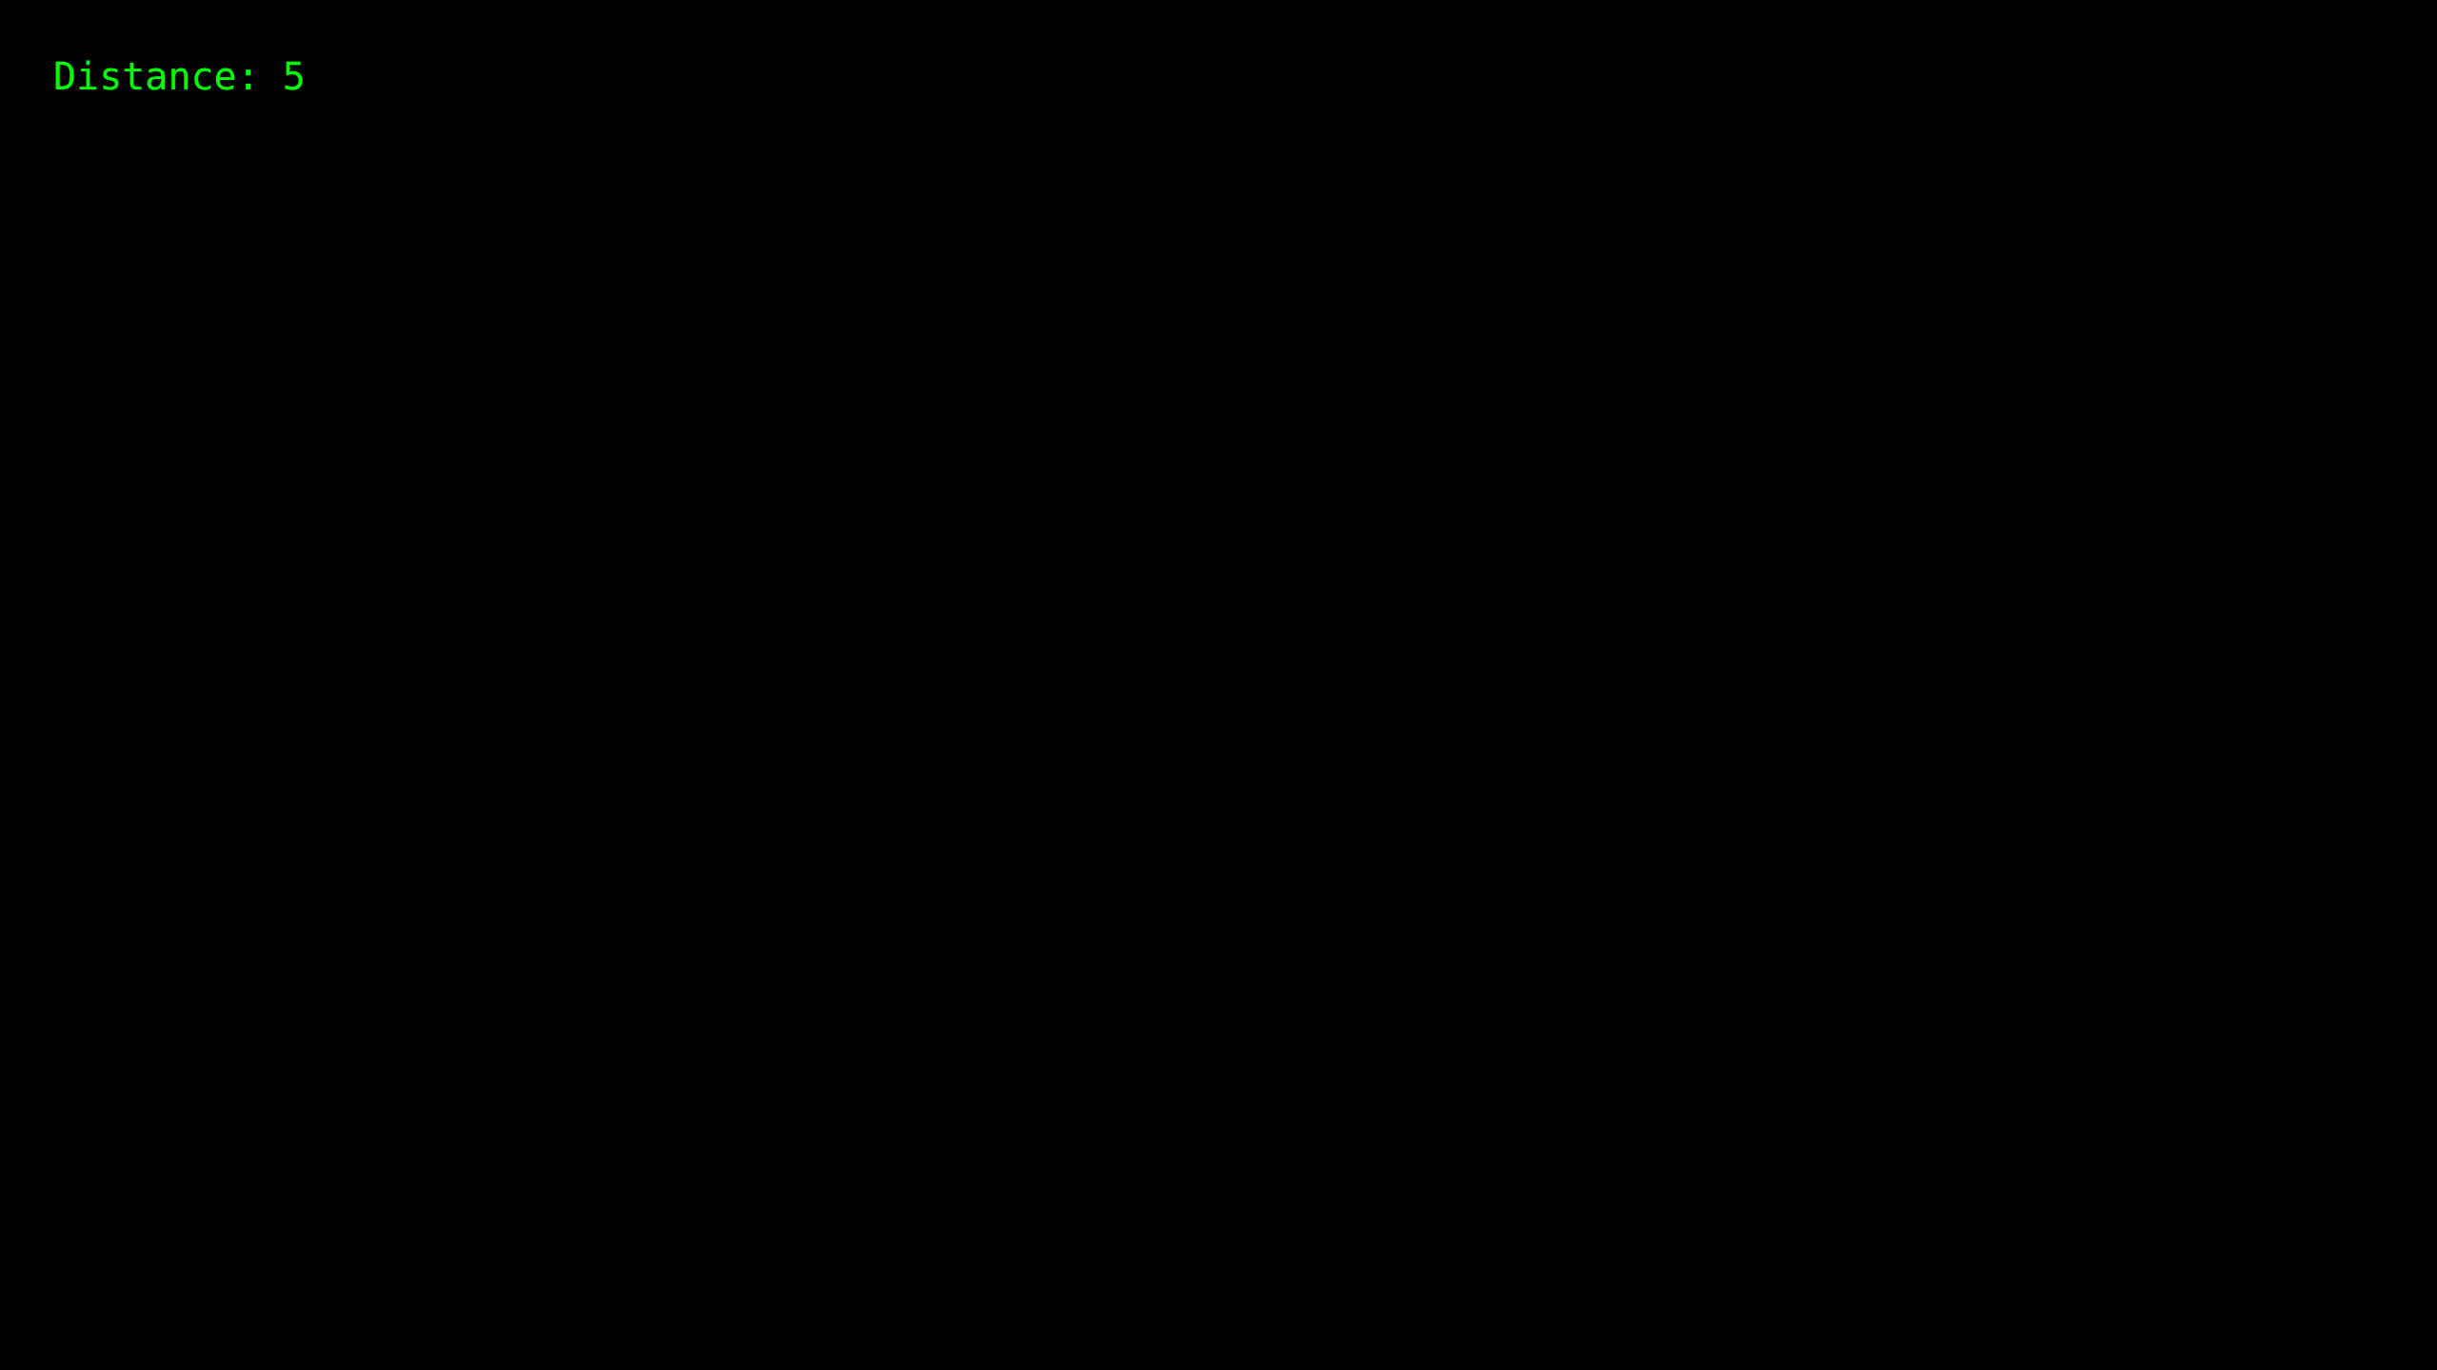

Practical 10.2: Friend Function (2)

Source Code:
#include <iostream>
using namespace std;
class Box
{
private:
int length;
public:
Box(): length(0) { }
friend int printLength(Box);
};
int printLength(Box b)
{
b.length += 10;
return b.length;
}
int main()
{
Box b;
cout<<"Length of box: "<< printLength(b)<<endl;
return 0;
}

Output Screenshot:
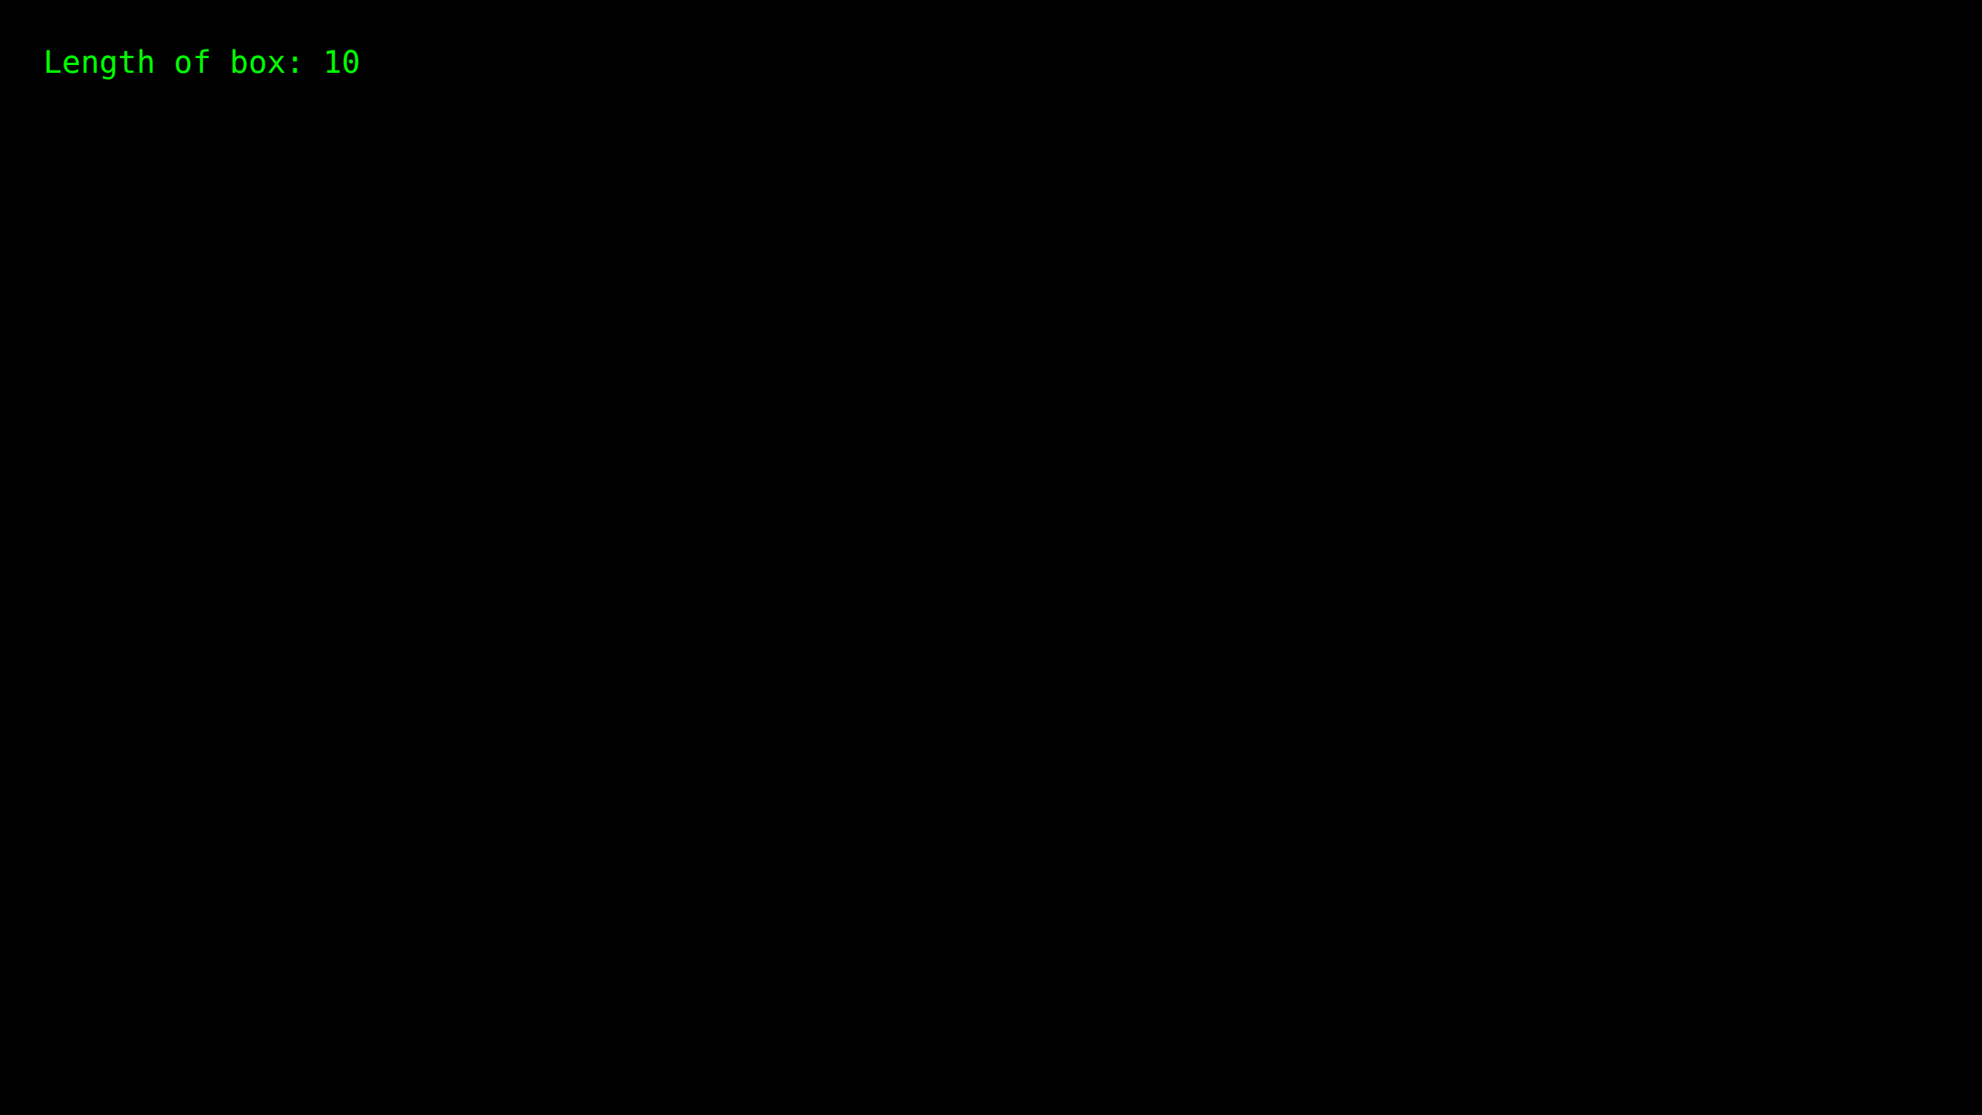

Practical 10.3: Friend Function (3)

Source Code:
#include <iostream>
using namespace std;
class ClassB;
class ClassA {
public:
ClassA() : numA(12) {}
private:
int numA;
friend int add(ClassA, ClassB);
};
class ClassB {
public:
ClassB() : numB(1) {}
private:
int numB;
friend int add(ClassA, ClassB);
};
int add(ClassA objectA, ClassB objectB) {
return (objectA.numA + objectB.numB);
}
int main() {
ClassA objectA;
ClassB objectB;
cout << "Sum: " << add(objectA, objectB) << endl;
return 0;
}

Output Screenshot:
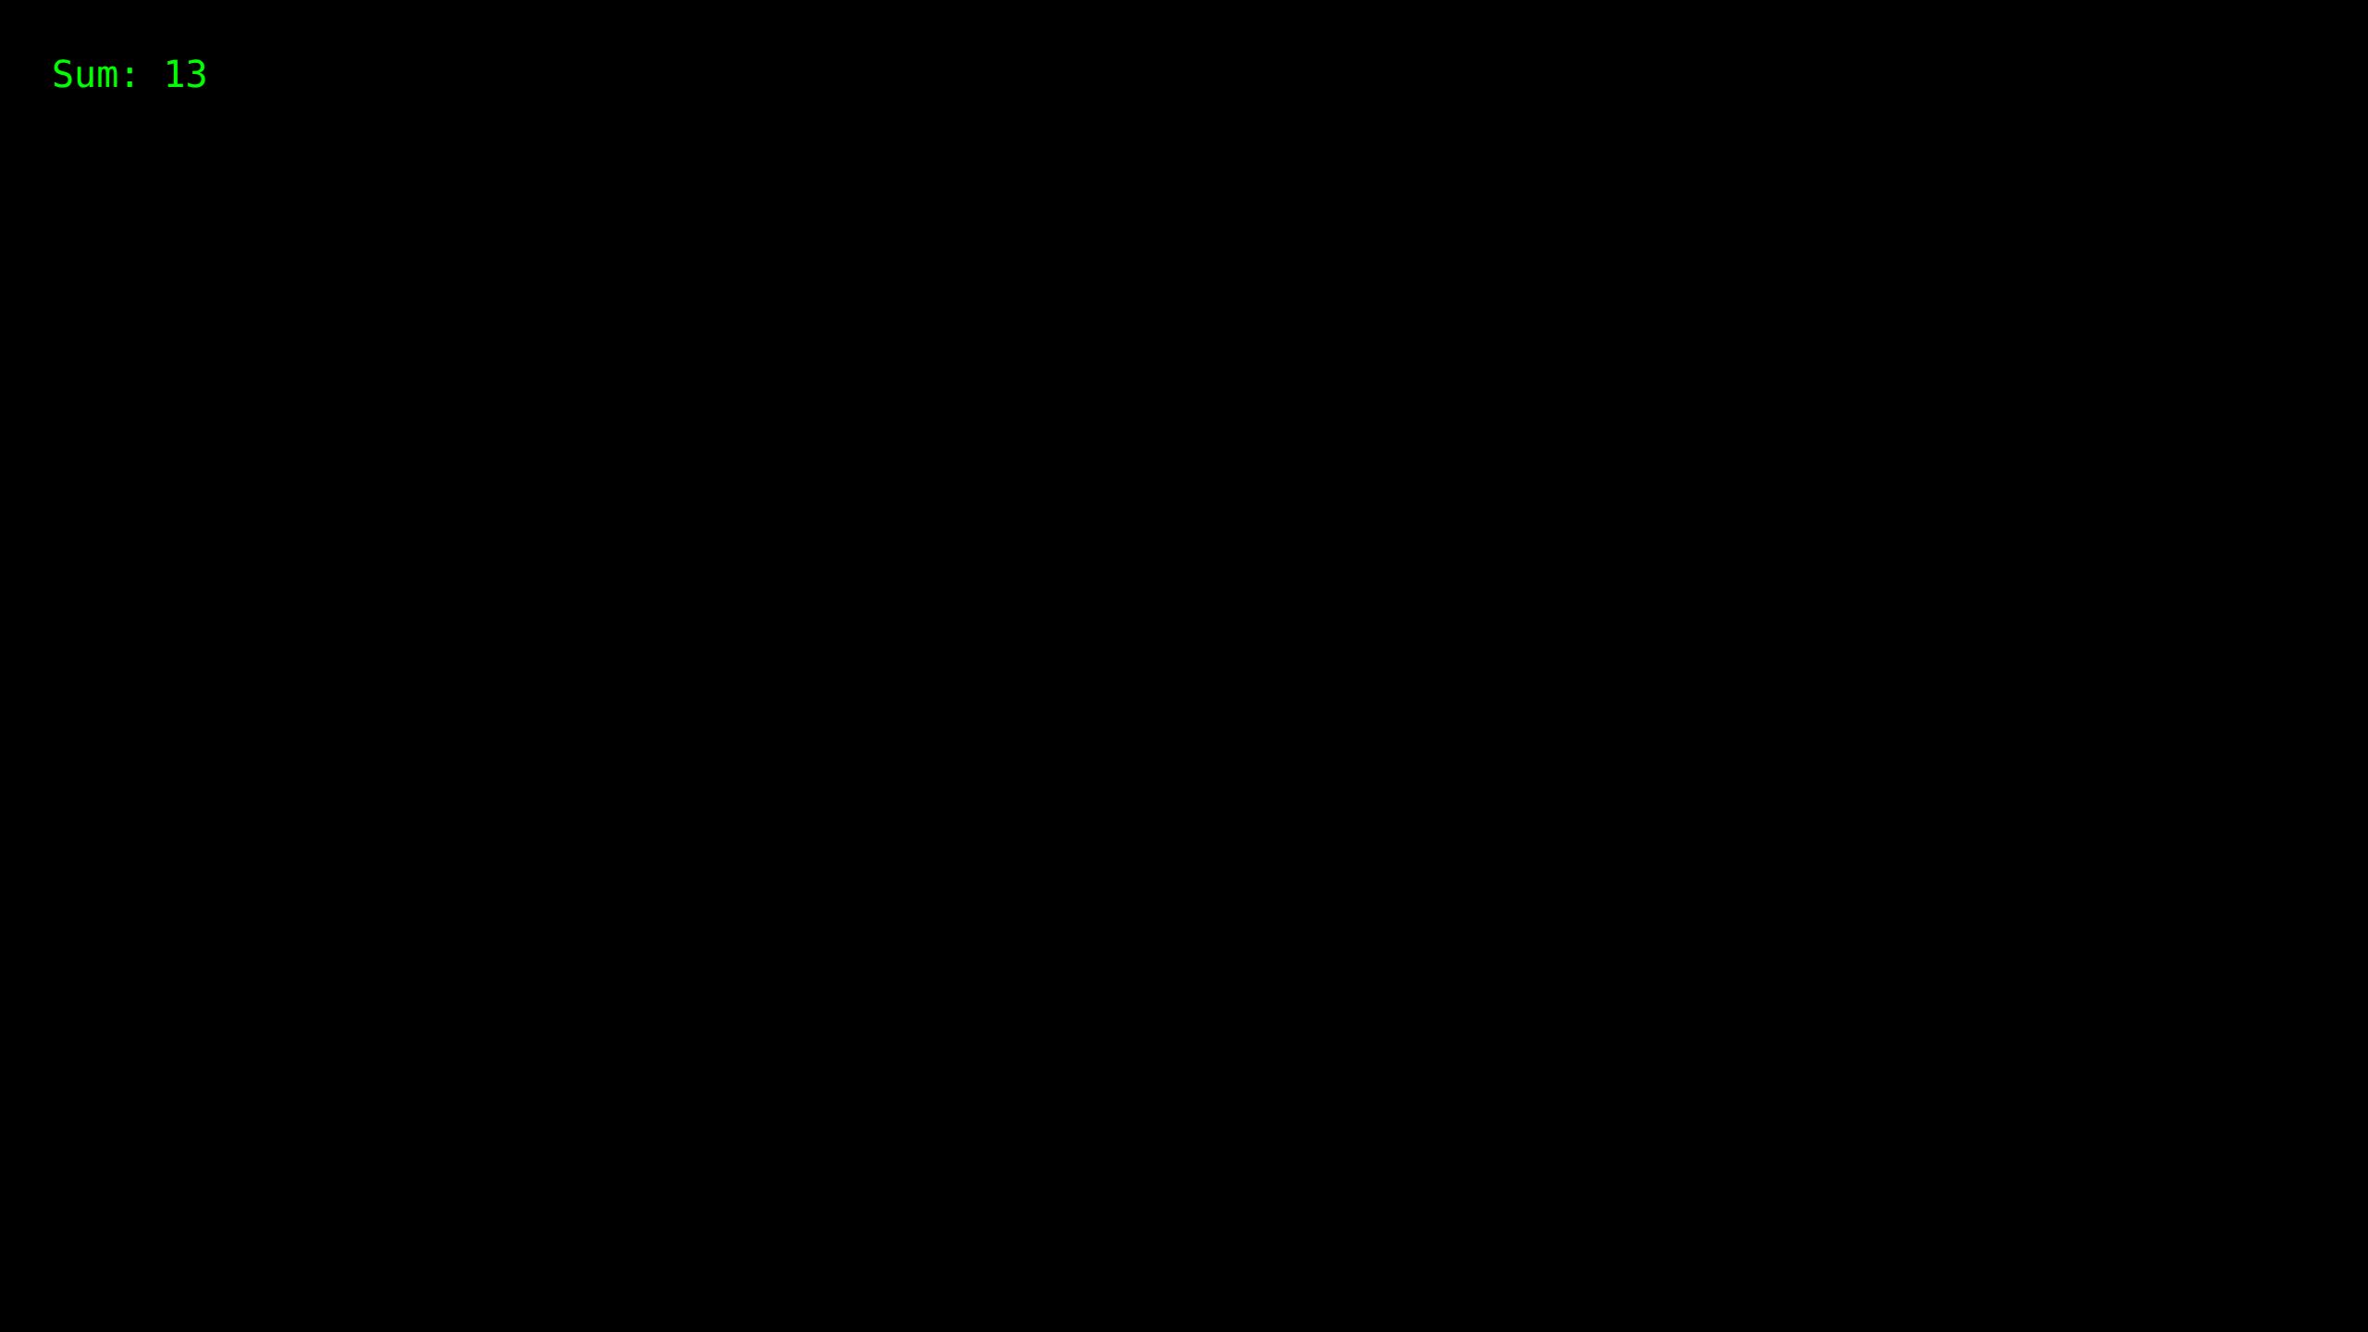

Practical 10.4: Friend Class

Source Code:
#include <iostream>
using namespace std;
class A
{
int x =5;
friend class B;
};
class B
{
public:
void display(A &a)
{
cout<<"value of x is : "<<a.x << endl;
}
};
int main()
{
A a;
B b;
b.display(a);
return 0;
}

Output Screenshot:
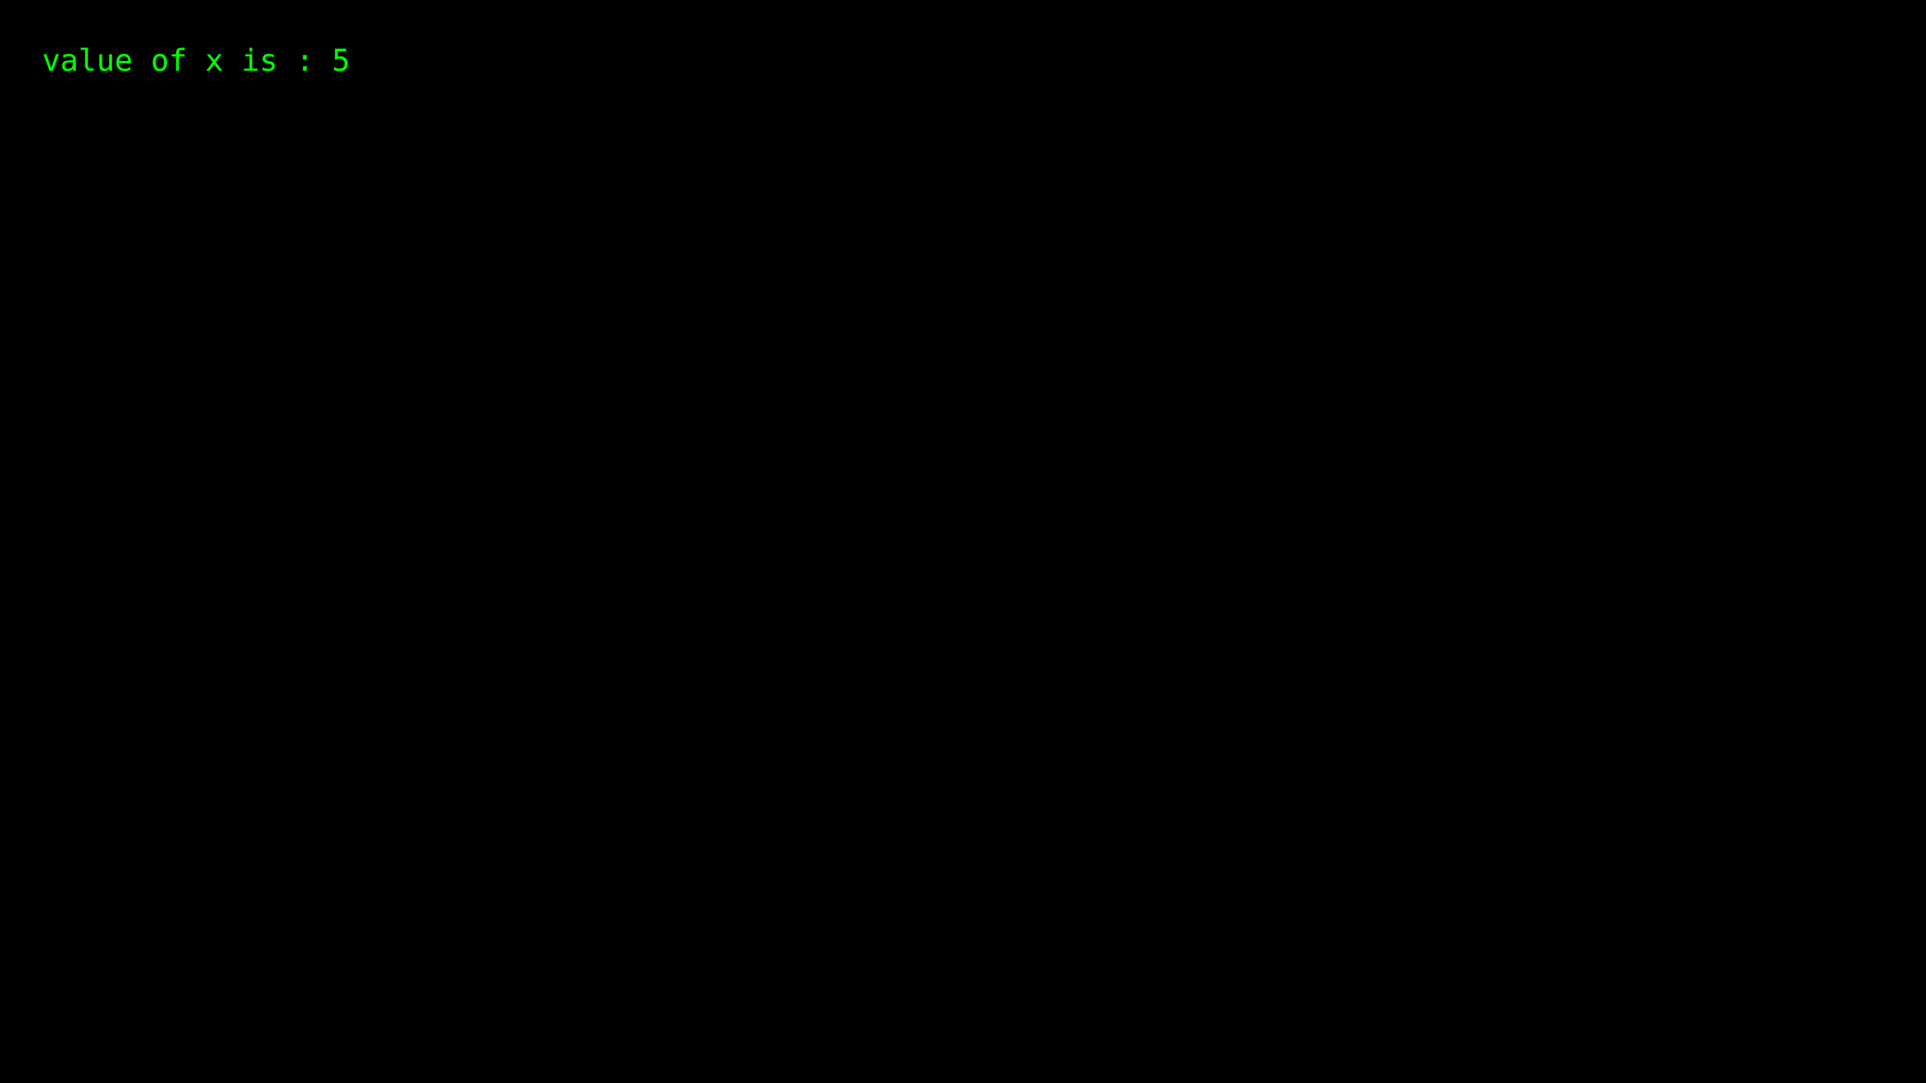

Practical 11.1: Function Overloading

Source Code:
#include <iostream>
using namespace std;
class Temp
{
private:
int x = 10;
double x1 = 10.1;
public:
void add(int y)
{
cout << "Value of x + y is: " << x + y << endl;
}
void add(double d)
{
cout << "Value of x1 + d is: " << x1 + d << endl;
}
void add(int y, int z)
{
cout << "Value of x + y + z is: " << x + y + z << endl;
}
};
int main()
{
Temp t1;
t1.add(10);
t1.add(11.1);
t1.add(12,13);
return 0;
}

Output Screenshot:
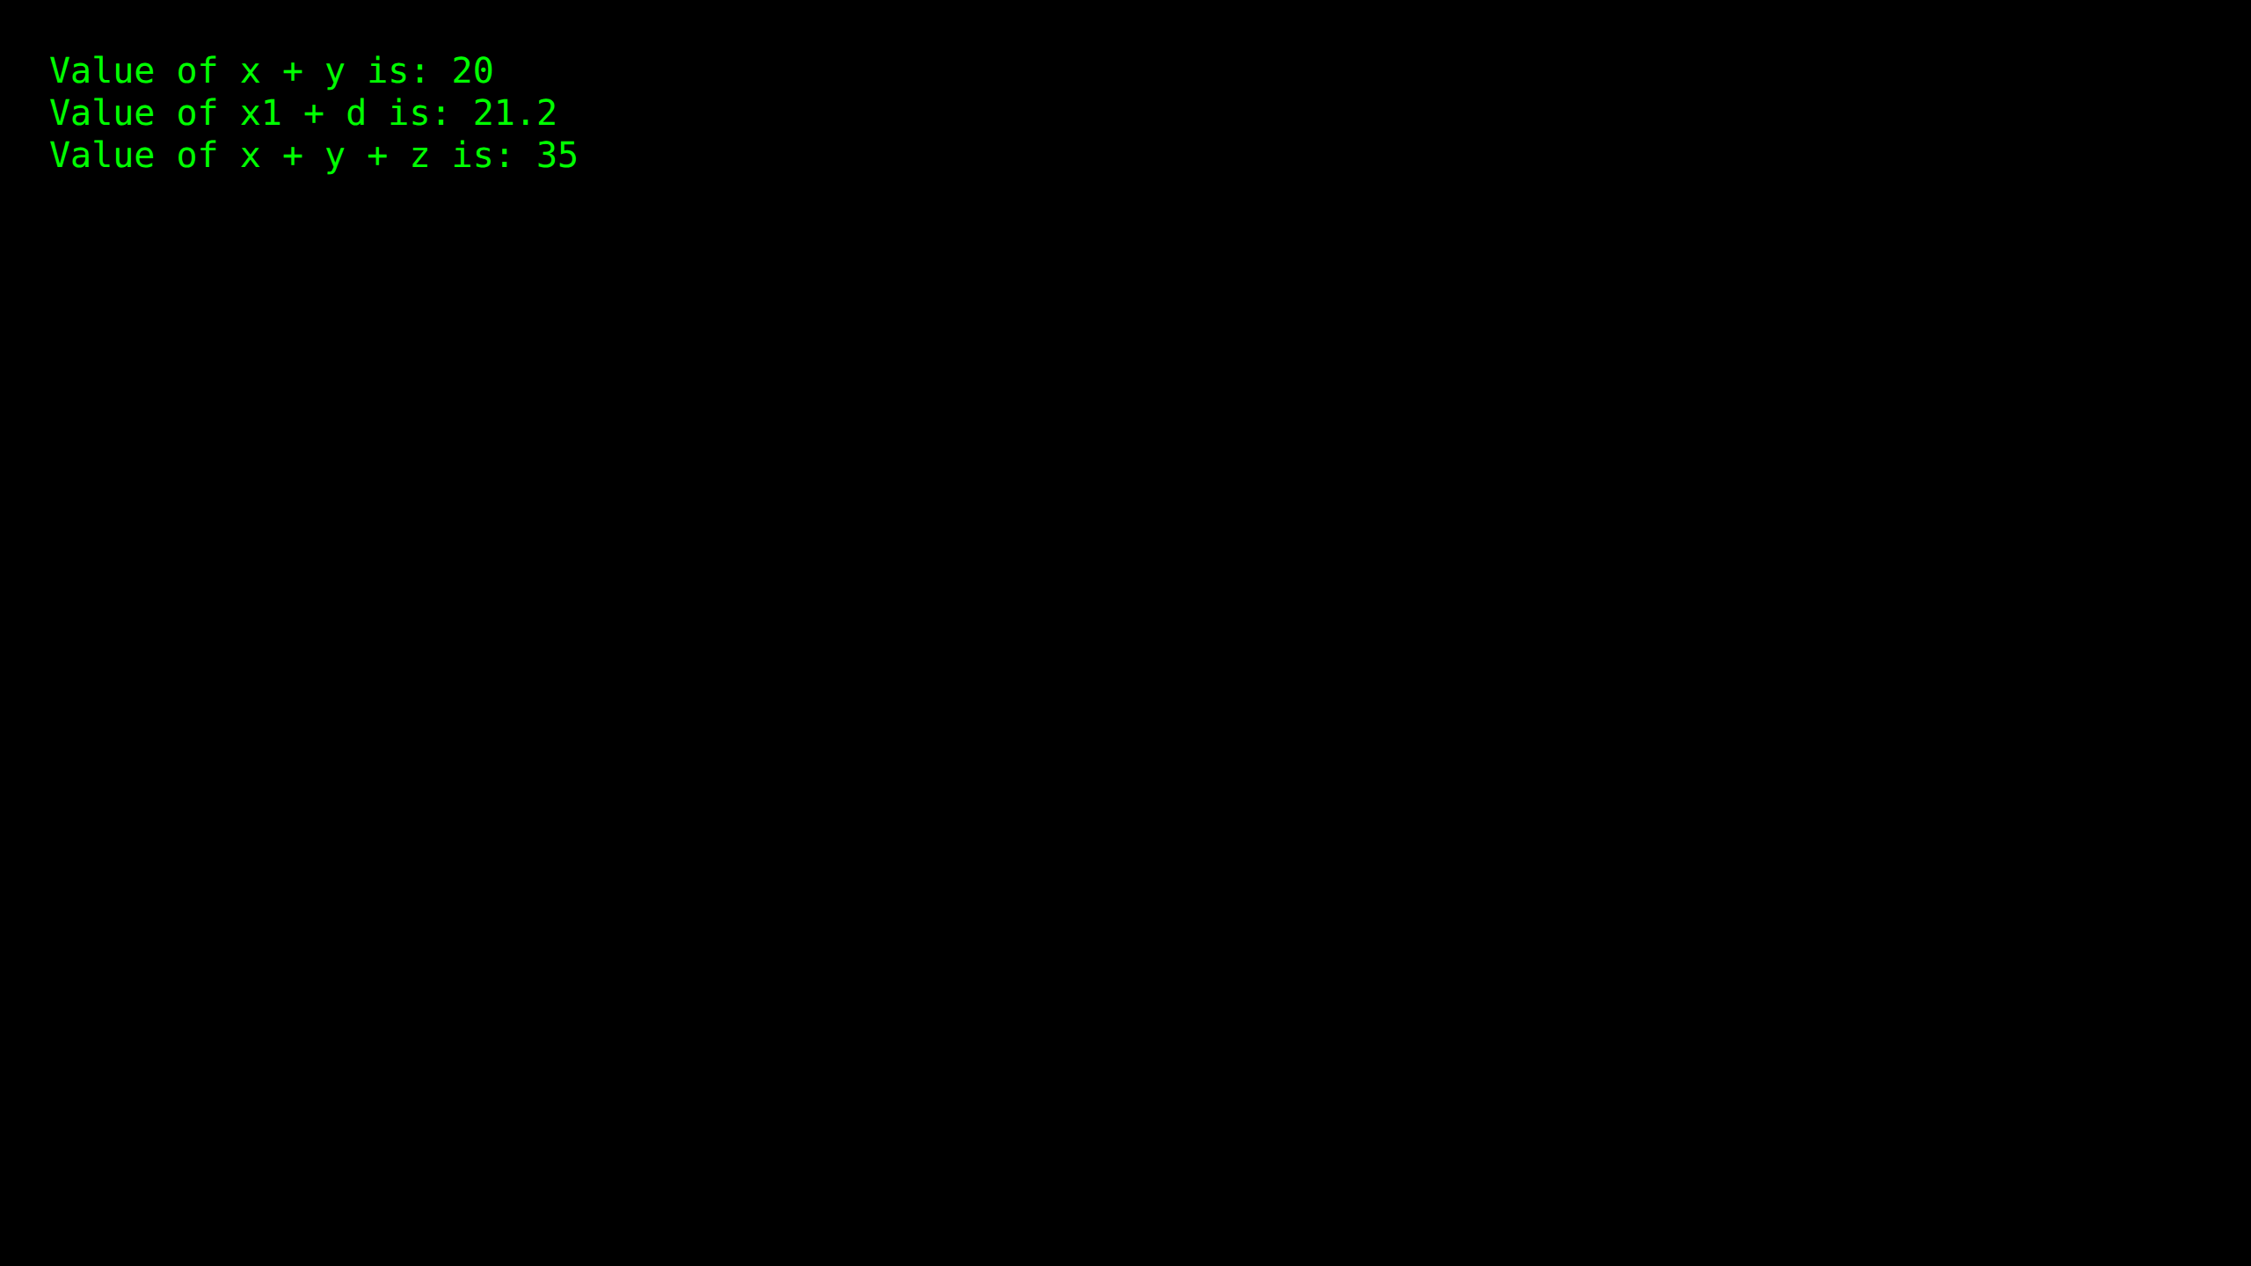

Practical 11.2: Operator Overloading

Source Code:
#include <iostream>
using namespace std;
class Math
{
int num;
public:
void setValue(int val)
{
num = val;
}
Math operator + (Math &obj) {
Math temp;
temp.num = num + obj.num;
return (temp);
}
Math operator - (Math &obj){
Math temp;
temp.num = num - obj.num;
return (temp);
}
Math operator * (Math &obj){
Math temp;
temp.num = num * obj.num;
return (temp);
}
Math operator / (Math &obj){
Math temp;
if(obj.num != 0)
temp.num = num / obj.num;
else
temp.num = 0;
return (temp);
}
void getValue(){cout << num;
}
};
int main ()
{
Math obj1, obj2, resObj;
obj1.setValue(20);
obj2.setValue(10);
cout << "Obj 1: ";
obj1.getValue();
cout << "\nObj 2: ";
obj2.getValue();
resObj = obj1 + obj2;
cout << "\n\nObj1 + Obj2 : " ;
resObj.getValue();
resObj = obj1 - obj2;
cout << "\nObj1 - Obj2 : " ;
resObj.getValue();
resObj = obj1 * obj2;
cout << "\nObj1 * Obj2 : " ;
resObj.getValue();
resObj = obj1 / obj2;
cout << "\nObj1 / Obj2 : " ;
resObj.getValue();
cout << endl;
return 0;
}

Output Screenshot:
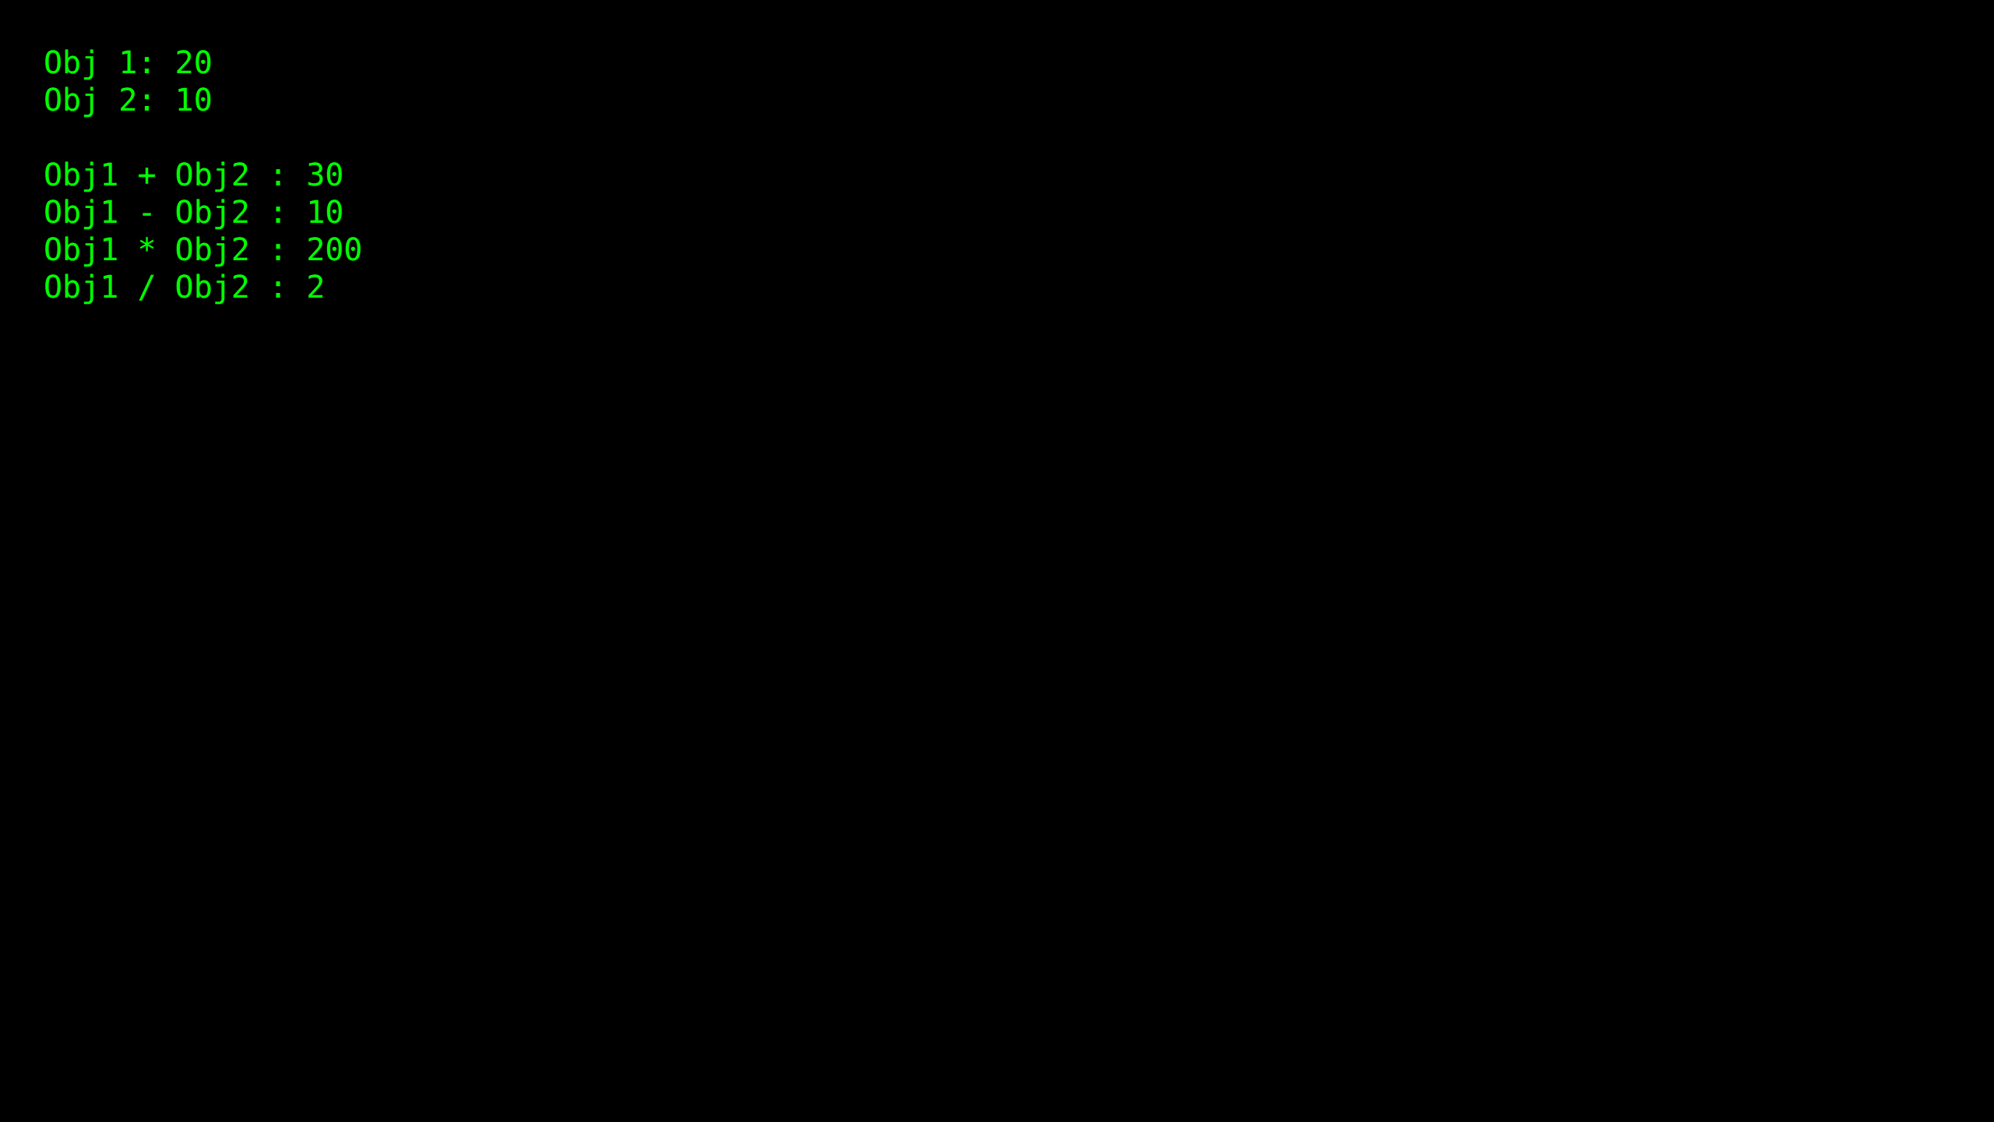

Practical 11.3: Function Overriding

Source Code:
#include <iostream>
using namespace std;
class Exam {
public:
virtual void colorP(){
cout<<"Black" << endl;
}
};
class Atkt: public Exam
{
public:
void colorP(){
cout<<"Grey" << endl;
}
};
int main(void) {
Atkt kt;
kt.colorP();
return 0;
}

Output Screenshot:
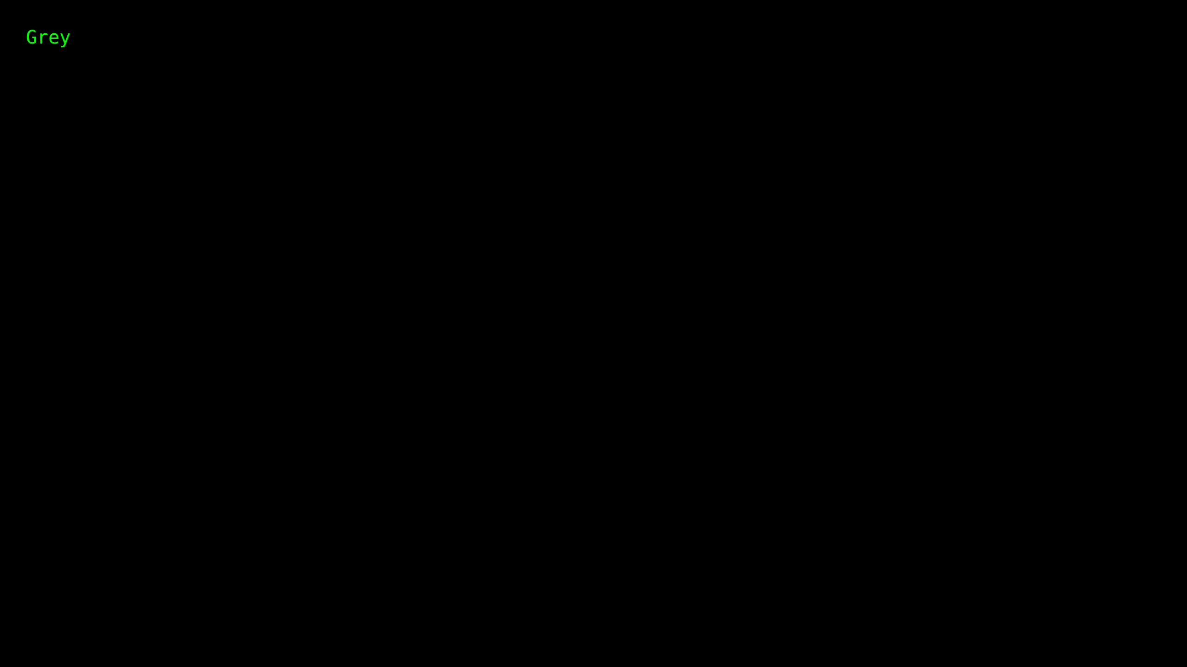

Practical 11.4: Pure Virtual Function

Source Code:
#include <iostream>
using namespace std;
class Shape
{
public:
virtual float calculateArea() = 0;
};
class Square : public Shape
{
float a;
public:
Square(float l)
{
a = l;
}
float calculateArea()
{
return a*a;
}
};
class Circle : public Shape
{
float r;
public:
Circle(float x)
{
r = x;
}
float calculateArea()
{
return 3.14*r*r ;
}
};
class Rectangle : public Shape
{
float l;
float b;
public:
Rectangle(float x, float y)
{
l=x;
b=y;
}
float calculateArea()
{
return l*b;
}
};
int main()
{
Shape *shape;
Square s(3.4);
Rectangle r(5,6);
Circle c(7.8);
shape =&s;
float a1 =shape->calculateArea();
shape = &r;
float a2 = shape->calculateArea();
shape = &c;
float a3 = shape->calculateArea();
cout << "Area of the square is " <<a1<< endl;
cout << "Area of the rectangle is " <<a2<< endl;
cout << "Area of the circle is " <<a3<<endl;
return 0;
}

Output Screenshot:
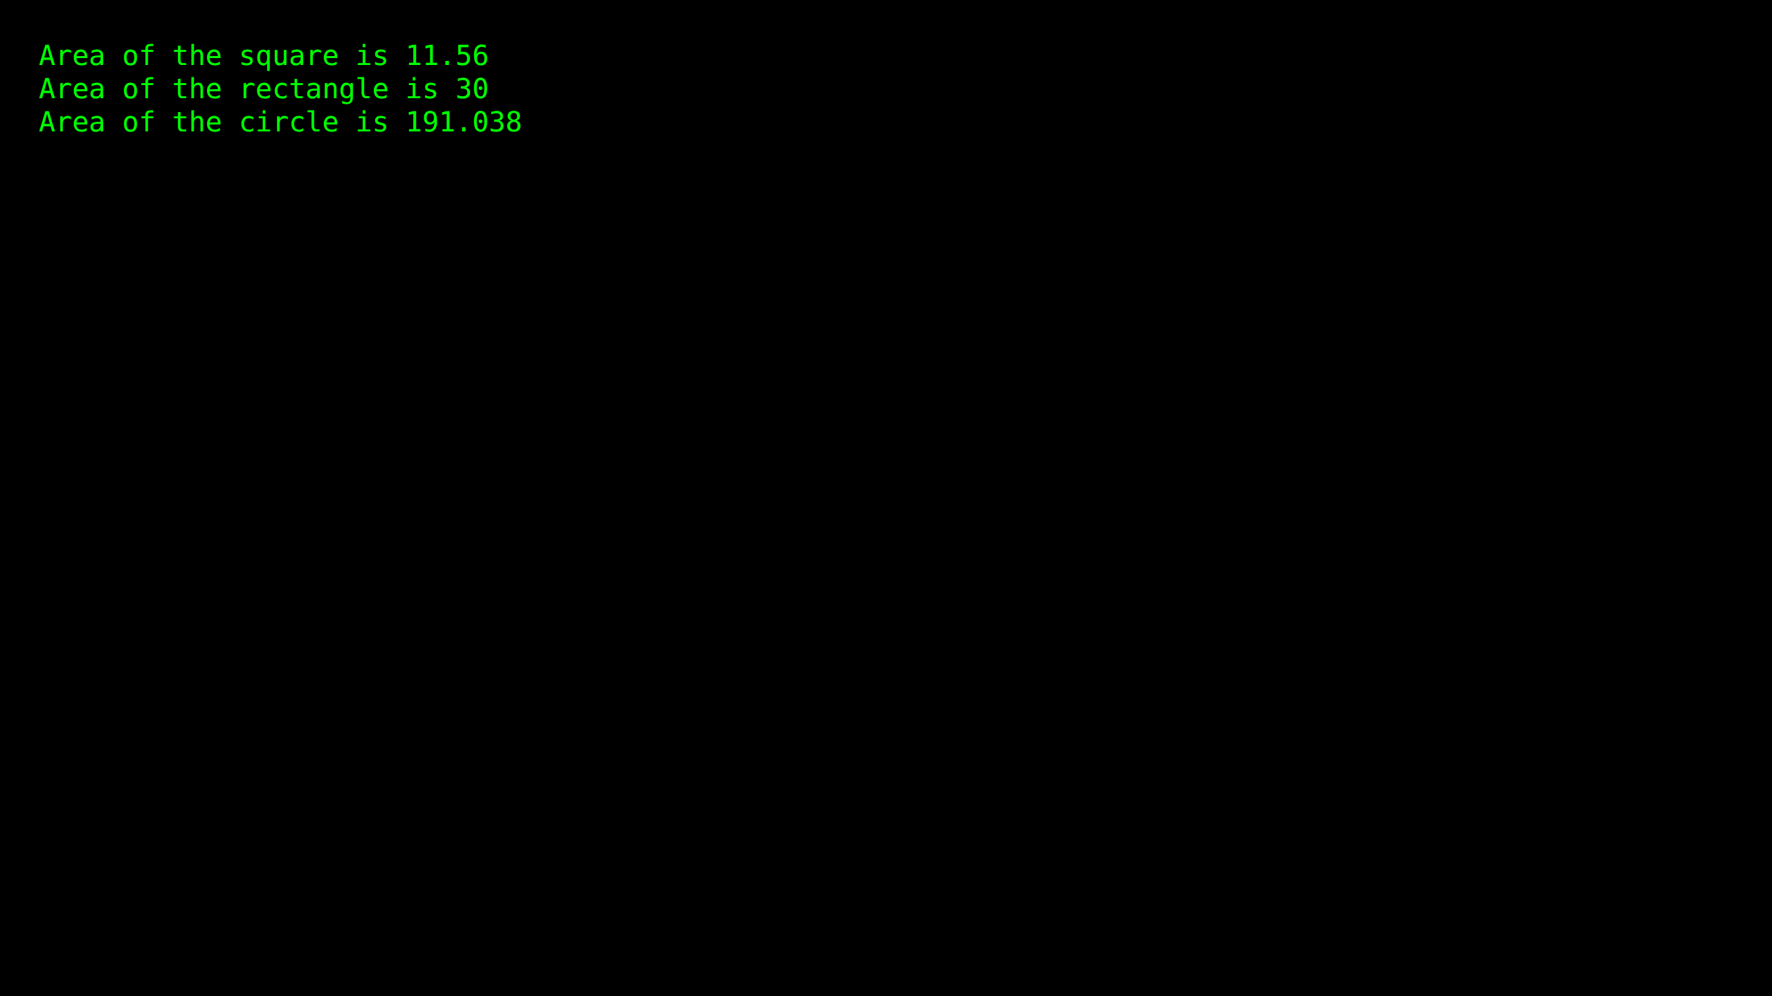

Practical 12: This Pointer

Source Code:
#include <iostream>
#include <string>
using namespace std;
class Employee {
public:
int id;
string name;
float salary;
Employee(int id, string name, float salary)
{
this->id = id;
this->name = name;
this->salary = salary;
}
void display()
{
cout<<id<<" "<<name<<" "<<salary<<endl;
}
};
int main(void) {
Employee e1 =Employee(101, "Pinocchio", 890000);
Employee e2=Employee(102, "Naruto", 59000);
e1.display();
e2.display();
return 0;
}

Output Screenshot:
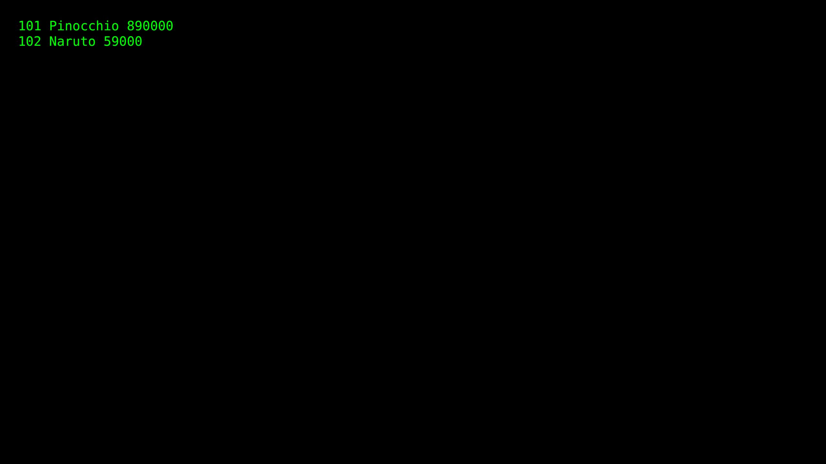

Practical 13.1: Pointers and Address-of

Source Code:
#include <iostream>
using namespace std;
void Pointers()
{
int var = 20;
int* ptr;
ptr = &var;
cout << "Value at ptr = " << ptr << "\n";
cout << "Value at var = " << var << "\n";
cout << "Value at *ptr = " << *ptr << "\n";
}
int main()
{
Pointers();
return 0;
}

Output Screenshot:
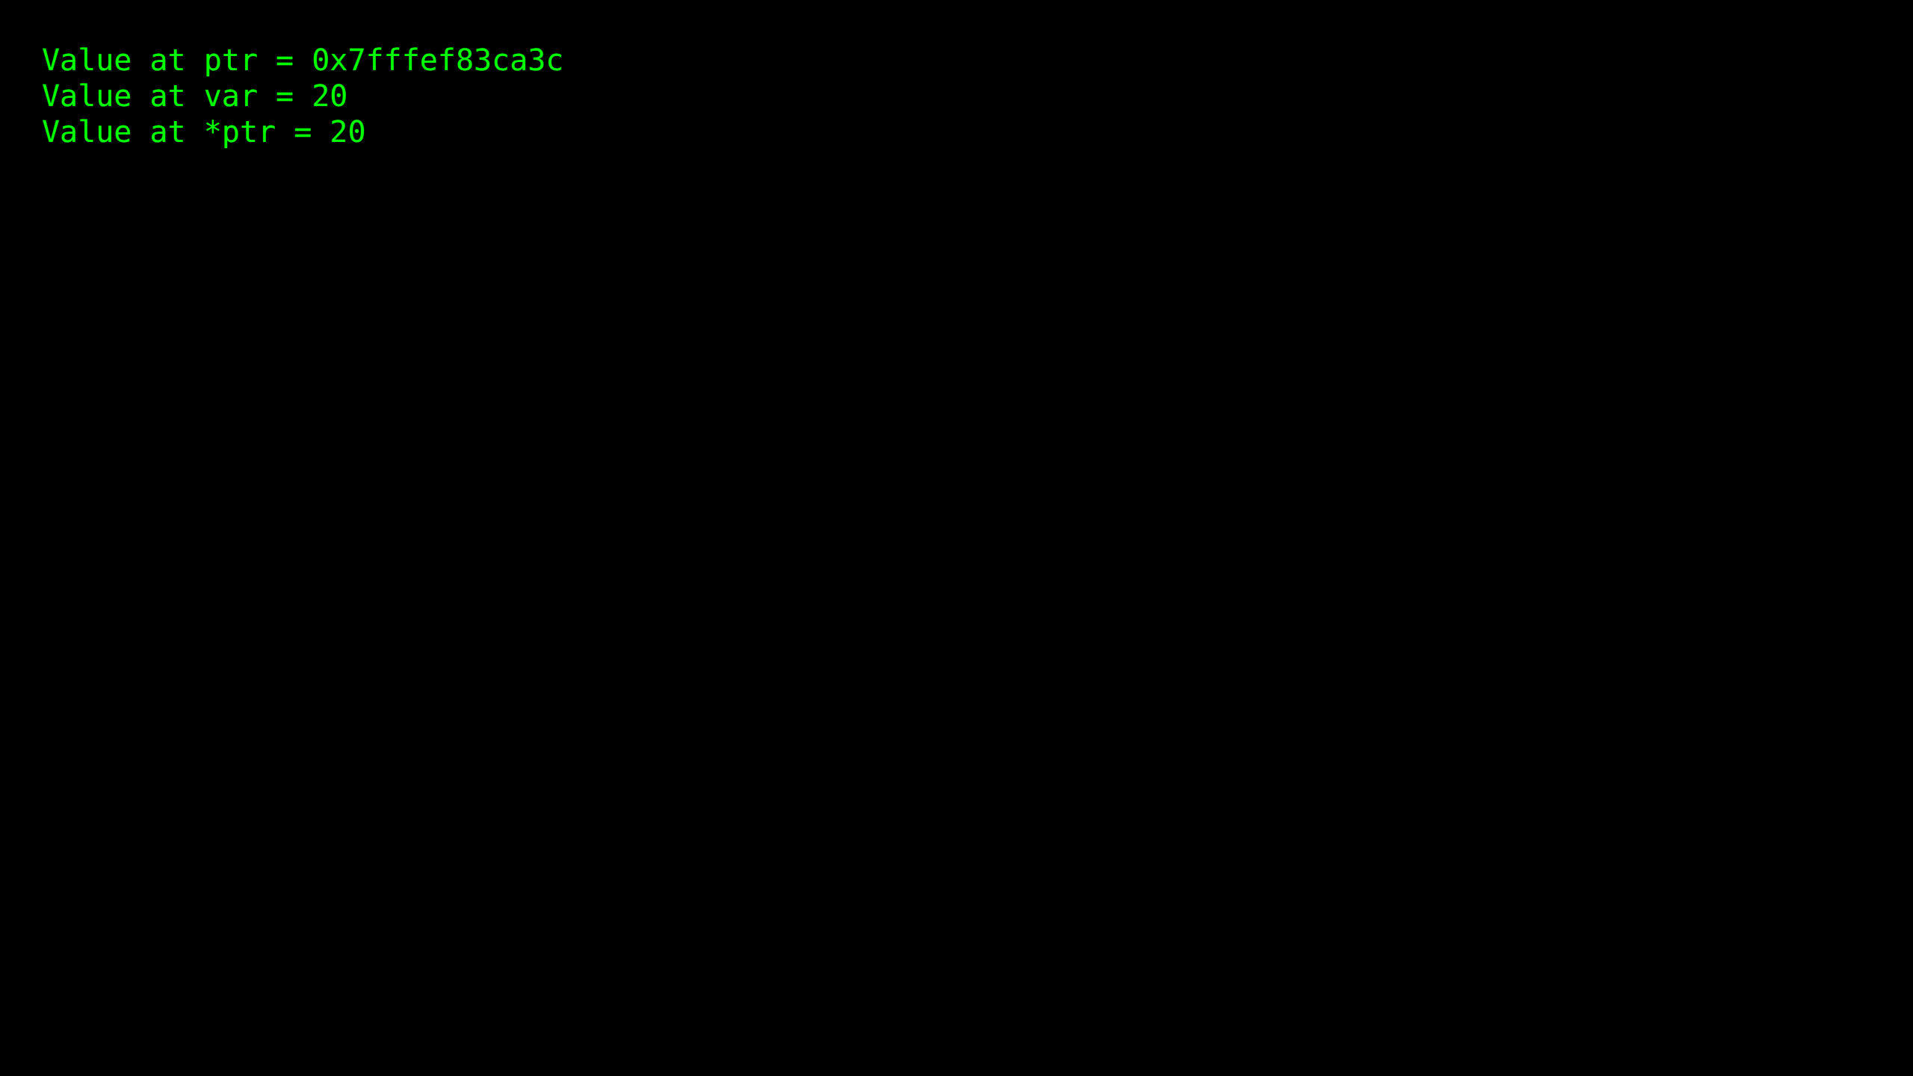

Practical 13.2: Pointer to Pointers

Source Code:
#include<iostream>
using namespace std;
int main ()
{
int a;
int * ptr_b;
int ** ptr_c;
a = 1;
ptr_b = &a;
ptr_c = &ptr_b;
cout << a << "\n";
cout << *ptr_b << "\n";
cout << ptr_b << "\n";
cout << *ptr_c << "\n";
cout << **ptr_c << "\n";
return 0;
}

Output Screenshot:
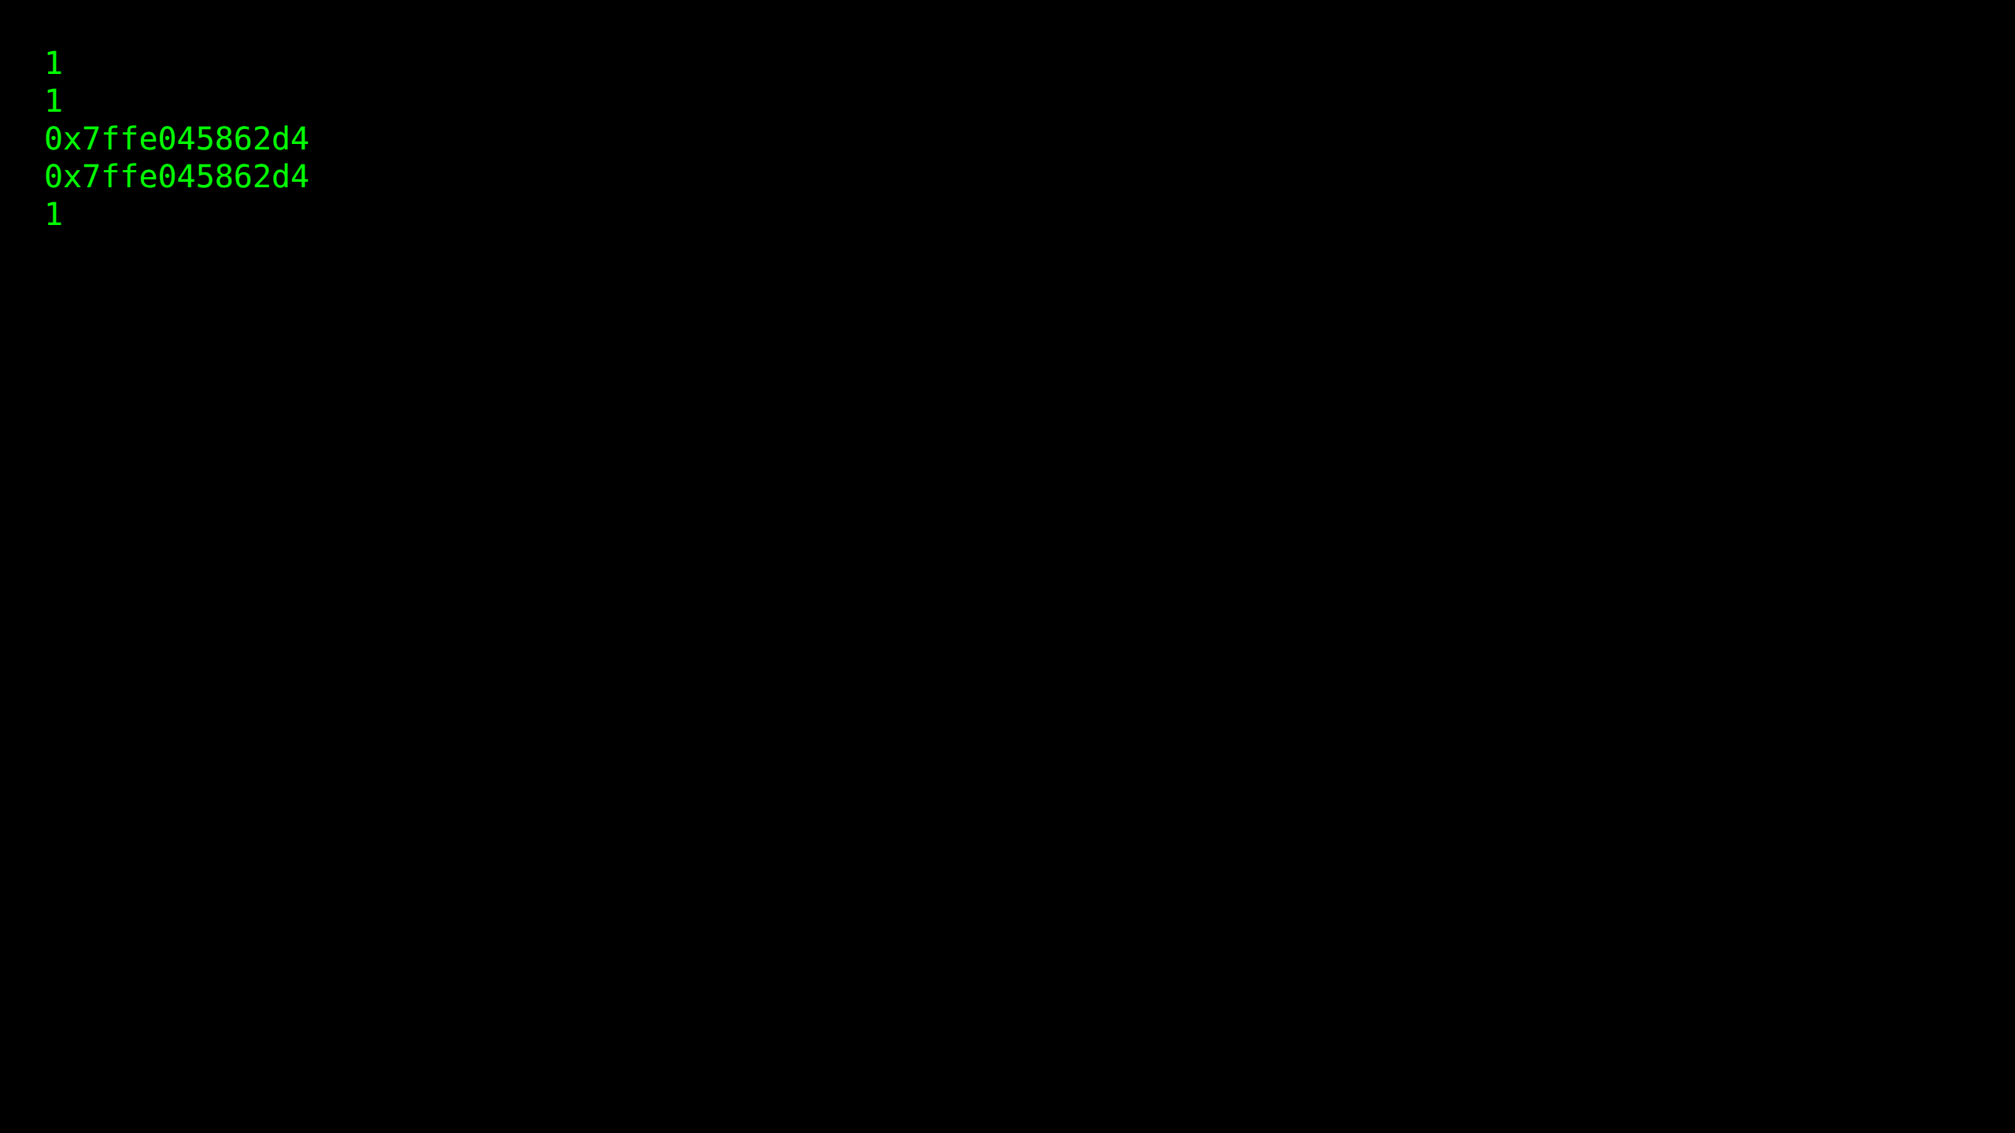

Practical 13.3: Call by Value

Source Code:
#include<iostream>
using namespace std;
void swapping(int c, int d)
{
int temp;
temp = c;
c = d;
d = temp;
cout << "In function:\n" << c << " \n " << d << " \n ";
}
int main()
{
int a,b;
a=5;
b=10;
cout << "Before Swapping :\n " << a << " \n " << b << " \n ";
swapping(a,b);
cout << "After Swapping:\n " << a << " \n " << b << " \n ";
return 0;
}

Output Screenshot:
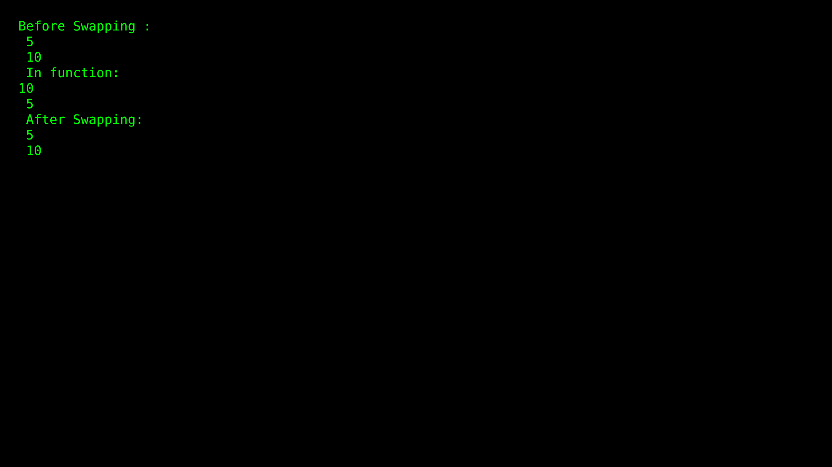

Practical 13.4: Call by Reference

Source Code:
#include<iostream>
using namespace std;
void swapping(int *ptr_c, int *ptr_d)
{
int tmp;
tmp = *ptr_c;
*ptr_c = *ptr_d;
*ptr_d = tmp;
cout << "In function:\n" << *ptr_c << "\n " << *ptr_d << '\n';
}
int main()
{
int a,b;
a=5;
b=10;
cout << "Before:\n" << a << " \n" << b << "\n";
swapping(&a,&b);
cout << "After:\n" << a << "\n " << b << " \n ";
return 0;
}

Output Screenshot:
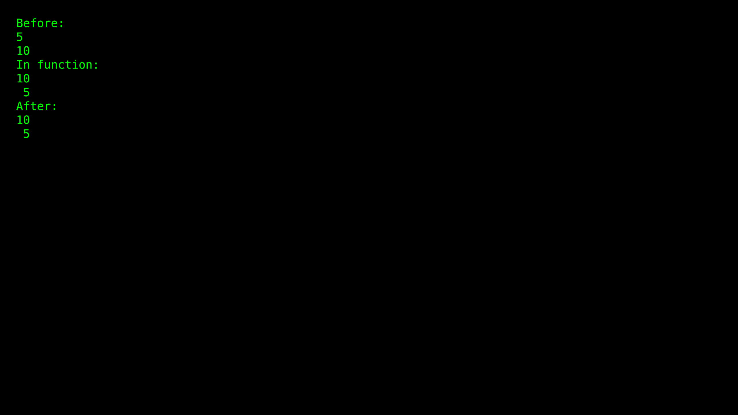

Practical 14.1: Text File Read/Write

Source Code:
#include <iostream>
#include <fstream>
#include <string>
using namespace std;
int main(){
fstream newfile;
newfile.open("testFile.txt",ios::out);
if(newfile.is_open())
{
newfile<<"Hello World from CPP \n";
newfile.close();
}
newfile.open("testFile.txt",ios::in);
if (newfile.is_open()){
string tp;
while(getline(newfile, tp)){
cout << tp << "\n";
}
newfile.close();
}
return 0;
}

Output Screenshot:
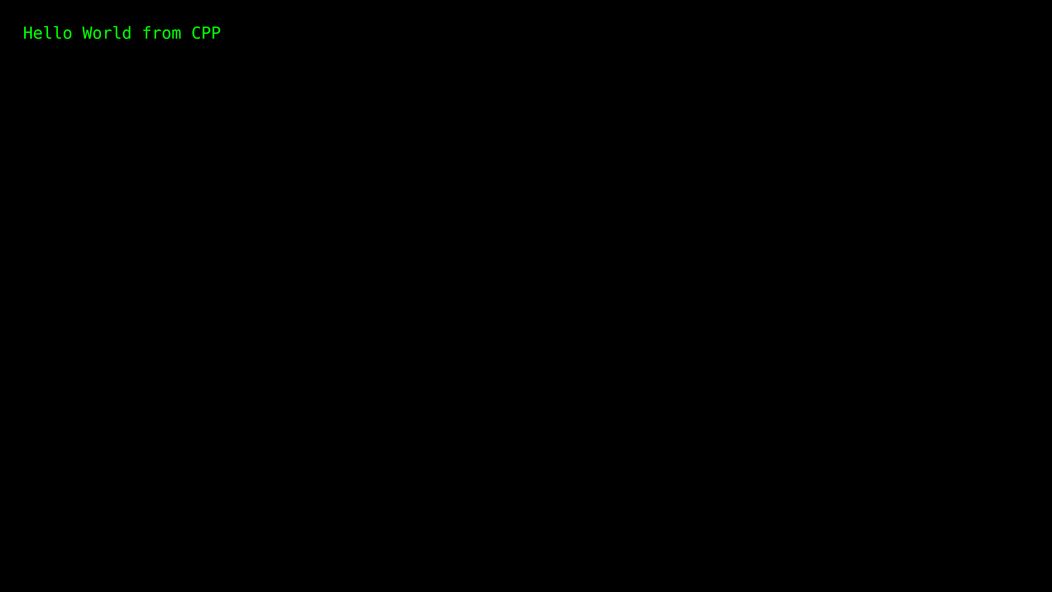

Practical 14.2: Text File Write (Long)

Source Code:
#include <iostream>
#include <fstream>
int main() {
std::ofstream outputFile("InfoOnCpp.txt");
if (outputFile.is_open()) {
outputFile << "C++ is a high-level, general-purpose programming language created by Danish computer scientist Bjarne Stroustrup. \n";
outputFile << "First released in 1985 as an extension of the C programming language, it has since expanded significantly over time. \n";
outputFile << "Modern C++ currently has object-oriented, generic, and functional features, in addition to facilities for low-level memory manipulation.\n";
outputFile << "It is almost always implemented in a compiled language.\n";
outputFile << "Many vendors provide C++ compilers, including the Free Software Foundation, LLVM, Microsoft, Intel, Embarcadero, Oracle, and IBM.";
outputFile.close();
std::cout << "Text has been written to the file." << std::endl;
} else {
std::cout << "Failed to create the file." << std::endl;
}
return 0;
}

Output Screenshot:
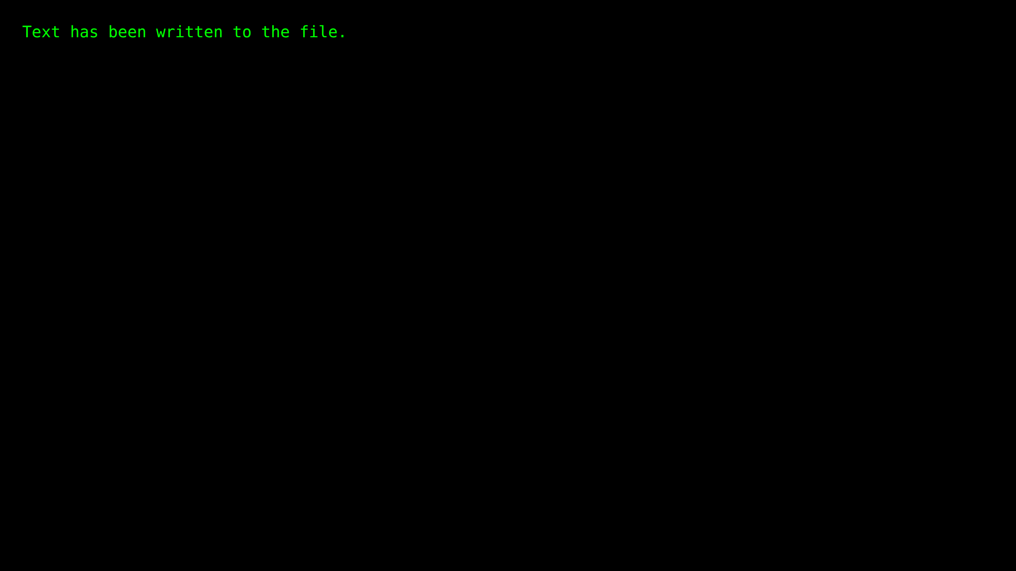

Practical 14.3: Text File Read (Long)

Source Code:
#include <iostream>
#include <fstream>
#include <string>
using namespace std;
int main(){
fstream newfile;
newfile.open("InfoOnCpp.txt",ios::in);
if (newfile.is_open()){
string tp;
while(getline(newfile, tp)){
cout << tp << "\n";
}
newfile.close();
}
return 0;
}

Output Screenshot:
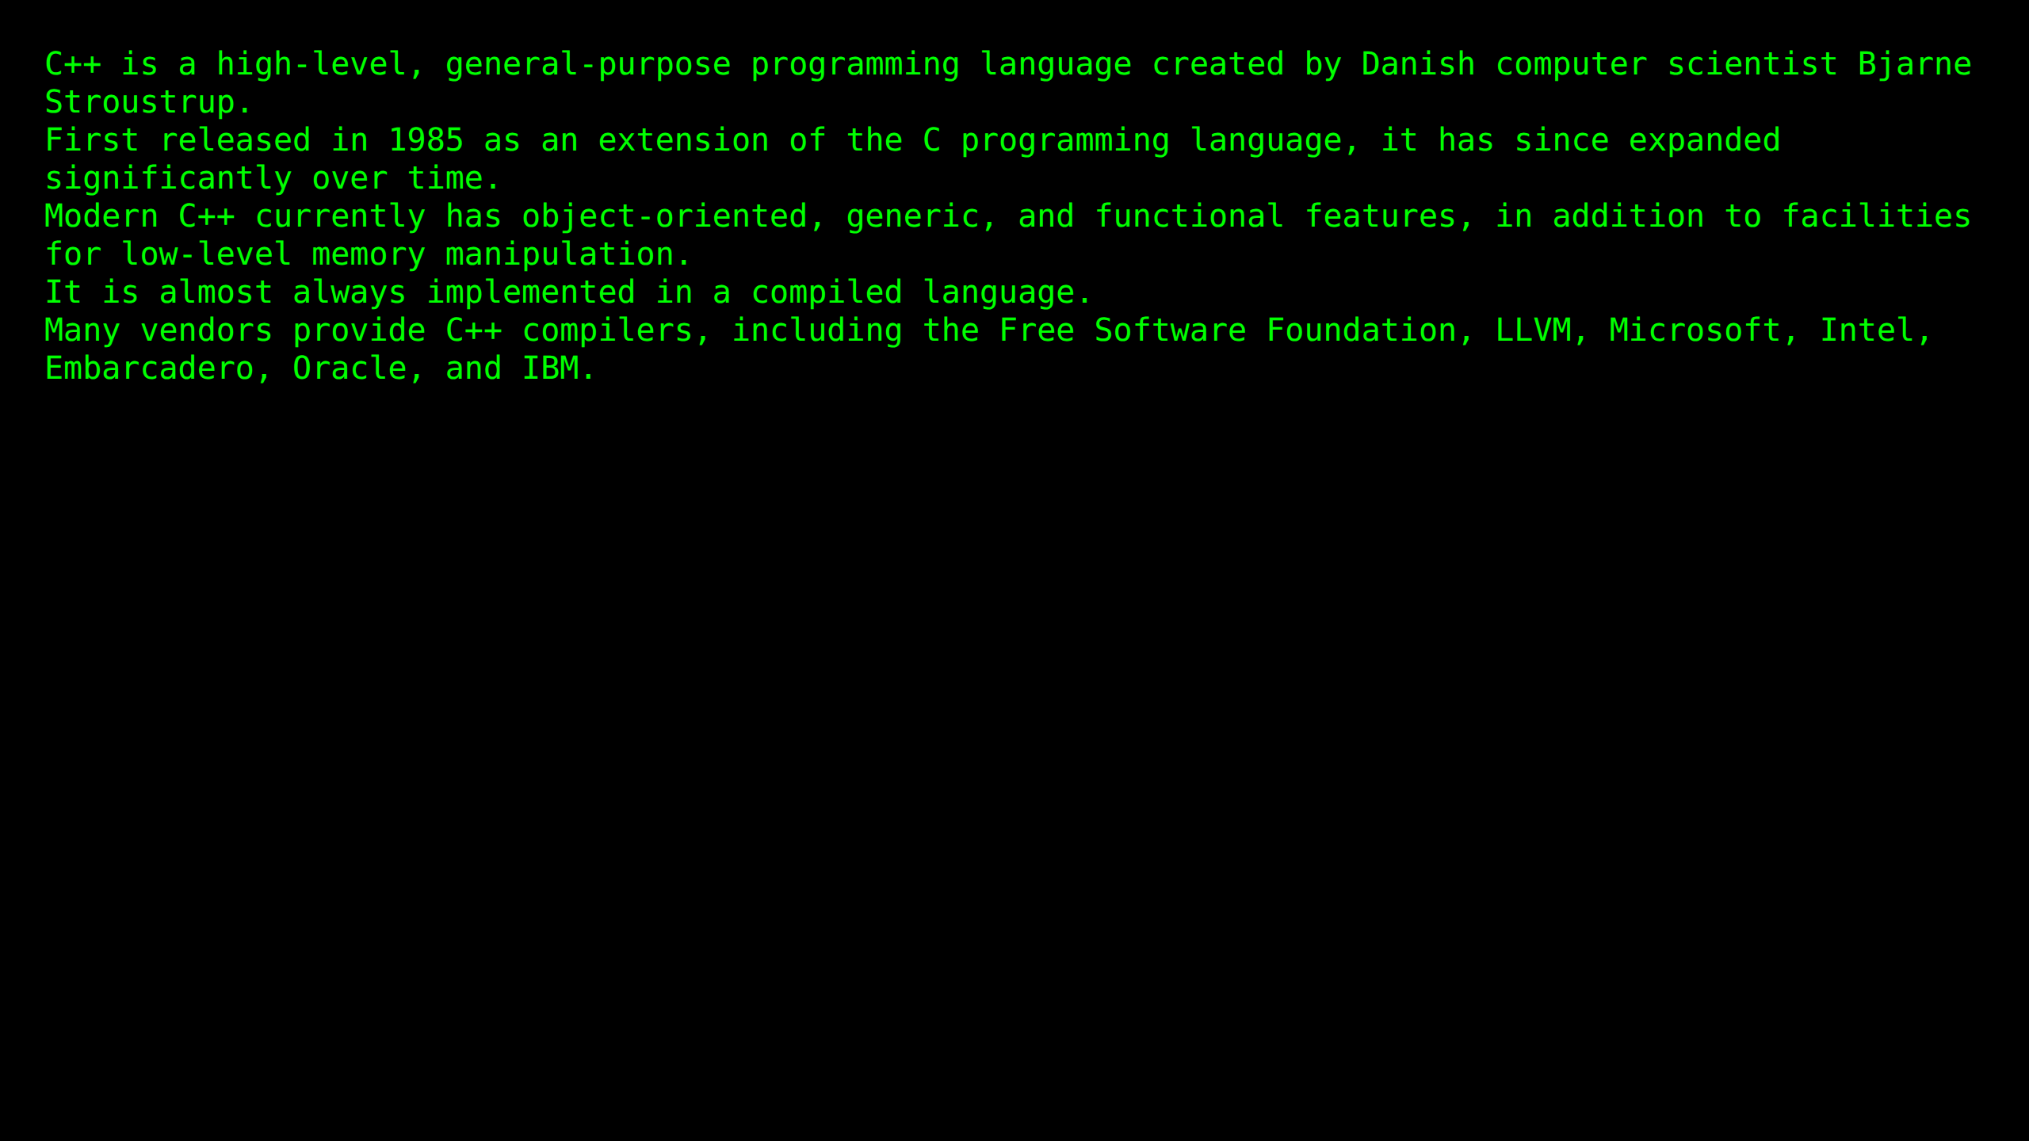

Practical 14.4: Text File Append

Source Code:
#include <iostream>
#include <fstream>
using namespace std;
int main()
{
ofstream my_file("InfoOnCpp.txt", ios::app);
if(!my_file) {
cout << "Failed to open the file for appending." << endl;
return 1;
}
my_file << "Attempted to open file in append mode" << endl;
my_file << "and type the data" << endl;
my_file << "It's a Success" << endl;
my_file.close();
cout << "Appended text successfully" << endl;
return 0;
}

Output Screenshot:
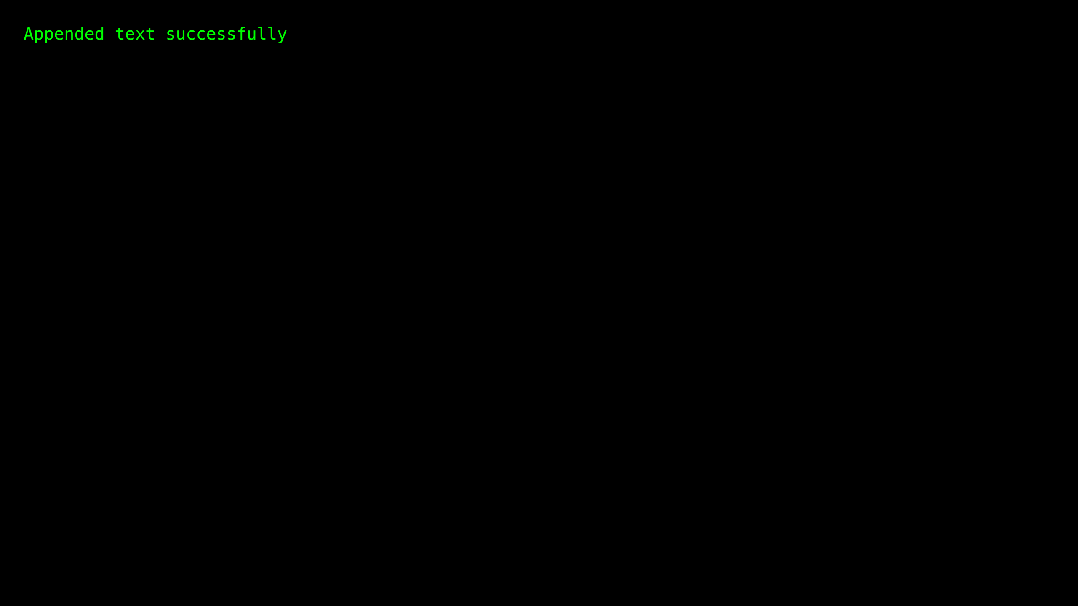

Practical 14.5: Binary File Read/Write

Source Code:
#include<iostream>
#include<fstream>
#include <cstring>
using namespace std;
struct Student
{
int roll_no;
char name[50];
};
int main() {
ofstream wbf("student.dat", ios::out | ios::binary);
if (!wbf) {
cout << "Cannot open file!" << endl;
return 1;
}
Student wstu[3];
wstu[0].roll_no = 101;
strncpy(wstu[0].name, "Ambika", 50);
wstu[1].roll_no = 102;
strncpy(wstu[1].name, "Chandra", 50);
wstu[2].roll_no = 103;
strncpy(wstu[2].name, "Madhu", 50);
for (int i = 0; i < 3; i++)
wbf.write((char * ) & wstu[i], sizeof(Student));
wbf.close();
if (!wbf.good())
{
cout << "Error occurred at writing time!" << endl;
return 1;
}
ifstream rbf("student.dat", ios::in | ios::binary);
if (!rbf)
{
cout << "Cannot open file!" << endl;
return 1;
}
Student rstu[3];
for (int i = 0; i < 3; i++)
rbf.read((char * ) & rstu[i], sizeof(Student));
rbf.close();
cout << "Student's Details:" << endl;
for (int i = 0; i < 3; i++)
{
cout << "Roll No: " << rstu[i].roll_no << endl;
cout << "Name: " << rstu[i].name << endl;
cout << endl;
}
return 0;
}

Output Screenshot:
