DAA Practicals Report

P6 1 FindMethod

Source Code
def find_pattern_find(text, pattern):
return text.find(pattern)
text = "This is a sample text where we search for a pattern"
pattern = "search"
index = find_pattern_find(text, pattern)
if index != -1:
print("Pattern found at index:", index)
else:
print("Pattern not found")

Output Screenshot
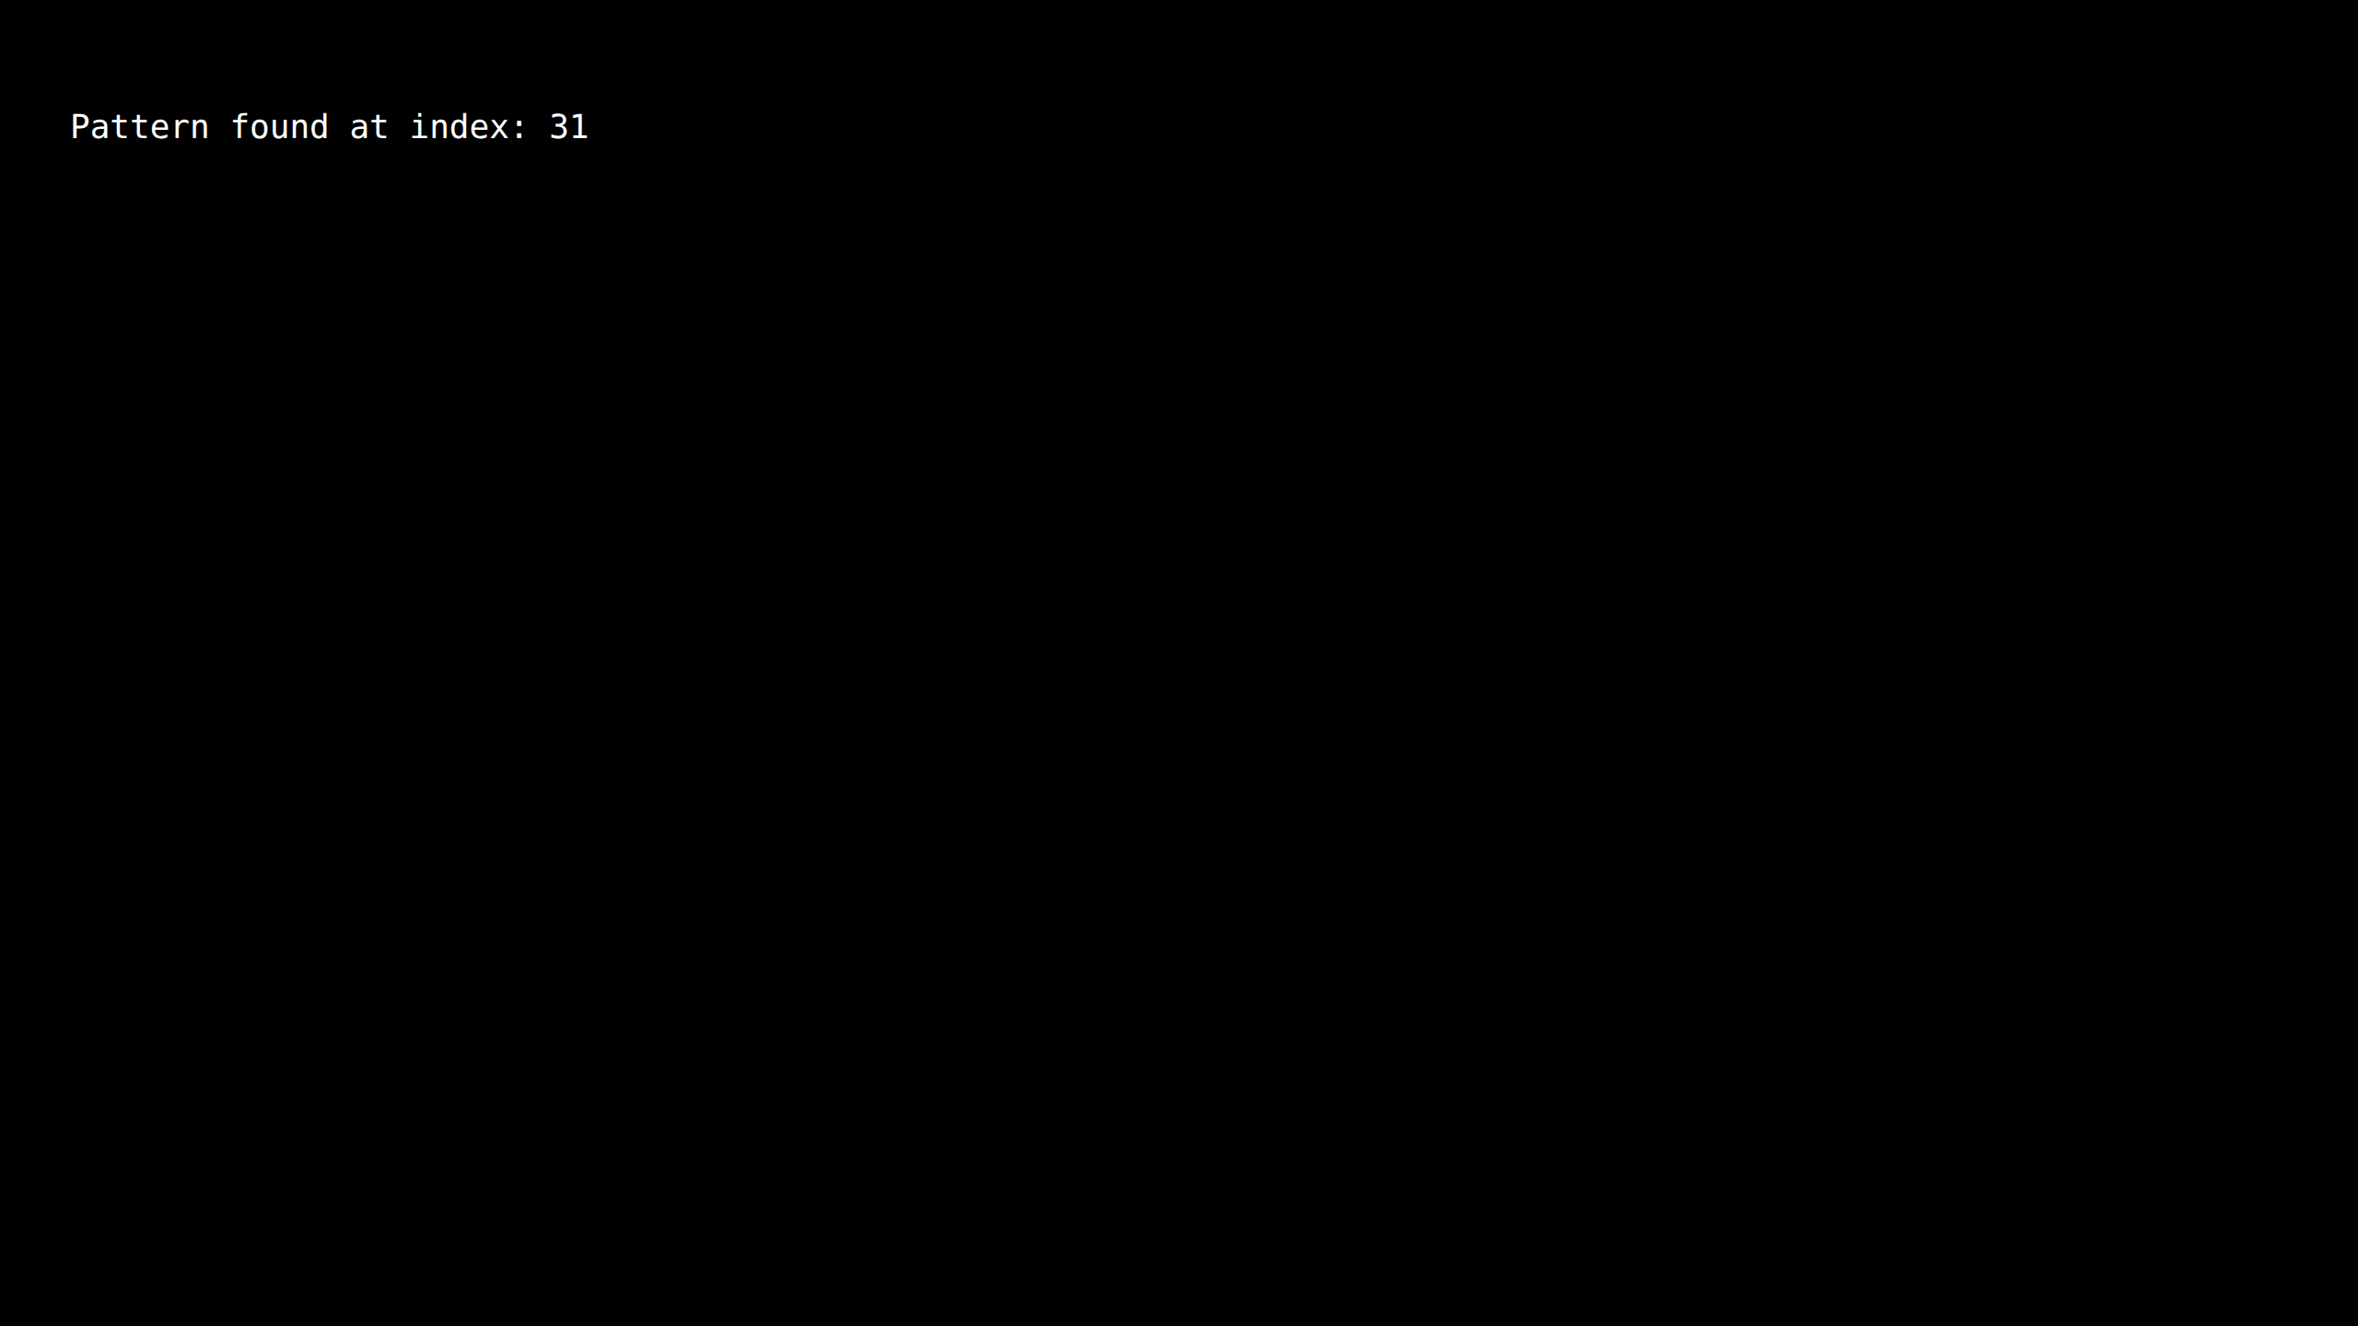

P6 2 RegexSearch

Source Code
import re
def find_pattern_regex(text, pattern):
return bool(re.search(pattern, text))
text = "This is a sample text where we search for a pattern"
pattern = "search"
if find_pattern_regex(text, pattern):
print("Pattern found")
else:
print("Pattern not found")

Output Screenshot
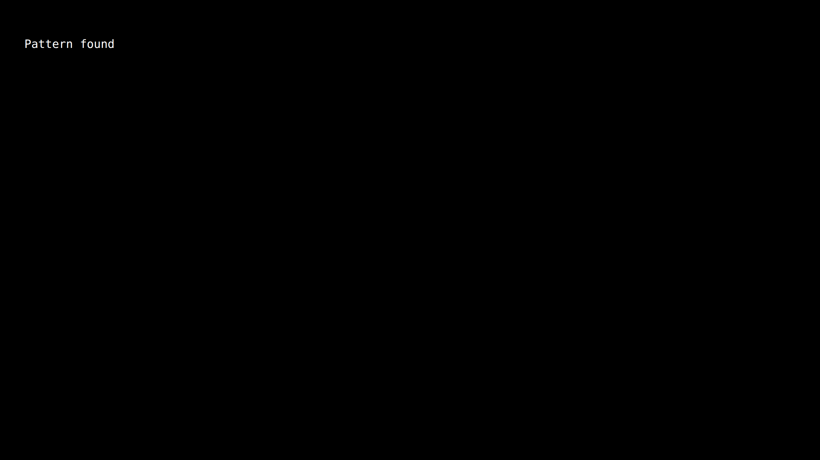

P6 3 BruteForce

Source Code
def brute_force_match(text, pattern):
n = len(text)
m = len(pattern)
for i in range(n - m + 1):
j = 0
while j < m:
if text[i + j] != pattern[j]:
break
j += 1
if j == m:
return True
return False
text = "This is a sample text"
pattern = "sample"
print("Pattern found:", brute_force_match(text, pattern))

Output Screenshot
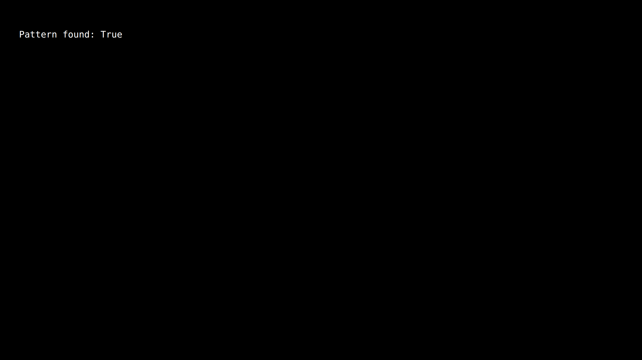

P6 4 NaiveFindAll

Source Code
def naive_pattern_matching(text, pattern):
n = len(text)
m = len(pattern)
occurrences = []
for i in range(n - m + 1):
match = True
for j in range(m):
if text[i + j] != pattern[j]:
match = False
break
if match:
occurrences.append(i)
return occurrences
text = "ABABCABABABCABAB"
pattern = "ABAB"
print("Occurrences found at indices:", naive_pattern_matching(text, pattern))

Output Screenshot
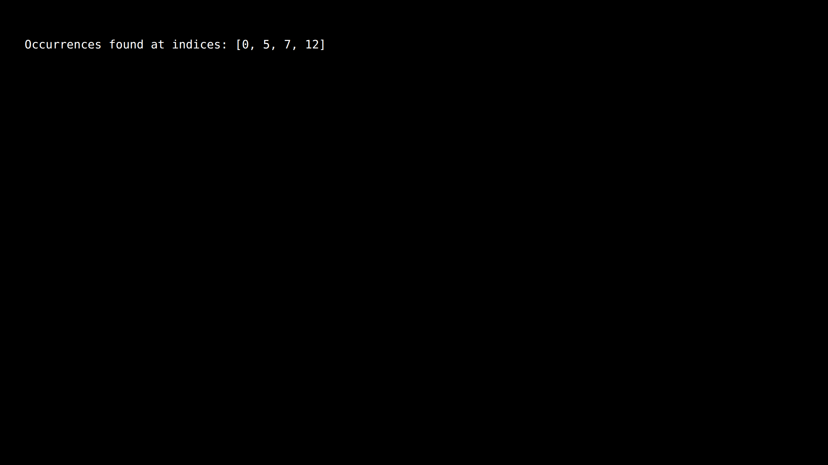

P6 5 CaseInsensitive

Source Code
def case_insensitive_match(text, pattern):
text = text.lower()
pattern = pattern.lower()
n = len(text)
m = len(pattern)
for i in range(n - m + 1):
if text[i:i+m] == pattern:
return i
return -1
text = "Data Structures and Algorithms"
pattern = "algorithms"
index = case_insensitive_match(text, pattern)
if index != -1:
print("Pattern found at index:", index)
else:
print("Pattern not found")

Output Screenshot
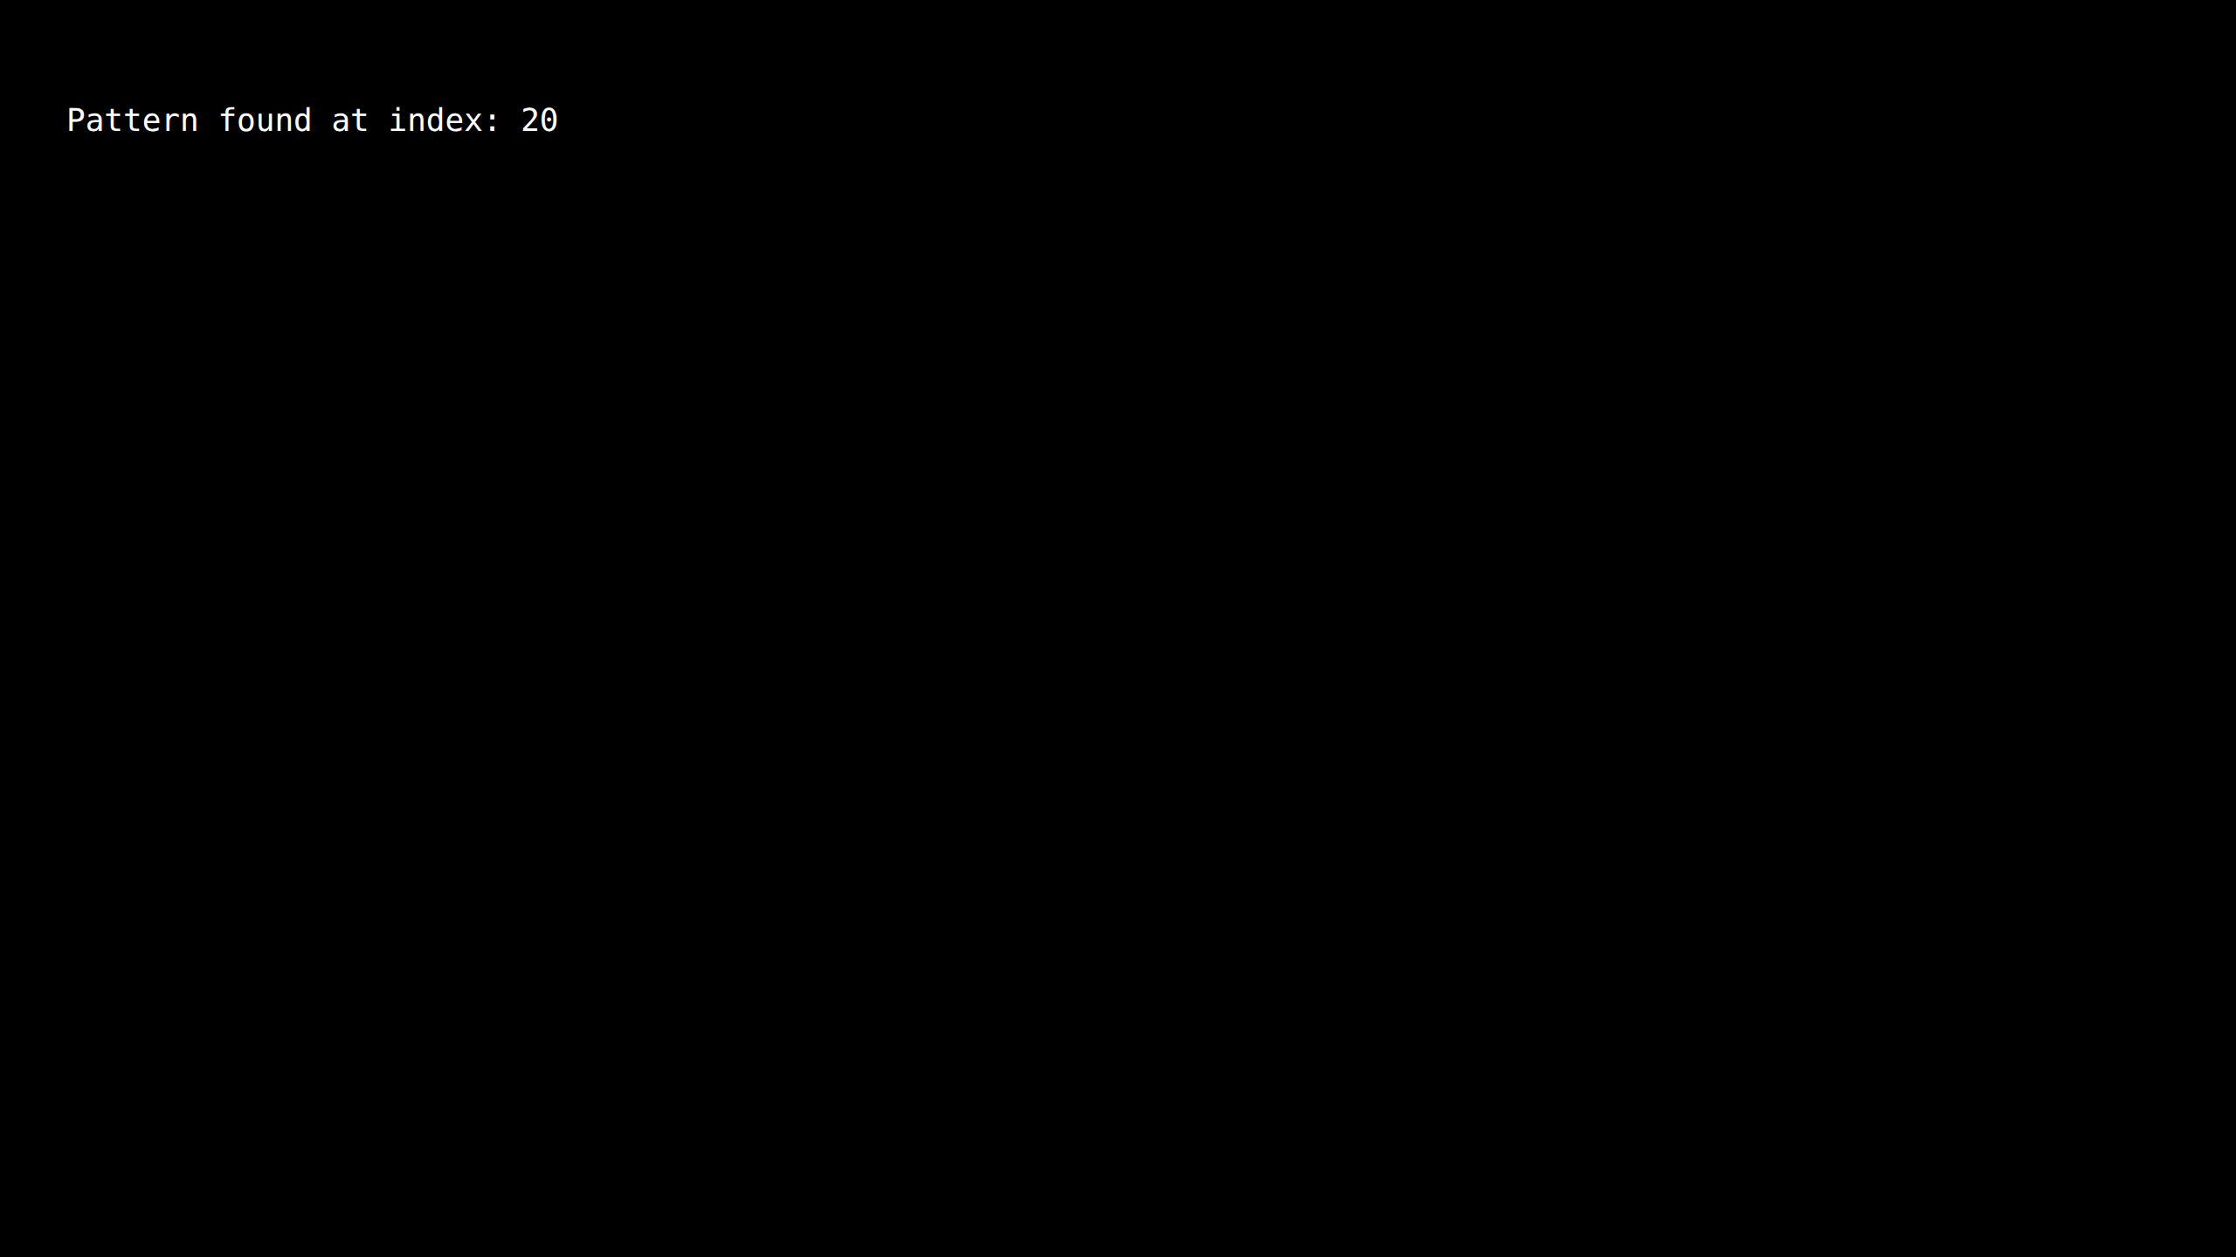

P6 6 TimeComparison

Source Code
import timeit
import re
def find_general(text, pattern):
return text.find(pattern) != -1
def find_regex(text, pattern):
return bool(re.search(pattern, text))
def brute_force(text, pattern):
n = len(text)
m = len(pattern)
for i in range(n - m + 1):
if text[i:i+m] == pattern:
return True
return False
text = "This is a sample text where we search for a pattern"
pattern = "search"
t1 = timeit.timeit(lambda: find_general(text, pattern), number=10000)
t2 = timeit.timeit(lambda: find_regex(text, pattern), number=10000)
t3 = timeit.timeit(lambda: brute_force(text, pattern), number=10000)
print("Time using find():", t1)
print("Time using regex:", t2)
print("Time using brute force:", t3)

Output Screenshot
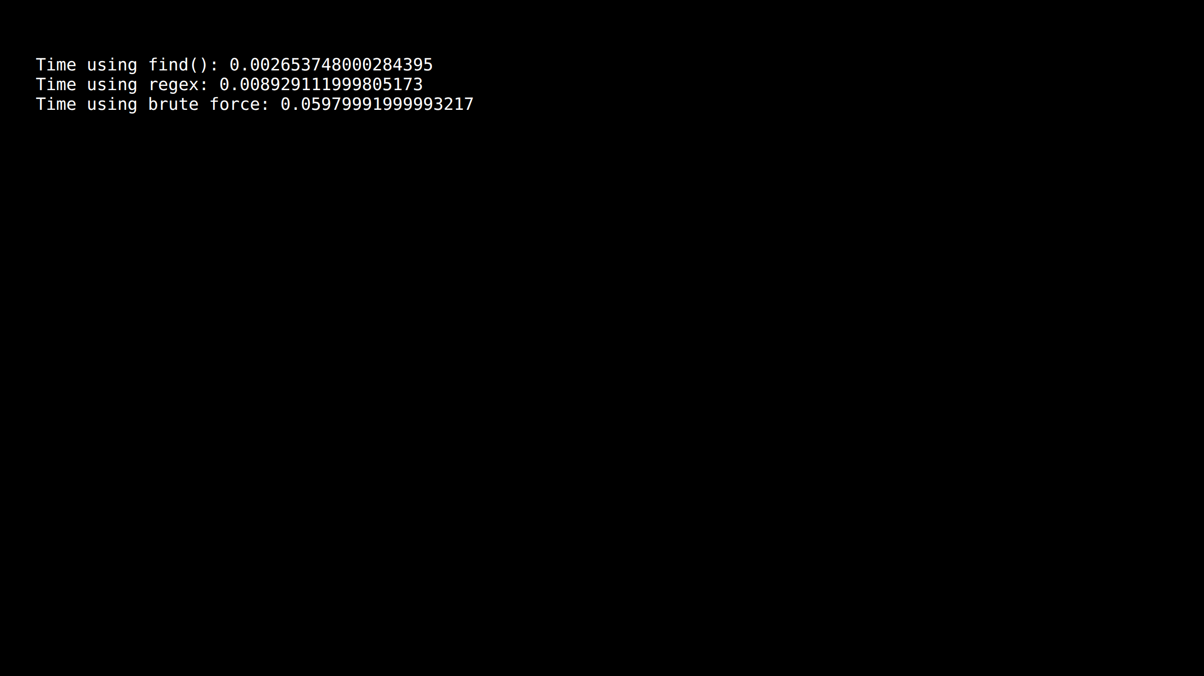

P6 7 TimeComplexity

Source Code
def naive_match(text, pattern):
n = len(text)
m = len(pattern)
for i in range(n - m + 1):
for j in range(m):
if text[i + j] != pattern[j]:
break
else:
return i
return -1
text = "A" * 1000 + "B"
pattern = "AB"
print("Pattern found at index:", naive_match(text, pattern))

Output Screenshot
