C++ Practicals Report

P12 ThisPointer

Source Code
#include <iostream>
using namespace std;
class Employee {
public:
int id; //data member (also instance variable)
string name; //data member(also instance variable)
float salary;
Employee(int id, string name, float salary)
{
this->id = id;
this->name = name;
this->salary = salary;
}
void display()
{
cout<<id<<" "<<name<<" "<<salary<<endl;
}
};
int main(void) {
Employee e1 =Employee(101, "Pinocchio", 890000); //creating an object of Employee
Employee e2=Employee(102, "Naruto", 59000); //creating an object of Employee
e1.display();
e2.display();
return 0;
}

Output Screenshot
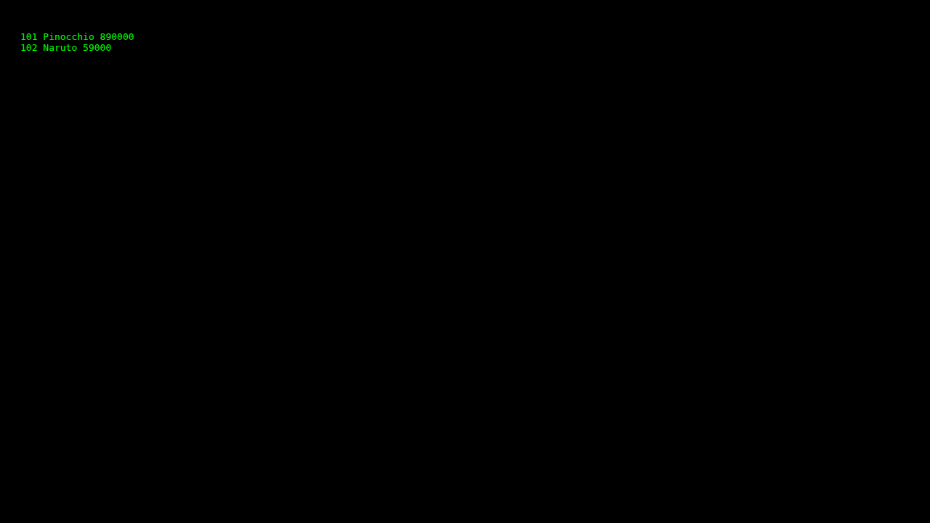

P13 1 PointersBasics

Source Code
#include <iostream>
using namespace std;
void Pointers()
{
int var = 20;
int* ptr; // declare pointer variable
ptr = &var; // data type of ptr and var must be same
// assign the address of a variable to a pointer
cout << "Value at ptr = " << ptr << "\n";
cout << "Value at var = " << var << "\n";
cout << "Value at *ptr = " << *ptr << "\n";
}
int main()
{
Pointers();
return 0;
}

Output Screenshot
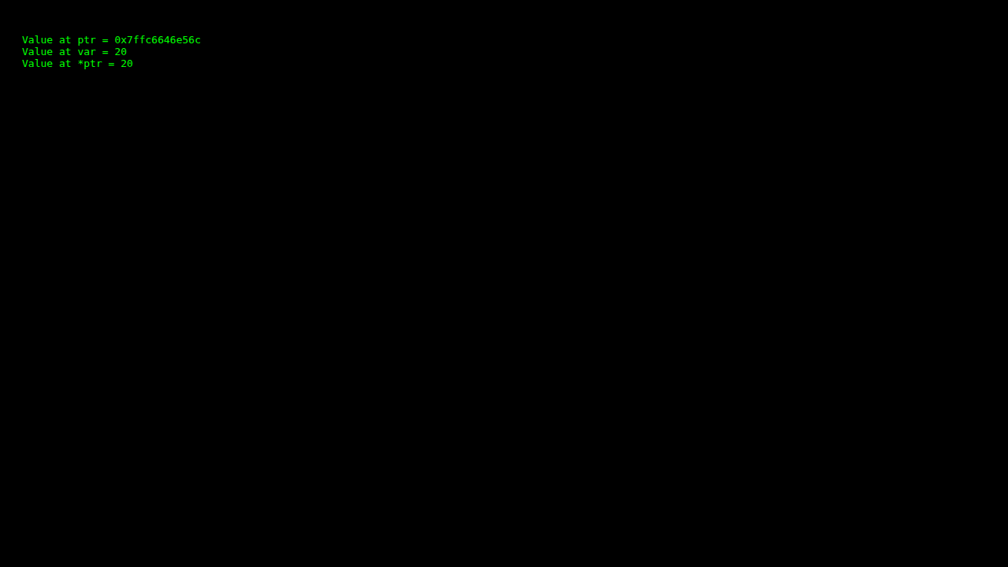

P13 2 PointerToPointers

Source Code
#include<iostream>
using namespace std;
int main ()
{
int a;
int * ptr_b;
int ** ptr_c;
a = 1;
ptr_b = &a;
ptr_c = &ptr_b; //Get address of ptr_b
cout << a << "\n"; //print value of a
cout << *ptr_b << "\n"; //print value where pointer ptr_b points to
cout << ptr_b << "\n"; //print value of pointer ptr_b
cout << *ptr_c << "\n"; //print address of ptr_b
cout << **ptr_c << "\n"; //print value where ptr_c points to
return 0;
}

Output Screenshot
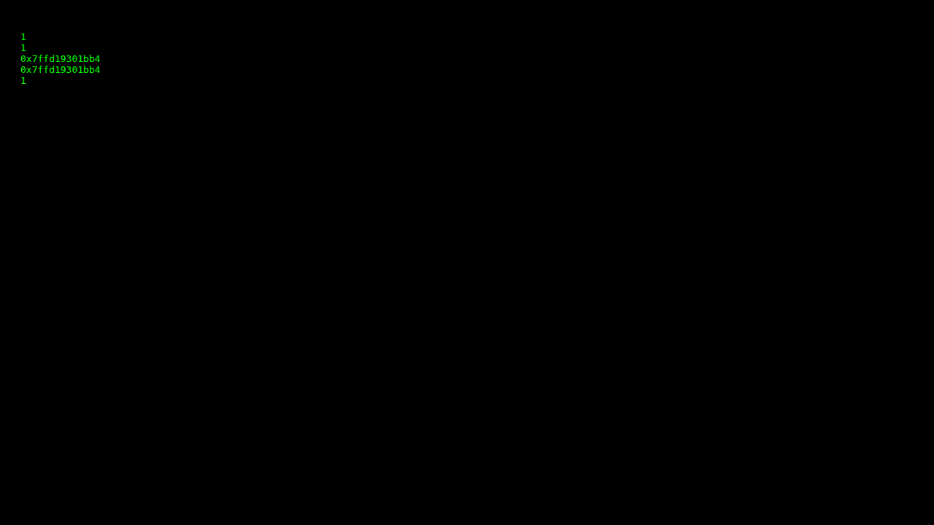

P13 3 CallByValue

Source Code
#include<iostream>
using namespace std;
void swapping(int c, int d)
{
int temp;
temp = c;
c = d;
d = temp;
cout << "In function:\n" << c << " \n " << d << " \n ";
}
int main()
{
int a,b;
a=5;
b=10;
cout << "Before Sapping :\n " << a << " \n " << b << " \n ";
swapping(a,b);
cout << "After Swapping:\n " << a << " \n " << b << " \n ";
return 0;
}

Output Screenshot
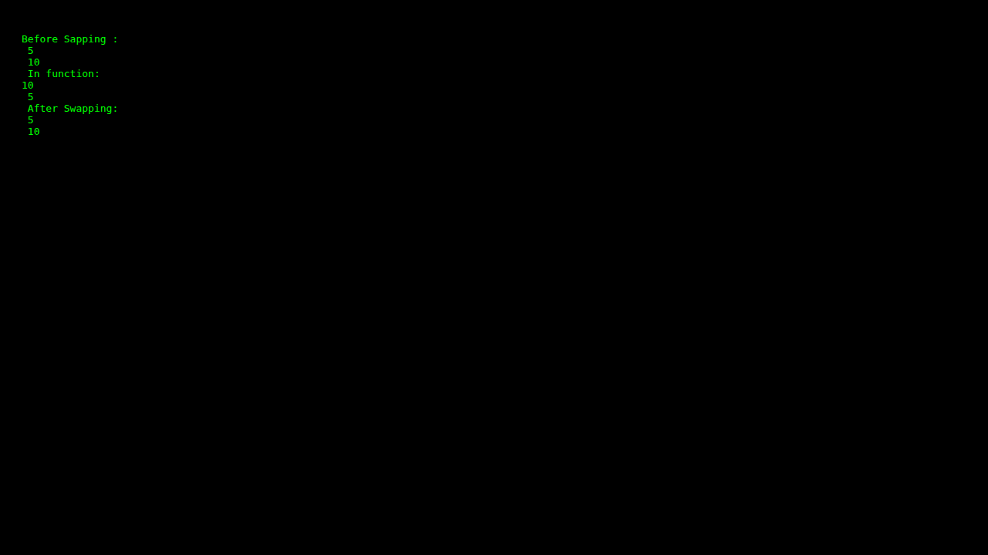

P13 4 CallByReference

Source Code
#include<iostream>
using namespace std;
void swapping(int *ptr_c, int *ptr_d)
{
int tmp;
tmp = *ptr_c;
*ptr_c = *ptr_d;
*ptr_d = tmp;
cout << "In function:\n" << *ptr_c << "\n " << *ptr_d << '\n';
}
int main()
{
int a,b;
a=5;
b=10;
cout << "Before:\n" << a << " \n" << b << "\n";
swapping(&a,&b);
cout << "After:\n" << a << "\n " << b << " \n ";
}

Output Screenshot
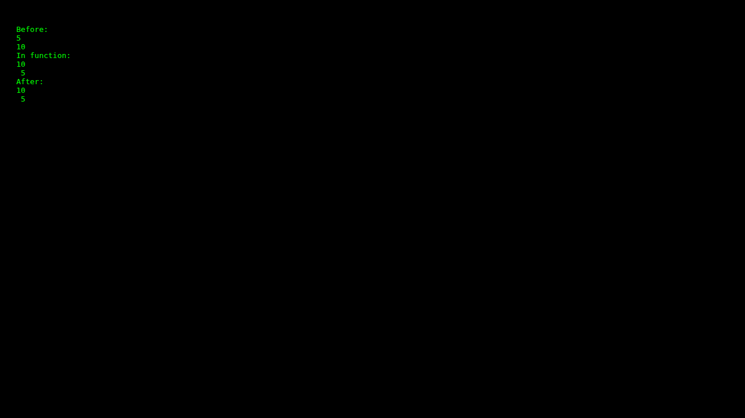

P14 1 FileReadWrite

Source Code
#include <iostream>
#include <fstream>
#include <string>
using namespace std;
int main(){
fstream newfile,newfile1;
newfile.open("testFile.txt",ios::out); // open a file to perform write operation using file object
if(newfile.is_open()) //checking whether the file is open
{
newfile<<"Hello World from CPP \n"; //inserting text
newfile.close(); //close the file object
}
newfile.open("testFile.txt",ios::in); //open a file to perform read operation using file object
if (newfile.is_open()){ //checking whether the file is open
string tp;
while(getline(newfile, tp)){ //read data from file object and put it into string.
cout << tp << "\n"; //print the data of the string
}
newfile.close(); //close the file object.
}
}

Output Screenshot
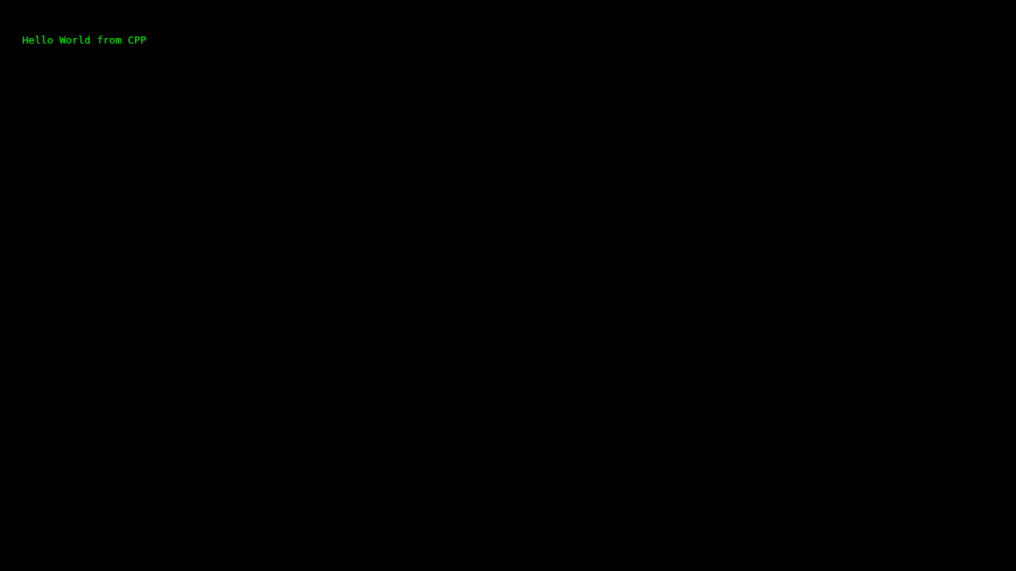

P14 2 FileWrite

Source Code
#include <iostream> // Include the input/output stream library
#include <fstream> // Include the file stream library
int main() {
// Create a new file named "InfoOnCpp.txt"
std::ofstream outputFile("InfoOnCpp.txt"); // Open/create a file named "test.txt" for writing
if (outputFile.is_open()) { // Check if the file was successfully opened
// Write some text into the file
outputFile << "C++ is a high-level, general-purpose programming language created by Danish computer scientist Bjarne Stroustrup. \n"; // Write a line of text to the file
outputFile << "First released in 1985 as an extension of the C programming language, it has since expanded significantly over time. \n"; // Write a line of text to the file
outputFile << "Modern C++ currently has object-oriented, generic, and functional features, in addition to facilities for low-level memory manipulation.\n"; // Write a line of text to the file
outputFile << "It is almost always implemented in a compiled language.\n"; // Write a line of text to the file
outputFile << "Many vendors provide C++ compilers, including the Free Software Foundation, LLVM, Microsoft, Intel, Embarcadero, Oracle, and IBM."; // Write a line of text to the file
// Close the file
outputFile.close(); // Close the file after writing
std::cout << "Text has been written to the file." << std::endl; // Display a success message
} else {
std::cout << "Failed to create the file." << std::endl; // Display an error message if file creation failed
}
return 0; // Return 0 to indicate successful execution
}

Output Screenshot
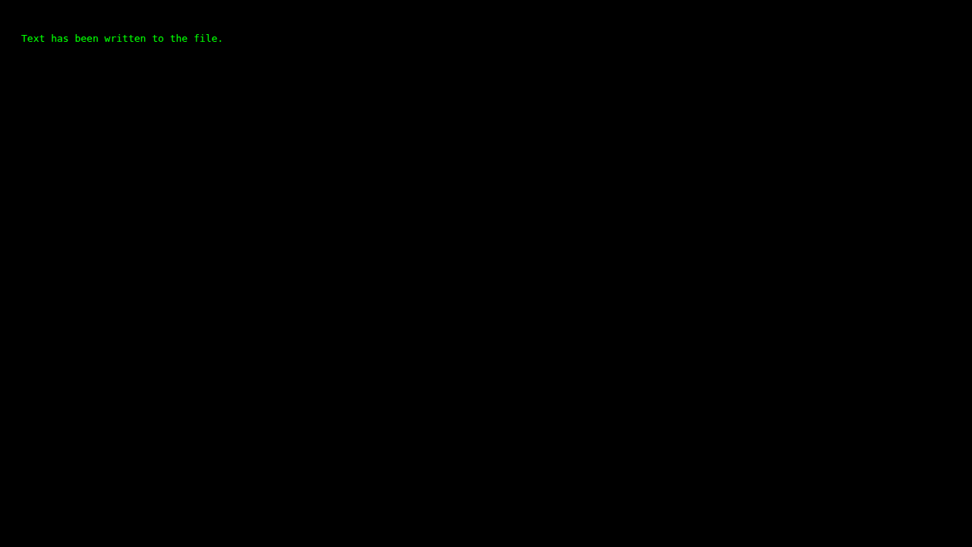

P14 3 FileRead

Source Code
#include <iostream>
#include <fstream>
#include <string>
using namespace std;
int main(){
fstream newfile;
newfile.open("InfoOnCpp.txt",ios::in); //open a file to perform read operation using file object
if (newfile.is_open()){ //checking whether the file is open
string tp;
while(getline(newfile, tp)){ //read data from file object and put it into string.
cout << tp << "\n"; //print the data of the string
}
newfile.close(); //close the file object.
}
return 0;
}

Output Screenshot
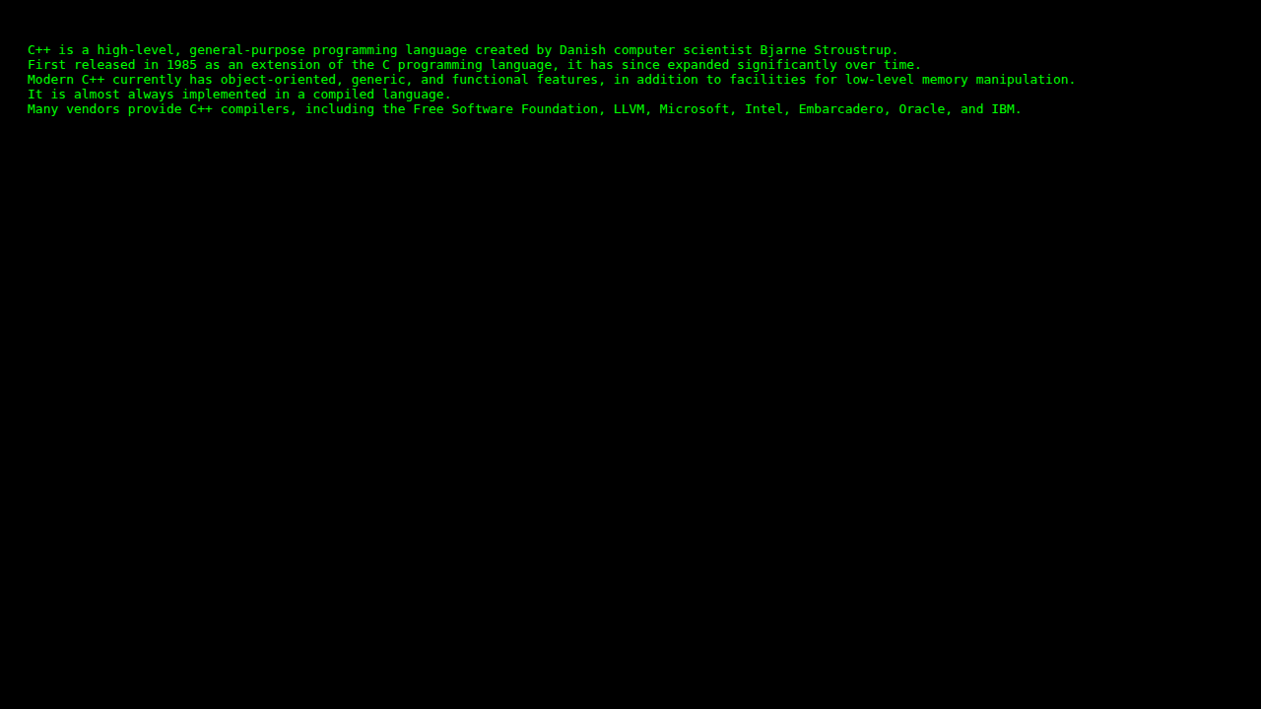

P14 4 FileAppend

Source Code
#include <iostream>
#include <fstream>
using namespace std;
int main()
{
ofstream my_file("InfoOnCpp.txt", ios::app); // open a text file for appending
// if the file doesn't open successfully, print an error message
if(!my_file) {
cout << "Failed to open the file for appending." << endl;
return 1;
}
// append multiple lines to the file
my_file << "Attempted to open file in append mode" << endl;
my_file << "and type the data" << endl;
my_file << "It’s a Success" << endl;
my_file.close(); // close the file
return 0;
}

Output Screenshot
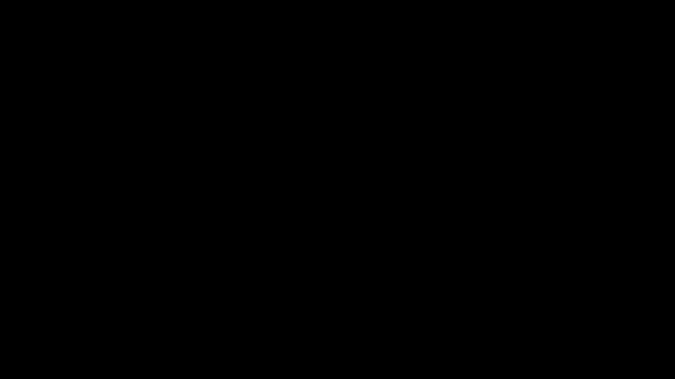

P14 5 BinaryFile

Source Code
#include<iostream>
#include<fstream>
#include<string>
#include<cstring>
using namespace std;
struct Student
{
int roll_no;
char name[50]; // Changed string to char array for binary safety
};
int main() {
ofstream wbf("student.dat", ios::out | ios::binary);
if (!wbf) {
cout << "Cannot open file!" << endl;
return 1;
}
Student wstu[3];
wstu[0].roll_no = 101;
strcpy(wstu[0].name, "Ambika");
wstu[1].roll_no = 102;
strcpy(wstu[1].name, "Chandra");
wstu[2].roll_no = 103;
strcpy(wstu[2].name, "Madhu");
for (int i = 0; i < 3; i++)
wbf.write((char * ) & wstu[i], sizeof(Student));
wbf.close();
ifstream rbf("student.dat", ios::in | ios::binary);
if (!rbf)
{
cout << "Cannot open file!" << endl;
return 1;
}
Student rstu[3];
for (int i = 0; i < 3; i++)
rbf.read((char * ) & rstu[i], sizeof(Student));
rbf.close();
cout << "Student's Details:" << endl;
for (int i = 0; i < 3; i++)
{
cout << "Roll No: " << rstu[i].roll_no << endl;
cout << "Name: " << rstu[i].name << endl;
cout << endl;
}
return 0;
}

Output Screenshot
