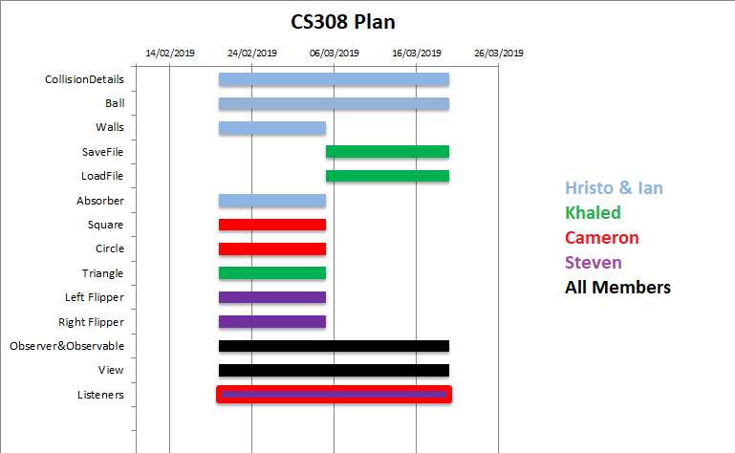

The Plan was based on which members had specialised on each prototype. It aims to have the main gizmo components of the model itself completed first alongside the corresponding listeners and view sections. While the Collision specifics and File managing can be done after, with the View and Listeners being continuously improved and modified throughout.