**SDS**

**Simple Library Management System**

**Team 3**

**Team Names :-**

**1-Reem Waleed**

**2-Rawan Farouk**

**3-Yehia Mohamed**

**4-Ziad Osama**

**Requirements:**

1. **﻿﻿﻿**Data Structures: Use lists and dictionaries to store and manage the library's book inventory and borrowed books.
2. ﻿﻿﻿Functions: Create functions for each operation (e.g., add _book, remove_book , search_book, borrow_book, return_book).
3. File Handling: Implement file handling to save and load the library's inventory and borrowed books data.
4. ﻿﻿﻿Error Handling: Use try-except blocks to handle potential errors (e.g., file not found, invalid input).
5. ﻿﻿﻿User Interface: Develop a simple text-based menu to interact with the system.

Technologies Used:

• **Backend:** Python with Flask framework

• **Database:** JSON

• **Frontend:** HTML and CSS

DB Schema :-

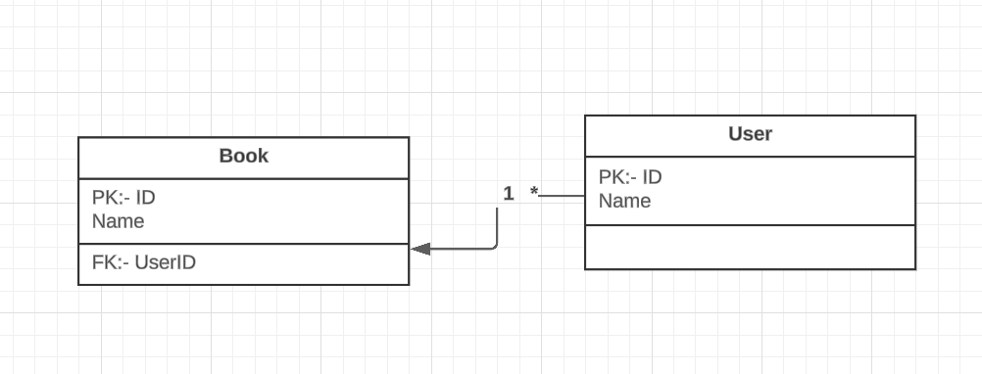

User stories :-

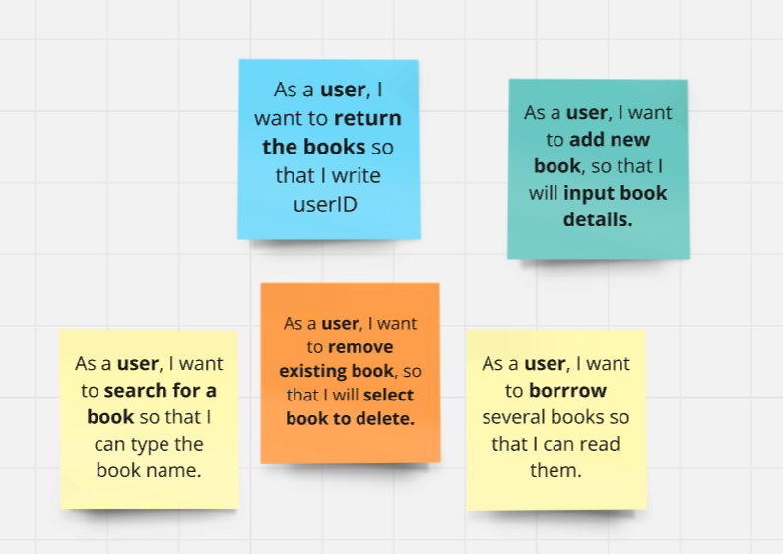

Class Diagram :-

