On the origin of citations

Ittai Eres

September 15, 2015

# Load the data, suckaaaaaaa!

## using read.delim

counts_raw <- read.delim("data/counts-raw.txt.gz")  
counts_norm <- read.delim("data/counts-norm.txt.gz")

# Data exploration.

What's the distributiuon of authors in all articles of our data set? 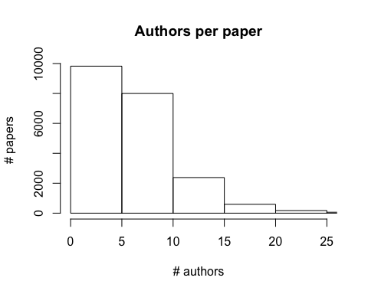

How many facebook likes do articles tend to get? 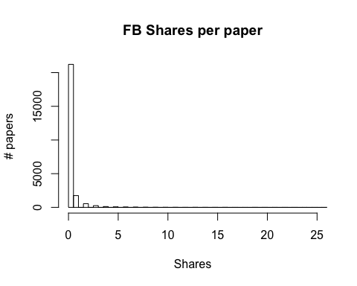

The average number of Facebook shares per paper in the data set is 0.6524187

Which row has the paper with the most shares? 16201

The paper with the most shares is "Fellatio by Fruit Bats Prolongs Copulation Time"

You can use render("name_of_markdown_file") to make an html knit without it popping up.