Visual Reference
Analog Synthesizer Explorer
Companion to PRD + Build Instructions

1. Overall Aesthetic Direction
What should the synth feel like? Pick a direction or describe your own.

Theme: | Light

Vibe: | Retro-futuristic

Mood: | Playful

Describe the feeling in your own words (e.g. "like a vintage Moog synth but cleaner" or "like a Teenage Engineering product page"):
Like a vintage cyberpunk device – but with retro pixelated graphics

Reference Screenshots / Moodboard

Reference 1
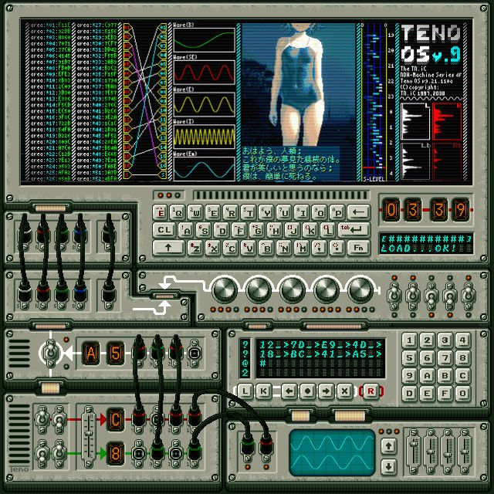
I like the retro style of the device – the physical screws and vents.
I also like the waveform display at the bottom right

Reference 2
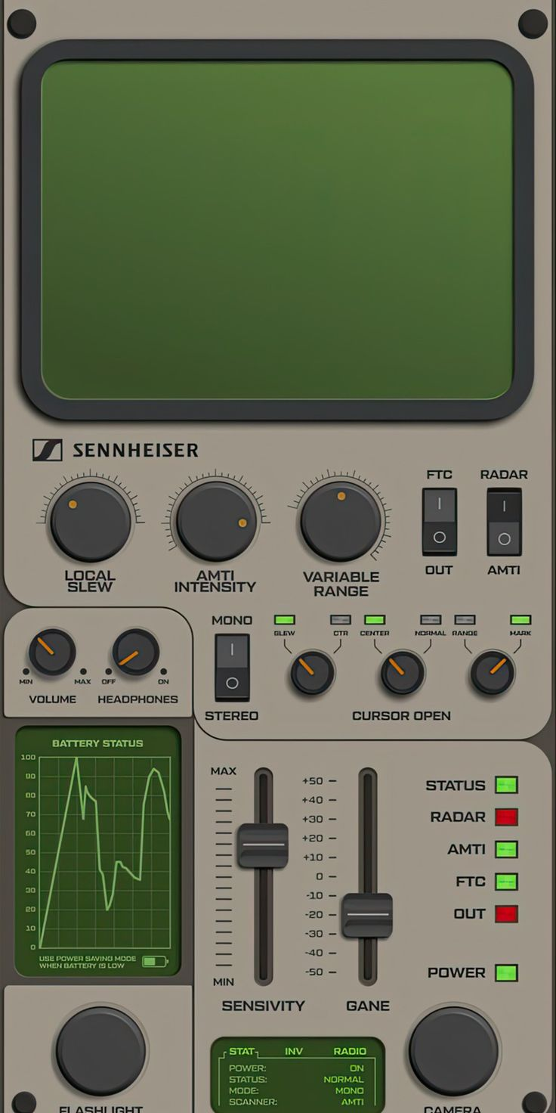
I like the design of the knobs and sliders and led lights
I like the font used to mark the knobs etc. on the device
I like the colors used in this – especially for the device

Reference 3
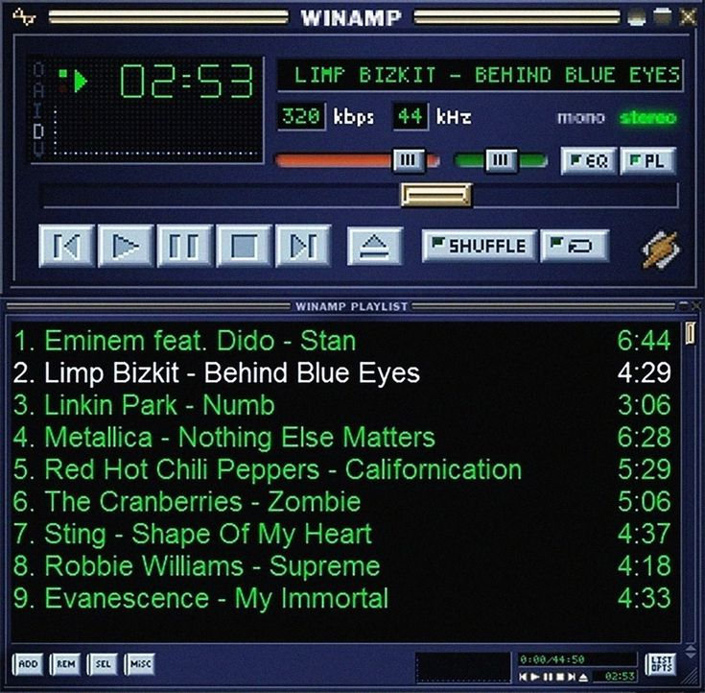
For the section where users can select a popular riff, or a preset voice – I want it to look like in the style of retro music player UI like this reference. It need not have all the controls like play pause shuffle etc – but I want that selection interaction to be on a retro style interface like this

2. Color Palette
Define the key colors. You can paste hex codes, color swatches, or just describe what you want.

Background: | e.g. #1A1A2E or "very dark navy"

Primary accent: | e.g. #00FF88 or "neon green"

Secondary accent: | e.g. #FF6B6B or "warm coral"

Text color: | e.g. #FFFFFF or "off-white"

Control surfaces: | e.g. #2A2A4A or "slightly lighter than background"

Any other color notes (e.g. "I want the oscilloscope to be green on black like a real scope" or "each synth section should have a subtle color tint"):

3. Typography
What fonts should the app use? Leave blank if you want Claude Code to choose.

Heading font: | Space Mono

Body/label font: | Inter

Number displays: | Monospace

Any typography notes:
I like the teenage engineering style typography

4. Control Style
How should the knobs, sliders, and toggles look and behave?

Knobs vs sliders: | Mix (knobs for some, sliders for others – as per standard synth practices

Control aesthetic: |  similar to the controls in this reference image

Value display: | Show numbers on controls/device marking like in this reference image 

Any control-specific notes:
I want the waveform selector to show actual wave shapes

5. Layout & Spacing
How should the sections be arranged on the page? The PRD defines the information architecture — this is about the visual treatment.

Density: | Spacious (breathing room, requires scroll)

Section separation: | Subtle background color changes

Signal flow diagram: | Top right of page (horizontal),

Wireframe / Layout Sketch
Paste a rough wireframe here — can be from Figma, hand-drawn and photographed, or a quick sketch tool. Doesn't need to be polished.
Paste wireframe
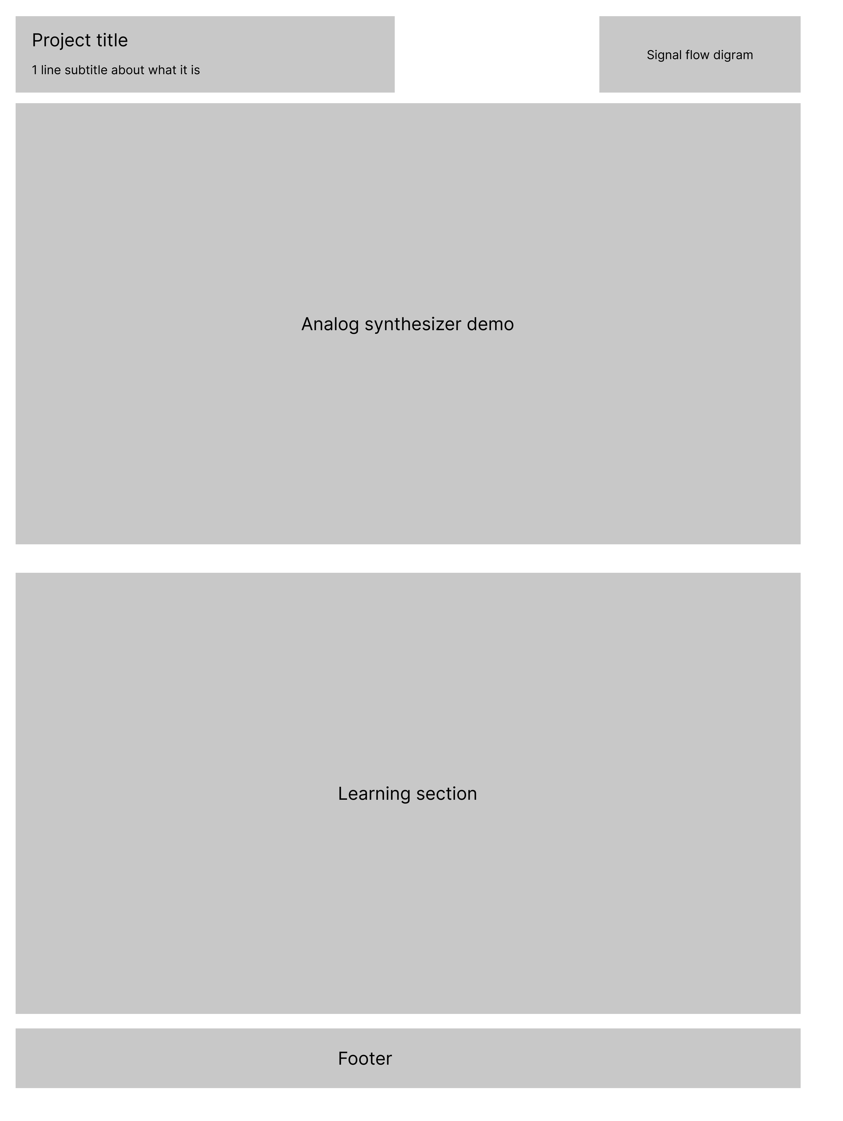

6. Oscilloscope / Visualizer
The live waveform display is a key visual element.

Style: | Circle one: Classic green-on-black / Match accent color on dark / Colorful/gradient / No preference

Size: | Medium

Line style: | Thin crisp line

Reference image
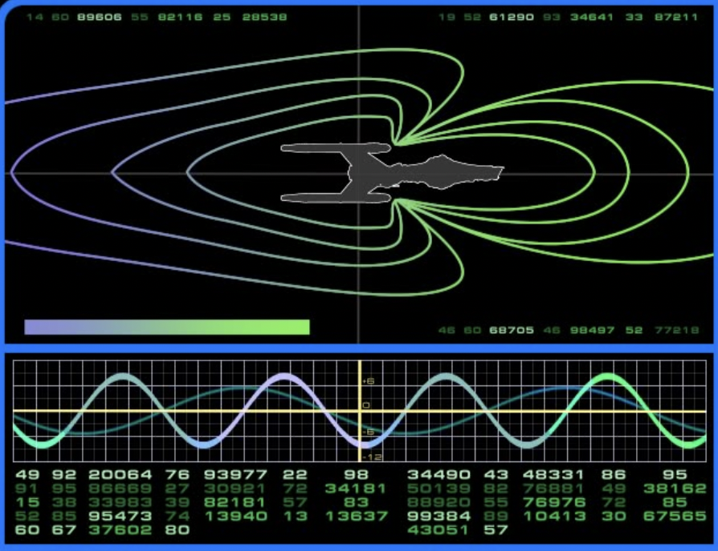

7. Learning Section
The static educational content below the synth.

Visual separation: | Clear divider between synth and learning

Background: | Different (e.g. lighter section)

Any notes on how the learning section should look and feel:
I want the style to be uniform and consistent with the section above it
It should be super simple and concise, with explainer diagrams for concepts like this reference -
