**The dynamic and evolving landscape of cloud computing has propelled Kubernetes as a pivotal platform for orchestrating containerized applications. This project introduces an innovative application to enhance the security of Kubernetes pods by automating security configurations. The proposed solution addresses three critical areas: Isolation, Role-Based Access Control (RBAC), and Ingress-Specific IP. Our approach introduces a granular isolation framework at the container level, ensuring that unauthorized access is prevented between pods, thereby reducing the attack surface and maintaining integrity. We implement a sophisticated RBAC system at the pod level, defining and enforcing access permissions based on user roles and specific policies. This ensures that only authorized entities interact with sensitive pod resources, striking a balance between operational efficiency and security. The project also introduces network policies to regulate ingress traffic between pods, allowing only specified IP addresses to communicate with designated containers, reducing the risk of unauthorized access and safeguarding sensitive data from eavesdropping. By integrating these security measures, our solution establishes a robust security posture for Kubernetes deployments, securing containerized applications from a broad spectrum of internal and external threats while facilitating compliance with industry standards and regulations, ensuring secure, scalable, and reliable Kubernetes environments.**

**Keywords: Kubernetes, pod security, policy enforcement, container isolation, RBAC, ingress traffic control, secure cloud management**

**1. Introduction**

In the dynamic landscape of cloud computing, Kubernetes has emerged as a crucial platform for orchestrating containerized applications. The scale and complexity of Kubernetes deployments have grown, making robust security measures essential. This project aims to automate the security configuration of Kubernetes pods by focusing on three key areas: isolation, Role-Based Access Control (RBAC), and ingress-specific IP controls.

The motivation behind this project is twofold. Firstly, the growing sophistication of cyber threats necessitates advanced security measures to safeguard Kubernetes deployments. Secondly, regulatory requirements for data protection and privacy call for stringent protocols that ensure compliance and mitigate unauthorized access to sensitive resources.

The project addresses these challenges by developing a comprehensive security framework. This framework implements:

1. Isolation: A granular isolation framework at the container level, preventing unauthorized access between pods, reducing the attack surface, and maintaining integrity.
2. RBAC: A dynamic RBAC system at the pod level, defining and enforcing access permissions based on user roles and specific policies. The system allows for granular control, ensuring that only authorized entities interact with sensitive pod resources, balancing security with operational efficiency. The RBAC policies can be dynamically managed, adapting to different apps in different pods, with examples provided to illustrate their functionality.
3. Ingress-Specific IP: Network policies regulate ingress traffic between pods, allowing only specified IP addresses to communicate with designated containers. This reduces the risk of unauthorized access and safeguards sensitive data from eavesdropping.

By integrating these security measures, the project aims to establish a robust security posture for Kubernetes deployments. The solution secures containerized applications from both internal and external threats, while facilitating compliance with industry standards and regulations, ensuring secure, scalable, and reliable Kubernetes environments.

**2. Related work**

In our project, we're focusing on making sure data and resources are safe within the Kubernetes pod. In this section, we'll look at what others have done to improve security between pods. We'll explore how they've set rules, controlled access, and encrypted data. By learning from their methods, we can make our project even more secure.

[1] ITNEXT Article by Shazad Brohi proposed implementing Pod Security Policies (PSPs) to secure Kubernetes clusters. These policies manage cluster operations by setting conditions for pods, covering aspects such as host access, container UIDs, and volumes.

[2] Alawala & Ray on Amazon EKS proposed pod security standards for Amazon EKS to safeguard clusters against unwanted changes. They highlight the role of PSPs in enforcing security settings but note their deprecation in Kubernetes 1.21 and removal in 1.25, urging for alternative strategies.

[3] Rostami on RBAC in Kubernetes proposed Role-Based Access Control (RBAC) to secure Kubernetes control plane layers, including etcd objects. RBAC allows fine-grained access control over components, including PODs, namespaces, and deployments, with roles defined at the namespace or cluster level.

[4] Budigiri et al. on Network Policies proposed network policies in Kubernetes, particularly for 5G cloud environments. They demonstrate that these policies impose minimal performance overhead and highlight potential security challenges for container isolation.

[5] Binnie & McCune on Kubernetes Authorization proposed using RBAC for Kubernetes authorization, emphasizing user access control over API objects. They cover various authorization mechanisms and tools for RBAC auditing, highlighting both cluster and namespace-level roles, as well as built-in roles and groups.

[6] Microsoft Learn discusses developer best practices for securing pods in Azure Kubernetes Services (AKS). The article emphasizes the importance of pod security context and how it can be configured to manage aspects such as container privileges, capabilities, and security policies. It also highlights how these practices contribute to safeguarding Kubernetes deployments against unauthorized access and vulnerabilities.

[7] Red Hat provides a guide to Kubernetes Security Context and Pod Security Policy (PSP). It explains how security context configurations manage container privileges, user IDs, and capabilities, enhancing cluster security. PSPs enforce these settings across the cluster, providing a cohesive strategy to manage security risks.

[8] Packet Pushers presents four methods of Kubernetes isolation, highlighting how various isolation strategies can help secure Kubernetes clusters. These methods include network segmentation, namespace isolation, runtime restrictions, and RBAC configurations, each contributing to a layered security approach.

[9] AWS introduces security groups for pods, offering fine-grained controls to restrict ingress traffic. This feature helps manage communication between pods, minimizing the risk of unauthorized access and providing a secure communication framework for Kubernetes clusters.

[10] Wiz's 2023 Kubernetes Security Report provides key takeaways on the state of Kubernetes security, identifying common vulnerabilities and offering insights into securing Kubernetes deployments. The report also outlines strategies for improving security posture, including securing the control plane and managing container configurations.

[11] Aqua offers ten steps for securing Kubernetes clusters, focusing on securing data transmission, managing access control, and monitoring deployments. These steps include enforcing RBAC policies, implementing network policies, and securing pod configurations, providing a comprehensive strategy for securing Kubernetes environments.

[12] An IEEE publication discusses various security measures for Kubernetes, including network policies and RBAC configurations【12】, emphasizing their role in securing Kubernetes clusters against internal and external threats.

[13] ARMO provides insights into Kubernetes security best practices, covering topics such as access control, data encryption, and monitoring. The blog offers strategies to secure Kubernetes deployments, including enforcing network policies and RBAC configurations, minimizing security risks.

[14] Trilio's resources focus on Kubernetes security monitoring, discussing tools and techniques for tracking Kubernetes deployments. The guide highlights strategies for identifying and mitigating security threats, ensuring secure Kubernetes operations.

[15] SentinelOne offers a guide on defending modern cloud-based workloads, including Kubernetes security strategies. The guide covers aspects such as securing data transmission, managing access control, and implementing monitoring solutions, providing a comprehensive strategy for securing Kubernetes deployments.

**3. Our Proposed Scheme**

**A. System Model**

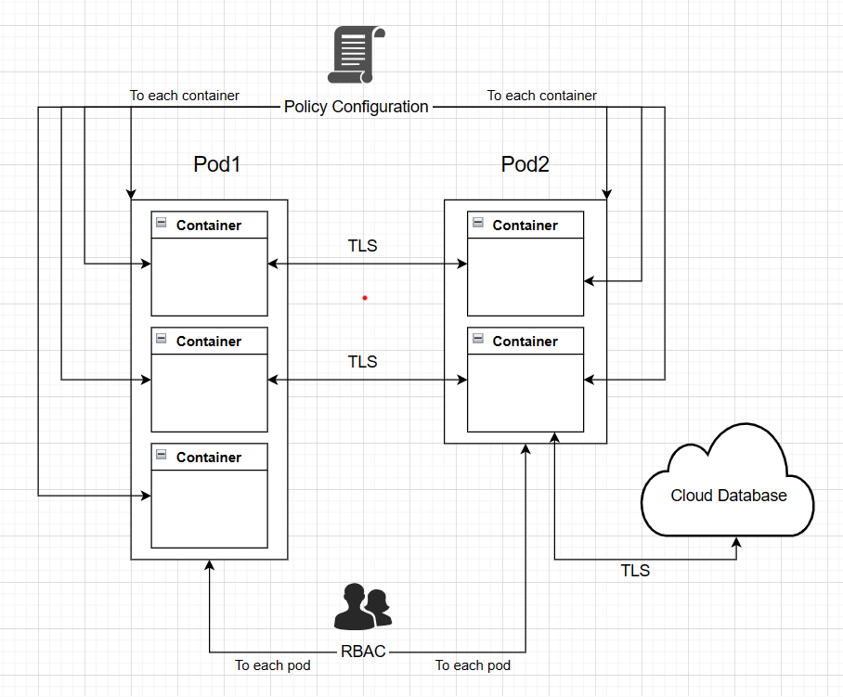

**System Model:**

**1. Container-Level Policies:**

- Policy Management: Each container is configured with its own set of security policies, defining access controls, network restrictions, and encryption requirements specific to the container's functionality and sensitivity of data it handles.

- Policy Enforcement: Policies are enforced at the container level to ensure isolation and security within the pod, preventing unauthorized access and ensuring compliance with organizational security requirements.

**2. RBAC for Pod Access:**

- Role-Based Access Control (RBAC): Role-Based Access Control (RBAC) in Kubernetes dynamically adapts access controls to fit the changing needs of applications across different pods. For instance, RBAC policies can be designed to automatically adjust permissions based on factors such as the deployment environment or application state. This dynamic adjustment ensures that permissions are as permissive as necessary and as restrictive as feasible, aligning with the principle of least privilege.Here are examples of how RBAC policies can be applied:

* Development vs. Production Access: Define separate roles and role bindings that restrict developers to manage pods only in a development namespace, while stricter controls are enforced in production.
* Temporary Privilege Escalation: Implement policies allowing operations staff temporary access to sensitive operations during incident resolution, with automatic revocation after a set period.

**3. Data Encryption:**

- Pod-to-Pod Communication: Data exchanged between pods is encrypted using robust encryption algorithms such as TLS

-Pod-to-Cloud Communication: Communication between pods and cloud services is encrypted to protect sensitive information from unauthorized access and eavesdropping, maintaining data confidentiality and security.

**4. Access Control:**

- RBAC for Pod Access: RBAC policies are enforced at the pod level to regulate access to pod resources based on user roles and permissions, ensuring that only authorized entities can interact with the pod and its containers.

- Network Policies: Network policies are implemented to restrict network communication between containers within the same pod and between pods, allowing only authorized traffic according to defined rules and access controls.

**5. Integration Interfaces:**

- Kubernetes API Integration: Interfaces with the Kubernetes API server to retrieve pod metadata, manage security policies, and enforce access controls within the Kubernetes cluster.

- Cloud Service Integration: Integrates with cloud service providers to establish secure communication channels, exchange cryptographic keys, and enforce encryption policies for communication between pods and cloud services.

**B. Methodology**

**Phase 1:** Pod Listing and Selection Phase From Cloud

This phase introduces a systematic approach to enforce policies within Kubernetes pods at the container level, focusing on root access restriction, ingress traffic control, isolation enforcement, and overall policy enforcement.

Function listPods():

Get the element with ID 'podList'

If element is not found:

Log error message 'Element with ID "podList" not found.'

Return

Try:

Call coreV1Api.listPodForAllNamespaces() to get the list of pods

Extract the items from the response body as pods

Clear existing content in 'podList'

Set innerHTML of 'podList' to 'Select : '

Create a select element

Set the width and overflow style of the select element

Set the ID of the select element to 'podSelect'

Set the size of the select element to 1 (dropdown)

Create a default option element

Set the text content of the default option to 'Select a pod'

Disable and select the default option

Append the default option to the select element

For each pod in pods:

If pod's namespace is 'default':

Log pod information to console

Create an option element

Set the value of the option element to 'pod.metadata.labels.app|pod.metadata.namespace'

Set the text content of the option element to 'pod.metadata.name (pod.metadata.namespace)'

Append the option element to the select element

Append the select element to 'podList'

Catch error:

Log error message 'Error listing pods: ' and the error

Set the text content of 'podList' to 'Failed to load pods. Error: ' and the error message

**Phase 2:** Enforce The Policy To Each Pod

In this phase, the goal is to apply security policies to each pod within the Kubernetes cluster to enhance security. This includes implementing pod isolation policies, specific pod ingress policies, and enforcing non-root policies between pods.

**Algorithm 1**: Pod isolation policy

In Kubernetes, network policies are used to control the communication between pods. The following pseudo code demonstrates the creation of a network isolation policy for a specified pod within a given namespace. This policy denies both ingress and egress traffic to ensure complete isolation of the pod.

Function createIsolationPolicy(podName, namespace) {

set apiVersion to 'networking.k8s.io/v1'

set kind to 'NetworkPolicy'

set metadata to {

name: concatenate 'isolate-' with podName

namespace: namespace

}

set spec to {

podSelector: {

matchLabels: {

'app': podName

}

}

policyTypes: ['Ingress', 'Egress']

ingress: []

egress: []

}

return {

apiVersion: apiVersion

kind: kind

metadata: metadata

spec: spec

}

}

**Algorithm 2**: Specific Pod ingress policy

In Kubernetes, network policies are used to control the communication between pods. The following pseudo code demonstrates the creation of a specific ingress policy for a specified pod within a given namespace. This policy allows ingress traffic only from specified IP addresses, while denying all other ingress and egress traffic.

Function createSpecificIsolationPolicy(podName, namespace, allowedIps) {

allowedIps = Array.isArray(allowedIps) ? allowedIps : [allowedIps];

set apiVersion to 'networking.k8s.io/v1'

set kind to 'NetworkPolicy'

set metadata to {

name: concatenate 'isolate-' with podName

namespace: namespace

}

set spec to {

podSelector: {

matchLabels: {

'app': podName

}

}

policyTypes: ['Ingress', 'Egress']

ingress: [

{

from: allowedIps.map(ip => ({

ipBlock: {

cidr: concatenate ip with '/32'

}

}))

}

]

egress: []

}

return {

apiVersion: apiVersion

kind: kind

metadata: metadata

spec: spec

}

}

**Algorithm 3**: Can’t run as root policy

In Kubernetes, it's important to enforce security policies to prevent containers from running as root. The following pseudo code demonstrates the application of a non-root policy to deployments within a namespace, based on a specified pod name filter.

Function applyNonRootPolicy(podNameFilter, namespace)

Load the Kubernetes configuration

Initialize kc as new KubeConfig()

kc.loadFromDefault()

Create a CoreV1Api client

Initialize k8sApi as kc.makeApiClient(CoreV1Api)

Try

List all pods in the specified namespace podsResponse = k8sApi. listNamespacedPod (namespace)

pods = podsResponse.body.items

Filter pods based on the provided name filter

filteredPods = Filter pods where pod.metadata.name includes podNameFilter

Extract unique deployment names from the filtered pods

deploymentNames = Get unique deployment names from filteredPods

Iterate over each unique deployment name

For each deploymentName in deploymentNames

Apply non-root policy to each unique deployment

Print "Applying non-root policy to deployment", deploymentName, "in namespace", namespace

Note: The actual implementation would use k8sAppsApi.patchNamespacedDeployment(...) here

Catch error

Handle errors and print detailed error information

Print "Failed to retrieve or update deployments in namespace", namespace, ":", error

If error.response exists

Print 'HTTP Status:', error.response.statusCode

Print 'Response Headers:', error.response.headers

Print 'Response Body:', error.response.body

Else

Print 'Error details:', error.message

**Phase 3 :** Revoke The Policy From Each Pod

**Algorithm 1**: Discard Networkpolicy

This algorithm is designed to delete a specific NetworkPolicy associated with a pod in a given namespace.

Function deleteIsolatePolicy(podName, namespace):

Try:

Attempt to delete the NetworkPolicy

Await netV1Api.deleteNamespacedNetworkPolicy (isolate-' + podName, namespace)

Log deletion success

Print 'Network policy deleted: isolate-' + podName

Catch error:

Handle errors

(omitting the handling)

**Algorithm 2**: Discard Can’t run as root policy

This algorithm is designed to remove the "runAsNonRoot" policy from all containers within a specified pod.

Function deleteNonRootPolicy(podName, namespace):

Try:

Read the pod details

const response = await coreV1Api. readNamespacedPod(podName, namespace);

const pod = response.body;

Remove runAsNonRoot from security context for each container

For each container in pod.spec.containers:

If container.securityContext and container.securityContext.runAsNonRoot:

Delete container.SecurityContext.

runAsNonRoot

Prepare the patch

const patch = [

{ op: 'replace', path: '/spec/containers', value: pod.spec.containers }

];

Patch the pod to remove runAsNonRoot policy

Await coreV1ApipatchNamespacedPod (podName, namespace, patch, undefined, undefined, undefined, {

headers: { 'Content-Type': 'application/json-patch+json' }

});

Log success message

Print 'Pod "', podName, '" in namespace "', namespace, '" runAsNonRoot policy removed successfully.'

Catch error:

Handle errors

Print 'Error:', error

If error.response:

Print 'Status Code:', error.response.statusCode

Print 'Response Body:', error.response.body

Print 'Failed to delete non-root policy for pod "', podName, '" in namespace "', namespace, '".'

**4. Implementation And Experiment**

This section describes the implementation of our security configuration system for Kubernetes pods, detailing its design and architecture. It also outlines the experiments conducted to evaluate the system's functional modules, security mechanisms, and overall performance.

**A.Prototype System**

The system prototype for our Kubernetes security configuration system is developed based on JavaScript, HTML, and CSS. We use NPM packages in Node.js to implement system APIs and services for service integration. Additionally, we use Docker Desktop and Google Cloud as a Docker engine, with Kubernetes to manage Docker containers, images, and Kubernetes clusters. In this section, we provide example screenshots demonstrating the GUI of our system, showcasing its interface and functionalities.

.

Figure 1 shows the interface of a "Kubernetes Pod Configuration Manager" application. The user can select a pod from a dropdown menu and then apply various security configurations. Options include "Isolate selected pod," "Cannot Access Root," and "Allow Ingress from Specific IP," with a "Select" button and an "Apply Changes" button for applying configurations to the chosen pod. The terminal section shows a command output, highlighting an "isolate-service" pod configuration.

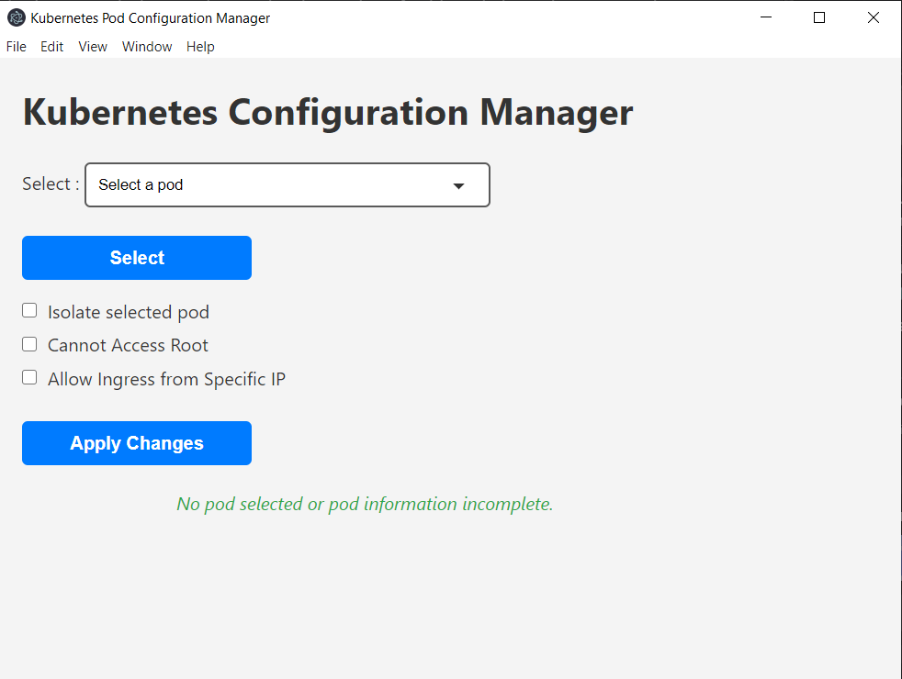

Fig 1. Configuration Page

**B.Experiment**

In this experiment, we demonstrate the creation and use of an application designed to configure security policies for Kubernetes pods. This application focuses on two key aspects:

* Isolation of Specific Pods: Ensuring that designated pods are completely isolated from other pods within the Kubernetes cluster, preventing any unauthorized communication.
* Ingress Traffic Control: Defining and enforcing policies that allow only specified pods to communicate with the designated isolated pods.

**Isolation of Specific Pods**

**Table 1** present a summarizes results of communication tests between Service A, Service B, and Service C before and after applying an isolation policy to Service A. It demonstrates the impact of the isolation policy on inter-service communication within the Kubernetes cluster.

**TABLE 1. Result of isolation**

| **Communication Test** | **From** | **To** | **Result Before Isolation** | **Result After Isolation** |
| --- | --- | --- | --- | --- |
| **External Communication** | Service A | google.com | Success | Failed |
| **Internal Communication** | Service A | Service B | Success | Failed |
| **Internal Communication** | Service A | Service C | Success | Failed |
| **Ingress Communication** | Service B | Service A | Success | Failed |
| **Ingress Communication** | Service C | Service A | Success | Failed |

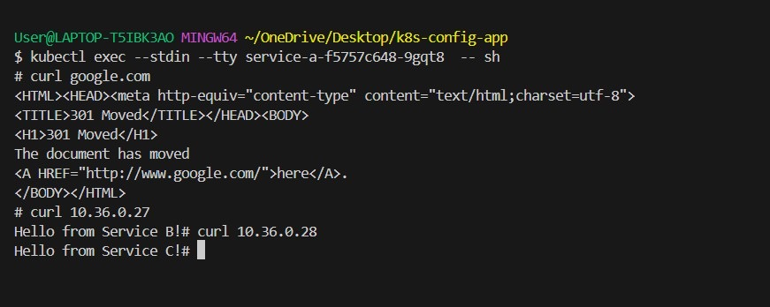

Before applying the isolation policy to Service A. It shows that Service A can freely communicate with other services in the Kubernetes cluster, as well as with external websites like Google. This means there are no network policies restricting the ingress or egress traffic for Service A at this stage.

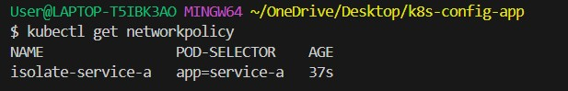

The terminal output shows the result of applying an isolation policy to Service A using the Configuration application. This confirms that Service A has been successfully isolated.

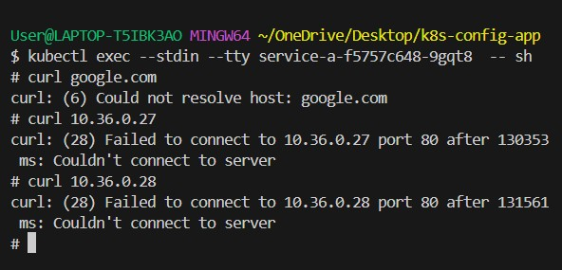

After applying an isolation policy at Service A. The isolation policy restricts Service A's ability to communicate with both external websites and other services within the Kubernetes cluster. This confirms that the isolation policy is effectively blocking all network traffic to and from Service A.

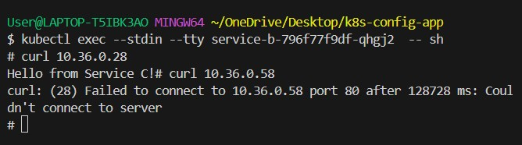

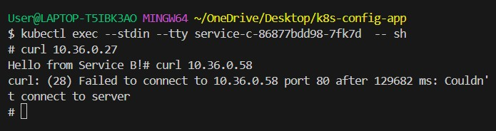

After applying specific network policies. The results show that Service B and Service C can communicate with each other but are unable to communicate with Service A due to the applied isolation policy on Service A.

**Ingress Traffic Control**

**Table 2** summarizes the ingress communication capabilities between Service A, Service B, and Service C before and after applying an ingress-specific policy to Service A. It shows how the ingress-specific policy affects the ability of Service B and Service C to interact with Service A.

**TABLE 2. Result of Ingress Traffic Control**

| **Communication Test** | **From** | **To** | **Result Before Set Ingress** | **Result After Set Ingress** |
| --- | --- | --- | --- | --- |
| **Ingress Communication** | Service B | Service A | Success | Success |
| **Ingress Communication** | Service C | Service A | Success | Failed |

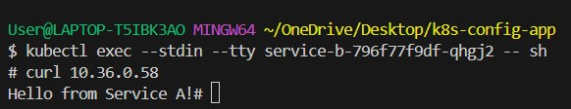

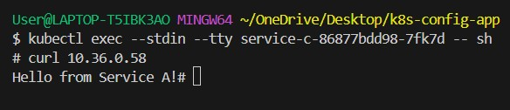

Before applying an ingress-specific policy to Service A, other services in the Kubernetes cluster, such as Service B and Service C, can freely communicate with Service A. This means that pods can send and receive network requests without any restrictions.

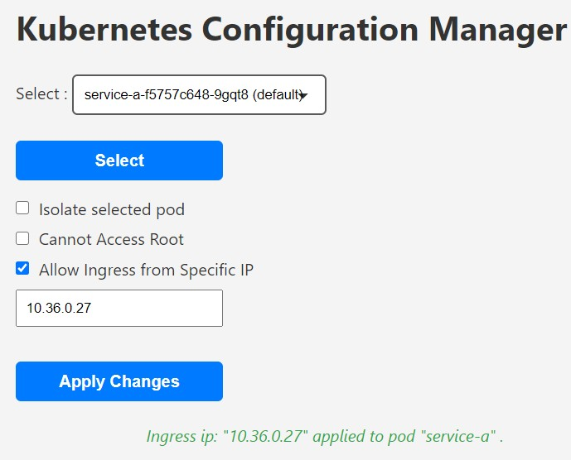

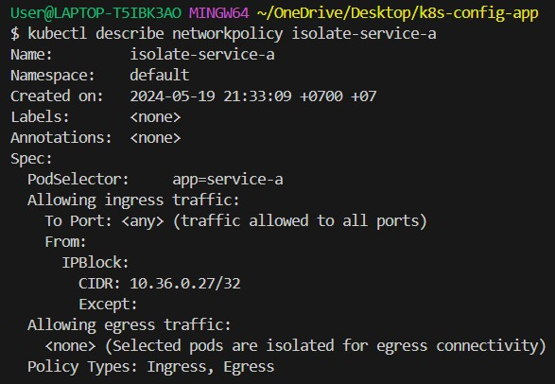

After applying the ingress-specific policy to Service A, only Service B is allowed to communicate with Service A. This ensures that Service A is protected from any unauthorized access from other services within the Kubernetes cluster. The provided terminal output demonstrates that Service B can still communicate with Service A, confirming that the ingress-specific policy is functioning correctly.

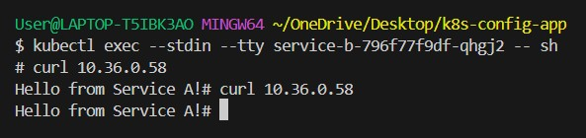

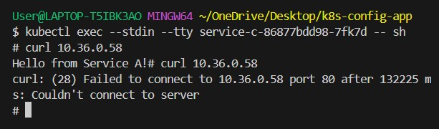

The provided terminal output demonstrates after applying an ingress-specific policy that allows only Service B to communicate with Service A. This means that Service C cannot communicate with Service A, while Service B can still successfully communicate with it.

**5.Conclusions**

This project presents a comprehensive solution for enhancing the security of Kubernetes deployments through automated pod configurations. Our system introduces granular isolation measures at the container level and ingress-specific IP controls. These features collectively establish a robust security posture, safeguarding Kubernetes clusters from internal and external threats.

Through our implementation and experiments, we've demonstrated the system's ability to effectively configure pods, manage security settings, and ensure compliance with industry standards. By integrating these security mechanisms, the project contributes to securing Kubernetes deployments, providing a secure, scalable, and reliable environment for containerized applications.

Future work will explore further enhancements, such as integrating additional security measures, refining dynamic RBAC policies, optimizing performance, encrypting the data in transit and ensuring continued protection for Kubernetes deployments.

**Reference**

[1] S. Brohi, “Implementing a Secure-First Pod Security Policy Architecture | by Shazad Brohi | Nov, 2020 | Medium | ITNEXT,” *Medium*, Dec. 16, 2021. <https://itnext.io/implementing-a-restricted-first-pod-security-policyarchitecture-af4e906593b0>

[2] “Implementing Pod Security Standards in Amazon EKS | Amazon Web Services,” *Amazon Web Services*, Oct. 27, 2022. <https://aws.amazon.com/blogs/containers/implementing-pod-security-standards-in-amazon-eks/>

[3] “Role-Based Access Control (RBAC) Authorization in Kubernetes,” *River Publishers Journals & Magazine | IEEE Xplore*, 2023. <https://ieeexplore.ieee.org/document/10255393>

[4] “Network Policies in Kubernetes: Performance Evaluation and Security Analysis,” *IEEE Conference Publication | IEEE Xplore*, Jun. 08, 2021. <https://ieeexplore.ieee.org/document/9482526>

[5] “Kubernetes Authorization With RBAC,” *part of Cloud Native Security | Wiley Data and Cybersecurity books | IEEE Xplore*. <https://ieeexplore.ieee.org/document/9932381>

[6] Schaffererin, “Developer best practices - Pod security in Azure Kubernetes Services (AKS) - Azure Kubernetes Service,” *Microsoft Learn*, Jan. 12, 2024. <https://learn.microsoft.com/en-us/azure/aks/developer-best-practices-pod-security>

[7] W. L. Dang, “Guide to Kubernetes Security Context & Pod Security Policy (PSP),” Mar. 31, 2021. <https://www.redhat.com/en/blog/guide-to-kubernetes-security-context-pod-security-policy-psp>

[8] M. Levan, “4 Methods Of Kubernetes Isolation,” *Packet Pushers Interactive LLC*, Jan. 26, 2024. <https://packetpushers.net/blog/4-methods-of-kubernetes-isolation/>

[9] “Introducing security groups for pods | Amazon Web Services,” *Amazon Web Services*, Jan. 28, 2021. <https://aws.amazon.com/blogs/containers/introducing-security-groups-for-pods/>

[10] S. Berkovich and R. Lipowitch, “Key takeaways from the Wiz 2023 Kubernetes Security Report,” *wiz.io*, Nov. 08, 2023. <https://www.wiz.io/blog/key-takeaways-from-the-wiz-2023-kubernetes-security-report>

[11] “Kubernetes Security Best Practices: 10 Steps to Securing K8s,” *Aqua*, Jan. 16, 2024. <https://www.aquasec.com/cloud-native-academy/kubernetes-in-production/kubernetes-security-best-practices-10-steps-to-securing-k8s/>

[12]“‘Under-reported’ Security Defects in Kubernetes Manifests,” *IEEE Conference Publication | IEEE Xplore*, Jun. 01, 2021. <https://ieeexplore.ieee.org/document/9476056>

[13] B. Hirschberg, “Kubernetes Security Best Practices for Security Professionals,” *ARMO*, Apr. 07, 2024. <https://www.armosec.io/blog/kubernetes-security-best-practices/>

[14] K. Jackson, “Kubernetes Security Monitoring in 2024: Tools, Techniques, &amp; Trends,” *OpenStack Backup and Recovery | Kubernetes Backup and Recovery*, Apr. 24, 2024. <https://trilio.io/resources/kubernetes-security-monitoring/>

[15] M. Aslaner, “Defending Cloud-Based Workloads: A Guide to Kubernetes Security,” *SentinelOne*, Apr. 03, 2024. <https://www.sentinelone.com/blog/defending-modern-cloud-based-workloads-a-guide-to-kubernetes-security/>