**PROJECT: college Admission system**

|  |  |  |
| --- | --- | --- |
| Project College AdmissionSystem 2019 | | |
| Project Completed by: Group Members | | |
| Student Number | Surname | Name |
| 216005496 | Matsolo | Yolanda |
| 216008775 | Oliphant | Itumeleng |
| 215089774 | Tholwana | Leponesa |
| 215090829 | Gingoes | Ofentse |
| 216008684 | Thaele | Neo |
| 214114775 | Ntsapi | Paballo |

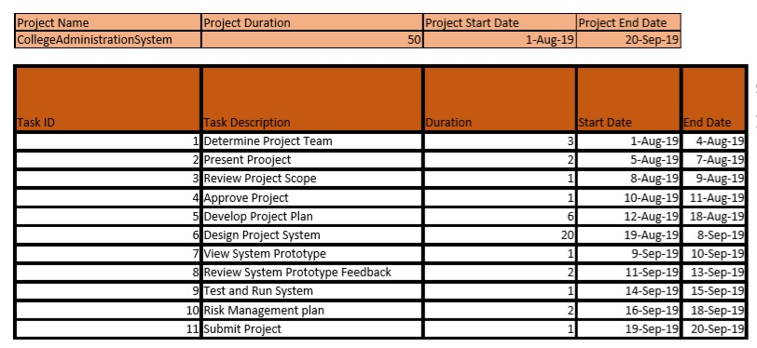

Work Break-Down Structure

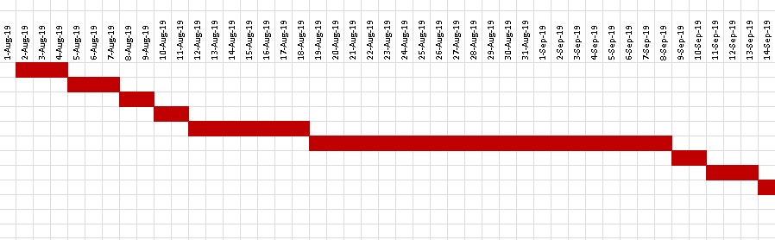Gantt chart

Requirements Workflow: Use Case Diagram

Admin

Student

Anonymous User

(

s

)



Registration

View Available

books

Buy/Sell books

View Courses

Reset

Password

Update personal Info

Add Course

Login

Set Roles

Generate Reports

View Data

textbooks

Approve/Disapprove

Books

Apply

Calculate APS

# Anonymous Users Use Case

Anonymous User(s)



View Courses

Apply

Calculate APS

**Use Case**: View courses Applying, or Calculating APS **Brief Description**: Anonymous User applying for admission **Step By step Description**:

|  |  |
| --- | --- |
| 1. | Anonymous user may be able to view courses offered by the institution. |
| 2. | Anonymous user may be able to apply for all courses offered by the institution. |
| 3. | Anonymous user may also be able to calculate APS |

# Admin Use Case

Admin



Change Password

Update Personal

Info

Set Roles

Approve/Disapprove

Book

Add

Course

View Data

Generate

Reports

Login

Reset

Password

**Use Case**: Authenticate User, Login, or Course Cancellation **Brief Description**: Admin Identifying identity of User **Step By step Description**:

1. Admin should verify the identity of a user, ensures that the individual using the system is recognised.

1. Admin may be able to login to the system.

1. Admin should be able to update personal Information

1. Admin should be able to set roles of the users

1. Admin should be able to add course or subjects

1. Admin should be able to view data(Statistics)

1. Amin should be able to generate reports

1. Admin should be able to approve or disapprove books to be sold

1. Admin should be able to change password

Student



Login

Update

personal

Info

Buy/Sell 2

nd

Hand books

Reset Password

Registration

View available

books

**Use Case**: Login, Reset Password, Register, view and sell 2nd hand books and update info **Brief Description**: Student Admitted to the Institution **Step By step Description**:

1. Student should be able to login to the system

1. Student should be able to Update his/her personal Information

1. Student should be able to buy or sell second hand text books through the system

1. Student should be able to Reset his/her password

1. Student should also be able to Register to the relevant course

1. Student should be able to view available books