**Installation Guide: Jupyter Notebook and Required Libraries**

This guide provides step-by-step instructions to install Jupyter Notebook and the required libraries for your workshop on both **Windows** and **Ubuntu** systems.

**Part 1: Installing Jupyter Notebook**

**1.1 On Windows**

1. **Install Python**
   * Download the latest version of Python from the [official website](https://www.python.org/ftp/python/3.11.9/python-3.11.9-amd64.exe).

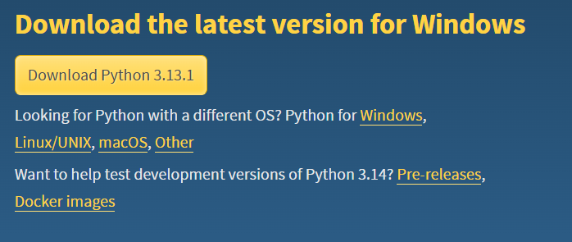

**Do not download this latest version as there is no support for TensorFlow on 3.12 or 3.13 yet**

* + During installation, check the box **"Add Python to PATH"** and click "Install Now."

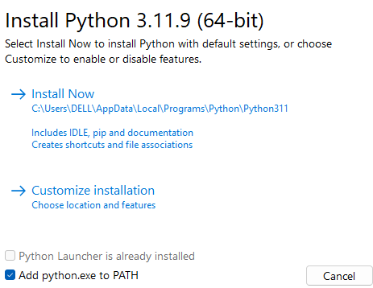

1. **Install Jupyter Notebook**
   * Open the Command Prompt **(Open the Run menu with Windows Key + R, then type "cmd." Press Ctrl + Shift + Enter to open as an Administrator)**

* + run the following commands:

**pip install notebook**

* + Verify the installation by running:

**jupyter notebook**

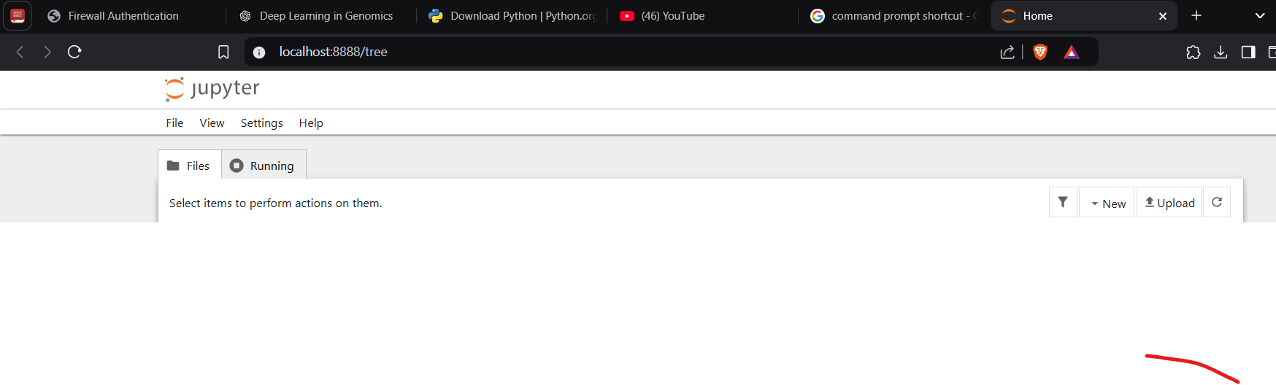

1. **Install Pip (if not already installed)**
   * If pip is not available, run:

**python -m ensurepip --upgrade**

**1.2 On Ubuntu**

1. **Update System Packages**
   * Open a terminal and run:

**sudo apt update **

**sudo apt upgrade** 

1. **Install Python and Pip**
   * Install Python 3 and pip using:

**sudo apt install python3 python3-pip -y**



1. **Install Jupyter Notebook**
   * Use apt to install Jupyter Notebook:

**sudo apt install jupyter-notebook**



Note the hyphen between “jupyter” and “Notebook”

* + Verify the installation:

**jupyter notebook**



**Part 2: Installing Required Libraries**

The libraries required for the workshop include:

* **pandas**
* **numpy**
* **matplotlib**
* **seaborn**
* **scikit-learn**
* **TensorFlow**
* **PyTorch**
* **biopython** (optional for advanced genomics tasks)

**2.1 Install Libraries on Windows**

1. Open the Command Prompt.
2. Run the following command to install all libraries:

**pip install pandas numpy matplotlib seaborn scikit-learn tensorflow torch biopython**



**2.2 Install Libraries on Ubuntu**

1. Open a terminal.
2. Run the following command to install all libraries:

**pip3 install pandas numpy matplotlib seaborn scikit-learn tensorflow torch biopython**



**Part 3: Testing the Installation**

1. Open a terminal or Command Prompt.
2. Start Jupyter Notebook by running:

**jupyter notebook**

1. Create a new Python 3 notebook and run the following code to verify the libraries:

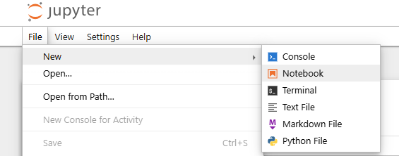

**import pandas as pd**

**import numpy as np**

**import matplotlib.pyplot as plt**

**import seaborn as sns**

**import sklearn**

**import tensorflow as tf**

**import torch**

**import Bio**

**print("All libraries are installed successfully!")**

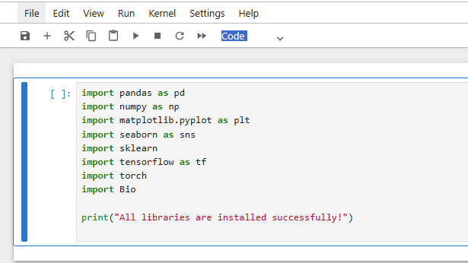

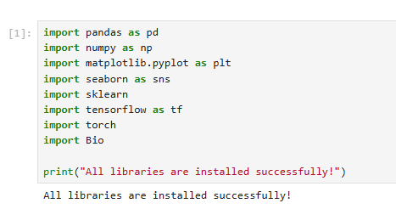

**Part 4: Troubleshooting**

**Common Issues and Fixes**

* **Command not found:**
  + Ensure Python and pip are added to the system PATH.
  + Reinstall Python and select the option to "Add Python to PATH."
* **Permission errors (Ubuntu):**
  + Use sudo with pip commands.
* **Jupyter Notebook does not open:**
  + Clear browser cache or use another browser.
  + Check if the jupyter command is in your PATH by running:
  + which jupyter

You are now ready to use Jupyter Notebook with the required libraries for the workshop!