**X Dlamini**

**22209059**

locations = [

Admin Building, # 0

Engineering Block, # 1

Science Labs, # 2

Library, # 3

ICT Department, # 4

Residence A, # 5

Residence B, # 6

Cafeteria, # 7

Sports Complex, # 8

Main Entrance, # 9

]

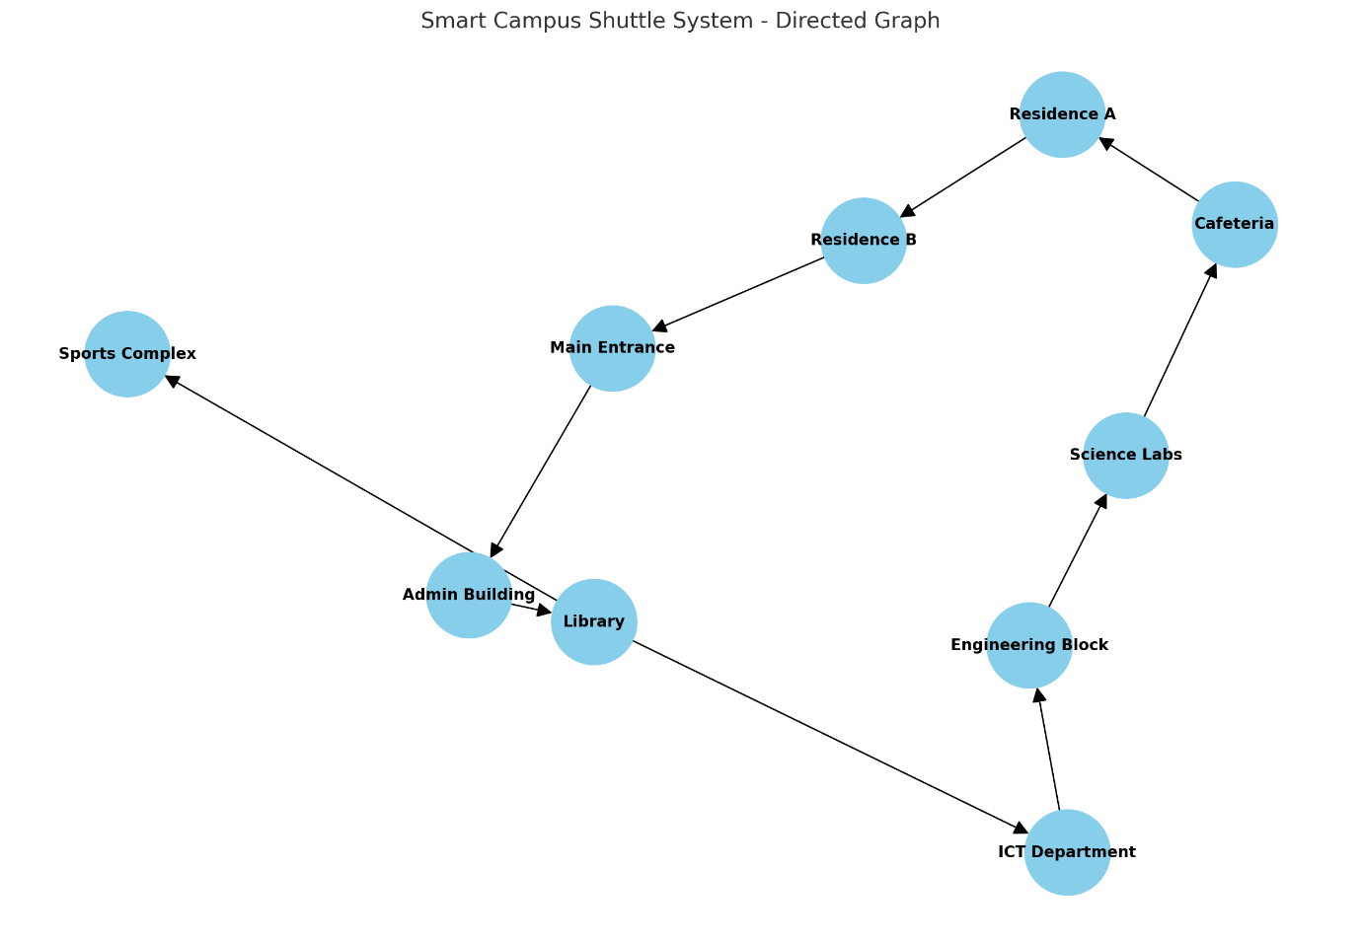

Hash map representing the directed shuttle routes

shuttle routes = {0: [1]; 1: [2,9]; 2 : [3]; 3:[4]; 4:[5]; 5: [6]; 6:[9]; 7:[5]; 8:[]; 9:[1]}

Adjacency Matrix

0 1 2 3 4 5 6 7 8 9

0 | 0 0 0 1 0 0 0 0 0 0

1 | 0 0 1 0 0 0 0 0 0 0

2 | 0 0 0 0 0 0 0 1 0 0

3 | 0 0 0 0 1 0 0 0 1 0

4 | 0 1 0 0 0 0 0 0 0 0

5 | 0 0 0 0 0 0 1 0 0 0

6 | 0 0 0 0 0 0 0 0 0 1

7 | 0 0 0 0 0 1 0 0 0 0

8 | 0 0 0 0 0 0 0 0 0 0

9 | 1 0 0 0 0 0 0 0 0 0