The Islamia University of Bahawalpur â€” Department of Computer Science
Course: Computer Vision
Instructor: Abdullah Ali Sumro
Author: Hamza Jamshaid & Hassan Munir | Student ID: Hamza Jamshaid (F23BDOCS1E02099), Hassan Munir (1206)
Date: 14 June 2026

Multi-Label Chest X-ray Disease Classification using Transfer Learning
Abstract
Chest radiography is the most common medical imaging examination worldwide, but expert interpretation is time-consuming and unevenly available. This project develops an automated system that performs multi-label classification of chest X-rays, simultaneously predicting the presence of 14 thoracic conditions. We use the publicly available NIH ChestX-ray14 sample dataset (5,606 frontal X-ray images with weakly-supervised disease labels mined from radiology reports). Because the work targets a low-resource, CPU-only environment, we adopt a transfer-learning strategy: a MobileNetV2 network pretrained on ImageNet is used as a frozen feature extractor, its 1280-dimensional features are cached, and a compact fully-connected classifier head is trained on top using a sigmoid output and class-weighted binary cross-entropy to address severe class imbalance. The data are split by patient (3897/868/841 train/validation/test) to avoid leakage. On the held-out test set the model attains a macro-averaged ROC-AUC of 0.69, with the strongest performance on Emphysema (AUC 0.82), Hernia (0.78) and Edema (0.78). Training curves reveal early overfitting, with the best validation performance reached at epoch 3. We conclude that frozen-feature transfer learning is a viable, reproducible baseline for multi-label chest X-ray classification without specialised hardware, while class imbalance and limited data remain the principal obstacles to higher accuracy.

Keywords: Chest X-ray, Multi-Label Classification, Transfer Learning, Convolutional Neural Network, Medical Imaging, MobileNetV2

1. Introduction

1.1 Background & Motivation
Chest X-ray (CXR) imaging is a cornerstone of modern diagnostic medicine because it is fast, inexpensive and low-dose. However, the global volume of radiographs far exceeds the capacity of trained radiologists, and interpretation is subjective and error-prone, particularly in under-resourced settings. Computer-aided diagnosis powered by deep learning has therefore become an active research area [1], [2]. The release of large, labelled datasets such as ChestX-ray14 [1] and CheXpert [3] has enabled convolutional neural networks (CNNs) to reach, and in some narrow tasks exceed, radiologist-level performance [2].
A key characteristic of real chest radiographs is that a single image frequently exhibits several abnormalities at once (for example, effusion together with cardiomegaly). The task is thus inherently multi-label rather than single-class, which motivates models that output an independent probability for each condition.

1.2 Problem Statement
This project builds a system that takes a single frontal chest X-ray as input and outputs the probability of each of 14 thoracic findings, allowing multiple findings to be reported simultaneously. Existing high-performing solutions typically rely on fine-tuning very deep networks end-to-end using GPU hardware and the full 112,000-image dataset [2], [3], which is impractical for students and practitioners without such resources. The problem addressed here is to obtain a credible multi-label CXR classifier under a strict CPU-only, limited-data constraint.

1.3 Objectives
To develop a multi-label classifier that predicts 14 thoracic conditions from a single chest X-ray.
To apply transfer learning with a frozen pretrained CNN backbone so that the system trains on a CPU.
To address class imbalance using class-weighted loss and threshold-independent evaluation.
To evaluate the model with ROC-AUC and F1-score, targeting a macro ROC-AUC of at least 0.65 on the ChestX-ray14 sample test set.
To deliver a reproducible pipeline and an interactive demonstration application.
- To develop a multi-label classifier that predicts 14 thoracic conditions from a single chest X-ray.
- To apply transfer learning with a frozen pretrained CNN backbone so that the system trains on a CPU.
- To address class imbalance using class-weighted loss and threshold-independent evaluation.
To evaluate the model with ROC-AUC and F1-score, targeting a macro ROC-AUC of at least 0.65 on the ChestX-ray14 sample test set.
To deliver a reproducible pipeline and an interactive demonstration application.

1.4 Scope & Limitations
The system is intended as an educational decision-support prototype, not a certified diagnostic device. It is trained only on the 5,606-image ChestX-ray14 sample, so its performance does not represent what is achievable on the full dataset. Labels are weakly supervised (text-mined from reports) and therefore noisy. The model uses only frontal images, performs classification but not localisation (no bounding boxes), and the backbone is frozen rather than fine-tuned. Clinical deployment would require far larger, curated data, prospective validation and regulatory approval.

1.5 Report Organisation
The remainder of this report is structured as follows. Section 2 reviews related work. Section 3 describes the dataset. Section 4 presents the methodology. Section 5 details the implementation. Section 6 reports experimental results. Section 7 provides a discussion. Section 8 concludes the report.

2. Literature Review

2.1 CNN-Based Chest X-ray Classification
Wang et al. [1] introduced ChestX-ray8/14 and established CNN baselines for weakly-supervised classification of common thorax diseases, framing the task as multi-label. Rajpurkar et al. [2] proposed CheXNet, a 121-layer DenseNet trained on the full dataset, reporting radiologist-level pneumonia detection and high AUCs across all 14 findings. Irvin et al. [3] extended this line with CheXpert, a larger dataset with explicit uncertainty labels, and benchmarked several CNN architectures. These works consistently report ROC-AUC as the primary metric because of severe class imbalance, but they depend on end-to-end GPU training over very large datasets.

2.2 Transfer Learning and Pretrained Backbones
Transfer learning reuses representations learned on large source datasets such as ImageNet [7], [12] for data-scarce target tasks [8], [9]. Architectures including ResNet [6] and DenseNet [4] are popular backbones, while MobileNetV2 [5] offers a lightweight inverted-residual design well suited to constrained hardware. A common and efficient variant freezes the convolutional base and trains only a new classifier head, which dramatically reduces computation — the approach adopted in this project.

2.3 Datasets and Benchmarks
Public CXR benchmarks include ChestX-ray14 [1] and CheXpert [3]; the survey by Çallı et al. [10] reviews datasets, label-noise issues and methodological pitfalls in deep learning for chest radiography. A recurring theme is that headline accuracy is misleading on imbalanced data, and that patient-level data splitting is essential to avoid over-optimistic results. Implementations in this area are dominated by deep learning frameworks such as PyTorch [11].

2.4 Research Gap
Most prior work assumes abundant GPU compute, end-to-end fine-tuning and the complete 112,000-image dataset. Comparatively little attention is paid to whether a useful multi-label classifier can be obtained under strict low-resource constraints. This project addresses that gap by quantifying the performance of a frozen-feature transfer-learning pipeline trained entirely on a CPU using only the 5,606-image sample, and by documenting a fully reproducible workflow.

3. Dataset Description

3.1 Dataset Source
The dataset is the Random Sample of the NIH Chest X-ray dataset, made available on Kaggle (https://www.kaggle.com/datasets/nih-chest-xrays/sample) and derived from the ChestX-ray14 database released by the U.S. National Institutes of Health [1]. It contains 5,606 frontal-view radiographs with multi-label disease annotations that were text-mined from the associated radiology reports.

3.2 Dataset Characteristics
Total Images | 5,606
Number of Classes | 14 thoracic findings (multi-label) + 'No Finding'
Class Names | Atelectasis, Cardiomegaly, Effusion, Infiltration, Mass, Nodule, Pneumonia, Pneumothorax, Consolidation, Edema, Emphysema, Fibrosis, Pleural_Thickening, Hernia
Image Dimensions (pixels) | 1024 x 1024 (original); resized to 224 x 224
File Format | PNG (grayscale)
Train / Validation / Test Split | 3897 / 868 / 841 (approx. 70% / 15% / 15%), split by patient ID to prevent leakage
Class Distribution | Highly imbalanced (Infiltration 967 ... Hernia 13 positives)

3.3 Sample Images
Figure 1 shows representative chest X-rays from the dataset, each annotated with its ground-truth findings. The examples illustrate the grayscale nature of the images and the fact that many radiographs carry several labels simultaneously.
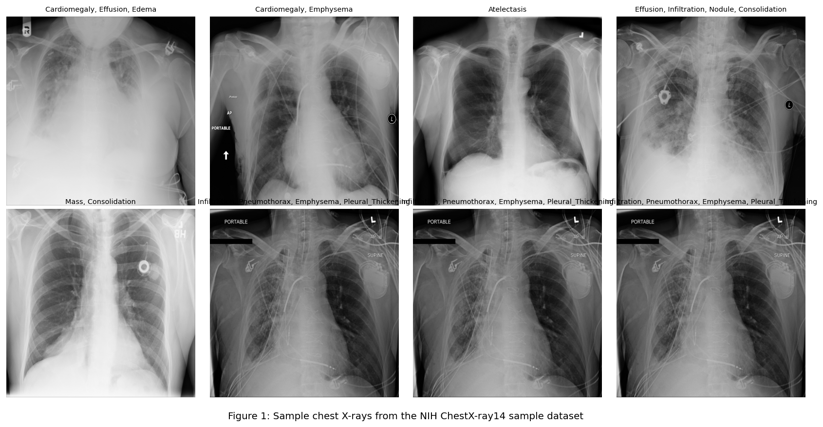

3.4 Data Challenges & Preprocessing Rationale
The dataset is severely class-imbalanced. Across the sample, Infiltration is the most frequent finding (967 positives) while Hernia is extremely rare (13 positives); the majority of label slots are negative. Labels are also noisy because they are automatically extracted from free text rather than verified by radiologists, and the images are single-channel grayscale at varying effective resolution. These characteristics directly motivated three design choices: (i) resizing and 3-channel replication so images match the pretrained backbone; (ii) class-weighted loss so rare findings are not ignored; and (iii) evaluation with ROC-AUC and F1 rather than plain accuracy.

4. Methodology

4.1 System Overview
The system follows a five-stage pipeline (Figure 2): (1) an input chest X-ray is (2) preprocessed, (3) passed through a frozen MobileNetV2 backbone to produce a 1280-dimensional feature vector that is cached to disk, (4) classified by a small trainable head, and (5) converted to 14 independent probabilities via a sigmoid activation. Decoupling feature extraction from training is what makes the workflow feasible on a CPU: the expensive convolutional pass is computed once, after which the head trains in seconds.
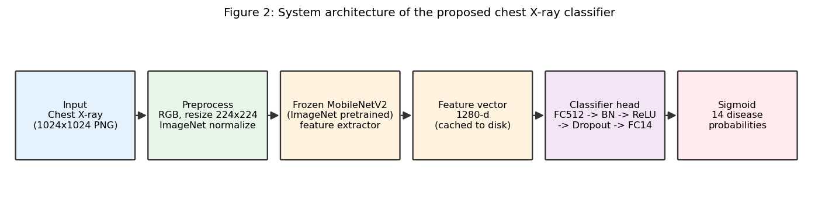

4.2 Data Preprocessing

4.2.1 Resizing & Normalisation
Each grayscale radiograph is converted to three identical channels and resized to 224 x 224 pixels to match MobileNetV2's expected input. Pixel intensities are scaled to [0, 1] and then standardised using the ImageNet channel means (0.485, 0.456, 0.406) and standard deviations (0.229, 0.224, 0.225), so the input statistics align with those the backbone was originally trained on.

4.2.2 Data Augmentation
No data augmentation was applied in the reported configuration. Because the convolutional backbone is frozen and its features are pre-computed and cached once, applying random augmentations per epoch would require re-running the backbone every epoch and would defeat the CPU-efficiency goal. Augmentation (e.g. small rotations and horizontal flips) is identified in Section 8.2 as a clear avenue for reducing the overfitting observed in training.

4.2.3 Other Preprocessing
No additional preprocessing (such as histogram equalisation or lung-field segmentation) was used, in order to keep the baseline simple and the comparison with the pretrained feature space clean.

4.3 Feature Extraction (If Applicable)
Feature extraction is performed by a deep CNN rather than hand-crafted descriptors (such as SIFT or HOG). The MobileNetV2 backbone [5], pretrained on ImageNet [7], is truncated after its final convolutional block and followed by global average pooling, yielding a 1280-dimensional embedding per image. All backbone weights are frozen. Embeddings for the train, validation and test splits are computed once and stored as NumPy arrays, so subsequent experiments reuse them instantly.

4.4 Model Architecture
The trainable component is a compact multi-layer perceptron head (Figure 3) that maps the 1280-dimensional feature vector to 14 logits: Linear(1280 -> 512) -> BatchNorm1d -> ReLU -> Dropout(p=0.3) -> Linear(512 -> 14). A sigmoid is applied at inference to obtain an independent probability per condition. Only this head (roughly 0.66 million parameters) is optimised; the backbone is fixed. This is a deliberate transfer-learning choice that keeps training tractable on a CPU.
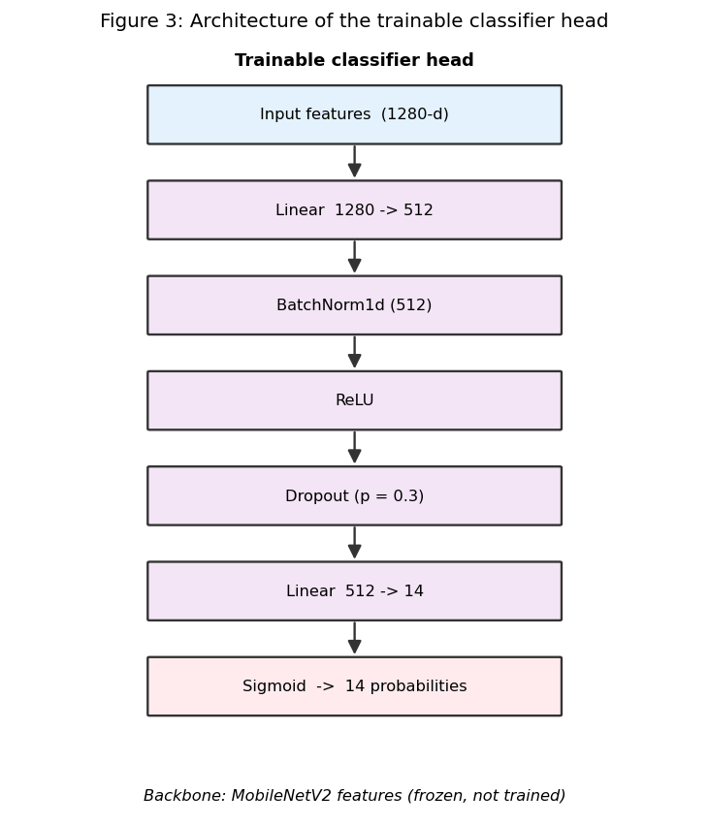

4.5 Training Procedure
Framework | PyTorch 2.7.1 (CPU build) + TorchVision 0.22.1
Optimizer | Adam (beta1=0.9, beta2=0.999)
Learning Rate | 0.001 (weight decay 1e-5)
Loss Function | Binary Cross-Entropy with logits (per-class pos_weight for imbalance)
Batch Size | 128 (head training); 32 (feature extraction)
Epochs | 30 (best checkpoint at epoch 3 by validation macro-AUC)
Early Stopping | Best-checkpoint selection on validation macro-AUC
Hardware | CPU only (no GPU)
Training Time | Head < 1 min on cached features; feature extraction ~5 min (one-time)

5. Implementation Details

5.1 Software Environment
Programming Language | Python 3.12
Deep Learning Framework | PyTorch 2.7.1 + TorchVision 0.22.1
Key Libraries | scikit-learn, NumPy, pandas, Pillow, Matplotlib, Streamlit, kagglehub
IDE / Notebook | Visual Studio Code

5.2 Hardware Used
All experiments were run locally on a CPU-only Windows 11 machine (no GPU / CUDA). Feature extraction over all 5,606 images completed in approximately five minutes, and training the classifier head on the cached features completed in under one minute, confirming the practicality of the frozen-feature approach on commodity hardware.
[State CPU/GPU specs, RAM, whether cloud or local machine]

5.3 Project Folder Structure
chest-xray-multilabel-classifier/
config.py - central settings (labels, backbone, hyper-parameters)
model.py - frozen backbone + trainable classifier head
dataset.py - image preprocessing and multi-label parsing
download_data.py - downloads the dataset via the Kaggle API
prepare_data.py - builds the patient-level train/val/test split
extract_features.py - caches frozen-backbone feature vectors
train.py - trains the head, evaluates, saves metrics/model
make_figures.py - generates all report figures
app.py - Streamlit demonstration app
requirements.txt - dependencies
README.md - setup and run instructions
artifacts/ - cached features, trained model, metrics
results/ - generated figures

5.4 Reproducibility Note
Random seed: 42. All experiments can be reproduced by running download_data.py, prepare_data.py, extract_features.py and train.py in order (see README.md).

6. Experimental Results

6.1 Evaluation Metrics
Because the task is multi-label and highly imbalanced, plain accuracy is misleading: a trivial model that predicts 'no finding' for every image already achieves very high per-label accuracy. We therefore report the Receiver Operating Characteristic Area Under the Curve (ROC-AUC), which is threshold-independent and measures ranking quality per class, as the primary metric, alongside Precision, Recall and F1-score at a 0.5 threshold. AUC and F1 are averaged across the 14 classes (macro-averaging) so that rare findings count as much as common ones.

6.2 Quantitative Results
Table 3 summarises overall test-set performance against a naive all-negative baseline. The model reaches a macro ROC-AUC of 0.692 (best validation 0.715). The accuracy column illustrates the 'accuracy paradox': the all-negative baseline scores ~95% per-label accuracy yet is clinically useless (zero recall), whereas our model deliberately trades some accuracy for substantially higher recall and a non-zero F1. Per-class results are shown in Table 4 and Figure 7.
Metric | Your Model | Baseline / Comparison | Improvement
Accuracy (%) | 76.4 (per-label) | 95.0 (all-negative) | -18.6
Precision (%) | 9.2 | 0.0 | +9.2
Recall (%) | 44.2 | 0.0 | +44.2
F1-Score (%) | 14.9 | 0.0 | +14.9
Table 4: Per-class performance on the test set (sorted by ROC-AUC).
Class | ROC-AUC | Precision | Recall | F1-score
Emphysema | 0.820 | 0.094 | 0.655 | 0.165
Hernia | 0.781 | 0.000 | 0.000 | 0.000
Edema | 0.780 | 0.110 | 0.360 | 0.168
Effusion | 0.769 | 0.202 | 0.781 | 0.321
Pneumothorax | 0.758 | 0.141 | 0.545 | 0.224
Consolidation | 0.741 | 0.109 | 0.583 | 0.183
Pleural_Thickening | 0.707 | 0.039 | 0.455 | 0.072
Atelectasis | 0.705 | 0.144 | 0.603 | 0.232
Pneumonia | 0.682 | 0.033 | 0.091 | 0.049
Cardiomegaly | 0.657 | 0.042 | 0.450 | 0.077
Infiltration | 0.630 | 0.227 | 0.667 | 0.339
Mass | 0.621 | 0.069 | 0.324 | 0.114
Nodule | 0.583 | 0.059 | 0.447 | 0.105
Fibrosis | 0.462 | 0.018 | 0.231 | 0.034
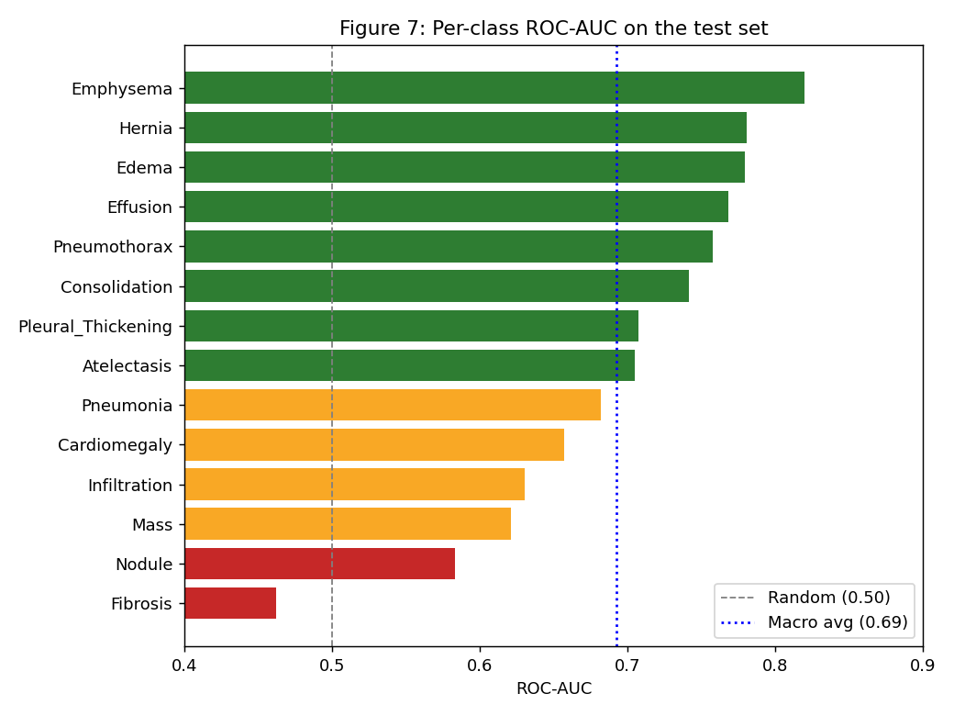

6.3 Training Curves
Figures 4 and 5 plot loss and validation macro-AUC against epoch. Training loss decreases steadily, but validation loss begins rising after only a few epochs while validation AUC peaks at epoch 3 and then declines — a clear signature of overfitting. Best-checkpoint selection on validation AUC mitigates this by saving the model from epoch 3 for final testing.
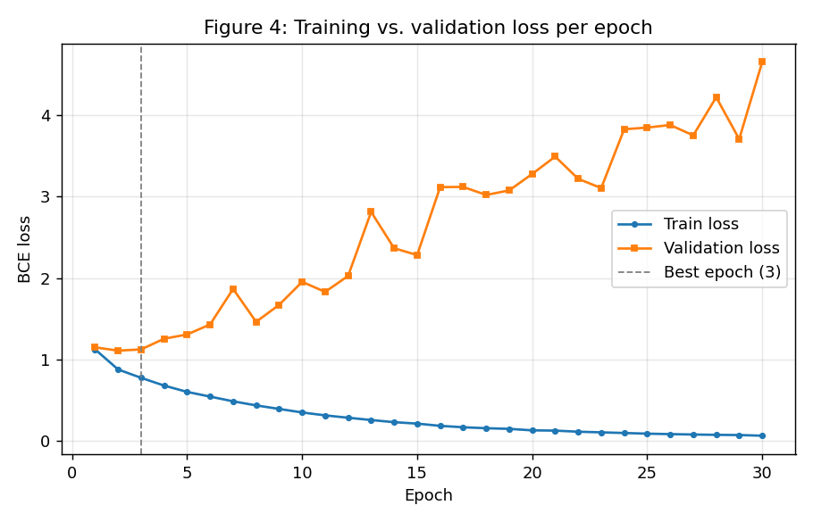
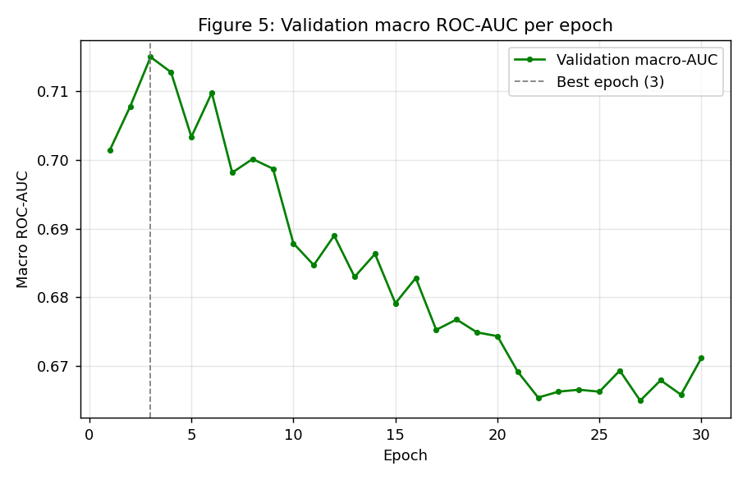

6.4 Confusion Matrix
Figure 6 shows row-normalised confusion matrices for four representative classes. Because the class-weighted loss emphasises the rare positive class, the model tends to achieve high recall (most true positives are caught) at the cost of many false positives, i.e. lower precision — visible as substantial mass in the predicted-positive column.
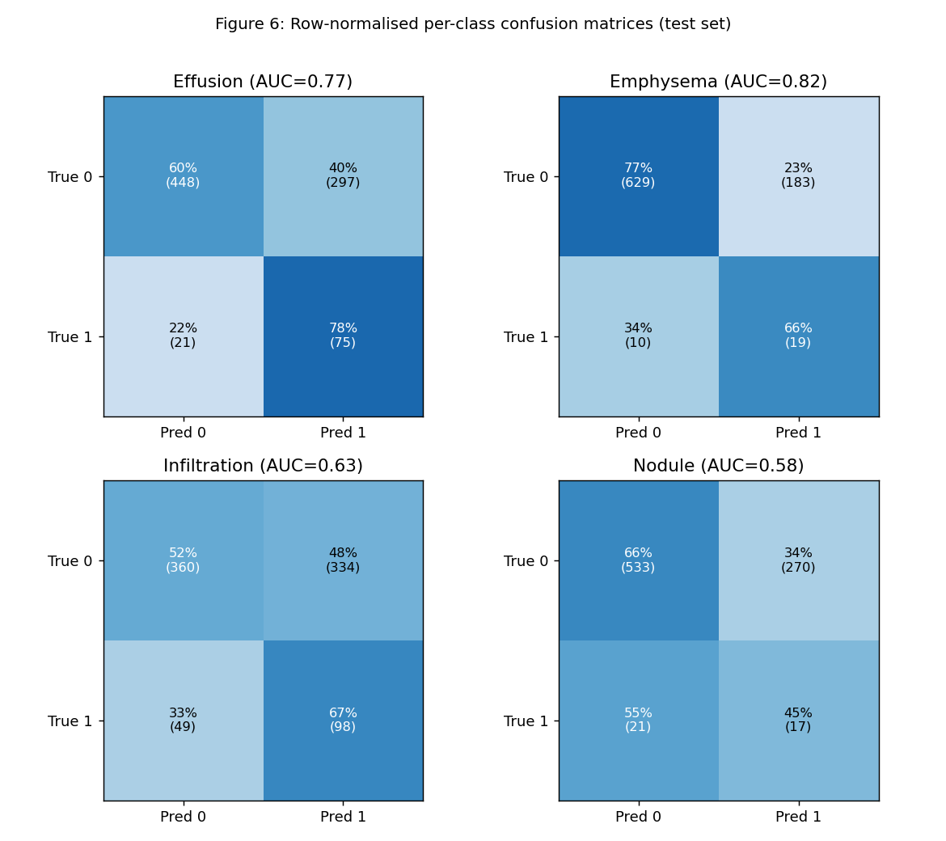

6.5 Visual Results
Figure 8 presents example predictions: the top row shows confident, correct detections while the bottom row shows characteristic errors. Each panel lists the model's top predicted findings with confidence scores alongside the ground-truth labels.
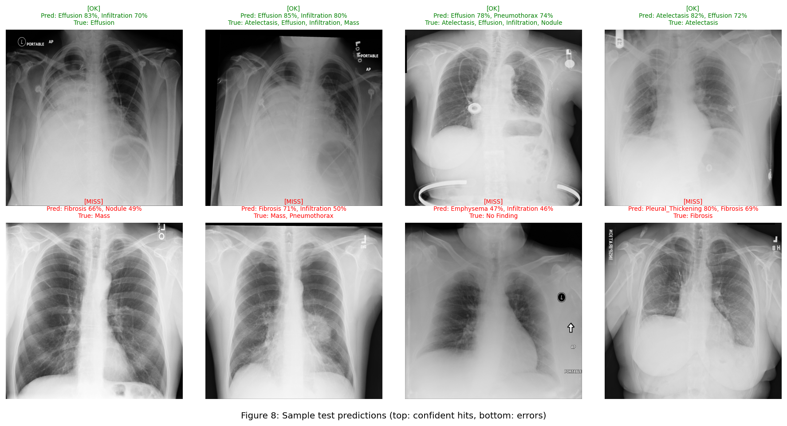

6.6 Error Analysis
Three patterns dominate the errors. First, performance tracks class frequency and signal strength: findings with a distinctive global appearance such as Emphysema (AUC 0.82) and Effusion (AUC 0.77) are detected well, whereas small, localised findings such as Nodule (AUC 0.58) and the rare, heterogeneous Fibrosis (AUC 0.46) are near or below chance. Second, precision is low across the board because the class-weighted loss biases the model toward predicting positives, producing many false alarms. Third, extremely rare classes such as Hernia (13 positives total) have too few examples for stable learning. A frozen ImageNet backbone, which never saw radiographs during pretraining, also limits the discriminability of subtle radiological texture.

7. Discussion

7.1 Were Objectives Achieved?
The core objectives were met. A working multi-label classifier for all 14 findings was built and trained entirely on a CPU using frozen-feature transfer learning, and class imbalance was handled via class-weighted loss and AUC/F1 evaluation. The quantitative target — a macro ROC-AUC of at least 0.65 — was achieved (0.69). A reproducible pipeline and an interactive Streamlit demo were also delivered. The objective of high precision was only partially met, as discussed below.

7.2 Strengths of the Proposed Approach
The principal strength is efficiency: by caching features from a frozen backbone, the entire system trains in minutes on a CPU, making it highly reproducible and accessible. The design also follows sound methodology — patient-level splitting prevents leakage, class weighting counters imbalance, and threshold-independent metrics give an honest picture of performance.

7.3 Weaknesses & Limitations
The main weaknesses are overfitting (validation performance degrades after epoch 3) and low precision at the default threshold, leading to a modest macro-F1 of 14.9%. Using only the 5,606-image sample with a frozen, non-medical backbone caps achievable accuracy, and the noisy weak labels add further ceiling effects.

7.4 Comparison with Related Work
On the full 112,000-image dataset, end-to-end models such as CheXNet [2] report per-class AUCs around 0.80-0.85, and CheXpert benchmarks [3] are similar. Our macro AUC of 0.69 is lower, which is expected given that we use roughly 5% of the data, a frozen lightweight backbone, and CPU-only training. The gap quantifies the cost of the low-resource constraint rather than a flaw in the method, and several classes (e.g. Emphysema, Effusion) already approach the literature range.

8. Conclusion & Future Work

8.1 Conclusion
This project demonstrated that multi-label chest X-ray classification is achievable without specialised hardware by combining a frozen ImageNet-pretrained MobileNetV2 feature extractor with a lightweight trainable head. Trained on the 5,606-image ChestX-ray14 sample, the system reached a macro ROC-AUC of 0.69, performing best on findings with strong global signatures. The experiments also clearly exposed the two central challenges of this domain — class imbalance and overfitting on limited data — and showed why ranking metrics are essential for honest evaluation. The result is a reproducible, accessible baseline and a working demonstration application.

8.2 Future Work
Apply on-the-fly data augmentation (small rotations, horizontal flips, random crops) and stronger regularisation to curb the overfitting observed after the first few epochs.
Fine-tune the upper backbone blocks (or adopt a chest-X-ray-pretrained backbone) instead of fully freezing them, to better capture subtle radiological texture.
Tune per-class decision thresholds and train on the full 112,000-image dataset to raise precision and overall AUC toward the published CheXNet/CheXpert range.
- Apply on-the-fly data augmentation (small rotations, horizontal flips, random crops) and stronger regularisation to curb the overfitting observed after the first few epochs.
- Fine-tune the upper backbone blocks (or adopt a chest-X-ray-pretrained backbone) instead of fully freezing them, to better capture subtle radiological texture.
- Tune per-class decision thresholds and train on the full 112,000-image dataset to raise precision and overall AUC toward the published CheXNet/CheXpert range.

References
[1] X. Wang, Y. Peng, L. Lu, Z. Lu, M. Bagheri, and R. M. Summers, "ChestX-ray8: Hospital-scale chest X-ray database and benchmarks on weakly-supervised classification and localization of common thorax diseases," in Proc. IEEE CVPR, 2017, pp. 2097-2106.
[2] P. Rajpurkar et al., "CheXNet: Radiologist-level pneumonia detection on chest X-rays with deep learning," arXiv:1711.05225, 2017.
[3] J. Irvin et al., "CheXpert: A large chest radiograph dataset with uncertainty labels and expert comparison," in Proc. AAAI, 2019, pp. 590-597.
[4] G. Huang, Z. Liu, L. van der Maaten, and K. Q. Weinberger, "Densely connected convolutional networks," in Proc. IEEE CVPR, 2017, pp. 4700-4708.
[5] M. Sandler, A. Howard, M. Zhu, A. Zhmoginov, and L.-C. Chen, "MobileNetV2: Inverted residuals and linear bottlenecks," in Proc. IEEE CVPR, 2018, pp. 4510-4520.
[6] K. He, X. Zhang, S. Ren, and J. Sun, "Deep residual learning for image recognition," in Proc. IEEE CVPR, 2016, pp. 770-778.
[7] O. Russakovsky et al., "ImageNet large scale visual recognition challenge," Int. J. Comput. Vis., vol. 115, no. 3, pp. 211-252, 2015.
[8] S. J. Pan and Q. Yang, "A survey on transfer learning," IEEE Trans. Knowl. Data Eng., vol. 22, no. 10, pp. 1345-1359, 2010.
[9] C. Tan, F. Sun, T. Kong, W. Zhang, C. Yang, and C. Liu, "A survey on deep transfer learning," in Proc. ICANN, 2018, pp. 270-279.
[10] E. Calli, E. Sogancioglu, B. van Ginneken, K. G. van Leeuwen, and K. Murphy, "Deep learning for chest X-ray analysis: A survey," Med. Image Anal., vol. 72, 102125, 2021.
[11] A. Paszke et al., "PyTorch: An imperative style, high-performance deep learning library," in Proc. NeurIPS, 2019, pp. 8024-8035.
[12] J. Deng, W. Dong, R. Socher, L.-J. Li, K. Li, and L. Fei-Fei, "ImageNet: A large-scale hierarchical image database," in Proc. IEEE CVPR, 2009, pp. 248-255.

