**Date: 01/07/2025**

**Intro. to JS**

**JavaScript (JS) is a programming language that brings interactivity and dynamic behaviour to websites**

* **Keywords in JS:**

1. **Variables**

**It’s a temporal data storer in a computer’s memory**

* + - * + ***Example of variables:***

**Var (outdated)**

**Let (currently used)**

* + - * + **Rules of variables**

**Cannot be a reserved keyword (for example: true, else, typeof)**

**It should be meaningful (i.e. no abbreviation & letters)**

**Cannot start with a number (for example: 1name)**

**Cannot contain space or hyphens**

**They are case-sensitive (i.e. firstName and FirstName are not the same)**

1. **Constance**

**These are datatypes that cannot be redefined**

**TYPES OF DATA TYPES**

* **Primitive Data type (value type)**
* **Reference type**

**Primitive are of 5**

1. **Strings**
2. **Number**
3. **Boolean**
4. **Null**
5. **Undefined**

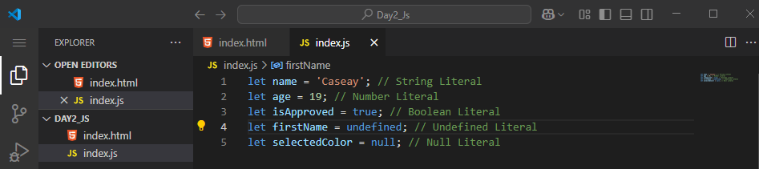

**Reference are of 3**

1. **Objects**
2. **Arrays**
3. **Function**
4. **Arrays**

**It’s a data structure that is used to represent a list of items**

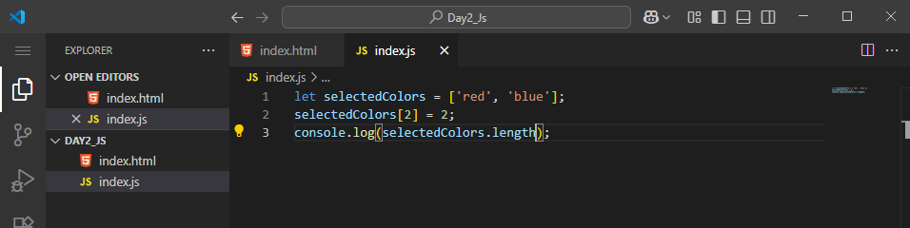

1. **Function**

**It’s a set of statement that either perform a task or carry out calculation**

