SCHOOL OF COMPUTER SCIENCE AND ARTIFICIAL INTELLIGENCE |  |  |  |  | DEPARTMENT OF COMPUTER SCIENCE ENGINEERING
ProgramName:B. Tech |  |  |  | Assignment Type: Lab |  |  | AcademicYear:2025-2026
CourseCoordinatorName |  |  |  | Venkataramana Veeramsetty
Instructor(s)Name |  |  |  | Dr. V. Venkataramana (Co-ordinator)  Dr. T. Sampath Kumar  Dr. Pramoda Patro  Dr. Brij Kishor Tiwari  Dr.J.Ravichander  Dr. Mohammand Ali Shaik  Dr. Anirodh Kumar  Mr. S.Naresh Kumar  Dr. RAJESH VELPULA  Mr. Kundhan Kumar  Ms. Ch.Rajitha  Mr. M Prakash  Mr. B.Raju  Intern 1 (Dharma teja)  Intern 2 (Sai Prasad)  Intern 3 (Sowmya)  NS_2 ( Mounika)
CourseCode |  |  | 24CS002PC215 | CourseTitle |  | AI Assisted Coding
Year/Sem |  |  | II/I | Regulation |  | R24
Date and Day  of Assignment |  |  | Week4 - Wednesday | Time(s)
Duration |  |  | 2 Hours | Applicableto  Batches
AssignmentNumber:9.3(Present assignment number)/24(Total number of assignments)
STUDENT DETAILS:-
NAME :- B.RAMCHARAN
ADM NO:-2403A510D2
DATE:-09-09-2025
 | Q.No. | Question |  |  |  |  |  | ExpectedTime  to complete
 | 1 | Lab 8: Documentation Generation: Automatic documentation and code comments  Lab Objectives:  - To understand the importance of documentation and code comments in software development.  - To explore how AI-assisted coding tools can generate meaningful documentation and inline comments.  - To practice generating function-level and module-level docstrings automatically.  - To evaluate the quality, accuracy, and limitations of AI-generated documentation.  - To develop a small automated tool for documentation generation in Python..  Lab Outcomes (LOs):  After completing this lab, students will be able to:  - Apply AI-assisted coding tools to generate docstrings and inline comments for Python code.  - Critically analyze AI-generated documentation for correctness, completeness, and readability.  - Create structured documentation (function-level, module-level) following standard formats.  - Design and implement a mini documentation generator tool to automate code commenting and docstring creation.  Task Description#1 Basic Docstring Generation  - Write python function to return sum of even and odd numbers in the given list.  - Incorporate manual docstring in code with Google Style  - Use an AI-assisted tool (e.g., Copilot, Cursor AI) to generate a docstring describing the function.  - Compare the AI-generated docstring with your manually written one.  #CODE:-  #PROMPT:- Write a Python function to return the sum of even and odd numbers in a list  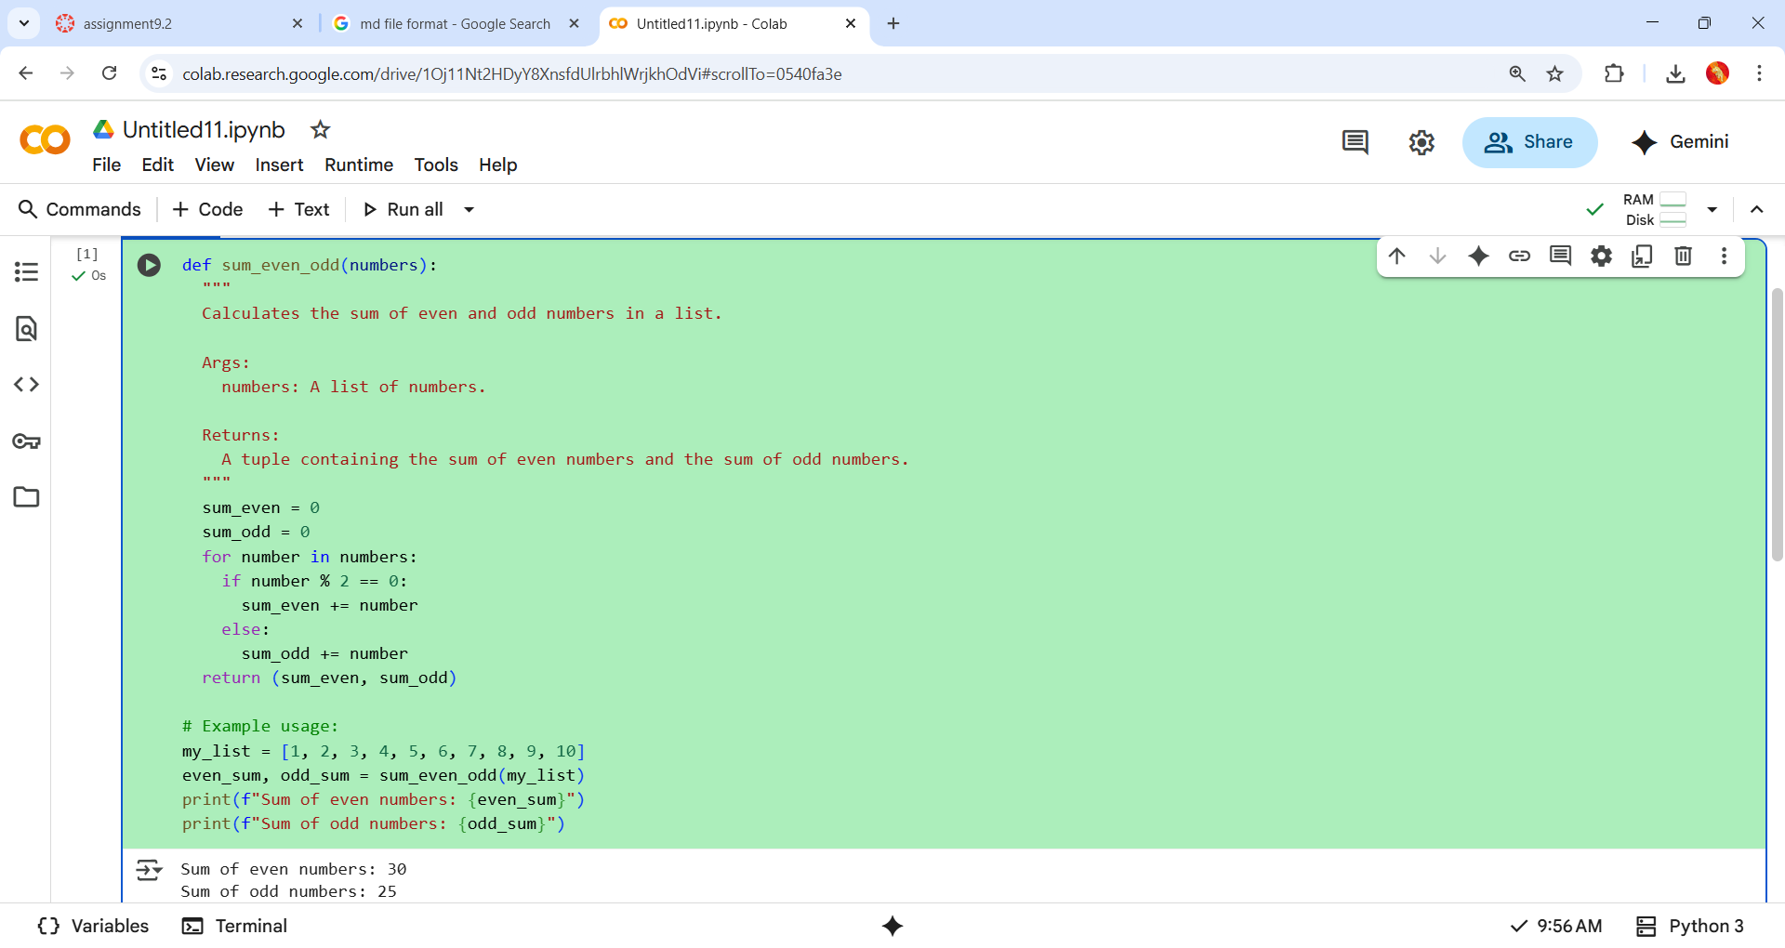  #incorporate manual docstring in code with google style:-  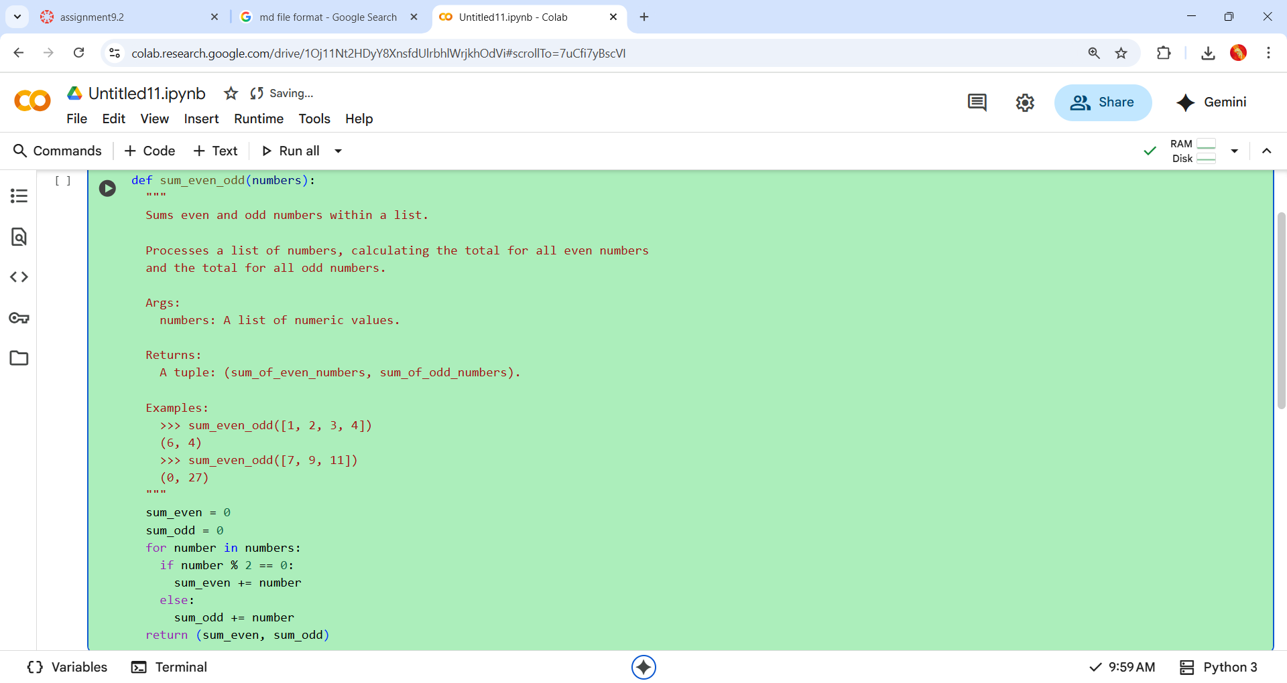  #using AI-ASSISTED CO-PILOT IN VS CODE:-  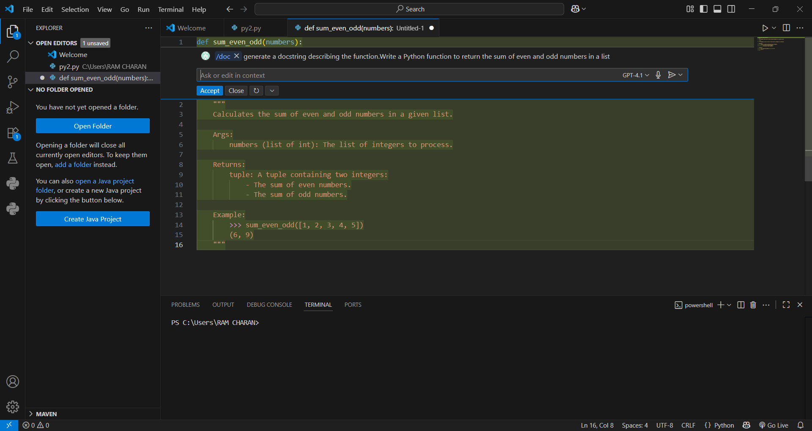  #comparison:-  - Manual docstrings:- using Google style are generally more detailed, formal, and standardized, making them suitable for projects with strict documentation requirements.  - AI-generated docstrings:- are fast, often accurate, but may lack examples or structured sections unless specifically requested, and sometimes omit edge-case details.  - Both types correctly describe the basic logic and return value of the function.  Expected Outcome#1: Students understand how AI can produce function-level documentation.  Task Description#2 Automatic Inline Comments  - Write python program for sru_student class with attributes like name, roll no., hostel_status and fee_update method and display_details method.  - Write comments manually for each line/code block  - Ask an AI tool to add inline comments explaining each line/step.  - Compare the AI-generated comments with your manually written one.  - #CODE:-  - #PROMPT:- CREATE python program for sru_stud class with attributes like name, roll no, hostel_status and fee_update method and display_details method.  - 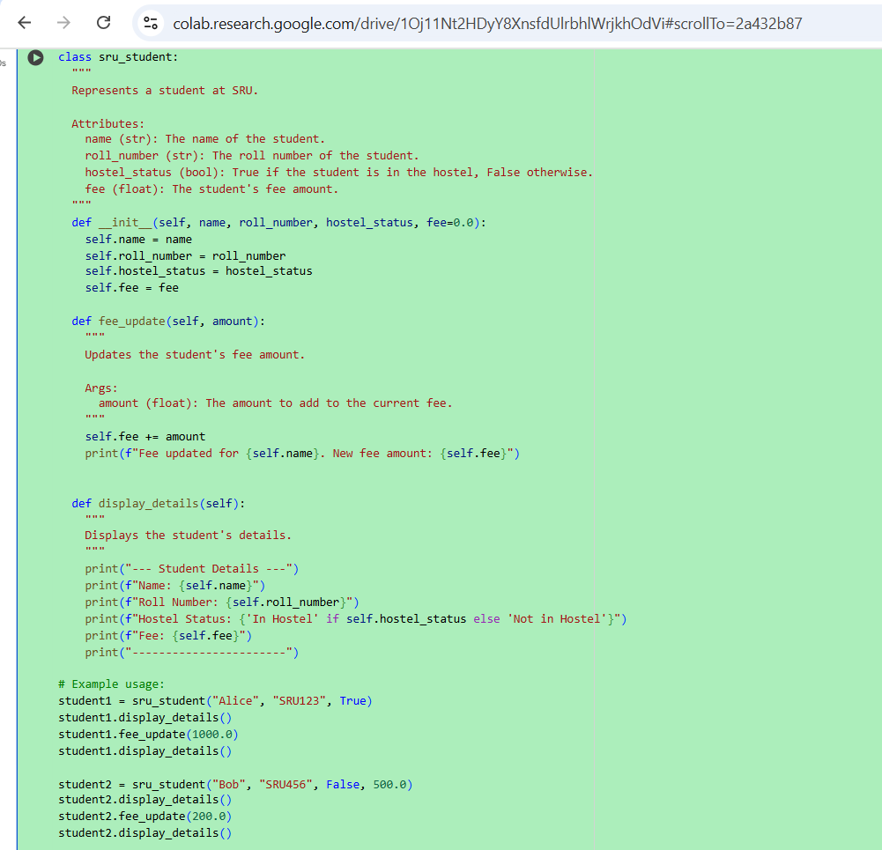  - #OUTPUT:-  - 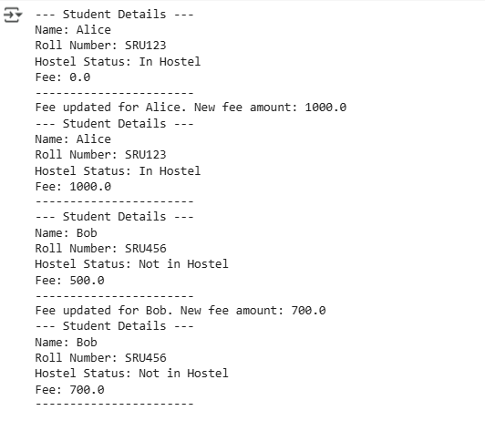  - # Write comments manually for each line/code block  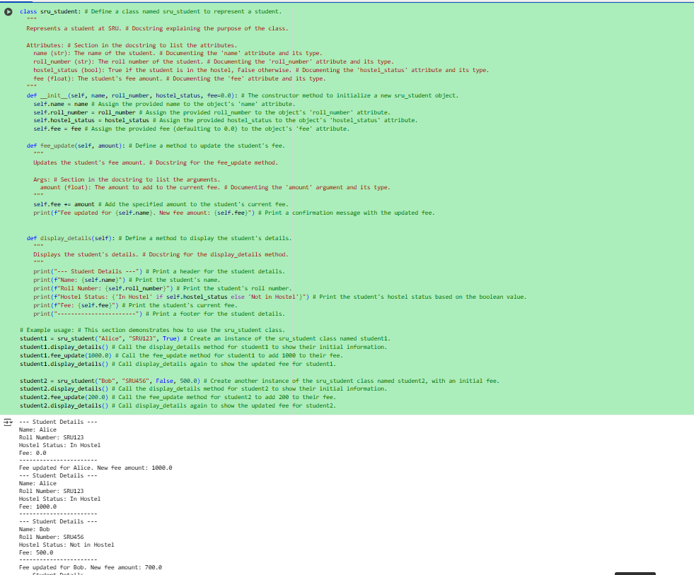  #using ai vs code co-pilot add inline comments:-  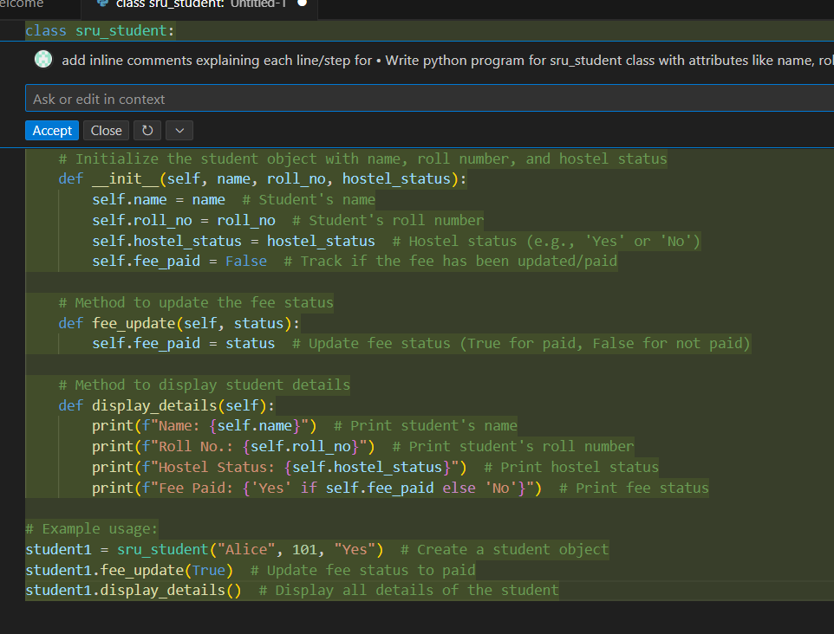  #comparison :-  - Manual comments:- often strive to clarify complex logic or why something happens, and may skip trivial assignments, aiming for clarity and conciseness for humans maintaining the code later.  - AI-generated comments:-tend toward exhaustive and literal explanations—sometimes resulting in redundancy, but ensuring comprehensive coverage and standardization across codebases.  - This illustrates how manual comments add design context and intent, while AI-generated comments prioritize coverage and surface-level clarity for each line. Combining both approaches can help ensure code is both readable and maintainable.  Expected Output#2: Students critically analyze AI-generated code comments.  Task Description#3  - Write a Python script with 3–4 functions (e.g., calculator: add, subtract, multiply, divide).  - Incorporate manual docstring in code with NumPy Style  - Use AI assistance to generate a module-level docstring + individual function docstrings.  - Compare the AI-generated docstring with your manually written one.  #CODE:-  - #PROMPT:- CREATE a Python script with 3–4 functions calculator: add, subtract, multiply, divide.  GENERATE docstring in code with NumPy Style  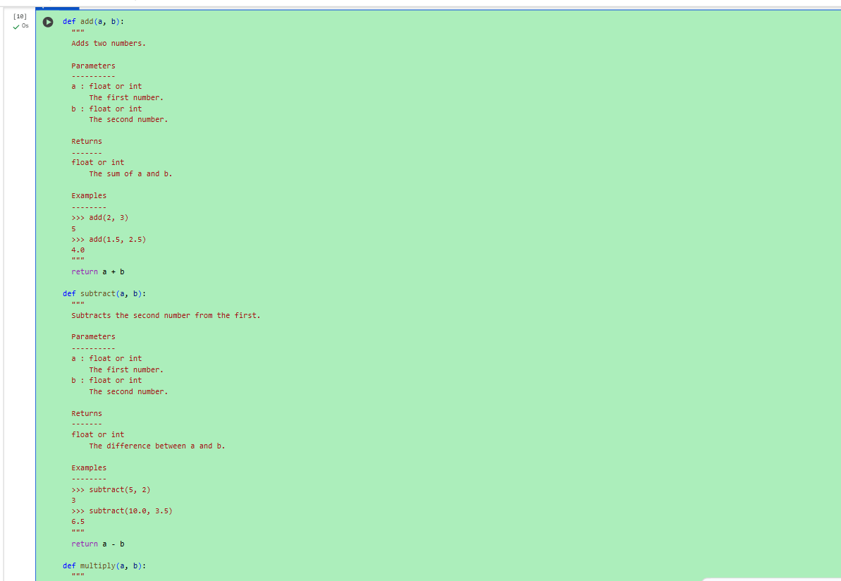  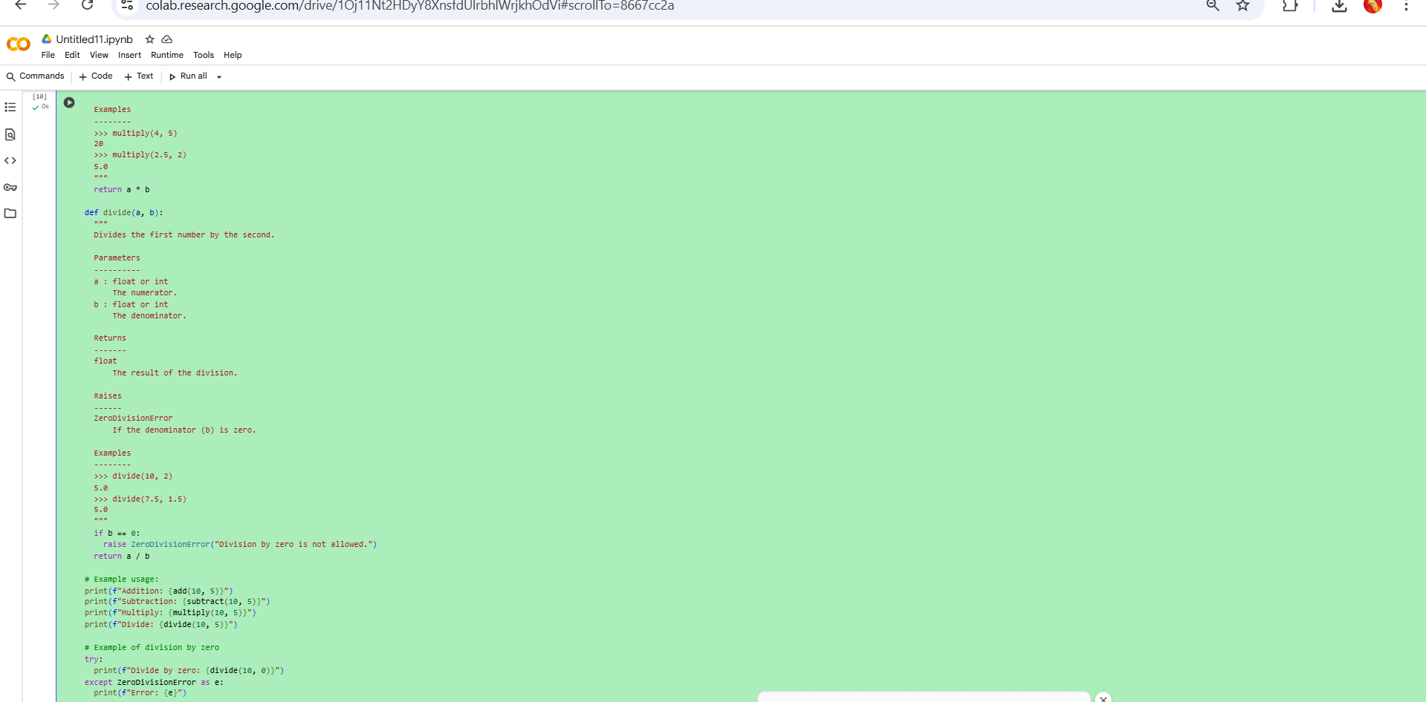  #OUTPUT:-  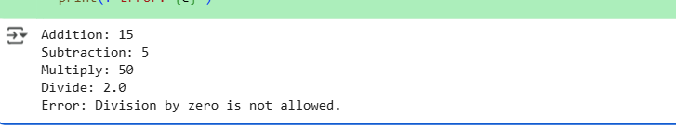  #USING AI VS CO-PILOT MODULE LEVEL DOCSTRINGS:-  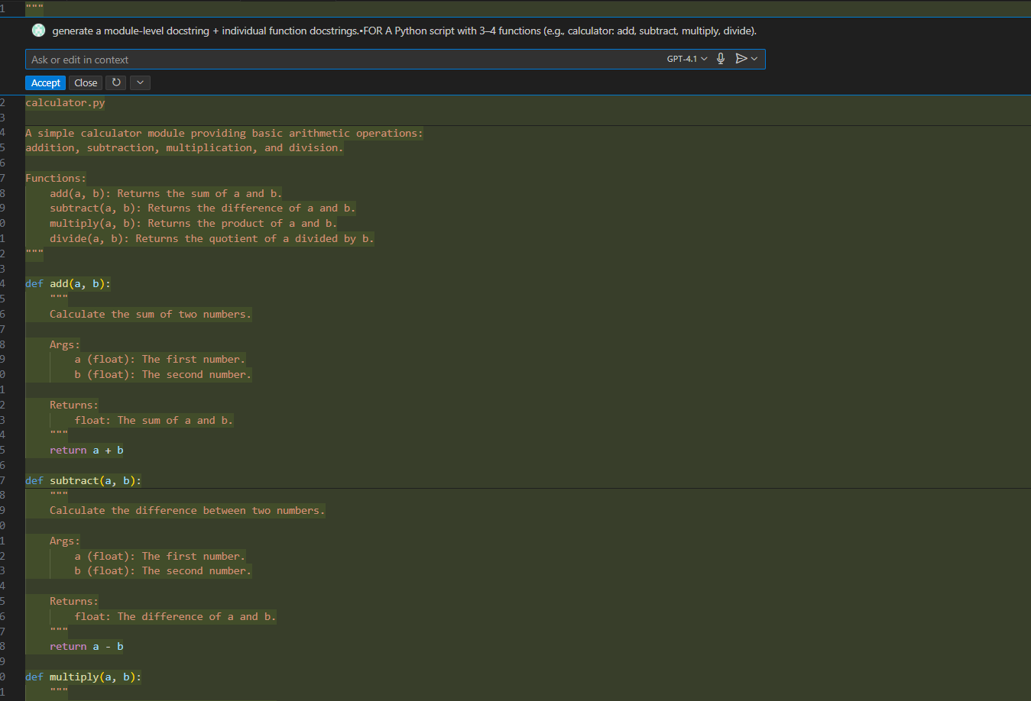  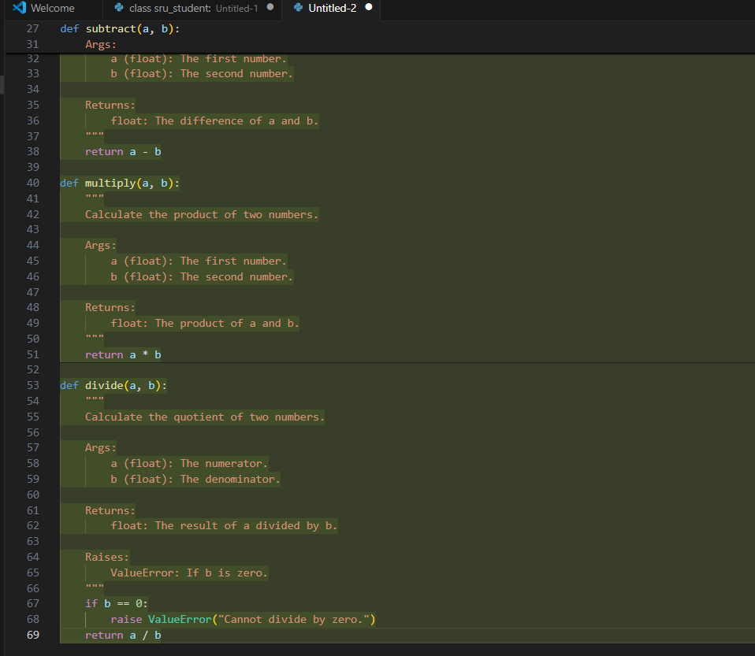  #COMPARISON:-  - Manual docstrings:- give greater detail, are standardized, include usage examples and exception handling, and are more suitable for formal documentation.  - AI-generated docstrings:- are faster, suitable for quick navigation and small functions, but often miss format, typing, and example requirements unless further edited.  Both styles correctly describe the function but suit different needs in documentation and software lifecycle.  Expected Output#3: Students learn structured documentation for multi-function scripts  Push documentation whole workspace as .md file in GitHub Repository  Note: Report should be submitted a word document for all tasks in a single document with prompts, comments & code explanation, and output and if required, screenshots.  ****TASKS COMPLETED**** |  |  |  |  |  | Week4 - Wednesday

