SCHOOL OF COMPUTER SCIENCE AND ARTIFICIAL INTELLIGENCE |  |  |  |  | DEPARTMENT OF COMPUTER SCIENCE ENGINEERING
Program Name: B. Tech |  |  |  | Assignment Type: Lab |  |  | Academic Year:2025-2026
Course Coordinator Name |  |  |  | Venkataramana Veeramsetty
Instructor(s) Name |  |  |  | Dr. V. Venkataramana (Co-ordinator)  Dr. T. Sampath Kumar  Dr. Pramoda Patro  Dr. Brij Kishor Tiwari  Dr.J.Ravichander  Dr. Mohammand Ali Shaik  Dr. Anirodh Kumar  Mr. S.Naresh Kumar  Dr. RAJESH VELPULA  Mr. Kundhan Kumar  Ms. Ch.Rajitha  Mr. M Prakash  Mr. B.Raju  Intern 1 (Dharma teja)  Intern 2 (Sai Prasad)  Intern 3 (Sowmya)  NS_2 ( Mounika)
Course Code |  |  | 24CS002PC215 | Course Title |  | AI Assisted Coding
Year/Sem |  |  | II/I | Regulation |  | R24
Date and Day  of Assignment |  |  | Week5 - Monday | NAME:- |  | RAMCHARAN BAYYA
Duration |  |  | 2 Hours | ADM NO.:- |  | 2403A510D2
AssignmentNumber: 9.1(Present assignment number)/24(Total number of assignments)
NAME:-B.RAMCHARAN
ADM NO:-2403a510D2
BATCH NO.:-04
 | Q.No. | Question |  |  |  |  |  | Expected Time  to complete
 | 1 | Lab 9 – Code Review and Quality: Using AI to improve code quality and readability  Lab Objectives  - Inline comments  - Docstrings  - Auto-documentation tools  - AI-assisted summarization  Task Description #1 (AI-Assisted Bug Detection)  Scenario: A junior developer wrote the following Python function to calculate factorials:  def factorial(n):  result = 1  for i in range(1, n):  result = result * i  return result  - Run the code and test it with factorial(5)  (expected output = 120).  #CODE:-  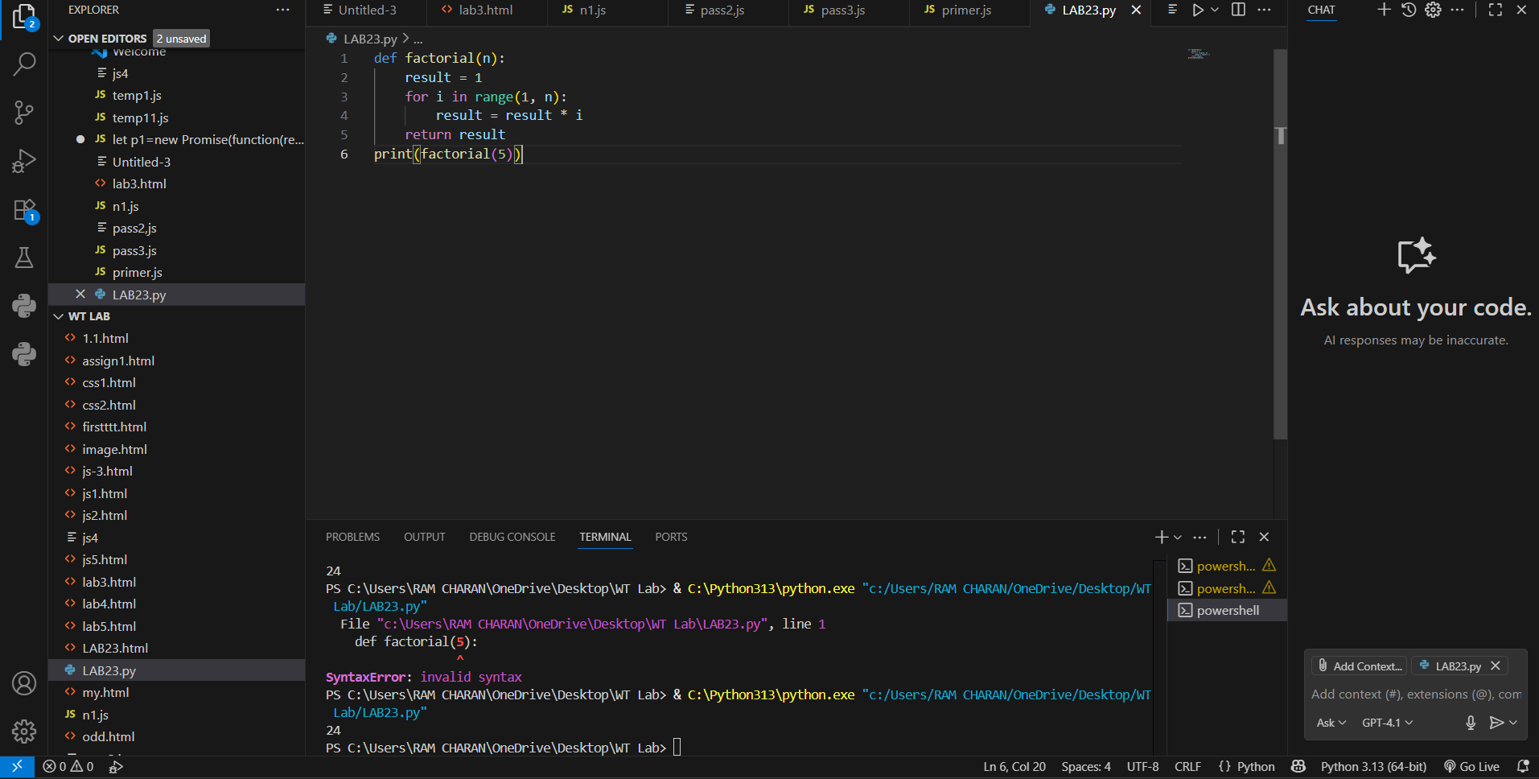  - OUTPUT:-24 ,EXPECTED OUTPUT:-120  - BUG FOUND  - Use AI (prompting) to review this code and identify the bug.  - 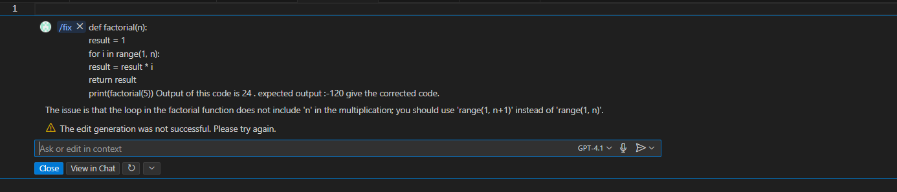  - BUG:-THE LOOP IN FACTORIAL FUNCT DOES NOT INCLUDE ‘N’ IN THE MULTIPLICATION YOU USE RANGE  - (1,N+1)’ INSTEAD OF N.  - Ask AI to suggest corrections and rewrite the code.  - AFTER REWRITING CODE:-  - 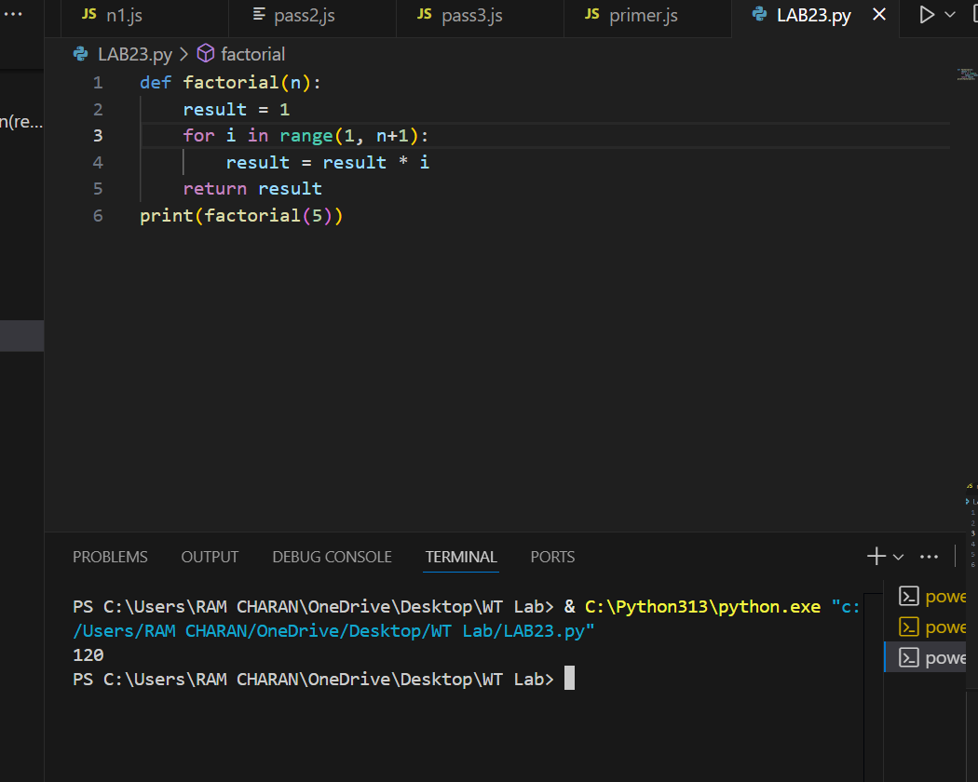  - Compare AI’s corrected code with your own fix:-  - The AI-corrected code fixes the off-by-one error in the loop, resulting in the right factorial calculation.  - This demonstrates how AI review quickly detects common boundary bugs and provides reliable corrections for mathematical algorithms.  Task Description #2 (Improving Readability & Documentation)  Scenario: The following code works but is poorly written:  def calc(a,b,c):  if c=="add":  return a+b  elif c=="sub":  return a-b  elif c=="mul":  return a*b  elif c=="div":  return a/b  - Use AI to review this code for readability, naming, and documentation issues.  - 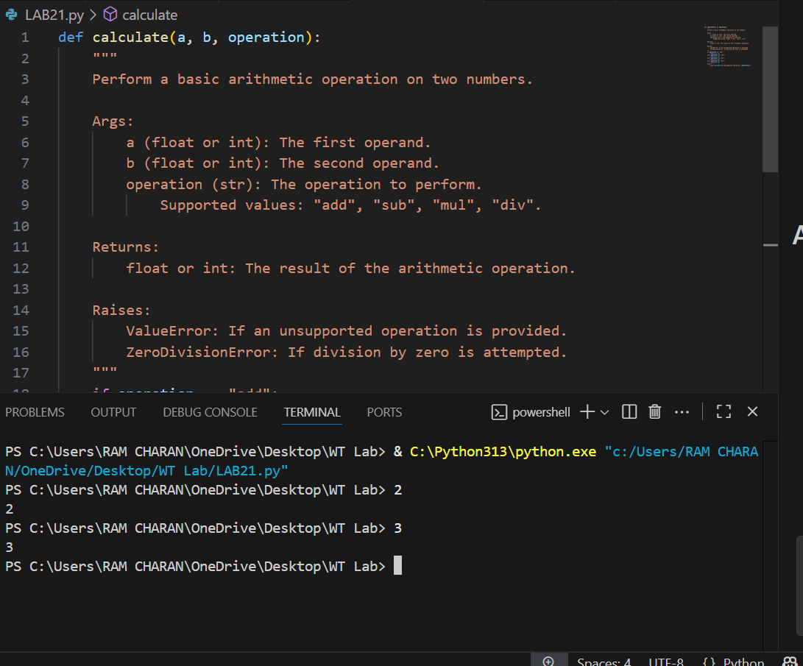  - 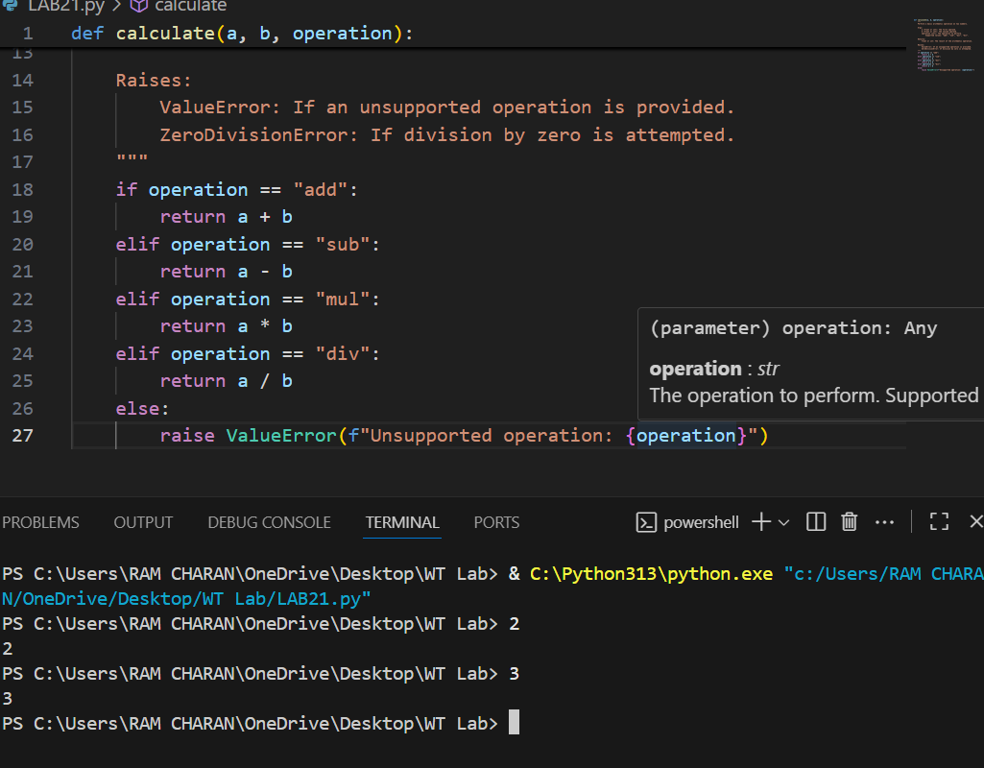  - Prompt AI to:-  - rewrite the code with:  - Clear function & variable names.  - Proper docstrings.  - Exception handling for division by zero.  - REWRITTEN CODE:-  - 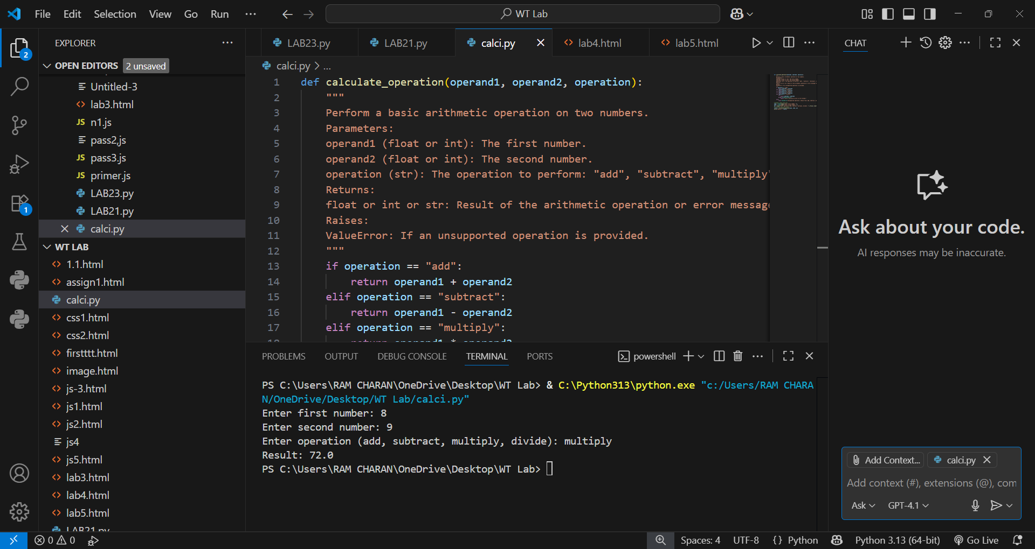  - 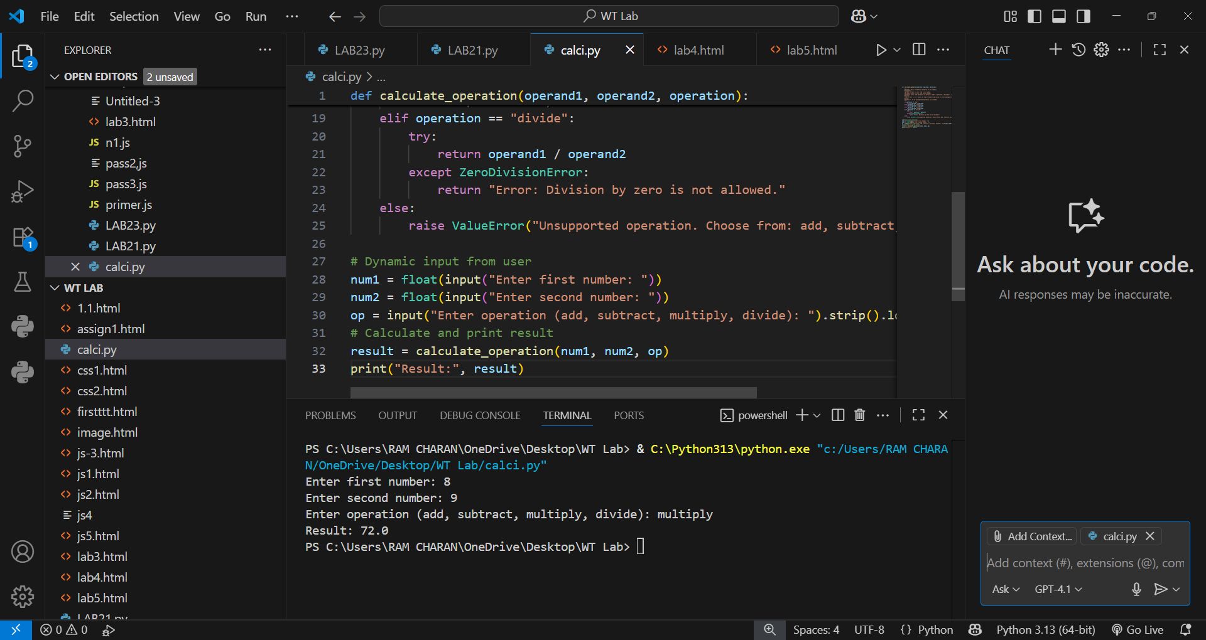  - Compare the before-and-after versions to evaluate AI’s contribution.  AI’s Contribution:-  - Readability: Improved through clear naming and structure.  - Documentation: Addition of a comprehensive docstring facilitates easier understanding and maintenance.  - Robustness: Enhanced by input validation and error handling.  - Professionalism: The code meets best practices, making it production-ready.  Task Description #3 (Enforcing Coding Standards)  Scenario: A team project requires following PEP8 style guide. One developer submits:  def Checkprime(n):  for i in range(2,n):  if n%i==0:  return False  return True  - Run this code and verify correctness.:-  - 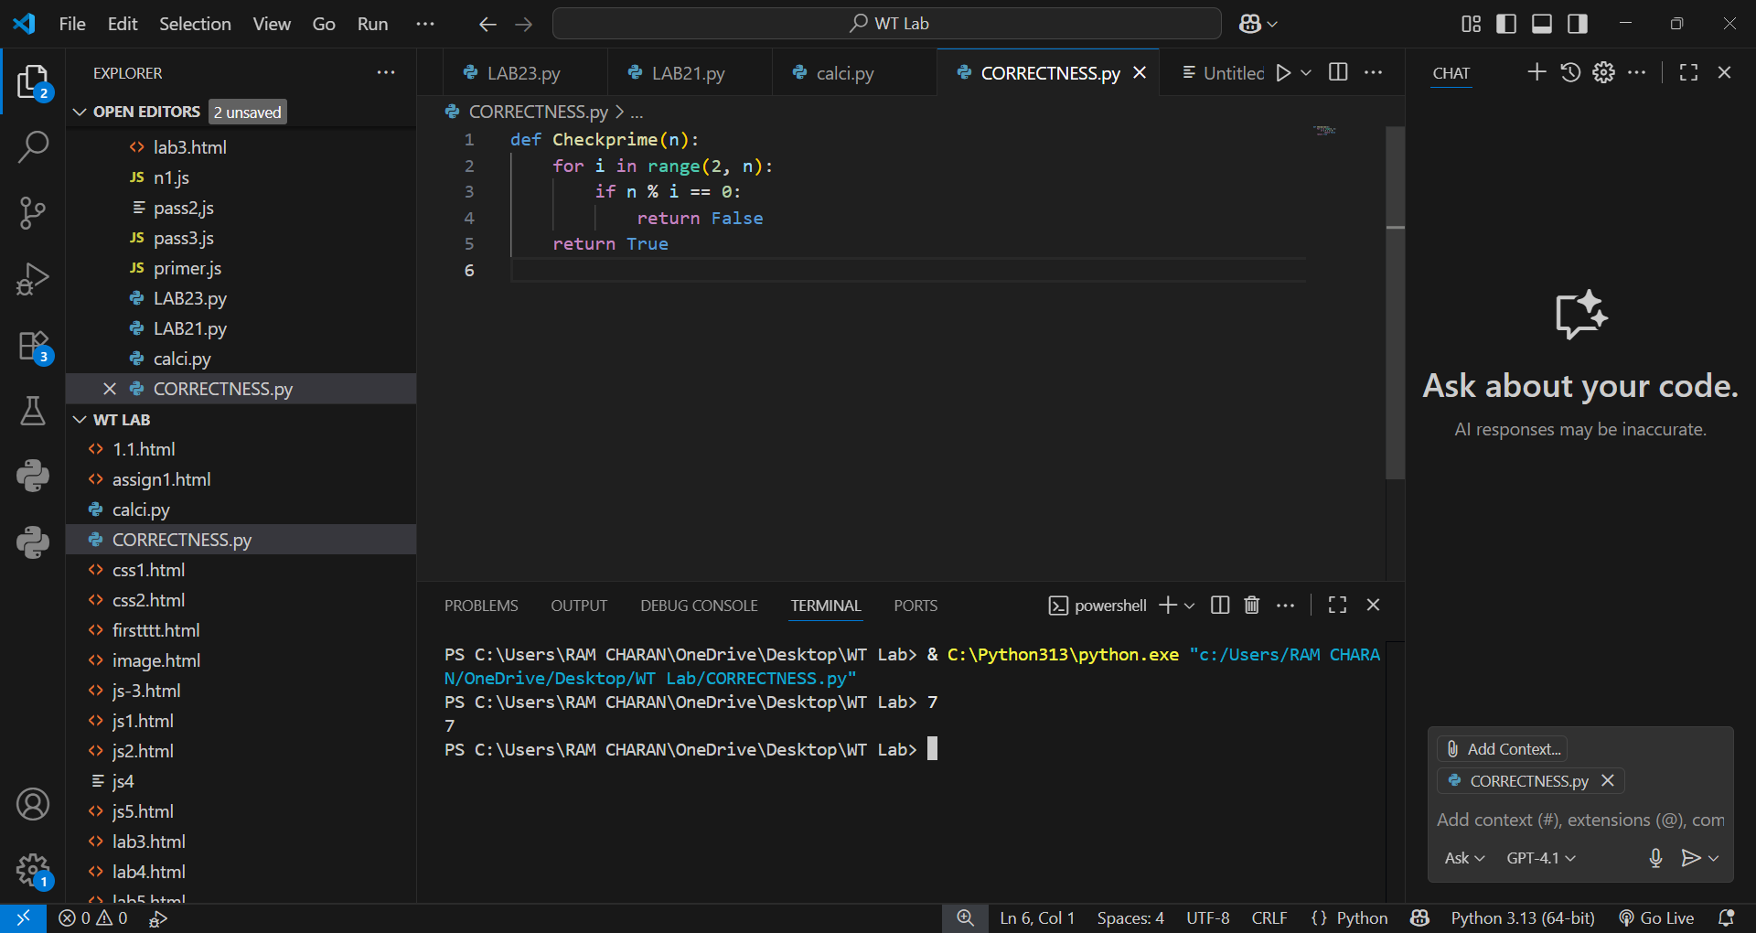  - Use AI to perform a code quality review for PEP8 compliance.  PEP8 Issues:-  - Function name should be lowercase with underscores (check_prime)  - Lack of consistent spacing (after commas)  - No docstring  - Prompt AI to return a refactored version with proper indentation, spacing, and naming conventions.  - 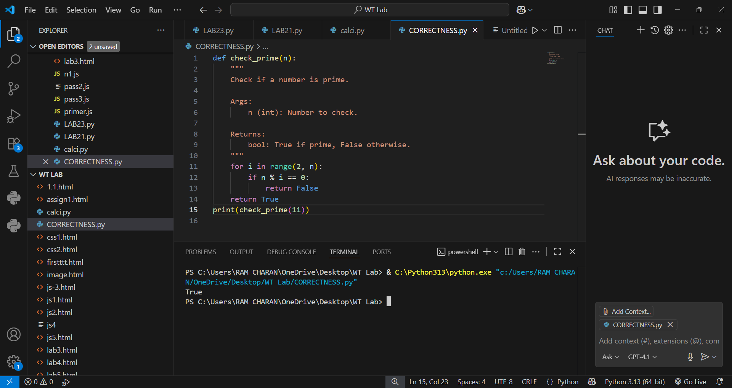  - Discuss how automated AI review can save time in large-scale projects.:-  - AI REVIEW:-  - In large-scale projects where codebases are extensive and changes frequent, automated AI review acts as an efficient gatekeeper for code style and quality. It reduces human effort on mundane tasks, enforces standards uniformly, and accelerates overall development velocity while maintaining high code quality.  Task Description #4 (AI as a Code Reviewer in Real Projects)  Scenario: You are part of a GitHub project. A teammate submits this pull request:  def processData(d):  return [x*2 for x in d if x%2==0]  - Review this function manually for readability, reusability, and edge cases.  - 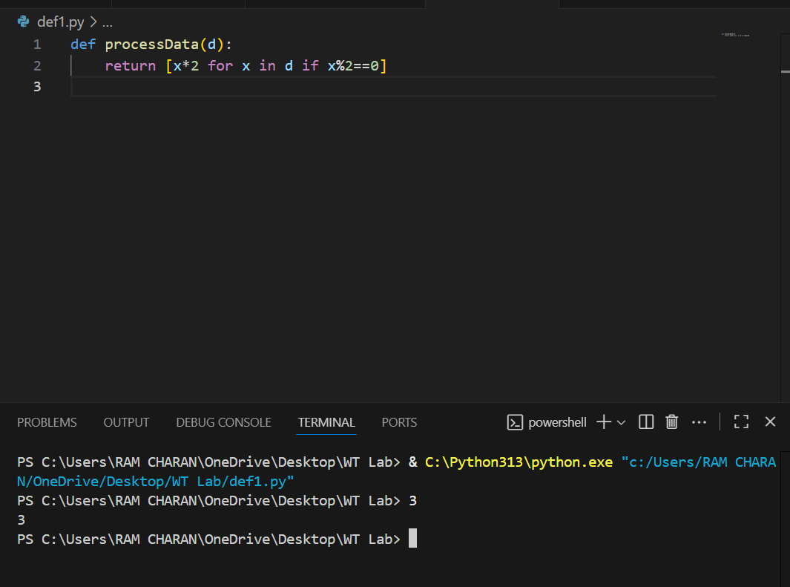  Manual Review:-  Reflection on AI as Code Reviewer  - Trustworthiness: AI is effective as a support tool for detecting common issues, improving readability, and enforcing best practices.  - Limitations: AI may miss complex edge cases, deep architectural concerns, or project-specific conventions.  - Best Use: AI should complement human reviewers by handling style, naming, and basic validation while humans focus on logic and design decisions.  - Benefit: Speeds up review cycles and reduces reviewer workload, improving team productivity and code quality  - Use AI to generate a code review comment, focusing on:  - Naming conventions.  - Input validation (e.g., what if d is not a list?).  - Adding type hints.  - Modify the function based on  - AI’S suggestions:-  Naming: Rename to double_even_numbers for clarity.  - Input Validation: Add type check to ensure input is a list/iterable.  - Type Hints: Include type hints for better maintenance and clarity.  - Error Handling: Raise appropriate exceptions for invalid inputs.  - 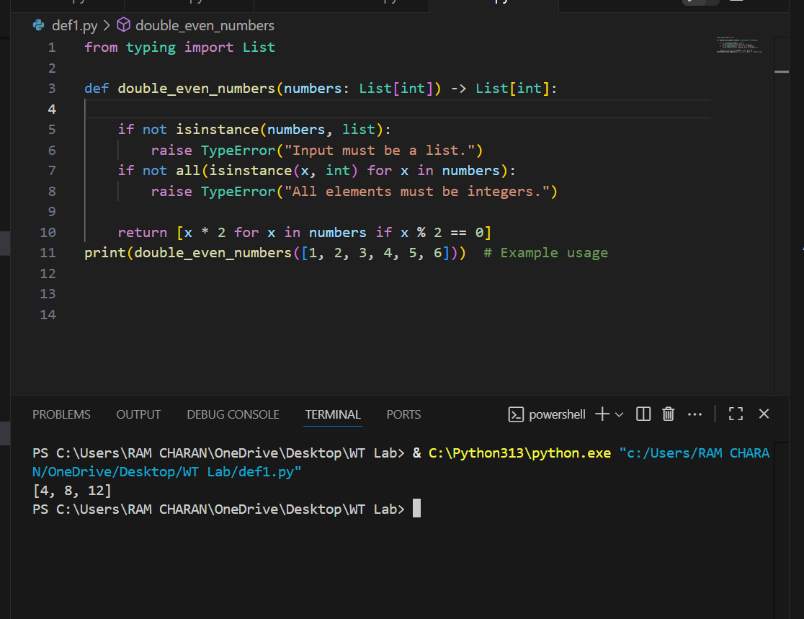  - Write a short reflection: Would you trust AI as a standalone reviewer, or only as a support tool? Why?  Reflection on AI as Code Reviewer:-  - Trustworthiness: AI is effective as a support tool for detecting common issues, improving readability, and enforcing best practices.  - Limitations: AI may miss complex edge cases, deep architectural concerns, or project-specific conventions.  - Best Use: AI should complement human reviewers by handling style, naming, and basic validation while humans focus on logic and design decisions.  - Benefit: Speeds up review cycles and reduces reviewer workload, improving team productivity and code quality |  |  |  |  |  | Week5 - Monday

