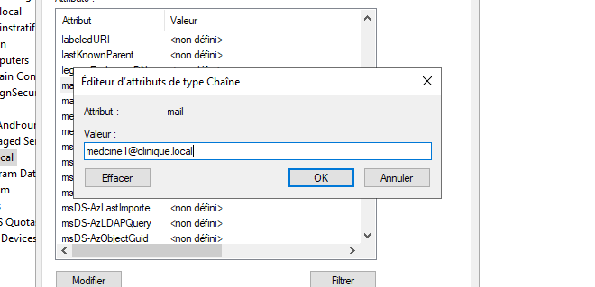

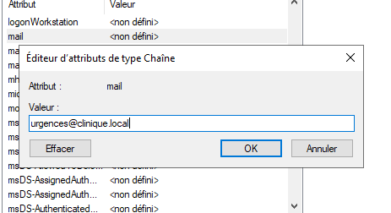

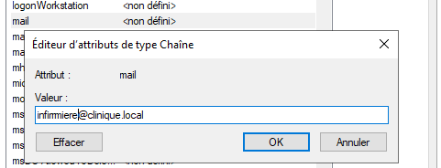

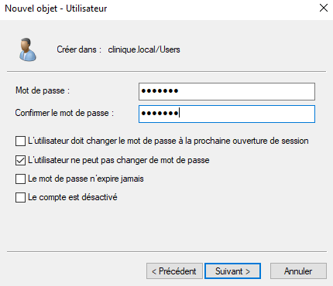

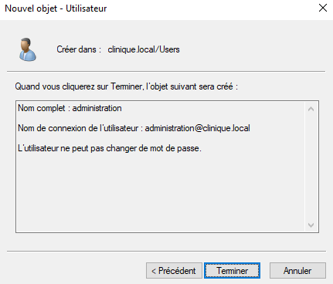

https://chatgpt.com/share/67ab69d3-e518-800e-8a1e-ae453c3b213c

https://chatgpt.com/c/6811b5ef-606c-800e-aa3c-01e07ebb1532

