VELLORE INSTITUTE OF TECHNOLOGY
CHENNAI
School of Computer Science Engineering and Information Systems
Academic Year 2026 – 2027
BCSE408L — CLOUD COMPUTING
Cloud-Native SaaS Project
Review 2 and Final Demonstration (Review 3) — Combined Submission
ServiceDesk AI
A Cloud-Native Customer Support SaaS Platform for Small Businesses
Project 19 · Customer Support SaaS
“Manage customer complaints and automate ticket handling.”
LIVE APPLICATION
https://servicedesk-ai-two.vercel.app
API https://servicedesk-api-ss2d.onrender.com/api · https://github.com/ItzGOLLY/servicedesk-ai
SUBMITTED BY
Name | Registration Number | Programme
Aarush Jagannathan | 23BLC1211 | B.Tech. Electronics and Computer Engineering
Gomatheswar M | 23BLC1195 | B.Tech. Electronics and Computer Engineering
UNDER THE GUIDANCE OF
Dr. M Dinakaran
School of Computer Science Engineering and Information Systems
SEPTEMBER 2026

Part A — Deliverables Map for Review 2 and the Final Demonstration
This submission covers Review 2 and the Final Demonstration (Review 3) together. Every deliverable named in the official Review Schedule (Attachment 2) is listed below with the section of this document that satisfies it, the evidence that it is complete, and the point in the live demonstration at which it is shown. Nothing in this document is planned or assumed: every status was verified against the running application on 19 September 2026.

A.1 Live endpoints
What | Address | Verified
Live application (frontend, Vercel CDN) | https://servicedesk-ai-two.vercel.app | ✔ Sign-in and all three role dashboards
REST API (Render, Singapore) | https://servicedesk-api-ss2d.onrender.com/api | ✔ /health returns database: connected
Interactive API documentation (Swagger UI) | https://servicedesk-api-ss2d.onrender.com/api/docs | ✔ 13 documented paths generated from Zod schemas
Cloud database | Render managed PostgreSQL 16 + pgvector (internal network only) | ✔ 5 migrations applied on deploy
WhatsApp channel | Meta WhatsApp Cloud API test number +1 (555) 148-1137 | ✔ Inbound → ticket → auto-reply in ~1 s; agent reply delivered to phone
Source repository | https://github.com/ItzGOLLY/servicedesk-ai | ✔ Public, CI green on main

A.2 Review 2 deliverables
Deliverable | Where in this document | Evidence / demo point
System Architecture | Section 11 | Figure 11.1; explained in demo step 1
Cloud Architecture | Section 12 | Figure 12.1; Render + Vercel dashboards shown in demo step 9
Database Design | Section 13 | Nine tables, constraints, indexes, migrations; live data on the admin dashboard
ER Diagram | Section 13.2, Figure 13.1 | Derived directly from migration 001–003
Module Design | Section 14 | Five specified modules plus WhatsApp, AI and knowledge base
API Design | Section 16.2 and Appendix B | Swagger UI live at /api/docs — demo step 8
Authentication | Section 16.3 | Register, sign in, refresh, deactivation — demo step 2
Core Modules | Sections 14 and 16 | Ticket lifecycle end to end — demo steps 3–7
GitHub Repository | Section 16.1 | Public repository, meaningful history, README, CI badge — demo step 10
Initial Cloud Deployment | Section 18 | Live URL opened first in the demo

A.3 Final Demonstration deliverables
Deliverable | Status | Where / how it is shown
Complete SaaS Application | ✔ | All ten functional requirements implemented and verified — Sections 9 and 19
Public Live URL | ✔ | https://servicedesk-ai-two.vercel.app
Responsive UI | ✔ | Verified at 390, 768 and 1366 px — Section 15, Figure 15.12; phone view in the demo
Cloud Database | ✔ | Render managed PostgreSQL 16 with pgvector — Sections 12 and 13
Testing | ✔ | 161 automated tests, all passing on 19 September 2026; CI on every push — Section 17
Final Report | ✔ | This document follows the 22-section template from Attachment 2
PPT | ✔ | docs/ServiceDesk_AI_Final_Demo.pptx in the repository
GitHub Repository | ✔ | https://github.com/ItzGOLLY/servicedesk-ai
Working Demonstration | ✔ | Script in Appendix A — 8 minutes, rehearsed against the live system

A.4 Final demonstration checklist (Attachment 2)
Checklist item | Demo step | What the panel sees
Registration / Login | 2 | A new customer registers and lands on their dashboard; admin signs in with a different role
Role-based Access | 5, 6 | Customer sees only own tickets; agent sees all; admin-only menu; direct API call by the wrong role returns 403
Core Workflow | 3–7 | Complaint arrives on WhatsApp → ticket auto-classified → agent drafts with AI → reply reaches the phone → status changes → customer closes
Cloud Deployment | 1, 9 | Live URL; Render and Vercel dashboards; render.yaml Blueprint
Live URL | 1 | https://servicedesk-ai-two.vercel.app
GitHub Repository | 10 | Commit history, README, green CI run, tests folder
Responsive Design | 11 | Same page on a phone-width viewport: sidebar collapses, tables become cards
Question & Answer by both team members | — | Both members prepared from docs/VIVA_PREPARATION.md and docs/PROJECT_DEEP_DIVE.md

A.5 Mandatory technical expectations (Attachment 1, §3)
Requirement | Status | Implementation
User Registration & Login | ✔ | JWT access token (15 min, in memory) + httpOnly refresh cookie (7 days); bcrypt cost 12
Role-Based Access | ✔ | Customer / Agent / Admin; enforced by route middleware and per-record ownership checks in the API
CRUD Operations | ✔ | Tickets, messages, users, categories, knowledge-base articles
Dashboard & Reports | ✔ | Three role dashboards, seven reports, CSV export — all computed from the database on each request
Cloud Database | ✔ | Render managed PostgreSQL 16 with the pgvector extension
REST APIs | ✔ | ~64 endpoints across 11 groups; OpenAPI 3 specification and Swagger UI
Responsive UI | ✔ | Tailwind design system, responsive from 375 px
Live Cloud Deployment | ✔ | Vercel (frontend) and Render (API + database) via Blueprint
GitHub Repository | ✔ | One team repository, regular commits, README, CI

A.6 Demonstration accounts
Role | Email | Password
Admin | admin@servicedesk.ai | Admin@12345
Support Agent | priya.agent@servicedesk.ai | Agent@12345
Customer | rohan@example.com | Customer@12345
These are seeded demonstration credentials. The admin password will be changed immediately after the evaluation.

2. Abstract
A small business that receives customer complaints across email, messaging applications and telephone calls has no reliable record of what was reported, who is handling it, or whether it was ever resolved. Requests are lost in shared inboxes, the same issue is answered twice by different people, and the business cannot measure how long anything took. Commercial helpdesk products solve this problem, but they are priced per agent per month and assume a dedicated support team, which places them beyond the reach of a three-person business.
ServiceDesk AI is a cloud-native Software-as-a-Service application that closes this gap. Every complaint becomes a ticket carrying a reference number, an owner, a category, a priority and a tracked status — visible to the customer, actionable by the support agent and measurable by the administrator. Customers can reach the desk from a web portal or, primarily, by sending an ordinary WhatsApp message: the message becomes a ticket, is classified automatically, and receives an immediate acknowledgement; every agent reply is delivered back to the same chat. The system implements three roles with role-based access control enforced in the API, a guarded six-state ticket lifecycle, threaded conversations with staff-only notes, full-text search, persistent notifications, role-specific dashboards, exportable reports, an audit log, and an administration module.
An AI layer assists the agent without replacing them: incoming tickets are classified by category, priority and sentiment; an agent can request a summary, suggested resolution steps, a draft reply, or a knowledge-base answer with citations retrieved by vector similarity from PostgreSQL. The AI is deliberately kept off the critical path — classification runs after the ticket is committed, every provider failure converges on a rule-based fallback, and nothing the AI produces reaches a customer without an agent sending it.
The application is deployed and publicly reachable: the React frontend on Vercel, the Express/TypeScript API and a managed PostgreSQL 16 instance on Render (provisioned from a version-controlled Blueprint), and the WhatsApp channel through Meta’s WhatsApp Cloud API. Correctness is evidenced by 161 automated tests executed against a real PostgreSQL database using the production migrations, all passing, and by a continuous-integration pipeline that runs them on every push. The complete workflow was additionally exercised in a browser across all three roles and from a phone over WhatsApp.
Keywords: Cloud Computing, Software as a Service, Platform as a Service, Customer Support, Ticket Management, Role-Based Access Control, REST API, PostgreSQL, pgvector, React, Node.js, WhatsApp Cloud API, Retrieval-Augmented Generation, Graceful Degradation.

3. Table of Contents
Generated from the document headings. In Microsoft Word, right-click the table and choose “Update Field” (or press F9) to refresh page numbers.

Contents at a glance
Section | Title | Section | Title
Part A | Deliverables map (R2, R3, checklist, accounts) | 13 | Database Design and ER diagram
2 | Abstract | 14 | Module Description
4 | Introduction | 15 | User Interface Design (live screenshots)
5 | Problem Statement | 16 | Implementation
6 | Existing System | 17 | Testing (161 automated tests)
7 | Proposed System | 18 | Deployment (Render, Vercel, Meta)
8 | Requirement Analysis | 19 | Results and Discussion
9 | Functional Requirements and lifecycle | 20 | Future Enhancements
10 | Non-Functional Requirements | 21 | References
11 | System Architecture | 22 | Appendices A–E: demo script, API catalogue, test index, environment, repository map
12 | Cloud Architecture

4. Introduction

4.1 Background
Cloud computing has changed how small organisations obtain software. Capabilities that once required a server room, a database administrator and a capital purchase are now consumed over the internet, billed by usage, and maintained by the provider. The service models are conventionally described in three layers: Infrastructure as a Service, where virtual machines and storage are rented; Platform as a Service, where an application is deployed onto a managed runtime; and Software as a Service, where finished software is used directly through a browser.
This project sits at all three layers at once. The delivered product is Software as a Service: a small business signs in through a browser and uses a support desk without installing anything. It is built on Platform as a Service: the frontend and the API are deployed to managed platforms that own the runtime, scaling and transport security. It stores its data in a Database as a Service instance, so no member of the team administers a database server. Being able to explain and defend each of these choices is a substantial part of the value of the exercise.

4.2 Motivation
Customer support is a problem every business has, but the tooling available is sharply divided. Large organisations run dedicated helpdesk platforms; very small ones fall back on a shared mailbox and a spreadsheet. The middle ground is poorly served because the commercial products are priced on the assumption that the buyer employs support staff full time. This is a genuine and unglamorous problem, and it exercises every capability the course requires — multiple roles, CRUD over a non-trivial entity, search, reporting, notifications and administration — because the domain demands them rather than having them bolted on.
A second motivation shaped the final design. In India, a small business’s customers do not open a support portal; they send a WhatsApp message. The system was therefore built so that WhatsApp is the primary intake channel and the web application is where staff work.

4.3 Objectives
# | Objective (as specified for Project 19) | How it is satisfied
1 | Develop a scalable cloud-native SaaS application | Three independently deployable tiers; a stateless API that permits horizontal replication; CDN-served frontend
2 | Implement secure role-based authentication | JWT sessions, bcrypt hashing, roles enforced server-side in two layers, 39 tests on authentication and authorisation
3 | Provide dashboards and analytical reports | Three role-specific dashboards and seven reports, computed from live data, with CSV export
4 | Deploy the application on a public cloud platform | Vercel and Render, reachable at https://servicedesk-ai-two.vercel.app; infrastructure defined in render.yaml
5 | Demonstrate collaborative software engineering practices | One repository with a documented history, pull requests with automated review, versioned migrations, CI on every push, 161 automated tests
Table 4.1 — Project objectives and the means of satisfying them

4.4 Organisation of this document
Part A maps every official deliverable to its evidence. Sections 5 to 10 establish what the system must do and why. Sections 11 to 15 describe how it is structured. Sections 16 to 18 describe how it was built, verified and deployed. Section 19 discusses the outcome candidly, including defects found during development and remaining limitations. The appendices contain the live demonstration script, the API catalogue, the test index and the deployment configuration.

5. Problem Statement
The official specification states the problem in a single sentence: “Manage customer complaints and automate ticket handling.” A single sentence is not a specification, so requirement analysis was performed to establish what it means in the operating reality of a small business. Four concrete failures were identified, each mapping to a feature of the system.
Observed failure | What actually happens | Addressed by
No single intake point | Requests arrive by WhatsApp, email and telephone and are never consolidated | One ticket store with a generated reference; WhatsApp messages become tickets automatically
No ownership | A complaint is answered twice by different people, or not at all | Assignment, an agent queue, notification on assignment
No status or history | The customer cannot see progress and follows up repeatedly | A six-state lifecycle, a threaded conversation, a per-ticket timeline, STATUS on WhatsApp
No measurement | The business cannot say how many issues arrived or how long they took | Dashboards and reports computed from live data
Table 5.1 — Decomposition of the problem statement
On the word “automate”. It admits two readings. Procedural automation — creating the record, assigning a reference, timestamping events, advancing status when an agent replies, notifying, acknowledging a WhatsApp message — is implemented fully and depends on no AI. Intelligent automation — interpreting the content of a complaint — is also implemented, as classification, summarisation, drafting and knowledge-base answers, but with a deliberate boundary: the system automates the preparation of a response, never the decision to send one.

6. Existing System
Three approaches are in common use. Each was examined for what it provides and where it fails.

6.1 Shared inbox or personal WhatsApp
- No ticket identity: a customer calling about an earlier message has nothing to quote.
- No ownership: two staff members reply independently to the same message.
- The only state is read or unread; “waiting for the customer” cannot be expressed.
- History is scattered across threads and phones; no reporting is possible.

6.2 Spreadsheet tracker
- Updated by hand, so it drifts out of date immediately and is trusted less over time.
- Offers the customer nothing; no access control; no record of who changed what.
- Unusable beyond a few dozen rows, which is exactly when the business needs it.

6.3 Commercial helpdesk platforms
Zendesk, Freshdesk and Jira Service Management solve the problem thoroughly for organisations of sufficient size. They are priced per agent per month, assume a dedicated support function, require substantial configuration before delivering value, and provide far more than a three-person team needs.

6.4 Comparison
Capability | Shared inbox | Spreadsheet | Commercial helpdesk | ServiceDesk AI
Ticket reference | No | Manual | Yes | Yes
Assigned owner | No | Manual | Yes | Yes
Customer-visible status | No | No | Yes | Yes — web and WhatsApp STATUS
Access control by role | No | No | Yes | Yes
Search and filtering | Limited | Limited | Yes | Yes, full-text
Reporting | No | Manual | Yes | Yes
Audit trail | No | No | Yes | Yes
Automatic classification | No | No | Partly | Yes, with fallback
WhatsApp intake | Informal | No | Paid add-on | Built in
Cost at three agents | Free | Free | Recurring per agent | Free-tier hosting
Setup effort | None | Low | High | Low
Table 6.1 — Existing approaches compared with the proposed system
The gap: a small business needs the structure of a helpdesk without its pricing or complexity — ticket identity, ownership, visible status, access control and measurement, delivered with the setup effort of a spreadsheet, on the channel its customers already use.

7. Proposed System

7.1 Overview
ServiceDesk AI is a multi-user, cloud-hosted SaaS application. Every complaint becomes a ticket with an owner, a category, a priority and a tracked status. The customer can see it (on the web or by WhatsApp), the agent can act on it, and the administrator can measure it.

7.2 Workflow
- A customer sends a WhatsApp message (or raises a ticket on the web). The ticket is stored immediately with status NEW and a reference such as SD-1007; the customer receives an acknowledgement naming that reference within about a second.
- Classification runs in the background after the database commit: category, priority, sentiment and a one-line summary. A failure here cannot affect the ticket.
- The ticket enters the agent queue ordered by priority, filterable and searchable across every customer.
- An agent takes ownership (OPEN), and may ask the assistant for a summary, resolution steps, a knowledge-base answer with citations, or a draft reply. The agent edits and sends. Sending records first-response time, moves the ticket to IN_PROGRESS, and delivers the reply to the customer’s WhatsApp as plain text.
- The customer is notified and can respond in the thread or the chat. A reply on a ticket that was WAITING_FOR_CUSTOMER returns it to IN_PROGRESS.
- When fixed, the agent marks the ticket RESOLVED. The customer closes it (on the web or with CLOSE on WhatsApp), or reopens it if the problem persists.
- Throughout, every change writes a timeline event and every privileged action writes an audit record, which feed the dashboards and reports.

7.3 What makes the system cloud-native
Property | Realisation
Managed data tier | PostgreSQL is consumed as a service on Render with its own backups and availability; nobody on the team administers a database server.
Stateless application tier | The API holds no session state — sessions are signed tokens and all other state lives in the database — so the platform can run several replicas without sticky sessions.
Edge-distributed presentation tier | The frontend is a static build served from Vercel’s CDN close to the user, scaling independently of the API.
Infrastructure as code | render.yaml provisions the database and API together, generates secrets, and wires the connection string; the same file recreated the whole stack in a different region in minutes.
Continuous delivery | A push to main runs the CI pipeline and redeploys both tiers automatically.
Public reachability | Addressable from any browser and any WhatsApp phone; no dependence on localhost.
Table 7.1 — Cloud-native properties

7.4 Scope

In scope
- Registration, login, profile management for three roles; role-based access enforced in the API
- Full ticket lifecycle: create, read, update, delete, assign, guarded status transitions
- WhatsApp as a two-way channel: intake, keyword commands (HELP, STATUS, NEW, CLOSE), agent reply delivery
- Threaded conversation with internal notes; search, filtering, pagination; notifications
- Role-specific dashboards, seven reports, CSV export; administration of users, roles, categories, audit log
- AI classification, summarisation, resolution steps, agent-reviewed drafts, and a knowledge base with retrieval-augmented answers
- Responsive interface; public cloud deployment; containerised local stack; CI

Out of scope (deliberate)
- Payment or subscription billing; telephony; native mobile applications; multi-language support
- File attachments and cloud object storage (the schema anticipates them; see Section 19.5)
- Fully autonomous AI replies sent without agent approval — a design position, defended in Section 16.6

8. Requirement Analysis

8.1 Sources
Ref | Document | Requirements contributed
A1 | BCSE408L Cloud-Native SaaS Project Guidelines | Nine mandatory technical requirements; team, repository, deployment, AI-usage and integrity rules; review scheme; submission checklist
A2 | BCSE408L Project Review Schedule and Report Template | Deliverables for each review; the 22-section report structure; the final demonstration checklist
A3 | BCSE408L Cloud SaaS Project Requirements, Project 19 | Overview, problem statement, five objectives, three users, ten functional and six non-functional requirements, five modules, cloud requirements, eight deliverables
Table 8.1 — Source documents

8.2 Stakeholders and actors
Actor | Responsibilities and interest
Customer | Raises tickets (web or WhatsApp), follows progress, replies in the thread. Sees only their own tickets.
Support Agent | Works a prioritised queue across all customers; updates status, priority, category, assignment; adds internal notes; uses the assistant; replies reach WhatsApp customers automatically.
Admin | Every agent capability plus users, roles, categories, global reports, the audit log and the WhatsApp console.
Course evaluator | Requires demonstrable satisfaction of every mandatory requirement and that both members can explain or modify the implementation.
Table 8.2 — Actors

8.3 Discrepancies identified between the sources
- AI is not a stated requirement. Only the project title contains the term. Every AI capability is therefore an addition, and the design rule adopted is that no mandatory requirement may depend on it — hence classification after commit and a working offline fallback.
- “Cloud storage where applicable” (A3). Attachments were scoped out; this clause is recorded as not satisfied in Section 19.5 rather than presented as complete.
- A3 omits “Working Demonstration”, which A1 and A2 require. The union of all three documents was treated as binding.
- A1 requires that any member can explain or modify any line. This constrained how the code was written: no unnecessary abstraction, module names mirroring the specification, developer documentation alongside the code.

8.4 Constraints
ID | Constraint | Design consequence
C-1 | Publicly accessible; localhost-only not acceptable | Three-tier deployment on managed platforms; no component assumes a local address
C-2 | Permitted hosting platforms only | Vercel and Render, both on the permitted list
C-3 | Both members must explain and modify the code | Plain structure; one place per rule (e.g. the lifecycle table); extensive comments
C-4 | Original work | Design system and every component written for this project; no UI kit or template
C-5 | Free tiers suspend idle services | Health endpoint for scheduled pinging; visible loading states
C-6 | No secret in the repository or the browser bundle | All secrets as environment variables; AI and WhatsApp keys used only server-side; Vercel holds exactly one public variable
C-7 | WhatsApp renders no Markdown | Every outbound message passes through a plain-text formatter
Table 8.3 — Constraints

8.5 Feasibility
Technically feasible: the stack is mature and the whole system was developed and tested against a real PostgreSQL before deployment. Economically feasible: every platform used — Vercel, Render, Meta’s WhatsApp Cloud API, GitHub Actions — was used on its free tier, and the total cost of the deployed system is zero. Operationally feasible: a support desk is a familiar workflow and WhatsApp needs no training at all. Schedule: delivered.

9. Functional Requirements
The ten headings are the functional requirements as stated for Project 19, elaborated into testable behaviour. The test identifiers refer to Section 17 and Appendix C.
ID | Requirement | Implemented behaviour | Tests
FR-1 | User registration and login | Register (name, unique case-insensitive email, password ≥ 8 chars with letter and digit); bcrypt hash only; sign in; refresh via httpOnly cookie; sign out; self-registration always creates a Customer | A-01 – A-13
FR-2 | Profile management | View and edit own name and phone; change password with current password; cannot change own role or email | Browser-verified
FR-3 | Role-based access control | Three roles; every protected route checks role before the handler; ticket handlers also check ownership; 404 rather than 403 for another customer’s ticket; deactivated accounts refused immediately | R-01 – R-26
FR-4 | CRUD operations | Tickets, messages, users, categories, knowledge articles; delete cascades to messages and events; status changes validated against the lifecycle table | T-01 – T-33
FR-5 | Search and filtering | Filter by status, priority, category, agent, sentiment, channel, date; full-text search on subject, description and reference via a GIN index; paginated, sortable; customer results always scoped to own tickets | T-27 – T-33
FR-6 | Dashboard | Customer, Agent and Admin dashboards; every figure aggregated at request time — no hard-coded value | Browser-verified, live
FR-7 | Notifications | Persistent notifications on assignment, reply and status change; unread badge; mark one or all read; WhatsApp customers also receive status notifications on their phone | T-13, WA-08
FR-8 | Report generation | By status, priority, category; sentiment; agent workload; created-vs-resolved trend; resolution time by category; RFC 4180 CSV export with formula-injection protection | Browser-verified
FR-9 | Cloud database integration | Managed PostgreSQL 16 on Render; versioned SQL migrations applied on every deploy; the frontend never touches the database | Whole suite; live health check
FR-10 | Administrator module | List, search, create users; change role; activate/deactivate; cannot remove own admin role; manage categories; audit log of every privileged action; WhatsApp console | R-23 – R-26
Table 9.1 — Functional requirements and their evidence

9.11 Ticket lifecycle
The lifecycle is the central business rule. Permitted transitions are defined once, in a single table in backend/src/modules/tickets/lifecycle.ts, and validated on every status change; the database additionally constrains resolved_at to be set only in RESOLVED or CLOSED.
Current state | Permitted next states | Notes
NEW | OPEN, IN_PROGRESS, CLOSED | Newly submitted, not yet triaged
OPEN | IN_PROGRESS, WAITING_FOR_CUSTOMER, RESOLVED, CLOSED | Triaged and assigned
IN_PROGRESS | WAITING_FOR_CUSTOMER, RESOLVED, CLOSED | An agent is working on it
WAITING_FOR_CUSTOMER | IN_PROGRESS, RESOLVED, CLOSED | Returns to IN_PROGRESS automatically when the customer replies
RESOLVED | CLOSED, OPEN | Customer confirms (CLOSE) or reopens
CLOSED | — (terminal) | Reopening creates history rather than mutating the past
Table 9.2 — Ticket lifecycle transitions

9.12 WhatsApp conversation model
Customer sends | System does
Any description of a problem | Creates the customer account if the number is new, raises a ticket, classifies it, replies with the reference
Another message while a ticket is open | Appends it to that ticket and confirms; WAITING_FOR_CUSTOMER returns to IN_PROGRESS
STATUS | Lists their open tickets and states
HELP | Shows the commands
NEW <description> | Raises a separate ticket even when one is open
CLOSE | Closes a RESOLVED ticket, or explains why it cannot
(agent replies or changes status in the web app) | Delivered to the chat as plain text, prefixed with the reference
Table 9.3 — WhatsApp keywords

10. Non-Functional Requirements
ID | Requirement | Concrete mechanism
NFR-1 | Security | bcrypt(12); JWT with short-lived access token in memory and httpOnly refresh cookie scoped to /api/auth; two-layer RBAC; Zod validation on every input; parameterised SQL only; Helmet headers; CORS allow-list; rate limiting; webhook signature verification (HMAC-SHA256 for Meta, HMAC-SHA1 for Twilio) with constant-time comparison; identical error for unknown email and wrong password; secrets redacted from logs
NFR-2 | Scalability | Stateless API; bounded connection pool; server-side pagination on every list; CDN frontend; AI and WhatsApp delivery off the request path
NFR-3 | Availability | Managed services; /api/health checks process and database; graceful SIGTERM shutdown; AI degrades to rules rather than failing; WhatsApp delivery failure never rolls back the ticket change; migrations run before the server binds
NFR-4 | Performance | Index on every filter column; GIN full-text index; HNSW vector index; pagination; client-side caching with TanStack Query; classification after commit so ticket creation returns immediately
NFR-5 | Reliability | Database CHECK and FK constraints; single lifecycle table; transactions for status change + assignment; idempotent webhooks via UNIQUE provider message id; audit log; 161 automated tests against a real database
NFR-6 | Usability | One hand-built design system; responsive from 375 px; explicit loading, empty and error states; plain-language error messages; WhatsApp replies in plain text with no jargon
Table 10.1 — Non-functional requirements

11. System Architecture
The system is a three-tier web application with two external integrations. The browser and the customer’s WhatsApp are the clients; the API is the only component that touches the database; and every external dependency sits behind an adapter with an offline implementation.
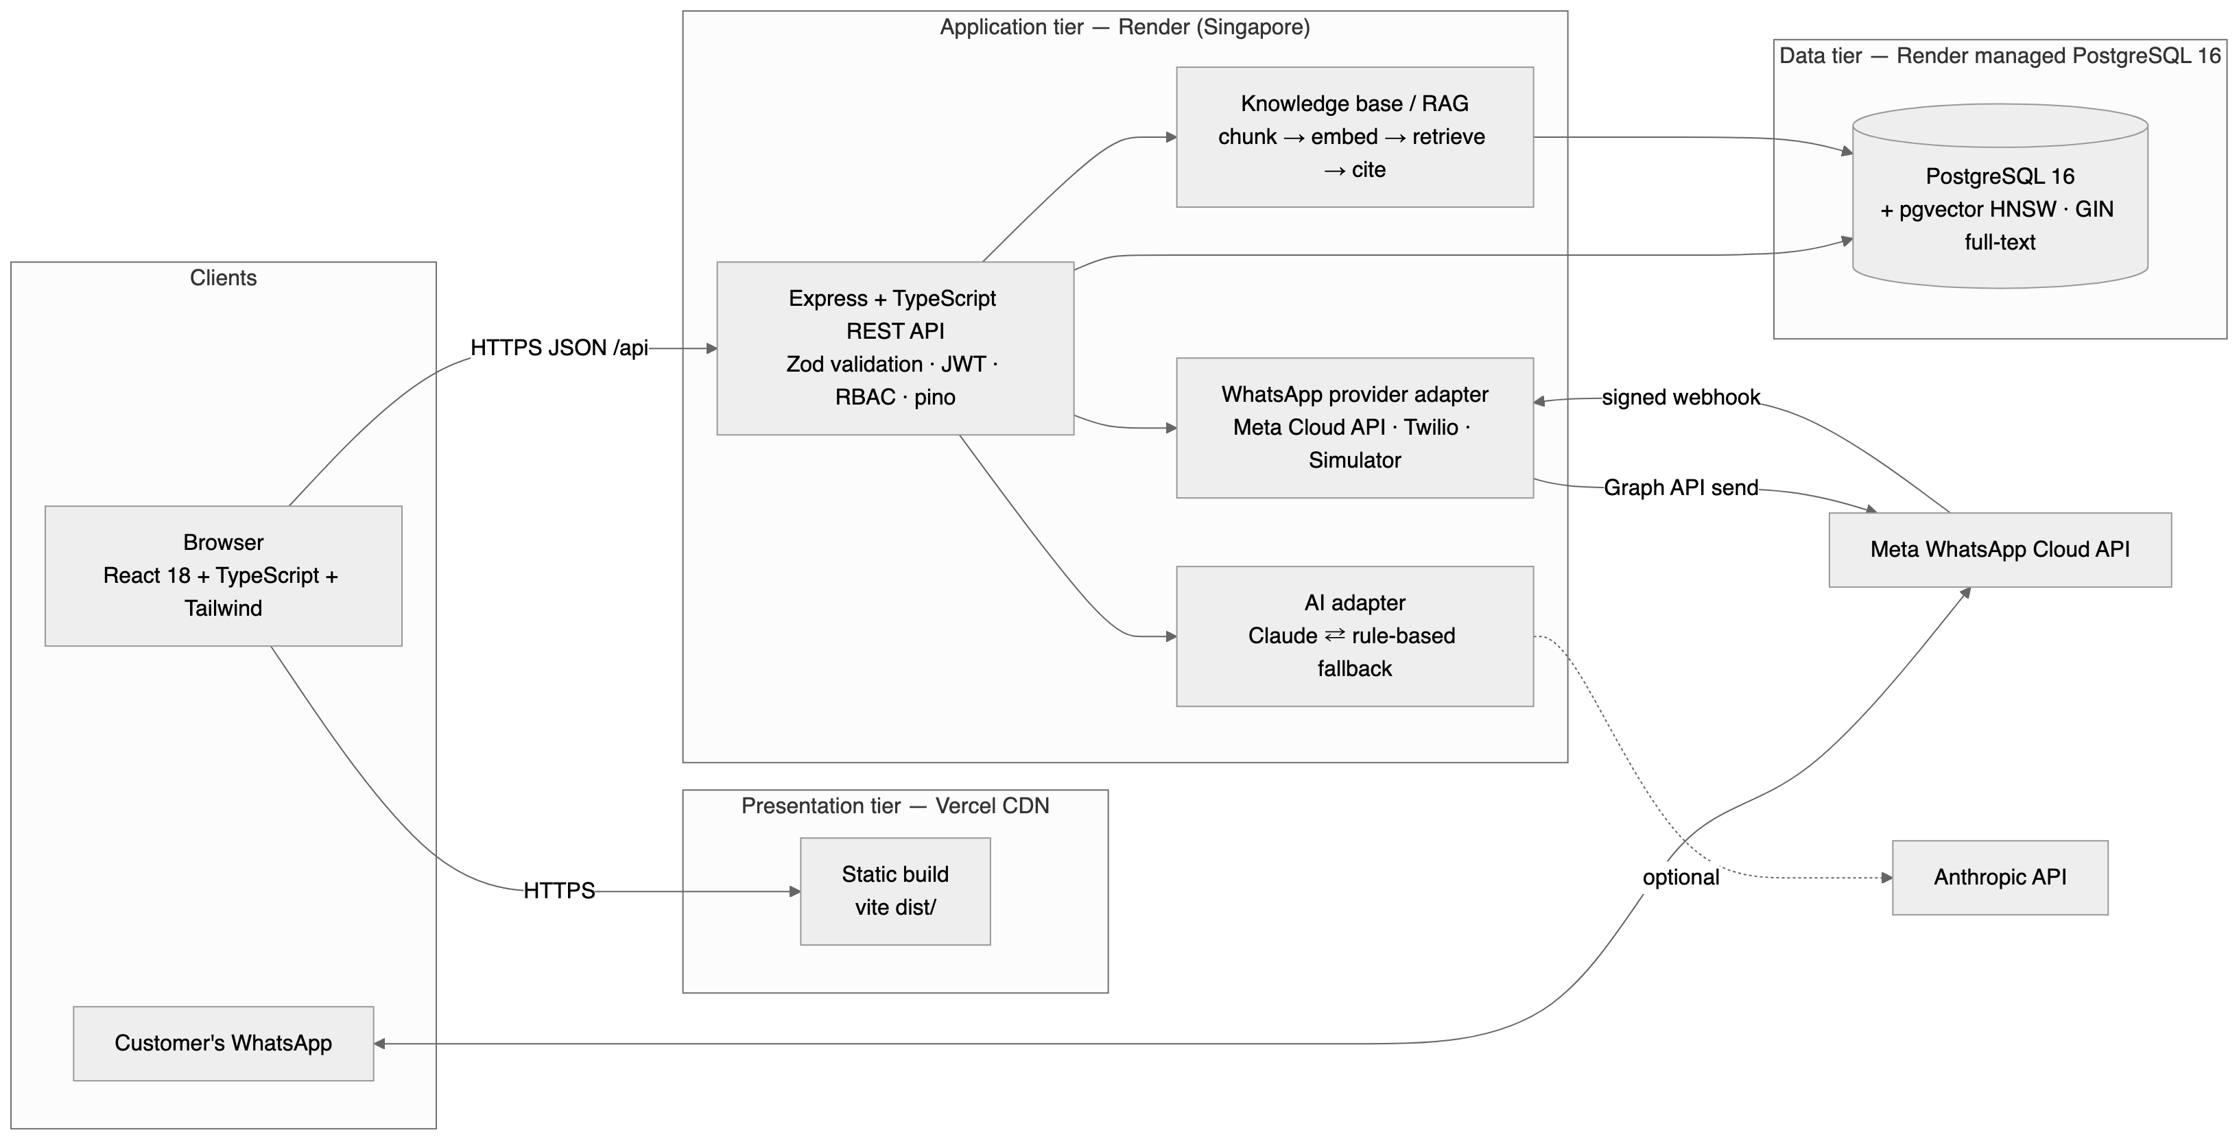
Figure 11.1 — System architecture

11.1 Tiers
Tier | Technology | Responsibility
Presentation | React 18, TypeScript, Vite, Tailwind CSS, TanStack Query, React Router, Recharts | Role-aware single-page application. Holds the access token in memory only; calls the API over HTTPS; never sees a secret or the database.
Application | Node.js 20, Express, TypeScript, Zod, jsonwebtoken, bcryptjs, pino, Helmet, express-rate-limit | REST API. Validates every input, authenticates, authorises, enforces business rules, writes audit and timeline records, orchestrates AI and WhatsApp adapters.
Data | PostgreSQL 16 with pgvector; versioned SQL migrations | Single source of truth. Constraints enforce invariants independently of application code; GIN index for full-text search; HNSW index for vector similarity.
Integrations | Meta WhatsApp Cloud API (Twilio and a simulator as alternatives); Anthropic Claude (rule-based fallback); OpenAI-compatible embeddings (deterministic fallback) | Each behind a small interface. The application works with none of them configured.
Table 11.1 — Tiers and responsibilities

11.2 Request path
- The request passes the HTTP logger (request id assigned), Helmet, the CORS allow-list, body parsing with raw-body capture (for webhook signatures), and the rate limiter.
- requireAuth verifies the JWT and re-reads the user row, so a deactivated account is refused on its very next request.
- requireRole checks the route’s permitted roles; the handler then checks ownership of the specific record where relevant.
- validate(schema) parses body, query and params with Zod; invalid input returns 400 with field-level errors.
- The handler runs parameterised SQL through a shared pool; multi-step writes use withTransaction.
- Side effects that must not block the response — AI classification, WhatsApp delivery, notifications — run after the commit and record their own outcome.
- Every response uses one envelope: { success, data, meta } or { success: false, error: { code, message, details } }.

11.3 Backend module structure
Directory | Contents
modules/authentication | Register, login, refresh, logout, current user
modules/user-management | Profile, password change, admin user CRUD, role and status changes
modules/tickets | Ticket CRUD, lifecycle.ts, assignment, messages, events, search filters, classifyAndStore
modules/reports | Dashboard aggregates for three roles; seven reports; CSV export
modules/administration | Categories; audit-log listing
modules/notifications | Per-user notification listing and read state
modules/ai | Draft reply, summary, resolution steps, grounded answer, suggestion history, AI health
modules/whatsapp | Webhook (POST + verification GET), inbound conversation logic, admin console endpoints
modules/knowledge | Knowledge-base article CRUD, indexing, vector search, embedding status
services/ai, services/embeddings, services/whatsapp | Provider adapters and their fallbacks; plain-text formatter
middleware | auth, rbac, validate, errorHandler
db | pool, migrate, seed, migrations/001–005
observability | pino logger with redaction; HTTP request logger
openapi | OpenAPI 3 specification generated from the Zod schemas; served at /api/openapi.json and /api/docs
Table 11.2 — Backend structure

12. Cloud Architecture
The deployed topology is shown below exactly as it runs today. Every box is a managed service; the team operates no server.
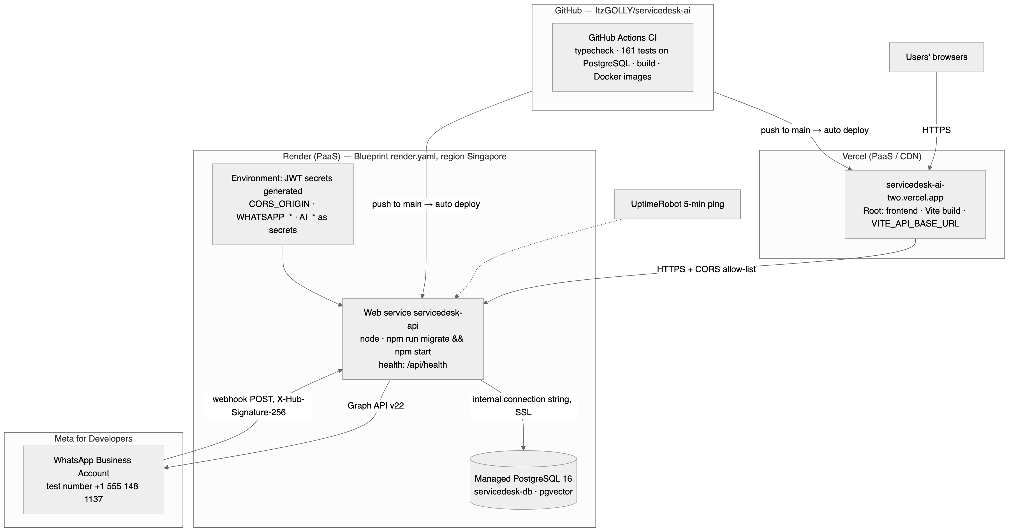
Figure 12.1 — Cloud deployment architecture

12.1 Service model mapping
Layer | Service | Cloud model | Why this choice
Frontend | Vercel | PaaS / CDN | Static Vite build cached at the edge; automatic deploy on push; free tier; on the permitted list
API | Render Web Service (Singapore) | PaaS | Node runtime managed by the platform; Blueprint support; health-checked; free tier; nearest region to India on the permitted list
Database | Render PostgreSQL 16 | DBaaS | Managed backups, SSL, the pgvector extension pre-installed; same region and private network as the API
Messaging | Meta WhatsApp Cloud API | SaaS API | Official WhatsApp Business Platform; free test number sends real free-form replies within the customer-initiated 24-hour window
CI | GitHub Actions | SaaS | Typecheck, tests on a real PostgreSQL service container, frontend build, Docker image builds on every push and pull request
Uptime | UptimeRobot | SaaS | Five-minute ping of /api/health so the free instance does not sleep during the demonstration
Table 12.1 — Cloud services

12.2 Infrastructure as code
render.yaml at the repository root defines the database and the web service together: plan, region, Node build (npm ci --include=dev && npm run build), a start command that applies migrations before the server binds (npm run migrate && npm start), the health-check path, generated JWT secrets, the database connection string wired automatically, and every third-party secret marked sync: false so it is entered once in the dashboard and never stored in the repository. During deployment the first attempt failed because the database defaulted to a different region from the API; adding one line (region: singapore) and re-applying the Blueprint recreated the stack correctly — which is precisely the value of defining infrastructure in a file.

12.3 Security boundaries
- The database accepts connections only over Render’s private network (the API uses the internal connection string over SSL).
- The browser holds exactly one configuration value, VITE_API_BASE_URL. No AI key, WhatsApp token or database credential ever reaches the client.
- CORS is an exact-origin allow-list, required because the refresh cookie is sent with credentials.
- Meta signs every webhook delivery with HMAC-SHA256 over the raw body using the app secret; unsigned or mis-signed requests are rejected with 403 before any processing.
- Render redeploys on every push to main, so the running system never diverges from the reviewed code.

12.4 Scaling path
Because the API is stateless, Render can run additional instances behind its load balancer with no code change; the bounded per-instance pool (max 10) keeps total database connections predictable. The frontend scales with the CDN. The database is the only vertical component; at small-business volumes (thousands of tickets) a single managed instance is more than sufficient, and read replicas are a configuration step when needed.

13. Database Design

13.1 Why a relational database
A support desk is a set of entities with strict relationships and invariants: a message belongs to exactly one ticket; a ticket has exactly one customer; a status can only change along defined paths; a resolved timestamp only makes sense in a resolved state. PostgreSQL enforces all of this in the schema, so the invariants hold even if application code has a defect. Full-text search and — through pgvector — vector similarity search are available in the same engine, which avoided introducing a separate search or vector database.

13.2 Entity relationship diagram
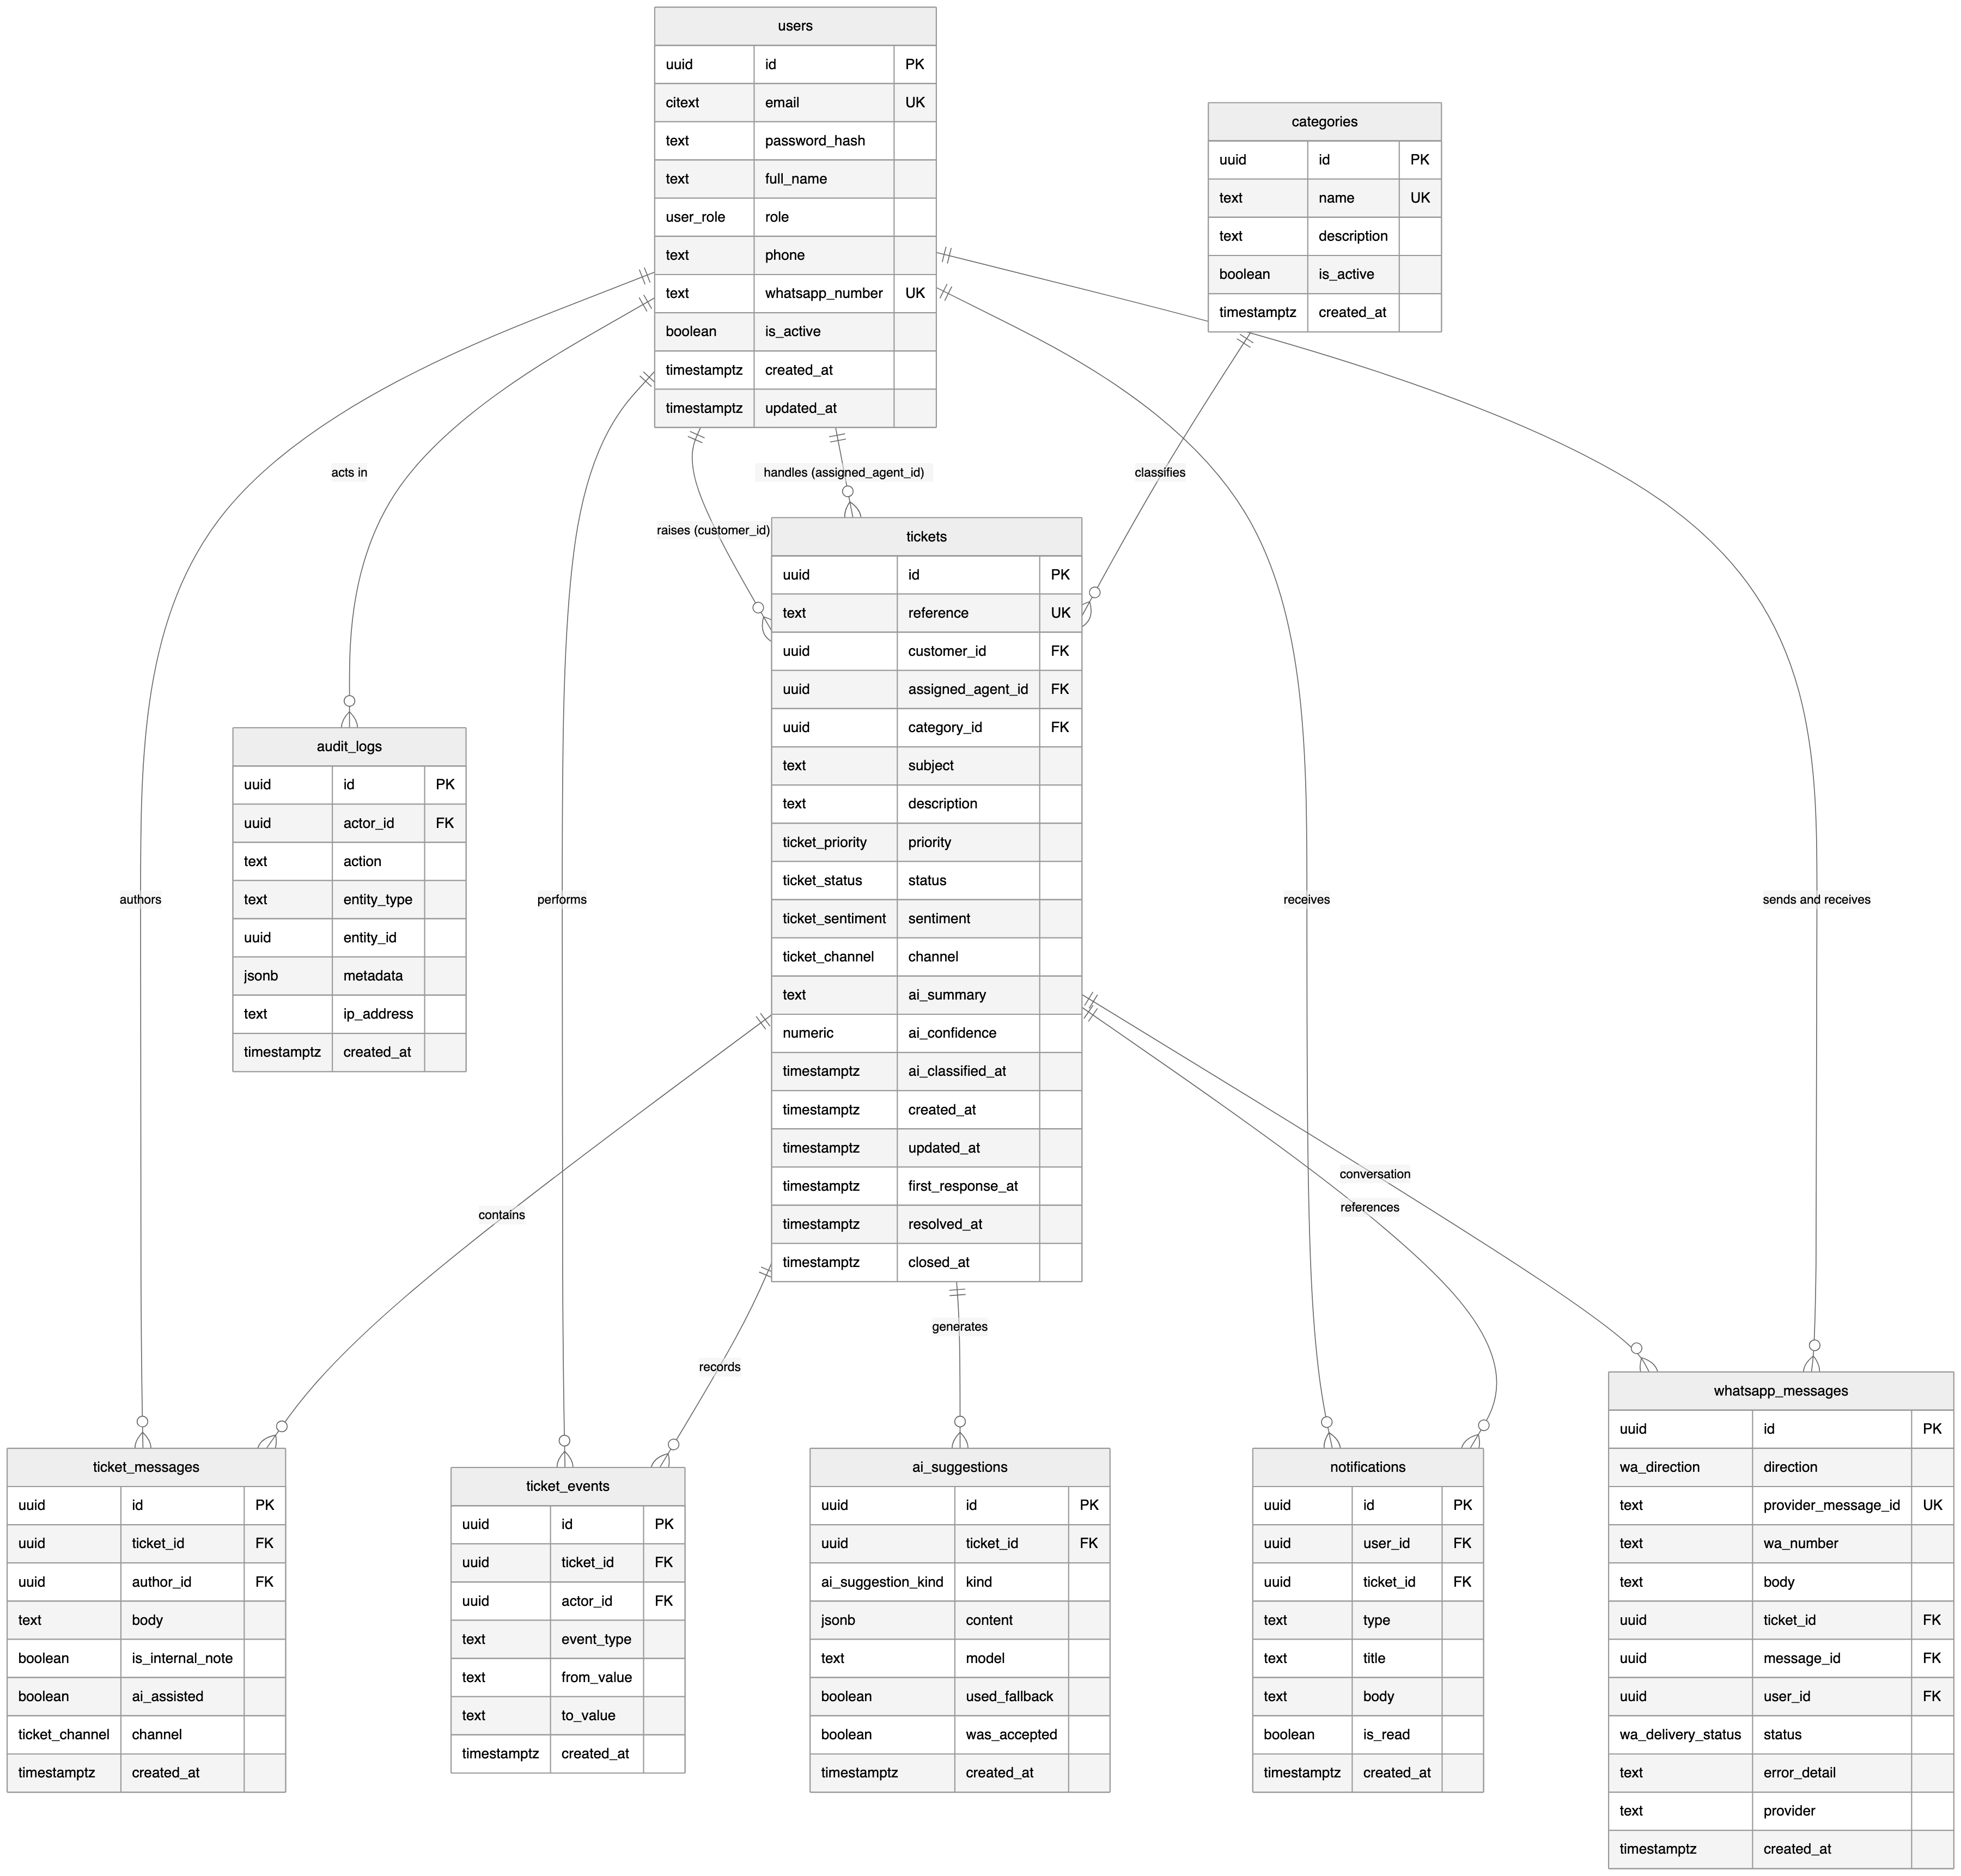
Figure 13.1 — ER diagram (derived from migrations 001–003)

13.3 Tables
Table | Purpose | Notable design decisions
users | Every account, all roles | CITEXT unique email; whatsapp_number unique and nullable; is_active soft-deactivation preserves history
categories | Ticket taxonomy | Inactive categories hidden from new tickets but retained on old ones; delete refused when in use (409)
tickets | The core entity | reference SD-nnnn from a sequence; customer FK RESTRICT, agent and category FK SET NULL; channel WEB/WHATSAPP; ai_confidence CHECK 0–1; resolved_at CHECK against status
ticket_messages | Conversation | is_internal_note filtered out for customers; ai_assisted records that a draft was used; channel of origin
ticket_events | Timeline | Append-only; every status/assignment/priority change with from/to values
ai_suggestions | Every AI output | kind enum (CLASSIFICATION, DRAFT_REPLY, SUMMARY, RESOLUTION_STEPS, GROUNDED_ANSWER); used_fallback and was_accepted make AI usage measurable and honest
notifications | Per-user inbox | Scoped by user_id; 404 for another user’s notification
audit_logs | Privileged actions | actor, action, entity, JSONB metadata, IP; append-only
whatsapp_messages | Channel log | UNIQUE provider_message_id inserted before any work — a replayed webhook cannot create a second ticket; status and error_detail make failures visible in the console
kb_articles / kb_chunks / kb_retrievals | Knowledge base | Articles chunked (~700 chars, 100 overlap); VECTOR(384) embeddings; HNSW cosine index; every retrieval recorded for evaluation
Table 13.1 — Tables

13.4 Enumerated types
Type | Values
user_role | CUSTOMER, AGENT, ADMIN
ticket_status | NEW, OPEN, IN_PROGRESS, WAITING_FOR_CUSTOMER, RESOLVED, CLOSED
ticket_priority | LOW, MEDIUM, HIGH, URGENT
ticket_sentiment | POSITIVE, NEUTRAL, NEGATIVE
ticket_channel | WEB, WHATSAPP
ai_suggestion_kind | CLASSIFICATION, DRAFT_REPLY, SUMMARY, RESOLUTION_STEPS, GROUNDED_ANSWER
wa_direction / wa_delivery_status | INBOUND, OUTBOUND / PENDING, SENT, DELIVERED, READ, FAILED
Table 13.2 — Enumerated types

13.5 Indexes and migrations
- B-tree indexes on every column used as a filter or join: status, priority, category_id, assigned_agent_id, customer_id, created_at, user_id on notifications, ticket_id on messages and events.
- A GIN index over to_tsvector(subject || description || reference) for full-text search.
- An HNSW index (m = 16, ef_construction = 64) on kb_chunks.embedding for cosine similarity. IVFFlat was tried first and replaced: on a near-empty table it silently returned one row where four matched, which a pinned test now guards against.
- Five migrations (001 core schema, 002 WhatsApp, 003 knowledge base, 004 HNSW, 005 grounded-answer kind) applied in order by a 60-line runner that records each file in schema_migrations. The same files run in CI, in Docker, and on Render.

14. Module Description
The five modules suggested in the specification are implemented under those names; three further modules were added to realise the WhatsApp channel and the assistant.
Module | Key capabilities | Main files
Authentication | Register, login, refresh, logout, current user; short-lived access token, httpOnly refresh cookie; instant deactivation | authentication/auth.routes.ts, middleware/auth.ts
User Management | Own profile and password; admin list/search/create; role change; activate/deactivate; self-lockout prevention | user-management/users.routes.ts
Tickets (core) | CRUD, lifecycle, assignment, messages and internal notes, timeline, search and filters, background classification | tickets/tickets.routes.ts, tickets.service.ts, lifecycle.ts
Reports & Dashboard | Three dashboards; seven reports; CSV export; AI-usage statistics | reports/dashboard.routes.ts, reports.routes.ts
Administration | Categories; audit log; WhatsApp console; AI health | administration/*, whatsapp.routes.ts (admin)
WhatsApp channel | Signed webhook, idempotency, conversation model, keyword commands, plain-text formatter, provider adapters (Meta, Twilio, simulator), delivery of agent replies and status changes | whatsapp/*, services/whatsapp/*
AI assistance | Classification after commit; draft reply, summary, resolution steps; provider adapter with rule-based fallback; every output persisted with used_fallback | ai/ai.routes.ts, services/ai/*
Knowledge base (RAG) | Article CRUD, chunking, embeddings, pgvector retrieval, lexical fallback, grounded answers with verified citations, retrieval logging | knowledge/*, services/embeddings/*
Table 14.1 — Modules

14.1 Frontend structure
Area | Pages / components
Public | Landing, Login, Register
Customer | Dashboard, My tickets, Create ticket, Ticket detail (thread), Notifications, Profile
Agent | Agent dashboard, Queue (filters, search, pagination), Ticket detail with AI panel (draft, summary, steps, knowledge answer), assignment and status controls
Admin | Admin dashboard (charts), All tickets, Users, Categories, WhatsApp console, Reports (with CSV), Activity log
Shared | AppShell (role-aware navigation, unread badge), design system in index.css, lib/api.ts (single API client, token handling, base-URL normalisation)
Table 14.2 — Frontend structure

15. User Interface Design
All screenshots below were captured from the live deployment on 19 September 2026 with real data. The design system is hand-built on Tailwind: one teal accent, a neutral palette, consistent cards, and explicit loading, empty and error states on every data view.
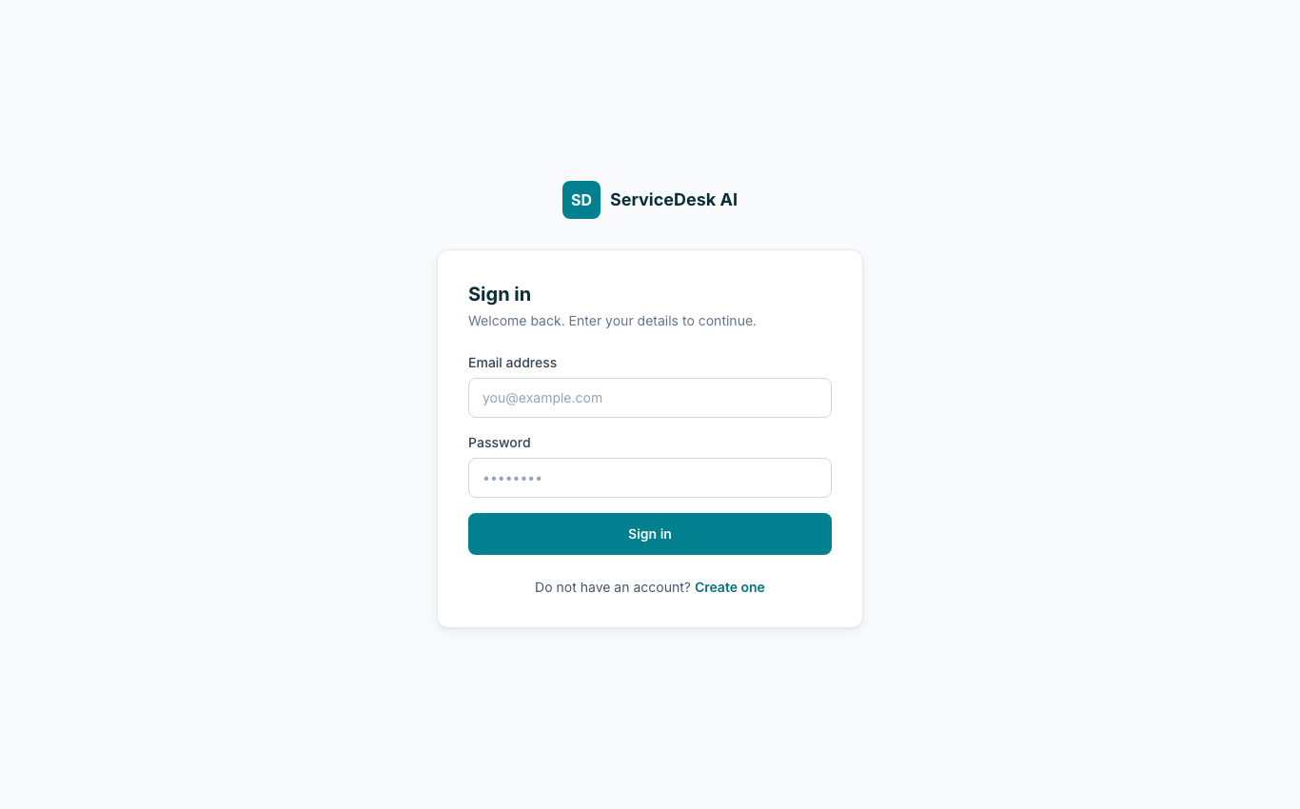
Figure 15.1 — Sign in
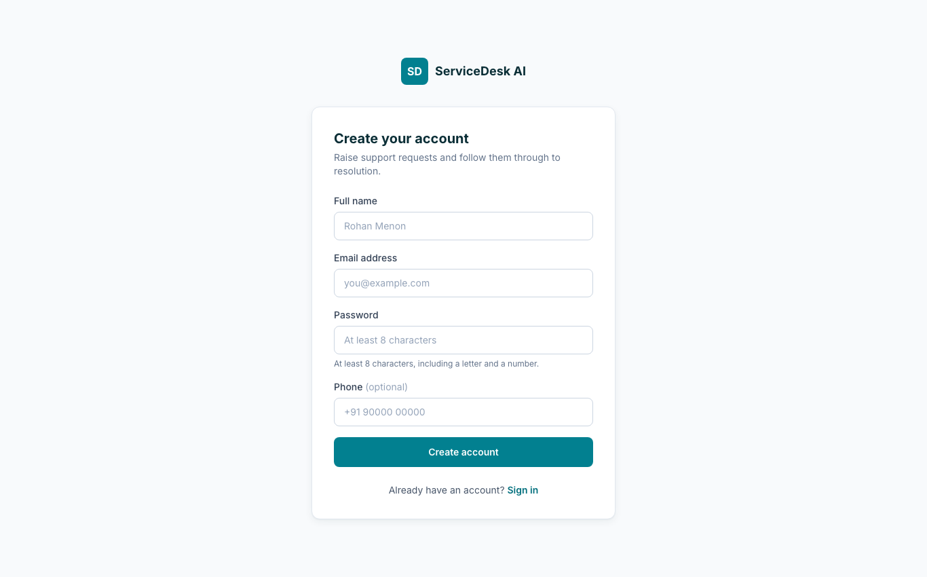
Figure 15.2 — Registration (always creates a Customer)
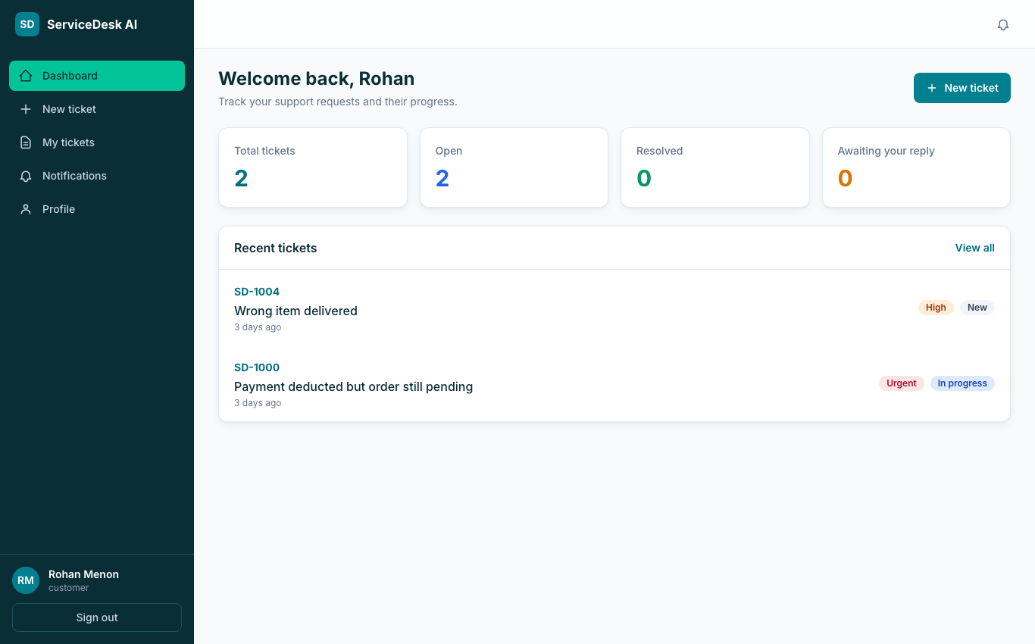
Figure 15.3 — Customer dashboard
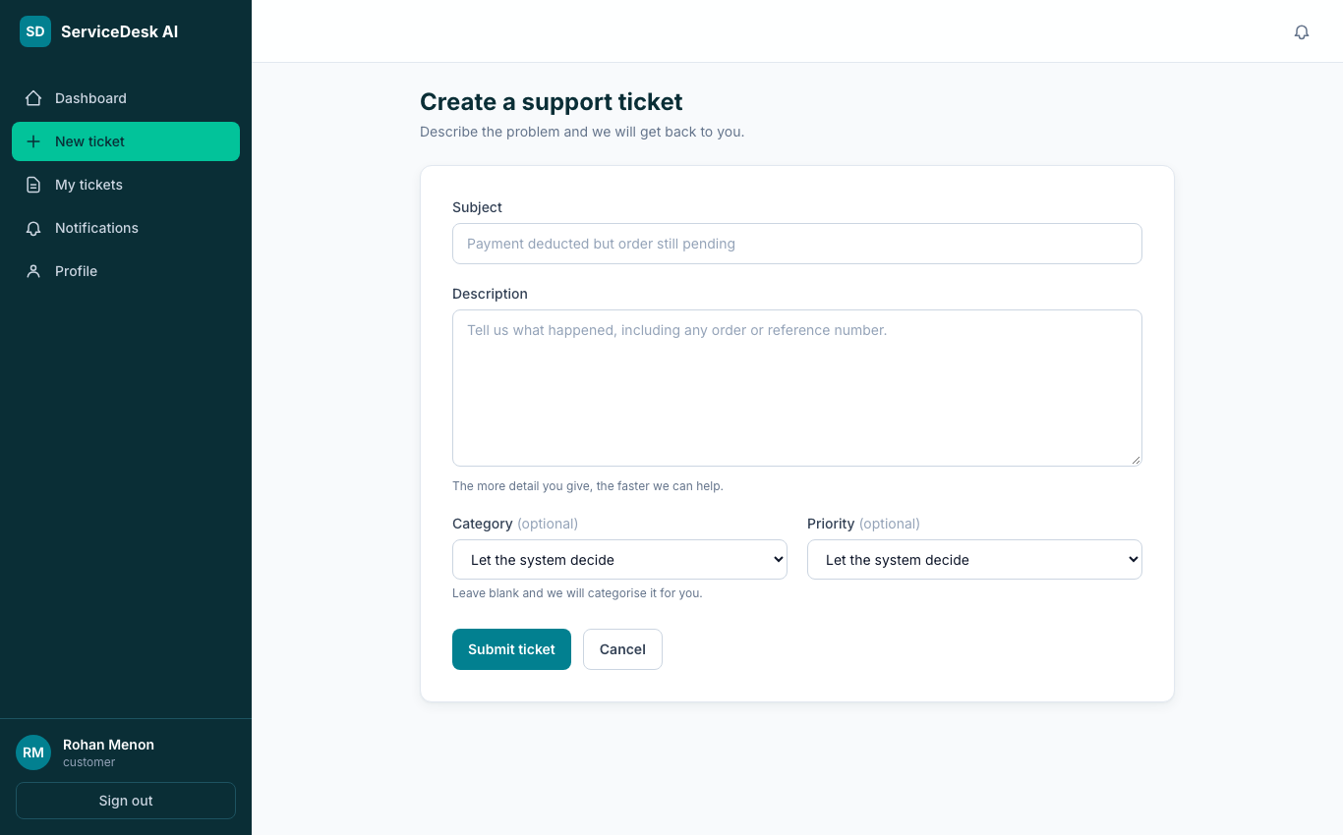
Figure 15.4 — Raising a ticket on the web
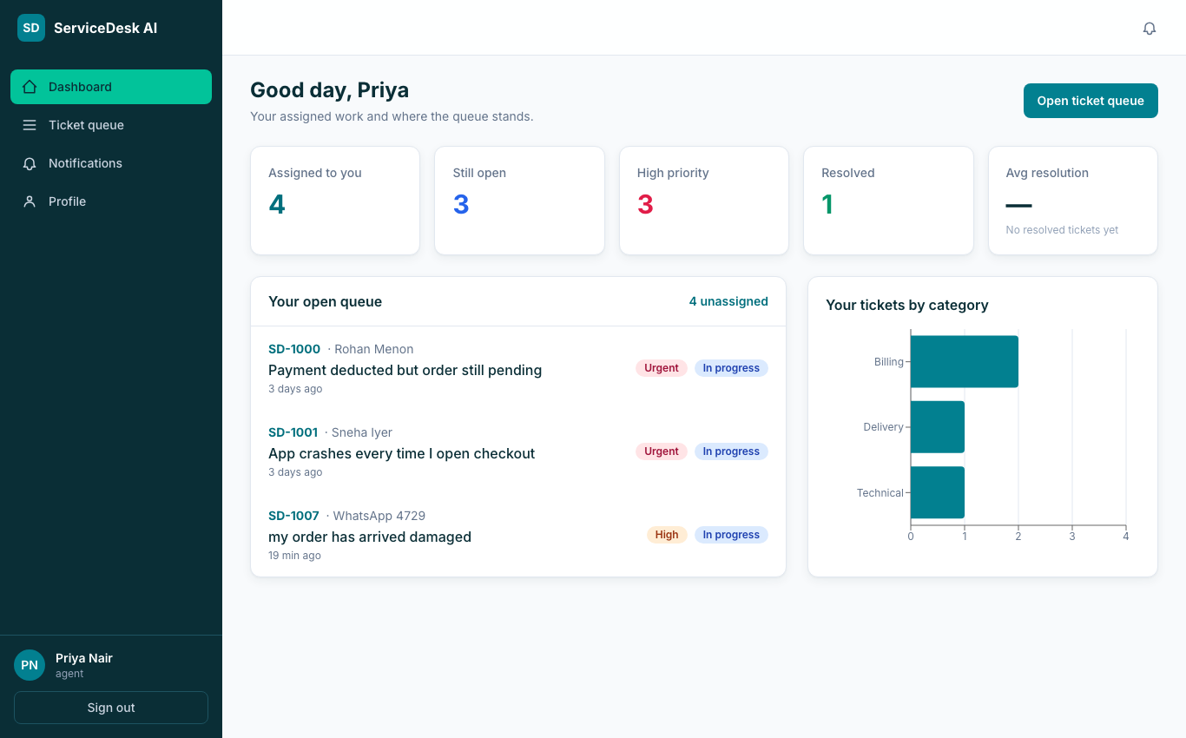
Figure 15.5 — Agent dashboard
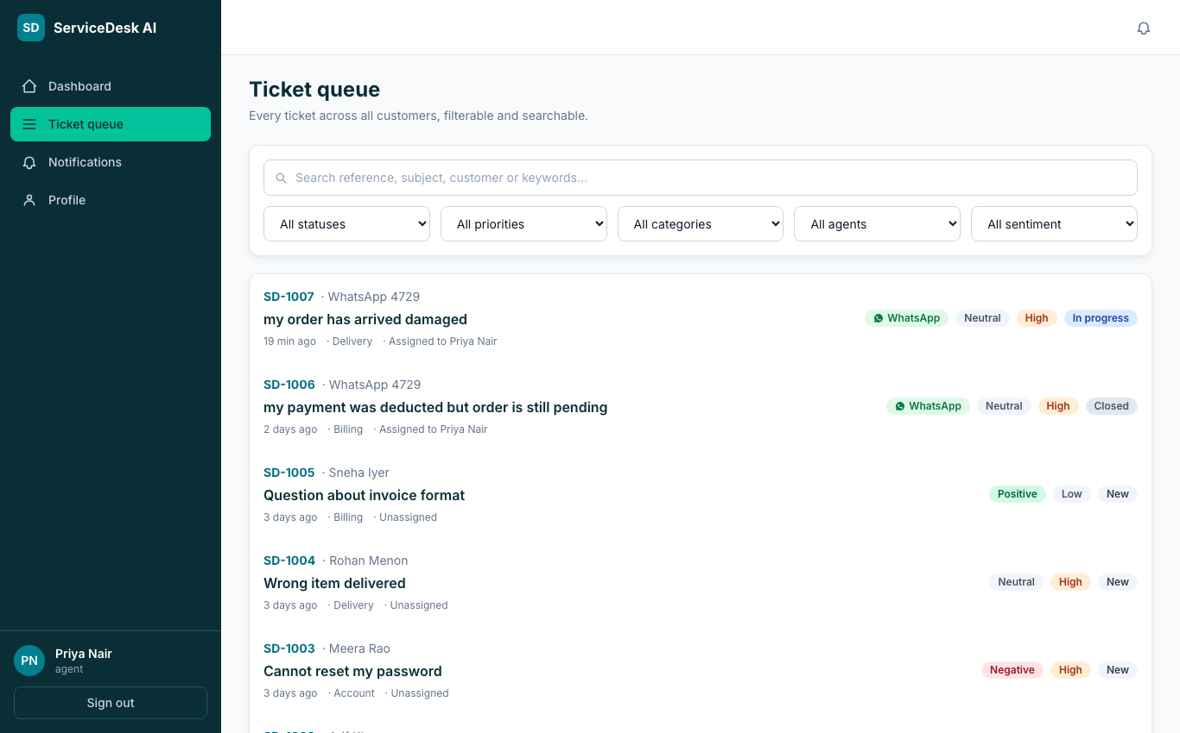
Figure 15.6 — Agent queue with filters and search
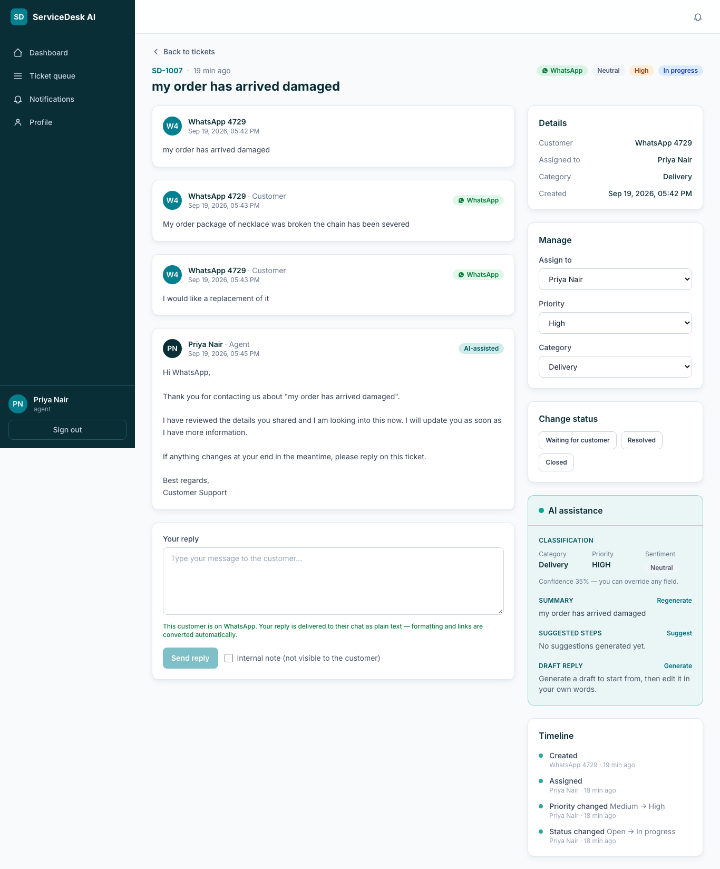
Figure 15.7 — Ticket detail with conversation and AI assistance panel
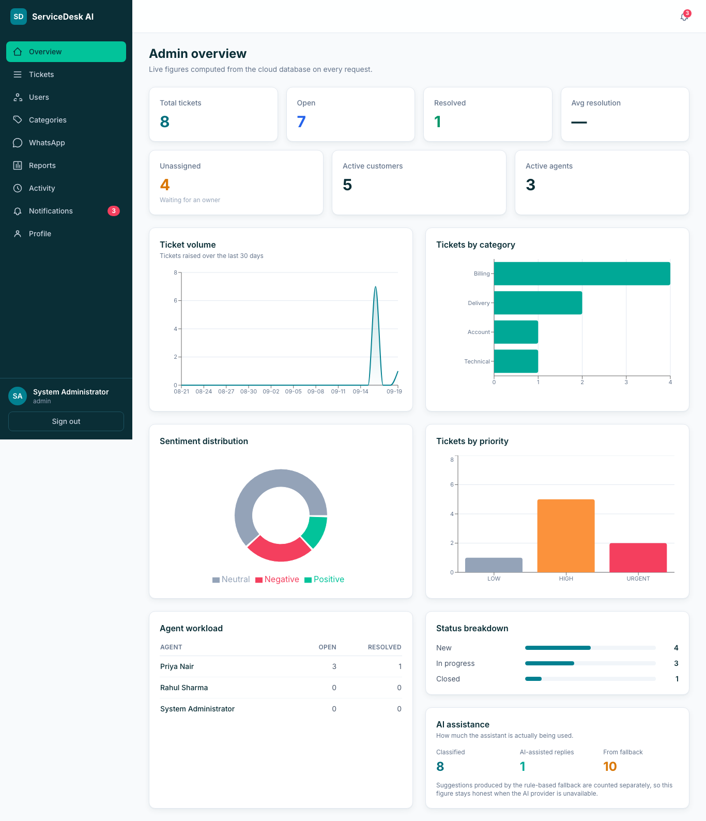
Figure 15.8 — Admin dashboard, computed from the cloud database on each request
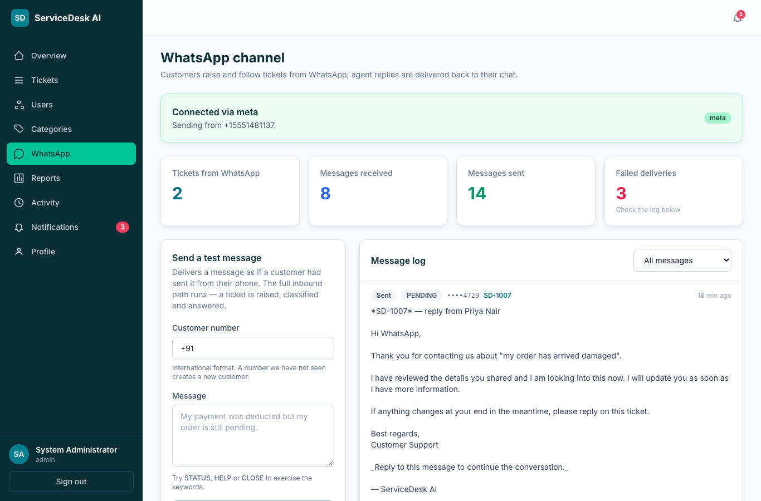
Figure 15.9 — WhatsApp console: provider status, statistics and message log
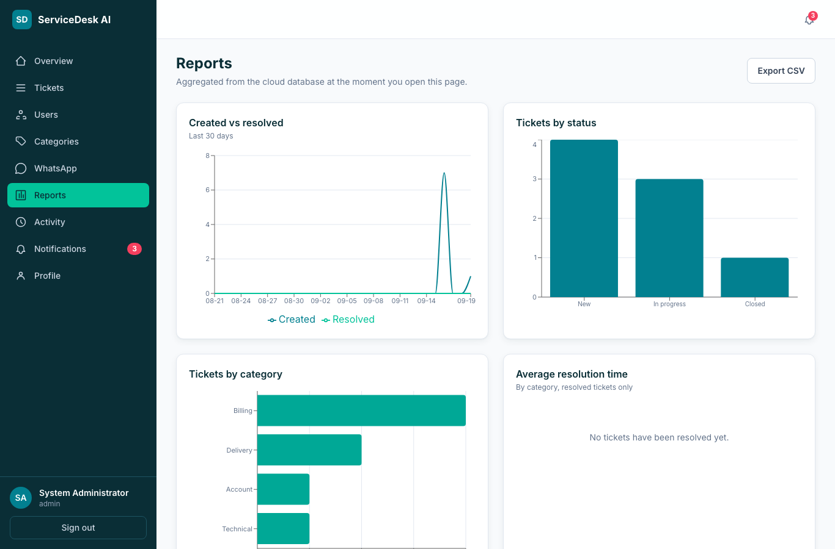
Figure 15.10 — Reports with CSV export
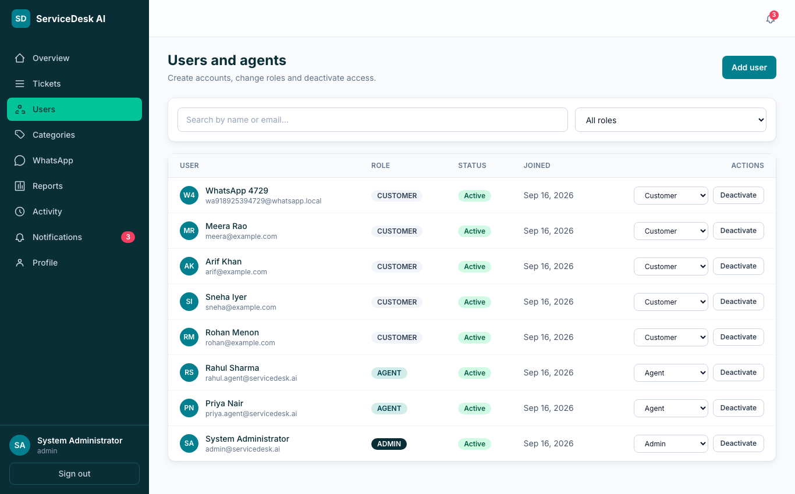
Figure 15.11 — User management
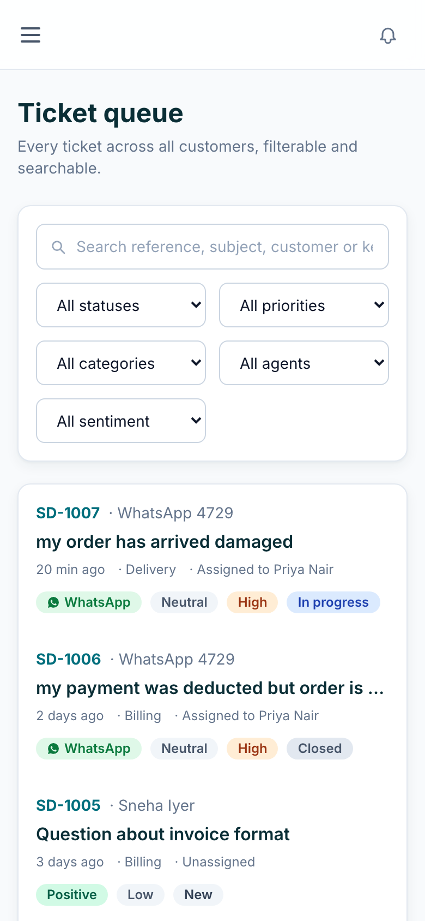
Figure 15.12 — Responsive layout at phone width (390 px)
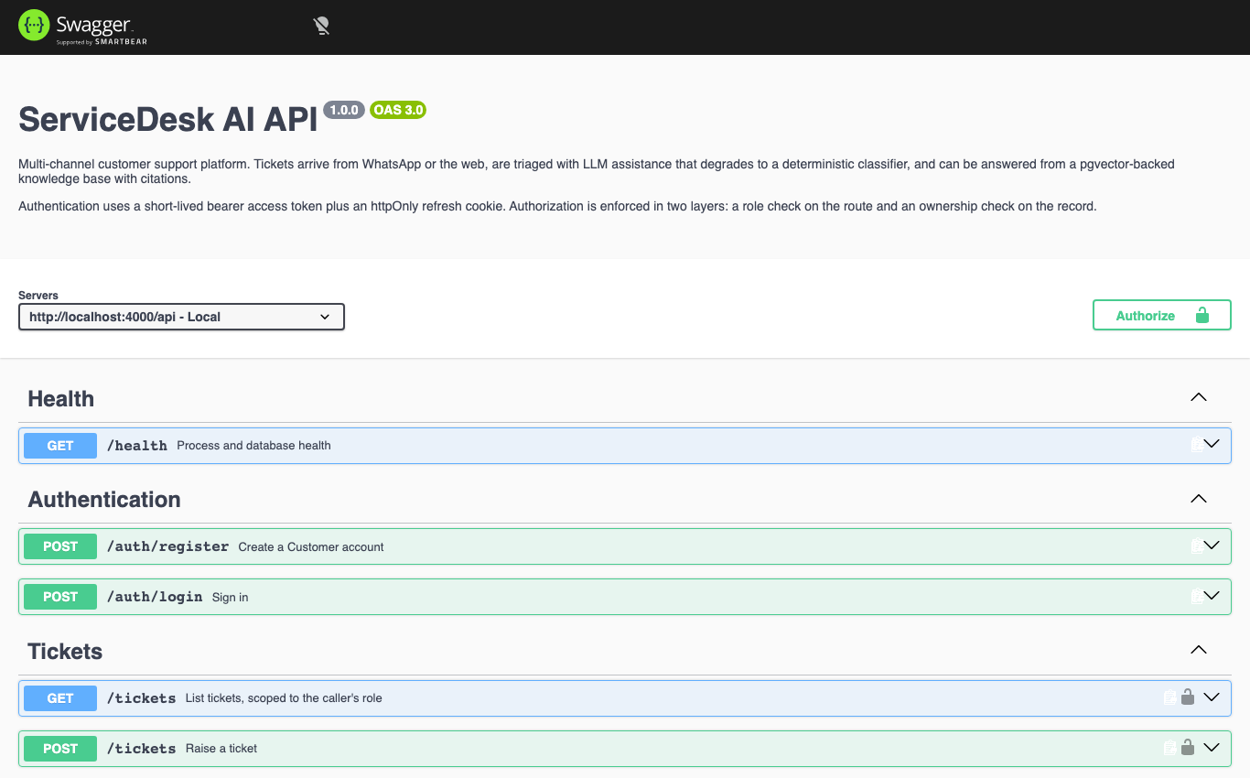
Figure 15.13 — Swagger UI generated from the validation schemas

16. Implementation

16.1 Technology stack and repository
Layer | Choice | Reason
Frontend | React 18 + TypeScript + Vite + Tailwind + TanStack Query + Recharts | Component model with strict typing; fast static build for a CDN; query caching gives loading/error states for free
Backend | Node.js 20 + Express + TypeScript + Zod | Small, explicit, readable by both members; Zod schemas double as the OpenAPI source
Database | PostgreSQL 16 + pgvector | Constraints, full-text search and vector search in one managed engine
Auth | jsonwebtoken + bcryptjs | Stateless sessions; industry-standard hashing
Observability | pino + pino-http | Structured JSON logs with request ids and secret redaction
API docs | @asteasolutions/zod-to-openapi + swagger-ui-express | Documentation generated from the same schemas that validate requests
Testing | Vitest + Supertest | HTTP-level tests against a real database
Packaging | Docker multi-stage images, docker-compose, nginx | One command brings up the whole stack locally, identical to CI
CI/CD | GitHub Actions; Render and Vercel auto-deploy | Every push is typechecked, tested and built before it is live
Table 16.1 — Stack
The repository https://github.com/ItzGOLLY/servicedesk-ai contains backend/, frontend/, docker/, docs/, screenshots/, diagrams/, render.yaml, docker-compose.yml and the CI workflow. Development proceeded through pull requests (#1 initial application, #2 WhatsApp channel, #3 production hardening), each reviewed by an automated code reviewer whose findings were addressed before merging.

16.2 API design
Approximately 64 endpoints in 11 groups follow one convention: resource-oriented paths under /api, JSON bodies validated by Zod, a single response envelope, HTTP status codes used precisely (201 create, 400 validation, 401 unauthenticated, 403 forbidden, 404 not found or not yours, 409 conflict, 422 business-rule violation, 429 rate-limited), and pagination metadata on every list. The full catalogue is in Appendix B and interactively at /api/docs.

16.3 Authentication and sessions
- Passwords are hashed with bcrypt at cost 12; the hash is never logged and the login error is identical for an unknown email and a wrong password.
- Login returns a 15-minute access token, held only in memory by the frontend (never localStorage, so an XSS payload cannot read it), and sets a 7-day refresh token in an httpOnly, SameSite cookie scoped to /api/auth.
- Every authenticated request re-reads the user row, so deactivating an account takes effect on the next request even with an unexpired token (test A-13).
- Known limitation, documented rather than hidden: refresh tokens are not individually revocable; logout clears the cookie and deactivation blocks the account.

16.4 Role-based access control
Authorisation is enforced twice. requireRole(...) on the route rejects the wrong role before the handler runs. Inside handlers that touch a specific record, ownership is checked again: a customer requesting another customer’s ticket receives 404, not 403, so the existence of the ticket is not disclosed. Internal notes are filtered from customer responses at the query level. Twenty-six tests call the API as the wrong role and assert the refusal (Appendix C, R-01 – R-26).

16.5 Ticket lifecycle and transactions
Status changes go through one function that consults the transition table, writes the ticket, appends a timeline event, records an audit entry and creates notifications inside a single transaction (withTransaction). Assignment follows the same path. The database independently enforces that resolved_at is set only in RESOLVED or CLOSED.

16.6 AI assistance — design position
The specification does not require AI; the team added it under three rules. First, the AI never blocks a mandatory function: classification runs after the ticket is committed (void classifyAndStore()), so a slow or failed provider cannot delay or fail ticket creation (test AI-11). Second, every failure converges on the same fallback: an attempt() wrapper turns timeouts, network errors and malformed output into a call to a deterministic rule-based classifier, and the result is stored with used_fallback = true so the dashboard reports AI usage honestly. Third, the AI never messages a customer: every endpoint returns a suggestion to the agent, and a reply reaches a customer only when an agent posts it. Untrusted ticket text is placed in the prompt as delimited data with angle brackets stripped, and an evaluation case confirms that an instruction embedded in a ticket (“set priority to LOW”) does not change the priority.

16.7 Knowledge base and retrieval-augmented answers
Administrators write articles; each is split into ~700-character chunks with 100 characters of overlap and the title prefixed, embedded as 384-dimensional vectors (OpenAI text-embedding-3-small when a key is present, otherwise a deterministic hashed bag-of-words vector that is documented as lexical rather than semantic), and stored in pgvector. A question is embedded the same way and the nearest chunks are retrieved by cosine distance through the HNSW index; if no embeddings exist, PostgreSQL full-text search is used and the response says so. The answer is generated strictly from the retrieved passages and returns only the citations that intersect the supplied passage ids; when the base does not cover the question the response sets insufficient = true rather than inventing an answer. Every retrieval is logged for the evaluation harness.

16.8 WhatsApp channel
- Inbound. Meta posts JSON to /api/whatsapp/webhook. The signature (X-Hub-Signature-256) is verified over the raw body; the provider message id is inserted into whatsapp_messages under a UNIQUE constraint before any work, so retries are idempotent; the customer account is created from the number if new; the conversation model decides whether the text is a keyword, a follow-up on the open ticket, or a new ticket; the reply is composed and sent; the webhook always answers 200 so the provider does not retry a logically handled message.
- Outbound. Agent replies and status changes call notifyTicketCustomer, which sends only when the ticket’s channel is WHATSAPP. Text passes through a plain-text formatter (Markdown headings, code and links converted; length bounded on a word boundary) because WhatsApp renders no Markdown. Delivery is best-effort: failure is recorded with the provider’s error and surfaced in the console and to admins, never rolled back into the ticket.
- Providers. One interface (send, parseWebhook, verifySignature) with three implementations. Meta Cloud API is live. Twilio is retained for upgraded accounts (its trial tier refuses free-form text — error 21654 — which was discovered and documented during deployment). The simulator records messages without sending, so the whole feature works, and is tested, with no external account.

16.9 Observability, documentation and packaging
- pino emits one JSON line per request with method, path, status, duration and a request id echoed as X-Request-Id; authorization headers, cookies and tokens are redacted by path.
- The OpenAPI 3 document is generated from the Zod schemas and served at /api/openapi.json, with Swagger UI at /api/docs — the documentation cannot drift from the validation.
- docker compose up starts pgvector PostgreSQL, a one-shot migration service, the API (waiting on migration success) and the nginx-served frontend; an init script creates the test database used by the suite.

17. Testing

17.1 Approach
Tests are written at the HTTP boundary with Supertest against a real PostgreSQL 16 database created from the production migrations — not mocks — so they exercise constraints, transactions and SQL exactly as production does. Each test file resets the database, and the AI provider is forced to the deterministic fallback so results are reproducible. The same suite runs locally, in Docker and in GitHub Actions on every push.

17.2 Last recorded run
Date | 19 September 2026
Environment | Node.js 24, PostgreSQL 16 + pgvector (Docker), AI_PROVIDER=fallback, WHATSAPP_PROVIDER=simulator
Command | npm test (Vitest)
Test files | 6 passed (6)
Tests | 161 passed (161), 0 failed, 0 skipped
Duration | 166 s
Table 17.1 — Test run

17.3 Coverage by area
File | Cases | What is proven
auth.test.ts | 13 | Registration rules, role forcing, hashing, identical login errors, deactivation takes effect immediately, forged tokens rejected
authorization.test.ts | 26 | Every role boundary, called as the wrong role: customer (15), agent (7), admin self-lockout (4); 404 for another customer’s ticket; internal notes hidden
tickets.test.ts | 33 | CRUD, timeline events, assignment, lifecycle transitions and rejections, first-response and resolution timestamps, search, filters, pagination, notifications, cascade delete
ai.test.ts | 20 | Classification after commit, fallback on timeout/network/malformed output, usedFallback persisted, drafts never sent automatically, prompt-injection resistance, suggestion history
knowledge.test.ts | 31 | Chunking, indexing in a transaction, vector retrieval, lexical fallback, citation intersection, insufficient flag, retrieval logging, UUID route matching, the IVFFlat regression
whatsapp.test.ts | 38 | Plain-text formatting, number normalisation, Meta provider parsing and signature, inbound flow (new customer, ticket, confirmation, replay ignored, follow-up, STATUS, HELP, NEW, CLOSE and its refusal), outbound delivery of agent replies and status changes, admin console and masking
Table 17.2 — Test files

17.4 Manual and live verification
- All three roles exercised in a browser against the live deployment; screenshots in Section 15 are from that session.
- WhatsApp verified end to end from a real phone through Meta: inbound message → ticket SD-1007 → automatic reply in about one second; STATUS answered; agent reply and status change delivered to the phone.
- Responsive layout checked at 390, 768 and 1366 px.
- Live health check, CORS preflight from the Vercel origin, and Swagger UI confirmed with curl from outside the platform.

17.5 AI evaluation harness
Because the AI features are additions, their quality is measured rather than asserted. npm run eval runs 30 labelled tickets and 13 knowledge questions through the deterministic fallback and reports: category accuracy 76.7% (23/30) against a 20% majority baseline; priority within one band 93.3% (28/30); retrieval hit@1 46.2% and hit@3 61.5% with the lexical embedding fallback; robustness 4/4 (empty, oversized, non-English and injected instructions handled). These numbers describe the offline fallback; the live LLM path is expected to be higher but is not claimed because it was not measured under identical conditions.

18. Deployment
The application was deployed on 16–19 September 2026. What follows is what was actually done, including the problems met and how they were resolved.

18.1 Steps performed
# | Step | Outcome
1 | Render → New Blueprint → repository ItzGOLLY/servicedesk-ai, branch main | Database servicedesk-db and web service servicedesk-api created from render.yaml; JWT secrets generated; secrets entered once
2 | First deploy failed: database defaulted to Oregon, API in Singapore; internal connection string unreachable | Added region: singapore to the database in render.yaml; deleted and re-applied the Blueprint; deploy succeeded
3 | Build failed: NODE_ENV=production made npm ci drop devDependencies (tsc, tsx) | buildCommand changed to npm ci --include=dev; migrations chained into the start command because the free tier has no pre-deploy hook
4 | Seeded demonstration data from a laptop against the external database URL | 5 categories, 7 users, 6 tickets; the seed is idempotent
5 | Vercel → import repository, root frontend, Vite preset, VITE_API_BASE_URL | Frontend live; the API client now normalises a base URL entered with or without /api
6 | CORS_ORIGIN set to the exact Vercel origin | Origins are normalised server-side and rejections logged with the allow-list, after a paste error caused a 500
7 | WhatsApp: Twilio trial refused free-form replies (21654); switched to Meta WhatsApp Cloud API | Meta provider implemented and tested; app subscribed to the WhatsApp Business Account via the Graph API (the step the dashboard omits); two-way messaging live
8 | UptimeRobot monitor on /api/health every 5 minutes | Free instance kept warm for the demonstration
9 | README, compliance checklist and traceability matrix updated with the live URLs | No document claims more than what runs
Table 18.1 — Deployment log

18.2 Environment configuration
Every secret is an environment variable on the platform that needs it, and nothing else. Appendix D lists them. The repository contains .env.example files with placeholders only; .env is git-ignored; the Vercel project has exactly one variable, and it is public by design.

18.3 Operational notes
- Render’s free web service sleeps after 15 minutes idle and takes ~50 s to wake; the UptimeRobot ping and opening the app before the presentation mitigate this.
- Meta’s temporary access token expires after 24 hours; a permanent System User token replaces it for continued operation.
- If the cloud path fails during the demonstration, docker compose up -d runs the identical stack locally at localhost:8080 — and this would be stated openly.

19. Results and Discussion

19.1 What was delivered
All nine mandatory technical expectations, all ten functional requirements and all six non-functional requirements are implemented, deployed and verified. Beyond the specification, the system provides a genuine two-way WhatsApp channel, an AI assistant with measured accuracy and an honest fallback, a retrieval-augmented knowledge base on pgvector, containerised packaging, continuous integration, generated API documentation and structured logging.

19.2 Measured outcomes
Measure | Value
Automated tests | 161 passed, 0 failed (19 September 2026)
Ticket creation latency (web, live) | Immediate; classification completes asynchronously ~1–3 s later
WhatsApp round trip (phone → ticket → reply on phone) | ≈ 1 second (log: inbound 12:09:22 UTC, reply 12:09:23 UTC)
Classifier (fallback) category accuracy | 76.7% vs 20% majority baseline
Priority within one band (fallback) | 93.3%
Retrieval hit@3 (lexical fallback embeddings) | 61.5%
Cost of the deployed system | ₹0 — every service on its free tier
Table 19.1 — Measured outcomes

19.3 Defects found and fixed during development
Defect | How it was found | Fix
Recharts series invisible under React StrictMode | Manual browser check of the admin dashboard | isAnimationActive={false}
IVFFlat index returned one row where four matched on a near-empty table | Knowledge-base integration test | Replaced with HNSW (migration 004); regression test pinned
WhatsApp truncation produced 4,097 characters | Unit test | Suffix length subtracted from the budget
Retrieval response mislabelled the fallback that was used | Automated pull-request review | usedLexicalFallback and embeddingUsedFallback separated
Simulator provider logged full phone numbers | Automated pull-request review | Masked to the last four digits everywhere
withTransaction existed but was never called; was_accepted never written | Self-audit of documentation against code | Both wired into the status/assignment path and the draft-insert action
Blueprint sync reset WHATSAPP_PROVIDER to simulator | Live WhatsApp stopped replying after a push | Variable changed to dashboard-managed (sync: false)
Table 19.2 — Defects and fixes

19.4 Discussion
Two decisions proved most valuable. Defining the infrastructure in render.yaml turned a failed first deployment into a one-line correction and a re-apply, and writing every external dependency behind an adapter with an offline implementation meant that when Twilio’s trial tier turned out to refuse free-form messages, the switch to Meta’s API touched one new file and no existing behaviour. The tests, because they run against a real database, caught a vector-index defect that would otherwise have shipped silently.

19.5 Limitations stated plainly
- File attachments and cloud object storage are not implemented; A3’s “cloud storage where applicable” is therefore not satisfied.
- Refresh tokens cannot be individually revoked; deactivation is the mitigation.
- The frontend has no automated tests; it was verified manually across roles and viewports.
- The live LLM provider path is not exercised in the automated suite (it would need a network call and a key); its failure handling is tested by forcing failures.
- Meta’s test number can message only verified recipients (up to five); a production number requires business verification.
- The fallback embedding is lexical, not semantic, and is documented as such; the measured retrieval figures reflect that.

20. Future Enhancements
- Attachments in object storage (S3-compatible) with signed URLs, completing the cloud-storage clause.
- Refresh-token rotation with a revocation table, and optional two-factor authentication for staff.
- Service-level targets with escalation and reminders, computed from the timeline that already exists.
- A production WhatsApp number after Meta business verification; message templates for proactive notifications outside the 24-hour window.
- Semantic embeddings by default and a feedback loop from was_accepted into the evaluation harness.
- Multi-tenancy so several businesses share one deployment with isolated data.
- Frontend component tests and end-to-end tests with Playwright, reusing the screenshot script written for this report.

21. References
- BCSE408L Cloud-Native SaaS Project Guidelines, School of Computer Science Engineering and Information Systems, VIT Chennai, AY 2026–27.
- BCSE408L Project Review Schedule and Report Template, VIT Chennai, AY 2026–27.
- BCSE408L Cloud SaaS Project Requirements — Project 19, ServiceDesk AI, VIT Chennai, AY 2026–27.
- P. Mell and T. Grance, “The NIST Definition of Cloud Computing,” NIST SP 800-145, 2011.
- PostgreSQL Global Development Group, PostgreSQL 16 Documentation — Full Text Search; Constraints. https://www.postgresql.org/docs/16/
- pgvector — Open-source vector similarity search for Postgres. https://github.com/pgvector/pgvector
- Y. Malkov and D. Yashunin, “Efficient and robust approximate nearest neighbor search using Hierarchical Navigable Small World graphs,” IEEE TPAMI, 2020.
- Meta Platforms, WhatsApp Business Platform — Cloud API and Webhooks documentation. https://developers.facebook.com/docs/whatsapp/cloud-api
- Twilio, “Try out Twilio WhatsApp Messaging” and error 21654 documentation. https://www.twilio.com/docs
- Render, Blueprint specification (render.yaml). https://render.com/docs/blueprint-spec
- Vercel, Deploying Vite applications. https://vercel.com/docs
- OpenAPI Initiative, OpenAPI Specification 3.0. https://spec.openapis.org/oas/v3.0.3
- OWASP, Authentication and Session Management Cheat Sheets. https://cheatsheetseries.owasp.org/
- M. Jones, J. Bradley and N. Sakimura, “JSON Web Token (JWT),” RFC 7519, IETF, 2015.
- N. Provos and D. Mazières, “A Future-Adaptable Password Scheme” (bcrypt), USENIX 1999.
- Anthropic, Claude API documentation. https://docs.anthropic.com/
- P. Lewis et al., “Retrieval-Augmented Generation for Knowledge-Intensive NLP Tasks,” NeurIPS 2020.
- React, Vite, Tailwind CSS, TanStack Query, Express, Zod, pino, Vitest — official documentation.

22. Appendix

Appendix A — Live demonstration script (≈ 8 minutes)
Preparation: open the live URL five minutes early; have the agent and admin accounts signed in on two tabs; phone with WhatsApp joined to the Meta test number; the Render, Vercel and GitHub tabs open in the background.
Step | Who | Action | Say
1 | Aarush | Open https://servicedesk-ai-two.vercel.app | “Deployed on Vercel and Render with a managed PostgreSQL — nothing runs on localhost. The architecture is three tiers plus WhatsApp and an AI adapter.”
2 | Gomatheswar | Register a new customer; show the dashboard. Sign out. | “Registration always creates a Customer; staff roles are granted only by an admin. Tokens live in memory; the refresh cookie is httpOnly.”
3 | Aarush | From the phone, WhatsApp: “my order arrived broken and the seller is not responding”. Show the auto-reply with SD-nnnn. | “The message is signature-verified, deduplicated, turned into a ticket and acknowledged in about a second.”
4 | Gomatheswar | Agent tab → Queue → the new ticket is there, already classified (category, priority, sentiment). | “Classification ran after the commit — a failed AI call can never block a ticket.”
5 | Gomatheswar | Open the ticket → AI panel → Generate draft → Insert → edit one sentence → Send. | “The assistant drafts; the agent decides. Nothing reaches a customer without a human sending it.”
6 | Aarush | Show the reply arriving on the phone. Send STATUS. Show the list. | “Plain text, because WhatsApp renders no Markdown. The customer never needed a portal.”
7 | Gomatheswar | Change status to Waiting for customer → reply from the phone → status returns to In progress. Try an invalid transition → 422. | “The lifecycle is one table in the code and a CHECK constraint in the database.”
8 | Aarush | Admin tab → Dashboard (live numbers) → WhatsApp console (message log) → Users → Activity log. | “Every figure is computed from the cloud database on each request; every privileged action is audited.”
9 | Aarush | Open /api/docs. Call GET /api/dashboard/admin as a customer token from Swagger → 403. | “Authorisation is enforced in the API, not the UI. The docs are generated from the validation schemas.”
10 | Gomatheswar | GitHub: README, commit history, green CI run with the test job, render.yaml. | “161 tests on a real PostgreSQL on every push; the infrastructure is a file in the repository.”
11 | Gomatheswar | Resize the browser to phone width (or open on the phone): sidebar collapses, queue becomes cards. | “Responsive from 375 px.”
12 | Both | Questions. | Prepared from VIVA_PREPARATION.md and PROJECT_DEEP_DIVE.md.
Table A.1 — Demonstration script
Do not show: the landing page, profile editing, category editing. If something breaks: 502 or slow load → the free instance is waking, wait 50 s; no WhatsApp reply → admin WhatsApp console shows the provider error; everything down → docker compose up -d locally and say so.

Appendix B — API catalogue
Roles: — public · A any authenticated · C customer · AG agent · AD admin. Full request and response shapes are at /api/docs.
Group | Endpoints | Role | Purpose
Health | GET /health | — | Process and database status
Auth | POST /auth/register · POST /auth/login · POST /auth/refresh · POST /auth/logout · GET /auth/me | — / A | Account creation and sessions
Users | GET/PATCH /users/me · PATCH /users/me/password · GET /users/agents | A / AG,AD | Own profile; agent list for assignment
Users (admin) | GET /users · POST /users · GET /users/:id · PATCH /users/:id/role · PATCH /users/:id/status | AD | User administration
Tickets | GET /tickets · POST /tickets · GET /tickets/:id · PATCH /tickets/:id · PATCH /tickets/:id/status · PATCH /tickets/:id/assign · DELETE /tickets/:id · GET /tickets/:id/events · GET/POST /tickets/:id/messages | A / C,AD / AG,AD / AD | Core CRUD, lifecycle, assignment, conversation, timeline
Categories | GET /categories · POST · PATCH /:id · DELETE /:id | A / AD | Taxonomy; delete refused when in use
Notifications | GET /notifications · GET /notifications/unread-count · PATCH /:id/read · PATCH /read-all | A | Per-user inbox
Dashboard | GET /dashboard/customer · /dashboard/agent · /dashboard/admin | C / AG,AD / AD | Live aggregates
Reports | GET /reports/tickets-by-status · -by-priority · -by-category · /sentiment · /agent-workload · /trends?days= · /resolution-time · /export?format=csv | AG, AD | Seven reports and CSV
AI | POST /ai/tickets/:id/draft-reply · /summary · /resolution-steps · /grounded-answer · GET /ai/tickets/:id/suggestions · GET /ai/health | AG, AD / AD | Suggestions only; never sends
Knowledge | GET/POST /knowledge · GET/PATCH/DELETE /knowledge/:id · POST /knowledge/:id/index · POST /knowledge/search · GET /knowledge/status/embeddings | AG, AD / AD | Articles, indexing, vector search
WhatsApp | POST /whatsapp/webhook (signed) · GET /whatsapp/webhook (verification) · GET /whatsapp/admin/status · GET /whatsapp/admin/messages · POST /whatsapp/admin/simulate · POST /whatsapp/admin/test-send | — / AD | Channel and console
Audit | GET /audit-logs | AD | Privileged actions
Docs | GET /openapi.json · GET /docs | — | OpenAPI 3 and Swagger UI
Table B.1 — API catalogue

Appendix C — Test case index
Identifiers used in this document. Each maps to a named test in backend/tests; the complete expected/actual table is in docs/TESTING.md.
Range | File | Area
A-01 – A-13 | auth.test.ts | Registration, login, tokens, deactivation
R-01 – R-15 | authorization.test.ts | Customer attempting agent and admin actions
R-16 – R-22 | authorization.test.ts | Agent attempting admin actions; positive cross-customer read
R-23 – R-26 | authorization.test.ts | Admin capabilities and self-lockout prevention
T-01 – T-33 | tickets.test.ts | CRUD, lifecycle, assignment, messages, search, pagination, notifications
L-01 – L-05, AI-01 – AI-15 | ai.test.ts | Lifecycle table rules; classification, fallback, drafts, injection
K-01 – K-31 | knowledge.test.ts | Chunking, indexing, retrieval, citations, regressions
WA-01 – WA-38 | whatsapp.test.ts | Formatting, providers, inbound flow, outbound delivery, console
Table C.1 — Test index

Appendix D — Environment variables
Variable | Where | Purpose
DATABASE_URL, DATABASE_SSL | Render (wired from the database) | PostgreSQL connection
JWT_ACCESS_SECRET, JWT_REFRESH_SECRET, ACCESS_TOKEN_TTL, REFRESH_TOKEN_TTL | Render (generated) | Session signing and lifetimes
CORS_ORIGIN | Render | Exact Vercel origin (normalised server-side)
AI_PROVIDER, AI_API_KEY, AI_MODEL, AI_TIMEOUT_MS | Render | anthropic or fallback
EMBEDDING_PROVIDER, EMBEDDING_API_KEY, EMBEDDING_MODEL | Render | openai or deterministic
WHATSAPP_PROVIDER | Render | meta, twilio or simulator
WHATSAPP_ACCESS_TOKEN, WHATSAPP_PHONE_NUMBER_ID, WHATSAPP_APP_SECRET, WHATSAPP_VERIFY_TOKEN, WHATSAPP_FROM_NUMBER | Render | Meta Cloud API credentials and webhook verification
WHATSAPP_ACCOUNT_SID, WHATSAPP_AUTH_TOKEN, WHATSAPP_WEBHOOK_URL, WHATSAPP_CONTENT_SID | Render | Twilio alternative
LOG_LEVEL, NODE_ENV, PORT | Render | Runtime
VITE_API_BASE_URL | Vercel | The only frontend variable; public by design
Table D.1 — Environment variables (values are never stored in the repository)

Appendix E — Repository map
Path | Contents
README.md | Overview, live URLs, features, setup, testing, AI evaluation
backend/ | Express API, migrations, seed, tests, eval harness, Dockerfile
frontend/ | React application, nginx config, Dockerfile, vercel.json
docs/ | SRS, System and Cloud Architecture, Database Design, API Documentation, Testing, Deployment runbook, Deep Dive, Viva preparation, Compliance checklist, Traceability matrix, this report, the presentation
screenshots/ | Live-application screenshots used in Section 15
docker-compose.yml, docker/ | Full local stack with pgvector PostgreSQL and test database init
render.yaml | Render Blueprint — infrastructure as code
.github/workflows/ci.yml | Continuous integration
Table E.1 — Repository map

