VoltWise
Electrical Wiring Schematic & Connection Guide
Smart Energy Tracking & Monitoring System · IoT sensor layer · AC mains → PZEM-004T v3.0 + CT clamp → 2-channel relay → loads, with ESP32 control

1. What this schematic shows
The schematic on the next page is the complete electrical picture of the VoltWise sensor node. It is split by a red dashed line into two domains that must never be confused with each other:
- AC mains side — everything above the dashed line is 230 V / 60 Hz mains — lethal, and must be enclosed.
- Low-voltage DC side — everything below is 5 V and 3.3 V DC — safe to probe with a multimeter while it runs.
Only two components straddle both domains: the Hi-Link power module (mains in on top, 5 V out at the bottom) and the PZEM-004T (AC measurement terminals on top, UART on the bottom). Everything else lives entirely in one domain or the other.
The five subsystems it documents:
- AC mains inlet — the 2-pole breaker supplying one LIVE and one NEUTRAL conductor.
- PZEM-004T v3.0 energy meter — measures voltage from its AC terminals and current from the CT clamp.
- CT clamp — clipped around the live conductor only; it is the current sensor.
- 2-channel relay module — switches the live conductor of two load groups together as one master cut-off.
- ESP32 DevKit V1 — reads the meter over UART, drives the relay, and publishes to HiveMQ Cloud over MQTT/TLS.

2. Full schematic
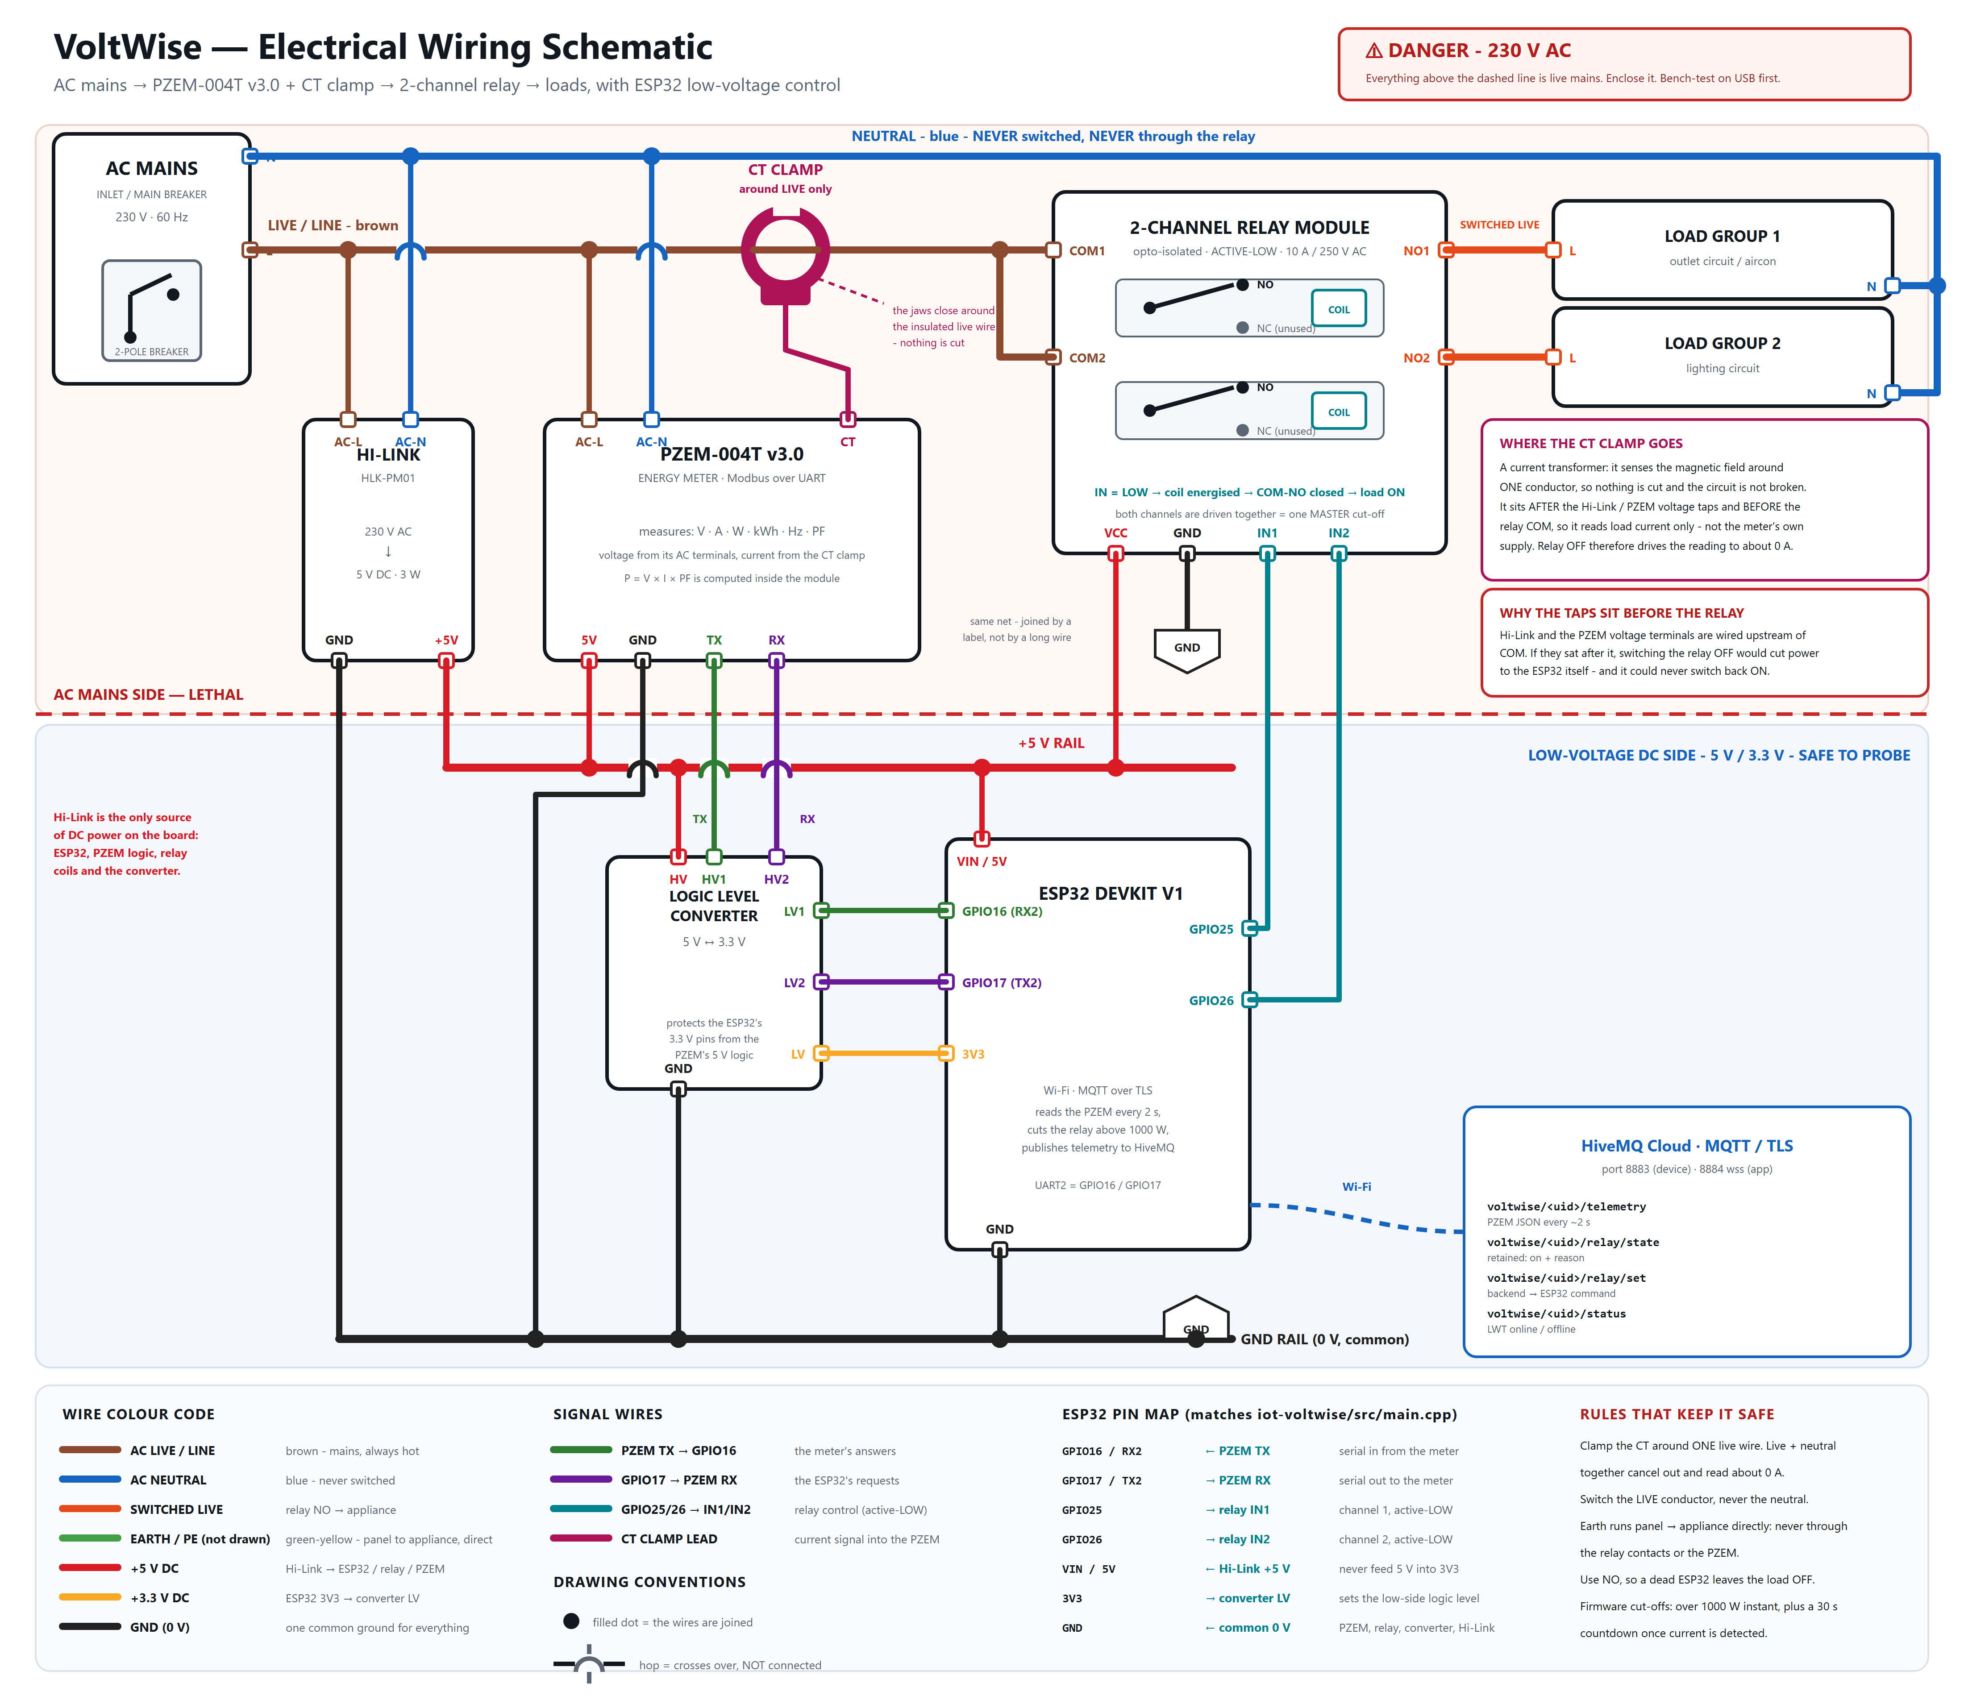
Figure 1 — VoltWise electrical wiring schematic. Filled dots are electrical joins; a small arc (hop) means the wires cross without touching. The ⟨GND⟩ tag is a net label: both ends belong to the same ground net, drawn twice instead of as one long wire.

3. Detail views
Detail A — AC mains side: taps, CT clamp position, relay contacts and loads.
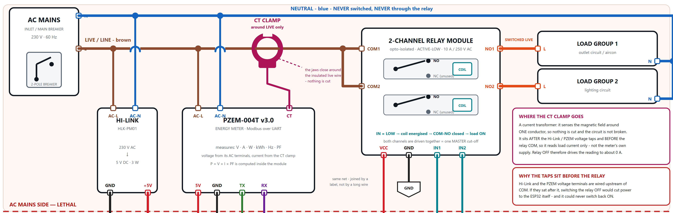

Detail B — Low-voltage DC side: 5 V / GND rails, logic level converter, UART and relay control.
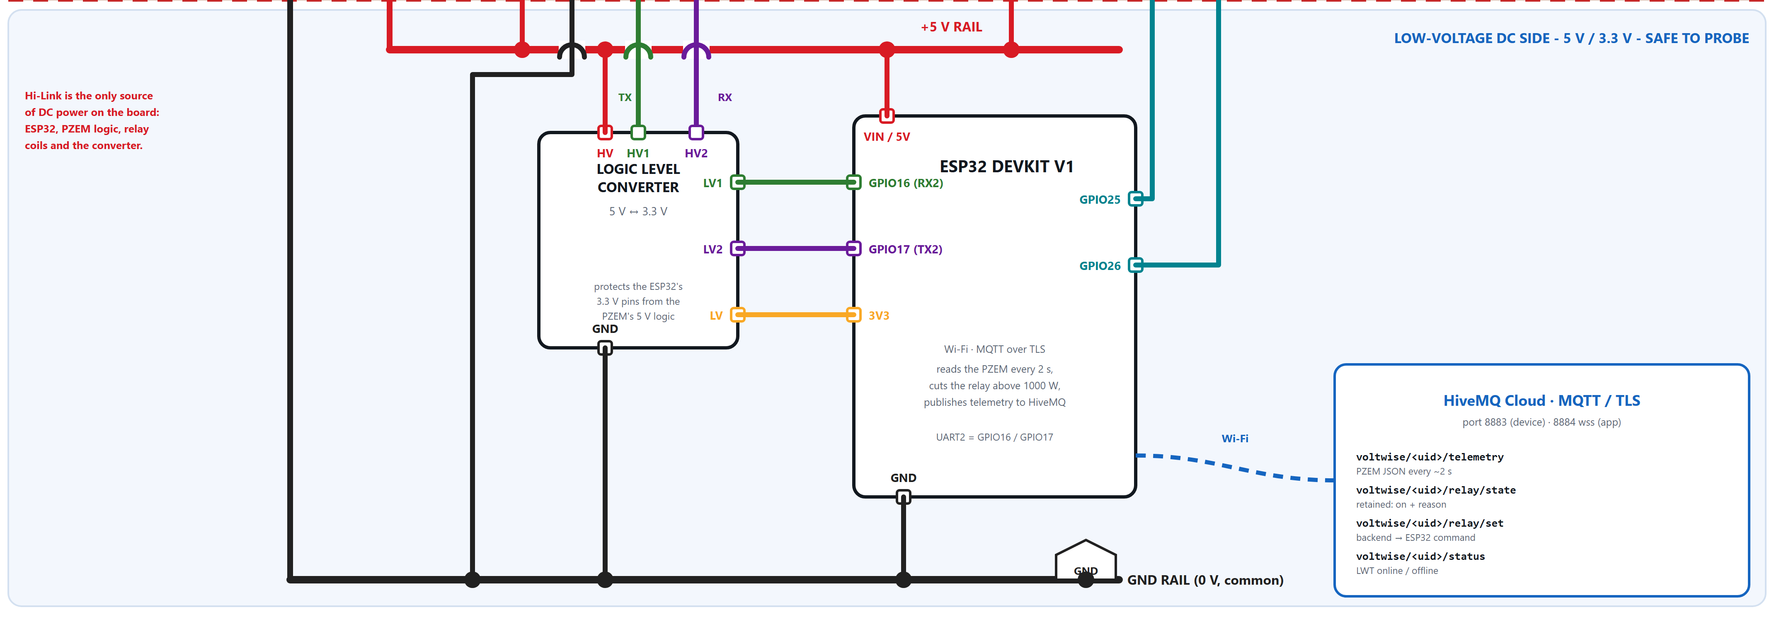

4. Connection summary — what connects to what
Read each bullet as “this terminal goes to that terminal”. Wire colours in brackets match the schematic.

4.1 AC mains side
- Main breaker LIVE → goes to the live bus, which feeds three places: Hi-Link AC-L, PZEM AC-L, and the relay COM1 + COM2 terminals. [brown]
- Main breaker NEUTRAL → goes to the neutral bus, which feeds Hi-Link AC-N, PZEM AC-N, and the N terminal of both load groups directly. It never enters the relay. [blue]
- Hi-Link AC-L / AC-N ← tapped from the live and neutral buses upstream of the relay, so relay OFF cannot cut the node's own power supply. [brown + blue]
- PZEM AC-L / AC-N ← tapped from the same buses; this is how the meter reads voltage, frequency and power factor. [brown + blue]
- CT clamp → closes around the LIVE conductor only, positioned after the Hi-Link and PZEM taps and before the relay COM. [magenta]
- CT clamp lead → plugs into the PZEM CT connector; this is the current signal. [magenta]
- Relay NO1 → live of load group 1 (outlet circuit). [orange = switched live]
- Relay NO2 → live of load group 2 (lighting circuit). [orange = switched live]
- Relay NC1 / NC2 — left unused. Using NO means the loads are OFF whenever the ESP32 is unpowered or crashed.
- Earth / PE — runs from the panel straight to each appliance. It never passes through the relay contacts or the PZEM, and it is not switched. [green-yellow]

4.2 DC power distribution
- Hi-Link +5 V OUT → the +5 V rail, which feeds ESP32 VIN/5V, relay VCC, PZEM 5V and the level converter HV. [red]
- Hi-Link GND OUT → the GND rail, which feeds ESP32 GND, relay GND, PZEM GND and the level converter GND — one common 0 V for everything. [black]
- ESP32 3V3 → level converter LV, which sets the low side of the converter to 3.3 V logic. [amber]
- Rule — Never feed 5 V into the ESP32 3V3 pin — use VIN / 5V.

4.3 Data and control signals
- PZEM TX → converter HV1, and converter LV1 → ESP32 GPIO16 (RX2). The meter's answers. [green]
- ESP32 GPIO17 (TX2) → converter LV2, and converter HV2 → PZEM RX. The ESP32's requests. [purple]
- Note — TX and RX cross over: the ESP32's RX pin listens to the PZEM's TX pin, and vice versa.
- ESP32 GPIO25 → relay IN1 (channel 1). [teal]
- ESP32 GPIO26 → relay IN2 (channel 2). [teal]
- Polarity — the relay module is ACTIVE-LOW — driving IN low energises the coil and closes COM–NO, turning the load ON.

5. Point-to-point connection table
From | To | Wire | Purpose
Breaker LIVE | Live bus (brown) | Brown | Single hot conductor from the 2-pole breaker
Live bus | Hi-Link AC-L | Brown | Mains input to the 5 V supply — upstream of the relay
Live bus | PZEM AC-L | Brown | Voltage measurement input
Live bus | Relay COM1 / COM2 | Brown | Common pole of both relay contacts
Breaker NEUTRAL | Neutral bus (blue) | Blue | Return conductor — never switched
Neutral bus | Hi-Link AC-N | Blue | Mains input to the 5 V supply
Neutral bus | PZEM AC-N | Blue | Voltage measurement reference
Neutral bus | Load 1 N / Load 2 N | Blue | Straight to the appliances, bypassing the relay
CT clamp (on live) | PZEM CT connector | Magenta | Current signal; clamp around LIVE only
Relay NO1 | Load group 1 LIVE | Orange | Switched live — outlet circuit
Relay NO2 | Load group 2 LIVE | Orange | Switched live — lighting circuit
Panel PE | Appliance PE | Green-yellow | Direct earth; never through relay or PZEM
Hi-Link +5 V OUT | +5 V rail | Red | Sole DC source for the whole node
+5 V rail | ESP32 VIN / 5V | Red | Board power
+5 V rail | Relay VCC | Red | Relay coil + opto supply
+5 V rail | PZEM 5V | Red | PZEM logic supply
+5 V rail | Converter HV | Red | High side reference of the level converter
Hi-Link GND OUT | GND rail | Black | Common 0 V
GND rail | ESP32 GND / Relay GND / PZEM GND / Converter GND | Black | All grounds must be common
ESP32 3V3 | Converter LV | Amber | Low side reference — 3.3 V logic
PZEM TX | Converter HV1 | Green | Meter → MCU serial, 5 V side
Converter LV1 | ESP32 GPIO16 (RX2) | Green | Meter → MCU serial, 3.3 V side
ESP32 GPIO17 (TX2) | Converter LV2 | Purple | MCU → meter serial, 3.3 V side
Converter HV2 | PZEM RX | Purple | MCU → meter serial, 5 V side
ESP32 GPIO25 | Relay IN1 | Teal | Channel 1 control, active-LOW
ESP32 GPIO26 | Relay IN2 | Teal | Channel 2 control, active-LOW

6. ESP32 pin assignment
These match iot-voltwise/src/main.cpp exactly. Avoid GPIO0, GPIO2, GPIO12 and GPIO15 for anything else — they affect boot behaviour.
ESP32 pin | Connects to | Function
GPIO16 / RX2 | ← PZEM TX (via converter LV1) | Serial in from the meter
GPIO17 / TX2 | → PZEM RX (via converter LV2) | Serial out to the meter
GPIO25 | → Relay IN1 | Channel 1, active-LOW
GPIO26 | → Relay IN2 | Channel 2, active-LOW
VIN / 5V | ← Hi-Link +5 V | Board supply — never feed 5 V into 3V3
3V3 | → Converter LV | Sets the low-side logic level
GND | ← Common 0 V | Shared with PZEM, relay, converter, Hi-Link

7. Wire colour code
Colour | Net | Where it runs
Brown | AC live / line | Mains hot, always energised — upstream of the relay
Blue | AC neutral | Return path; never switched, never through the relay
Orange | Switched live | Relay NO → appliance; dead when the relay is open
Green-yellow | Earth / PE | Panel to appliance, direct (not drawn as a wire in Figure 1)
Red | +5 V DC | Hi-Link → ESP32, relay, PZEM logic, converter HV
Amber | +3.3 V DC | ESP32 3V3 → converter LV
Black | GND (0 V) | One common ground for every module
Green | UART: PZEM TX → GPIO16 | The meter's answers
Purple | UART: GPIO17 → PZEM RX | The ESP32's requests
Teal | GPIO25/26 → IN1/IN2 | Relay control, active-LOW
Magenta | CT clamp lead | Current signal into the PZEM

8. Why the wiring is arranged this way
- The Hi-Link and PZEM taps sit upstream of the relay. Both are wired to the live and neutral buses before the relay COM. If they sat after it, switching the relay OFF would cut power to the ESP32 itself — and it could never switch back ON.
- The CT clamp position is deliberate. It is placed after those taps and before the relay COM, so it measures load current only, not the node's own supply draw. It also means relay OFF drives the reading to about 0 A, which is exactly what the firmware's shutdown countdown watches for.
- The clamp goes around ONE conductor. A current transformer senses the magnetic field around one conductor. Clamping live and neutral together makes the two fields cancel, and the reading collapses to roughly zero. This is the most common wiring mistake on this build.
- The relay switches live, never neutral. Neutral is a return path; opening it leaves the appliance still connected to a live conductor. Switching live is what actually makes the load safe.
- The contacts are wired normally-open. With NO, an unpowered or crashed ESP32 leaves both load groups OFF. With NC, a firmware fault would silently leave mains connected.
- A logic level converter sits in the UART path. The ESP32 is a 3.3 V part and the PZEM's UART is 5 V. The converter keeps the meter's 5 V logic off the ESP32's pins.
- Both relay channels move together. Both channels are driven together as one master cut-off, which is what the app's Master Power control on the dashboard actually toggles.

9. Firmware behaviour tied to this wiring
Item | Value | Notes
Sampling | Every 2 s | PZEM read over Serial2 (GPIO16/17), 3 retries before declaring a fault
Over-power cut-off | 1000 W | MAX_ALLOWED_POWER_WATTS — instant relay open, never overridable
Shutdown countdown | 30 s | Starts once current above 0.05 A is detected; opens the relay at zero
Relay polarity | Active-LOW | IN low = coil energised = COM–NO closed = load ON
Remote OFF | Latched | Stays off until a remote ON clears the latch
Remote ON | Suppresses countdown | Until current drops once (remoteOverride)
Telemetry topic | voltwise/<uid>/telemetry | PZEM JSON published every ~2 s
Relay state topic | voltwise/<uid>/relay/state | Retained: { on, reason: boot | remote | overpower | countdown }
Relay command topic | voltwise/<uid>/relay/set | Backend → ESP32, { on: boolean }
Status topic | voltwise/<uid>/status | Retained LWT: online / offline

The device UID must match in three places: DEVICE_UID in iot-voltwise/include/secrets.h, MQTT_DEVICE_UID in backend/.env, and EXPO_PUBLIC_MQTT_DEVICE_UID in app-voltwise/.env.

10. Commissioning checklist
- With everything unplugged from mains, wire the DC side only and power the ESP32 from USB.
- Confirm the ESP32 boots and the serial monitor prints at 115200 baud (DIAGNOSTIC_MODE is on by default).
- Check continuity: every module's GND must be common with the ESP32's GND.
- Verify 5 V at the relay VCC and PZEM 5V pins, and 3.3 V at the converter LV pin.
- Toggle GPIO25/26 and listen for the relay to click; confirm active-LOW behaviour matches RELAY_ACTIVE_LOW.
- Power the PZEM logic and confirm the serial monitor reads its slave address — that proves the UART link before any AC is involved.
- Only now, with the circuit de-energised at the breaker, wire the AC side: Hi-Link input, PZEM AC terminals, relay COM and NO.
- Clamp the CT around the LIVE conductor only, arrow/K-L marking facing the source side.
- Close the enclosure, energise, and confirm voltage reads about 230 V with no load connected.
- Switch on a known load (a 60 W lamp) and confirm the current and power readings are sane.
- Publish a relay command from the app and confirm the firmware echoes the new state on relay/state.

If the current reads zero but voltage is correct
The UART link and AC voltage sensing are fine — the fault is on the current path. Check that the CT clamp is fully closed, that it is around one conductor only, and that its plug is seated in the PZEM CT connector. A clamp around live and neutral together is the usual cause.

11. Bill of materials
Component | Qty | Notes
ESP32 DevKit V1 | 1 | Dual-core MCU with Wi-Fi; 3.3 V logic
PZEM-004T v3.0 + CT clamp | 1 | Energy meter: V, A, W, kWh, Hz, PF over UART
2-channel relay module | 1 | Opto-isolated, active-LOW, 10 A / 250 V AC contacts
Hi-Link HLK-PM01 | 1 | 230 V AC → 5 V DC, 3 W
Logic level converter | 1 | Bi-directional 5 V ↔ 3.3 V, 4 channels
Enclosure, terminal blocks, fuse | 1 set | Required for any permanent mains installation

Source files: docs/voltwise_wiring_schematic.png (raster) and docs/voltwise_wiring_schematic.svg (vector, editable). Wiring reference: docs/esp32_pzem_relay_iot_build_guide.md. Firmware: iot-voltwise/src/main.cpp.

