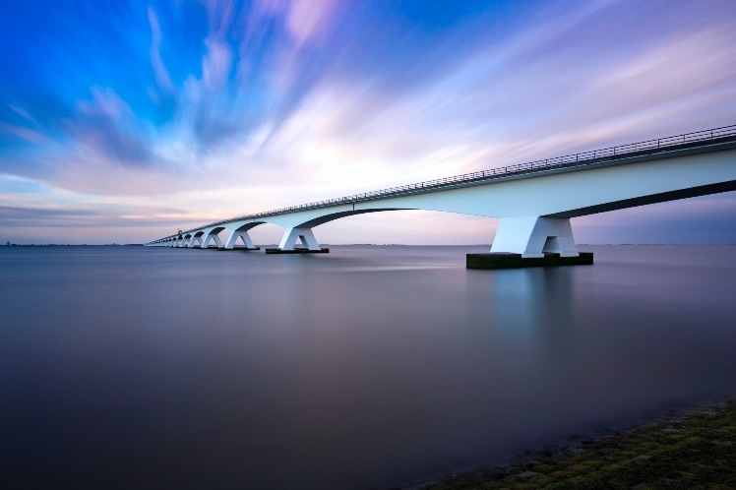Lorem ipsum dolor sit amet, consectetuer adipiscing elit. Maecenas porttitor congue massa.

Figure 1: Caption