**EE569: HOMEWORK 2**

Issued: 9/18/2015 Due: 10/11/2015

Name: Meiyi Yang

Email: [meiyiyan@usc.edu](mailto:meiyiyan@usc.edu)

USC ID: 6761040585

Problem 1: Texture analysis and classification (30%)

a. Texture classification: two classes + minimum mean distance classifier (15%)

b. Advanced texture classification: multi-classes + SVM (15%)

Problem 2: Edge detection (40%)

a. Sobel edge detector and non maximal suppression (10%)

b. Canny edge detector (10%)

c. Structured edge (10%)

d. Performance evaluation (10%)

Problem 3: Image segmentation (40%)

a. MS + superpixel segmentation (15%)

b. Color Palettes generation (15%)

c. Segmentation result evaluation (10%)

Problem 1

I. Concept

Texture

Feature

Extract features from texture

Compute local energy

Filter bank

"Multichannel feature extraction" method

Laws filter

Pattern recognition algorithm

Extract Laws' features

original or reduced feature spaces

Eliminate the redundant features

Reduce computational complexity

II. Approach

PCA (Principal component analysis)

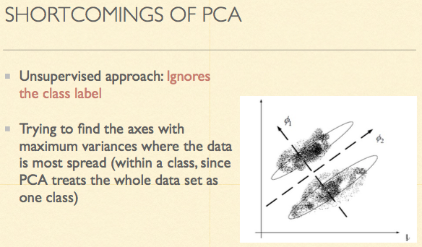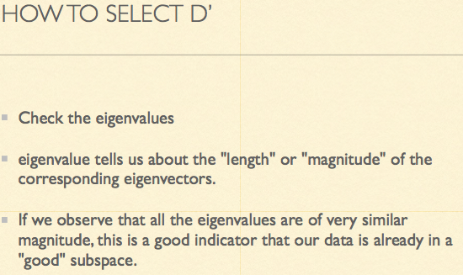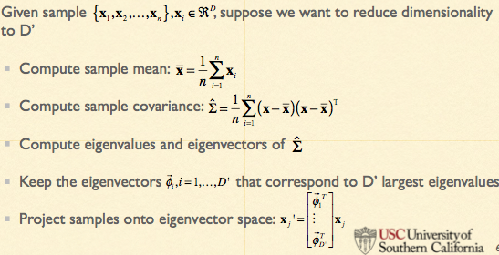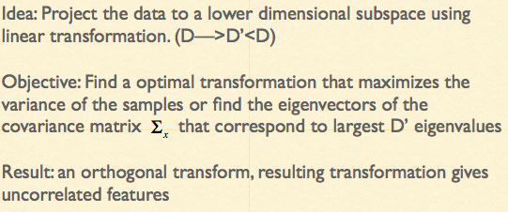

III. Procedure

1. Pre-processing: Compute local mean using the 5 * 5 window, and subtract the local mean from its original intensity value

2. Filter bank processing: Apply 25 5 * 5 Laws' filters

3. Feature averaging

4. Minimum mean distance classification

5. Error rate

6. PCA justification

7. PCA

8. LDA

9. Apply minimum mean distance to PCA result

10. Apply minimum mean distance to LDA result

11. Error rate

12. Compare those result