EE 541 – Project Final Report
©Wenrui Xu, Yichuan Shi, Yixuan Xu
Dec 9, 2021

Introduction
In recent years, computer vision has made great progress, and now GAN can imitate objects in a very convincing way. The competition requires us to use the form of GAN to create a generative model that can deceive the classifier.

Our project mainly focuses on the use of neural network-based generative modeling to generate realistic artworks. We want to create two neural networks: a generator model and a discriminator model. The generator is a neural network that creates images. The generator should generate images in Monet's style and use the discriminator for training. These two models will fight each other, the generator tries to fool the discriminator, and the discriminator tries to accurately classify the real image and the generated image. Finally, build a GAN that generates 7,000 to 10,000 Monet-style images.

The latest advances in deep learning are mainly the result of modern computing architectures, which have led to the creation of models that can learn to generate realistic data. Models such as the Generative Adversarial Network (GAN) we used in this project learn a mapping from the latent vector space, which encodes the features needed to generate the data into the synthetic data in the input data set domain. GAN uses a game-theoretic approach to do this, where two agents (a generator and a discriminator) fight against each other to help each other learn.

Other methods such as variational autoencoders try to construct data generative models by trying to compress the data and reconstruct the learning data. Our project focuses on using GAN to learn painting representations that allow the generation of synthetic paintings.

1.1 Generative Adversarial Networks
Generative Adversarial Networks (GANs) are a neural network architecture composed of two parts: First, A Generator that attempts to map a latent vector space, pulled from a set of random distributions such as Gaussians, to the space in which data lives. Secondly, a Discriminator, which maps from a vector space of the data distribution to a binary classification of whether or not the data given to the network is real or counterfeit.

The purpose of this architecture is to learn a Generator that can create data that looks like it is from the distribution of real data. The Generator and Discriminator play a min-max game in which they make each other better over time. The Generator tries to outsmart the Discriminator and vice versa. These models are trained in an unsupervised manner using the above described min-max game optimization.

1.2 Variational Autoencoders
A Variational Autoencoder (VAE) is a machine learning framework that takes a set of data and forms a compressed (latent) representation of data. An encoder function maps data from an input domain (i.e. images, sounds, etc.), to a lower-dimensional latent space that encodes the features necessary to reconstruct the original data.

Additionally, VAEs encode inputs to distributions over latent space, as opposed to individual points. The decoder function reverses the compression by reconstructing the original data from the latent representation. Typically these decoder and encoder functions are parameterized by neural networks, but it is a flexible framework that can be used with other methods. The VAEs are trained by jointly optimizing for reconstruction of the input data from the compressed representation, and having the latent space fit a predetermined prior distribution (typically Gaussian). This is done by jointly optimizing via gradient descent the reconstruction error (how well the input was reconstructed from a latent form), and a KL divergence term between the learned posterior distribution and a prior distribution.

This has the effect of both learning how to reconstruct input items, and also having the latent space have the shape of a Gaussian. In contrast to traditional Autoencoders, which don’t have the variational aspect, VAEs are capable of generating realistic looking data from latent space that did not exist in the initial training set. This is because when training, the encoder maps to the parameters of a distribution (i.e. mean and standard deviation in the Gaussian case), and that distribution is randomly sampled from. This sampled latent vector is then mapped out to the input space using the decoder. This causes the latent space of the VAE to be smoother, which is conducive to better representations.

1.3 Convolutional Neural Networks
Convolutional Neural Networks (CNNs) are deep learning models that employ “convolutional” filters that scan across the domain of an input distribution to learn a desired output distribution. The key component of CNNs is the convolutional filter that moves across the X and Y spatial dimensions of images, computing a dot product at each location. These filters learn features that are equivariant (change independent) to translation. Images have many features, like eyes or ears in a face dataset, that can be present at any location in an image.

CNNs allow the sharing of parameters across different spatial dimensions of data thus lowering the size of the network necessary to learn certain patterns and avoiding all of the problems with having a larger network like slower convergence, overfitting, and slower training time. We employ convolutional layers in our GANs as well as VAEs to more easily learn representations of the image data.

1.4 CycleGAN
We use a neural network architecture called CycleGAN that enables the learning of image to image translation. CycleGAN is largely based on an architecture called pix2pix[4] that outlines what is called a conditional GAN. Typical GANs learn mapping from a latent vector z to the input distribution x. The novelty of pix2pix was the addition of conditioning the mapping z to x on an input image p. This takes into account additional information from an input image when rendering the output image x. This could be thought of as learning a mapping from p to x through the intermediate representation z that is learned in an adversarial fashion. CycleGAN builds on top of pix2pix by both learning the mapping p to x and x to p. This has been shown to lead to better representations and generated data. This architecture is useful for the application of image to image translation. We use CycleGAN to learn mappings between art data and regular images.
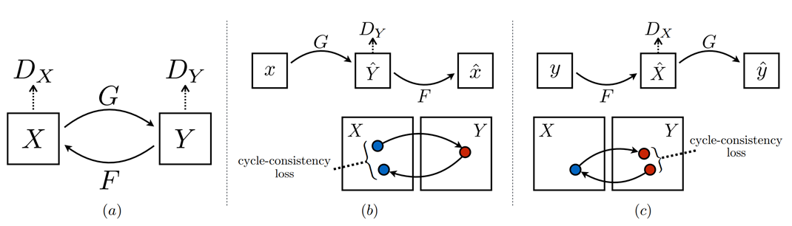 (Zhu et al. #)

Project Goal
We aim to leverage novel machine learning methods to generate realistic looking and aesthetically pleasing art from a dataset of examples. We would also like to be able to render artwork that encompasses certain parameters of a painting like the year, artist, color content, and style. We want to employ some of the methods described in section one to learn generative models based on art datasets.

Dataset
We primarily used a Kaggle dataset of the Best Artworks of All Time. This dataset included mostly paintings from artists like Monet, Da Vinci, and Warhol. We prepared the data by fitting it to a 150x150 grid that shows the central part of the paintings. A secondary dataset that was used was the monet2photo dataset[6] that shows mappings between monet paintings and photos of the scenes that those paintings depict. We also used the CMP Facade Dataset briefly, which included rectified images of facades from various sources and their source images.

Methods and Results
We did several trials to realize the Monet style transformation. At the beginning, we start with an intuitive network using the pretrained Model VGG16 to extract the input image and the style image features. By taking in a content image and a style image as input, we use MSE to separately calculate the loss between the output image with the content image and the loss between the output image with the style image. Through minimizing the total loss of these two, we can get a output that is both similar to the content image(shape) and the style image(texture)

Next, we train basic GAN infrastructure as it is highlighted in the kaggle learning and implement the cycleGAN to depict images based on the appearance and visual style of other images. To build the model, we need to focus on building the generator, building the discriminator and handling the loss function.

4.1 Generator and discriminator structure
The generator first downsamples the input image and then upsample while establishing long skip connections. Skip connections are a way to help bypass the vanishing gradient problem by concatenating the output of a layer to multiple layers instead of only one. The architecture of the generator is a modified U-Net, consisting of an encoder block and a decoder block in a symmetrical fashion, each of them is made up of simpler blocks of layers. Unet are pretty versatile and help out in our Generator to distill the input image to a lower dimension and then back to the full size at the target.

The generator can be decomposed into the following blocks: The execution of a downsample-k block -> the execution of an upsampleD-k block (with Dropout) -> the execution of an upsample-k block (without Dropout) -> Transposed Convolution of 3 filters to convert the output into a 256X256 image by 3 channels
While the discriminator does not need a Unet, just a nice simple downsample to get a simple fake or real representation in numbers. The downsample inside mainly consists of convolution,normalisation and relu layer.
During their competition, the discriminator improves the ability to detect if the images are real, and the Generator improves the ability to generate fake images that look more real.

4.2 CycleGan

By utilizing the basic structure of generator and discriminator, we can build the following networks combining into cycleGAN to perform image to image mapping on images of monet paintings to lifelike images.
Monet Generator: Creates monet style images using photos.
Photo Generator: Creates photos using monet style images
Monet Discriminator: Determines whether the monet image is real or generated
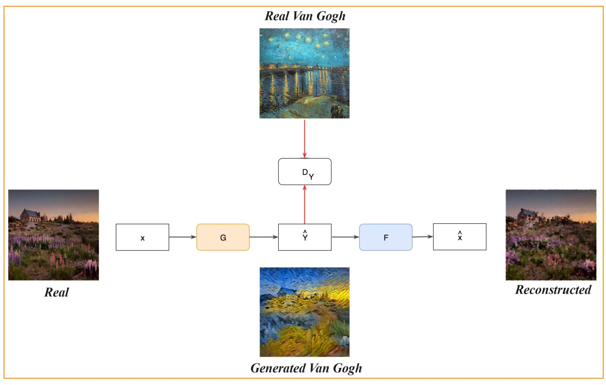
Photo Discriminator: Determines whether the photo is real or generated.
During the training step, the model transforms a photo to a Monet painting and then back to a photo. The difference between the original photo and the twice-transformed photo is the cycle-consistency loss. We want the original photo and the twice-transformed photo to be similar to one another.
There are 8 type of data in a CycleGAN:
Real Photos: Real photos from the dataset
Real Monet Style Images: Real monet paintings from the dataset
Generated Photos (using Monet Style Images)
Generated Monet Style Images (using Photos)
Cycled Photos: Real Photo => Monet Generator => Generated Monet => Photo Generator => Photo
Cycled Monet Style Images: Real Monet => Photo Generator => Generated Photo => Monet Generator => Monet
Same Photos: Real Photo => Photo Generator => Photo
Same Monet Style Images: Real Monet => Monet Generator => Monet

4.3 Loss Function
There are 4 types of loss functions in a CycleGAN, the rate of generator loss and the discriminator loss in the learning epochs is shown below:
Discriminator loss: Total of real_image loss and fake_image loss (BCE loss)
The discriminator loss function compares real images to a matrix of 1s and fake images to a matrix of 0s. The perfect discriminator will output all 1s for real images and all 0s for fake images. The discriminator loss outputs the average of the real and generated loss.
Generator loss: Fake image loss (BCE loss)
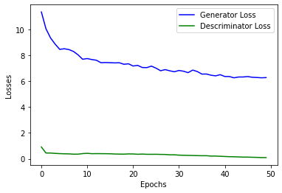
The generator wants to fool the discriminator into thinking the generated image is real. The perfect generator will have the discriminator output only 1s. Thus, it compares the generated image to a matrix of 1s to find the loss.
Cycle Loss: We want our original photo and the twice transformed photo to be similar to one another. Thus, we can calculate the cycle consistency loss by finding the average of their difference
Identity Loss: The identity loss compares the photo with a photo generator. If given a photo as input, we want it to generate the same image as the image was originally a photo. The identity loss compares the input with the output of the generator.

4.4 Visualized Results

We had great results in our CycleGAN and style transfer experiments, since with our approach, we were able to generate a variety of images that successfully transferred a style from a source image to a destination image. While the generated results are less vibrant than the real monet painting, this makes sense as the real world is less vibrantly colored than Monet’s imagination.
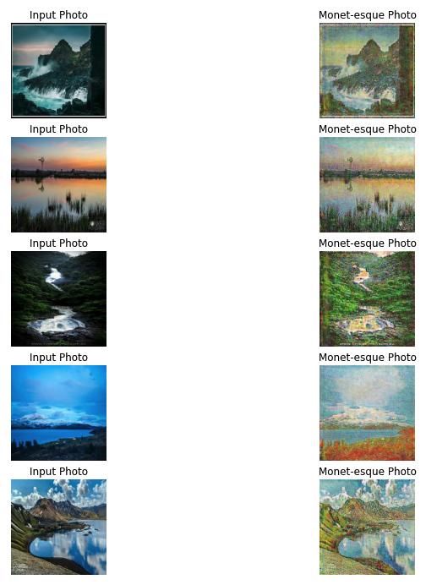

Summary
The project explored many knowledge and frameworks in machine learning and generative modeling. It has many supervised and unsupervised components as our main machine learning framework: GAN applies supervised learning by labeling real and false generated images with a discriminator, and the rest of the architecture is applied to unsupervised learning problems, such as generating images.

Our experimental results achieved the goals we. We have achieved very good results in the CycleGAN experiment, and obtained close to photo-realistic results from the accurate object detection of Monet paintings and the input architecture images we input.

Generative modeling is a rapidly developing field in deep learning. The various models explored in this project, including GAN and CycleGAN, allow us to better understand how they work and how they are applied.

Reference
- https://github.com/sw-song/PyTorch-GAN

- https://github.com/junyanz/CycleGAN

- https://www.kaggle.com/bootiu/cyclegan-pytorch-lightning

- https://www.kaggle.com/nachiket273/cyclegan-pytorch

- https://www.kaggle.com/shivansh002/gentle-introduction-to-gan

- https://jakepresent.github.io/

- https://www.kaggle.com/songseungwon/cyclegan-tutorial-from-scratch-monet-to-photo

