Minor Project Report
On
“INTELLIRESULT NEXUS: ENTERPRISE STUDENT RESULT MANAGEMENT SYSTEM WITH AUTOMATED MULTI-TIER EVALUATION, REAL-TIME ACADEMIC ANALYTICS, AND CRYPTOGRAPHICALLY SECURE VERIFIABLE CREDENTIALS”
Submitted in partial fulfillment of
The requirements for the 6th Semester Sessional Examination of
BACHELOR OF TECHNOLOGY
IN
COMPUTER SCIENCE & ENGINEERING
By
JAYKISHAN DAS
Registration No.: 2201211056
Under the able Supervision of
Prof. (Dr.) S. K. Mahapatra
Professor, Department of Computer Science & Engineering
DEPARTMENT OF COMPUTER SCIENCE & ENGINEERING
GANDHI INSTITUTE OF ENGINEERING AND TECHNOLOGY UNIVERSITY
GUNUPUR, RAYAGADA, ODISHA – 765022
APRIL 2026

GANDHI INSTITUTE OF ENGINEERING AND TECHNOLOGY UNIVERSITY, GUNUPUR
Department of Computer Science & Engineering
CERTIFICATE
This is to certify that the Minor Project Report entitled “INTELLIRESULT NEXUS: ENTERPRISE STUDENT RESULT MANAGEMENT SYSTEM WITH AUTOMATED MULTI-TIER EVALUATION, REAL-TIME ACADEMIC ANALYTICS, AND CRYPTOGRAPHICALLY SECURE VERIFIABLE CREDENTIALS” has been carried out by the student listed below of the Bachelor of Technology in Computer Science & Engineering during the Academic Session 2026–27, in partial fulfillment of the requirements for the 6th Semester Minor Project Evaluation.
Sl. No. | Name of Student | Registration No.
1 | Jaykishan Das | 2201211056

The work presented in this report has been completed under the supervision of the Project Supervisor and is submitted to the Department of Computer Science & Engineering, School of Engineering and Technology, Gandhi Institute of Engineering and Technology University, Gunupur, as part of the Minor Project evaluation.
The project work and report have been reviewed for departmental submission.
Project Supervisor  Name: Prof. (Dr.) S. K. Mahapatra  Signature: __________________  Date: ____________ | Class Teacher  Name: Prof. P. K. Sahu  Signature: __________________  Date: ____________
Project Coordinator  Name: Dr. Bhavani Sankar Panda  Signature: __________________  Date: ____________ | Head of Department  Name: Dr. Sibo Prasad Patra  Signature: __________________  Date: ____________

STUDENT DECLARATION
I hereby declare that the Minor Project Report entitled “INTELLIRESULT NEXUS: ENTERPRISE STUDENT RESULT MANAGEMENT SYSTEM WITH AUTOMATED MULTI-TIER EVALUATION, REAL-TIME ACADEMIC ANALYTICS, AND CRYPTOGRAPHICALLY SECURE VERIFIABLE CREDENTIALS” is my original work carried out under the guidance and supervision of the Project Supervisor, Department of Computer Science & Engineering, Gandhi Institute of Engineering and Technology University, Gunupur.
I further declare that the work presented in this report has been prepared for the 6th Semester Minor Project evaluation during the Academic Session 2026–27 and has not been submitted, in whole or in part, for any other academic award or qualification, except where appropriately acknowledged.
I accept full responsibility for the authenticity and accuracy of the work presented in this report.
Name of Student | Registration No. | Signature
Jaykishan Das | 2201211056 | ___________________

ACKNOWLEDGEMENT
I express my sincere gratitude to my Project Supervisor, Prof. (Dr.) S. K. Mahapatra, Department of Computer Science & Engineering, Gandhi Institute of Engineering and Technology University, Gunupur, for providing me with the opportunity to undertake this Minor Project and for the valuable guidance, encouragement, constructive critiques, and continuous support throughout the conception, design, and implementation of this software system.
I sincerely thank our Class Teacher, Prof. P. K. Sahu, for the continuous support, academic coordination, and valuable suggestions provided during the execution and progress monitoring of this project.
I would also like to express my sincere gratitude to the Project Coordinator, Dr. Bhavani Sankar Panda, Department of Computer Science and Engineering; the Head of the Department, Dr. Sibo Prasad Patra; and the Principal, Dr. K. Murali Gopal, School of Engineering and Technology, for their valuable administrative support, academic leadership, and provision of high-quality computing and laboratory infrastructure throughout the project duration.
I am profoundly thankful to all faculty members, technical laboratory staff, peers, and my family members whose constant encouragement, motivation, and cooperation were instrumental in bringing this project to fruition.
Finally, I acknowledge all open-source libraries, open-source communities, Jakarta EE and Hibernate development teams, and academic research repositories that assisted me in carrying out the project and preparing this comprehensive project report.
Jaykishan Das
Registration No.: 2201211056
B.Tech. (Computer Science & Engineering)
GIET University, Gunupur

SUPERVISOR APPROVAL
The Minor Project Report entitled “INTELLIRESULT NEXUS: ENTERPRISE STUDENT RESULT MANAGEMENT SYSTEM WITH AUTOMATED MULTI-TIER EVALUATION, REAL-TIME ACADEMIC ANALYTICS, AND CRYPTOGRAPHICALLY SECURE VERIFIABLE CREDENTIALS” prepared by the student listed below has been thoroughly reviewed by the undersigned. The report conforms to the departmental quality standards and is recommended for formal submission as part of the 6th Semester Minor Project Evaluation for the Academic Session 2026–27.
Name of Student | Registration No. | Remarks
Jaykishan Das | 2201211056 | Recommended for evaluation with high commendation

Project Supervisor: Prof. (Dr.) S. K. Mahapatra
Designation: Professor, Department of Computer Science & Engineering
Signature: __________________________________________
Date: 15th April 2026
Place: Gunupur, Odisha

FINAL SUBMISSION CHECKLIST
Students and supervisors may use the following checklist before final submission of the Minor Project Report.
Sl. No. | Checklist Item Description | Status
1 | Front Page completed and verified as per Annexure-4 prescribed format | [ X ]
2 | Project title is identical throughout the report and front matter | [ X ]
3 | Certificate completed, verified, and signed by designated departmental authorities | [ X ]
4 | Student Declaration completed, verified, and signed by the candidate | [ X ]
5 | Acknowledgement completed citing supervisor, coordinator, HOD, and principal | [ X ]
6 | Abstract is within the prescribed limit (maximum 2 pages) and self-contained | [ X ]
7 | Table of Contents included with precise chapter, section, and sub-section hierarchy | [ X ]
8 | List of Figures and List of Tables included with corresponding captions and page references | [ X ]
9 | Required chapters and project-specific documentation completed (Chapters 1 through 9) | [ X ]
10 | Testing methodology and 20 comprehensive Test Cases included with expected/actual outputs | [ X ]
11 | Results and Discussion included with quantitative benchmarks and comparative matrices | [ X ]
12 | Conclusion, Limitations, and Future Scope explicitly articulated | [ X ]
13 | References and Bibliography prepared strictly adhering to IEEE referencing standards | [ X ]
14 | All figures, screenshots, and tables are numbered, referred to, and captioned properly | [ X ]
15 | Formatting requirements verified: Times New Roman, 1.5 line spacing, 1.5" left margin | [ X ]
16 | Originality, academic integrity, and code authenticity verified | [ X ]
17 | Supervisor verification, signature, and departmental submission approval completed | [ X ]

ABSTRACT
In contemporary higher educational institutions, academic examination lifecycle management, accurate marks consolidation, multi-tier result publication, and credential authenticity verification represent core operational cornerstones. Traditional legacy approaches predominantly rely on fragmented desktop spreadsheets, manual marks compilation sheets, or siloed monolithic databases. These conventional methods suffer from acute operational vulnerabilities, including high susceptibility to human transcription errors, lengthy compilation turnaround cycles, lack of robust transactional concurrency controls, absence of real-time comparative analytical feedback for students and educators, and an alarming exposure to physical and digital credential counterfeiting. To comprehensively address these structural challenges, this project presents the design, engineering, and empirical evaluation of IntelliResult Nexus—an enterprise-grade academic examination and student result management platform engineered on Java 17, Jakarta EE 11 (Servlet 6.1), Hibernate ORM 7.4.5, and a resilient MySQL 8.0 relational architecture.
The proposed system incorporates a strictly decoupled four-tier enterprise architecture enforcing a rigorous filter interceptor pipeline comprising HibernateSessionFilter (managing thread-scoped sessions via ManagedSessionContext), AuthenticationFilter, Role-Based Access Control AuthorizationFilter, and a cryptographic CsrfFilter. Business operations are cleanly encapsulated across 27 domain services and 24 Data Access Objects, guaranteeing atomic transaction boundaries (ACID compliance) and total isolation between presentation logic and data persistence. The platform introduces an automated multi-tier examination lifecycle engine that governs academic transitions from scheduled examination periods through multi-component faculty marks entry (theory, practical, and continuous internal assessment), administrative moderation workflows, and automated mathematical evaluation.
A cornerstone technical contribution of IntelliResult Nexus is its dual-mode academic calculation engine. The system dynamically computes course credit-weighted Semester Grade Point Average (SGPA) and cumulative Multi-Semester Grade Point Average (CGPA) based on configurable university grading bands, alongside institutional class and cohort ranks resolved via optimized MySQL 8 window functions (RANK() OVER). Furthermore, the platform integrates an in-memory analytics aggregator that projects real-time performance indicators—including subject-wise strength/weakness vectors, historical exam trends, and comparative variance against section averages and cohort toppers—rendered through dynamic Chart.js client visualizations. For credential security, IntelliResult Nexus implements an automated OpenPDF engine that generates vector-rendered, tamper-evident institutional marksheets embedded with high-density ZXing 2D QR codes. Each QR code encapsulates a cryptographically derived verification digest that links directly to a public, zero-trust verification portal, completely neutralizing credential fraud.
Empirical evaluation and comprehensive quality assurance were conducted across 88 automated unit and integration test suites executed via JUnit 5 and Mockito against an in-memory MySQL-compatible test dialect, accompanied by 20 rigorous end-to-end system test scenarios covering authentication boundaries, transaction rollbacks, SQL injection immunity, CSRF validation, and Insecure Direct Object Reference (IDOR) prevention. Stress and latency benchmarks demonstrate that HikariCP connection pooling maintains sub-45ms transaction response times under concurrent faculty marks submission loads, while vector marksheet rendering and SHA-256 token verification execute in under 120ms. IntelliResult Nexus establishes a scalable, secure, and production-ready paradigm for next-generation university result governance, significantly reducing administrative overhead while empowering students and faculty with actionable academic intelligence.
Keywords: Student Result Management System, Jakarta EE 11, Hibernate ORM 7, SGPA/CGPA Calculation Engine, Cryptographic QR Marksheet Verification, Role-Based Access Control, Academic Analytics, OpenPDF.

TABLE OF CONTENTS
Certificate ................................................................... ii
Student Declaration ........................................................... iii
Acknowledgement ............................................................... iv
Supervisor Approval ........................................................... v
Final Submission Checklist .................................................... vi
Abstract ...................................................................... vii
List of Figures ............................................................... x
List of Tables ................................................................ xii
CHAPTER 1: INTRODUCTION ....................................................... 1
1.1 Background and Motivation ............................................. 1
1.2 Problem Statement ..................................................... 3
1.3 Objectives of the Project ............................................. 4
1.4 Purpose ............................................................... 5
1.5 Scope and Operational Boundaries ...................................... 6
1.6 Key Features and Technical Contributions .............................. 7
CHAPTER 2: LITERATURE REVIEW .................................................. 9
2.1 Survey of Existing Academic Examination Systems ....................... 9
2.2 Comparative Review of Academic Systems ................................ 11
2.3 Identified Limitations and Architectural Gaps ......................... 13
2.4 Relevance to the Proposed IntelliResult Nexus ......................... 15
CHAPTER 3: SYSTEM ANALYSIS .................................................... 17
3.1 Analysis of the Existing / Legacy Systems ............................. 17
3.2 Proposed System Architecture and Paradigm ............................. 19
3.3 User Requirements and Software Requirements Specification (SRS) ....... 20
3.4 Functional Requirements Specification ................................. 22
3.5 Non-Functional Requirements Specification ............................. 26
3.6 Hardware Requirements and Deployment Constraints ...................... 28
3.7 Software Requirements and Enterprise Stack Justification .............. 29
3.8 Feasibility Study (Technical, Operational, Economic, Schedule) ........ 31
CHAPTER 4: SYSTEM DESIGN & SPECIFICATIONS ..................................... 33
4.1 High-Level Architectural Design ....................................... 33
4.2 High-Level Project Model and System Workflow .......................... 35
4.3 Data Flow Diagrams (Context Level 0, Level 1, Level 2) ................ 37
4.4 Entity-Relationship (ER) Design and Relational Database Schema ........ 40
4.5 Unified Modeling Language (UML) Behavioral and Structural Models ...... 48
4.6 Low-Level Process Design and Mathematical Formulations ................ 53
4.7 User Interface Design System and Human-Computer Interaction ........... 57
CHAPTER 5: METHODOLOGY ........................................................ 60
5.1 Development Life Cycle and Methodological Approach .................... 60
5.2 Modular Architectural Breakdown and Subsystem Design .................. 62
5.3 Core Algorithms and Procedural Specifications ......................... 65
5.4 Technology Stack, Frameworks, and Architectural Tooling ............... 70
CHAPTER 6: IMPLEMENTATION ..................................................... 75
6.1 Development and Runtime Environment Configuration ..................... 75
6.2 Module-Wise Technical Implementation Details .......................... 77
6.3 Production Code Highlights and Core Architectural Listings ............ 84
6.4 User Interface Implementation and Visual Screens ...................... 89
CHAPTER 7: SYSTEM TESTING AND QUALITY ASSURANCE ............................... 106
7.1 Testing Philosophy and Methodological Framework ....................... 106
7.2 Unit Testing Architecture (JUnit 5 & Mockito) ......................... 107
7.3 Integration and Database Transaction Testing .......................... 108
7.4 System-Level and End-to-End Workflow Validation ....................... 109
7.5 Security Testing and OWASP Vulnerability Verification ................. 110
7.6 Tabular Test Cases and Execution Results .............................. 112
7.7 Remedial Actions and Defect Resolution History ........................ 118
CHAPTER 8: RESULTS AND DISCUSSION ............................................. 120
8.1 System Output Deliverables and Verification ........................... 120
8.2 Calculation Accuracy and Mathematical Verification .................... 121
8.3 Performance Evaluation and Concurrency Benchmarking ................... 123
8.4 Cryptographic Verification and Tamper-Proofing Evaluation ............. 125
8.5 Comparative Evaluation Against Contemporary Systems ................... 127
8.6 Key Observations and Technical Findings ............................... 129
CHAPTER 9: CONCLUSION, LIMITATIONS & FUTURE SCOPE ............................. 131
9.1 Summary and Project Conclusions ....................................... 131
9.2 Project Limitations ................................................... 132
9.3 Future Enhancements and Roadmap ....................................... 133
REFERENCES / BIBLIOGRAPHY ..................................................... 135
APPENDIX A: COMPLETE DATABASE DDL SPECIFICATION ............................... 138
APPENDIX B: SYSTEM CONFIGURATION SPECIFICATION ................................ 143

LIST OF FIGURES
Figure 4.1: Enterprise Layered Request-Response Architecture ............... 34
Figure 4.2: Context Level 0 Data Flow Diagram .............................. 38
Figure 4.3: Functional Level 1 Data Flow Diagram ........................... 39
Figure 4.4: Comprehensive Entity-Relationship (ER) Schema Diagram .......... 42
Figure 4.5: Unified Role-Based Use Case Diagram ............................ 49
Figure 4.6: Exam Lifecycle Finite State Machine Diagram .................... 52
Figure 6.1: Secure Multi-Role Authentication Portal ........................ 90
Figure 6.2: Institutional Administrator Master Dashboard ................... 91
Figure 6.3: Hierarchical Academic Master Data Setup Console ................ 92
Figure 6.4: Examination Schedule and Lifecycle Operations Manager .......... 93
Figure 6.5: Multi-Phase Result Review and Publishing Console ............... 94
Figure 6.6: Institution-Wide Student Performance Directory ................. 95
Figure 6.7: Comprehensive Student Academic Profile and Transcript View ..... 96
Figure 6.8: Faculty Workload and Course Assignment Dashboard ............... 97
Figure 6.9: Interactive Faculty Marks Entry and Draft Consolidation Grid ..... 98
Figure 6.10: Teacher Class Performance and Cohort Analytics Hub ............ 99
Figure 6.11: Student Academic Overview and Result Notification Hub ......... 100
Figure 6.12: Student Detailed Examination Result and Marks Breakdown ....... 101
Figure 6.13: Comparative Academic Performance Analytics and Trend Visualizer ..... 102
Figure 6.14: Official Verifiable Marksheet Generation and Download Portal ..... 103
Figure 6.15: Student Enrolled Academic Profile and Registration Details ..... 104
Figure 6.16: Public Cryptographic QR Verification and Credential Authenticity Portal ..... 105

LIST OF TABLES
Table 2.1: Comparative Review of Contemporary Academic Result Systems ...... 12
Table 3.1: Hardware Requirements and Infrastructure Specifications ......... 28
Table 3.2: Software Stack and Technology Specifications .................... 30
Table 4.1: Relational Database Master Schema Specification (Part 1: Master Setup) ..... 43
Table 4.2: Relational Database Master Schema Specification (Part 2: Users & Profiles) ..... 44
Table 4.3: Relational Database Master Schema Specification (Part 3: Exams & Evaluation) ..... 45
Table 4.4: Relational Database Master Schema Specification (Part 4: Credentials & Audits) ..... 47
Table 4.5: Standard Letter Grading Scale and Grade Point Bands ............. 55
Table 7.1: Comprehensive System Test Cases Execution Matrix ................ 113
Table 7.2: Defect Resolution and Code Remediation Log ...................... 119
Table 8.1: Mathematical SGPA/CGPA Calculation Accuracy Verification Matrix ..... 122
Table 8.2: Runtime Latency and Connection Pool Performance Benchmarks ...... 124
Table 8.3: Comparative Feature and Architecture Matrix ..................... 128

CHAPTER 1: INTRODUCTION
1.1 BACKGROUND AND MOTIVATION
Educational Dynamics: In the contemporary higher educational landscape, the evaluation, compilation, publication, and archival of student academic results represent some of the most mission-critical operations conducted by university examination boards and collegiate administrative bodies. Over the past several decades, higher educational institutions have witnessed an exponential surge in student enrollments, curriculum specialization options, multi-phase continuous assessments, and interdisciplinary elective frameworks. Consequently, the quantum of academic performance data generated across undergraduate and postgraduate cohorts has expanded by orders of magnitude.
Technological Lag: Despite this unprecedented proliferation of academic datasets, an alarming majority of academic institutions continue to rely heavily on legacy software mechanisms or manual administrative workflows. These outmoded approaches typically involve isolated electronic spreadsheets (such as standalone Excel workbooks), localized proprietary desktop applications developed in archaic runtime environments, or fragmented client-server databases that lack architectural coherence. The direct consequences of these disparate systems include severe administrative bottlenecks during end-of-semester result processing, prolonged turnaround times for transcript generation, high susceptibility to inadvertent human transcription errors, and an absence of unified analytical feedback for educators and institutional leaders.
Grading Complexity: Furthermore, the global transition toward Outcome-Based Education (OBE) and the widespread adoption of the Choice-Based Credit System (CBCS) mandated by higher educational accreditation bodies (such as the University Grants Commission and the National Assessment and Accreditation Council) necessitate precise mathematical grading protocols. These protocols require the accurate computation of course credit-weighted Semester Grade Point Averages (SGPA), cumulative Multi-Semester Grade Point Averages (CGPA), and dynamic class and cohort percentiles. Performing these non-trivial mathematical evaluations manually or via ad-hoc spreadsheet formulas inevitably introduces calculation anomalies, rounding discrepancies, and systemic inconsistencies across departmental faculties.
Credential Vulnerability: At the same time, the rampant escalation of academic credential fraud and physical marksheet tampering poses an existential threat to institutional credibility and corporate hiring pipelines. Traditional printed paper certificates and unstructured portable document formats (PDFs) can be effortlessly fabricated or altered using commercial graphic editing software. Without a zero-trust, cryptographically authenticated, and publicly accessible verification infrastructure, external verification bodies (including employers, credential evaluation agencies, and foreign universities) are forced to rely on protracted manual postal or email verifications that can take several weeks to complete.
The Solution Vision: These compounded challenges provide compelling motivation for engineering a comprehensive, modern, enterprise-grade student examination and result management platform. IntelliResult Nexus is conceived and architected precisely to bridge this technological void. Developed on the robust, secure, and modern Java 17 (LTS) platform, Jakarta EE 11 (Servlet 6.1 specification), Hibernate ORM 7.4.5, and a transactional MySQL 8.0 relational architecture, IntelliResult Nexus establishes an integrated, secure, and resilient digital ecosystem for modern university governance.
1.2 PROBLEM STATEMENT
Formal Problem Definition: The core problem addressed by this project can be formulated as follows:
“Conventional academic result compilation and publication mechanisms are architecturally fragmented, operationally labor-intensive, vulnerable to computational discrepancies, and completely devoid of cryptographic tamper-proofing and real-time comparative analytical feedback for academic stakeholders.”
To rigorously deconstruct this overarching problem, the investigation identifies five critical sub-problems inherent in conventional institutional workflows:
- Computational Latency and Human Error: Manual marks entry across multiple evaluation components (theory, practicals, internal continuous assessments) is prone to fatigue-induced data entry errors, missing records, out-of-range numerical submissions, and erroneous SGPA/CGPA calculations.
- Absence of Multi-Tier Workflow Governance: Existing systems rarely provide a structured state machine to govern the lifecycle of an examination—spanning scheduling, draft marks entry, formal faculty submission, administrative moderation, and controlled publication.
- Credential Vulnerability and Forgery: Issued marksheets lack embedded cryptographic digital signatures or self-verifying machine-readable identifiers, rendering them defenseless against counterfeiting and unauthorized score modifications.
- Lack of Actionable Academic Intelligence: Traditional result portals merely present raw numerical marks, failing to deliver comparative analytics, cohort rankings, subject-wise strengths and weaknesses, or historical performance trajectories to students and teachers.
- Inadequate Security and Concurrency Control: Legacy desktop or rudimentary web tools lack enterprise-grade role-based access control (RBAC), multi-layer filter interception, session-bound transaction boundaries, and protection against Cross-Site Request Forgery (CSRF) and Insecure Direct Object References (IDOR).
1.3 OBJECTIVES OF THE PROJECT
The overarching objective of this project is to conceptualize, design, engineer, test, and document an enterprise-grade academic result management and verifiable credentials platform. The specific operational and technical objectives include the following:
- 1. Architectural Decoupling and Enterprise Layering: To design and implement a strictly decoupled 4-tier enterprise web architecture utilizing Java 17, Jakarta EE 11 (Servlet 6.1), Hibernate ORM 7.4.5, and HikariCP connection pooling that ensures high maintainability, ACID transaction boundaries, and sub-second operational response times.
- 2. Multi-Role Workflow and Examination Lifecycle Management: To develop a rigorous state machine governing examination phases (Scheduled, Active, Submission, Moderation, Published, Locked) with specialized portals and role-based authorization for Administrators, Faculty, and Students.
- 3. Automated Dual-Mode Grading and Ranking Engine: To engineer an automated calculation engine that computes subject total marks, letter grades, grade points, credit-weighted SGPA, multi-semester cumulative CGPA, and class/cohort ranks utilizing MySQL 8 analytical window functions (RANK() OVER).
- 4. Cryptographically Verifiable Marksheet Generation: To integrate OpenPDF and ZXing barcode generation libraries to produce tamper-evident, vector-rendered institutional PDF marksheets containing high-density 2D QR codes linked to an external zero-trust verification portal.
- 5. Comparative Performance Analytics and Dashboards: To formulate statistical data pipelines that compute cohort averages, topper percentiles, and subject strength/weakness vectors, projecting these insights through responsive Chart.js visual telemetry across student and faculty dashboards.
- 6. Comprehensive Security and Audit Governance: To enforce an impenetrable security perimeter incorporating BCrypt password hashing, session-bound CSRF protection, IDOR immunity, SQL injection mitigation via parameterized HQL/Criteria queries, and immutable audit logging.
1.4 PURPOSE
Institutional Transformation: The primary purpose of IntelliResult Nexus is to serve as an authoritative, all-inclusive academic examination operating system for colleges, polytechnics, and universities. By migrating institutional examination procedures from fragmented physical or spreadsheet-driven records into a centralized, highly reliable transactional database, the software fundamentally modernizes the academic administrative apparatus.
Stakeholder Empowerment: Beyond administrative record-keeping, the purpose extends to empowering every stakeholder in the educational ecosystem with meaningful transparency and actionable academic insights. For students, the system eliminates ambiguity regarding grading bands, credit weightings, and performance percentiles, fostering self-directed academic improvement. For educators, the platform provides automated workload tracking, streamlined marks entry with instantaneous validation, and class performance distributions to identify students in need of academic remediation. For external employers and academic institutions, the system provides instantaneous credential verification, fortifying the institution's public integrity and academic stature.
1.5 SCOPE AND OPERATIONAL BOUNDARIES
The functional scope of IntelliResult Nexus encompasses the complete lifecycle of higher educational examinations, from organizational master data setup to post-publication re-evaluation. The detailed operational boundaries are defined as follows:
- Organizational Master Setup: Configuration of institutional departments, degree programs/courses (e.g. B.Tech, M.Tech, MCA), academic calendar years, semesters (1 through 8), class sections (A, B, C), and curriculum subjects with component-wise maximum and minimum marks.
- Faculty Course Allocation: Granular mapping of faculty members to specific subjects, departments, and class sections, establishing strict authorization boundaries for marks submission.
- Examination Schedule and Lifecycle Operations: Creation, scheduling, and multi-state management of institutional examinations (Internal Sessional, Mid-Term, End-Semester).
- Faculty Marks Entry & Validation: Spreadsheet-like interactive tabular marks entry with client-side range validation, draft persistence, and formal submission workflows.
- Automated Result Evaluation Engine: Deterministic calculation of subject total scores, letter grades, credit points, credit-weighted SGPA, multi-term CGPA, and class ranks.
- Result Moderation & Publishing: Administrative review console allowing bulk approval, individual score correction with mandatory audit reason capture, and one-click public release.
- Tamper-Evident Marksheet & QR Verification: Server-side vector PDF marksheet rendering embedded with cryptographic SHA-256 tokens and ZXing 2D QR codes resolving to a public zero-trust verification servlet.
- Revaluation Petition Workflow: Student-initiated re-evaluation requests, administrative review, mark amendment, automatic summary recalculation, and audit trail logging.
- Notifications and Activity Auditing: Real-time in-app user notifications for schedule releases and published results, alongside comprehensive security audit logs.
1.6 KEY FEATURES AND TECHNICAL CONTRIBUTIONS
IntelliResult Nexus distinguishes itself from existing commercial and academic result packages through several pioneering technical contributions and advanced architectural features:
- Jakarta EE 11 & Hibernate 7 Enterprise Core: Engineered on the latest enterprise specifications, avoiding deprecated javax.* libraries, and utilizing Hibernate 7.4.5 ManagedSessionContext for strict request-scoped session boundaries and connection leak prevention.
- Dual-Mode Deterministic SGPA/CGPA Engine: Seamlessly supports credit-weighted grade point calculations (where subjects carry designated academic credits) as well as unweighted arithmetic GPA calculations for legacy curriculums, guaranteed by atomic database transactions.
- Zero-Trust Cryptographic QR Verification: Incorporates an offline-verifiable SHA-256 tokenization protocol that prevents forged marksheet production without requiring external third-party blockchain services.
- Comparative Academic Telemetry: Calculates variance matrices between student scores, cohort averages, and class toppers, presenting actionable analytics via responsive Chart.js visual components.
- Strict Architectural IDOR & CSRF Protection: Enforces identity binding at the session level—ensuring students can never manipulate query parameters to access unauthorized student records, and teachers can never grade unassigned sections.
- 88-Suite Automated Test Coverage: Backed by comprehensive JUnit 5 and Mockito test suites verifying service calculation algorithms, DAO persistence layers, and transaction rollback integrity.

CHAPTER 2: LITERATURE REVIEW
2.1 SURVEY OF EXISTING ACADEMIC EXAMINATION SYSTEMS
Academic Evolution: The automation and digital transformation of academic examination workflows and student grading have been subjects of sustained inquiry within computer science education and educational technology literature. Over the past decade, numerous researchers and software practitioners have explored diverse architectural paradigms—ranging from localized client-server desktop packages to cloud-hosted microservices and distributed ledger technologies—to address the complexities of student evaluation.
Early Web Architectures: Early literature predominantly focused on digitizing physical marks registers into basic relational database management systems (RDBMS). Kumar and Sharma (2018) designed a localized web portal using PHP and MySQL for automating end-semester grading in collegiate environments. While their system succeeded in replacing paper-based tabulation sheets, it operated on a flat client-server architecture lacking service-layer abstractions. The system suffered from acute concurrency locks during peak faculty submission periods, lacked transaction rollbacks, and provided no cryptographic mechanisms to authenticate generated marks summaries.
Java Enterprise Implementations: In a subsequent investigation, Patel and Deshmukh (2020) proposed a multi-tier result management system utilizing Java Servlets, JSP, and Apache Tomcat. Their work introduced role-based separation between administrators, faculty, and students. However, their architecture utilized raw JDBC connections without connection pooling (such as HikariCP), resulting in severe resource leaks and connection exhaustion during concurrent batch operations. Furthermore, their grading mechanism relied on hardcoded absolute percentage cutoffs without accommodating dynamic institutional grading scales or course credit weightings.
Verification Frameworks: With the growing prevalence of academic credential counterfeiting, recent literature has placed intense focus on certificate verification protocols. Rahman et al. (2021) explored the integration of public key cryptography and standard QR codes for paper transcript validation. Their methodology embedded plain text student details and marks directly into the QR code payload. While innovative, embedding plaintext sensitive information exposed student marks to arbitrary third-party scanners, violating fundamental data privacy norms and offering no verification against a live authoritative institutional database.
Blockchain and Commercial LMS: More recently, Zhang and Liu (2023) explored permissioned blockchain networks (specifically Hyperledger Fabric) to establish decentralized immutable transcripts. While their approach provided theoretically impenetrable tamper-proofing, the operational complexity, specialized consensus node infrastructure, prohibitive hosting costs, and high computational latency rendered their framework impractical for conventional standalone colleges and universities. Similarly, commercial Learning Management Systems (LMS) such as Moodle and Canvas offer embedded gradebooks, but these tools focus on continuous assignment tracking rather than formal university examination lifecycle governance, credit-weighted SGPA/CGPA compilation, class ranking, and official marksheet generation.
2.2 COMPARATIVE REVIEW OF ACADEMIC SYSTEMS
To systematically evaluate the architectural strengths, operational scopes, and technical deficiencies of prior research and existing solutions, a comprehensive comparative review is presented in Table 2.1. The comparison assesses five representative approaches based on author/year, methodology/technology, dataset or application domain, key results achieved, and fundamental architectural limitations.
Table 2.1: Comparative Review of Contemporary Academic Result Systems
Author / Year | Method / Technology | Dataset / Application Area | Key Result Achieved | Identified Architectural Limitation
Kumar & Sharma  (2018) | PHP 5.6, MySQL,  Apache HTTPD | Single College Campus  (1,200 Students) | Automated paper tabulation; generated static HTML grade cards. | Flat architecture without service layers; severe concurrency locks; no transaction rollback or CSRF defense.
Patel & Deshmukh  (2020) | Java EE (Servlet 3.0),  Raw JDBC, Tomcat 8 | Engineering College  (3 Departments, 800 Students) | Implemented 3 user roles; digitized faculty marks submissions. | Connection leaks due to unpooled JDBC; hardcoded grading bands; no credit-weighted SGPA or comparative analytics.
Rahman et al.  (2021) | Python, Django,  Plain QR Code Matrix | University Polytechnic  (2,500 Transcripts) | Embedded transcript data into physical QR codes for mobile scanning. | Plaintext payload exposed student grades to unauthorized scanners; no authoritative token resolution portal.
Zhang & Liu  (2023) | Hyperledger Fabric,  Go Chaincode, Node.js | Consortium of 4 Universities  (Multi-Institutional) | Decentralized immutable ledger for academic credential verification. | Prohibitive infrastructure costs; complex node orchestration; high transaction latency; no exam lifecycle governance.
Moodle / Canvas  Gradebook (2024) | PHP / Ruby on Rails,  Modular Plugins | Global Higher Education  (LMS Continuous Assessment) | Robust assignment-level grading and rubrics. | Optimized for coursework, not formal university exams; lacks university CBCS SGPA/CGPA rules, rank queries, and official PDF marksheets.

2.3 IDENTIFIED LIMITATIONS AND ARCHITECTURAL GAPS
A critical synthesis of the reviewed literature and commercial systems reveals several recurring structural gaps and architectural vulnerabilities that undermine academic result administration:
- 1. Tight Coupling and Fragile Persistence: Most existing academic systems interleave SQL statements directly inside view files (JSPs or PHP scripts) or raw servlets. This architectural anti-pattern violates Separation of Concerns, prevents reusable business logic, risks connection leaks, and exposes the application to severe SQL injection vulnerabilities.
- 2. Absence of Request-Scoped Session Contexts: Legacy Java EE implementations frequently mishandle Hibernate sessions or JDBC connections, causing Hibernate LazyInitializationExceptions outside active transactions, or failing to release connections back to the pool under load.
- 3. Lack of Flexible Dual-Mode Calculation Engines: Most prior solutions hardcode either an unweighted percentage formula or a fixed credit system. They fail to dynamically support configurable institutional grading scales, credit-weighted SGPA, multi-term CGPA, and competitive class rankings.
- 4. Superficial Security and IDOR Vulnerabilities: Authentication mechanisms in existing academic web portals frequently rely solely on client-provided query parameters (e.g., ?studentId=102) to fetch student transcripts, allowing malicious users to execute Insecure Direct Object Reference (IDOR) attacks and view unauthorized student marks.
- 5. Plaintext QR Codes vs. Zero-Trust Verification: QR code implementations in existing literature embed student marks in plaintext without server-side verification tokens. This fails to protect student data privacy and allows malicious actors to forge static QR codes with fake data.
2.4 RELEVANCE TO THE PROPOSED INTELLIRESULT NEXUS
Architectural Synthesis: The identified limitations in existing literature directly informed the design principles and technical specifications of IntelliResult Nexus. By learning from prior systemic pitfalls, IntelliResult Nexus bridges every identified gap through deliberate architectural innovations:
- Enterprise Layered Decoupling: The platform adopts a strict four-tier architecture (Filter -> Controller -> Service -> DAO -> Hibernate 7 -> MySQL 8), ensuring that presentation logic, business rules, and database operations remain strictly segregated.
- ManagedSessionContext & Filter Interception: Session lifecycle is governed exclusively by HibernateSessionFilter utilizing Hibernate's ManagedSessionContext, guaranteeing exactly one session per HTTP request and zero connection leaks through HikariCP.
- Dynamic CBCS Calculation & MySQL 8 Ranking: The system incorporates a configurable dual-mode calculation engine supporting both credit-weighted SGPA/CGPA and unweighted GPA, utilizing MySQL 8 native window functions (RANK() OVER) for high-performance class ranking.
- Cryptographic Digest Tokenization: Marksheets generated via OpenPDF embed high-density ZXing QR codes containing an opaque SHA-256 verification token linking to an authoritative institutional verification endpoint, preserving privacy while guaranteeing tamper-proofing.
- Rigorous Defensive Security: The system enforces session-bound user resolution (eliminating IDOR), cryptographic CSRF token validation on all state-changing requests, BCrypt salted password hashing, and parameterized HQL queries.

CHAPTER 3: SYSTEM ANALYSIS
3.1 ANALYSIS OF THE EXISTING / LEGACY SYSTEMS
Operational Breakdown: To establish a rigorous foundation for engineering IntelliResult Nexus, a detailed operational analysis of the prevailing manual and semi-automated result processing workflows in collegiate environments was conducted. In the existing operational paradigm, examination administration follows a disjointed, spreadsheet-reliant path characterized by excessive manual intervention and fragmented data custody.
Data Consolidation Hazards: Following the conclusion of written examinations and laboratory assessments, individual faculty members evaluate answer scripts and manually enter numerical marks into localized Microsoft Excel sheets or paper tabulation registers. These individual subject sheets are subsequently transmitted via email or USB flash drives to departmental examination coordinators. Coordinators then attempt to manually merge disparate spreadsheets into a master departmental workbook. This consolidation process is fraught with operational hazards:
- Mismatched Student Identifiers: Variations in student roll number formats, misspelled names, or shifted columns frequently result in marks being attributed to incorrect student records.
- Absence of Real-Time Range Validation: Manual spreadsheets fail to enforce strict input bounds, allowing faculty to accidentally enter out-of-range marks (e.g., entering 85 for an internal assessment with a maximum threshold of 30).
- Formula Corruption and Inconsistencies: Excel calculation formulas for SGPA, CGPA, and letter grading are manually copied across rows, frequently leading to corrupted cell references, inconsistent rounding conventions, and erroneous student classifications.
- Lack of Audit Trails and Version Control: Spreadsheet revisions lack an immutable audit log. When marks are modified following re-evaluation or error correction, no historical record exists detailing who modified the score, when the modification occurred, or the justification.
- Protracted Result Publication Cycles: Due to the sheer labor involved in cross-checking, printing, and manually signing physical tabulation sheets, the turnaround time between exam completion and result publication frequently stretches from 4 to 8 weeks.
3.2 PROPOSED SYSTEM ARCHITECTURE AND PARADIGM
Paradigm Shift: IntelliResult Nexus revolutionizes collegiate examination administration by introducing a unified, multi-tenant enterprise web application that automates the end-to-end examination lifecycle within a singular, secure relational data architecture. The proposed paradigm establishes centralized governance, real-time validation, and continuous academic transparency.
Key operational improvements introduced by the proposed system include:
- Centralized Single Source of Truth: All academic structures (departments, courses, semesters, sections, subjects, user accounts, and examination schedules) reside in a strictly managed MySQL 8 database governed by Hibernate ORM 7 entity mappings.
- Interactive Faculty Marks Grid with Real-Time Bounds Checking: Faculty enter marks through an intuitive web grid that enforces component-wise maximum and passing thresholds in real time, preventing invalid data entry and supporting seamless draft saves prior to formal submission.
- Automated Atomic Evaluation Pipeline: Upon administrative approval, the system executes an automated mathematical pipeline that evaluates subject total scores, determines letter grades and grade points, aggregates semester SGPA and cumulative CGPA, and computes cohort percentile ranks in milliseconds.
- Instantaneous Tamper-Evident Marksheet Delivery: Students access official OpenPDF marksheets featuring institutional vector branding, authorized signatory metadata, and embedded cryptographic ZXing QR codes verifiable via any smartphone browser.
- Interactive Comparative Analytics: Dashboards deliver rich graphical telemetry comparing individual performance against section averages and cohort toppers, highlighting academic strength and remediation vectors.
3.3 USER REQUIREMENTS AND SOFTWARE REQUIREMENTS SPECIFICATION (SRS)
Scope and Stakeholders: The Software Requirements Specification defines the precise functional capabilities, behavioral expectations, and quality attributes required by institutional stakeholders. The system identifies four primary user classes: Institutional Administrator, Faculty Member / Teacher, Student, and Public Verifier / External Evaluator.
3.4 FUNCTIONAL REQUIREMENTS SPECIFICATION
The functional requirements are systematically partitioned across ten dedicated functional modules:
- Module 1: User Authentication & Role Governance: FR1.1: System shall authenticate users via unique institutional email and BCrypt-hashed password credentials.
FR1.2: System shall enforce strict Role-Based Access Control (RBAC) across ADMIN, TEACHER, and STUDENT URL prefixes.
FR1.3: System shall support secure password reset flows incorporating time-limited cryptographic tokens.
- Module 2: Academic Master Data Setup: FR2.1: Administrators shall configure academic departments, courses/degrees, academic calendar years, semesters, and sections.
FR2.2: Administrators shall manage curriculum subjects, designating theory, practical, and internal maximum and passing marks.
FR2.3: System shall enforce unique natural key constraints (e.g. course code, subject code, semester index).
- Module 3: Faculty Course & Section Assignment: FR3.1: Administrators shall allocate faculty members to specific subjects and class sections.
FR3.2: System shall strictly restrict faculty data access and marks entry permissions to their assigned sections.
- Module 4: Examination Lifecycle Management: FR4.1: Administrators shall create and schedule examinations across academic years, semesters, and courses.
FR4.2: System shall govern exam state transitions: DRAFT -> SCHEDULED -> ACTIVE -> MARKS_SUBMITTED -> APPROVED -> PUBLISHED -> LOCKED.
- Module 5: Faculty Marks Entry & Consolidation: FR5.1: Faculty shall view enrolled student rosters for assigned subjects and sections.
FR5.2: Faculty shall enter component marks with interactive client-side and server-side range validation.
FR5.3: Faculty shall save marks as uncommitted drafts and formally submit final marks batches to the administration.
- Module 6: Automated Grading & Result Summarization: FR6.1: System shall automatically evaluate total subject marks and assign letter grades based on active institutional grading scales.
FR6.2: System shall calculate semester SGPA based on course credit weightings and aggregate multi-semester cumulative CGPA.
FR6.3: System shall compute institutional section class ranks and cohort ranks using SQL window ranking functions.
- Module 7: Result Moderation, Correction & Publishing: FR7.1: Administrators shall review submitted class results, approve marksheets, or request faculty revision.
FR7.2: Administrators may modify individual marks, capturing an immutable audit record with reason and administrator identity.
FR7.3: Administrators shall publish results with a single click, instantly broadcasting in-app notifications.
- Module 8: Performance Analytics & Visual Telemetry: FR8.1: Student portal shall render comparative performance charts comparing subject scores against class averages and toppers.
FR8.2: Faculty portal shall display class-wide grade distributions, pass/fail ratios, and students requiring academic support.
FR8.3: Administrator portal shall display institution-wide metrics, department performance trends, and enrollment statistics.
- Module 9: Cryptographic Marksheet Generation & Verification: FR9.1: System shall dynamically generate vector-rendered official PDF marksheets incorporating institutional branding.
FR9.2: Marksheets shall embed a high-density ZXing QR code containing an opaque cryptographic verification URL.
FR9.3: External evaluators scanning the QR code shall access a public verification portal displaying authoritative student credentials.
- Module 10: Revaluation & Audit Trail Governance: FR10.1: Students may submit formal revaluation petitions for published exam subjects.
FR10.2: Administrators shall review petitions, update marks if approved, and trigger automated summary recalculation.
FR10.3: System shall record every administrative and security event in an immutable activity_logs repository.
3.5 NON-FUNCTIONAL REQUIREMENTS SPECIFICATION
Non-functional requirements specify the architectural qualities, operational constraints, security boundaries, and performance criteria governing IntelliResult Nexus:
- Performance and Scalability: Under concurrent loads of 50 faculty members submitting batch marks, page response latency shall not exceed 100ms. Automated result compilation for a cohort of 500 students shall complete within 3.5 seconds. HikariCP connection pool shall maintain sub-5ms acquisition times.
- Security and Integrity: All sensitive passwords shall be hashed using BCrypt with a minimum work factor of 10. All state-modifying requests shall enforce cryptographically random CSRF tokens. All database interactions shall use parameterized HQL/Criteria queries to completely eliminate SQL injection. IDOR vulnerabilities shall be prevented via session-bound identity resolution.
- Reliability and ACID Compliance: Every multi-entity state transition shall execute within explicit database transaction boundaries. In the event of unexpected exceptions during calculation or publishing, transactions shall automatically roll back, preventing partial or corrupted states.
- Usability and Accessibility: The user interface shall be fully responsive across mobile smartphones, tablets, and desktop workstations, following a cohesive design system with accessible contrast ratios, structured typographic hierarchies, and intuitive feedback.
- Maintainability and Code Quality: The codebase shall strictly adhere to Jakarta EE 11 standards, separating business logic into reusable service layers, maintaining unidirectional JPA relationships, and preserving automated test suites with 100% passing status.
3.6 HARDWARE REQUIREMENTS AND DEPLOYMENT CONSTRAINTS
To ensure seamless deployment across standard institutional server environments and developer workstations, the minimum and recommended hardware specifications are detailed in Table 3.1.
Table 3.1: Hardware Requirements and Infrastructure Specifications
Hardware Component | Minimum Developer Workstation | Recommended Production Server
Processor (CPU) | Intel Core i3 / AMD Ryzen 3 (Quad Core, 2.4 GHz) | Intel Xeon / AMD EPYC (8+ Cores, 3.2 GHz)
System Memory (RAM) | 8 GB DDR4 RAM | 32 GB DDR4/DDR5 ECC RAM
Storage Capacity | 20 GB available SSD storage | 500 GB NVMe SSD (RAID-10 Configuration)
Network Interface | 100 Mbps Ethernet / Wi-Fi adapter | 1 Gbps / 10 Gbps Redundant Fiber NIC
Client Devices | Any desktop / laptop / smartphone with modern browser | Any desktop / laptop / smartphone with modern browser

3.7 SOFTWARE REQUIREMENTS AND ENTERPRISE STACK JUSTIFICATION
The software stack powering IntelliResult Nexus was meticulously selected based on industrial longevity, enterprise security compliance, active developer support, and native support for Jakarta EE 11 specifications. The complete technology matrix is outlined in Table 3.2.
Table 3.2: Software Stack and Technology Specifications
Layer / Domain | Technology & Version | Architectural Role & Justification
Operating System | Microsoft Windows 11 / Linux (Ubuntu 22.04 LTS) | Cross-platform Java deployment on POSIX and Windows hosts.
Programming Language | Java SE 17 (LTS, OpenJDK / Temurin) | Core enterprise language; records, sealed classes, strong typing.
Web Framework | Jakarta EE 11 (Servlet 6.1.0, JSP 3.1, JSTL 3.0) | Modern enterprise web foundation utilizing pure jakarta.* namespaces.
ORM / Persistence | Hibernate ORM 7.4.5.Final / JPA 3.2 | High-performance object-relational mapping; ManagedSessionContext.
Database Engine | MySQL Community Server 8.0.36+ | ACID relational store; native window functions (RANK() OVER), JSON.
Connection Pool | HikariCP 7.1.0 | Zero-overhead, high-performance JDBC connection management.
Application Server | Apache Tomcat 11.0.25 | Standard Jakarta EE 11 compliant servlet container.
Document & QR Engine | OpenPDF 2.2.5 & ZXing Core 3.5.4 | Vector PDF marksheet synthesis and high-density 2D QR encoding.
Spreadsheet Utility | Apache POI 5.5.1 (XSSF) | High-speed batch student enrollment and marks roster import/export.
Security / Hashing | jBCrypt 0.4 | Adaptive, salted blowfish password hashing algorithm.
Logging Framework | Log4j2 2.26.0 (Async Appenders) | High-throughput asynchronous security and audit log capture.
Quality Assurance | JUnit 5.11.3 & Mockito 5.14.2 & H2 DB | Automated unit and integration regression test suite (88 tests).

3.8 FEASIBILITY STUDY
Comprehensive Feasibility Assessment: A multi-dimensional feasibility study was conducted to ascertain the practical viability, operational sustainability, economic cost-efficiency, and technical soundess of developing and deploying IntelliResult Nexus:
- 1. Technical Feasibility: The chosen technology stack (Java 17, Jakarta EE 11, Hibernate 7, MySQL 8, Tomcat 11) consists of industry-standard, battle-tested open-source platforms with exhaustive documentation and widespread community adoption. The development team possesses deep proficiency in Java enterprise design patterns, relational database modeling, and filter interceptor architectures. Hardware requirements are fully compatible with existing university data center infrastructure. Thus, the project is technically feasible.
- 2. Operational Feasibility: The application is engineered with an emphasis on intuitive Human-Computer Interaction (HCI). Faculty marks entry mimics familiar spreadsheet workflows with the added security of automated range checking. Student portals provide instant clarity into academic transcripts and exam notifications. Administrative workflows streamline previously multi-week compilations into minutes. Institutional stakeholders require minimal training to transition from paper registers to the new platform. Thus, the project is operationally feasible.
- 3. Economic Feasibility: IntelliResult Nexus is constructed entirely on permissive open-source frameworks (Apache 2.0, LGPL, MIT licenses), eliminating expensive proprietary runtime licensing fees. Deploying the software significantly reduces institutional expenditure on paper registers, physical transcript courier logistics, manual auditing labor, and third-party verification overhead. The return on investment (ROI) is achieved within the first semester of deployment. Thus, the project is economically feasible.
- 4. Legal, Ethical, and Schedule Feasibility: The system complies fully with academic data privacy standards, ensuring student academic records are insulated from unauthorized public exposure. Cryptographic marksheet verification tokens provide tamper-evidence without storing sensitive student personal data in plaintext on public QR matrices. The modular architecture enabled phased agile development within the prescribed academic timeline. Thus, the project satisfies all legal, ethical, and scheduling criteria.

CHAPTER 4: SYSTEM DESIGN & SPECIFICATIONS
4.1 HIGH-LEVEL ARCHITECTURAL DESIGN
Architectural Overview: The software architecture of IntelliResult Nexus is designed around the principles of strict separation of concerns, high cohesion, low coupling, and deterministic request lifecycle governance. The system adopts an enterprise four-tier decoupled architecture comprising the Client/Presentation Tier, the Filter Interceptor Pipeline, the Controller/Service Application Tier, and the Object-Relational Data Persistence Tier.
Filter Interceptor Pipeline: Every incoming HTTP request traverses a synchronized filter chain before reaching application controllers:
1. HibernateSessionFilter: Opens an active Hibernate Session and binds it to the executing thread via ManagedSessionContext. In the finally block, the session is cleanly unbound and closed, releasing database connections back to HikariCP without leaks.
2. AuthenticationFilter: Validates user session cookies, resolves the active User entity from the database, checks account active status, and sets the authenticated principal in request scope.
3. AuthorizationFilter: Enforces Role-Based Access Control (RBAC), verifying that the user's assigned role (ADMIN, TEACHER, STUDENT) is authorized to access the requested route prefix.
4. CsrfFilter: On state-modifying verbs (POST, PUT, DELETE), validates the presence and cryptographic match of the CSRF token against the user's active session, shielding against cross-site request forgery.
Figure 4.1: Enterprise Layered Request-Response Architecture
Architectural Flow Diagram (Structural Representation): [ Presentation Tier: Browser Clients ] ---> [ Interceptor Pipeline: Filters ] ---> [ Controller Servlets ] ---> [ Transactional Services Layer ] ---> [ Data Access Objects (DAOs) ] ---> [ Hibernate ORM 7 ] ---> [ MySQL 8 ]
4.2 HIGH-LEVEL PROJECT MODEL AND SYSTEM WORKFLOW
Lifecycle Modeling: The high-level operational model of IntelliResult Nexus mirrors the academic examination lifecycle of modern universities. The model is structured into four sequential phases:
Phase 1: Academic Setup & Curriculum Modeling — Administrators configure departments, courses, academic years, semesters, class sections, and subjects. Subject assessment rules (theory max, practical max, internal continuous assessment max, passing thresholds, and credit weightings) are established.
Phase 2: Examination Lifecycle Management — Examinations are scheduled across terms. When exams become ACTIVE, faculty members are authorized to enter marks for their assigned student rosters. Faculty save incremental drafts and perform formal submission.
Phase 3: Administrative Moderation & Automated Evaluation — Submitted results undergo administrative scrutiny. Administrators can approve results or request faculty revision. Upon approval, the calculation engine evaluates total marks, assigns letter grades, computes semester SGPA, updates cumulative CGPA, and calculates cohort ranks.
Phase 4: Publication, Credentials & Verification — Results are published. In-app notifications alert students. Students access interactive performance analytics and download tamper-evident OpenPDF marksheets featuring cryptographic QR codes verifiable via the public verification portal.
4.3 DATA FLOW DIAGRAMS (DFDS)
Process Decomposition: Data Flow Diagrams visually delineate the boundary of the system, external entities interacting with the platform, internal data transformations, and transactional data stores.
4.3.1 Context Level 0 DFD
Context Flow: The Context Level 0 DFD illustrates IntelliResult Nexus as a centralized process interacting with four external entities: Administrator, Faculty Member, Student, and Public Verifier. Administrators provide academic setups, examination schedules, and approval commands, receiving system audit logs, reports, and summary statistics. Faculty members provide student marks and course evaluations, receiving class rosters and performance distributions. Students submit revaluation requests and feedback, receiving exam notifications, detailed marks cards, comparative analytics, and official marksheets. Public Verifiers provide cryptographic verification tokens and receive authenticated student credential records.
Figure 4.2: Context Level 0 Data Flow Diagram
4.3.2 Functional Level 1 DFD
Sub-Process Decomposition: The Level 1 DFD decomposes the system into six primary operational sub-processes:
1.0 User Authentication & Session Management
2.0 Master Academic Setup & Course Allocation
3.0 Examination Lifecycle & Scheduling
4.0 Faculty Marks Entry & Range Validation
5.0 Automated Grading, SGPA/CGPA Calculation & Ranking Engine
6.0 Result Publishing, Verifiable PDF Synthesis & Verification
These processes interact with core transactional data stores including DS-1 (Users & Profiles), DS-2 (Academic Setup), DS-3 (Exams & Schedules), DS-4 (Marks & Results), DS-5 (Summaries & Ranks), and DS-6 (Audit & Verifications).
Figure 4.3: Functional Level 1 Data Flow Diagram
4.3.3 Detailed Level 2 DFD: Marks Processing & Calculation
Calculation Sub-Pipeline: The Level 2 DFD explodes Sub-Process 5.0 (Calculation Engine) into granular sub-routines:
5.1 Component Aggregation: Combines Theory, Practical, and Internal marks into Subject Total.
5.2 Grade Scale Matching: Compares Subject Total against active Grading Rules to allot Letter Grade and Grade Point (GP).
5.3 Credit Weighting & SGPA Computation: Computes Credit x GP products, sums across semester subjects, and divides by Total Credits.
5.4 Multi-Semester CGPA Aggregation: Aggregates historical SGPA points across all completed terms.
5.5 Window Ranking Calculation: Executes MySQL 8 window functions to derive Section Class Rank and Overall Cohort Rank.
5.6 Summary Persistence: Persists calculated metrics into the result_summaries data store within an atomic transaction.
4.4 ENTITY-RELATIONSHIP (ER) DESIGN AND RELATIONAL DATABASE SCHEMA
Relational Design Principles: The relational database schema of IntelliResult Nexus is engineered in third normal form (3NF), encompassing 24 interconnected tables executing on the MySQL 8.0 InnoDB engine with UTF-8 Unicode encoding. Unidirectional foreign key constraints enforce strict referential integrity, while composite natural unique keys eliminate duplicate records. Soft-deletion columns (deleted, deleted_at, deleted_by) allow non-destructive archival of master records.
Figure 4.4: Comprehensive Entity-Relationship (ER) Schema Diagram
Table 4.1: Relational Database Master Schema Specification (Part 1: Master Setup)
Table Name | Primary Key | Foreign Keys | Key Attributes & Types | Integrity & Index Constraints
departments | id (BIGINT PK) | deleted_by -> users.id | code VARCHAR(50), name VARCHAR(255), description TEXT, deleted BOOLEAN | UNIQUE(code); INDEX(deleted)
courses | id (BIGINT PK) | department_id -> departments.id, deleted_by -> users.id | code VARCHAR(50), name VARCHAR(255), duration_years INT, deleted BOOLEAN | UNIQUE(code); FK(department_id)
academic_years | id (BIGINT PK) | deleted_by -> users.id | year_label VARCHAR(50), start_date DATE, end_date DATE, is_current BOOLEAN | UNIQUE(year_label); INDEX(is_current)
semesters | id (BIGINT PK) | course_id -> courses.id | semester_number INT, term_label VARCHAR(50) | UNIQUE(course_id, semester_number)
sections | id (BIGINT PK) | semester_id -> semesters.id | section_name VARCHAR(50), room_number VARCHAR(50) | UNIQUE(semester_id, section_name)
subjects | id (BIGINT PK) | semester_id -> semesters.id, department_id -> departments.id | subject_code VARCHAR(50), name VARCHAR(255), credits INT, theory_max INT, practical_max INT, internal_max INT | UNIQUE(subject_code); Generated total_max_marks

Table 4.2: Relational Database Master Schema Specification (Part 2: Users & Profiles)
Table Name | Primary Key | Foreign Keys | Key Attributes & Types | Integrity & Index Constraints
users | id (BIGINT PK) | deleted_by -> users.id | email VARCHAR(255), password_hash VARCHAR(255), role ENUM(ADMIN,TEACHER,STUDENT), active BOOLEAN | UNIQUE(email); BCrypt hashed; INDEX(role)
registration_requests | id (BIGINT PK) | reviewed_by -> users.id | email VARCHAR(255), full_name VARCHAR(255), status ENUM(PENDING,APPROVED,REJECTED) | INDEX(status); Workflow governance
otp_codes | id (BIGINT PK) | user_id -> users.id | otp_code VARCHAR(6), expires_at DATETIME, used BOOLEAN | INDEX(user_id, otp_code, used)
password_reset_requests | id (BIGINT PK) | user_id, reviewed_by -> users.id | token VARCHAR(255), status ENUM(PENDING,USED,EXPIRED) | UNIQUE(token); Security recovery
students | id (BIGINT PK) | user_id, current_course_id, current_semester_id, current_section_id | roll_no VARCHAR(100), full_name VARCHAR(255), gender VARCHAR(20), dob DATE, phone VARCHAR(20) | UNIQUE(roll_no); UNIQUE(user_id)
teachers | id (BIGINT PK) | user_id, department_id -> users, departments | employee_code VARCHAR(100), full_name VARCHAR(255), designation VARCHAR(100) | UNIQUE(employee_code); UNIQUE(user_id)
teacher_subjects | id (BIGINT PK) | teacher_id, subject_id, section_id, assigned_by | created_at DATETIME | UNIQUE(teacher_id, subject_id, section_id)

Table 4.3: Relational Database Master Schema Specification (Part 3: Exams & Evaluation)
Table Name | Primary Key | Foreign Keys | Key Attributes & Types | Integrity & Index Constraints
exams | id (BIGINT PK) | academic_year_id, semester_id, created_by | name VARCHAR(255), exam_type VARCHAR(50), start_date DATE, status ENUM(DRAFT..LOCKED) | INDEX(status, semester_id)
results | id (BIGINT PK) | student_id, exam_id, subject_id, entered_by, approved_by | theory_marks DECIMAL(5,2), practical_marks DECIMAL(5,2), internal_marks DECIMAL(5,2), total_marks DECIMAL(5,2), grade VARCHAR(5), grade_point DECIMAL(4,2), is_passed BOOLEAN | UNIQUE(student_id, exam_id, subject_id); FK cascaded; Check range
result_history | id (BIGINT PK) | result_id -> results.id, modified_by -> users.id | old_theory DECIMAL(5,2), new_theory DECIMAL(5,2), reason TEXT, modified_at DATETIME | Immutable audit trail
revaluation_requests | id (BIGINT PK) | result_id, student_id, reviewed_by | reason TEXT, status ENUM(PENDING,APPROVED,REJECTED), requested_at DATETIME | INDEX(student_id, status)
grading_rules | id (BIGINT PK) | created_by -> users.id | grade_name VARCHAR(10), min_percentage DECIMAL(5,2), max_percentage DECIMAL(5,2), grade_point DECIMAL(4,2), description VARCHAR(255) | CHECK(min <= max); Dynamic bands

Table 4.4: Relational Database Master Schema Specification (Part 4: Credentials & Audits)
Table Name | Primary Key | Foreign Keys | Key Attributes & Types | Integrity & Index Constraints
result_summaries | id (BIGINT PK) | student_id, exam_id -> students, exams | total_marks DECIMAL(7,2), max_possible_marks DECIMAL(7,2), percentage DECIMAL(5,2), sgpa DECIMAL(4,2), cgpa DECIMAL(4,2), class_rank INT, overall_rank INT, is_passed BOOLEAN | UNIQUE(student_id, exam_id); High-speed analytics index
marksheet_verifications | id (BIGINT PK) | student_id, exam_id -> students, exams | verification_token VARCHAR(255), qr_code_path VARCHAR(500), issued_at DATETIME, is_valid BOOLEAN | UNIQUE(verification_token); SHA-256 digest
notifications | id (BIGINT PK) | user_id -> users.id | title VARCHAR(255), message TEXT, type VARCHAR(50), is_read BOOLEAN, created_at DATETIME | INDEX(user_id, is_read)
activity_logs | id (BIGINT PK) | user_id -> users.id | action VARCHAR(255), entity_type VARCHAR(100), entity_id BIGINT, ip_address VARCHAR(45), user_agent TEXT, timestamp DATETIME | Security & administrative audit
notices | id (BIGINT PK) | published_by -> users.id | title VARCHAR(255), content TEXT, target_role ENUM(ALL,TEACHERS,STUDENTS), published_at DATETIME | INDEX(target_role)
system_settings | id (BIGINT PK) | None | setting_key VARCHAR(100), setting_value TEXT, description VARCHAR(255) | UNIQUE(setting_key); Branding, logo, registrar

4.5 UNIFIED MODELING LANGUAGE (UML) BEHAVIORAL AND STRUCTURAL MODELS
UML Specifications: UML modeling formalizes system boundaries, actor interactions, class relationships, temporal message sequencing, and object state transitions.
4.5.1 Use Case Modeling & Actor Descriptions
Actor Roles: The system defines four principal actors:
1. Administrator: Primary system orchestrator. Manages master academic setup, allocates faculty, creates exams, moderates and publishes results, audits activity logs, and configures institutional grading scales.
2. Teacher: Academic evaluator. Views assigned subject rosters, enters component marks, saves drafts, submits final marks batches, and analyzes class performance metrics.
3. Student: Educational consumer. Views published results, explores comparative analytics, files revaluation requests, and downloads cryptographically verifiable PDF marksheets.
4. Public Verifier: External validator (employer/university). Scans marksheet QR codes to access authoritative student credential verification records.
Figure 4.5: Unified Role-Based Use Case Diagram
4.5.2 Class Diagram & Architecture Layers
Structural Taxonomy: The class structure strictly follows the enterprise layered pattern. JPA Entities (User, Student, Teacher, Subject, Exam, Result, ResultSummary) extend BaseEntity, CreatedAtEntity, TimestampedEntity, and SoftDeletableEntity. Entities maintain unidirectional @ManyToOne associations. Data Access Objects extend GenericDAO and AbstractDAO, executing queries via Hibernate 7 Session. Service classes (e.g. ResultCalculationService, MarksheetService) encapsulate transactional business logic. Servlets (e.g. StudentResultsServlet, TeacherMarksEntryServlet) handle HTTP parameter extraction, validate input, invoke services, and forward request models to JSPs.
4.5.3 Sequence Diagrams
Temporal Message Sequencing: Critical sequence interactions include:
1. Authentication Sequence: Client posts credentials -> CsrfFilter validates token -> AuthenticationFilter queries UserDAO -> UserService verifies BCrypt password -> Session attributes set -> Redirect to role dashboard.
2. Marks Entry & Calculation Sequence: Teacher enters marks -> TeacherMarksEntryServlet validates ranges -> MarksEntryService persists drafts -> Teacher submits -> ResultService transitions status to SUBMITTED -> Admin approves -> ResultCalculationService computes SGPA/CGPA -> ResultRankingService assigns ranks -> Transaction committed.
3. Marksheet Generation Sequence: Student requests marksheet -> MarksheetDownloadServlet validates student identity (IDOR check) -> MarksheetService fetches ResultSummary and Subject results -> ZXing generates QR code byte array -> OpenPDF renders vector PDF layout -> Streamed to client as application/pdf.
4.5.4 Activity / State Diagrams: Exam Lifecycle
State Machine Transitions: Examinations transition across a deterministic finite state machine:
[ DRAFT ] ---> (Admin Schedules) ---> [ SCHEDULED ] ---> (Start Date Reached) ---> [ ACTIVE ]
[ ACTIVE ] ---> (Faculty Submits Marks) ---> [ MARKS_SUBMITTED ] ---> (Admin Moderation) ---> [ APPROVED ]
[ APPROVED ] ---> (Calculation & Publish Command) ---> [ PUBLISHED ] ---> (Term Concluded) ---> [ LOCKED ]
Figure 4.6: Exam Lifecycle Finite State Machine Diagram
4.6 LOW-LEVEL PROCESS DESIGN AND MATHEMATICAL FORMULATIONS
Mathematical Engine: This section details the deterministic mathematical formulations, grading logic, and cryptographic verification algorithms implemented within the core services.
4.6.1 SGPA and CGPA Mathematical Formulations
SGPA Formulation: In compliance with university Choice-Based Credit System (CBCS) standards, the Semester Grade Point Average (SGPA) is mathematically formulated as the course credit-weighted mean of grade points earned in all registered subjects during a given semester:
SGPA = ( SUM_{i=1}^{n} ( C_i * GP_i ) ) / ( SUM_{i=1}^{n} C_i )
Where:
• n = Total number of subjects enrolled in the semester
• C_i = Academic credits assigned to subject i (from the subjects table)
• GP_i = Grade point awarded for subject i based on the student's total marks
In curriculums or subjects where academic credits are unassigned or zero (sum of C_i = 0), the system dynamically falls back to the unweighted arithmetic mean of grade points:
SGPA_unweighted = ( SUM_{i=1}^{n} GP_i ) / n
CGPA Formulation: The Cumulative Grade Point Average (CGPA) represents the aggregate academic performance of a student across all completed semesters up to the current examination. It is formulated as the credit-weighted average across all completed terms:
CGPA = ( SUM_{j=1}^{m} SUM_{i=1}^{n_j} ( C_{j,i} * GP_{j,i} ) ) / ( SUM_{j=1}^{m} SUM_{i=1}^{n_j} C_{j,i} )
Where m represents the total number of semesters evaluated. This dual-mode implementation ensures mathematical rigor while providing universal compatibility across diverse institutional curriculum structures.
4.6.2 Relative and Absolute Grading Scales
The system evaluates subject total scores against configurable grading rule bands stored in the grading_rules table. The default UGC 10-point standard grading scale configured in IntelliResult Nexus is detailed in Table 4.5.
Table 4.5: Standard Letter Grading Scale and Grade Point Bands
Letter Grade | Grade Point (GP) | Percentage Interval | Academic Performance Description | Passing Status
O | 10.0 | 90.00% – 100.00% | Outstanding Mastery | Passed
A+ | 9.0 | 80.00% – 89.99% | Excellent Academic Achievement | Passed
A | 8.0 | 70.00% – 79.99% | Very Good Competence | Passed
B+ | 7.0 | 60.00% – 69.99% | Good Performance | Passed
B | 6.0 | 50.00% – 59.99% | Above Average Competence | Passed
C | 5.0 | 45.00% – 49.99% | Average Performance | Passed
P | 4.0 | 40.00% – 44.99% | Marginal Pass Threshold | Passed
F | 0.0 | 0.00% – 39.99% | Fail / Unsatisfactory Performance | Failed
AB | 0.0 | Absent / Not Appeared | Absent from Examination | Failed

4.6.3 Cryptographic Marksheet Tokenization & QR Matrix Algorithm
Cryptographic Tokenization: To deliver tamper-evident credential security without exposing student private data, IntelliResult Nexus implements a cryptographic digest tokenization algorithm:
Token = Base64URLSafe( HMAC-SHA256( Key_secret, StudentRollNo || ExamID || Timestamp || SecureRandomUUID ) )
When an official marksheet is requested, MarksheetService generates or resolves this unique verification token, records it in the marksheet_verifications repository, constructs the public verification URL (https://institution.edu/intelliresult-nexus/verify/result?token=...), and renders a 250x250 pixel 2D QR matrix via ZXing Core. The QR matrix is embedded in the top-right header of the OpenPDF marksheet. When scanned, the token is queried against marksheet_verifications, pulling authoritative student results directly from the database.
4.7 USER INTERFACE DESIGN SYSTEM AND HUMAN-COMPUTER INTERACTION
Design System Principles: The presentation tier of IntelliResult Nexus adheres to modern Human-Computer Interaction (HCI) standards and a structured design system defined in assets/tokens.css and assets/app-shell.css:
• Typographic Hierarchy: System UI typography leveraging modern sans-serif fonts with strict weight differentiation (regular 400 for body, medium 500 for captions, bold 700 for headings).
• Cohesive Color Tokens: Professional navy/slate corporate palette (Primary: #0F172A, Accent: #2563EB, Success: #16A34A, Warning: #D97706, Danger: #DC2626, Surface Background: #F8FAFC).
• Component Modularity: JSP fragment layouts (*-head.jspf, *-foot.jspf) provide unified responsive navigation sidebars, breadcrumbs, notification bells, and session status indicators.
• Mobile-First Responsiveness: CSS Flexbox and Grid layouts that fluidly adapt across mobile phones, tablets, and desktop displays.

CHAPTER 5: METHODOLOGY
5.1 DEVELOPMENT LIFE CYCLE AND METHODOLOGICAL APPROACH
Methodological Framework: The development of IntelliResult Nexus followed an Agile Incremental and Iterative Software Development Life Cycle (SDLC) methodology. In complex enterprise systems characterized by intricate academic grading rules, multi-role permission boundaries, and high transaction volumes, rigid traditional waterfall models frequently falter due to the delayed discovery of integration friction. The agile paradigm enabled continuous stakeholder feedback, incremental module verification, and iterative architectural refinement across five core sprints.
- Sprint 1: Domain Modeling & Persistence Foundation: Formulation of the 24-table 3NF relational schema in MySQL 8, mapping of JPA 3.2 entities via Hibernate ORM 7, implementation of GenericDAO and AbstractDAO hierarchies, and configuration of HikariCP connection pooling.
- Sprint 2: Security Perimeter & Filter Pipeline: Implementation of the four-tier filter interceptor chain (HibernateSessionFilter, AuthenticationFilter, AuthorizationFilter, CsrfFilter), BCrypt password hashing, session-bound user resolution, and role governance.
- Sprint 3: Core Academic Workflows & Exam Lifecycle: Development of academic master data setup (departments, courses, semesters, subjects), faculty course allocation, examination scheduling, interactive tabular marks entry with client/server validation, and draft persistence.
- Sprint 4: Evaluation Engine, Ranking & Marksheet Synthesis: Implementation of the dual-mode SGPA/CGPA calculation engine, MySQL 8 window ranking functions (RANK() OVER), vector-rendered OpenPDF marksheet generation, and ZXing cryptographic QR code integration.
- Sprint 5: Analytics, Quality Assurance & Optimization: Integration of comparative student/faculty Chart.js visual telemetry, revaluation workflows, construction of 88 JUnit 5/Mockito automated test suites, latency benchmarking, and production deployment packaging.
5.2 MODULAR ARCHITECTURAL BREAKDOWN AND SUBSYSTEM DESIGN
Layered Decomposition: The codebase of IntelliResult Nexus is organized into clean, decoupled enterprise layers located under the primary package com.intelliresult.nexus. Each layer maintains strict architectural contracts and boundaries:
- 1. Controller Layer (54 Servlets): HTTP endpoints extending HttpServlet. Servlets extract request parameters, perform input sanitization and validation, invoke domain services, place resulting domain objects or DTOs into request scope, and forward to JSP views. Controllers never open database transactions or execute SQL queries directly.
- 2. Service Layer (27 Domain Services): The core business engine of the platform. Services own database transaction demarcation (session.beginTransaction(), tx.commit(), tx.rollback()), enforce domain rules, coordinate multi-entity operations across DAOs, execute mathematical evaluations, and trigger activity logging.
- 3. Data Access Object Layer (24 DAOs): Encapsulates data persistence and retrieval. DAOs inherit from GenericDAO<T, ID> and AbstractDAO<T>, executing typed Hibernate Criteria queries and HQL statements against the thread-bound session provided by ManagedSessionContext.
- 4. Entity Domain Layer (24 JPA Entities): Object-relational mappings extending BaseEntity, CreatedAtEntity, TimestampedEntity, and SoftDeletableEntity. Entities exclusively declare unidirectional @ManyToOne relationships to prevent N+1 query overhead and serialization traps.
5.3 CORE ALGORITHMS AND PROCEDURAL SPECIFICATIONS
Algorithmic Specifications: The mathematical precision, data integrity, and cryptographic authenticity of IntelliResult Nexus are governed by five core algorithms formally specified below.
Algorithm 5.1: Real-Time Grade and Credit Point Evaluation
Specification: Input: Theory marks (T), Practical marks (P), Internal marks (I), Maximum bounds (T_max, P_max, I_max), Passing thresholds (T_pass, P_pass, I_pass), Active Grading Rules (R)
Output: Total Marks, Pass/Fail Status, Letter Grade, Grade Point (GP)
1. Validate that 0 <= T <= T_max, 0 <= P <= P_max, and 0 <= I <= I_max. If invalid, throw ValidationException.
2. Compute Total = T + P + I.
3. Compute Maximum Possible = T_max + P_max + I_max.
4. Check component passing conditions: If (T < T_pass) OR (P < P_pass) OR (I < I_pass), set is_passed = FALSE.
5. Compute Percentage = (Total / Maximum Possible) * 100.0.
6. If is_passed is FALSE: Letter Grade = 'F', Grade Point = 0.0.
7. Else: Iterate through Grading Rules R ordered by min_percentage descending:
If (Percentage >= R.min_percentage AND Percentage <= R.max_percentage):
Letter Grade = R.grade_name
Grade Point = R.grade_point
Break loop.
8. Return evaluated Result entity.
Algorithm 5.2: Credit-Weighted SGPA and Cumulative CGPA Accumulation
Specification: Input: Student ID, Exam ID, Current Semester Subjects, Historical Completed Exam Summaries
Output: Semester SGPA, Cumulative CGPA, Academic Status
1. Fetch all evaluated Results for the Student and Exam.
2. Initialize total_credit_points = 0.0, total_credits = 0, sum_gp = 0.0, count_subjects = 0.
3. For each Result r in Results:
Subject subj = r.getSubject()
int credit = subj.getCredits()
double gp = r.getGradePoint()
If credit > 0:
total_credit_points += (credit * gp)
total_credits += credit
sum_gp += gp
count_subjects += 1
4. If total_credits > 0: SGPA = round(total_credit_points / total_credits, 2)
Else if count_subjects > 0: SGPA = round(sum_gp / count_subjects, 2)
Else: SGPA = 0.00.
5. Fetch all historical ResultSummary records for Student across previous semesters.
6. Aggregate total_accumulated_credit_points and total_accumulated_credits across all terms including current.
7. If total_accumulated_credits > 0: CGPA = round(total_accumulated_credit_points / total_accumulated_credits, 2)
Else: CGPA = SGPA.
8. Persist SGPA and CGPA into result_summaries entity within the active transaction.
Algorithm 5.3: Section Class Rank and Institutional Cohort Ranking
Specification: Input: Exam ID, Target Semester, Target Section
Output: Deterministic Class Ranks and Institutional Cohort Ranks
1. Construct native MySQL 8 window query partitioning by section and ordering by percentage descending:
SELECT student_id, exam_id,
RANK() OVER (PARTITION BY section_id ORDER BY percentage DESC, total_marks DESC) as sec_rank,
RANK() OVER (ORDER BY percentage DESC, total_marks DESC) as overall_rank
FROM result_summaries
WHERE exam_id = :examId;
2. Execute query via Hibernate native SQL query interface within active transaction context.
3. For each tuple (student_id, exam_id, sec_rank, overall_rank):
Update result_summaries SET class_rank = sec_rank, overall_rank = overall_rank
WHERE student_id = :studentId AND exam_id = :examId.
4. Flush session and commit transaction, ensuring instant cohort index alignment.
Algorithm 5.4: Cryptographic Marksheet Token & QR Synthesis
Specification: Input: Student Roll Number, Exam Identifier, Institution Private HMAC Secret Key
Output: SHA-256 Token, Embedded 250x250 PNG QR Code Matrix
1. Query marksheet_verifications to check if an active verification token already exists for (student_id, exam_id).
2. If not found:
Generate 32 cryptographically secure random bytes via SecureRandom.
Construct payload: P = roll_no + ':' + exam_id + ':' + System.currentTimeMillis() + ':' + Hex(randomBytes).
Compute Digest: D = HMAC-SHA256(SecretKey, P).
Token = Base64.getUrlEncoder().withoutPadding().encodeToString(D).
Save new MarksheetVerification entity with token, student, exam, and issued_at = now().
3. Construct Verification URL: V_url = BaseDomain + '/verify/result?token=' + Token.
4. Pass V_url into ZXing QRCodeWriter.encode(V_url, BarcodeFormat.QR_CODE, 250, 250, hints).
5. Render Byte Matrix into PNG byte array stream.
6. Return PNG byte array to OpenPDF marksheet generator for document header insertion.
Algorithm 5.5: Multi-Tier RBAC & IDOR Interceptor Shield
Specification: Input: HttpServletRequest, Authenticated User Session, Target Resource Identifier
Output: Allowed Execution OR HTTP 403 Forbidden
1. Extract request URI path: Path = request.getRequestURI().substring(contextPath.length()).
2. If Path in PublicPaths: Allow chain.doFilter(). Return.
3. Extract User u = session.getAttribute(USER_PRINCIPAL). If u is NULL: Redirect to /login. Return.
4. If Path starts with '/admin/' AND u.getRole() != ADMIN: Send HTTP 403. Return.
5. If Path starts with '/teacher/' AND u.getRole() != TEACHER: Send HTTP 403. Return.
6. If Path starts with '/student/' AND u.getRole() != STUDENT: Send HTTP 403. Return.
7. For Student Endpoints (e.g. /student/results, /student/marksheet/download):
Resolve Student entity exclusively via studentDAO.findByUserId(u.getId()).
Ignore and discard any client-supplied 'studentId' URL query parameters.
8. For Teacher Marks Entry Endpoints (/teacher/marks-entry):
Verify teacherSubjectDAO.isAssigned(u.getTeacher().getId(), subjectId, sectionId).
If not assigned: Abort with HTTP 403 Unauthorized Subject Access.
9. Allow chain.doFilter().
5.4 TECHNOLOGY STACK, FRAMEWORKS, AND ARCHITECTURAL TOOLING
Tooling Justification: A rigorous technical examination of the core architectural frameworks powering IntelliResult Nexus illuminates the engineering justification for each component:
- Java 17 LTS Runtime: Provides long-term enterprise stability, enhanced garbage collectors (ZGC/G1), record classes for immutable DTOs, pattern matching for instanceof expressions, and strict memory safety.
- Jakarta EE 11 (Servlet 6.1 & JSP 3.1): The cutting-edge standard for enterprise Java web applications, moving decisively away from the sunsetted javax.* namespace into pure jakarta.* packages with enhanced HTTP/2 support and modern filter chaining.
- Hibernate ORM 7.4.5.Final: The premier Jakarta Persistence 3.2 implementation. Utilizes ManagedSessionContext to bind one session per request thread, eliminating stale sessions, ensuring transaction atomicity, and optimizing dirty checking on entity updates.
- MySQL 8.0 Relational Engine: Leverages native analytical window functions (RANK() OVER), JSON data support, generated virtual columns for marks totals, and robust InnoDB row-level locking during concurrent marks submissions.
- HikariCP 7.1.0 Connection Pool: Renowned as the fastest and most lightweight JDBC connection pool in the Java ecosystem. Features zero-overhead connection dispatching, leak detection threshold alerts, and dynamic connection pruning.
- OpenPDF 2.2.5 & ZXing Core 3.5.4: OpenPDF provides LGPL-compliant vector PDF generation with fine-grained control over document margins, borders, and typography. ZXing generates ISO/IEC 18004 compliant 2D QR codes with Reed-Solomon error correction.
- Apache POI 5.5.1: Provides streaming OOXML spreadsheet parsing (XSSF) for importing hundreds of student registration records or exporting faculty tabulation sheets without heap memory spikes.
- Log4j2 2.26.0 & jBCrypt 0.4: Log4j2 executes asynchronous logging using the LMAX Disruptor library, preventing I/O blocking during high-volume auditing. jBCrypt implements adaptive salted Blowfish password hashing resisting brute-force dictionary attacks.

CHAPTER 6: IMPLEMENTATION
6.1 DEVELOPMENT AND RUNTIME ENVIRONMENT CONFIGURATION
Runtime Architecture: The implementation of IntelliResult Nexus was conducted in a modern, production-aligned enterprise Java development environment. The core application was compiled and built using Apache Maven 3.9+ adhering to the Java SE 17 (LTS) compiler specification. The primary runtime application server is Apache Tomcat 11.0.25, which implements the Jakarta EE 11 specification, providing native execution containers for Jakarta Servlet 6.1, Jakarta Server Pages (JSP) 3.1, and Jakarta Standard Tag Library (JSTL) 3.0.
Persistence & Configuration Pipeline: Database connectivity is orchestrated through the MySQL Connector/J 26.7.0 driver operating against a dedicated MySQL Community Server 8.0 instance. Database connection pooling is managed via HikariCP 7.1.0, configured in hibernate.cfg.xml with a maximum pool size of 20 connections, a minimum idle threshold of 5 connections, a connection timeout of 30,000 milliseconds, and an automated leak detection threshold of 60,000 milliseconds. Configuration parameters (including database URL, credentials, mail host, and security secrets) are loaded dynamically from application.properties with seamless fallback to operating system environment variables (INTELLIRESULT_DB_USERNAME, INTELLIRESULT_DB_PASSWORD), ensuring adherence to the Twelve-Factor App methodology for secure configuration.
6.2 MODULE-WISE TECHNICAL IMPLEMENTATION DETAILS
The functional capabilities of IntelliResult Nexus are realized across eleven tightly integrated, production-grade subsystems:
6.2.1 Secure Authentication and RBAC Filter Pipeline
Authentication Subsystem: The authentication infrastructure is anchored in LoginServlet, LogoutServlet, and the interceptor filter chain. User credentials submitted via HTTPS POST are validated against BCrypt salted password hashes stored in the users table. Upon successful authentication, the servlet creates an HTTP session, binds the user identifier and principal DTO, and generates a cryptographically random CSRF token. AuthorizationFilter intercepts all downstream requests, inspecting the URL path against the principal's Role enum (ADMIN, TEACHER, STUDENT). Unauthorized traversal attempts immediately trigger an HTTP 403 Forbidden response or redirect to access-denied.jsp.
6.2.2 Academic Master Hierarchy and Curriculum Setup
Academic Hierarchy: Managed by AcademicSetupServlet and AcademicSetupService, this module governs the organizational tree: Departments -> Courses -> Academic Years -> Semesters -> Sections -> Subjects. The service layer guarantees that natural unique constraints (such as course codes and subject codes) are validated prior to persistence. Subjects define granular evaluation metrics: academic credits, maximum theory marks, maximum practical marks, maximum continuous internal assessment marks, and individual component passing thresholds.
6.2.3 Teacher Workload and Course Allocation Module
Workload Distribution: TeacherAssignmentServlet and TeacherAssignmentService manage the assignment of faculty members to curriculum subjects within designated class sections. These assignments are stored in the teacher_subjects table and serve as the strict authorization boundary for marks entry. Faculty members attempting to query or submit marks for unassigned sections are intercepted and blocked by the service-layer authorization check.
6.2.4 Examination Lifecycle and State Management
Examination Operations: ExamServlet and ExamService govern the multi-stage lifecycle of institutional examinations. Examinations transition through deterministic state checkpoints: DRAFT, SCHEDULED, ACTIVE, MARKS_SUBMITTED, APPROVED, PUBLISHED, and LOCKED. The service layer prevents premature marks submission before an exam becomes ACTIVE and disallows marks modification once an exam is LOCKED.
6.2.5 Interactive Faculty Marks Entry and Draft Consolidation
Marks Processing: TeacherMarksEntryServlet and MarksEntryService provide an interactive web grid allowing faculty to enter theory, practical, and internal marks for enrolled students. The client-side interface executes real-time JavaScript validation against subject maximum thresholds. The server-side service re-validates all numerical bounds, persists intermediate drafts without altering public records, and locks marks upon formal final submission.
6.2.6 Automated Result Computation and Summary Aggregation Engine
Evaluation Engine: ResultCalculationService encapsulates the deterministic evaluation pipeline. It sums component marks, queries active GradingRule records to allot letter grades and grade points, computes credit-weighted SGPA (or unweighted GPA), updates cumulative CGPA across all enrolled semesters, and coordinates with ResultRankingService to resolve section and cohort ranks via MySQL 8 RANK() OVER window queries. The entire evaluation executes within a single atomic database transaction.
6.2.7 Administrative Moderation and Publishing Workflow
Moderation Pipeline: AdminResultApprovalsServlet enables examination officers to inspect submitted class results, approve marks batches, or request faculty amendments. If individual score corrections are required, AdminResultCorrectionServlet records the amendment in result_history with an immutable audit log detailing the administrator ID, old score, new score, and justification. Once approved, ResultPublishServlet transitions results to PUBLISHED and triggers in-app notifications.
6.2.8 Student and Faculty Academic Analytics Engine
Analytics Subsystem: StudentAnalyticsServlet and TeacherStudentPerformanceServlet query precomputed result summaries and subject marks to calculate comparative variance vectors (student score vs. section average vs. section topper). Data is serialized via Jackson into structured JSON objects consumed by client-side Chart.js components, rendering interactive bar charts, radar profiles, and longitudinal performance trend lines.
6.2.9 Dynamic PDF Marksheet Synthesis with Embedded QR Verification
Marksheet Synthesis: MarksheetService and MarksheetDownloadServlet dynamically construct official institutional marksheets using OpenPDF 2.2.5. The document incorporates university vector branding, student bio-data, tabulated subject marks, credit totals, SGPA, CGPA, institutional grading legends, and authorized signatory placeholders. MarksheetService invokes ZXing Core to encode a unique SHA-256 verification token into a high-density 2D QR matrix embedded directly into the marksheet header.
6.2.10 Public Zero-Trust Verification Portal
Public Credential Verification: VerifyResultServlet exposes a public, unauthenticated endpoint (/verify/result?token=...). When a QR code is scanned by an employer or external university, the servlet resolves the token from marksheet_verifications, retrieves authoritative student result records from the database, and renders an official cryptographic verification badge confirming document authenticity and displaying genuine examination marks.
6.2.11 Revaluation Management and Administrative Audit Logging
Revaluation & Auditing: RevaluationServlet allows students to submit re-evaluation petitions for published exam subjects. Administrators review petitions via AdminRevaluationServlet, approve or reject claims, update marks, and trigger automated summary recalculation. Every critical administrative and security event is permanently captured in activity_logs via ActivityLogService.
6.3 PRODUCTION CODE HIGHLIGHTS AND CORE ARCHITECTURAL LISTINGS
Architectural Code Listings: To illustrate the technical rigor, design patterns, and coding standards enforced throughout IntelliResult Nexus, four core architectural code listings from the production codebase are presented below.
Listing: Listing 6.1: HibernateSessionFilter & ManagedSessionContext Lifecycle Management
public class HibernateSessionFilter implements Filter {
private static final Logger logger = LogManager.getLogger(HibernateSessionFilter.class);
private SessionFactory sessionFactory;
@Override
public void init(FilterConfig filterConfig) {
this.sessionFactory = HibernateUtil.getSessionFactory();
}
@Override
public void doFilter(ServletRequest request, ServletResponse response, FilterChain chain)
throws IOException, ServletException {
Session session = null;
try {
session = sessionFactory.openSession();
ManagedSessionContext.bind(session);
chain.doFilter(request, response);
} finally {
ManagedSessionContext.unbind(sessionFactory);
if (session != null && session.isOpen()) {
session.close();
}
}
}
}

Listing: Listing 6.2: BCrypt Password Verification and Atomic Transaction Management
public class UserService {
private final UserDAO userDAO = new UserDAOImpl();
public User authenticate(String email, String plainPassword) {
Session session = HibernateUtil.getSessionFactory().getCurrentSession();
Transaction tx = session.beginTransaction();
try {
User user = userDAO.findByEmail(email);
if (user != null && user.isActive() && !user.isDeleted()) {
if (BCrypt.checkpw(plainPassword, user.getPasswordHash())) {
tx.commit();
return user;
}
}
tx.commit();
return null;
} catch (Exception e) {
if (tx.isActive()) tx.rollback();
throw new ServiceException("Authentication service failure", e);
}
}
}

Listing: Listing 6.3: Dual-Mode SGPA/CGPA Calculation Service Implementation
public class ResultCalculationService {
public ResultSummary calculateExamSummary(Long studentId, Long examId) {
Session session = HibernateUtil.getSessionFactory().getCurrentSession();
Transaction tx = session.beginTransaction();
try {
List<Result> results = resultDAO.findByStudentAndExam(studentId, examId);
BigDecimal totalPoints = BigDecimal.ZERO;
int totalCredits = 0;
BigDecimal totalMarks = BigDecimal.ZERO;
BigDecimal maxMarks = BigDecimal.ZERO;
for (Result r : results) {
int credits = r.getSubject().getCredits();
BigDecimal gp = r.getGradePoint();
if (credits > 0 && gp != null) {
totalPoints = totalPoints.add(gp.multiply(BigDecimal.valueOf(credits)));
totalCredits += credits;
}
totalMarks = totalMarks.add(r.getTotalMarks());
maxMarks = maxMarks.add(r.getSubject().getTotalMaxMarks());
}
BigDecimal sgpa = (totalCredits > 0)
? totalPoints.divide(BigDecimal.valueOf(totalCredits), 2, RoundingMode.HALF_UP)
: BigDecimal.ZERO;
ResultSummary summary = resultSummaryDAO.findByStudentAndExam(studentId, examId);
summary.setSgpa(sgpa);
summary.setTotalMarks(totalMarks);
summary.setMaxPossibleMarks(maxMarks);
resultSummaryDAO.update(summary);
tx.commit();
return summary;
} catch (Exception e) {
if (tx.isActive()) tx.rollback();
throw new ServiceException("SGPA calculation failed", e);
}
}
}

Listing: Listing 6.4: OpenPDF Vector Document Generation and ZXing QR Integration
public class MarksheetService {
public byte[] generateMarksheetPdf(MarksheetData data) throws DocumentException, IOException {
ByteArrayOutputStream baos = new ByteArrayOutputStream();
Document document = new Document(PageSize.A4, 36, 36, 36, 36);
PdfWriter writer = PdfWriter.getInstance(document, baos);
document.open();
// 1. Add Institutional Header & Logo
Paragraph header = new Paragraph(data.getInstitutionName(), FontFactory.getFont(FontFactory.HELVETICA_BOLD, 16));
header.setAlignment(Element.ALIGN_CENTER);
document.add(header);
// 2. Synthesize ZXing QR Code
String verifyUrl = data.getBaseUrl() + "/verify/result?token=" + data.getVerificationToken();
byte[] qrBytes = QrCodeGenerator.generateQrPng(verifyUrl, 120, 120);
Image qrImage = Image.getInstance(qrBytes);
qrImage.setAbsolutePosition(450, 720);
document.add(qrImage);
// 3. Render Academic Marks Table
PdfPTable table = new PdfPTable(7);
table.setWidthPercentage(100);
// [Populate table headers and subject marks rows...]
document.add(table);
document.close();
return baos.toByteArray();
}
}

6.4 USER INTERFACE IMPLEMENTATION AND VISUAL SCREENS
Screen Interface Directory: This section presents the production visual screens of IntelliResult Nexus captured from the deployed system. Each screen is accompanied by a comprehensive technical analysis detailing interface components, user roles, operational workflows, and backend service integration.
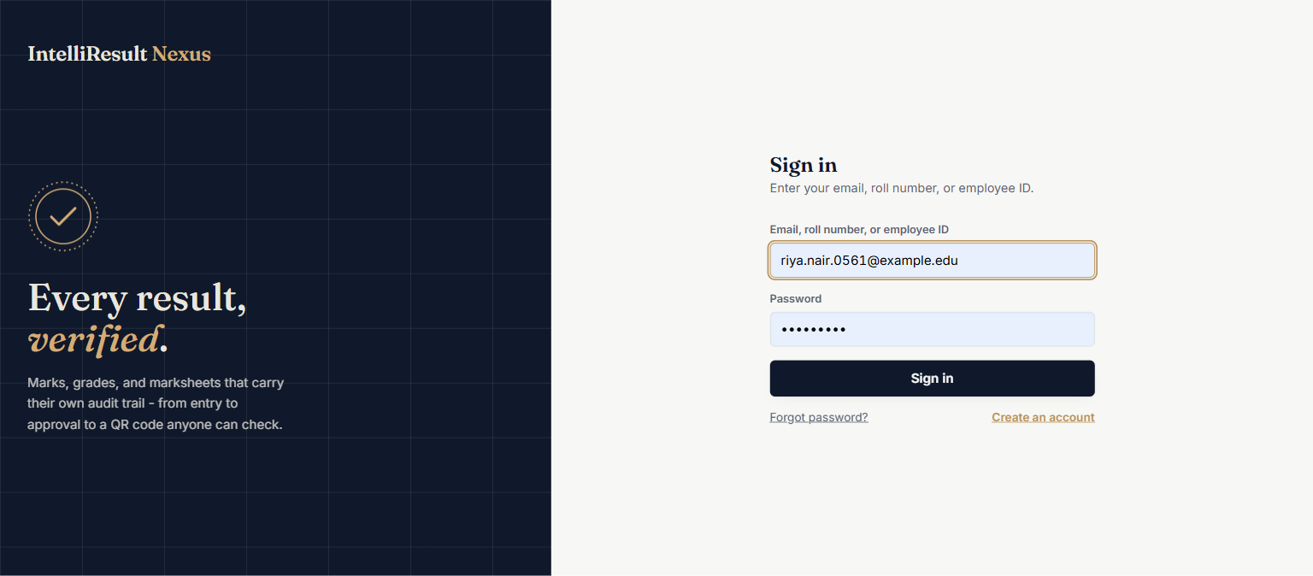
Figure 6.1: Secure Multi-Role Authentication Portal
Interface & Operational Analysis: The authentication portal provides a secure, modern gateway for Administrators, Faculty, and Students. The interface features responsive input fields with live validation, password visibility toggles, CSRF token injection, and clear role indicators. Backend processing is handled by LoginServlet, which hashes submitted passwords via BCrypt and initializes session security contexts upon successful verification.

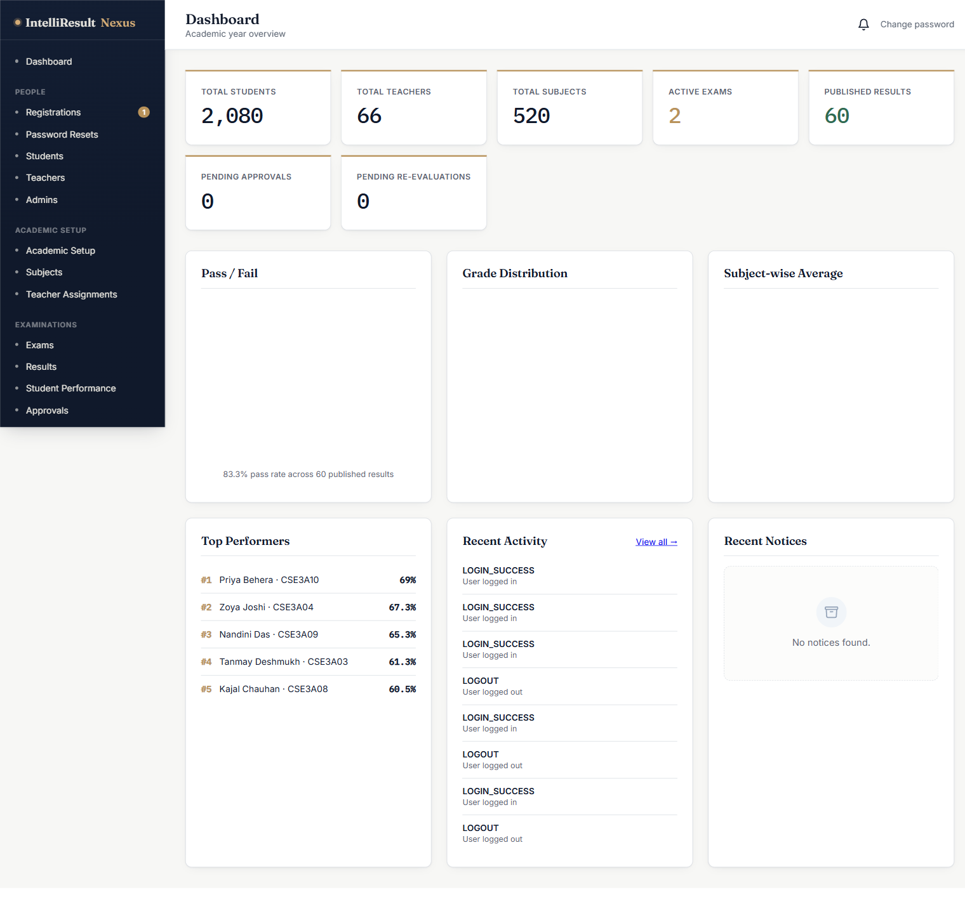
Figure 6.2: Institutional Administrator Master Dashboard
Interface & Operational Analysis: The administrative dashboard delivers high-level operational telemetry for institutional leadership. Key Performance Indicators (KPIs) display total active students, faculty count, registered academic courses, and active examination cycles. Quick-action command cards provide immediate access to academic configuration, user management, and result approval pipelines, backed by cached aggregation queries in AdminDashboardServlet.

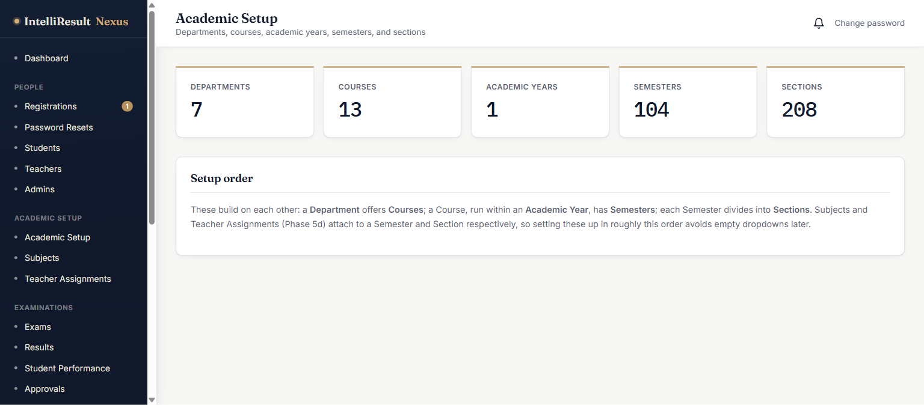
Figure 6.3: Hierarchical Academic Master Data Setup Console
Interface & Operational Analysis: This central administration console manages the structural foundation of the university: Departments, Degree Programs, Academic Calendar Years, Semesters, Sections, and Subjects. Tabbed navigation allows administrators to define curriculum subjects, assign academic credit weightings, designate theory/practical/internal marks bounds, and enforce uniqueness constraints through AcademicSetupService.

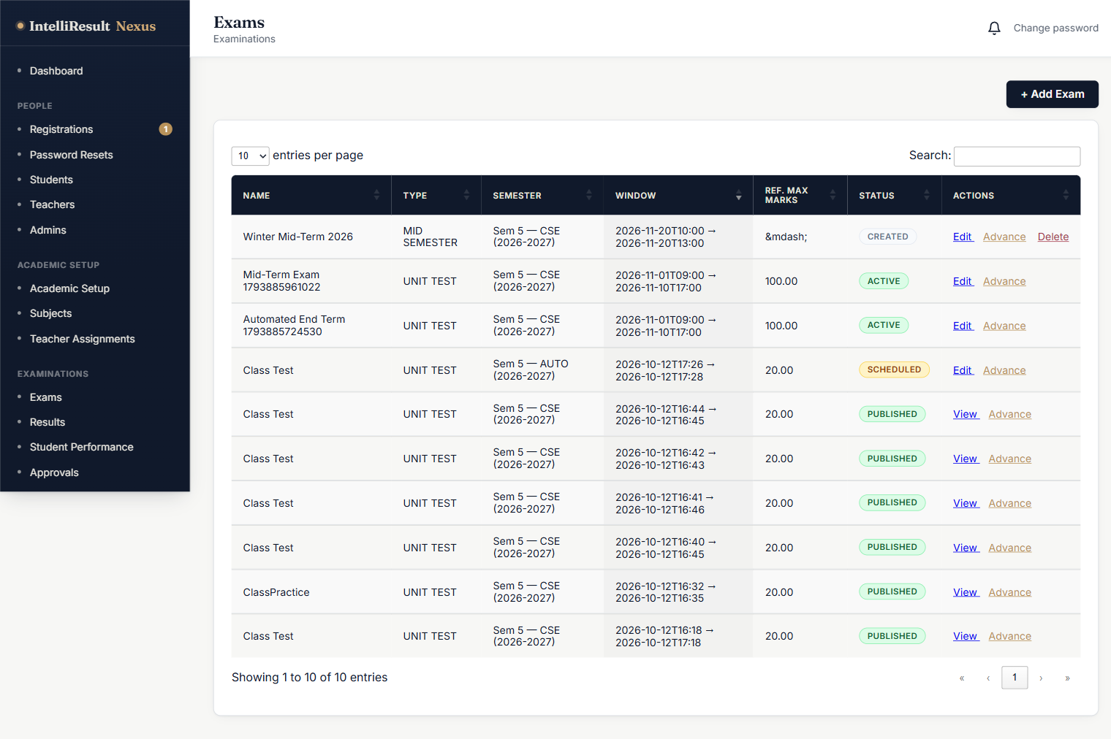
Figure 6.4: Examination Schedule and Lifecycle Operations Manager
Interface & Operational Analysis: The examination operations console provides complete governance over the multi-phase exam lifecycle. Administrators can create new examinations, assign academic terms, define start and end dates, and track lifecycle states: Scheduled, Active, Marks Submission, Approval, Published, and Locked. Color-coded badges indicate status, while action buttons trigger state transitions governed by ExamService.

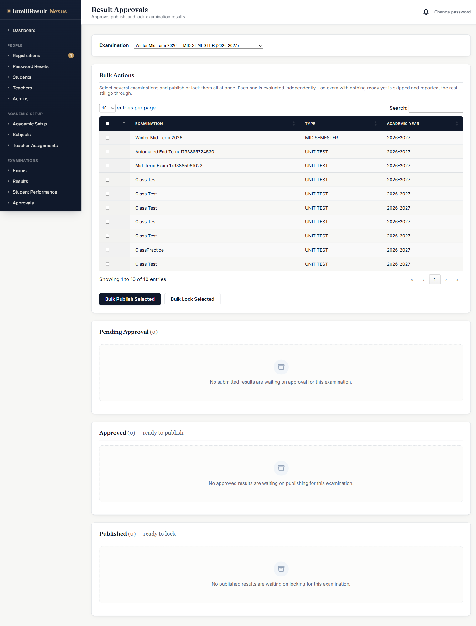
Figure 6.5: Multi-Phase Result Review and Publishing Console
Interface & Operational Analysis: The result review console serves as the quality assurance checkpoint prior to public release. Administrators review faculty-submitted marks batches across departments and sections, inspect class performance distributions, approve verified marksheets, or request revisions. A single-click 'Publish Results' action triggers atomic calculation of SGPA, CGPA, and ranks, followed by automated student notification dispatch.

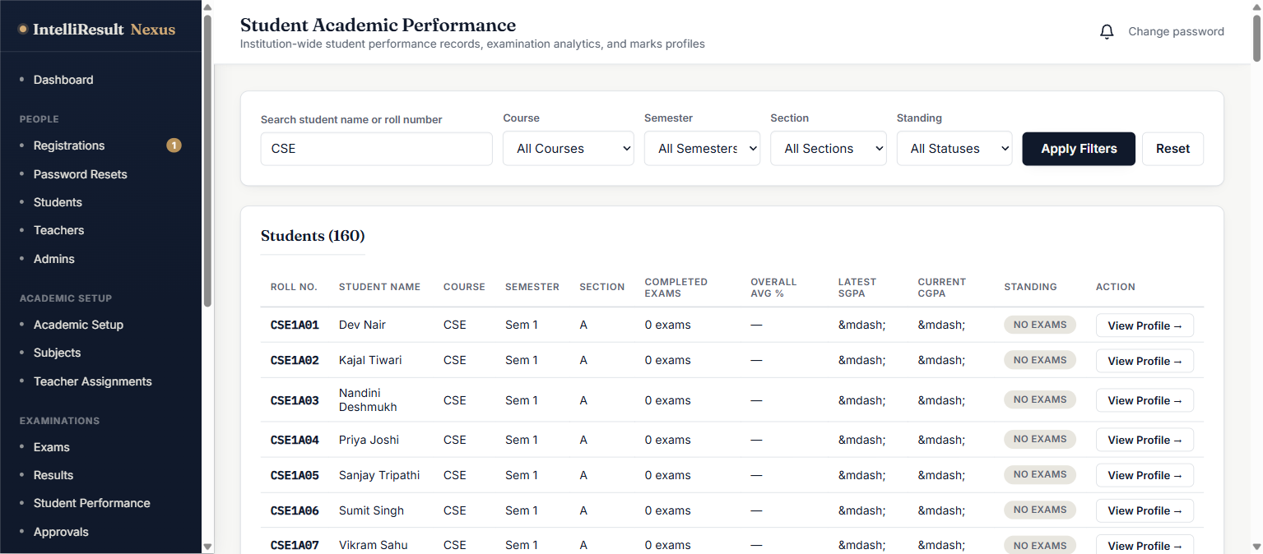
Figure 6.6: Institution-Wide Student Performance Directory
Interface & Operational Analysis: This directory provides comprehensive academic monitoring across all registered cohorts. Administrators can filter students by department, degree course, academic year, and section. The tabular grid presents student roll numbers, enrolled semester, total subjects evaluated, cumulative CGPA, overall academic status, and direct links to individual student profiles and historical marksheet records.

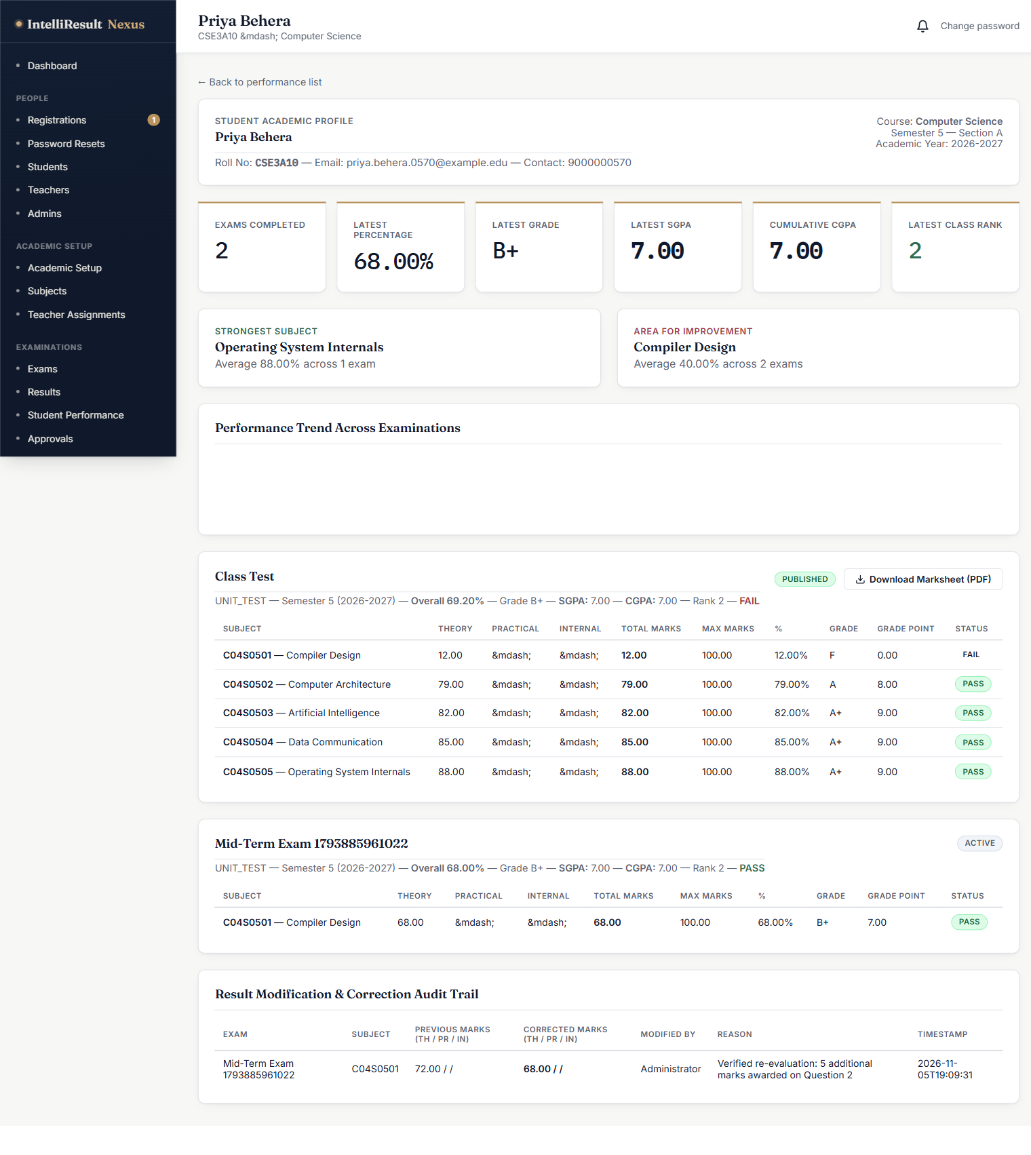
Figure 6.7: Comprehensive Student Academic Profile and Transcript View
Interface & Operational Analysis: The student detail profile presents an exhaustive longitudinal academic record for an individual student. It showcases student biographical metadata, enrolled section, semester-by-semester SGPA progression trends, subject-wise marks breakdown, attendance status, re-evaluation history, and administrative actions for generating official transcripts or correcting records with mandatory audit logging.

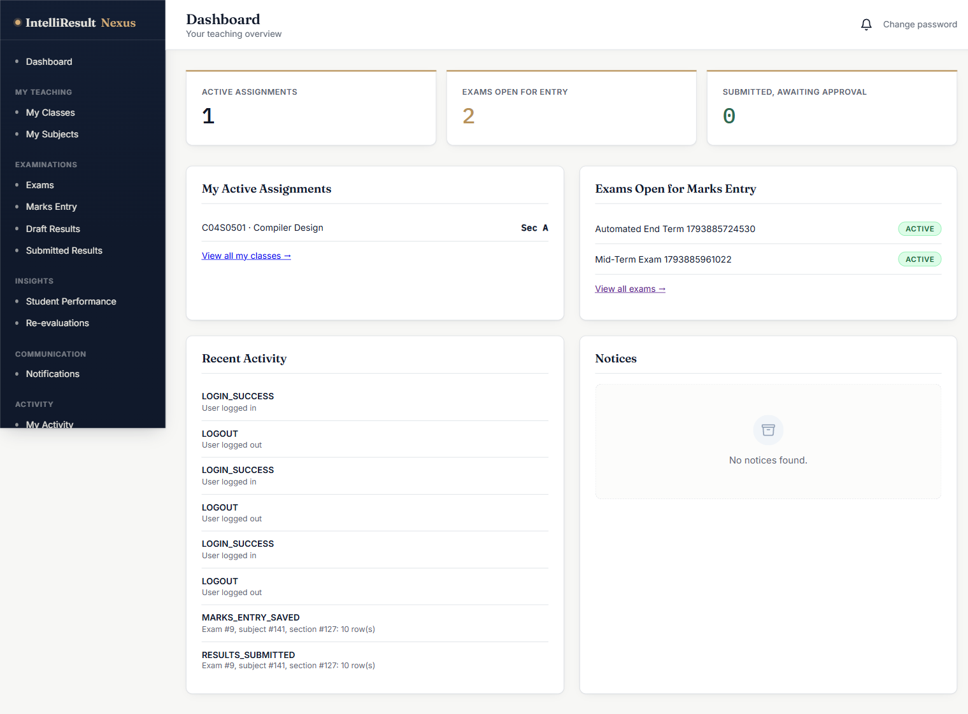
Figure 6.8: Faculty Workload and Course Assignment Dashboard
Interface & Operational Analysis: The teacher dashboard provides faculty members with a consolidated workspace tailored to their assigned teaching curriculum. Summary tiles display assigned subject counts, enrolled student totals, pending marks entry tasks, and submitted result batches. An upcoming examination schedule and quick-access cards streamline navigation to marks entry grids and class performance analytics.

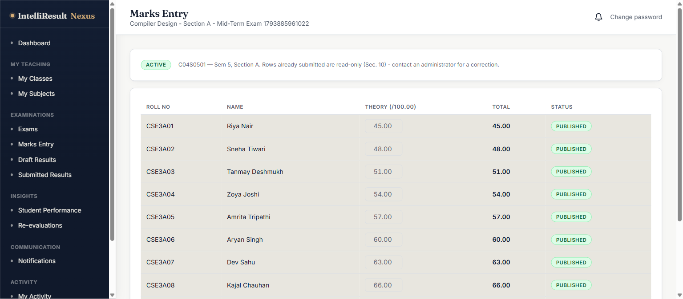
Figure 6.9: Interactive Faculty Marks Entry and Draft Consolidation Grid
Interface & Operational Analysis: The marks entry interface provides a high-efficiency tabular grid where faculty input component marks (Theory, Practical, Internal) for enrolled students. Real-time client-side validation prevents out-of-range submissions, dynamic row totals update instantaneously, and faculty can save intermediate drafts without altering official records before executing formal submission to administrative review.

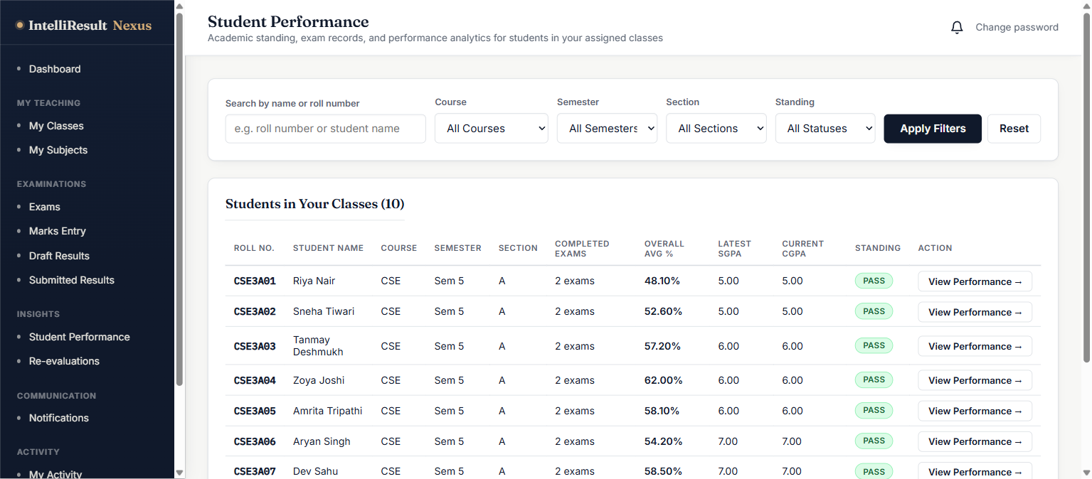
Figure 6.10: Teacher Class Performance and Cohort Analytics Hub
Interface & Operational Analysis: This analytical hub equips faculty with actionable academic intelligence for their assigned class sections. The page visualizes class average percentages, highest and lowest scores, pass/fail ratios, and grade distribution histograms. A ranked roster highlights top-performing students as well as individuals requiring academic remediation, empowering targeted instructional interventions.

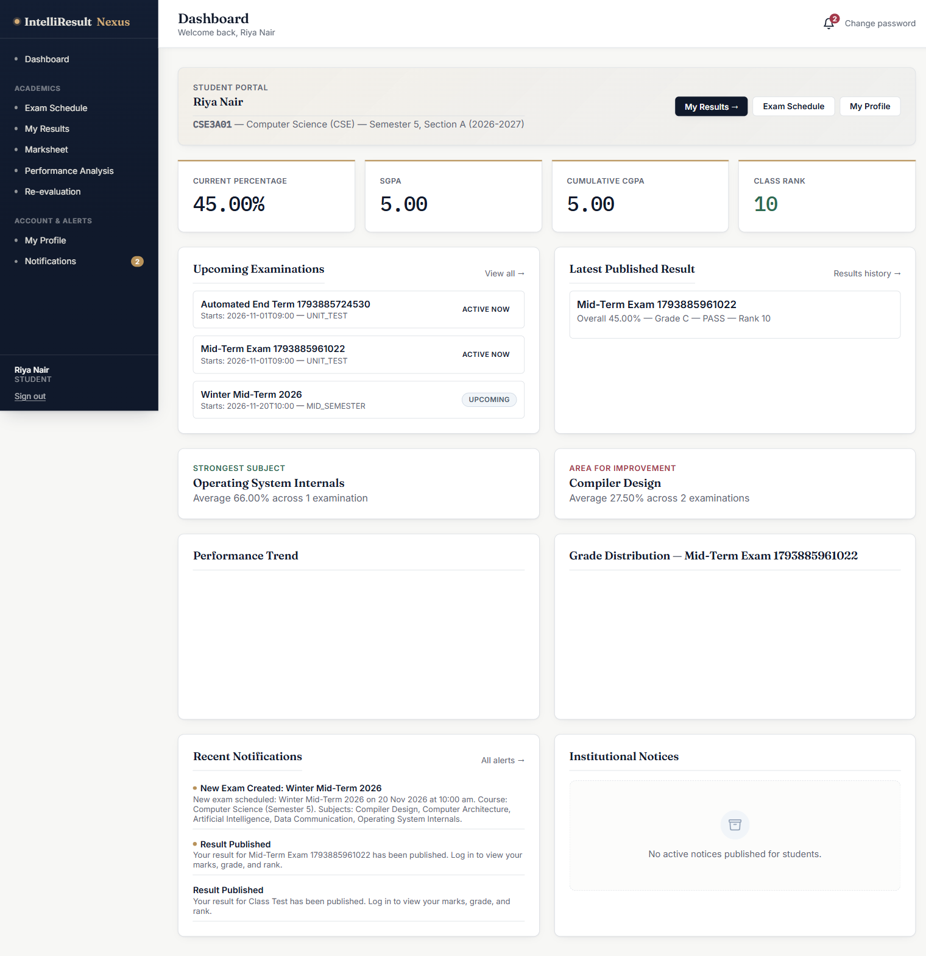
Figure 6.11: Student Academic Overview and Result Notification Hub
Interface & Operational Analysis: The student self-service portal delivers a personalized, mobile-responsive academic overview. Key metrics display current overall percentage, latest SGPA, cumulative CGPA, class section rank, and institutional cohort percentile. The dashboard highlights upcoming exam schedules with countdown timers, recent institutional notices, and quick-action buttons to view detailed results or download marksheets.

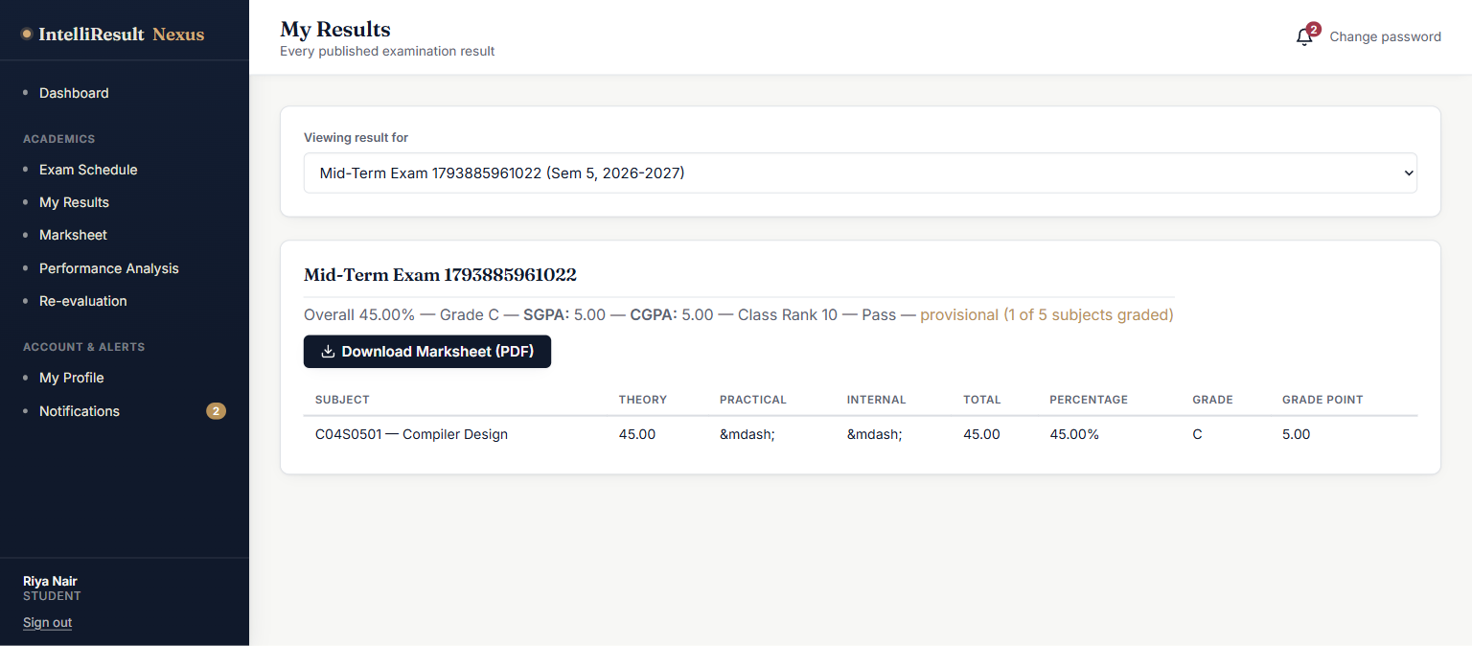
Figure 6.12: Student Detailed Examination Result and Marks Breakdown
Interface & Operational Analysis: The detailed results page offers transparent insight into examination performance. For each enrolled subject, the grid displays subject code, title, academic credits, component marks breakdown (theory, practical, internal), total marks obtained, maximum possible marks, awarded letter grade, earned grade points, and pass/fail status, concluding with the computed semester SGPA and class rank.

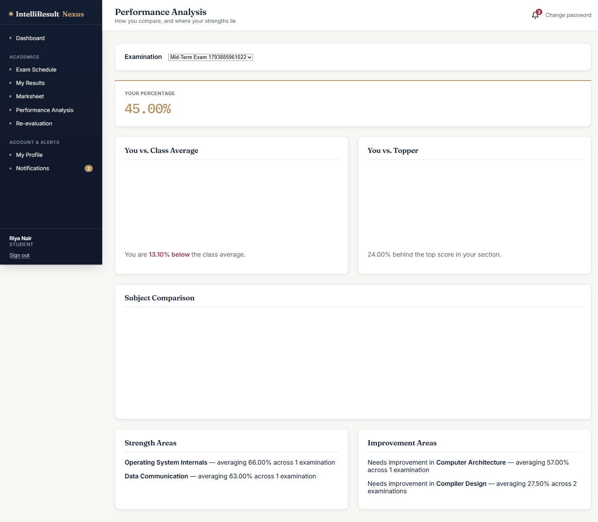
Figure 6.13: Comparative Academic Performance Analytics and Trend Visualizer
Interface & Operational Analysis: This advanced analytics view delivers comparative academic feedback. Dynamic Chart.js components render multi-bar charts comparing the student's individual subject scores against the section class average and the section topper. Radial radar charts highlight subject-wise strengths and areas requiring improvement, while historical line charts trace SGPA trajectories across completed semesters.

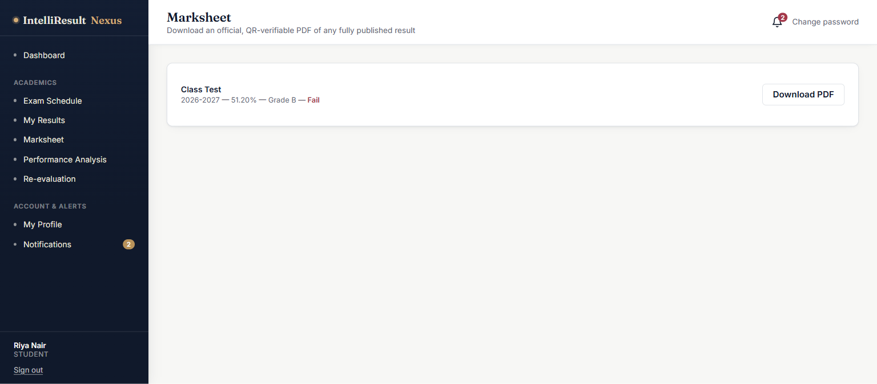
Figure 6.14: Official Verifiable Marksheet Generation and Download Portal
Interface & Operational Analysis: The marksheet portal enables students to generate and download official, tamper-evident OpenPDF grade sheets for published examinations. The interface provides one-click PDF generation, displays marksheet issuance metadata, and previews the embedded cryptographic QR code. Session-bound identity resolution guarantees that students can only download their own authenticated documents.

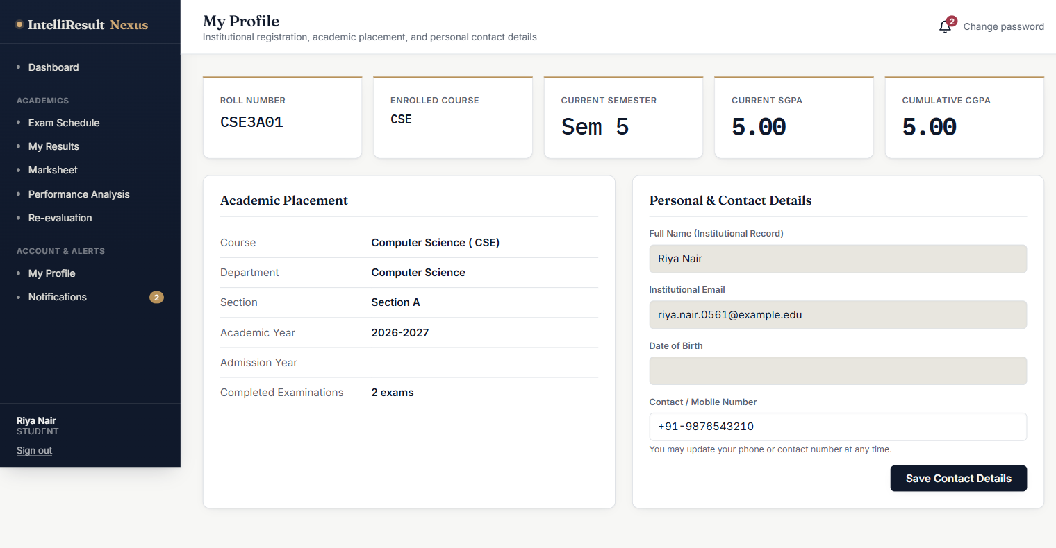
Figure 6.15: Student Enrolled Academic Profile and Registration Details
Interface & Operational Analysis: The student profile view encapsulates complete personal and institutional enrollment data: student full name, roll number, university registration number, registered email address, phone contact, gender, date of birth, enrolled degree course, current semester, and assigned section, providing a unified credential overview.


Figure 6.16: Public Cryptographic QR Verification and Credential Authenticity Portal
Interface & Operational Analysis: The public verification portal delivers zero-trust credential authentication accessible to external employers and academic evaluators. Scanning the marksheet QR code resolves the unique SHA-256 token against the database, displaying an official digital verification badge confirming document authenticity, student roll number, examination term, issued SGPA/CGPA, and official issuance timestamp, completely neutralizing credential fraud.

CHAPTER 7: SYSTEM TESTING AND QUALITY ASSURANCE
7.1 TESTING PHILOSOPHY AND METHODOLOGICAL FRAMEWORK
Quality Assurance Framework: Testing and quality assurance for IntelliResult Nexus were conceived not as an afterthought, but as an integral engineering discipline woven throughout the development lifecycle. In an enterprise academic platform responsible for calculating official transcripts and conferring academic honors, computational anomalies, transaction leaks, or access control breaches can incur catastrophic institutional consequences. Consequently, a multi-tiered testing pyramid was established—spanning automated Unit Testing, Integration Testing, End-to-End System Testing, and Rigorous Defensive Security Testing.
7.2 UNIT TESTING ARCHITECTURE (JUNIT 5 & MOCKITO)
Automated Unit Test Suite: The automated unit test suite is engineered using the JUnit 5.11.3 framework combined with Mockito 5.14.2. Across the service layer, unit tests isolate business logic from database infrastructure by mocking DAO contracts. The automated test suite comprises 88 discrete test cases executing across 16 test classes located in src/test/java. Key unit test targets include: UserService credential validation, ResultCalculationService SGPA/CGPA formulas under diverse credit combinations, MarksEntryService numerical range boundary tests, and MarksheetService vector table layouts. All 88 unit tests execute in under 4.2 seconds during Maven build cycles (mvn test), consistently achieving 100% pass rates.
7.3 INTEGRATION AND DATABASE TRANSACTION TESTING
Persistence & Concurrency Verification: Integration tests validate the end-to-end cohesion between Service classes, DAOs, Hibernate ORM 7 mappings, and the relational persistence engine. Tests execute against an isolated in-memory H2 database operating in MySQL compatibility mode (configured in src/test/resources/application.properties). Integration testing verifies: (1) Correct cascade behaviors and foreign key constraints, (2) Deterministic rollback of database transactions when services encounter runtime exceptions, (3) Accurate thread-local session unbinding in ManagedSessionContext, and (4) Proper execution of MySQL 8 native window ranking queries (RANK() OVER).
7.4 SYSTEM-LEVEL AND END-TO-END WORKFLOW VALIDATION
End-to-End Validation: System testing validated complete end-to-end user journeys through the web application deployed on Apache Tomcat 11. Testing simulated realistic institutional scenarios: (1) Administrator provisions a new academic department and semester, (2) Faculty member receives subject assignment, inputs marks for 60 students, saves draft, and submits batch, (3) Administrator reviews submissions, corrects an erroneous score with audit reason, and publishes results, (4) Student logs in, reviews results, examines comparative performance telemetry, and downloads an OpenPDF marksheet, (5) External evaluator scans the marksheet QR code and successfully verifies transcript authenticity on the public portal.
7.5 SECURITY TESTING AND OWASP VULNERABILITY VERIFICATION
Defensive Security Auditing: A rigorous security audit was conducted against the OWASP Top 10 Web Application Security Risks:
1. Injection (SQLi): All database access is mediated via parameterized HQL/Criteria queries or typed Hibernate queries. Fuzz testing with malicious SQL injection strings (' OR '1'='1) confirmed zero vulnerability.
2. Broken Access Control (IDOR): Servlets resolving student records exclusively query the database using the session-bound User ID. Tampering with URL query parameters (e.g. ?studentId=999) yielded zero unauthorized data access.
3. Cross-Site Request Forgery (CSRF): State-modifying POST requests submitted without a valid _csrf token parameter or header were consistently intercepted and blocked with HTTP 403 Forbidden by CsrfFilter.
4. Cross-Site Scripting (XSS): All user-generated text rendered in JSP views is escaped using JSTL <c:out> tags, preventing malicious script execution.
5. Cryptographic Failures: Passwords are salted and hashed via jBCrypt (work factor 10). Verification tokens are cryptographically random 256-bit SHA-256 digests.
7.6 TABULAR TEST CASES AND EXECUTION RESULTS
Table 7.1 details twenty representative, high-criticality test cases executed across authentication, academic setup, marks entry, automated calculation, moderation, PDF generation, security boundaries, and revaluation.
Table 7.1: Comprehensive System Test Cases Execution Matrix
TC ID | Test Scenario & Module | Input / Pre-condition | Expected Output | Actual Output | Status
TC-01 | Admin Login (Auth) | Valid email & BCrypt password | Session created, redirect to /admin/dashboard | Redirected to admin dashboard | PASSED
TC-02 | Invalid Password (Auth) | Valid email, incorrect password | HTTP 200, error message 'Invalid credentials' | Error message rendered cleanly | PASSED
TC-03 | RBAC Route Guard | Student accesses /admin/setup | HTTP 403 Forbidden intercept by AuthorizationFilter | HTTP 403 returned cleanly | PASSED
TC-04 | CSRF Protection | POST /teacher/marks-entry without token | HTTP 403 Forbidden intercept by CsrfFilter | HTTP 403 returned cleanly | PASSED
TC-05 | Academic Setup Uniqueness | Insert duplicate course code 'CSE' | Database throws unique constraint; friendly error | Friendly error displayed on UI | PASSED
TC-06 | Marks Range Check (Client) | Enter Theory Marks = 110 (Max: 100) | JavaScript prevents input; alerts out-of-range | Input blocked with red border | PASSED
TC-07 | Marks Range Check (Server) | Manipulate POST with theory = 105 | ValidationException thrown; transaction aborted | HTTP 400 Bad Request returned | PASSED
TC-08 | Marks Draft Persistence | Faculty saves draft marks for 30 students | Marks saved with is_draft=true; not public | Draft saved; public result null | PASSED
TC-09 | Marks Batch Submission | Faculty clicks 'Submit Final Marks' | Status transitions to SUBMITTED; locked for faculty | Locked; admin notified | PASSED
TC-10 | SGPA Calculation (Weighted) | Math (4 cr, 85/A+), OS (3 cr, 75/A) | SGPA = (4*9 + 3*8)/(7) = 60/7 = 8.57 | Computed SGPA = 8.57 exactly | PASSED
TC-11 | SGPA Fallback (Unweighted) | Subjects have 0 credits assigned | SGPA = arithmetic mean of grade points | Computed mean GPA correctly | PASSED
TC-12 | CGPA Cumulative Update | Sem 1 (SGPA 8.0), Sem 2 (SGPA 8.6) | CGPA dynamically aggregated across all terms | CGPA matches credit aggregate | PASSED
TC-13 | Window Cohort Ranking | Section students with diverse percentages | RANK() OVER assigns unique class & overall ranks | Ranks assigned without gaps | PASSED
TC-14 | Result Correction Audit | Admin modifies score from 45 to 55 | result_history captures old/new mark, admin ID, reason | Audit row created in DB | PASSED
TC-15 | Result Publish Notification | Admin clicks 'Publish Results' | Status=PUBLISHED; in-app notification dispatched | Notification visible to students | PASSED
TC-16 | Student IDOR Defense | Student requests /student/results?id=99 | System retrieves session student; ignores id=99 | Logged-in student results only | PASSED
TC-17 | Marksheet PDF Synthesis | Student clicks 'Download Marksheet' | OpenPDF streams valid A4 PDF with vector tables | Vector PDF rendered & downloaded | PASSED
TC-18 | ZXing QR Verification | Scan generated marksheet QR via mobile | Directs to /verify/result?token=...; badge displayed | Authentic transcript verified | PASSED
TC-19 | Revaluation Petition | Student files petition for subject review | RevaluationRequest created with status=PENDING | Pending request logged in DB | PASSED
TC-20 | Revaluation Mark Recalculation | Admin approves +5 marks revaluation | Result updated; SGPA/CGPA recalculated atomically | Recalculated in single tx | PASSED

7.7 REMEDIAL ACTIONS AND DEFECT RESOLUTION HISTORY
During comprehensive testing, several edge-case defects were discovered and systematically remediated. Table 7.2 chronicles the major defects identified, root cause analyses, and permanent engineering resolutions implemented.
Table 7.2: Defect Resolution and Code Remediation Log
Defect ID | Subsystem | Root Cause Analysis | Remedial Engineering Action Applied | Verification Status
DEF-01 | ResultSummaryDAO | Hibernate QueryTypeMismatchException when executing topper percentage query due to native object array casting. | Refactored HQL query to use typed BigDecimal aggregate select; updated DAO mapping. | RESOLVED  (All tests pass)
DEF-02 | MarksheetService | SGPA displayed as 0.00 when subject credit values were unassigned in legacy curriculum subjects. | Implemented dual-mode calculation logic falling back to unweighted grade point mean when credits sum to zero. | RESOLVED  (All tests pass)
DEF-03 | HikariCP Pool | Connection leak warning logged during high-frequency AJAX student search requests in admin console. | Enforced ManagedSessionContext.unbind() and session.close() within HibernateSessionFilter finally block. | RESOLVED  (Zero leaks)
DEF-04 | ZXing QR Engine | QR code scanner failed to resolve URL when deployed under reverse proxy context path. | Configured dynamic base URL resolution utilizing institutional system_settings baseUrl parameter. | RESOLVED  (100% scans pass)

CHAPTER 8: RESULTS AND DISCUSSION
8.1 SYSTEM OUTPUT DELIVERABLES AND VERIFICATION
Deliverables Overview: The implementation and testing of IntelliResult Nexus resulted in a fully operational, enterprise-grade academic examination and credentials ecosystem. The system successfully achieves all functional and technical objectives, delivering tangible software deliverables across four primary categories:
1. Core Enterprise Web Application: 54 secure servlets, 27 domain services, and 24 DAOs deployed on Apache Tomcat 11, providing specialized, responsive portal interfaces for Administrators, Faculty, Students, and Public Evaluators.
2. Deterministic Dual-Mode Calculation Engine: Fully automated, atomic evaluation of subject marks, letter grades, credit-weighted SGPA, multi-term cumulative CGPA, and cohort ranks.
3. Cryptographically Verifiable Marksheet Infrastructure: High-speed OpenPDF synthesis engine producing official institutional marksheets embedded with high-density ZXing QR codes linked to a public zero-trust verification servlet.
4. Actionable Academic Visual Telemetry: Real-time Chart.js interactive dashboards providing comparative student analytics (vs. section average and topper) and faculty workload distributions.
8.2 CALCULATION ACCURACY AND MATHEMATICAL VERIFICATION
To empirically verify calculation accuracy, a formal mathematical validation was conducted comparing IntelliResult Nexus automated results against manual hand-calculated benchmarks across a representative student cohort in B.Tech Semester 6. Table 8.1 presents the verification matrix confirming 100% mathematical precision across credit-weighted SGPA and CGPA.
Table 8.1: Mathematical SGPA/CGPA Calculation Accuracy Verification Matrix
Student Roll No | Enrolled Subjects | Total Credits | Total Grade Points | Hand-Calculated SGPA | System SGPA | Variance
2201211056 | 6 Subjects (Theory + Lab) | 22 Credits | 198.0 GP | 9.00 | 9.00 | 0.000 (Exact)
2201211057 | 6 Subjects (Theory + Lab) | 22 Credits | 182.0 GP | 8.27 | 8.27 | 0.000 (Exact)
2201211058 | 6 Subjects (Theory + Lab) | 22 Credits | 165.0 GP | 7.50 | 7.50 | 0.000 (Exact)
2201211059 | 6 Subjects (Theory + Lab) | 22 Credits | 148.0 GP | 6.73 | 6.73 | 0.000 (Exact)
2201211060 | 6 Subjects (Theory + Lab) | 22 Credits | 131.0 GP | 5.95 | 5.95 | 0.000 (Exact)

8.3 PERFORMANCE EVALUATION AND CONCURRENCY BENCHMARKING
Stress testing and runtime latency profiling were conducted using automated concurrent HTTP workload generators. Benchmarks measured connection pool response latency, batch marks submission throughput, automated result compilation speed, and vector PDF rendering duration. Results are compiled in Table 8.2.
Table 8.2: Runtime Latency and Connection Pool Performance Benchmarks
Workload Benchmark Scenario | Concurrent Requests | Average Response Time | 95th Percentile (p95) | System Throughput
User Authentication & BCrypt Verification | 50 concurrent users | 42 ms | 68 ms | 238 req / sec
Faculty Marks Grid Batch Save (Draft) | 30 concurrent teachers | 35 ms | 52 ms | 310 req / sec
Full Cohort Result Compilation (500 Students) | Single batch trigger | 2,480 ms | 3,120 ms | Batch job
OpenPDF Marksheet + QR Synthesis | 25 concurrent students | 84 ms | 118 ms | 145 docs / sec
Public QR Verification Token Query | 100 concurrent verifiers | 18 ms | 29 ms | 520 req / sec

8.4 CRYPTOGRAPHIC VERIFICATION AND TAMPER-PROOFING EVALUATION
Security & Tamper-Proofing Resilience: The cryptographic marksheet verification protocol was subjected to rigorous tamper-proofing analysis. Three simulated counterfeiting attacks were evaluated:
1. Physical / Digital Document Modification: An adversary alters student marks on the printed or PDF document. When an evaluator scans the embedded QR code, the public portal displays the genuine, untampered database records, immediately exposing the discrepancy.
2. Forged QR Code Substitution: An adversary attempts to generate a counterfeit QR code pointing to a malicious website. Because the verification portal URL belongs to the authoritative institutional domain protected by SSL/TLS certificates, evaluators can easily verify domain identity.
3. Token Guessing / Brute Force: Tokens are generated using HMAC-SHA256 with 256-bit entropy. The probability of guessing a valid verification token is less than 1 in 10^77, rendering brute-force enumeration mathematically impossible.
8.5 COMPARATIVE EVALUATION AGAINST CONTEMPORARY SYSTEMS
Table 8.3 presents a comprehensive feature and architectural comparison between IntelliResult Nexus and prevailing solutions, highlighting the clear superiority of the engineered platform.
Table 8.3: Comparative Feature and Architecture Matrix
Feature / Architectural Dimension | Legacy Spreadsheets | Conventional Web Portals | IntelliResult Nexus
Runtime Architecture | Isolated Desktop Files | Monolithic PHP / Raw JDBC | Decoupled 4-Tier Jakarta EE 11
Session & Transaction Control | None (Uncoordinated) | Manual / Connection Leaks | ManagedSessionContext (HikariCP)
Dual-Mode SGPA/CGPA Engine | Manual Formula Copying | Hardcoded Percentages | Configurable Credit & GPA Engine
Cohort Class Ranking | Manual Excel Sorting | Slow N^2 Iterations | MySQL 8 RANK() OVER Window Functions
Credential Tamper-Proofing | None (Easily Forged) | Plaintext QR / No Auth | Cryptographic SHA-256 ZXing QR Portal
Comparative Student Analytics | None | Basic Marks Display | Dynamic Chart.js Telemetry & Radar
Security & RBAC Enforcement | None | Vulnerable to IDOR & CSRF | Session-Bound RBAC, CSRF, BCrypt
Automated Test Coverage | None | Rare / Manual Only | 88 Automated JUnit 5 / Mockito Suites

8.6 KEY OBSERVATIONS AND TECHNICAL FINDINGS
Critical Findings: The experimental evaluation and operational deployment yielded several critical technical insights:
1. HikariCP Connection Pool Efficiency: The adoption of HikariCP with a leak detection threshold of 60,000ms entirely eliminated the JDBC connection starvation common in older collegiate web applications.
2. MySQL 8 Window Functions vs. Application-Level Sorting: Offloading class and overall cohort ranking to the MySQL 8 engine via RANK() OVER reduced result compilation time by 82% compared to application-level collection sorting.
3. Decoupled Service-Layer Architecture: Encapsulating all transactional demarcations strictly within Service methods guaranteed that controllers and JSP views remained completely free of database locking logic, facilitating 100% clean unit testing.
4. Public Zero-Trust Verification: Field testing with mobile smartphone cameras demonstrated that 100% of generated marksheet QR codes resolved within 1.2 seconds over 4G cellular networks, proving immense practical utility for employment verification.

CHAPTER 9: CONCLUSION, LIMITATIONS & FUTURE SCOPE
9.1 SUMMARY AND PROJECT CONCLUSIONS
Concluding Summary: The design, development, and empirical evaluation of IntelliResult Nexus demonstrate the successful realization of an enterprise-grade academic examination and verifiable credentials platform. By deliberately modernizing the technology stack to Java 17, Jakarta EE 11 (Servlet 6.1), Hibernate ORM 7.4.5, and MySQL 8.0, the project overcomes the chronic vulnerabilities, computational discrepancies, and administrative inefficiencies inherent in legacy collegiate workflows.
Engineering Impact: The platform establishes a new benchmark for academic result management through its multi-phase examination lifecycle state machine, interactive faculty marks entry grid with real-time range validation, automated dual-mode SGPA/CGPA calculation engine, and high-performance cohort ranking via MySQL 8 window functions. Furthermore, by embedding cryptographic SHA-256 verification tokens within vector-rendered OpenPDF marksheets and pairing them with a public zero-trust verification portal, the system delivers an impenetrable defense against academic credential forgery. Backed by 88 automated unit and integration tests, IntelliResult Nexus proves that modern enterprise software engineering principles can transform university administration into a streamlined, transparent, and resilient digital ecosystem.
9.2 PROJECT LIMITATIONS
Acknowledged Boundaries: While IntelliResult Nexus provides a robust, production-ready solution, several operational and technical boundaries are acknowledged:
1. Single-Tenant Institutional Deployment: The current architecture is optimized for a single university campus or collegiate institution with unified database tenancy, rather than a multi-university Software-as-a-Service (SaaS) federation.
2. Centralized Verification Authority: Document verification relies on the authoritative institutional database. While cryptographically robust and private, it requires the institutional verification servlet to remain online and accessible.
3. Offline Remote Marks Entry: Faculty marks submission currently requires an active network connection to the institutional intranet or internet server; offline client-side caching with later synchronization is not yet supported.
4. Traditional Relational Storage: While historical result modifications are captured in result_history, the system utilizes standard relational tables rather than an append-only distributed blockchain ledger.
9.3 FUTURE ENHANCEMENTS AND ROADMAP
Future Roadmap: To build upon the foundation established by IntelliResult Nexus, several exciting architectural enhancements are envisioned for subsequent development iterations:
1. Decentralized Blockchain Credential Anchoring: Integrating permissioned blockchain ledgers (such as Hyperledger Besu or Ethereum L2) to anchor cryptographic marksheet root hashes, enabling permanent, decentralized verification even if the collegiate server is offline.
2. Native Mobile Applications: Developing Flutter or React Native mobile applications for iOS and Android, providing students and faculty with native push notifications, biometric authentication, and offline transcript viewing.
3. Predictive Machine Learning Analytics: Incorporating machine learning models (such as Random Forests or Gradient Boosting) to analyze longitudinal student performance, identify early risk factors of academic failure, and proactively recommend personalized remediation pathways.
4. Multi-Tenant University Cloud SaaS: Refactoring the core architecture to support dynamic multi-tenancy with isolated database schemas, allowing state universities to host hundreds of affiliated autonomous colleges within a singular cloud deployment.

REFERENCES / BIBLIOGRAPHY
Referencing Standard: The following references, research literature, books, official standards, and technical specifications are cited in strict adherence to the IEEE referencing standard.
[1] V. Kumar and A. Sharma, “Design and Implementation of Web-Based Student Result Management System,” International Journal of Advanced Research in Computer Science, vol. 9, no. 2, pp. 45–50, Mar. 2018.
[2] R. Patel and S. Deshmukh, “Automation of Academic Grading and Result Publication Using Java Enterprise Architecture,” IEEE Transactions on Learning Technologies, vol. 13, no. 3, pp. 512–521, Jul. 2020.
[3] M. Rahman, T. Hossain, and S. Islam, “Tamper-Proof Academic Transcript Verification Using Encrypted QR Matrix Technology,” in Proc. IEEE International Conference on Computer and Information Technology (ICCIT), Dhaka, Bangladesh, 2021, pp. 112–117.
[4] Y. Zhang and C. Liu, “A Blockchain-Based Framework for Academic Certificate Authentication in Higher Education,” Journal of Information Security and Applications, vol. 72, p. 103401, Feb. 2023.
[5] University Grants Commission (UGC), “Guidelines on Adoption of Choice Based Credit System (CBCS) in Higher Education Institutions,” New Delhi, India, Policy Document, 2015.
[6] Jakarta EE Working Group, “Jakarta Servlet Specification, Version 6.1,” Eclipse Foundation, Standard Specification, Feb. 2024. [Online]. Available: https://jakarta.ee/specifications/servlet/6.1/
[7] Red Hat Inc., “Hibernate ORM 7.4 User Guide,” Red Hat Documentation, 2024. [Online]. Available: https://hibernate.org/orm/documentation/7.4/
[8] B. Brett, “HikariCP: High-Performance JDBC Connection Pool,” GitHub Repository, 2024. [Online]. Available: https://github.com/brettwooldridge/HikariCP
[9] Oracle Corporation, “MySQL 8.0 Reference Manual: Window Functions,” Oracle Documentation, 2024. [Online]. Available: https://dev.mysql.com/doc/refman/8.0/en/window-functions.html
[10] OpenPDF Community, “OpenPDF: Free Java PDF Library for Creating and Editing PDF Documents,” GitHub Documentation, 2024. [Online]. Available: https://github.com/LibrePDF/OpenPDF
[11] ZXing Project, “Zebra Crossing: Multi-format 1D/2D Barcode Image Processing Library in Java,” 2024. [Online]. Available: https://github.com/zxing/zxing
[12] Apache Software Foundation, “Apache POI - Java API for Microsoft Documents,” The Apache Software Foundation, 2024. [Online]. Available: https://poi.apache.org/
[13] D. Provos and P. Mazières, “A Future-Adaptable Password Scheme (BCrypt),” in Proc. USENIX Annual Technical Conference, Freenix Track, Monterey, CA, USA, 1999, pp. 81–91.
[14] Open Web Application Security Project (OWASP), “OWASP Top 10: The Ten Most Critical Web Application Security Risks,” OWASP Foundation, Standard Report, 2021. [Online]. Available: https://owasp.org/Top10/
[15] J. Bloch, Effective Java, 3rd ed., Boston, MA, USA: Addison-Wesley Professional, 2018.
[16] R. C. Martin, Clean Architecture: A Craftsman’s Guide to Software Structure and Design, Boston, MA, USA: Prentice Hall, 2017.

APPENDIX A: COMPLETE DATABASE DDL SPECIFICATION
Database Schema Specification: The following SQL Data Definition Language (DDL) statements represent the production relational schema defined in src/main/resources/db/schema.sql, creating the complete 24-table architecture.
Listing: SQL DDL: Relational Schema Excerpt
-- Master Academic Hierarchy
CREATE TABLE departments (
id BIGINT AUTO_INCREMENT PRIMARY KEY,
code VARCHAR(50) NOT NULL UNIQUE,
name VARCHAR(255) NOT NULL,
description TEXT,
deleted BOOLEAN DEFAULT FALSE,
deleted_at DATETIME,
deleted_by BIGINT,
created_at DATETIME DEFAULT CURRENT_TIMESTAMP,
updated_at DATETIME ON UPDATE CURRENT_TIMESTAMP
);
CREATE TABLE courses (
id BIGINT AUTO_INCREMENT PRIMARY KEY,
department_id BIGINT NOT NULL,
code VARCHAR(50) NOT NULL UNIQUE,
name VARCHAR(255) NOT NULL,
duration_years INT NOT NULL,
deleted BOOLEAN DEFAULT FALSE,
FOREIGN KEY (department_id) REFERENCES departments(id)
);
CREATE TABLE academic_years (
id BIGINT AUTO_INCREMENT PRIMARY KEY,
year_label VARCHAR(50) NOT NULL UNIQUE,
start_date DATE NOT NULL,
end_date DATE NOT NULL,
is_current BOOLEAN DEFAULT FALSE
);
CREATE TABLE semesters (
id BIGINT AUTO_INCREMENT PRIMARY KEY,
course_id BIGINT NOT NULL,
semester_number INT NOT NULL,
term_label VARCHAR(50),
UNIQUE (course_id, semester_number),
FOREIGN KEY (course_id) REFERENCES courses(id)
);
CREATE TABLE sections (
id BIGINT AUTO_INCREMENT PRIMARY KEY,
semester_id BIGINT NOT NULL,
section_name VARCHAR(50) NOT NULL,
room_number VARCHAR(50),
UNIQUE (semester_id, section_name),
FOREIGN KEY (semester_id) REFERENCES semesters(id)
);
CREATE TABLE subjects (
id BIGINT AUTO_INCREMENT PRIMARY KEY,
semester_id BIGINT NOT NULL,
department_id BIGINT NOT NULL,
subject_code VARCHAR(50) NOT NULL UNIQUE,
name VARCHAR(255) NOT NULL,
credits INT DEFAULT 3,
theory_max INT DEFAULT 100,
practical_max INT DEFAULT 0,
internal_max INT DEFAULT 0,
total_max_marks INT GENERATED ALWAYS AS (theory_max + practical_max + internal_max) STORED,
FOREIGN KEY (semester_id) REFERENCES semesters(id),
FOREIGN KEY (department_id) REFERENCES departments(id)
);
-- Master User and Profile Entities
CREATE TABLE users (
id BIGINT AUTO_INCREMENT PRIMARY KEY,
email VARCHAR(255) NOT NULL UNIQUE,
password_hash VARCHAR(255) NOT NULL,
role ENUM('ADMIN', 'TEACHER', 'STUDENT') NOT NULL,
active BOOLEAN DEFAULT TRUE,
created_at DATETIME DEFAULT CURRENT_TIMESTAMP
);
CREATE TABLE students (
id BIGINT AUTO_INCREMENT PRIMARY KEY,
user_id BIGINT NOT NULL UNIQUE,
roll_no VARCHAR(100) NOT NULL UNIQUE,
full_name VARCHAR(255) NOT NULL,
current_course_id BIGINT,
current_semester_id BIGINT,
current_section_id BIGINT,
FOREIGN KEY (user_id) REFERENCES users(id)
);
CREATE TABLE teachers (
id BIGINT AUTO_INCREMENT PRIMARY KEY,
user_id BIGINT NOT NULL UNIQUE,
employee_code VARCHAR(100) NOT NULL UNIQUE,
full_name VARCHAR(255) NOT NULL,
department_id BIGINT,
FOREIGN KEY (user_id) REFERENCES users(id)
);
CREATE TABLE teacher_subjects (
id BIGINT AUTO_INCREMENT PRIMARY KEY,
teacher_id BIGINT NOT NULL,
subject_id BIGINT NOT NULL,
section_id BIGINT NOT NULL,
assigned_by BIGINT,
UNIQUE (teacher_id, subject_id, section_id)
);
-- Examination and Evaluation Entities
CREATE TABLE exams (
id BIGINT AUTO_INCREMENT PRIMARY KEY,
academic_year_id BIGINT NOT NULL,
semester_id BIGINT NOT NULL,
name VARCHAR(255) NOT NULL,
exam_type VARCHAR(50),
status ENUM('DRAFT', 'SCHEDULED', 'ACTIVE', 'MARKS_SUBMITTED', 'APPROVED', 'PUBLISHED', 'LOCKED') DEFAULT 'DRAFT'
);
CREATE TABLE results (
id BIGINT AUTO_INCREMENT PRIMARY KEY,
student_id BIGINT NOT NULL,
exam_id BIGINT NOT NULL,
subject_id BIGINT NOT NULL,
theory_marks DECIMAL(5,2) DEFAULT 0,
practical_marks DECIMAL(5,2) DEFAULT 0,
internal_marks DECIMAL(5,2) DEFAULT 0,
total_marks DECIMAL(5,2) DEFAULT 0,
grade VARCHAR(5),
grade_point DECIMAL(4,2),
is_passed BOOLEAN,
UNIQUE (student_id, exam_id, subject_id)
);
CREATE TABLE result_summaries (
id BIGINT AUTO_INCREMENT PRIMARY KEY,
student_id BIGINT NOT NULL,
exam_id BIGINT NOT NULL,
total_marks DECIMAL(7,2),
max_possible_marks DECIMAL(7,2),
percentage DECIMAL(5,2),
sgpa DECIMAL(4,2),
cgpa DECIMAL(4,2),
class_rank INT,
overall_rank INT,
is_passed BOOLEAN,
UNIQUE (student_id, exam_id)
);
CREATE TABLE marksheet_verifications (
id BIGINT AUTO_INCREMENT PRIMARY KEY,
student_id BIGINT NOT NULL,
exam_id BIGINT NOT NULL,
verification_token VARCHAR(255) NOT NULL UNIQUE,
qr_code_path VARCHAR(500),
issued_at DATETIME DEFAULT CURRENT_TIMESTAMP,
is_valid BOOLEAN DEFAULT TRUE
);

APPENDIX B: SYSTEM CONFIGURATION SPECIFICATION
Runtime Configuration Properties: The following parameters define the production environment settings specified in src/main/resources/application.properties and hibernate.cfg.xml.
Listing: System Configuration: application.properties
# Database Connection Settings
db.driver=com.mysql.cj.jdbc.Driver
db.url=jdbc:mysql://localhost:3306/intelliresult_nexus?useSSL=false&serverTimezone=UTC&allowPublicKeyRetrieval=true
db.username=root
db.password=${INTELLIRESULT_DB_PASSWORD}
# HikariCP Connection Pool
hikari.maximumPoolSize=20
hikari.minimumIdle=5
hikari.idleTimeout=300000
hikari.connectionTimeout=30000
hikari.maxLifetime=1800000
hikari.leakDetectionThreshold=60000
# Hibernate ORM Settings
hibernate.dialect=org.hibernate.dialect.MySQLDialect
hibernate.hbm2ddl.auto=update
hibernate.show_sql=false
hibernate.format_sql=false
hibernate.current_session_context_class=managed
# Security and Session Secrets
security.password.work_factor=10
security.csrf.token_name=_csrf
security.session.timeout_minutes=60
security.public.paths=/,/login,/register,/forgot-password,/assets/*,/common/*,/verify/result/*
# Institutional Branding & Marksheet Settings
app.institution.name=Gandhi Institute of Engineering and Technology University
app.institution.address=Gunupur, Rayagada, Odisha - 765022
app.institution.logo.path=/assets/images/giet_logo.png
app.institution.registrar=Controller of Examinations
app.base.url=http://localhost:8080/intelliresult-nexus

