Object Oriented Analysis and Design of a Passenger
Flow Simulator for Airport Check-in and Security

First Semester 2026-27
Project Oct/Nov 2026 | Final Report (D2)
SS G514 OBJECT ORIENTED ANALYSIS & DESIGN
Area: 42, Simulation
STUDENT DETAILS
Name | Dalsania Kalpkumar Pradipkumar
ID No. | 2025H1030209P
Programme | M.E. Computer Science (Semester III)
Email | h20250209@pilani.bits-pilani.ac.in
Course | SS G514 Object Oriented Analysis & Design
Paper selected | Examining Passenger Flow Choke Points at Airports Using Discrete Event Simulation

Abstract
This project re-implements in Java the discrete event simulation of passenger flow at Norfolk International Airport described by Brown and Madhavan [1]. Passengers of three airline groups arrive at random, check in at a self check-in kiosk or at a counter with an agent, and are screened at one of two security checkpoints. Each scenario is run for 80 simulated days of 24 hours.
The design of Document D1, with 36 classes in four packages and eight design patterns, was built package by package from the simulation core upwards. It is checked by 133 JUnit 5 tests, kept in Git with one tag per phase, and still matches every D1 class diagram. One test is a single queue with a known answer from queueing theory: the program gives an average wait of 3.20 minutes, the same as the theory.
The paper prints all its distribution parameters as zeros, so station counts and service times are assumptions of this project. The service times were calibrated so that the real-world scenario gives the paper's utilization (78.57%, 83.39% and 82.46% against 78.40%, 83.38% and 82.43%), and were then frozen. The model agrees with the paper that check-in, and not security, is the choke point. It does not agree on the other two scenarios: more stations cut the waits to almost zero, and splitting the lines made them slightly longer. The report explains, with a simple queueing argument, why the utilization the paper reports for these two scenarios cannot come from the layouts it describes.
Table of Contents
Abstract 2
1. Introduction and Background 4
1.1 The selected paper 4
1.2 The work done in this project 4
1.3 Actors and requirements 5
1.4 Use case model 6
1.5 Activity model 7
2. How the Solution Was Approached 8
2.1 Development in phases 8
2.2 Testing 8
2.3 Three checks of the whole program 9
2.4 Changes during D2 10
3. How Patterns Were Used 11
4. Design and Results 12
4.1 Packages and class diagrams 12
4.2 Sequence diagrams 15
4.3 State diagrams 17
4.4 Business rules and where they are checked 17
4.5 Assumed and calibrated values 17
4.6 Results and comparison with the paper 19
5. Summary and Conclusion 22
5.1 What was learned 22
5.2 Conclusion on the paper's questions 22
5.3 Limitations 22
5.4 Future work 23
References 24
Internet Sources 24
Appendix A. How to View the Demonstration 25

1. Introduction and Background

1.1 The selected paper
Brown J.R., Madhavan P.; Examining Passenger Flow Choke Points at Airports Using Discrete Event Simulation; Selected Papers and Presentations Presented at MODSIM World 2010 Conference & Expo, NASA/CP-2011-217069/PT 2; Hampton, Virginia; Part 2, 2011, pp. 471–477 [1].
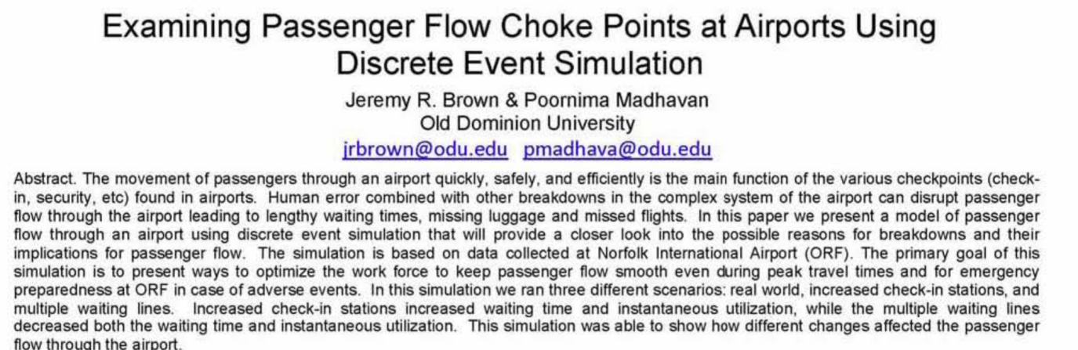
Figure 1: Abstract of the selected paper [1]
An airport has to move its passengers from the entrance to the aircraft quickly and safely. Most of the waiting happens at a few points, mainly the check-in counters and the security checkpoint. Trying out new staffing or a new queue layout on real passengers is costly, so airports use simulation to test such changes first. The paper does this for Norfolk International Airport (ORF). The authors timed passengers with a stopwatch, fitted distributions to the times, and built the model in Arena 10.0. Passengers are split by airline into three groups (American and Continental together, Southwest, and US Airways). Each passenger checks in at a kiosk or at a counter, and then goes to one of two security checkpoints. One run is a 24-hour day, and the model was run 80 times. The paper compares three scenarios: the real situation, more check-in stations, and check-in divided into two lines. It concludes that check-in, and not security, is the choke point.

1.2 The work done in this project
The paper's model is a set of Arena flowchart blocks. It works, but it can only be changed inside Arena, and its parts cannot be reused or tested on their own. This project builds the same model again in Java, using the techniques of this course: use cases, a domain model, UML diagrams of structure and behaviour, GRASP and design patterns. The following parts were built, as planned in D1.
- A small simulation engine: a clock, a list of future events sorted by time, as described by Schriber et al. [4], and random numbers from the Gamma, Exponential and Weibull distributions used in the paper.
- The airport model: arrivals split by airline, self and manned check-in, waiting lines, and the two security checkpoints with random stops.
- The three scenarios of the paper, each kept in an input file, so a new layout is a new file and not new code.
- Repeated runs of a 24-hour day (80 by default), with the average, standard deviation, minimum and maximum wait of each line, the utilization of each type of resource and the passengers per day.
- A console menu to set up a scenario, run it, view the results, save them to a CSV file and compare scenarios side by side.
Arena itself, animation, runways, baggage handling and the agent-based passengers that the paper leaves for future work are outside the scope.

1.3 Actors and requirements
Two kinds of people use the simulator. The analyst sets up scenarios, runs the simulation and studies the results. The airport manager only looks at results and compares layouts. The analyst can do everything the manager does, so the use case diagram draws the analyst as a special kind of manager. Passengers, agents and screeners belong to the simulated airport, so they are classes inside the model and not actors. Table 1 repeats the requirements of D1; all ten were built.
Table 1: Functional requirements (from D1)
No. | Requirement
1 | Read a scenario from a text file: airlines and shares, arrival distribution, kiosks and counters, kiosk share, lines, security lanes, stop share, run length, number of runs and seed.
2 | Check a scenario before it is run and report every missing or wrong value.
3 | Create passengers at random times and give each one an airline according to the shares.
4 | Send each passenger to a kiosk or a counter of their airline, and after check-in to a security checkpoint.
5 | Keep one or more lines for each kind of service and choose a line by the scenario's rule (at random, or the shortest line).
6 | Serve one passenger at a time at each kiosk, counter and lane, with a service time drawn from its distribution.
7 | Stop a given share of passengers at security for an extra check.
8 | Simulate a 24-hour day and repeat it a given number of times, each run starting with an empty airport.
9 | Record the waits of each line, the utilization of each type of resource and the passengers of each airline.
10 | Show results on screen, save them to a CSV file, and show scenarios side by side.

The non-functional requirements of D1 also hold. The same scenario and seed always give exactly the same results. The simulation core does not use any airport class (it compiles on its own). A new line rule, distribution or kind of service point can be added without changing existing classes. Every report prints a note on the assumed values. The 80 runs of a scenario take well under a second.

1.4 Use case model
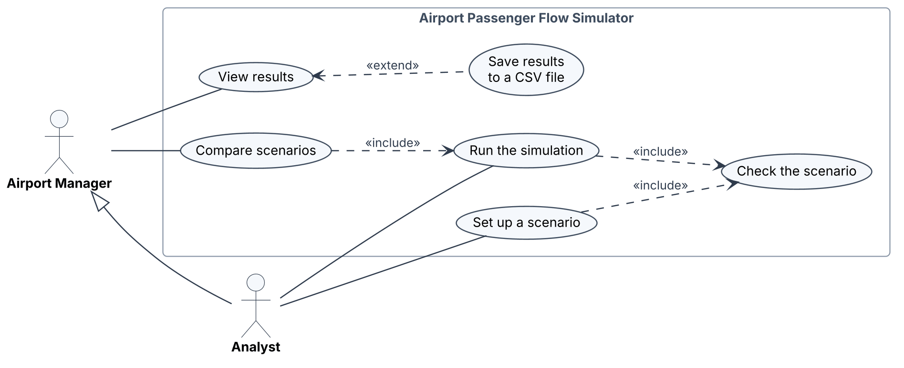
Figure 2: Use case diagram
Set up a scenario. The analyst names a scenario file. The system reads it and checks every value (the included use case Check the scenario). If there are problems it lists all of them and keeps the previous scenario; otherwise the new scenario becomes the current one.
Run the simulation. A scenario must be set up first. For each run the system builds a fresh airport, simulates 24 hours and records the statistics, showing the progress after each run. At the end it shows the waits, the utilization and the passengers per day. The results are kept, so they can be viewed again, saved to CSV or compared.
Compare scenarios. The analyst or the manager names two or more scenario files. The system runs each one (the included use case Run the simulation) and shows the average waits and utilization side by side. The three scenario files use the same seed and number of runs, so the comparison is fair.

1.5 Activity model
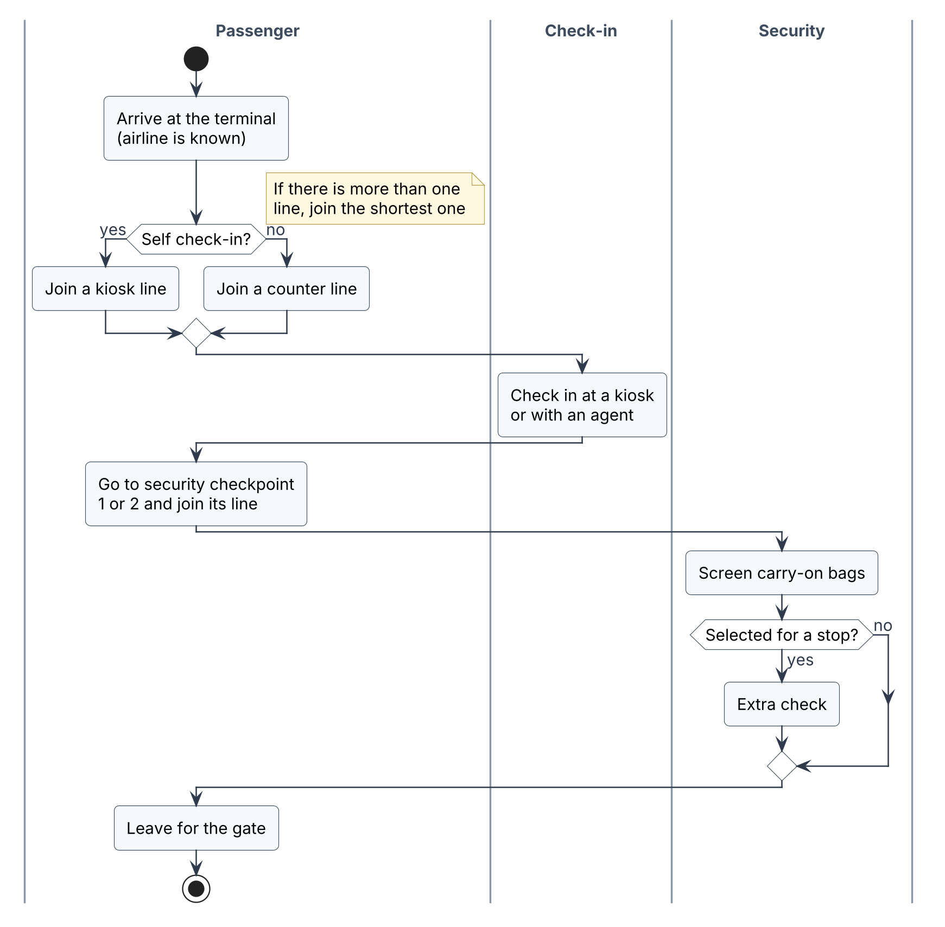
Figure 3: Activity diagram of a passenger's path through the airport
The activity diagram follows the Arena model in Figure 1 of the paper. A passenger arrives with a known airline and goes to self or manned check-in, then to one of the two security checkpoints. A set share of passengers is stopped for an extra check, and the model ends when the passenger leaves for the gate.

2. How the Solution Was Approached

2.1 Development in phases
D1 (Section 5) planned five short phases in the spirit of the Unified Process [2], building the packages from the bottom up: sim, then airport, then results and app. Each package is built on packages that already pass their tests, so a fault can be traced to the phase that brought it in. Table 2 shows what each phase produced.
Table 2: Development phases as carried out
Phase | What was built | How it was checked | Git tag
1. Simulation core | Package sim (8 classes): Event, Simulator, the three distributions, Shifted, DistributionFactory | 56 JUnit tests: event order and ties (rule 5), clock rules, mean and spread of every distribution, the parser | phase-1
2. Airport model | Package airport (19 classes): passengers, airlines, lines, service points, line rules, security, the three events | 38 JUnit tests: both state diagrams, rules 1 to 4, stops, routing, passenger creation (requirements 3 to 7) | phase-2
3. Results and application | Packages results and app (9 classes), the three scenario files, CSV output, build scripts | 39 JUnit tests: scenario checks, repeatability (rule 6), the known-answer queue, every use case (requirements 1, 2, 8 to 10) | phase-3
4. Calibration and experiments | Assumed values chosen and calibrated; 80 runs of each scenario; sample outputs | Utilization within 0.2 points of the paper; comparison tables (Section 4.6) | phase-4
5. Report and demonstration | Diagram check, this report, the Word note, README, submission package | Practice demonstration from a clean build | phase-5

The dates planned in D1 (17 October to 6 November) slipped, and the phases were carried out in early November 2026, just before the deadline. A first version of the code had been written while D1 was prepared, to make sure that the design could be built; it was checked by one test program with 32 checks. For D2 this code was taken through the phases in order. Within each phase every class was compared again with its diagram, and its JUnit tests were written. The phase was then committed to Git and tagged. The 32 checks were replaced by the JUnit tests.

2.2 Testing
The tests are written with JUnit 5 and kept in a test folder for each package, in the same Java package as the code they test. To make expected times exact, the airport tests build tiny airports by hand and use a test-only distribution that always returns the same value: if a counter takes 30 s and screening 20 s, a passenger must be screened from 30 s to 50 s. Each business rule of D1 and each arrow of both state diagrams has at least one test. Table 3 lists the test classes.
Table 3: JUnit test classes (133 tests in all)
Test class | What it checks | Covers
SimulatorTest | Events run in time order; equal times run in scheduling order; an event in the past is refused; the clock ends at the end time | Rule 5
DistributionTest | Mean within 1% and variance within 4% of theory for every distribution (200,000 samples); no negative samples; same seed, same values | Req. 6
DistributionFactoryTest | "54 + EXPO(60)" gives a Shifted with mean 114; parameter order; nine kinds of bad text refused with a clear message | Req. 1, 6
PassengerStateTest | Every arrow of Figure 10 is allowed and every other move of the 49 possible is refused | State diagram
WaitingLineTest | First in, first out; a passenger does not change line; one line feeding two points serves two at once | Rule 2, req. 5
ServicePointTest | One passenger at a time; Idle to Busy to Idle and Busy to Busy (Figure 11); busy time adds up | Rule 1, req. 6
LineChoiceTest | Shortest line, with a tie to the first line; random split is repeatable and even | Rule 3, req. 5
FlowTest | A passenger's states at exact times; security only after check-in; stop share 1, 0 and 0.3; kiosk or counter routing | Rule 4, req. 3, 4, 7
PassengerSourceTest | Airline shares, kiosk shares, increasing ids, negative gaps taken as zero | Req. 3
WaitStatsTest, StatisticsCollectorTest | Statistics of one run worked out by hand, including utilization of a service still in progress | Req. 9
ReportTest | Average of run averages, standard deviation, minimum and maximum; CSV rows; one column per scenario | Req. 9, 10
ScenarioCheckTest | Three planted errors give three messages; an empty file lists every missing key; a missing file gives a clear message | Req. 1, 2
RepeatabilityTest | Same seed, identical results; another seed, other results; run 2 of an experiment equals a run started alone with its seed | Rule 6, req. 8
QueueTheoryTest | The known-answer queue (Section 2.3) | Req. 8, 9
SimulatorFacadeTest, ConsoleMenuTest | Every use case through the facade, and the menu driven as a user would drive it | Req. 10
PaperScenarioTest | Passengers per day within 3% of the paper; 80 runs of each scenario within a few seconds | Calibration

To make sure the tests can fail, two faults were planted on purpose during phase 2: the tie rule of ShortestLine was reversed, and an extra arrow (Arrived to Waiting for screening) was added to the state diagram. Three tests failed, and the code was restored. All 133 tests pass, and the build scripts run them from a clean folder in about ten seconds.

2.3 Three checks of the whole program
The paper's exact numbers cannot be reproduced, because its parameters are not given and Arena uses its own random numbers. D1 therefore planned three other checks.
A known answer. With one counter, exponential times between arrivals (mean 60 s) and exponential service (mean 48 s), queueing theory gives the average wait Wq = λ / (μ(μ − λ)) = 192 s = 3.20 minutes and a utilization of λ/μ = 80%. Over 200 runs of 100 hours, the program gives 3.20 minutes and 79.95%. QueueTheoryTest checks this within ±5% and ±2 points.
Calibration. The real-world scenario should give close to the paper's passengers per day and utilization. It does (Section 4.6.1).
Trends. Whether check-in comes out as the choke point, and how the waits change when stations are added and when lines are split (Sections 4.6.2 to 4.6.5).

2.4 Changes during D2
No class, relationship or pattern of D1 was changed. A script compared the three class diagrams with the code: all 36 classes are drawn, and all 131 fields, operations and enumeration values in the diagrams exist in the code, so no diagram had to be redrawn. Three small changes were made inside existing classes, none of which changes the diagrams:
- Scenario.load() now says "scenario file not found" when the file does not exist, instead of only printing the file name.
- ExperimentResult has a new method, waitStdDev(), and the reports have a "Std dev" column: the standard deviation of the 80 run averages. The paper reports standard deviations and t-tests, and without this column it is not possible to tell a real difference between scenarios from random noise.
- The build scripts build.bat and build.sh were added, so the program and its tests can be built with one command.

3. How Patterns Were Used
Responsibilities were given with the GRASP principles [2]. Information Expert: a WaitingLine knows its own length, a Passenger its own wait, and a ServicePoint its own busy time. Creator: AirportBuilder creates the objects of an airport, and ExperimentRunner creates the Simulator and StatisticsCollector of each run. Controller: SimulatorFacade receives every request from the menu. Low Coupling and High Cohesion: the four packages form layers (app, results, airport, sim) and each package only uses packages after it, so there are no cycles. Polymorphism: ServicePoint, LineChoice and Distribution. Table 4 shows where each design pattern from Gamma et al. [3] is in the code, and what it gave in practice.
Table 4: Design patterns in the code
Pattern | Where it is in the code | What it gave in practice
Command | sim.Event with abstract execute(Simulator); airport.ArrivalEvent, ServiceEndEvent and StopEndEvent. Simulator.run() calls execute() on the earliest event. | The engine has no airport code, so package sim compiles and is tested on its own. SimulatorTest uses its own tiny events.
Template Method | ServicePoint.startNext() and finishService() are final and fix the steps of a service; CheckInPoint and ScreeningLane only fill in servingState() and sendOn(). | Each subclass is two short methods. Rule 1 and the busy time are written once and tested once.
Strategy | LineChoice with RandomSplit and ShortestLine; Distribution with ExponentialDist, GammaDist and WeibullDist. | Scenarios 1 and 3 differ only in a line in the file. Tests pass in a constant-time distribution to get exact times.
Decorator | Shifted(offset, base) is itself a Distribution and adds the offset to every sample of base. | The paper's "54 + EXPO", "60 + WEIB" and "10 + WEIB" need no extra classes.
Observer | airport.SimListener with passengerArrived() and waitEnded(); PassengerSource and ServicePoint notify; results.StatisticsCollector listens. | No counting code in the model, and airport does not depend on results. Tests use their own recording listener.
Factory | DistributionFactory.parse(text) reads Arena notation; PassengerSource.next(sim) creates passengers. | One place for the parsing rules and their error messages (nine are tested).
Builder | AirportBuilder.check(s) lists every problem; build(s, listener) wires a fresh airport in a fixed order (security first). | A wrong scenario gets all its errors in one message; each run gets a new airport.
Facade | app.SimulatorFacade with loadScenario(), run(), showResults(), saveCsv() and compare(), used by ConsoleMenu. | The menu depends on one class, one method per use case. It is also the GRASP Controller.

Singleton was deliberately not used for the clock or the random numbers, even though it is common in simulation code. Every run needs a fresh clock and its own random stream (rule 6), so a Simulator is created per run and passed as a parameter. This is what made RepeatabilityTest possible: run 2 of an experiment gives exactly the same result as the same seed run alone, which shows that nothing is carried over between runs.
The passenger's states are kept in the enumeration PassengerState, whose canMoveTo() holds the arrows of the state diagram, and Passenger.changeState() refuses any other move. This is a simple state machine rather than the full State pattern, because the states have no behaviour of their own.

4. Design and Results

4.1 Packages and class diagrams
The 36 classes are in four packages: app (5 classes), results (4), airport (19) and sim (8). Figure 4 shows the airport model, Figure 5 the simulation core with the three events, and Figure 6 the application and results classes. Parameter types are left out of the operations to keep the diagrams readable: sim is a Simulator, p a Passenger, rng a Random and s a Scenario. The diagrams are the same as in D1, and the code matches them (Section 2.4).
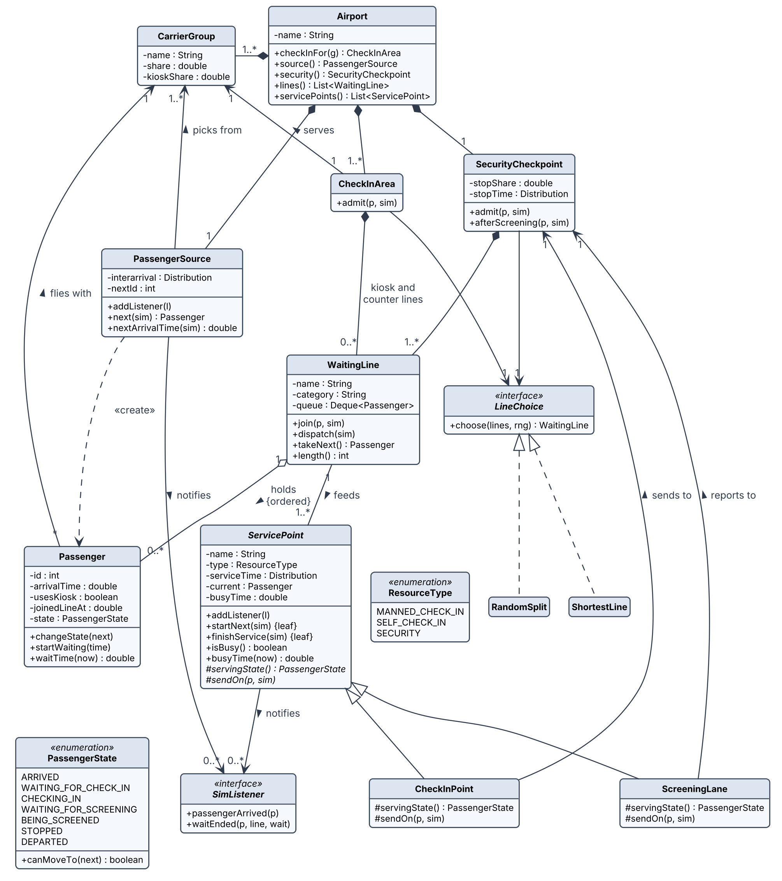
Figure 4: Class diagram of the airport model (package airport)
Airport owns everything that belongs to one simulated day. A PassengerSource creates passengers and gives each one an airline (CarrierGroup) and a choice between kiosk and counter. Each airline has a CheckInArea, and one SecurityCheckpoint serves all passengers. Both hold WaitingLines and use a LineChoice to pick a line. ServicePoint is the abstract class for anything that serves one passenger at a time: a CheckInPoint sends the passenger to security, and a ScreeningLane hands the passenger back to the checkpoint for the stop decision. Kiosks and counters behave the same way, so they are one class told apart by ResourceType. A WaitingLine can feed several service points, so the two-line scenario needed no new class, only a different scenario file.
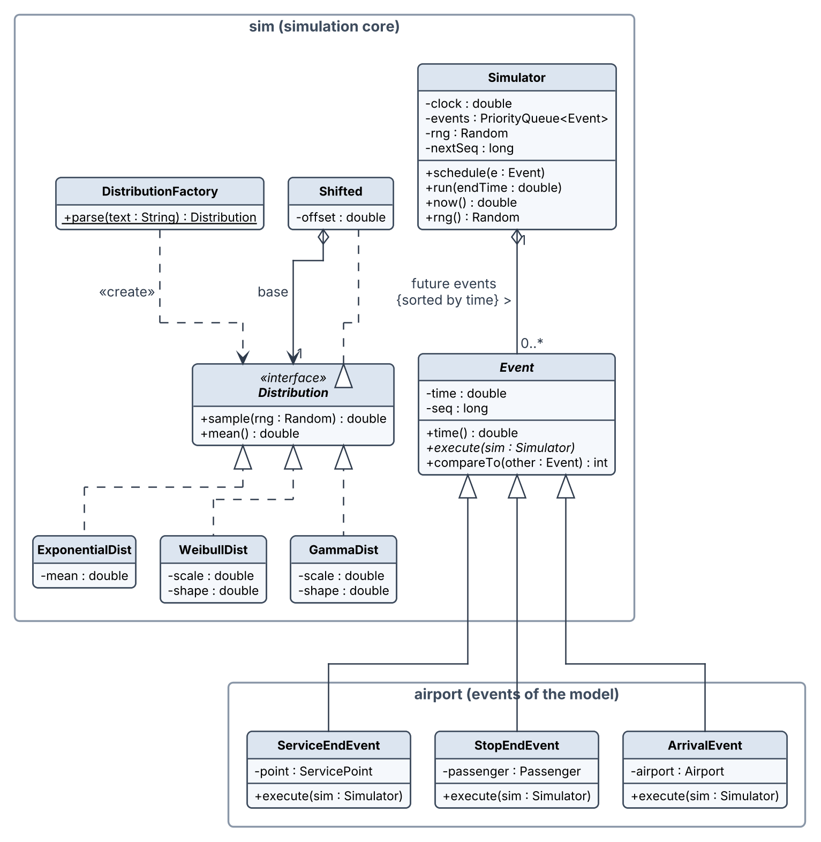
Figure 5: Class diagram of the simulation core (package sim) and the events
Simulator keeps the clock, the events sorted by time and the random stream of one run. The three events extend Event but live in the airport package, because each acts on an airport object; this keeps the core free of airport code.
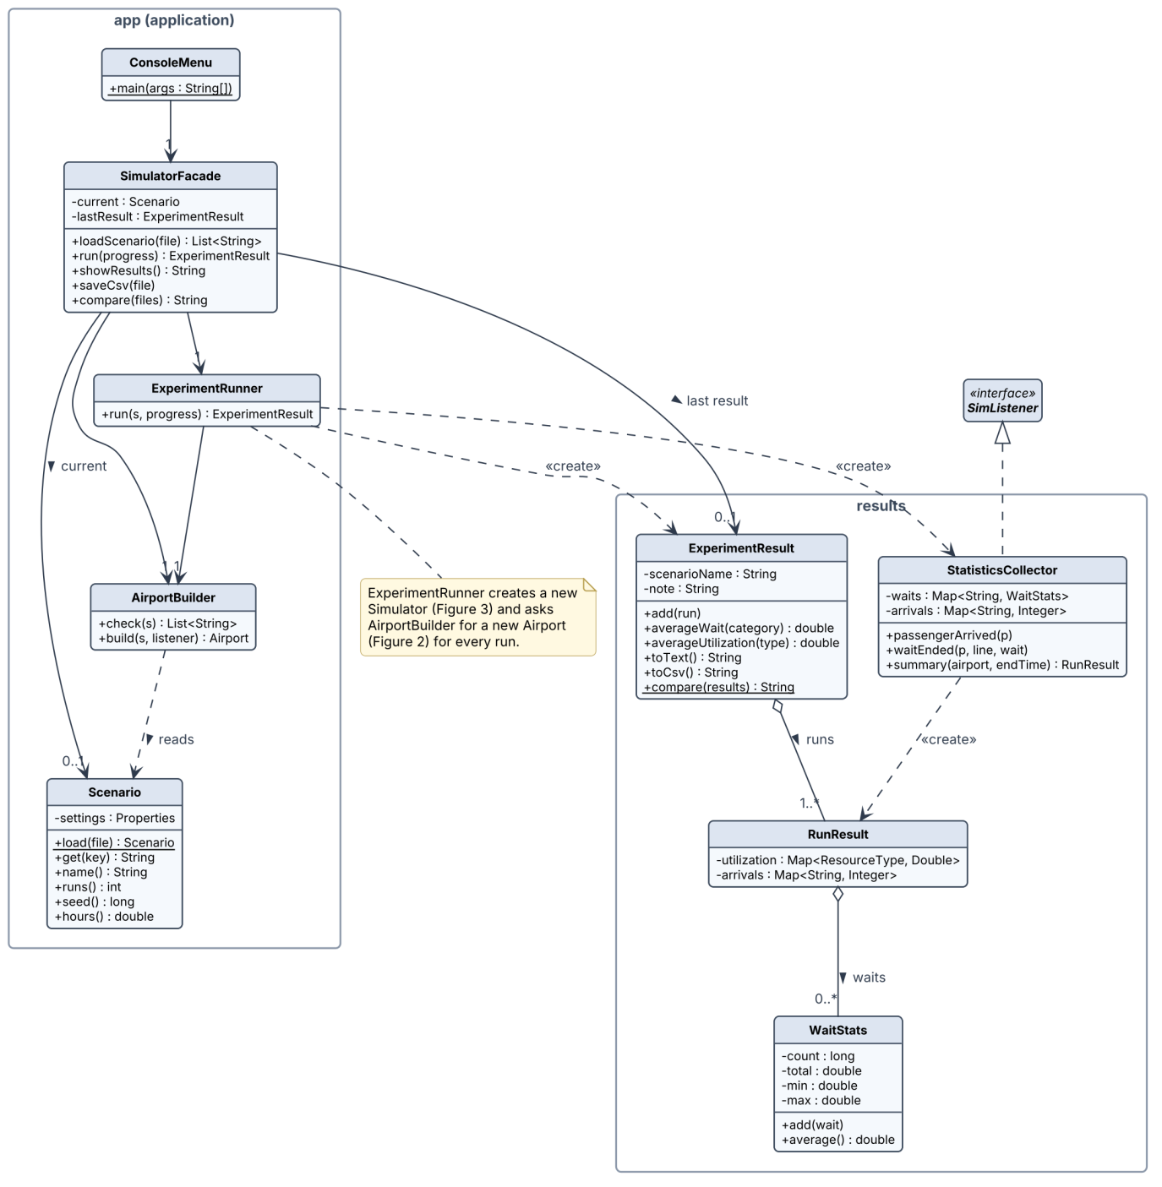
Figure 6: Class diagram of the application (package app) and results
SimulatorFacade is the single entry point for the console menu. ExperimentRunner repeats the runs, and AirportBuilder checks a Scenario and builds a fresh Airport for each run. StatisticsCollector implements SimListener and makes one RunResult per run; ExperimentResult combines the runs the way the paper reports them (average of run averages, smallest minimum, largest maximum, in minutes) and adds the standard deviation of the run averages.

4.2 Sequence diagrams
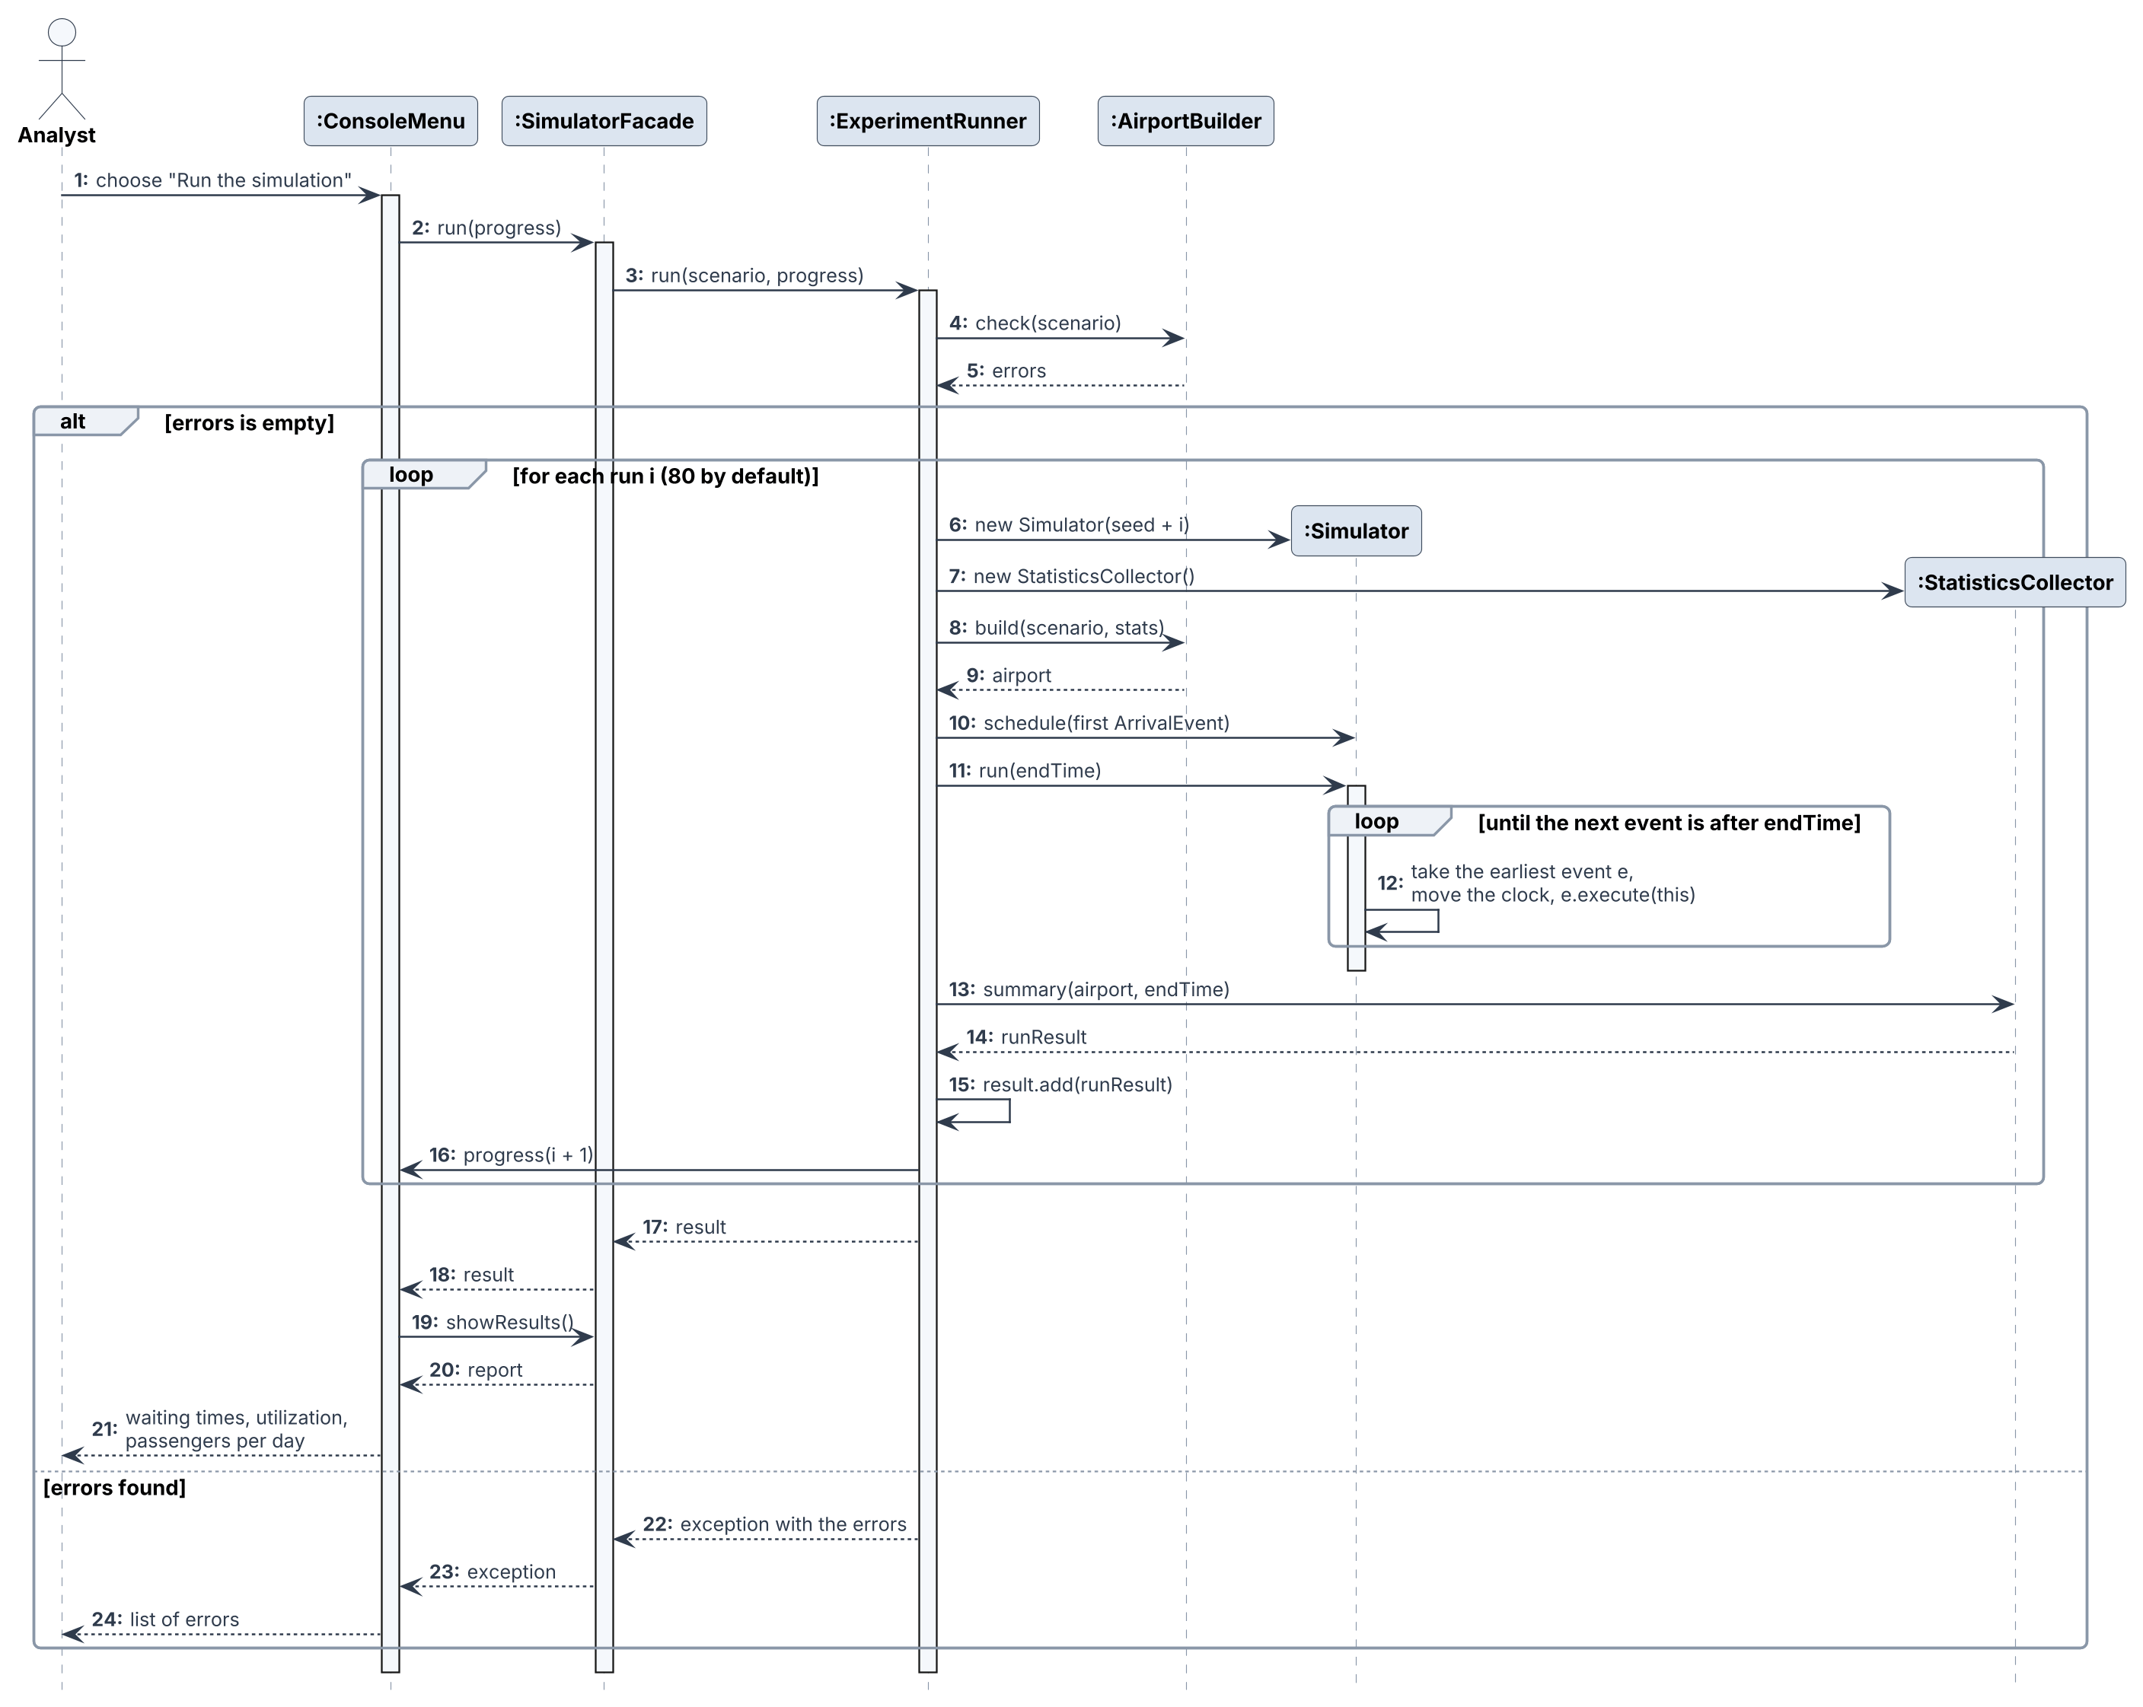
Figure 7: Sequence diagram for the use case Run the simulation
The request goes from the ConsoleMenu through the SimulatorFacade to the ExperimentRunner, which asks the AirportBuilder to check the scenario. Each run then creates a new Simulator and StatisticsCollector, builds a fresh airport connected to that collector, schedules the first arrival and runs for 24 hours, always executing the earliest event next.
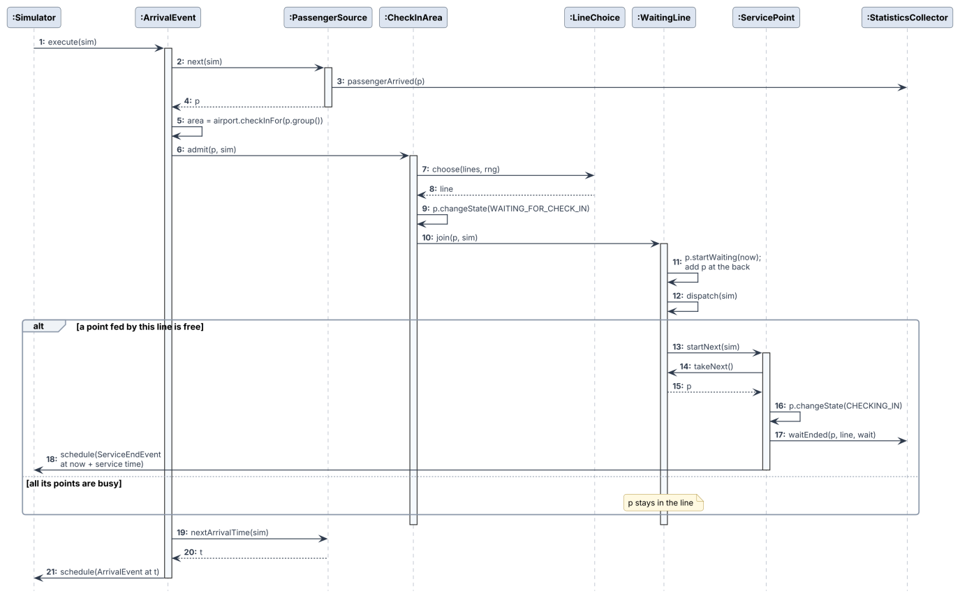
Figure 8: Sequence diagram for a passenger arriving at check-in
Inside one ArrivalEvent, the PassengerSource creates a passenger and tells the collector. The CheckInArea of the airline asks its LineChoice for a line. The line records the time of joining and, if a service point is free, that point takes the passenger, reports the wait and schedules a ServiceEndEvent. Finally the next arrival is scheduled.
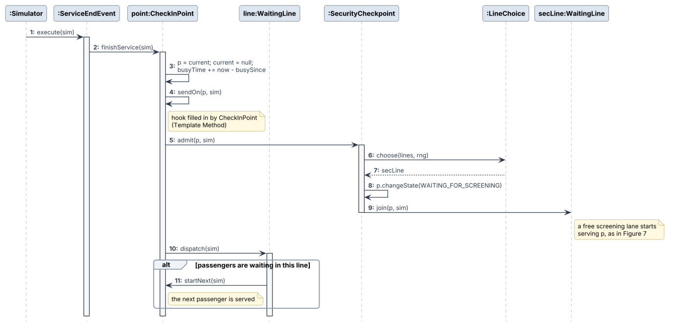
Figure 9: Sequence diagram for the end of a service
When a ServiceEndEvent runs, the service point adds to its busy time, sends the passenger on (to security after check-in, or to the stop decision after screening) and asks its line to dispatch the next passenger. This is where the Template Method of ServicePoint does its work.

4.3 State diagrams
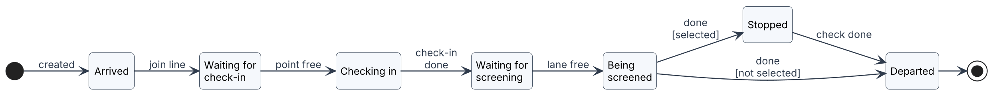
Figure 10: State diagram (a) of a passenger
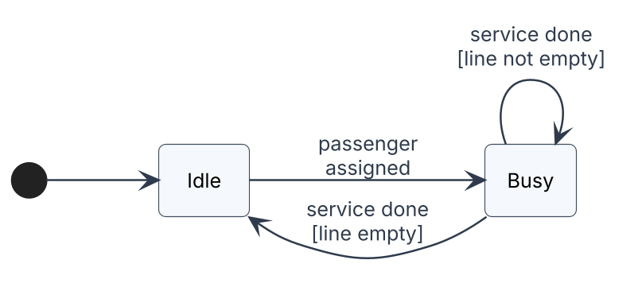
Figure 11: State diagram (b) of a service point (kiosk, counter or screening lane)
A passenger's state changes only along the arrows of Figure 10, so a passenger cannot be screened before checking in; PassengerStateTest checks all 49 pairs of states. A service point is Idle or Busy; after a service it stays Busy if its line is not empty. The diagrams also fix how the paper's two measures are calculated: waiting time is the time spent in a waiting state, and utilization is the share of the day a service point is Busy.

4.4 Business rules and where they are checked
Table 5: Business rules of D1, the code that enforces them, and their tests
Business rule (D1 Section 3.9) | Enforced in | Tested by
1. A kiosk, counter or lane serves one passenger at a time | ServicePoint.startNext() | ServicePointTest
2. First in, first out, and no change of line | WaitingLine (one queue per line) | WaitingLineTest
3. The line is chosen by the scenario's rule; a tie goes to the first | LineChoice, RandomSplit, ShortestLine | LineChoiceTest
4. Security only after check-in; leave only after screening and any stop | PassengerState.canMoveTo(), CheckInPoint.sendOn() | FlowTest, PassengerStateTest
5. Events in time order, ties in scheduling order | Event.compareTo(), Simulator | SimulatorTest
6. Each run starts empty with its own random stream | ExperimentRunner (new Simulator(seed + i)) | RepeatabilityTest

4.5 Assumed and calibrated values
Table 1 of the paper gives the form of each distribution (Gamma for the time between arrivals, a constant plus an Exponential for manned check-in, a constant plus a Weibull for self check-in and security), but every parameter is printed as zero and no units are given. The units are taken as seconds, as in D1. The paper also does not give the number of stations, the kiosk share, how security is split, or the stop settings. Table 6 lists every value used in the scenarios and where it comes from. Only the rows marked "Paper" or "Derived" come from the paper.
Table 6: Values used in the real-world scenario and their source
Item | Value | Source
Airline groups; distribution families and constants; 2 security checkpoints; 80 runs of 24 h | as in the paper | Paper (Section 2, Table 1)
Share of each airline | 0.0813 / 0.4846 / 0.4341 | Derived: the paper's passengers per day divided by their total
Time between arrivals | -0.001 + GAMM(39.2, 1) | Derived: 86,400 s / 2,204.66 passengers per day
Kiosks and counters | AA/CO 1 + 1, Southwest 4 + 4, US Airways 4 + 4 | Assumption: the fewest stations for which no airline's own stations are loaded above about 0.9 once utilization matches the paper
Share using a kiosk | 0.5 for every airline | Assumption: no information, so an even split
Weibull shape (self check-in, security) | 1.5 | Assumption: a moderate spread
Manned check-in time | 54 + EXPO(508.3), mean 562 s | Calibrated to the paper's utilization
Self check-in time | 60 + WEIB(593.3, 1.5), mean 596 s | Calibrated to the paper's utilization
Screening time | 10 + WEIB(61.73, 1.5), mean 65.7 s | Calibrated to the paper's utilization
Split between the two checkpoints | at random | Assumption (D1 Section 3.5)
Stops at security | 5% of passengers, EXPO(120) | Assumption; stopped passengers are checked aside, so this changes no reported measure

How the calibration was done. For each type of resource, utilization = arrival rate to that type × mean service time / number of stations of that type. With the stations of Table 6, each mean was first set from this formula (for example, security: 0.8243 × 2 lanes × 39.2 s ≈ 64.6 s). One run of the scenario then gave about 1 to 1.5 points less than the target, mainly because passengers still waiting at the end of the day are never served. Each mean was multiplied once by target / result, which brought all three within 0.2 points of the paper. The values were then frozen, and Scenarios 2 and 3 use them unchanged.
The calibrated check-in times are long, about 9 to 10 minutes on average. This follows from the paper's own figures: the model spreads about 2,205 passengers evenly over 24 hours (about 92 an hour), and for the few stations of an airport this size to be busy 78% to 83% of the day, each service must take that long. A real day has peaks and quiet hours, but the paper's model, and therefore this one, uses one constant arrival rate.

4.6 Results and comparison with the paper
All results below are averages over 80 runs of 24 hours with seed 2026, exactly as printed by the program (files .op1 to .op4). Waiting times are in minutes.

4.6.1 Calibration targets
Table 7: Real-world scenario against the calibration targets
Measure | Paper | This program | Difference
Passengers per day, American/Continental | 179.14 | 178.08 | -0.6%
Passengers per day, Southwest | 1068.43 | 1071.05 | +0.2%
Passengers per day, US Airways | 957.09 | 954.48 | -0.3%
Utilization, manned check-in | 78.40% | 78.57% | +0.17 points
Utilization, self check-in | 83.38% | 83.39% | +0.01 points
Utilization, security | 82.43% | 82.46% | +0.03 points

4.6.2 Waiting times in the real-world scenario
Table 8: Waiting times in the real-world scenario (minutes)
Line | Paper average | Our average | Our std dev | Paper max | Our max
American/Continental manned | 2.51 | 10.65 | 5.02 | 33.28 | 123.44
American/Continental self | 2.71 | 10.04 | 5.44 | 56.57 | 112.44
Southwest manned | 6.74 | 9.94 | 5.01 | 67.72 | 88.94
Southwest self | 6.60 | 14.48 | 8.49 | 75.26 | 98.49
US Airways manned | 2.64 | 4.79 | 2.14 | 33.92 | 56.26
US Airways self | 12.07 | 5.54 | 2.55 | 105.48 | 65.52
Security checkpoint 1 | 1.46 | 3.18 | 0.83 | 17.71 | 26.07
Security checkpoint 2 | 1.45 | 3.45 | 1.13 | 18.78 | 35.16

What agrees. As in the paper, check-in is the choke point: every one of the six check-in waits is longer than the security waits, and a t-test on the 80 run averages gives t between 6.3 and 13.1 (p < .001) for each of them against Security checkpoint 1. Southwest is among the longest waits, as in the paper, and the minimum wait is 0.00 everywhere, as in the paper.
What does not. The individual check-in waits differ from the paper by a factor of up to four, in both directions. American/Continental waits much longer than in the paper, because its one counter and one kiosk serve slowly (Section 4.5). US Airways self check-in, the longest wait in the paper, is short here, because the scenario gives every airline the same kiosk share and service time; the paper's data per airline is not published. Security waits are about twice the paper's. These values were not tuned to the waits, because D1 promised to calibrate only on passengers per day and utilization. As a sensitivity check, the file scenarios/sensitivity_security_shortest.properties sends passengers to the shorter security line instead of a random one. Security waits then fall to 1.69 and 1.51 minutes, close to the paper's 1.46 and 1.45, with the same utilization. So the paper's security results fit a shortest-line split better, but the paper does not say which it used, and the D1 assumption (random) is kept.

4.6.3 Scenario 2: more stations
Scenario 2 adds 2 agents and 10 kiosks to each airline, as in the paper; everything else is unchanged. Table 9 compares both scenarios with the paper, and Table 10 the utilization.
Table 9: Average waits (minutes) in the three scenarios, this program against the paper
Line | S1 paper | S1 ours | S2 paper | S2 ours | S3 paper | S3 ours
Am./Continental manned | 2.51 | 10.65 | 1.38 | 0.07 | 2.51* | 11.08
Am./Continental self | 2.71 | 10.04 | 0.83 | 0.00 | 2.71* | 11.24
Southwest manned | 6.74 | 9.94 | 25.13 | 0.58 | 0.19 | 11.53
Southwest self | 6.60 | 14.48 | 34.05 | 0.00 | 0.088 | 17.25
US Airways manned | 2.64 | 4.79 | 24.63 | 0.31 | 0.06 | 6.86
US Airways self | 12.07 | 5.54 | 34.45 | 0.00 | 0.14 | 7.16
Security checkpoint 1 | 1.46 | 3.18 | – | 3.65 | – | 3.26
Security checkpoint 2 | 1.45 | 3.45 | – | 3.68 | – | 3.27
S1 = real world, S2 = more stations, S3 = two lines. * American/Continental is not split in Scenario 3; the paper repeats its base values. – : not reported in the paper.
Table 10: Utilization in the three scenarios
Resource | S1 paper | S1 ours | S2 paper | S2 ours | S3 paper | S3 ours
Manned check-in | 78.40% | 78.57% | 85.39% | 47.27% | 40.70% | 78.72%
Self check-in | 83.38% | 83.39% | 89.11% | 19.31% | 43.89% | 83.41%
Security checkpoint | 82.43% | 82.46% | 79.69% | 82.86% | 82.32% | 82.19%

In this program, more stations cut every check-in wait to less than one minute (all six changes have p < .001), and utilization fell to 47.27% for counters and 19.31% for kiosks. These two figures are exactly what the utilization formula predicts with the same passengers spread over more stations: 78.57% × 9 / 15 counters = 47.1%, and 83.39% × 9 / 39 kiosks = 19.2%. The paper reports the opposite: waits for Southwest and US Airways rose to 25 to 34 minutes, and utilization rose to 85.39% and 89.11%. The paper itself calls this unexpected ("one would assume that increasing the number of stations would decrease this wait time") but gives no reason.
Security checkpoint 1 waited a little longer in Scenario 2 (3.18 to 3.65 minutes, p = .002); checkpoint 2 changed less (p = .23). With almost no wait at check-in, passengers reach security in bunches instead of being spaced out by the check-in queues.

4.6.4 Scenario 3: two lines
The paper describes Scenario 3 as dividing "the check-in stations into multiple lines, for this case two", so that people can choose the shorter line. The scenario file does exactly this for Southwest and US Airways: each kiosk line and counter line becomes two lines feeding two stations each, passengers join the shortest line, and no station is added.
In this program the utilization did not change (78.72% and 83.41%), and the waits of Southwest and US Airways became longer by 1.6 to 2.8 minutes. For US Airways the increase is clear (t = 3.81 and 4.23, p < .001); for Southwest it is not significant at the 5% level (p = .07 and .09). American/Continental, whose layout is the same in both scenarios, moved by 0.4 to 1.2 minutes (p > .3), which shows the size of the run-to-run noise. The paper reports waits cut to 0.06 to 0.19 minutes and utilization cut to 40.70% and 43.89%.

4.6.5 Why the trends differ from the paper
The differences in Scenarios 2 and 3 do not come from the assumed values, and changing those values would not reverse them. They follow from a property that holds for any queue in which every passenger is eventually served:
utilization = arrival rate × mean service time / number of stations
- Adding stations (Scenario 2) increases the number of stations and leaves the passengers and service times unchanged, so utilization must fall. A rise from 78% to 85%, as in the paper's Table 6, is not possible for the change the paper describes, unless something else was also changed in its model.
- Splitting lines (Scenario 3) changes none of the three terms, so utilization must stay the same. The paper's fall to about 40% ("workers were only working for 9-10 hours of the 24") is what would happen if the number of stations of Southwest and US Airways had about doubled, for example if each new line was given its own stations in the Arena model. The paper does not say so, and this project does not assume it.
- Why one line is better than two. With one line feeding four stations, the next passenger goes to whichever station becomes free first. With two lines of two stations each, a passenger can be waiting in one line while a station of the other line is free, because passengers do not change line (rule 2). Choosing the shorter line on arrival helps, but cannot fully make up for this, so waits grow slightly. This is the well-known advantage of a single shared queue.
One more point suggests an error in the paper's Table 4: every added-station row has the same maximum, 33.28 minutes, which is also the maximum of American/Continental manned in the base scenario. Following D1, the scenario values were not changed to force agreement; the differences are reported here as a finding.

5. Summary and Conclusion
The project re-implemented the passenger flow model of Brown and Madhavan [1] as an object oriented Java program that follows the D1 design: 36 classes in four layered packages, eight design patterns where they solve a real problem, and the use case, class, activity, sequence and state diagrams of D1, which still match the code. The program reads, checks, runs and compares scenarios, and 133 JUnit tests check every business rule, every state transition and every use case. A known-answer queue gives the result of queueing theory (3.20 minutes), and the real-world scenario gives the paper's passengers per day and utilization.

5.1 What was learned
- The design made the tests easy. Because the engine knows nothing about airports (Command), the core was tested before any airport class existed. Because times come from a Distribution (Strategy), tests could use constant times and check exact moments. Because statistics come through a listener (Observer), tests could record every wait with their own listener.
- Building bottom-up paid off. Each package was tested on packages that already passed their tests, so no fault had to be traced across layers.
- A state diagram in code catches errors. Keeping the arrows of the passenger state diagram in PassengerState.canMoveTo() means a wrong move fails at once with a clear message instead of giving wrong statistics later.
- A spread measure is needed to compare scenarios. American/Continental changed by up to 1.2 minutes between two scenarios in which nothing about it changed. Adding the standard deviation of the run averages made it possible to separate real effects from noise, as the paper does with its t-tests.

5.2 Conclusion on the paper's questions
The model agrees with the paper's main conclusion: at this airport the check-in stations, and not security, are the choke points. It does not reproduce the paper's two other findings. Adding stations removed the check-in waits, and splitting the lines made them slightly longer. For both scenarios the utilization reported by the paper cannot come from the layout the paper describes, if every passenger is served. The paper's recommendation to add staff or kiosks is supported by this model; its recommendation to divide the lines is not.

5.3 Limitations
- Station counts, kiosk shares, Weibull shapes, the security split and the stop settings are assumptions, and the service times were calibrated only to the paper's utilization. Different assumptions would give different waits, though not different trends for Scenarios 2 and 3 (Section 4.6.5).
- Arrivals have the same rate for all 24 hours, as in the paper's model, which makes the calibrated service times long.
- Every airline has the same service times and kiosk share, because the paper does not publish its data per airline.
- Stopped passengers are checked aside, only percentage-based stops are modelled, and waits still in progress at the end of a day are not counted.
- Each scenario uses its own random numbers, so small differences between scenarios need the t-tests above to be judged.

5.4 Future work
- Passengers as agents with their own experience, physical ability or children, as the paper suggests for future work. Passenger already carries its own state, so such attributes would go there.
- Arrival rates that change during the day, as a new Distribution or PassengerSource strategy, so that peaks can be studied with realistic service times.
- Separate service times and kiosk shares for each airline, if measured data becomes available.
- Common random numbers across scenarios, so that differences between layouts can be measured with less noise.

References
[1] Brown J.R., Madhavan P.; Examining Passenger Flow Choke Points at Airports Using Discrete Event Simulation; Selected Papers and Presentations Presented at MODSIM World 2010 Conference & Expo, NASA/CP-2011-217069/PT 2; Hampton, Virginia; Part 2, 2011, pp. 471–477.
[2] Larman C.; Applying UML and Patterns: An Introduction to Object-Oriented Analysis and Design and Iterative Development; Prentice Hall; Upper Saddle River, NJ; 3rd Edition, 2004.
[3] Gamma E., Helm R., Johnson R., Vlissides J.; Design Patterns: Elements of Reusable Object-Oriented Software; Addison-Wesley; Reading, MA; 1995, 395 pp.
[4] Schriber T.J., Brunner D.T., Smith J.S.; Inside Discrete-Event Simulation Software: How It Works and Why It Matters; Proceedings of the 2017 Winter Simulation Conference; Las Vegas, Nevada; 2017, pp. 735–749.

Internet Sources
[5] https://ntrs.nasa.gov/citations/20110012091 (the paper selected for the project)
[6] https://www.informs-sim.org/wsc17papers/includes/files/054.pdf (reference [4])

Appendix A. How to View the Demonstration
This is the same text as the separate note h2025H1030209P_D2_note.docx.

OO language used
Java, compiled for Java 17 (javac --release 17). The program uses only the standard Java library. The tests use JUnit 5, through the single file lib/junit-platform-console-standalone-1.10.5.jar, which is included in the zip.

Special software
- JDK 17 or later, with java and javac on the PATH. The program was developed and tested with JDK 21 (Microsoft Build of OpenJDK 21.0.12.1), compiling for Java 17.
- Nothing else is needed: no IDE, no Maven or Gradle, no database. The JUnit jar is in lib/.
- Optional: PlantUML, only to redraw the diagrams from the .puml files in uml/.

Special hardware
None. Any laptop is enough. It was tested on a Windows 10 laptop, where 80 runs of one scenario take well under a second.

How to view the demonstration
- Unzip h2025H1030209P_D2.zip and open a terminal (Command Prompt, PowerShell or a Unix shell) in the folder ooad-airport-sim. On Windows, unzip into a short folder such as a folder D2 directly on drive C, because Windows refuses file paths longer than 260 characters.
- Build and test: on Windows type build.bat; on Linux, macOS or Git Bash type sh build.sh. This compiles the program into out/, compiles the tests, and runs all JUnit tests. The last lines should say 133 tests successful and 0 tests failed.
- Start the menu: java -cp out app.ConsoleMenu. Choose 1 and type scenarios/real_world.properties, then 2 to run it (the progress shows each of the 80 runs), 3 to view the results again, 4 to save them to a CSV file, and 5 to compare scenarios (type the three file names separated by spaces). 0 ends the program.
- Or use the one-line forms: java -cp out app.ConsoleMenu run scenarios/real_world.properties runs one scenario, and java -cp out app.ConsoleMenu compare scenarios/real_world.properties scenarios/more_stations.properties scenarios/two_lines.properties shows the three scenarios side by side.
- To see the scenario check, load a file with a mistake in it (for example change security.lanes to 0): the menu lists every problem and keeps the previous scenario.

What to look for
- The average, standard deviation, minimum and maximum waiting time of each line, in minutes.
- The utilization of manned check-in, self check-in and security. For the real-world scenario it is close to the paper's 78.40%, 83.38% and 82.43%.
- The passengers per day of each airline group, close to the paper's 179, 1068 and 957.
- The side-by-side comparison of the three scenarios.
- The note at the top of every report, which says which values are assumptions. The comments at the top of each scenario file say where every value comes from.

Sample input and output
File | Content
h2025H1030209P_D2.ip1 | scenarios/real_world.properties: Scenario 1, the real situation
h2025H1030209P_D2.ip2 | scenarios/more_stations.properties: Scenario 2, 2 more agents and 10 more kiosks per airline
h2025H1030209P_D2.ip3 | scenarios/two_lines.properties: Scenario 3, two lines for Southwest and US Airways
h2025H1030209P_D2.op1 to .op3 | the output of the run command for .ip1 to .ip3 (seed 2026, 80 runs)
h2025H1030209P_D2.op4 | the output of the compare command for the three scenarios

The same seed always gives the same results, so running the commands above reproduces the .op files exactly.

