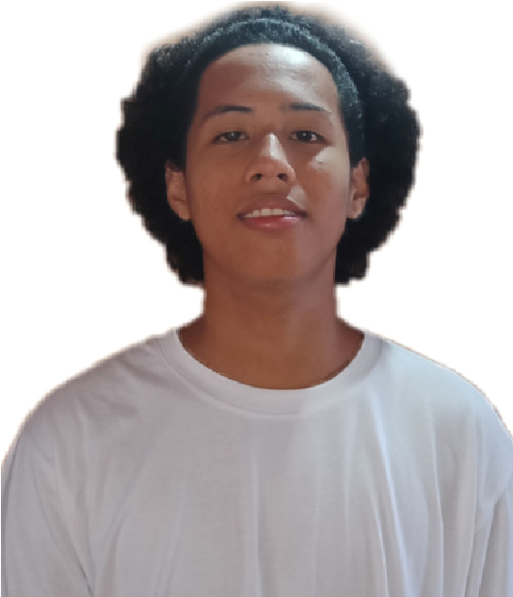
IAN GENESIS PROCTOR

Web Developer
CONTACT
09755779653
menezkieproctor@gmail.com www.iansite.com
Brgy. San Pablo Catbalogan
EDUCATION

Elementary
Salug ELelementary School
2012-2015
High School
CNCHS
2015-2019
Senior High
Samar College
2019-2022 College Samar College
2019-2022
EXPERTISE
Front-End Web Development
(HTML, CSS, JavaScript)
Responsive and CrossBrowser Website Design
Website Troubleshooting and Performance Optimization
Content Management and
Basic Backend Support

PROFILE SUMMARY
IT graduate with solid experience in website development, specializing in HTML, CSS, and JavaScript to create responsive and user-friendly websites. Skilled in troubleshooting, performance optimization, and ensuring cross-browser compatibility. Experienced in both freelance and company-based projects, with a strong sense of professionalism, integrity, and teamwork. Passionate about learning new technologies and committed to delivering high-quality web solutions.

WORK EXPERIENCE
Junior Web Developer
BrightCode Solutions – Quezon City 2019 - 2022
Built and maintained company websites using HTML, CSS, and JavaScript.
Improved website performance and reduced loading times by 25%. Assisted senior developers in troubleshooting and resolving bugs.
IT Support & Web Assistant
2017 - 2019 NetConnect Services – Tacloban City
Provided technical support for clients’ websites and systems.
Assisted in updating website content and layouts.
Ensured proper website functionality across different devices and browsers.
Freelance Web Developer
Self-Employed – Remote 2015 - 2017
Designed and developed simple websites for small businesses and individuals.
Customized templates and created responsive web pages.
Communicated directly with clients to deliver projects on time.

