ZESCO Bill Reconciliation & Anomaly Detector - User Guide

Date: 2025-06-11

Welcome to the ZESCO Bill Reconciliation & Anomaly Detector. This tool helps users upload and analyze ZESCO token purchase and unit consumption data to detect anomalies such as suspiciously high usage, no activity, or mismatched tokens and units.

# 1. Features

• Upload CSV of ZESCO token purchases and consumption.  
• View summary metrics (total tokens, units, efficiency, anomalies).  
• Visualize usage trends via interactive charts.  
• Detect multiple types of anomalies with explanations.  
• Export anomalies as PDF or CSV.  
• Export usage charts as PNG.  
• Filter by date range or meter number.  
• Dark mode support for better UI/UX.

# 2. How to Use

Step-by-step guide:

1. Visit the dashboard.  
2. Click 'Upload CSV' to load your data. The CSV should have the following Header format;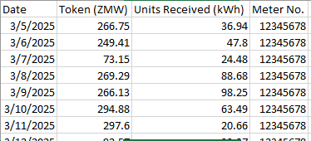  
3. View the summary stats and usage trends.  
4. Navigate to the Anomalies section to see suspicious patterns.  
5. Export anomalies via the export buttons (PDF or CSV).  
6. Use the date/meter filters to customize your view.

# 3. Chart Exports

You can export usage trend charts as PNG by clicking the 📤 Export Chart button above the charts.

# 4. Anomalies Explained

• Sudden spike in units: Units received > 2x recent average.  
• Token purchased but no units: Paid but received nothing.  
• Low efficiency: Units/ZMW below expected threshold.  
• No activity: No tokens or units recorded.  
• Units without token: Units received but no payment.  
• High token spending: Token amount exceeds usual.  
• High efficiency: Units/ZMW far above normal.

# 5. Deployment

This Flask project can be deployed on platforms like Render. Ensure to use production-ready servers (e.g. Gunicorn), and disable debug mode.  
Use `render.yaml` for easy Render deployment configuration.

# 6. Technologies Used

• Python & Flask (backend)  
• HTML, Bootstrap 5 (frontend)  
• Chart.js (charts)  
• SQLite (data storage)  
• ReportLab (PDF export)

# 7. Developer Notes

Ensure your data matches the expected format before uploading. All calculations are approximate and rule-based – manual verification is recommended for flagged anomalies.