Project brief

Application concept

Overview
This project focuses on a weather event simulator. The user interface will allow the user to switch between different events in an intuitive way. A textual description, displayed on screen within a box in the upper-left corner, will briefly explain the effects of the weather event and the meteorological conditions required for it to occur. The user will be able to interact with the simulator by adjusting the intensity of the event.

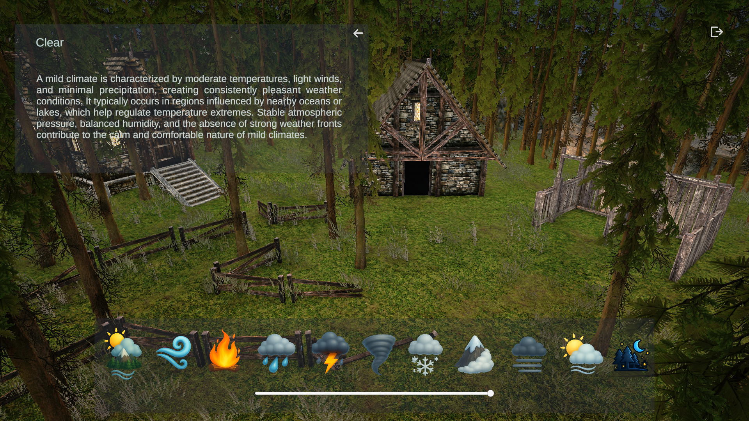
Questo progetto è ideato per poter mettere in pratica molte delle funzionalità incontrate durante il corso di Junior Programmer:
- User interaction, to enable them to change effects and influence the simulation
- Transitions between scenes, to enable further customization by the user
- Object- oriented design and programming
- Systems designed for extension, to increase the complexity of the simulation

Task checklist
What the project will show:

Scene management

- transitions between start scene and main scene
- configure start scene button so the user can go to the simulator scene
- configure a button to exit the application (or exit Play mode, in Unity Editor)

Inheritance and polymorphism

- create a base class for all weather events, with core functionalities
- create a number of weather events that will inherit from the base class and implement their own logic for atmospheric event simulation, overriding methods like StartEventInternal() and StopEventInternal()

Abstraction
- the base class for all weather events provides core functionalities in the form of methods that can be used by derived classes to help reduce code duplication and to render easier adding more atmospheric events
- utility classes and methods that can be used by other classes without knowing inner logic

Encapsulation
- Some variables are of public utility inside the project, but are read-only to avoid misuse

User Interface
- Use of a Canvas object to design and manage the simulator UI: buttons for weather events, a slider for changing effect intensity, text fields to show information about current weather event, callbacks to handle clicks

Use of different Unity components
- Particle systems are used to visually render the weather effects. Audio sources are used to play audio clips to improve effect impact on the user. Lights manipulation via code, prefabs, modification of global volume settings for improving app visuals, wind zone, terrain design, object placement, collisions trough ray-casting, etc...

Unity project overview

The application

Scene in the project
There are two scenes for the application in the Unity project:
- A starting scene (StartScene), where users can launch the main simulator scene
- A simulation scene (WeatherEffects), which is the main simulator scene

User interactions
The user will be able to go from the StartScene (splash screen) to the main scene (simulator):
- Between the two scenes
- To exit the app, from the simulator scene only

User interactions
The user will be able to:
- Launch the simulation scene from the starting scene
- Exit the app (or exit Play mode, for in-Editor testing)
- Minimize/maximize the infopanel
- Change weather effect intensity when allowed
- Select the weather effect

The weather effects simulation

The basic simulation
The weather simulation (in the WeatherEffects scene) contains:
- 3D ambient composed of a terrain, trees, rocks (in the background), fences, grass
- an interface that allow the user to interact with the simulator

Basic simulation functionality
In the basic simulation, the user can:
- Change the weather effect using the icon bar in the lower part of the screen
- Change the effect intensity when possible
- Read effect description showed in the info-panel
- Minimize/maximize the info-panel
- Exit the application

Project styling
The scene is a three dimensional, with a fixed camera. In the scene there are two small houses immersed in a forest-like scenary. Animated trees and grass will help show weather effects.

Scripts
The project comes with several scripts. There are also some additional scripts in subfolders to help keep the code well organized.

WeatherEvent.cs
This is a subclass of the Monobehaviour class. It has some basic data members, like event name and event description (assigned via editor) and relative getters. It provides functionality to play and stop background looping sound clip. It provides a general method to smoothly change a float parameter (i.e. shadow strength or light intensity). It defines an interface that all derived classes must implement, like StartEventInternal()/StopEventInternal() and so on.
DefaultEvent.cs/StormEvent.cs/RainEvent.cs ...
All weather effects are subclasses of WeatherEvent class. Usually, the play some background audio, modify global illumination intensity and play one or more particle system. Some effects allow change the intensity of the simulation (i.e.: a stronger or lighter rain precipitation).

WeatherController.cs
This script stores a reference to every gameobject that has a WeatherEvent component. It is responsible of starting and stopping events, signal to the current active event that the user changed the intensity of the effect (when allowed). It provides a way to get information about default light intensity and default wind intensity, as well as change wind intensity. It provides methods to get active event name and description. It is a singleton gameobject, so it is accessible to every WeatherEvent subclass.

StartScene.cs
This script handle the start scene, which is just a splash screen with a button that allow the user to transition to the main simulator scene..

WeatherSceneUI.cs
This script handle the user interface of the main scene. It contains callbacks for event buttons and interacts with WeatherController scripts to signal which event the user has selected. It handles the intensity slider. It updates the info-panel, which shows the active event name and description. It handles info-panel minimization/maximization and the button to exit the application. It implements a simple mechanism to disable for a few seconds the button bar in order to avoid changing the active effect too early and re-enable it automatically after a short delay.

FireflyController.cs
This script implements the handling of a single firefly. A firefly is implemented as a lightspot that roams around the scene. Roaming is implemented using splines.

FireflySpawner.cs
This script implements the spawning and destroying of firefly gameobjects. The FireflyEvent interact with it.

LightFlashes.cs
This class implements the visualization of light flashes, typically presents when there is a storm. It plays rumble audio clips and modify environment light in order to simulate the effect of a sequence of light flashes.

Lightning.cs
This script handle the visualization of lightning strikes. It uses coroutine to display sequence of single lightning effects and uses raycasting in order to compute where the lightning strikes and show a little fire in the point of collision.

Spline.cs
This class implements a simple Cubic hermite spline. It is used to compute a path for the tornado and the fireflies around.

