Documentatie proiect DB

Baza de date isi propune sa aduca ceva similar experientei intalnite pe Booking, de unde si numele acesteia.

Baza de date are urmatoarea structura:

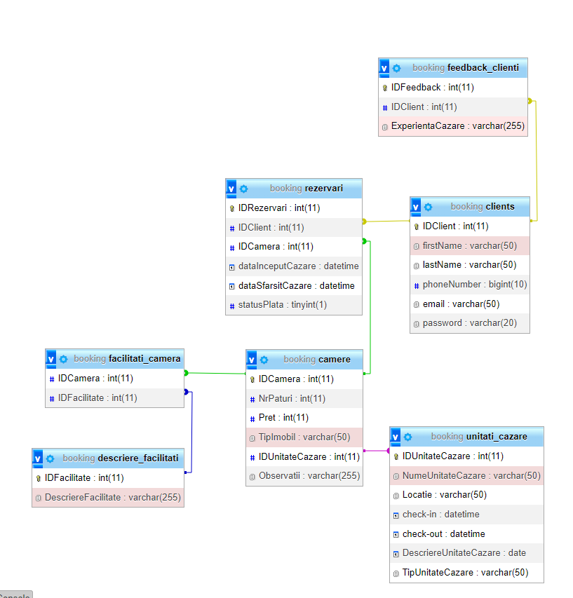

Legaturile prezentate in schema sunt descrise de urmatorul document:

Iar operatiile sunt de Insert, Update, Delete sunt urmatoarele:

Cod-ul sursa poate fi gasit si la adresa:

<https://github.com/Iulia-Andreea20/Booking>