Verificare

Gusatu Andreea

Capturi de ecran:

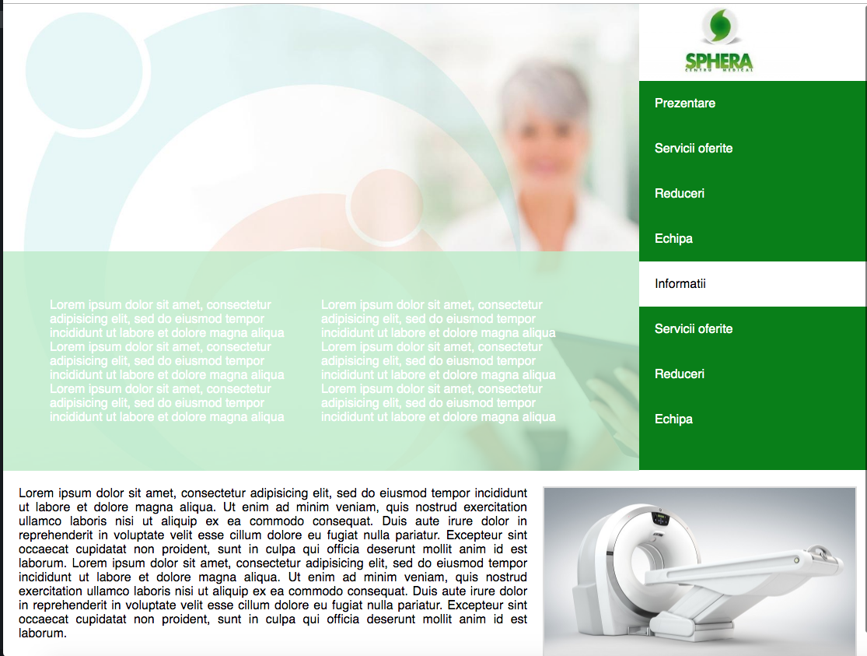

Cod HTML (index.html):

<!DOCTYPE html>

<html>

<head>

<meta charset="utf-8">

<title>Verificare HTML</title>

<link rel="stylesheet" type="text/css" href="style.css">

</head>

<body>

<div id="sus">

<div id="sus-stanga">

<div id="texte">

<div>

<p>Lorem ipsum dolor sit amet, consectetur adipisicing elit, sed do eiusmod

tempor incididunt ut labore et dolore magna aliqua</p>

<p>Lorem ipsum dolor sit amet, consectetur adipisicing elit, sed do eiusmod

tempor incididunt ut labore et dolore magna aliqua</p>

<p>Lorem ipsum dolor sit amet, consectetur adipisicing elit, sed do eiusmod

tempor incididunt ut labore et dolore magna aliqua</p>

</div>

<div>

<p>Lorem ipsum dolor sit amet, consectetur adipisicing elit, sed do eiusmod

tempor incididunt ut labore et dolore magna aliqua</p>

<p>Lorem ipsum dolor sit amet, consectetur adipisicing elit, sed do eiusmod

tempor incididunt ut labore et dolore magna aliqua</p>

<p>Lorem ipsum dolor sit amet, consectetur adipisicing elit, sed do eiusmod

tempor incididunt ut labore et dolore magna aliqua</p>

</div>

</div>

</div>

<div id="sus-dreapta">

<img src="http://sniffo.ro/img/company/logo/3113/small/logo.jpg">

<ol>

<li><a href="#">Prezentare</a></li>

<li><a href="#">Servicii oferite</a></li>

<li><a href="#">Reduceri</a></li>

<li><a href="#">Echipa</a></li>

<li class="obs"><a href="#">Informatii</a></li>

<li><a href="#">Servicii oferite</a></li>

<li><a href="#">Reduceri</a></li>

<li><a href="#">Echipa</a></li>

</ol>

</div>

</div>

<div id="jos">

<p>Lorem ipsum dolor sit amet, consectetur adipisicing elit, sed do eiusmod

tempor incididunt ut labore et dolore magna aliqua. Ut enim ad minim veniam,

quis nostrud exercitation ullamco laboris nisi ut aliquip ex ea commodo

consequat. Duis aute irure dolor in reprehenderit in voluptate velit esse

cillum dolore eu fugiat nulla pariatur. Excepteur sint occaecat cupidatat non

proident, sunt in culpa qui officia deserunt mollit anim id est laborum.

Lorem ipsum dolor sit amet, consectetur adipisicing elit, sed do eiusmod

tempor incididunt ut labore et dolore magna aliqua. Ut enim ad minim veniam,

quis nostrud exercitation ullamco laboris nisi ut aliquip ex ea commodo

consequat. Duis aute irure dolor in reprehenderit in voluptate velit esse

cillum dolore eu fugiat nulla pariatur. Excepteur sint occaecat cupidatat non

proident, sunt in culpa qui officia deserunt mollit anim id est laborum.</p>

<img src="https://bucovinamedical.ro/wp-content/uploads/2018/03/computer-tomografie.jpg">

</div>

</body>

</html>

Cod CSS (style.css):

\*{

margin: 0;

padding: 0;

font-family: sans-serif;

}

a{

text-decoration: none;

}

ol, ul{

list-style-type: none;

}

#sus{

display: flex;

height: 600px;

}

#sus-stanga{

flex-grow: 1;

position: relative;

}

#sus-dreapta{

width: 300px;

}

#sus-stanga{

background: url("https://besmax.ro/wp-content/uploads/2019/02/concierge-medical-1.jpg");

background-size: cover;

background-repeat: no-repeat;

}

#texte{

display: flex;

justify-content: space-between;

padding: 60px;

background-color: rgba(188, 235, 200, 0.8);

position: absolute;

bottom: 0;

left: 0;

right: 0;

color: #fff;

}

#texte div{

margin-right: 40px;

}

#sus-dreapta img{

height: 95px;

}

#sus-dreapta ol{

background-color: green;

height: 500px;

}

#sus-dreapta li{

padding: 20px;

}

.obs{

background-color: #fff;

}

#sus-dreapta .obs a{

color: #000;

}

#sus-dreapta ol a{

color: #fff;

}

#jos{

padding: 20px;

text-align: justify;

display: f;

}

#jos {

display: flex;

}

#jos p{

padding-right: 20px;

}

#jos img{

width: 400px;

border: 2px solid #ddd;

}