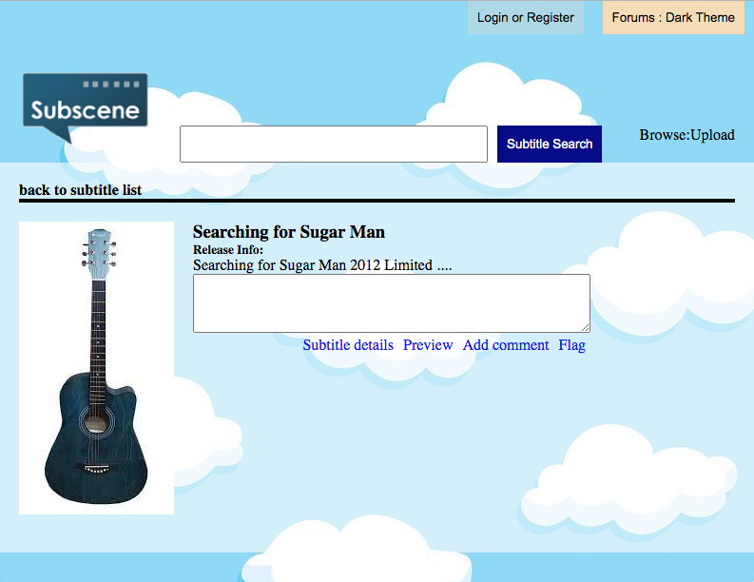

<!DOCTYPE html>

<html>

<head>

<meta charset="utf-8">

<title>Test HTML</title>

<style type="text/css">

*{

padding: 0;

margin: 0;

}

a{

text-decoration: none;

}

ol{

list-style-type: none;

}

body{

background: url("https://www.freevector.com/uploads/vector/preview/19766/8-06.jpg");

}

header{

display: flex;

justify-content: flex-end;

}

button {

padding: 10px;

border: none;

margin: 0 10px;

}

.blue-bttn{

background-color: lightblue;

}

.yellow-bttn{

background-color: wheat;

}

#up-part{

display: flex;

align-items: flex-end;

justify-content: space-between;

}

#up-part img{

width: 180px;

}

form{

display: flex;

justify-content: center;

}

input[type="text"]{

width: 300px;

padding: 10px;

}

.darkblue-bttn{

background-color: darkblue;

color: #fff;

}

#up-part p{

padding: 20px;

}

#central{

padding: 20px;

background-color: rgba(255,255,255,0.6);

}

hr{

border: 2px solid #000;

}

#cont{

display: flex;

padding: 20px 0;

}

#links{

display: flex;

justify-content: flex-end;

}

a{

padding: 0 5px;

}

</style>

</head>

<body>

<header>

<button type="button" class="blue-bttn">Login or Register</button>

<button type="button" class="yellow-bttn">Forums : Dark Theme</button>

</header>

<div id="up-part">

<img src="http://www.userlogos.org/files/logos/Sanjay/subscene.png">

<form>

<input type="text" name="search-bar">

<button class="darkblue-bttn">Subtitle Search</button>

</form>

<p>Browse:Upload</p>

</div>

<div id="central">

<h4>back to subtitle list</h4><hr>

<div id="cont">

<img src="https://encrypted-tbn0.gstatic.com/images?q=tbn:ANd9GcTauqKi0KqLxNRm_w3TrTlPrNYvx9UysUQSiKTs8MNbAIsafxwD3jmuhFi-ujw8RQg8btg&usqp=CAU"/>

<div style="margin-left: 20px;">

<h3>Searching for Sugar Man</h3>

<h5>Release Info:</h5>

<p>Searching for Sugar Man 2012 Limited ....</p>

<textarea id="w3review" name="w3review" rows="4" cols="50"></textarea>

<div id="links">

<a href="#">Subtitle details</a>

<a href="#">Preview</a>

<a href="#">Add comment</a>

<a href="#">Flag</a>

</div>

</div>

</div>

</div>

</body>

</html>