Laboratory 2

La nano:
[jiie3755@linux ~]$ nano lab_2.c – sa fac un file, il descrie si acolo scriu
[jiie3755@linux ~]$ cat lab_2.c - ca sa vad ce contine file-ul
#include <stdio.h>
int main(){
printf("Hello world");
return 0;
}
[jiie3755@linux ~]$

Ca sa salvez file-ul fac: ctrl+x, dupa dau y daca vreu sa salvez schimbarile si ma baga sa schimb numele. Daca nu vreau sa schimb ii dau doar enter si iese
Pt compilare
Imi face automat fila a.out pe care o compilez asa si imi afiseaza ce trebuie
Daca nu pun \n unde trb imi afiseaza aiurea
-------------------------------------------------------------------------------------------------------------
Gcc 1.c -o ceva_nume
Rename the file whatever I give it

./ = reference to the current directory
La ceva_nume nu trb sa am neaparat .c ca sa mearga

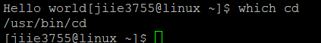
Sa gasesc path-ul absolut pt unde sunt eu acum

./ relative path to the whole directory, or I can use the path above (never use that pls)
-------------------------------------------------------------------------------------------------------------
Usually when using gcc can do something this on accident:
gcc -o 1.c 1.c - fatal error
- We do not have an extension in linux! – linux does not care for the ext.
- Need it for the first file – error without it comes from the compiler
- Linux does not recognize certain types after extension, but after the contents

Pt a gasi ce tip de file este
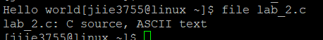
Acel hello world arata asa pt ca nu am pus \n la final…
-------------------------------------------------------------------------------------------------------------
-Wall = display all the warnings we have in the program
- the program will be compiled, but not how its supposed to run
-g = flag that enables some mechanism behind the compilation process – debug later

Warning: implicit declaration of function “printf” – using a function without importing it
It may tell me how to fix it
Whatis printf – put this command to check what is my function (here printf)
- It gives me the man page, open it to see what I need
To test the modifications in the program I need to recompile it!!!
Compile-ul e cel cu gcc -Wall…
The order in the parameters does not matter
Only after the -o I need the order (aka pot pune -Wall at the end)
-------------------------------------------------------------------------------------------------------------
Joe nume_file.c – deshide fisierul cu joe – ca sa ies dau ctrl+k ca sa salvez si x ca sa ies
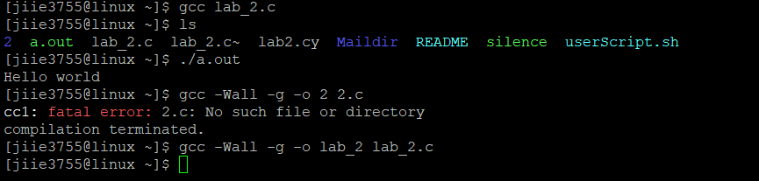
Am recompilat si dupa am facut chestia de jos unde imi dadea erorile daca aveam ceva probleme
Aici imi scrie orice erori ce apar

“a” must be used uninitialized
Int *a;
..
Scanf(“%d”, &a[i]), unde a este un array
Rezolv asa:
Int a[10] – pot sa folosesc doar 10 elem. Asa. Si daca folosesc maim ult e wasted momory
Best way: int *a;
And allocate memory dynam. Cu malloc
a= malloc(n*sizeof(int)); - nr of bytes an integer takes with sizeof… - but idk and idc
- Bc I store ints
- N is the nr of values in the vector
Pt malloc a nevoie de #include <stdlib.h>
La afisari nu pun & (cred)
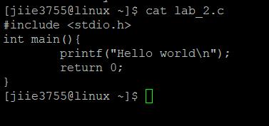
Ca sa se afiseze asa
SA IMI ALEG UN FILE EDITOR PANA ORA VIITOARE

Sa dealoc memoria dup ace folosesc malloc
How to see if I have memory to deallocate – with valgrind direct acolo
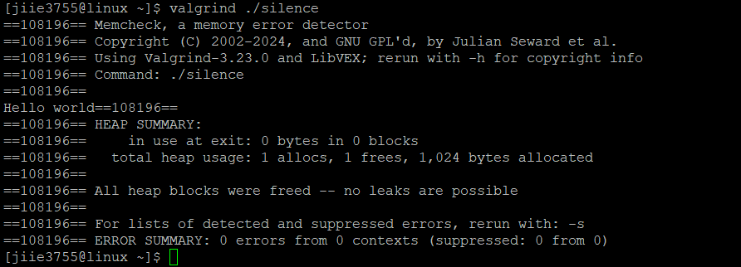
Sa vad daca sunt ok la memorie
Cand e ceva scrie: defin. Lost 16 bytes…
Pt dealocare folosesc FREE
Chiar la final fac
free(a)
acum apare ok “in use at exit: 0 bytes”
-------------------------------------------------------------------------------------------------------------
in c:
int main(int argc,char **argv)
{
return 0;
}
Int argc = argument count – nr of arg passed in the command line
Argv = argument vector – array containing the arguments themselves
Daca vreau sa printe
printf(“argc = %d\n”,argc)
for (i=0;i<argc;i++)
{
printf(“argv[%d]=%s,I,argv[i];
}
Daca dau run ca ./nume_program – imi da fix comanda de la rulare ala ./nume_fisier
Only the name itself – still have a command line arg
./1 sifnsewf sfenf sefw
Imi da fiecare chestier scrisa mai sus ca arg (fiecare care este separata prin spatii)
Pt “” imi pune ca 1, trb sa ii dau cancel their meanings
Ca sa afiseze “ fac /”
cp 2.c 3.c
-------------------------------------------------------------------------------------------------------------
read data from a file and write in c
directly from the file - fopen file
deschid o fila input, scriu ce vreau acolo
ca sa citesc de acolo fac cu fscanf
deci scriu in main dupa int..
FILE *input, *output, *history
input= fopen(argv[1],”r”)
output= fopen(argv[2],”w”)
history=fopen(argv[3],”a”)
fscanf(input,”%d”,&n)
…
In for
a[i]=a[i]+atoi(argv[4]);
in printare:
fprintf(output, “a[%d”=%d\n”,I,a[i])
pun la fel si in history

-dau ‘cat’ input ca sa vad ce am in file
./1 input output history 7 -could the a command
cat output ca sa vad ce am la final si la history trb sa le am pe ambele

totusi trb sa fac valgrind si dupa ca sa nu pic testul
valgrind ./3 input output history 234
nu trb sa am nimic la in use at exit
pot sa am fi free(a) si sa am memorie si sa am, deci e de la file
trb sa fac
fclose(input);
fclose(output);
fclose(history);
si dupa asta trb sa compliez againg ofc
now everything is cleannnnnnn!
-------------------------------------------------------------------------------------------------------------
Daca pun **a merge codul ok, dar la valgrind da 6 error from 2 contexts – misusage of pointers or parameters inside the program
Not lethal, but have the potential to be…
Imi arata unde sunt erorile, dar cu memory address.
Pt more information fac gcc 4.c -g la compilare, valgrind la fel, dar imi arata si unde e faulty context in my code (cu linia)
Ma uit sa vad ce e comun la toate liniile-> aici e a, deci probabil acolo e problema
Vad ca la a am **a, dar folosesc ca *a, deci e logical problem

Daca fac gcc 4.c -g -Wall imi da niste warnings si e fix unde folosesc acel a – si da”expect a type int*, but got int**”

La horea Muresan ubb gasesc exemple

Need to work with the matrix from a file, allocate momory for it, alter it and write it in another file

