LAB 8

5313 trebuie sa fie scheletul la tot ce fac

5423,b secvential, d parallel (cum trb)
If I do not need the output of fork I can use it in a for if(fork() == 0) like this
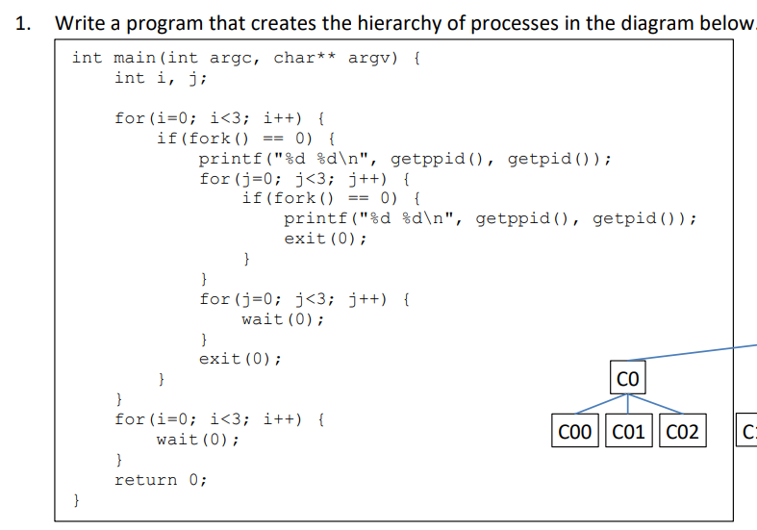
Enter in the child process
----------------------------------------------------------------------------------------------------------------------------------------------
#include <stdio.h>
2 #include <unistd.h>
3 #include <sys/wait.h>
4 #include <sys/types.h>
5 #include <stdlib.h>
6 int main() {
7 int a[4] = {1, 2, 3, 4};
8 int pid;
9 pid = fork();
10 if(pid == 0) {
11 a[2] += a[3];
12 exit(0);
13 }
14 a[0] += a[1];
15 wait(0); //put here so that in theory the child does it's sum before the
parents
16 // should have a pipe for the data to be used from the child to the parent
17 a[0] += a[2];
18 printf("%d\n", a[0]);
19 return 0;
20 }
----------------------------------------------------------------------------------------------------------------------------------------------
#include <stdio.h>
#include <unistd.h>
#include <sys/wait.h>
#include <sys/types.h>
#include <stdlib.h>
int main() {
int a[4] = {1, 2, 3, 4};
int pid;
int p[2]; // added later
pipe(p); // added later
pid = fork();
if(pid == 0) {
close(p[0]); // added later
a[2] += a[3];
write(p[1],&a[2],sizeof(int)); // added later
close(p[1]); // added later
exit(0);
}
close(p[1]); // added later
a[0] += a[1];
read(p[0],&a[2],sizeof(int)); // added later
close(p[0]); // added later
wait(0); //put here so that in theory the child does it's sum before the parents
// should have a pipe for the data to be used from the child to the parent
a[0] += a[2];
printf("%d\n", a[0]);
return 0;
}
// everyting that was added later has to do with pipes
=======================================================================================
5713:
while(1) {
49 if(read(b2p[0], &n, sizeof(int)) <= 0) {
50 break; // breaking because read returns -1 - the writer finishes execution, do not need to wait anymore
51 }
52 if(n <= 0) {
53 break;

