
EP-Lab04-2021
Olaru Gabriel Iulian, 342C2

EX1:
TaskA:

sudo tcpdump -ni any port 80 -v -s0 -X --time-stamp-precision=nano –number

curl ocw.cs.pub.ro
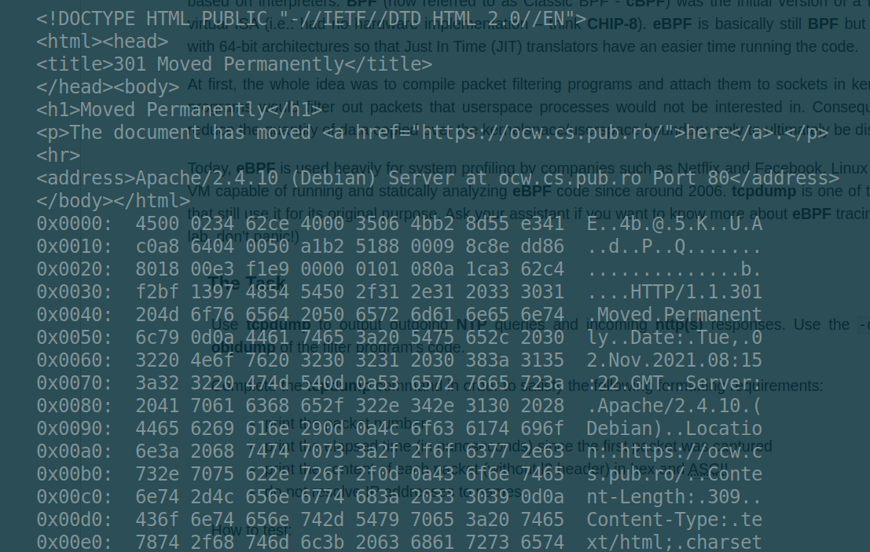
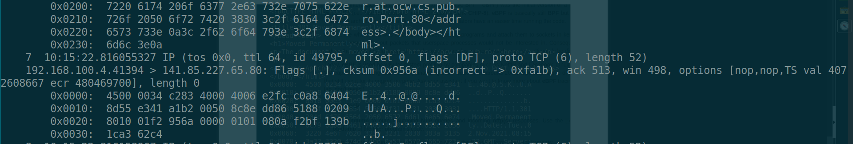
ntpdate -q ro.pool.ntp.org
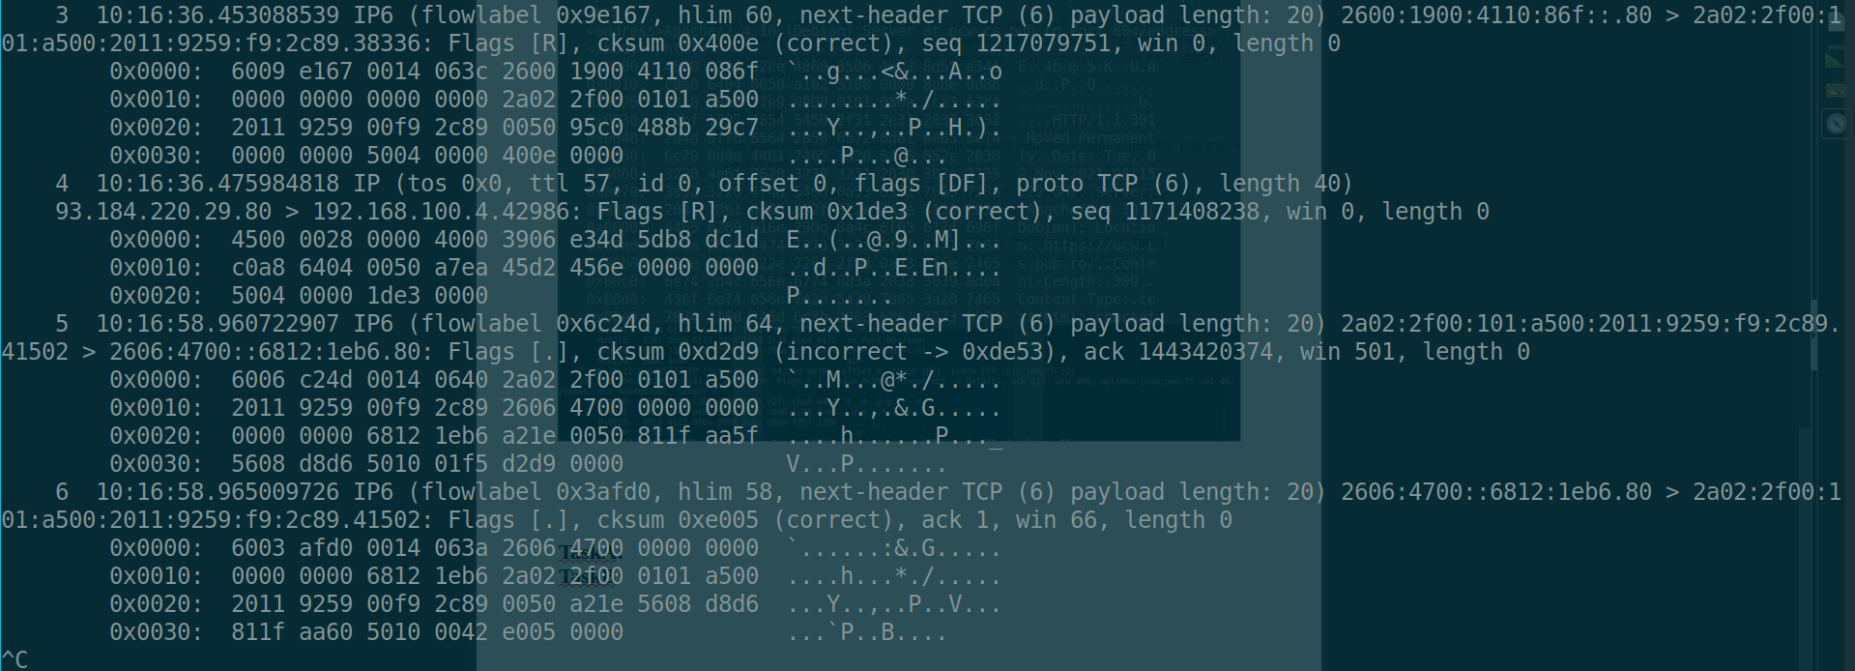
TaskB:

Task1:
sudo iptables -t filter -I OUTPUT -p tcp -j LOG --log-prefix "EP: "

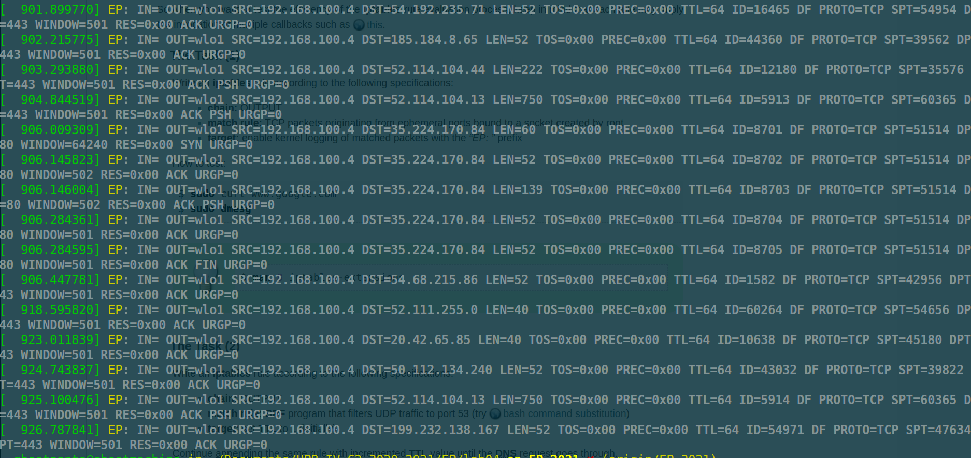
Task2:
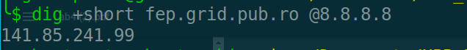
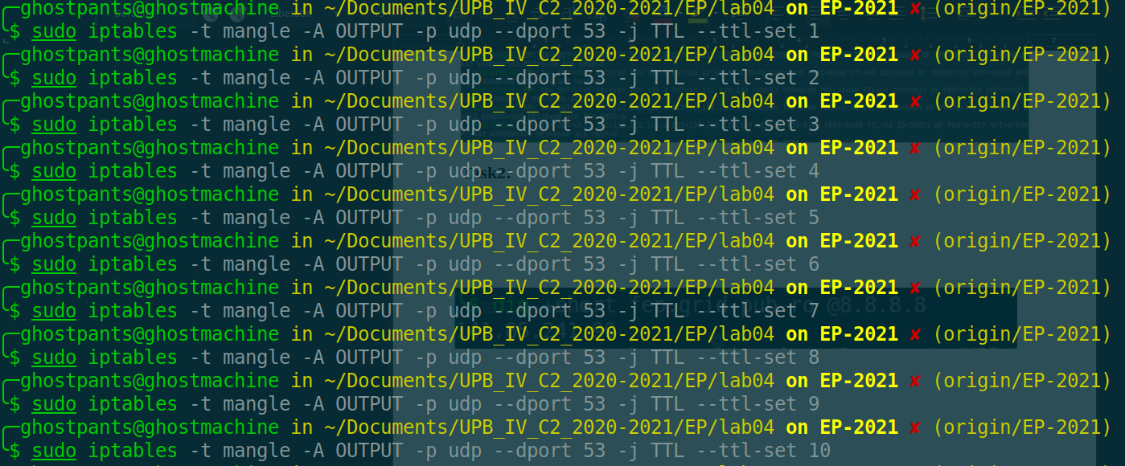
Task3:
Cand pachetele sunt blocate de firewall.

EX2:
TaskA:
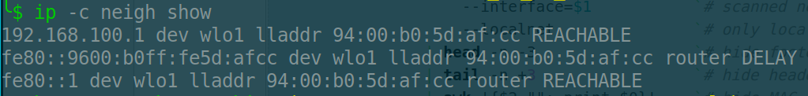
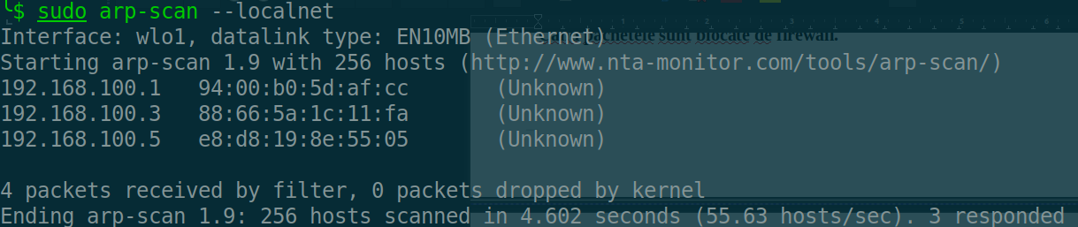
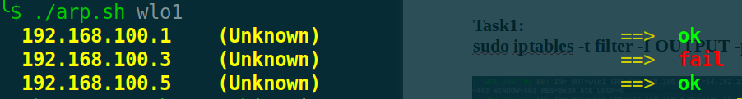

TaskB:
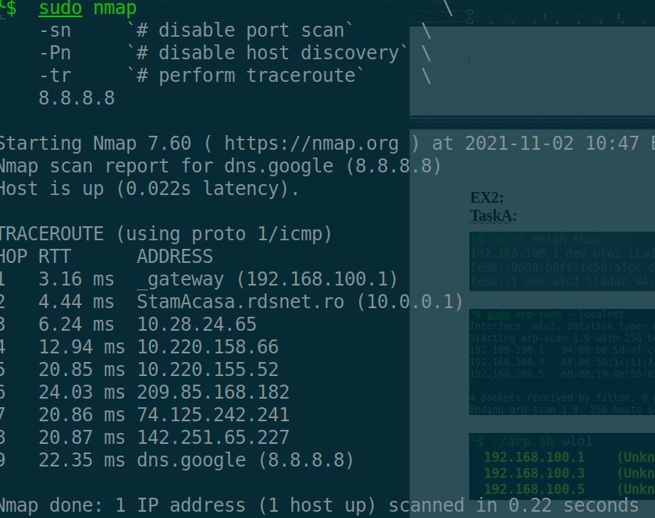
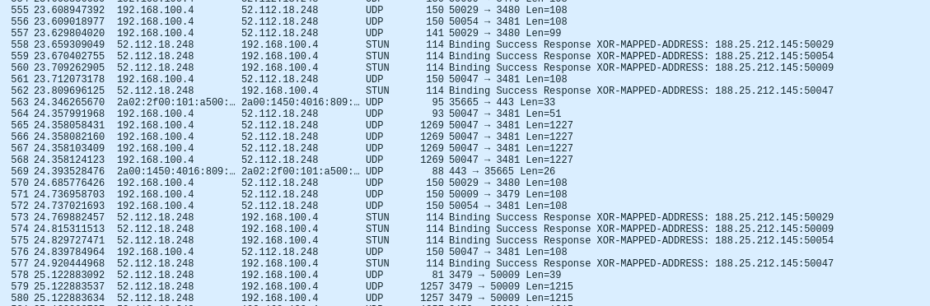

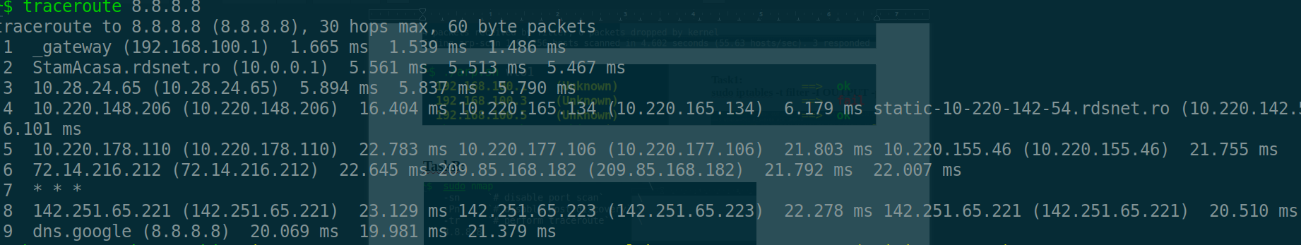
EX3:
TaskA:
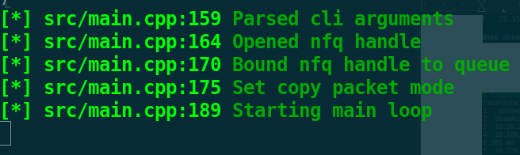
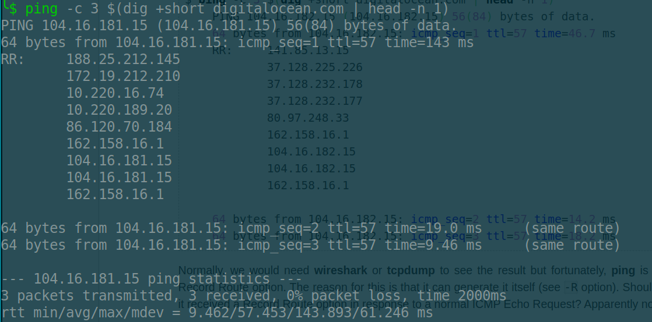

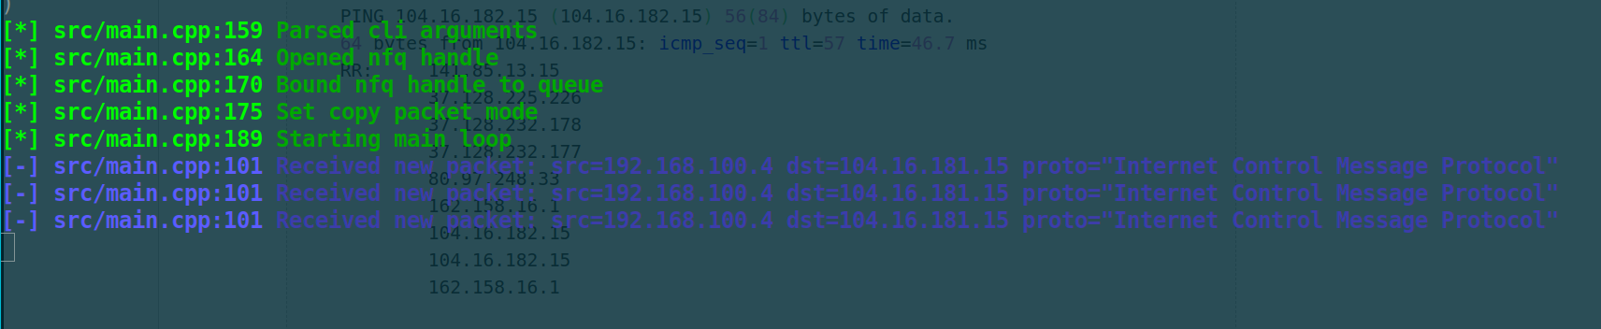

TaskB:

sudo tcpdump -U -i any -v -s0 -X >> log

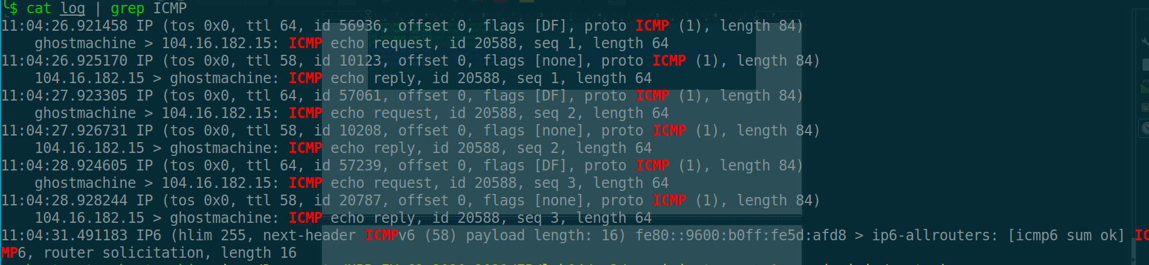

TaskC:

sudo tcpdump -U -i any -v -s0 -X -w logs.pcap
sudo tshark -r logs.pcap

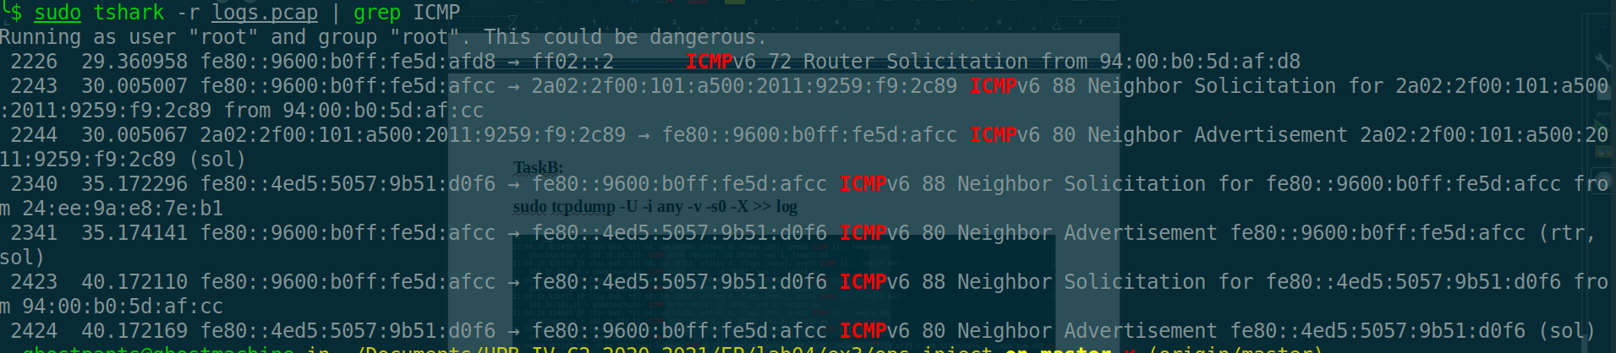

TaskD-E:

Atata s-a putut.

EX4:
