Tema 1
Olaru Gabriel Iulian
342CC


I. Scopul lucrarii

Sa se realizeze o comparare intre 2 sisteme cu microprocesoare CISC actuale diferite.

II. Configuratiile analizate

1. Microprocesor: AMD Athlon 64 3200+
Chipset: NVIDIA nForce3 Ultra
2. Microprocesor: Intel Pentium Gold G-4560
Chipset: Intel H110

III. Comparatia microprocesoarelor

 | AMD Athlon | Intel Pentium Gold
Microprocesor | CISC | CISC
Tehnologie de fabricare | 90nm | 14 nm
Frecventa | 2 GHz | 3.5 GHz
Numar Nuclee | 1 | 2
Socket | Socket 939 | LGA 1151
Arhitectura | 64 bit | 64 bit
Microarhitectura | K8 | Kaby Lake
L1 Cache | 64 Kb data  64 Kb instruction | 2 x 32 Kb data  2 x 38 Kb instruction
L2 Cache | 512 Kb | 2 x 256 Kb
L3 Cache | Nu | 2 x 1.5 Mb
SIMD instruction set | MMX, SEE, AVX, BMI | MMX, EMMX, SEE1 ..3, ABM, BMI1 ..2
Hyper Threading | Da | Da
FSB | 800 MHz

IV. Comparatia chipseturilor

 | NVIDIA nForce3 Ultra | Intel H110
CrossFire Support | Nu | Nu
RAM Controller | Integrat | DDR4
SATA | Da | Da
RAID | Da | Nu
Capacitate maxima memorie | - | 32 Gb
LAN | Ethernet | Ethernet
USB | 2.0 | 2.0
Grafica Integrata | Nu | Da

V. Comparatia arhitecturilor

AMD Athlon 64 3200+
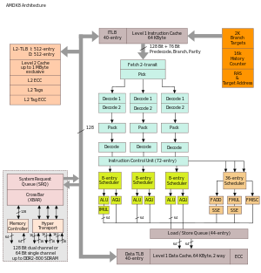
Intel Pentium Gold G-4560
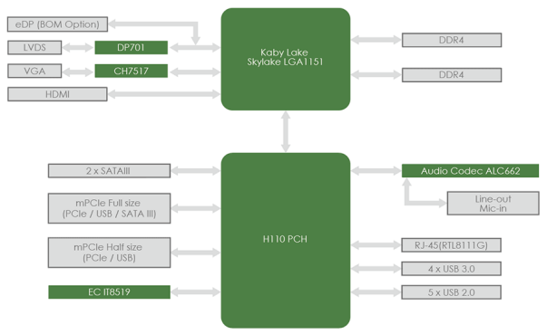

VI. Caracteristici

