
EP-Lab02-2021
Olaru Gabriel Iulian, 342C2

EX1.
Experiment 1:

Baseline:
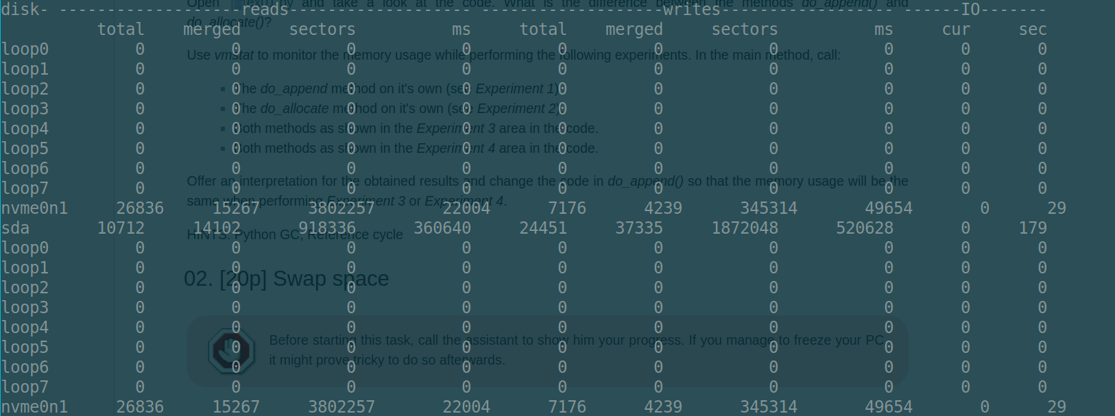

With processes running:
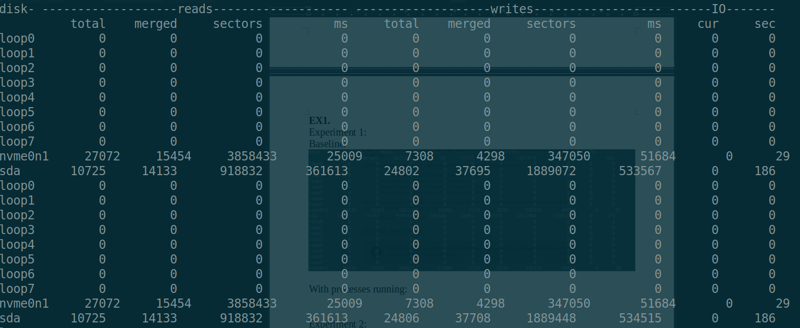

Experiment 2:

Baseline:
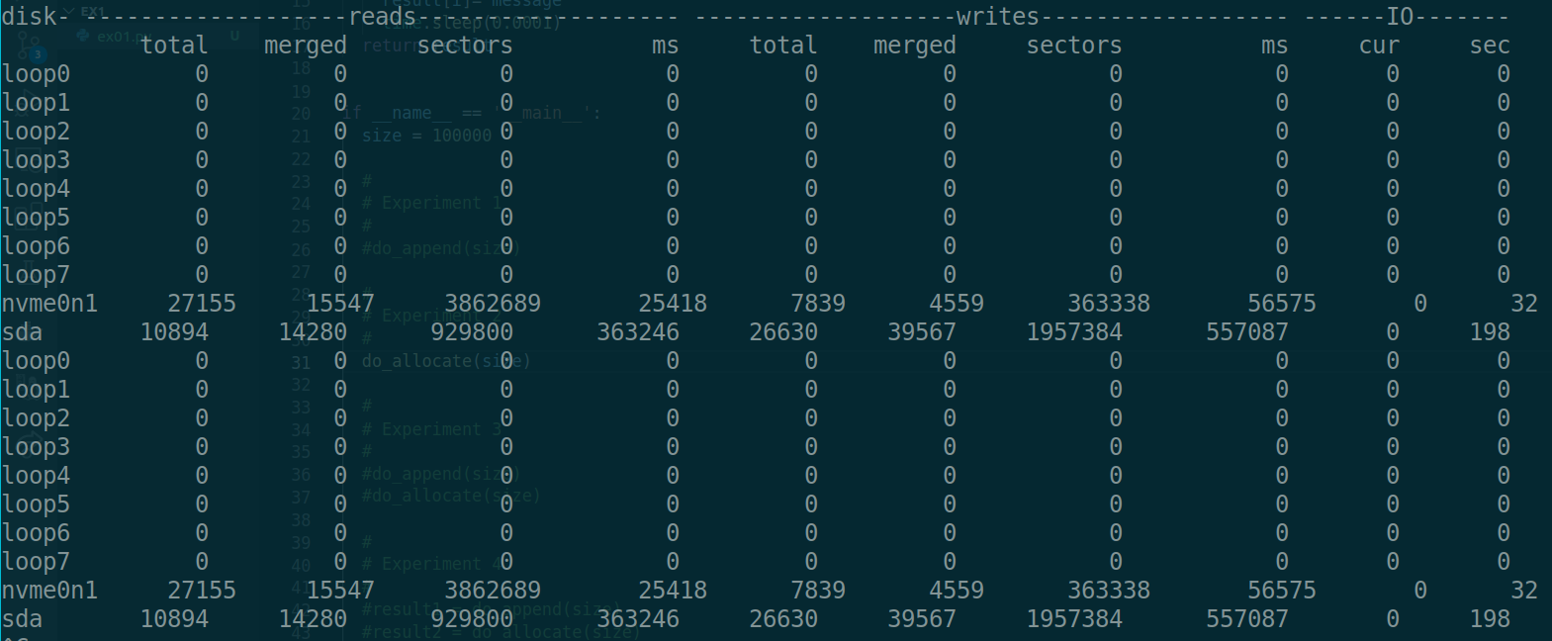

With processes running:

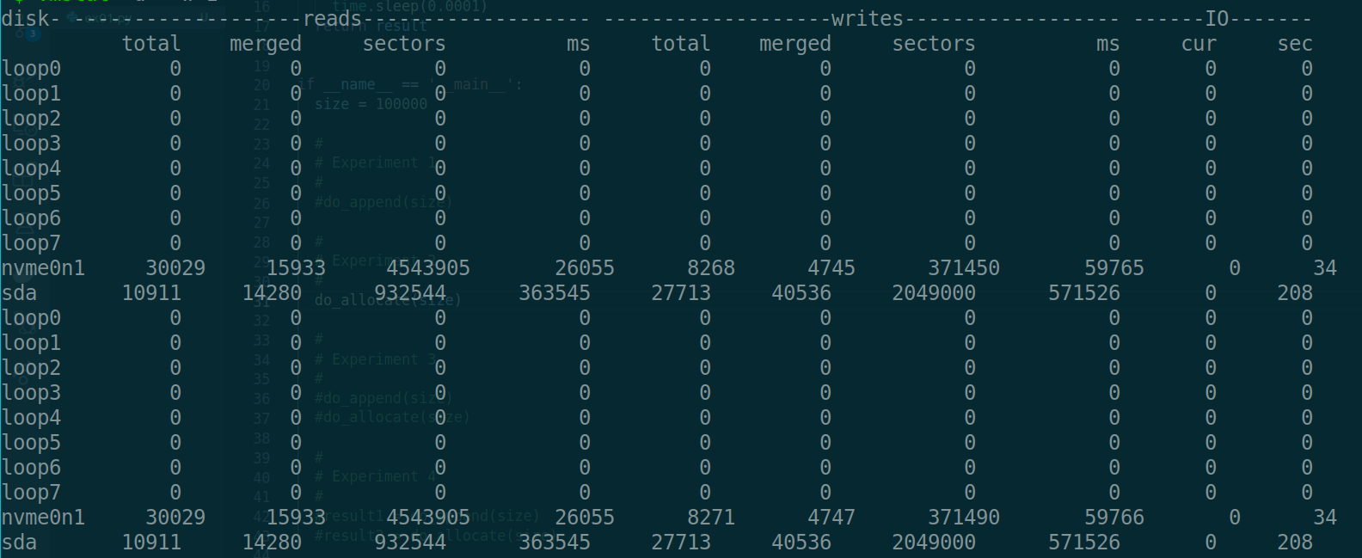
Experiment 3:

Baseline:

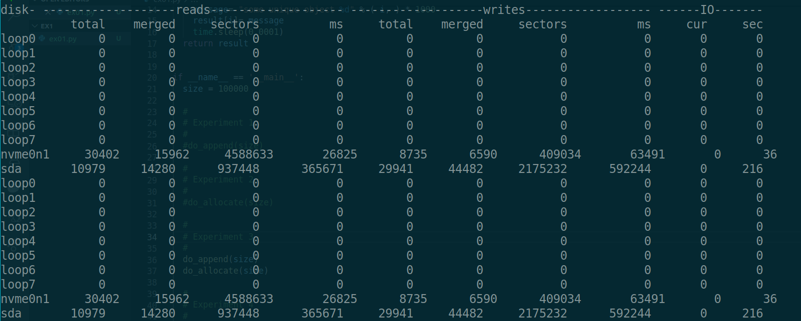

With processes running:

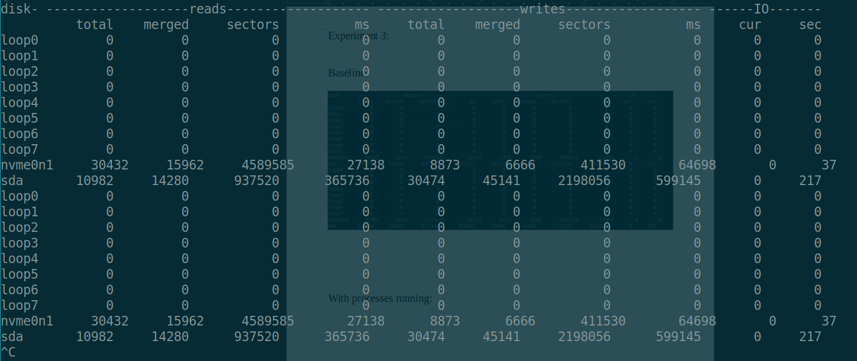

Experiment 4:

Baseline:

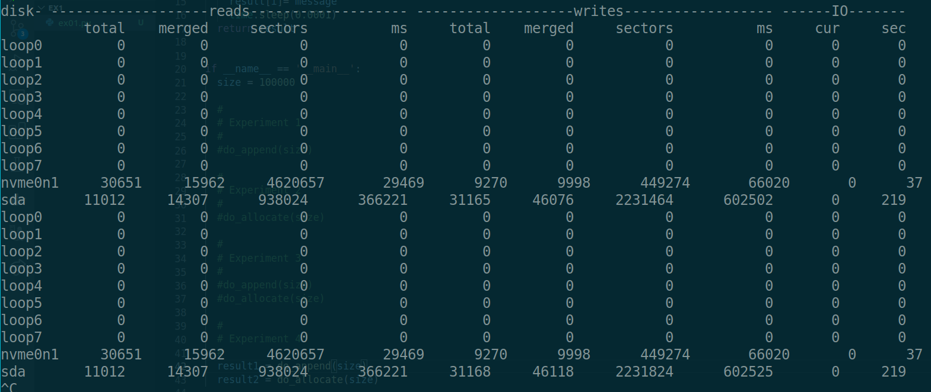

With processes running:
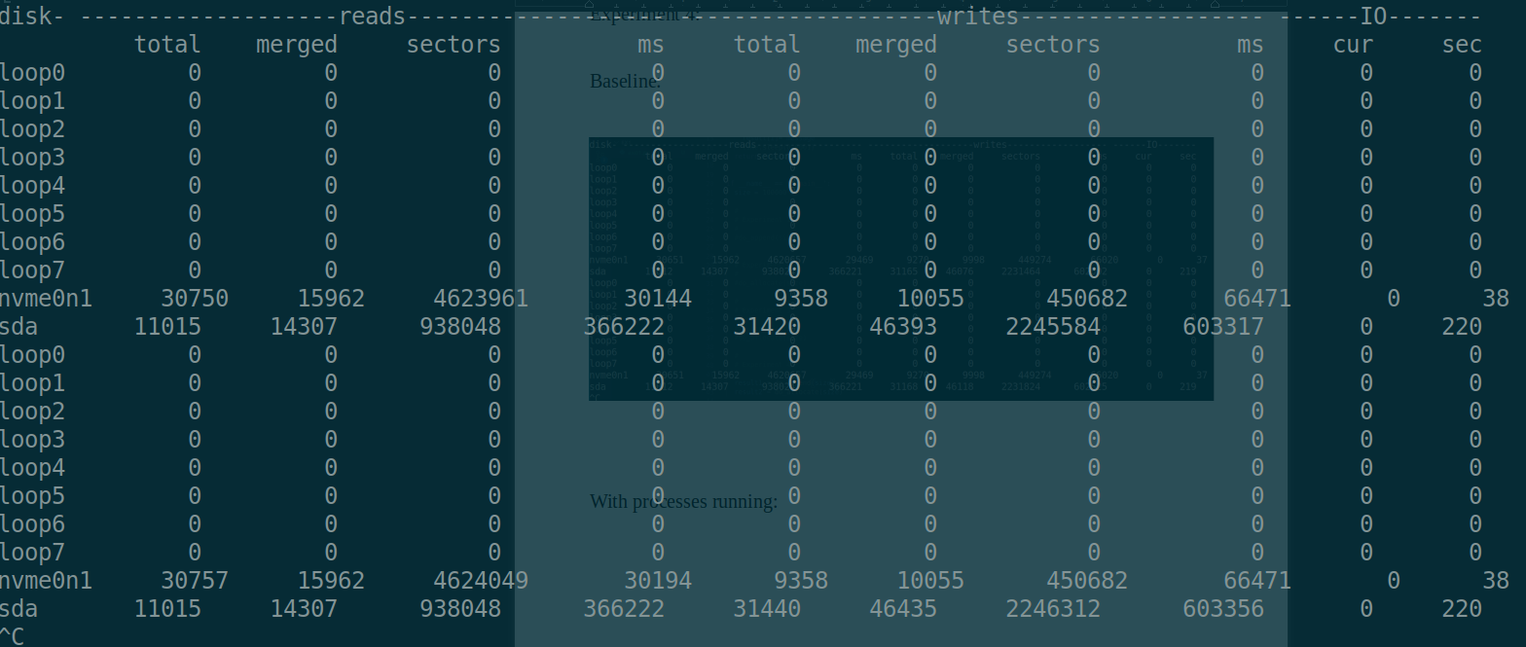

Task:

A reference cycle means one or more objects referencing each other. This, combined with the way the python garbage collector handles them( https://rushter.com/blog/python-garbage-collector/), is what causes the discrepancy in memory accesses between the two experiments. To prevent this, we can simply disable the python garbage collector with gc.disable() .

Experiment 3:

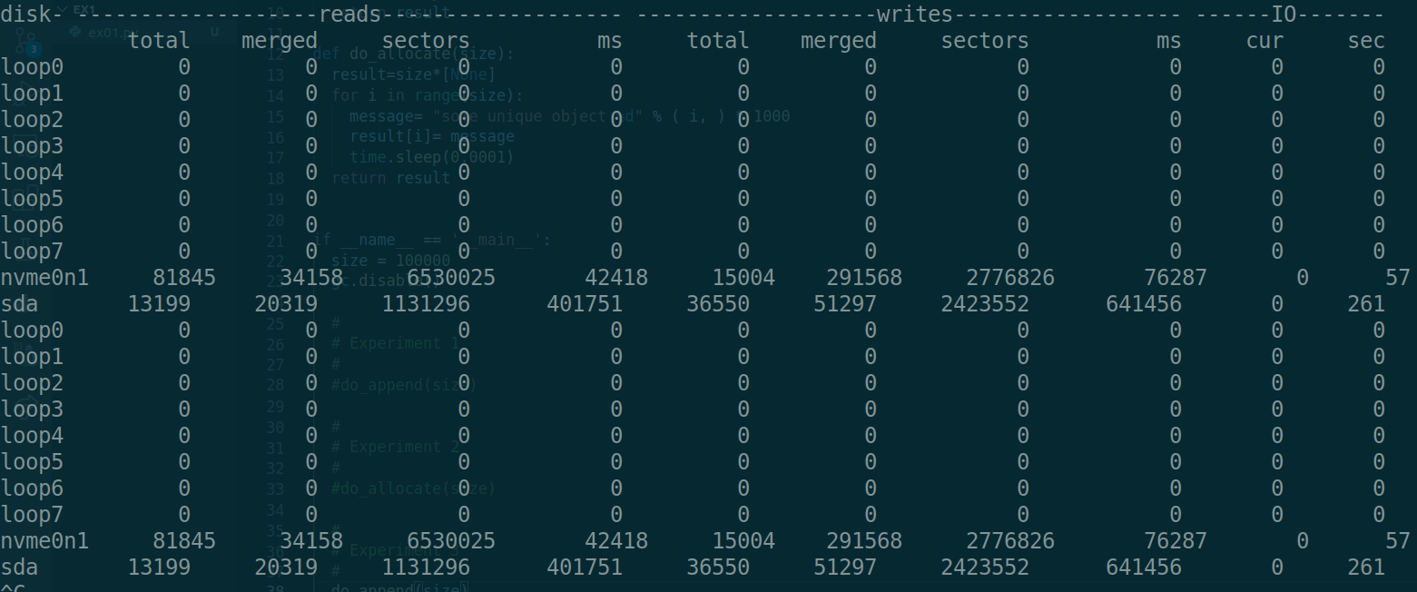

Experiment 4:

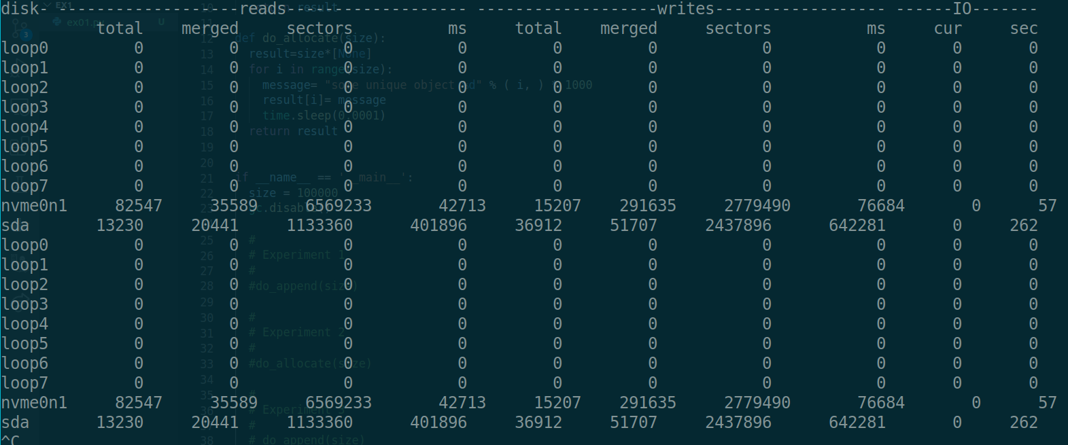

EX2:
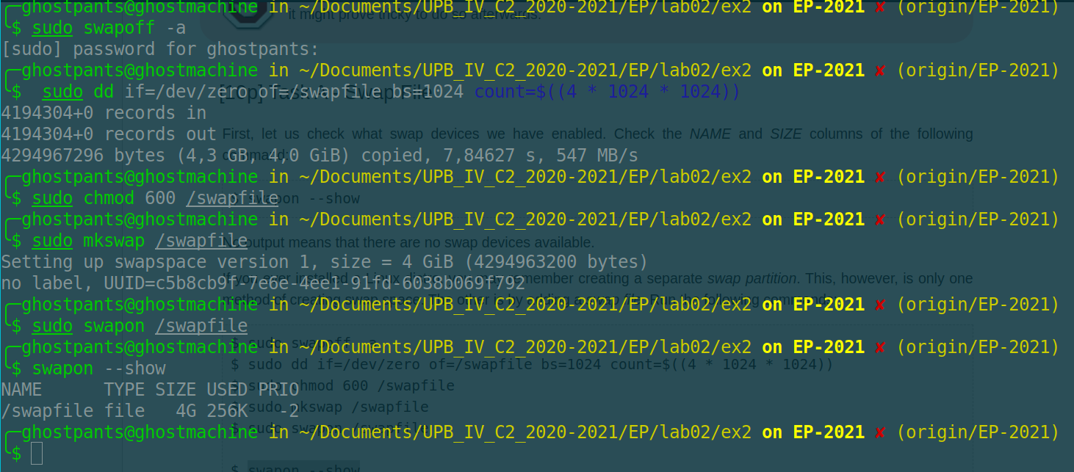
Decrease in free memory alter python allocation:
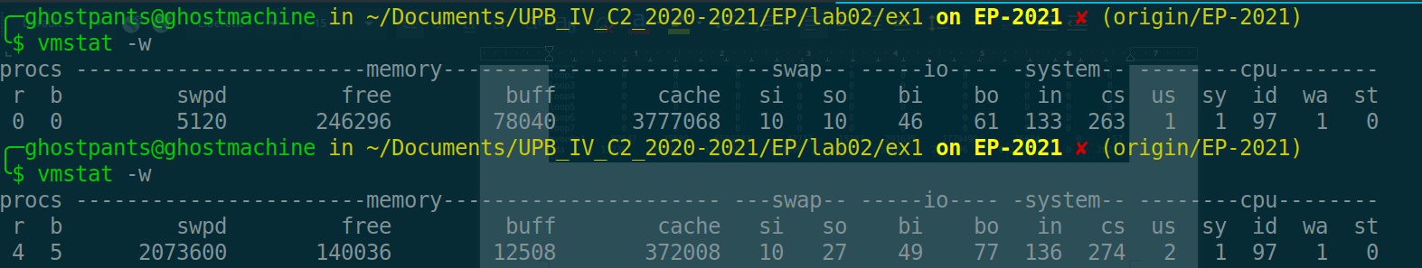
Before and after closing python shell:
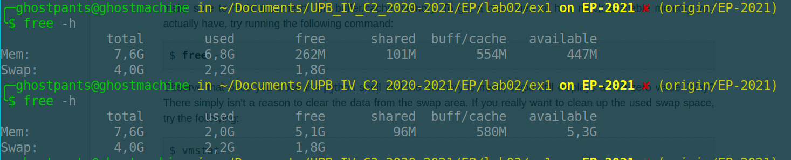
Task:
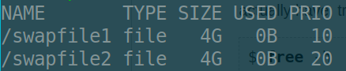

sudo swapoff -a
sudo dd if=/dev/zero of=/swapfile bs=1024 count=$((4 * 1024 * 1024))
sudo chmod 600 /swapfile
sudo mkswap /swapfile
sudo swapon /swapfile
swapon -p <priority> /path/to/swap

Advantages:
- It is very easy to change the swap file size
- There is a slight performance benefit, because the swap area is in the middle of the normal file area, so head movements will be smaller
Disatvantages:
- With the speed of SSDs fragmentation that can happen to the swapfile could be a thing of the pas
- requires configuration

EX3:

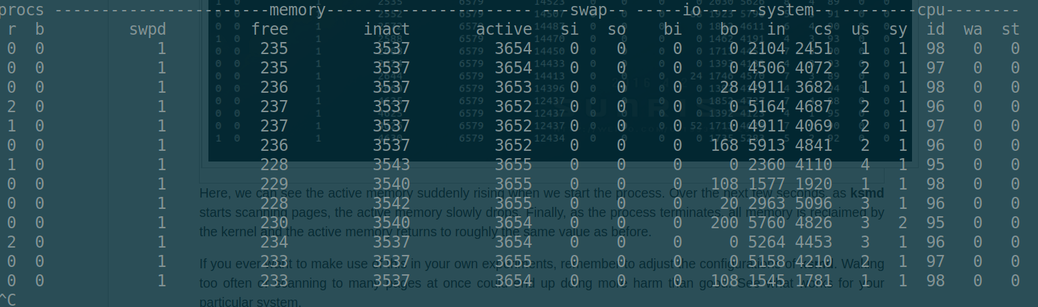

EX4:

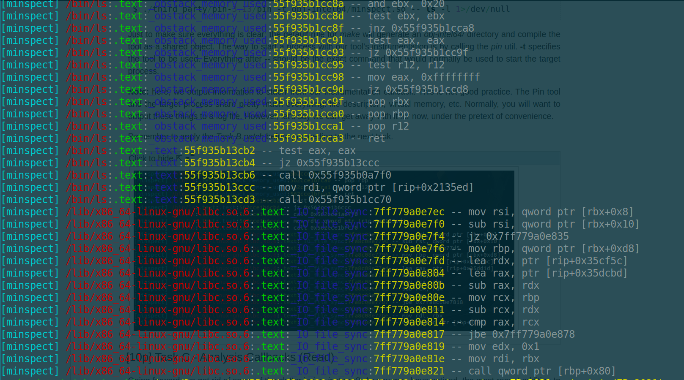

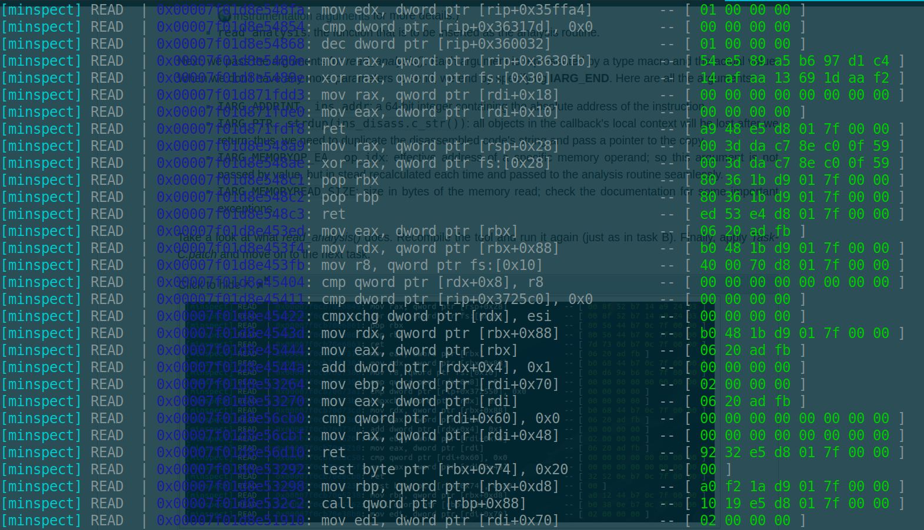

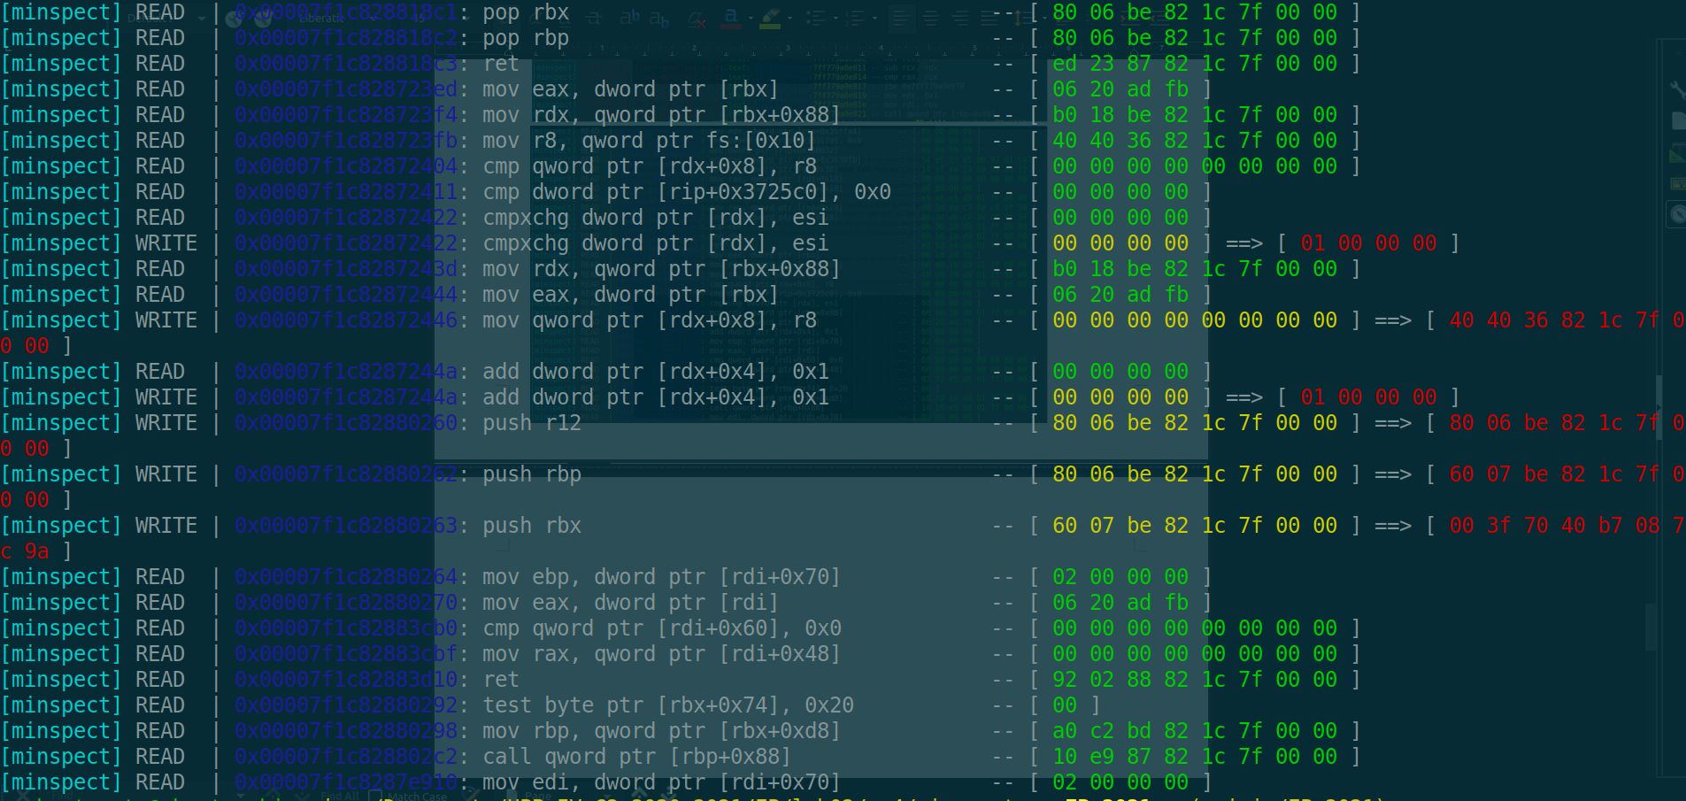

EX5:



