
EP-Lab03-2021
Olaru Gabriel Iulian, 342C2

EX1:

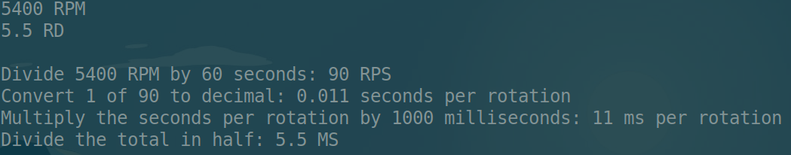

EX2:
TaskA:

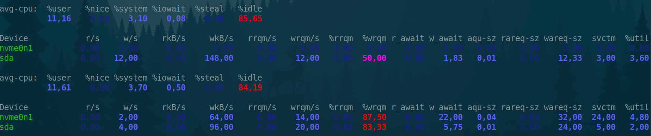
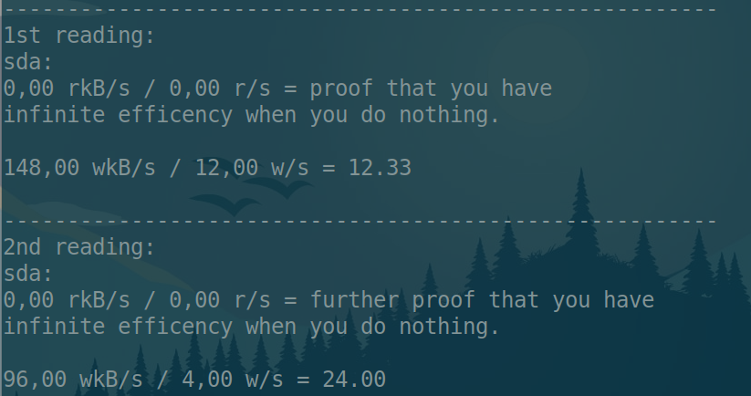

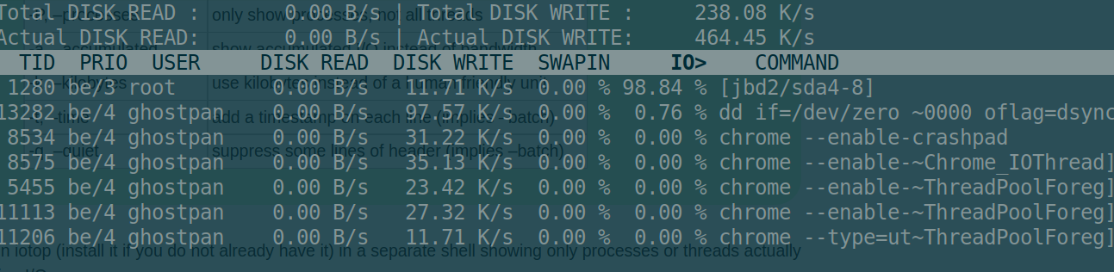
TaskB:
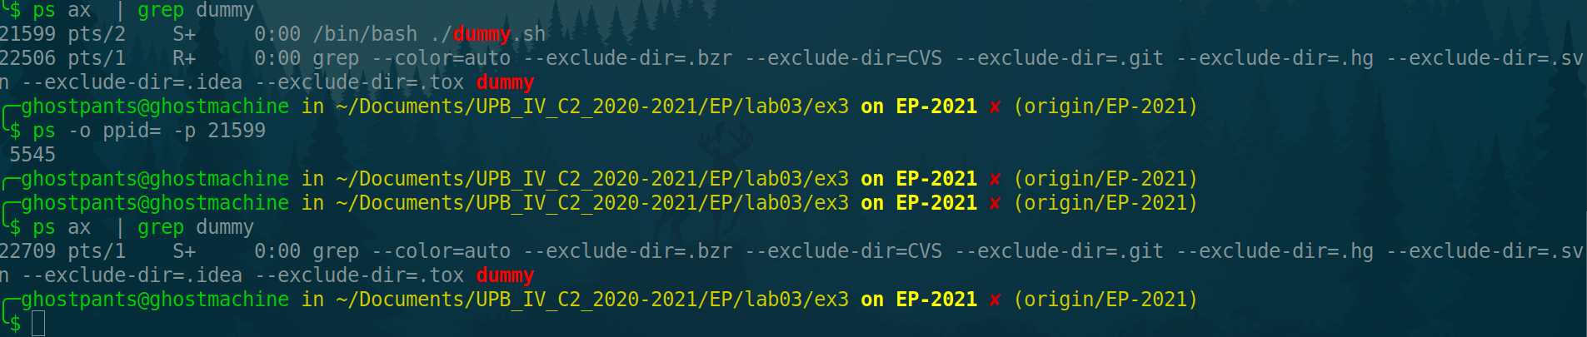
Ex3:
TaskA:
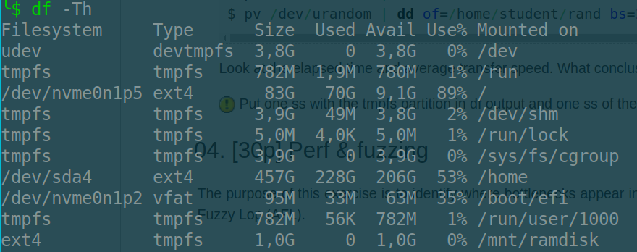
TaskB:
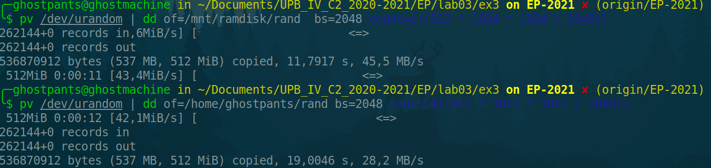
Conclusion: Writing to RAM is much faster.

Ex4:
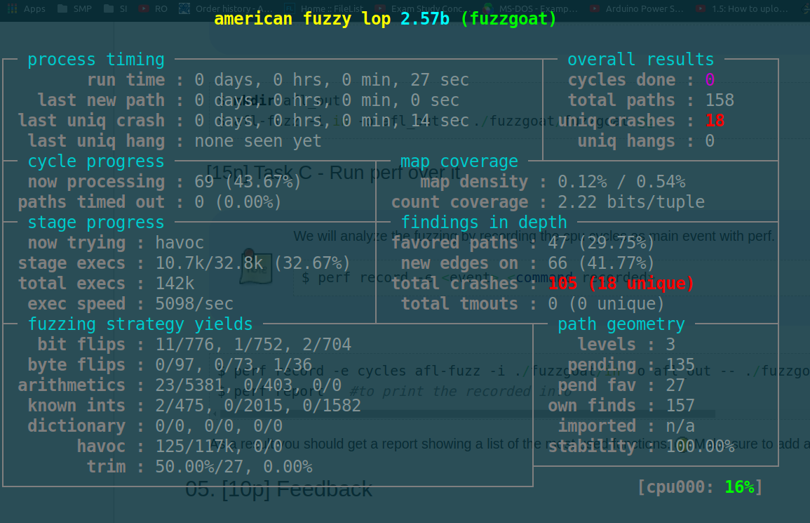
TaskA:

TaskB:
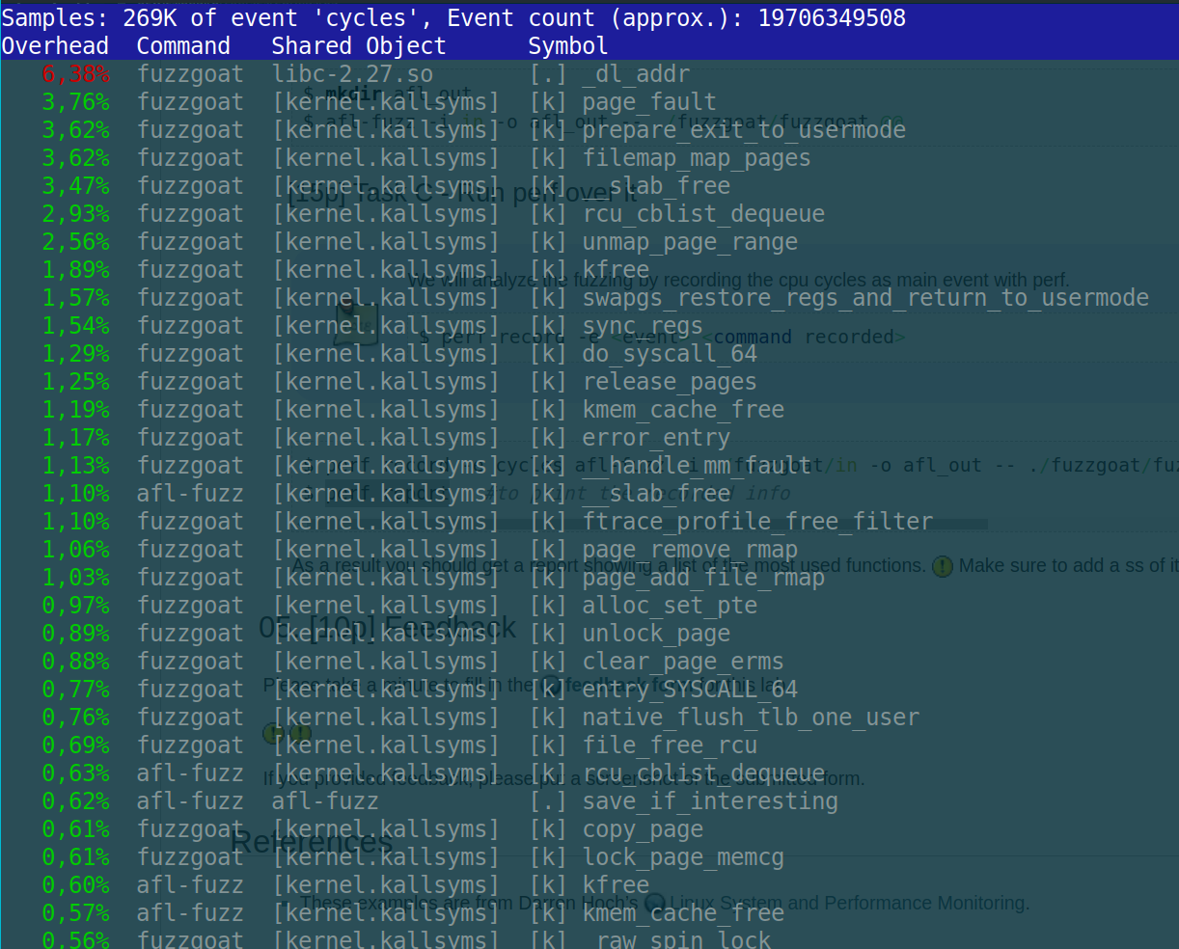
Ex5:



