
EP-Lab01-2021
Olaru Gabriel Iulian, 342C2

EX1
The impact of creating workers with stress will result in a greater number of interrupts(6000-7000), as depicted in the red square. Outside the red square is normal operation(3000-4000 in).
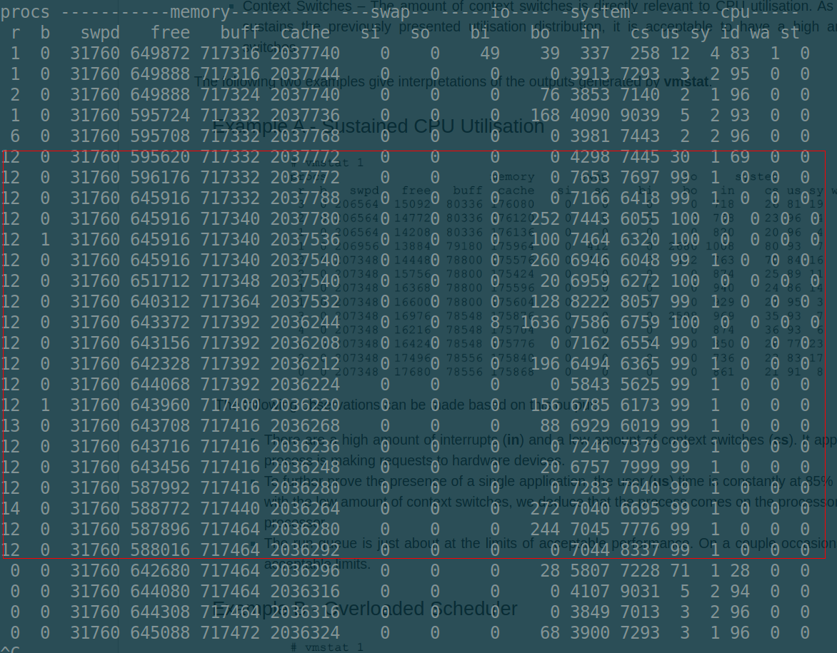
Stress command used, passing the number of cores indirectly:
sudo stress --cpu $(nproc) --timeout $1

Below is the one-liner required and the sorted output it generates.
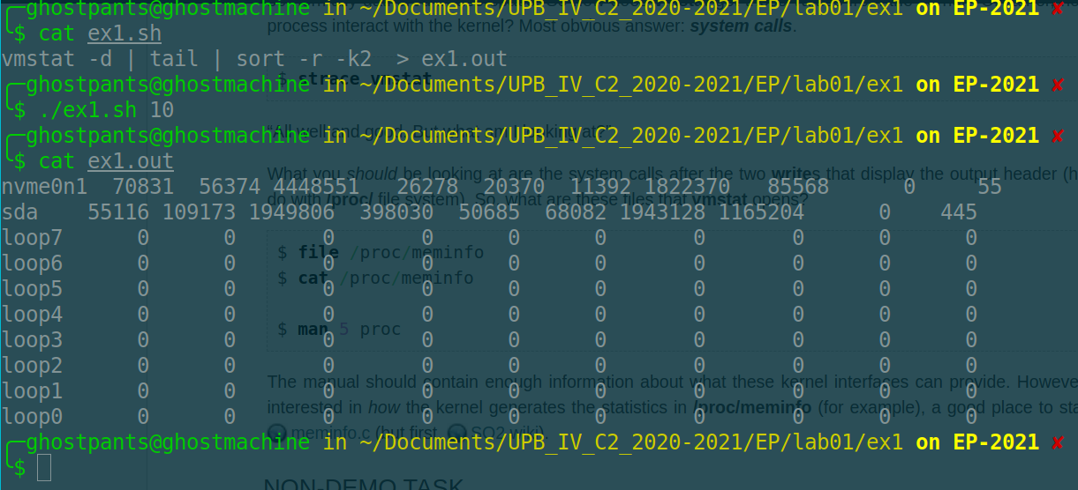

EX2.
The python script crashes because python enforces a max size of the recursion stack: no more than 1000 recursive calls. We can fix this by artificially increasing the limit when we get close to it, as shown in the screenshot below.
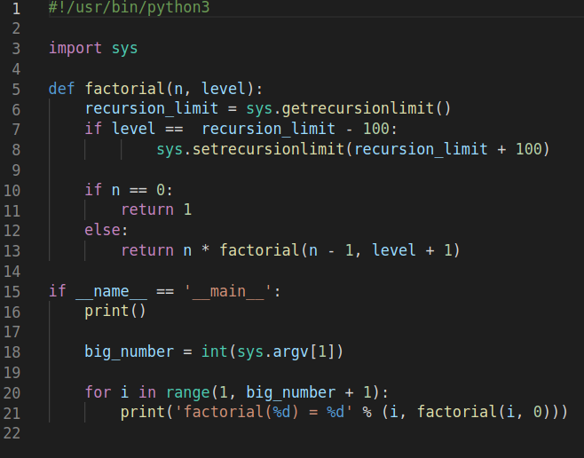

Creating workers then setting their affinity bonds them to speciffic CPUs. This can be seen when monitoring the activity.
sudo stress --cpu $((`nproc` - 1)) --timeout 2
sudo taskset -cp 1-<number of cores> <pid of workers from prev command>
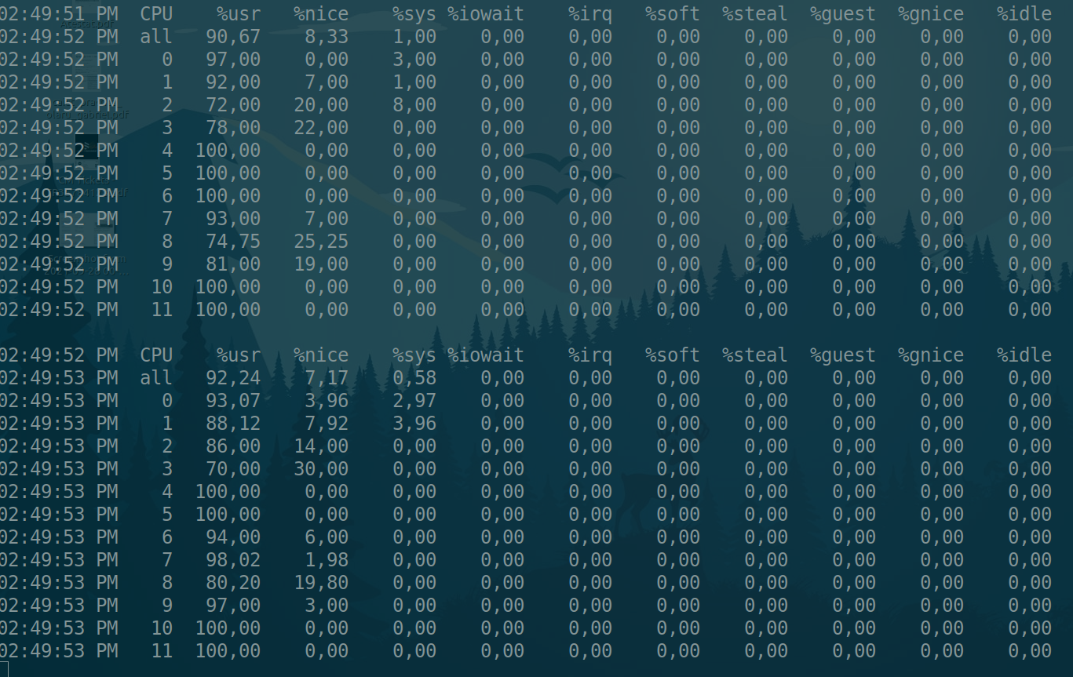

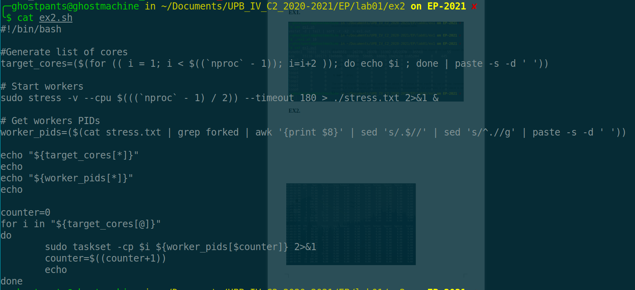
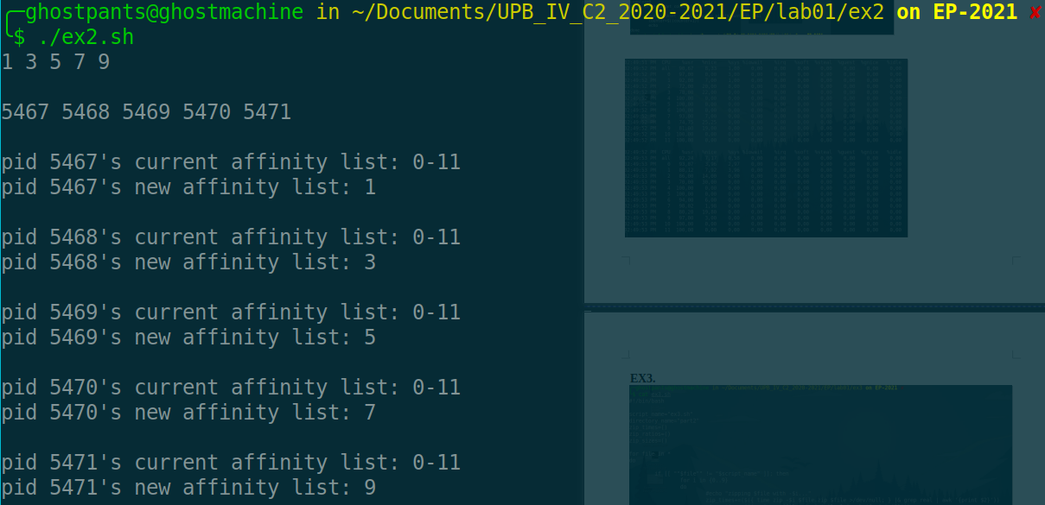
Below is the script generating N/2 workers and binding them to odd cores. First the list of cores is created and then the workers are started and their PID is extracted into a list. Finally, the pid is binded to the cores from the first list.
EX3
Below is the script that measures the compression rates and time and outputs the data as a list. The 0% compression rate is due to an empty file being present in the directory (by mistake). It also gets data about the size of the compressed files (used for the graphs).
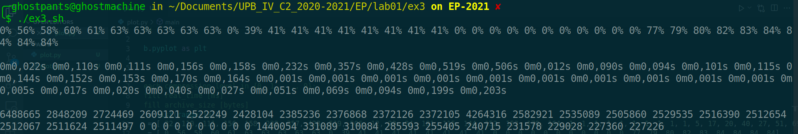
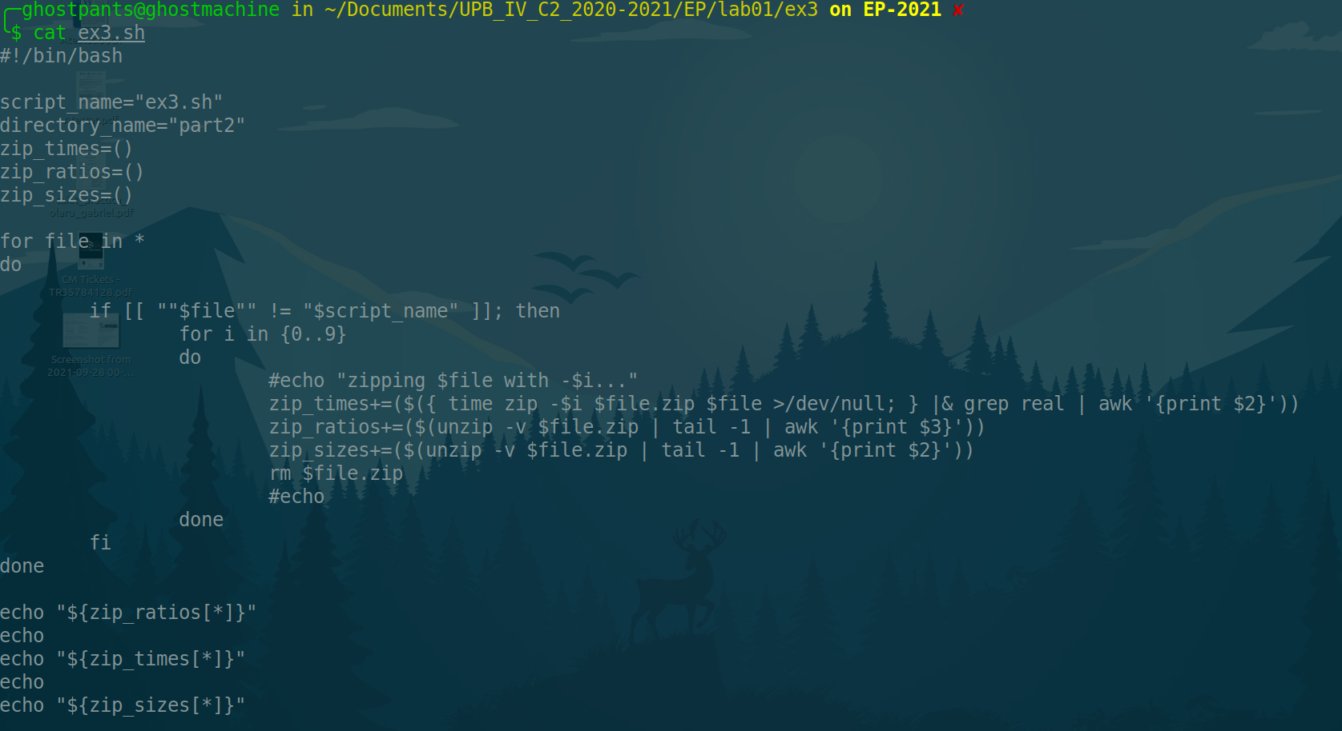
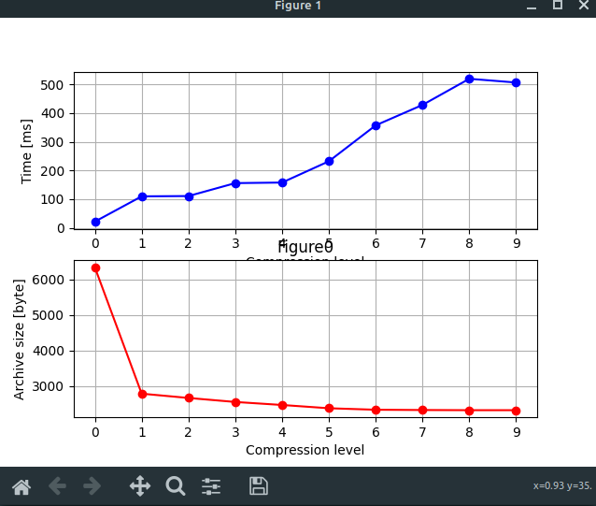
The graphs below are recreated from the data gathered above, and they depict how the size of the file decreases with the increase of the level of compression. Please note that the time of compression also increases

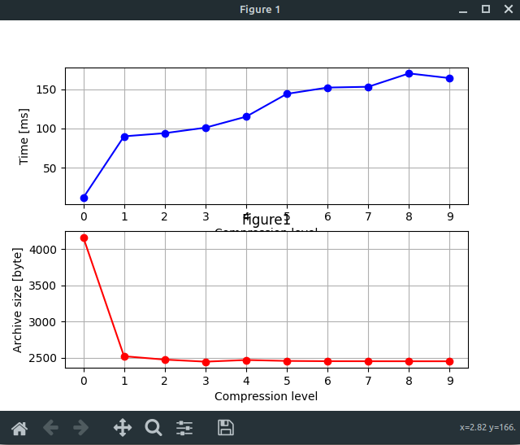
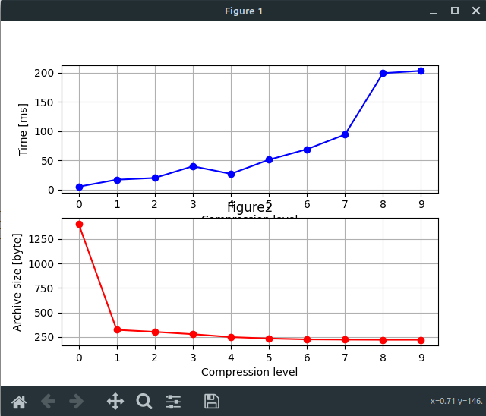

EX4.
The gist of it would be to extract the values from the registers and the pass themto the macro. Didn’t manage to get it done in time.
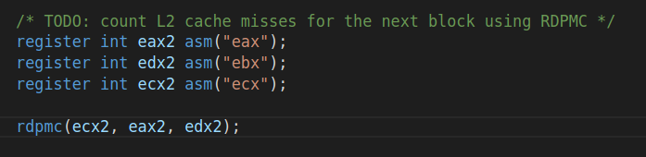

EX5.



