
EP-Lab07-2021
Olaru Gabriel Iulian, 342C2

EX1:

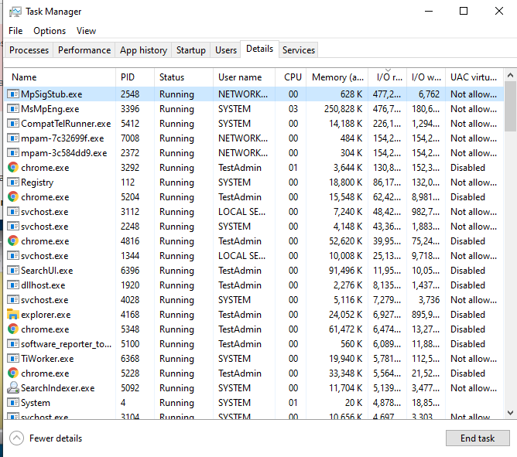
The resource consumption is justified since MgSigStub.exe is a service for a malware detection tool from Windows. Probably is accesses memory lots more frequently since it scans for malware.

EX2

Task manager view:
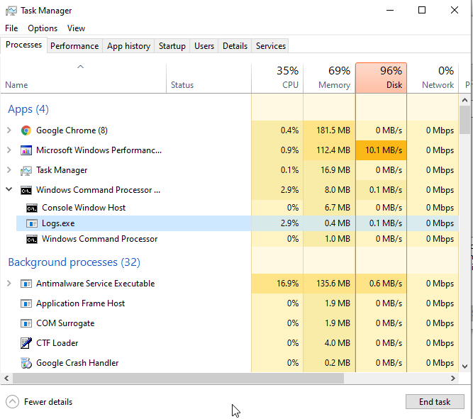

WPA view:
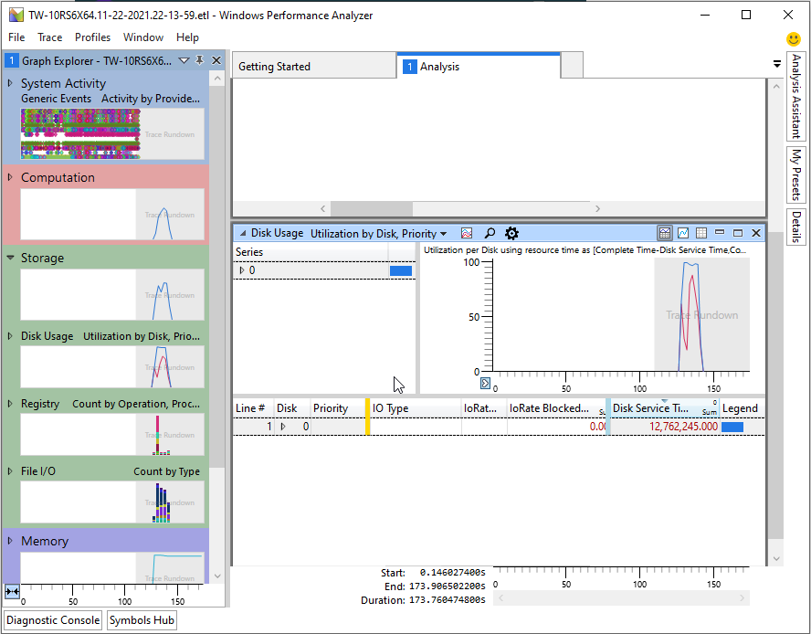

EX3:
TaskA

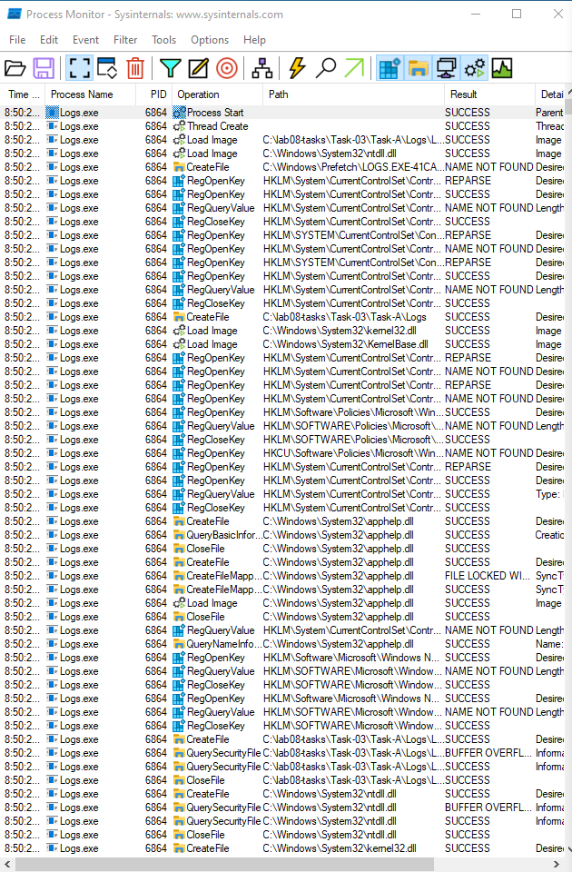
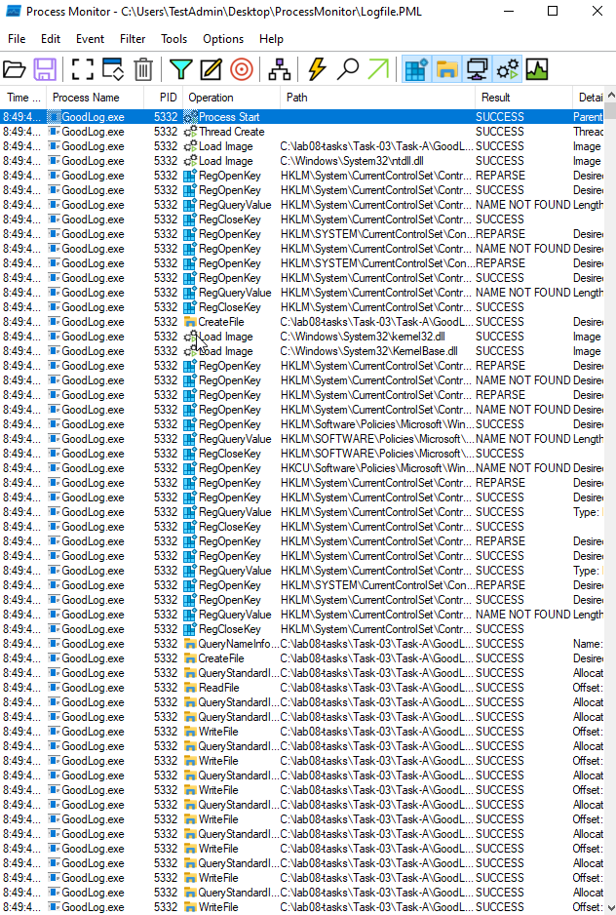
Log.exe vs GoodLog.exe

Task B:



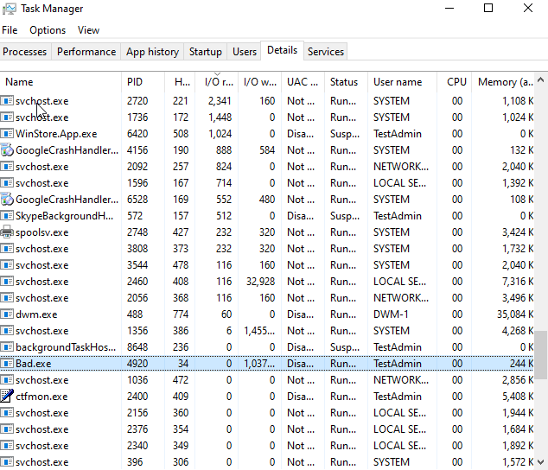
From SS we can observe the large number of hadles of the process (column after PID), proving that Bad.exe opens files without closing them, causing lag.

EX4:

Looks like the process keeps creating files then opens them without closing them.

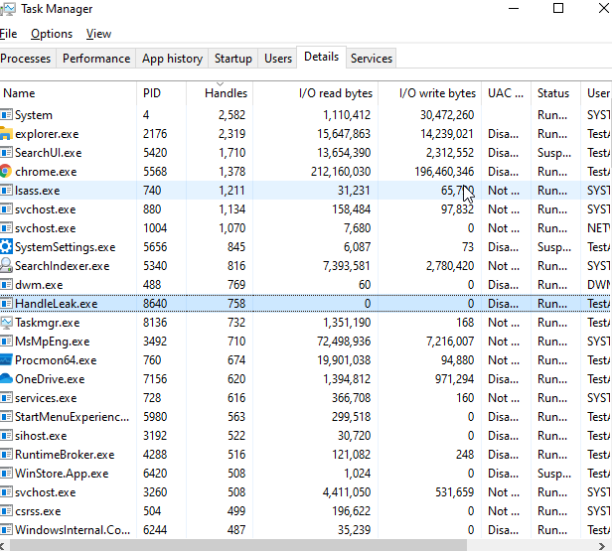

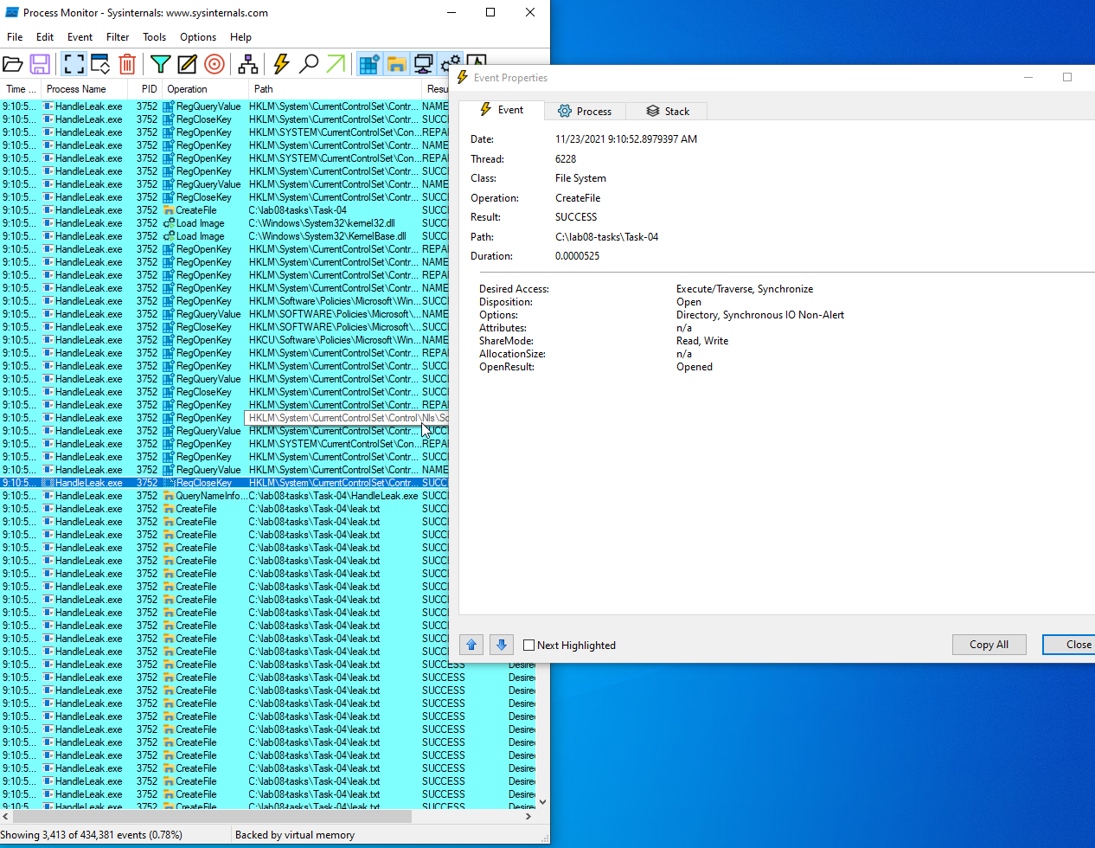

Ex5:

Didn’t manage to finish but did some work. Will attach source file.

Ex6:


