Test management tools
Jenkins Tutorial

Table of Contents
1. Access Jenkins 2
2. Connect to Jenkins 2
3. Create a new Job 2
4. Configure your Job 4
5. Build 9
6. Sending results from Jenkins to Testlink 10
7. View the state of a Test case in Testlink 10

Access Jenkins
https://www.scs.ubbcluj.ro:9090

Connect to Jenkins

Log in - user your scs_id_user
user: for example, for student Savu Victor Gabriel (svie1164@scs.ubbcluj.ro) the user is svie1164
pasword: the pasword of user svie1164

Create a new Job
Each student will create his/her own Job (for the TestPlan created in Testlink), the name of the job will be composed of: groupNumber followed by the names of the team members concatenated with the word Job. (93X_Name01Name02_Job)
- for example, for one of the team in group 931 Pop and Popescu the name of the job will be: 931_PopPopescu_Job.

  - Create a new Job from other existing job – please use this option, it is easier to created and faster.

    - Use “Copy from”: Lecture02MaxPointsParticipants-bis
    - Modify in your Job the following elements
      - Github link with your Github link
      - Test Project and Test Plan with
        - Lecture02MaxPointsParticipants with Projects93X
        - TestPlan_Lecture02MaxPointsParticipants with 93X_Name01Name02_TestPlan (created in Testlink).

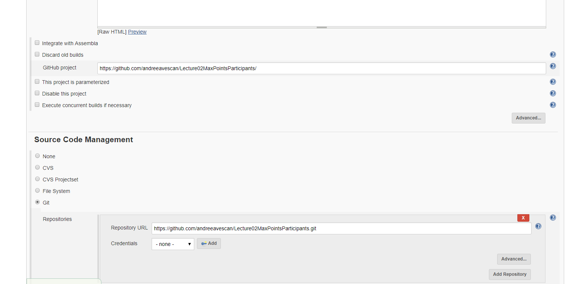

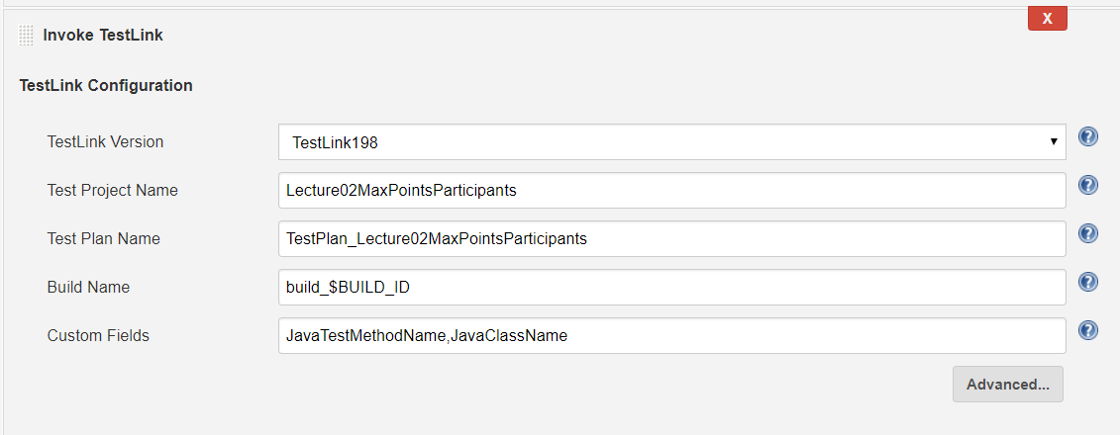

  - Create a new Job (empty job)

Create Job - STEPS
- Jenkins Menu
- Select New Job
  - Name:
    - 93X_Name01Name02_Job
  - Select Build a free -style software project
  - click button "ok"

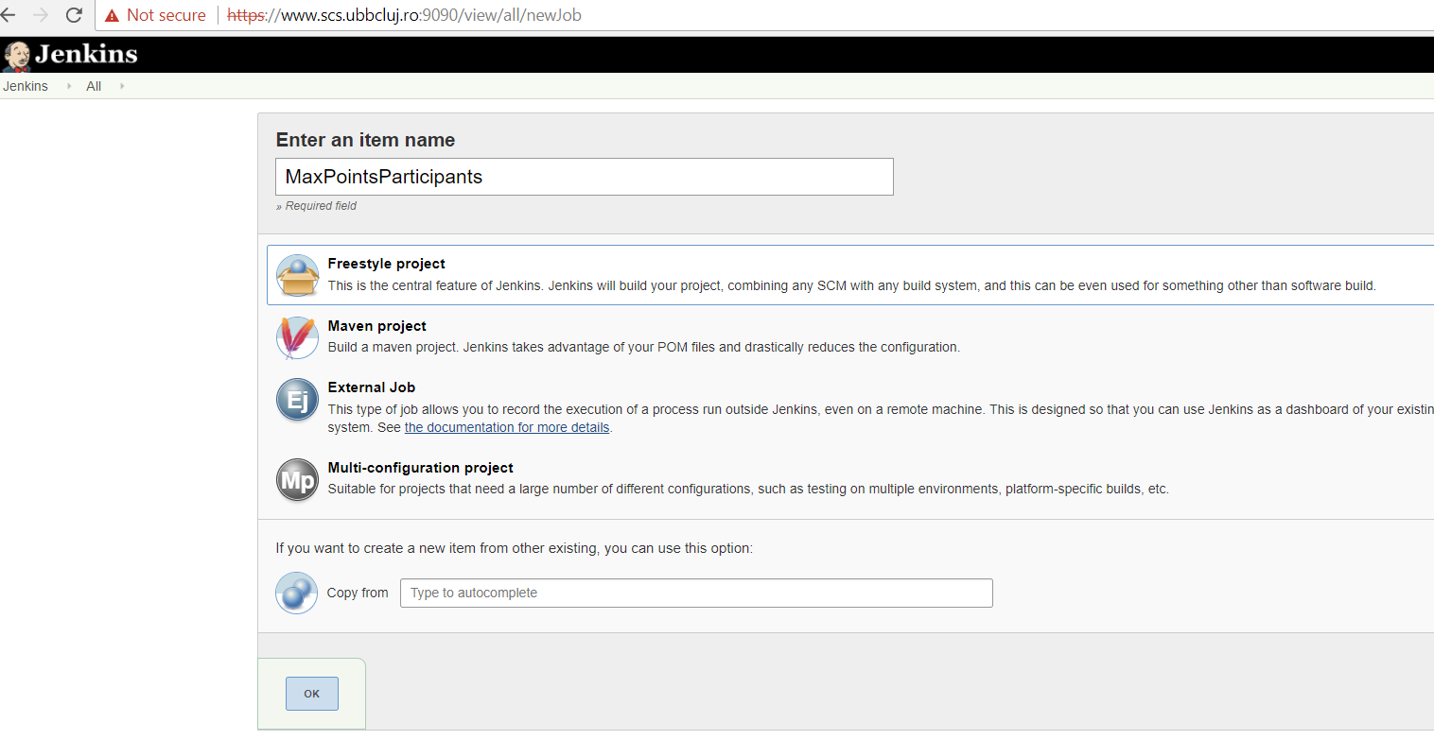

Figure 1. Jenkins – Creating new job

Configure your Job
- Jenkins Menu
- Select from the list of Jobs your previously created job
- Select from left menu the "Configure" section
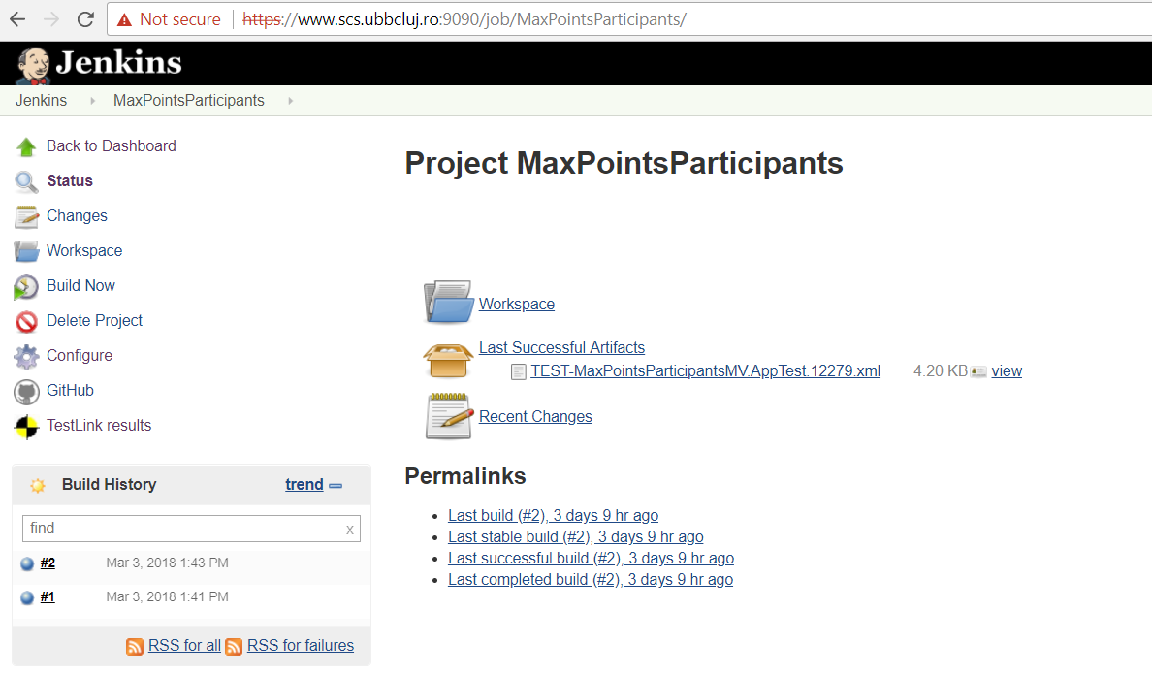

Figure 2. Jenkins – Configure job

- GitHub project and Repository URL
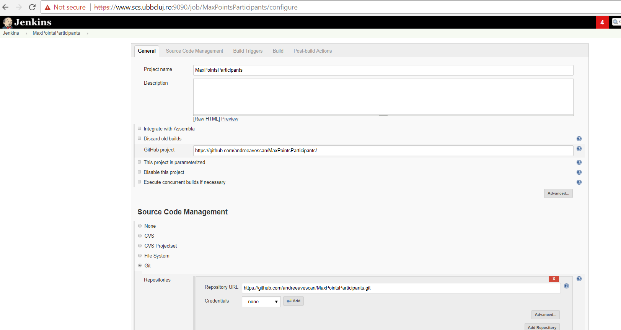

- From Build section

- Select Invoke top-level Maven targets
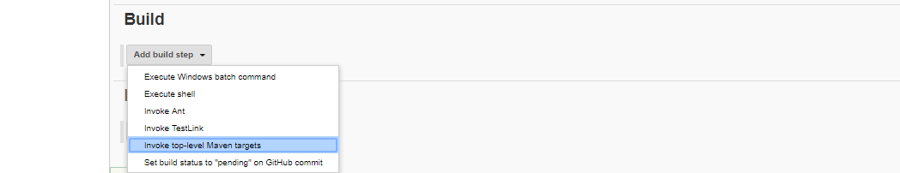

- Add info: Maven version: mvn and Goals: compile
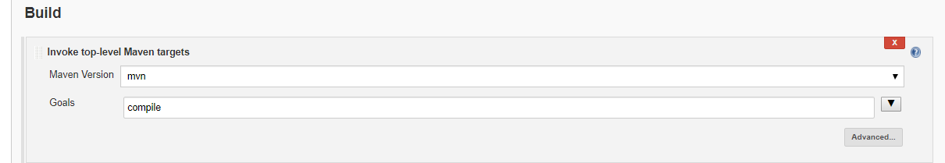

- From Build section

- Select Invoke TestLink
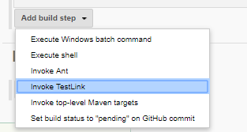

- Add info: Your TestProjectName, your Test Plan Name
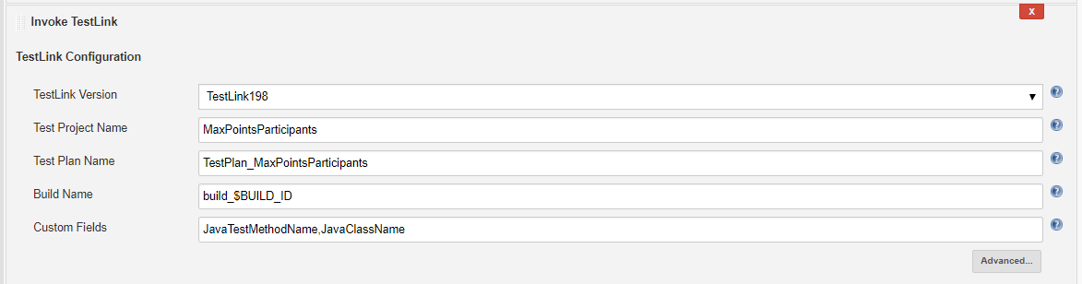

- On Invoke TestLink, at Test execution, on Iterative Test Build Steps, select an action

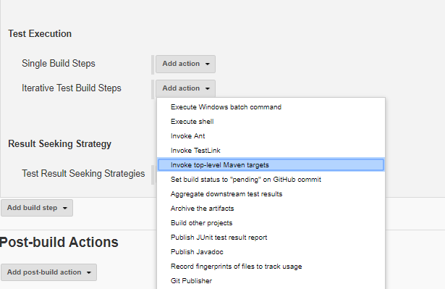

- Select Invoke top-level Maven targets and add the information: Maven: mvn and Goals: verify
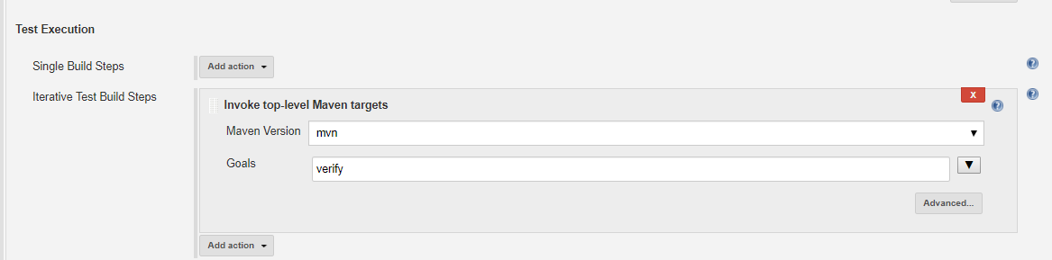

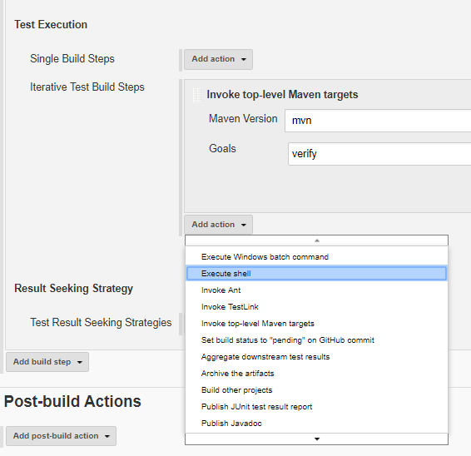
- Add another action: Execute Shell

- Add the following command

#!/bin/bash
mv ./target/surefire-reports/TEST-$TESTLINK_TESTCASE_JAVACLASSNAME.xml ./target/surefire-reports/TEST-$TESTLINK_TESTCASE_JAVACLASSNAME.$TESTLINK_TESTCASE_ID.xml

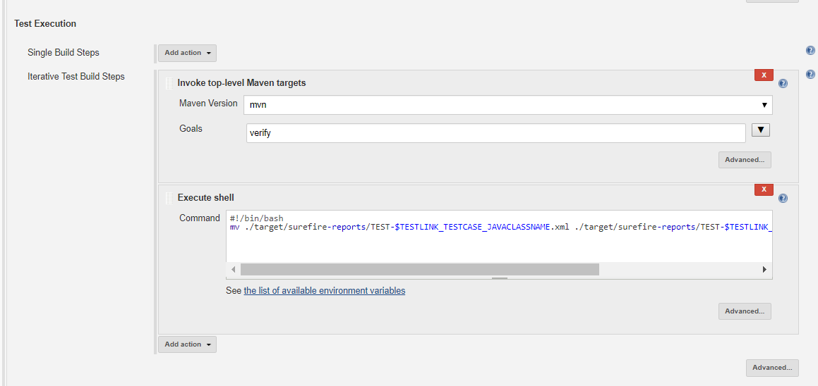

- On Invoke TestLink, at Result Seeking Strategy, add the strategy “Junit method name”
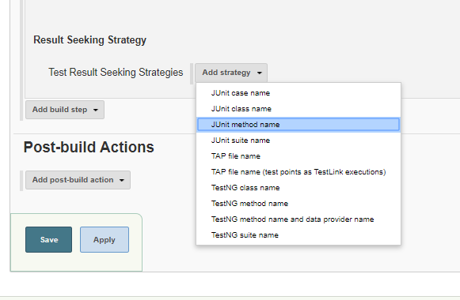

- Add the following information

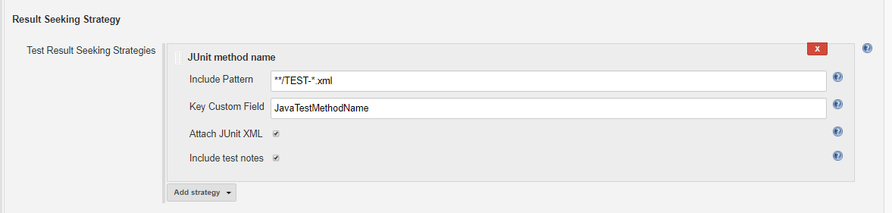

- At section “Post-build Actions”
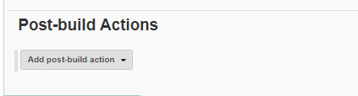

- At section “Post-build Actions”, add the post-build action “Archive the artifacts”
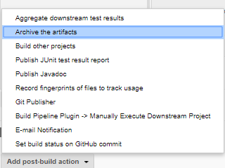

- Add the information
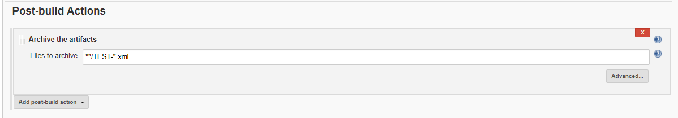

- And Save

Build
  - Select the Job
  - Select Build Now

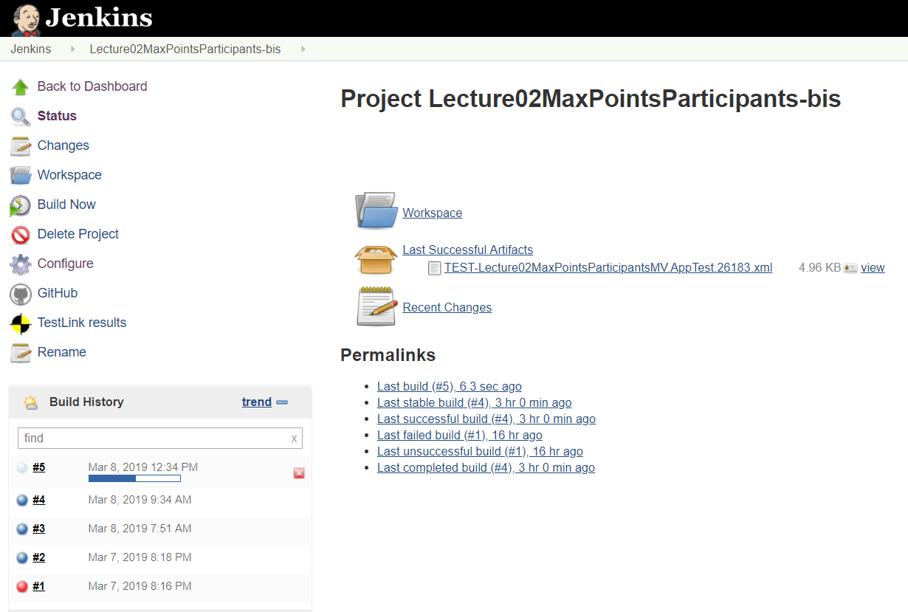

  - Console Output

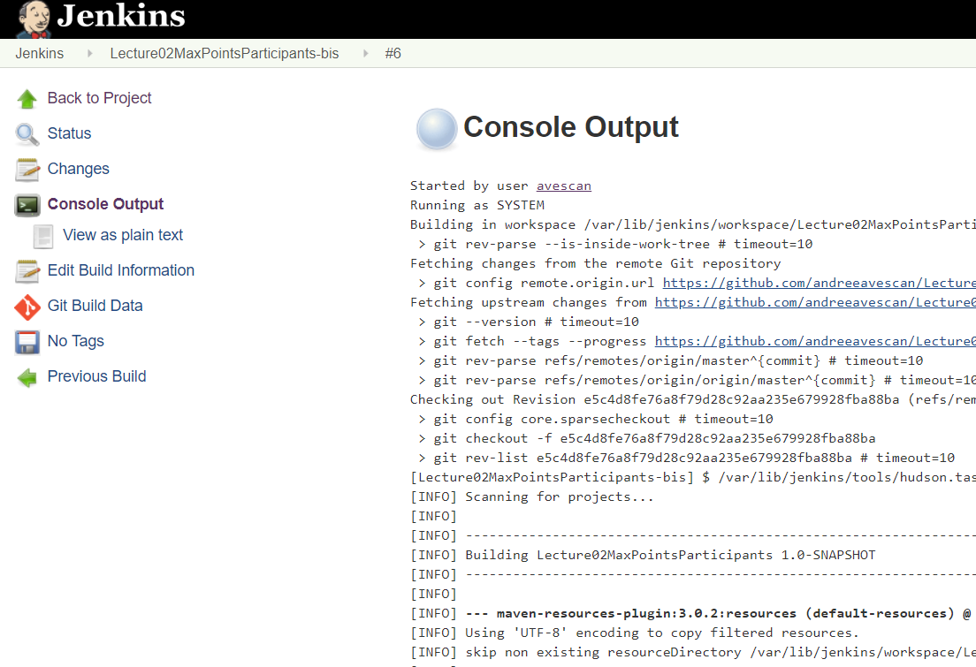

Sending results from Jenkins to Testlink
After successfully running the job, in Testlink it is updated automatically the status of the test cases in Not Run, Passed, Failed, or Blocked.

View the state of a Test case in Testlink
In the Test Specification menu, within the chosen project, eg Projects931, a desired Test Suite is selected, e.g., xxir1234_BBT, and a test case.

