Test management tools
Testlink Tutorial

Table of Contents
1. Accessing Testlink 2
2. Create an account 2
3. Create project 2
4. Selection of your Project - STEPS 2
5. Define Custom Fields 3
6. Assign Custom Fields 3
7. Create a Test Plan 3
8. Create Requirement specification 4
9. Create Requirement 4
10. Create Test Suites/ Test Cases 4
11. Create Test Cases - STEPS 5
12. Add a Test Case to a Test Plan 6
13. Associate a Requirement to a Test Case 7
14. Automated generation of a Test Case for a Requirement 7
15. Testlink generated documentation 8

Accessing Testlink

https://www.scs.ubbcluj.ro/testlink

Create an account
Create an account (at the Testlink provided above) with the following informations:
user: scs id user (for example, for student Savu Victor Gabriel (svie1164@scs.ubbcluj.ro) the name of the user will be svie1164)
pasword: your own password

Create project
Only admin user is allowed to create project. For each group I have created a project, thus each student will use the project name from his group.
The already created projects are:
- Projects931
- Projects932
- Projects933
- Projects934
- Projects935
- Projects936
- Projects937
- ProjectsOthers (for the students from other years of study or/and reenrolment)

Selection of your Project - STEPS
- Project Menu
- In the upper right corner select from the combo box your Test Project.
I will insert the screenshots of how to create a project in testlink (for future reference, not required for the laboratory work).
Create Project - STEPS
- Desktop menu --> Test Project section -->click on Test Project Management
- Create Button --> fill in the required field as in the Figure 1.
- Click Create button--> the project with the provided name is created.
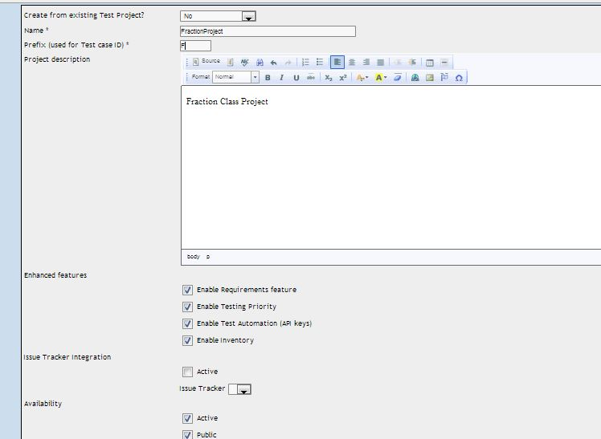

Figure 1. Create a project

Define Custom Fields
(already created, not needed for the laboratory work, but for future reference)

The defined Custom Field will be use later in Jenkins.
- JavaClassName - name of the autotest class.
- JavaTestMethodName - name of the test method.

I will insert the screenshots of how to create custom fields in testlink (for future reference, not required for the laboratory work).
Define Custom Fields - STEPS
- Project/Desktop menu-->Test Project--> click on Define Custom Fields
- Fill in the required fields as in Figure2a. and then click button "Add"
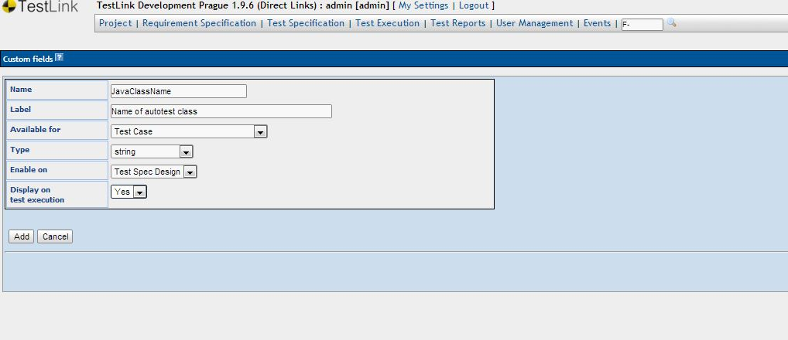

Figure 2. Define Custom Fields

Assign Custom Fields

The defined Custom Field (JavaClassName) will be assign to project (already created, not needed for the laboratory work, but for future reference - when created for the first time)

Assign Custom Fields - STEPS
- Project/Desktop menu-->Test Project--> click on Assign Custom Fields
- Select the Custom Field and press button "Assign"

Create a Test Plan
Each student will create his/her own Test Plan, the name of the test plan will be composed by groupNumber followed by the names of the team members concatenated with TestPlan.
93X_Name01Name02_TestPlan

Create Test Plan - STEPS
- Project/Desktop menu --> Test Plan section -->click on Test Plan Management
- Create Button --> fill in the required field as in the Figure 3.

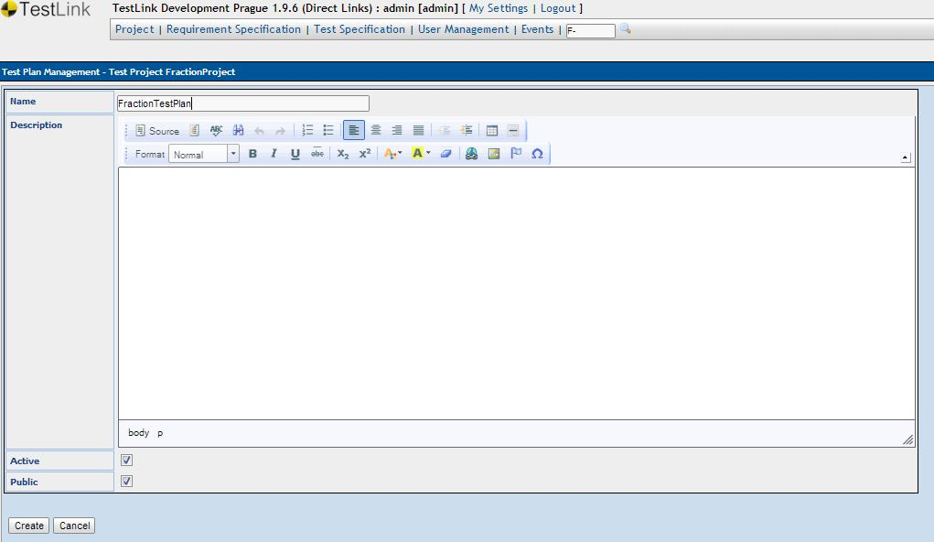
Figure 3. Create Test Plan

Create Requirement specification
Create Requirement specification- STEPS
- Project/Desktop menu --> Requirement specification section -->click on Requirement specification
- Select your Project from the left side tree
- Click the Create button to create Requirement specification. Each student will create one Requirement specification using the following name: 93X_Name01Name02_ReqSpec

Create Requirement
After creating your 93X_Name01Name02_ReqSpec you must create Requirement Operations
  - in your created requirement specification (93X_Name01Name02_ReqSpec) from the left side tree) click the requirements and then in the right panel select Create button in the Requirement Operations section.
  - Add the title/id and the number of test cases needed to be created to test that requirement.
  - Each student will create 3 Requirements for each problem requirement (93X_Name01Name02_ReqSpec _addStudent, 93X_Name01Name02_ReqSpec _addLabAssignment, 93X_Name01Name02_ReqSpec _addGrade))

Create Test Suites/ Test Cases

Each student will create in total 3 test suites:
- 1 test suite from laboratory 2 - black-box testing
  - Test Suite Name = 93X_Name01Name02_BBT
- 1 test case from laboratory 3 - white-box testing
  - Test Suite Name = 93X_Name01Name02_WBT
- 1 test case from laboratory 4 - integration testing.
  - Test Suite Name 93X_Name01Name02_IntegrationT

Create Test Suites - STEPS
- Project/Desktop menu --> Test Specification section -->click on Test Specification
- Select your test project in navigation tree (left side screen)
- In the Test Suite Operations panel click on the Create button. Figure 4.
- Fill in the required fields as in Figure 5 and click the Create Button
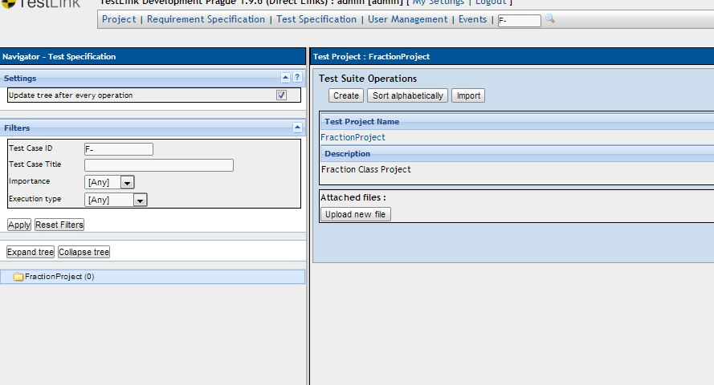

Figure 4. Test Suite Operations
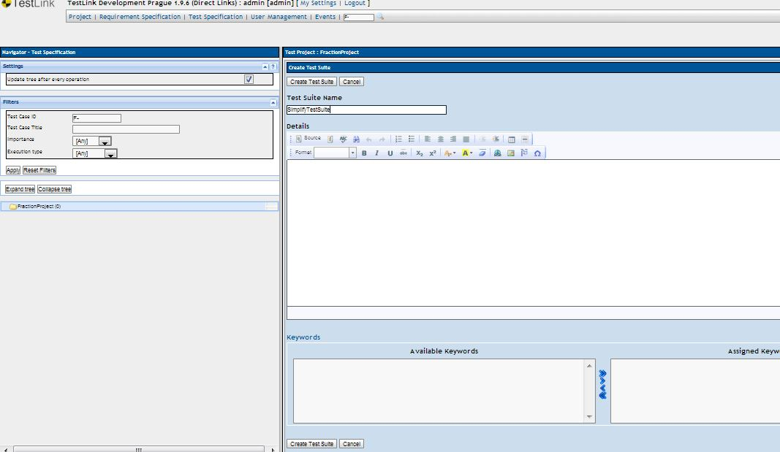

Figure 5. Create Test Suite

Create Test Cases - STEPS
- Select your test suite in navigation tree (left side screen)
- In the Test Suite Operations/ Test Case Operations panel click on the Create button (from Test Case Operation). Figure 6a and Figure 6b. Remember to modify Execution type to automated.
- Add the name of your autotest class
  - Name of autotest class: package.NameAutotestClass
  - Name of the test method: package.NameAutotestClass#NameMethodName
  - example: FractionMv.Fraction.FractionClassSimplifyTest, where
    - FractionMv.Fraction = package
    - FractionClassTest=the class for test
    - testSimplify=the name of the test method
- After fill in the required field click the Create button.
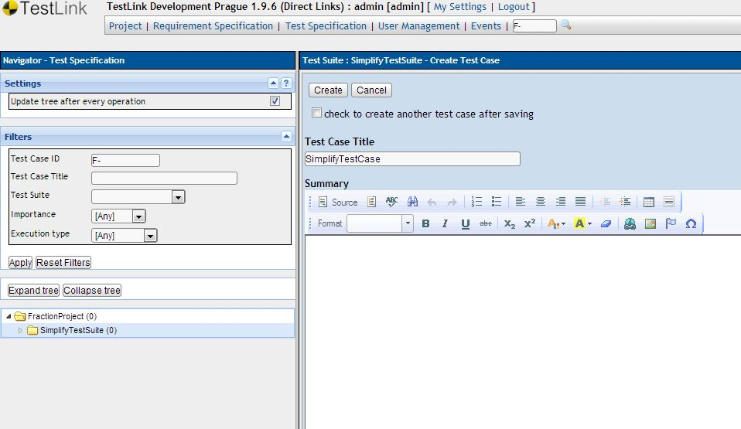

Figure 6a. Create a test case - part 1

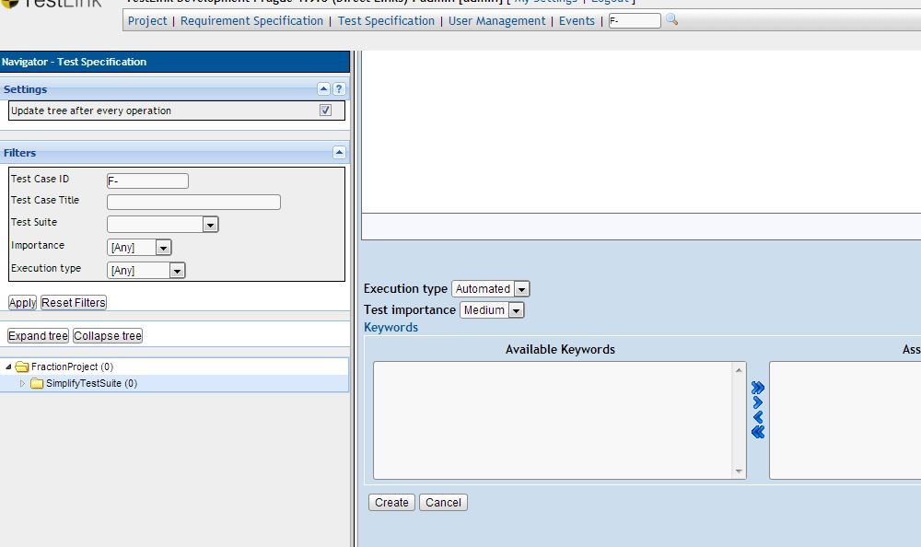
Figure 6b. Create a test case - part 2. Remember to modify Execution type to automated.

Add a Test Case to a Test Plan

Assign a Test Case to a Test Plan - STEPS
- Project/Desktop menu --> Test Specification section -->click on Test Specification
- Select your Test Case in navigation tree (left side screen) of your Test Project
- In the right panel click on the button "Add to Test Plans"
- Select your test plan (remember, the one with created ) and click button "Add". See Figure 7.
Remark: Assign the Test Case to the correct Test plan, ie. a Test case based on the specification to the Test plan with the "BBT" label, the Test case based on the source code to the Test plan with the "WBT" label,etc.
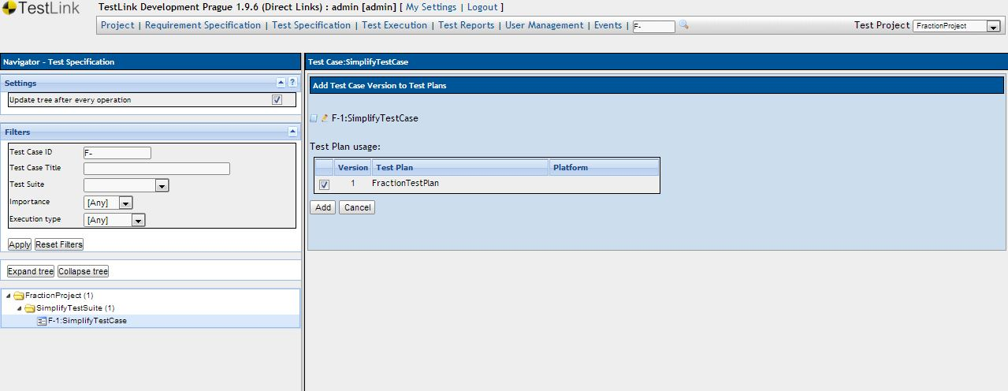

Figure 7. Assign your Test Case to your Test Plan

Associate a Requirement to a Test Case
- Project/Desktop menu---> Requirement Specification;
- Select Assign Requirements;
- Select the entity Test Case from the left side panel from your test project;
- From the right side frame select the document Requirement Specification and check the entity Requirement that should be associated with the current test case ---> Assign.
  - 93X_Name01Name02_ReqSpec _addStudent, 93X_Name01Name02_ReqSpec _addLabAssignment, 93X_Name01Name02_ReqSpec _addGrade

Automated generation of a Test Case for a Requirement
- Create a Requirement Specification (see tutorial);
- For a Requirement Specification create a Requirement (see tutorial), specifying also the number of test cases needed;
- Select the needed Requirement Specification, in the left side panel (menu Project ---> section Requirement Specification);
- From the right side panel in Requirement Operations ---> Create Test Cases and select the entities Requirement and the number of the test cases that are going to be created for the selected Requirement Specification;
- The test cases automated created are linked to the Requirement, but they have implicit settings. Each test case is edited such that:
  - Execution Type to Automated;
  - The two custom fields JavaClassName and JavaTestMethodName must be associated to the test case;
  - The test case must be associated to the test plan (see tutorial).

Testlink generated documentation

- Project/Desktop → in the Test Specification section click on the link Generate Test Specification Document
- check all options, select "Show as" MS WORD and then click on your project ==> it will download your documentation regarding the created Test.

