ML Project Documentation: Diabetes Risk Prediction
Diabetes/Pima dataset • Decision Tree • data cleaning • medical interpretation

Quick summary
Item | Value
Dataset | diabetes.csv / Pima Diabetes
Model | DecisionTreeClassifier
Target | Outcome: 0 = No Diabetes, 1 = Diabetes
Best focus | Recall / False Negative reduction
Graph file | diabetes_tree_clean.dot

1. Project goal
The goal of this project is to train a simple Machine Learning model that predicts diabetes risk based on tabular medical data.
The model uses an already labeled dataset: the Outcome column contains the correct answer for each patient: 0 = no diabetes, 1 = diabetes.
This is a supervised learning example: the model learns from examples where the correct answer is already known.

2. Libraries used
pandas: reading and exploring the CSV dataset.
numpy: temporarily treating suspicious zero values as missing values.
scikit-learn: train/test split, DecisionTreeClassifier, accuracy, recall, and confusion matrix.
tree.export_graphviz: exporting the decision tree to a .dot file for VS Code visualization.

3. Project workflow
Read the diabetes.csv dataset.
Quickly inspect the data: first rows, shape, columns, statistics, and missing values.
Split the dataset into X and y: X contains patient features, y contains Outcome.
Split the data into 80% training and 20% testing.
Train the first DecisionTreeClassifier model.
Evaluate the model using accuracy, recall, and confusion matrix.
Test new patients without Outcome.
Build an improved version: handle suspicious zero values, use class_weight="balanced", and max_depth=4.
Export the decision tree for Graphviz.

4. What X and y represent
X represents the input features: Pregnancies, Glucose, BloodPressure, SkinThickness, Insulin, BMI, DiabetesPedigreeFunction, and Age.
y represents the correct answer: Outcome. Value 0 means no diabetes, and value 1 means diabetes.
The model learns the relationship between X and y. After training, it can receive a new patient without Outcome and predict 0 or 1.

5. Results
Initial model: Accuracy = 0.7467, Recall = 0.7272, Confusion matrix = [[75, 24], [15, 40]].
Improved model: Accuracy = 0.7012, Recall = 0.8181, Confusion matrix = [[63, 36], [10, 45]].
The improved model has lower accuracy but higher recall. In a medical context, recall is very important because we want to miss as few real diabetes cases as possible.
False Negatives decreased from 15 to 10. This is a relevant improvement for medical screening.
False Positives increased from 24 to 36. This means more false alarms, but it can be acceptable if the goal is to avoid missing real cases.

6. Confusion matrix interpretation
TN = True Negative: a patient without diabetes correctly predicted as no diabetes.
FP = False Positive: a patient without diabetes incorrectly predicted as at risk.
FN = False Negative: a patient with diabetes incorrectly predicted as no diabetes.
TP = True Positive: a patient with diabetes correctly predicted as diabetes.
In medicine, False Negative is more dangerous because a sick patient may be missed and may not receive further testing.

7. Threshold 0.4 explanation
predict_proba(x_test_clean) returns the probabilities for each class.
[:, 1] means: take all rows, but only column 1, which is the probability for the Diabetes class.
Threshold 0.4 marks a patient as at risk if the diabetes probability is at least 40%.
In this test, threshold 0.4 did not change the predictions because the model probabilities were not between 0.4 and 0.5.

8. Decision tree visualization
The decision tree shows the rules learned by the model. At the top node, the model starts with Glucose, which makes sense for a diabetes dataset.
The True branch means the condition is true, while the False branch means the condition is false.
class = No Diabetes or class = Diabetes shows the predicted class at that node.
Figure: decision tree exported in Graphviz format.
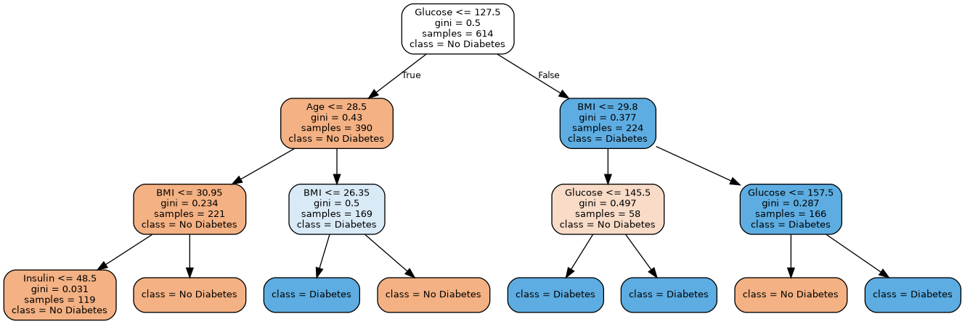

10. Conclusion
This project is a good exercise for understanding the tabular ML workflow: reading data, exploring it, splitting X/y, training, evaluating, and interpreting results.
For Medical AI, the key lesson is that accuracy is not enough. Recall and False Negatives are essential when the model is used for medical screening.
This model is not a real medical diagnosis tool. It is an educational Machine Learning project.

Main code
The code below is the cleaned version for the notebook/project.
# 1. Prima celulă — importuri și citire dataset
import pandas as pd
import numpy as np
from sklearn.model_selection import train_test_split
from sklearn.tree import DecisionTreeClassifier
from sklearn.metrics import accuracy_score, recall_score, confusion_matrix
from sklearn import tree
# 1. Citim datasetul
data = pd.read_csv('diabetes.csv')
# 2. Verificam rapid datele
data.head()
data.shape
data.columns
data.describe()
data.isnull().sum()
# 3. Separăm coloanele de intrare de rezultatul pe care vrem să îl prezicem
x = data.drop(columns=['Outcome'])
y = data['Outcome']
x.head()
y.head()
# 4. Împărțim datele în date de antrenare și date de testare
x_train, x_test, y_train, y_test = train_test_split(
x, y, test_size=0.2, random_state=42
)
print(x_train.shape)
print(x_test.shape)
print(y_train.shape)
print(y_test.shape)
# 5. Creăm modelul
model = DecisionTreeClassifier(random_state=42)
# 6. Antrenăm modelul
model.fit(x_train, y_train)
# 7. Facem predicții pe datele de test
predictions = model.predict(x_test)
# 8. Evaluăm rezultatele
accuracy = accuracy_score(y_test, predictions)
recall = recall_score(y_test, predictions)
matrix = confusion_matrix(y_test, predictions)
print("Accuracy:", accuracy)
print("Recall:", recall)
print("Confusion matrix:")
print(matrix)
# 9. Testăm un pacient nou
new_patient2 = pd.DataFrame(
[[6, 180, 90, 35, 160, 26.0, 0.8, 55]],
columns=x.columns
)
result = model.predict(new_patient2)
if result[0] == 1:
print("Modelul prezice risc de diabet.")
else:
print("Modelul prezice fara diabet.")
# Model imbunatatit
# 1. Păstrăm codul vechi și facem o copie a datelor
data_clean = data.copy()
# 2. Verificăm câte valori 0 suspecte avem
columns_to_fix = ["Glucose", "BloodPressure", "SkinThickness", "Insulin", "BMI"]
print("Valori 0 inainte de curatare:")
for column in columns_to_fix:
print(column, (data_clean[column] == 0).sum())
# 3. Înlocuim valorile 0 cu mediana
for column in columns_to_fix:
median_value = data_clean[column].replace(0, np.nan).median()
data_clean[column] = data_clean[column].replace(0, median_value)
print("Valori 0 dupa curatare:")
for column in columns_to_fix:
print(column, (data_clean[column] == 0).sum())
# 4. Refacem x și y pe datele curate
x_clean = data_clean.drop(columns=["Outcome"])
y_clean = data_clean["Outcome"]
# 5. Împărțim din nou datele
x_train_clean, x_test_clean, y_train_clean, y_test_clean = train_test_split(
x_clean, y_clean, test_size=0.2, random_state=42
)
# 6. Antrenăm un model îmbunătățit
model_clean = DecisionTreeClassifier(
random_state=42,
class_weight="balanced",
max_depth=4
)
model_clean.fit(x_train_clean, y_train_clean)
# 7. Facem predicții și evaluăm
predictions_clean = model_clean.predict(x_test_clean)
accuracy_clean = accuracy_score(y_test_clean, predictions_clean)
recall_clean = recall_score(y_test_clean, predictions_clean)
matrix_clean = confusion_matrix(y_test_clean, predictions_clean)
print("Accuracy imbunatatit:", accuracy_clean)
print("Recall imbunatatit:", recall_clean)
print("Confusion matrix imbunatatit:")
print(matrix_clean)
# 8. Test cu prag 0.4 pentru clasa 1 / risc diabet
probabilities = model_clean.predict_proba(x_test_clean)[:, 1]
predictions_threshold = []
for probability in probabilities:
if probability >= 0.4:
predictions_threshold.append(1)
else:
predictions_threshold.append(0)
accuracy_threshold = accuracy_score(y_test_clean, predictions_threshold)
recall_threshold = recall_score(y_test_clean, predictions_threshold)
matrix_threshold = confusion_matrix(y_test_clean, predictions_threshold)
print("Accuracy imbunatatit cu prag 0.4:", accuracy_threshold)
print("Recall imbunatatit cu prag 0.4:", recall_threshold)
print("Confusion matrix imbunatatit cu prag 0.4:")
print(matrix_threshold)
# 9. Exportăm arborele pentru VS Code / Graphviz
tree.export_graphviz(
model_clean,
out_file="diabetes_tree_clean.dot",
feature_names=x_clean.columns,
class_names=["No Diabetes", "Diabetes"],
label="all",
rounded=True,
filled=True
)

