**Storyboard 1**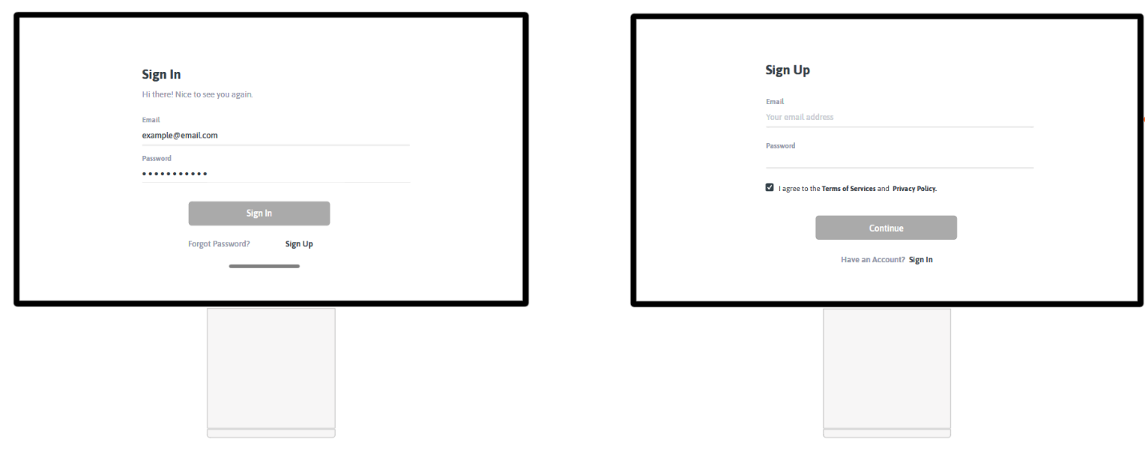

**Description: Sign In/ Sign Up**

User must first sign up on the site in order to play different games or see his scores. After he signed up, he must sign in to have all the privileges. Now, he will have displayed a “Quit” button and a welcome message.

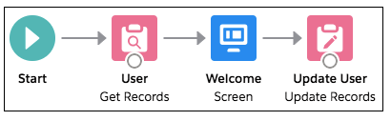

**Storyboard 2**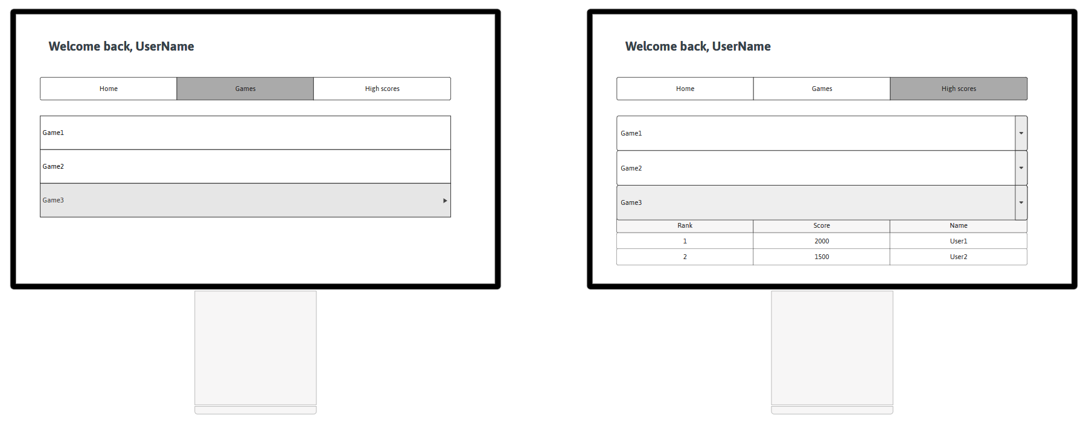

**Description: User navigates to Games Page/High Scores Page ( each game played will display a list with the scores)**

On Games Page the user can see the available games and he can play the game he chooses/rate a game.

The user can see his scores ( from previous played game) by clicking the High Scores Page in the menu.

**Storyboard 3**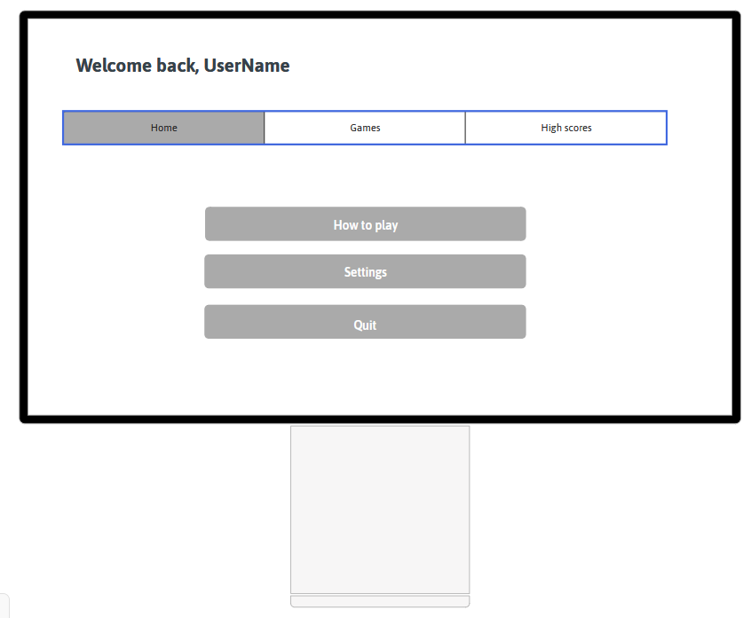

**Description: User navigates to Home Page**

From Home Page, the user cand choose to press “How to play” button to see a description of the games availables with some simple instructions. “Settings” button will open a window where the user cand vie and edit is profile.