Course: Data Analysis

Student’s Name and Surname Iurii Aksenov

Please do the tasks below.

1. Open Worldbank_data.dta file.

Do the cluster analysis using hierarchical clustering algorithm. Select not less than 4 interval variables for the analysis. Don’t forget to standardize the values of variables if needed.

Answer:

We choose internet, secure, export and import variables.

- Define the number of clusters. Explain your decision.

To define the number of clusters, we create a cluster and then use calinski index.

Also, we use wardslinkage because when we used averagelinkage then some clusters have only one element.

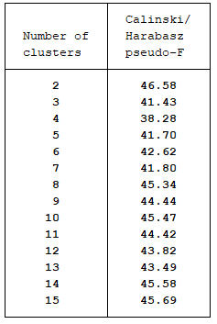

We choose 6 number of clusters because it’s not so much as 15, but quite good do observe the data.

b. Create a dendrogram.

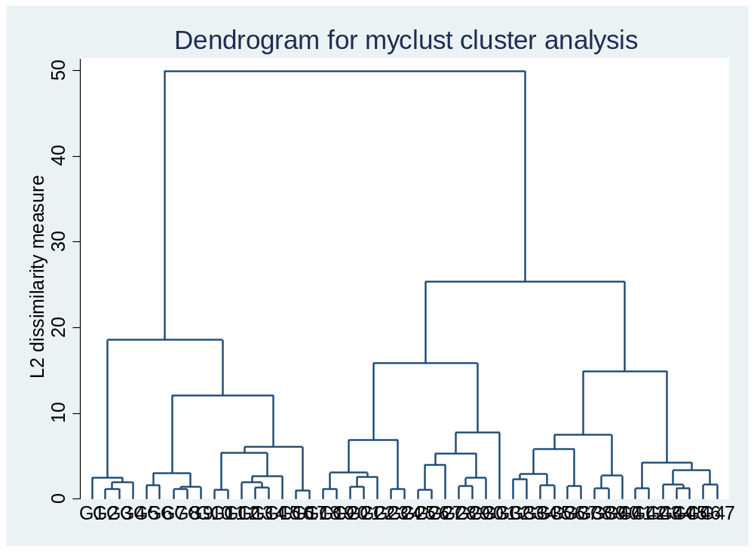

On the dendrogram we draw the line which present us 6 number of clusters

- Describe the clusters using descriptive statistics.
d. Try to name the obtained clusters.
f. Save cluster membership variable in the file.

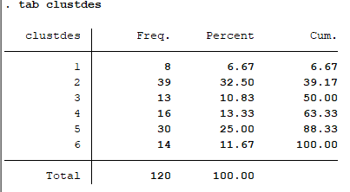

Firstly, we can see that all clusters contain good amount of countries, so our number of clusters is good. The cluster №3 has the most countries = 39.

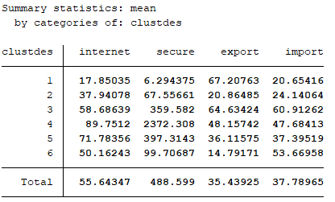

Cluster number | Countries
1 | AFG, ZAR, NIC, NPL, HND, PAK, BGD, PHL
2 | TUR, LTU, CYP, TJK, TZA, STP, COL, SLV, ALB, MEX, SLB, NAM, LSO, CPV, MMR, DOM, SDN, BLZ, ZAF, PRY, GUY, LAO, GTM, ZWE, KGZ, RWA, GRC, UGA, PAN, HTI, JOR, PER, LKA, ARM, GEO, THA, URY, MNG, ECU
3 | BRA, FRA, HUN, MKD, BEL, MRT, DZA, IRL, GHA, ISR, LBR, JPN, ROM
4 | SWE, AUT, BMU, DEU, FIN, MLT, CAN, ISL, NOR, GBR, USA, NLD, KOR, CHE, EST, LUX
5 | BLR, ESP, ABW, QAT, BHS, KWT, AUS, SVN, MDA, MAR, LBN, NZL, CHN, SGP, MYS, POL, CHL, BIH, MUS, SRB, DNK, ITA, SVK, PRT, UKR, CRI, LVA, ARG, RUS, CZE
6 | BRN, BTN, BWA, AZE, TMP, VEN, SUR, SYC, JAM, SAU, MDV, MNE, MOZ, HRV

Description:
1-th cluster represent the “outsider” by internet and secure. Actually, when we observe the countries (AFG, ZAR, NIC, NPL, HND, PAK, BGD, PHL) their economy is in crisis, they have wars. In that case spreading of the internet not so much.
2-th cluster is better than outsider. They have a little bit more import than export, and not so much internet distribution. These countries are more agricultural and lead an agricultural lifestyle than information
3-th “good middle”. Countries has more export than import and the secure of the countries are high. FRA has the 5-th strong economy in the world, so we can assume that because of it the export is bigger than import. Moreover, JPN is included in this cluster too, where the data privacy is the most valuable in culture, so secure is good one.
4-th cluster. From the summary statistics we can see that the fourth cluster has the highest values of internet and secure. We can cold them internet profi and secure countries. From the list of countries, we see that countries like USA, GBR, KOR etc are included in this cluster. They are one of the countries with the highest IT sector (IT and internet companies) in their GDP. We can say that these countries are the developed countries
5-th cluster the second one by the internet and secure. These countries are developing (RUS, CHN, POL etc). They lead to increase the amount of export, that’s why the difference between the export and import not so much.
6-th top of import. These countries import a lot, but they have good security after “good middle” cluster

The interesting thing that in all clusters accept 6 and 1 the import and export have approximately the same value. However, the 1-th cluster’s export is bigger than import more than in three times. It’ really interesting because the countries like AFG, NIC, NPL, PAK are not famous in export. In the 6-th cluster the situation is different, the import is bigger than export more than three times. Actually, it’s understandable because for example the VEN are lay under the economy sanctions, and under the economy crisis, so the country can’t produce enough computers technic, but the consume a lot.

2. Open video_games_sales.dta file.

Do the cluster analysis using k-means algorithm. Select not less than 4 interval variables for the analysis. Don’t forget to standardize the values of variables if needed.

- Define the number of clusters. Explain your decision.

To define the best k, we create several clusters and calculate to them calinski index.

Number of clusters | Calinski index
5 | 9611.75
6 | 9810.18
7 | 9975.14
8 | 9157.18
9 | 8775.00

We ca see than when the k = 6 then the clinski index has the highest value, so in our case k = 6.

3. Describe the clusters using descriptive statistics.
4. Try to name the obtained clusters.
5. Save cluster membership variable in the file.

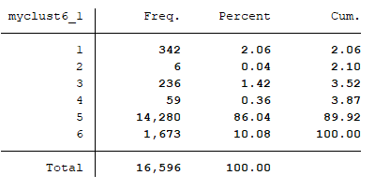

We can see that the 5-th cluster has the highest amount. The second is the 6-th cluster.

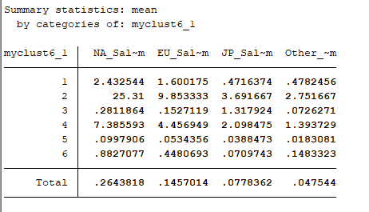

The 1-th cluster is “Lowest of three”. This cluster has the lowest sales among top 3. But on top 3 it has the highest number 342.
The 2-th cluster is “NA most sales” and, of course, this cluster has the most sales in Japan. But there are only 6 games.
The 3-th cluster “Japan forever” games which is sold in most cases in Japan than in other countries. It’s 236 games.
The 4-th cluster is “Good middle” which sells most games in NA, but no so much as 2-th cluster.
The 5-th cluster “No sales” because these games have few sales among the all countries. And it has the highest amount of games 14,280
The 6-th cluster “No so bad”. It’s the second one result by amount of games (1,673). The sales in Japan is much more less than in other countries.

Send this file with the Stata output or do-file to amelikyan@hse.ru

