Course: Data Analysis

Student’s Name and Surname Iurii Aksenov

Please do the task below.

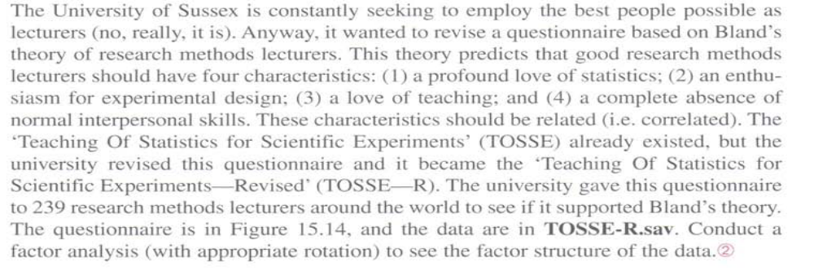

Conduct a factor analysis to see the factor structure if the data, in particular:

- Interpret the results of KMO
- Interpret communalities (cut point 0,3).
- Give your comments on the cumulative variance explained by the factor model.
- Interpret the rotated component matrix.
- Give the names and interpretations for the factors.
- Save the factors and recode them into ordinal variables with the same scale of measurement as the initial variables.
Send the interpretations and the modified file to amelikyan@hse.ru

- Interpret the results of KMO

Can we do the factor analysis?
KMO = 0.8941 => its acceptable the data are appropriate to the factor analysis

- Interpret communalities / uniqueness (cut point 07).

Firstly we calculate factor on all variables, then we rotate to do more appropriate.

Our table is

Factor analysis/correlation Number of obs = 231
Method: principal-component factors Retained factors = 5
Rotation: orthogonal varimax (Kaiser off) Number of params = 130

--------------------------------------------------------------------------
Factor Variance Difference Proportion Cumulative
-------------+------------------------------------------------------------
Factor1 5.08840 1.73168 0.1817 0.1817
Factor2 3.35672 0.30512 0.1199 0.3016
Factor3 3.05160 0.64658 0.1090 0.4106
Factor4 2.40502 0.09579 0.0859 0.4965
Factor5 2.30923 . 0.0825 0.5790
--------------------------------------------------------------------------

The most cumulative is on the 5 factors, so we choose 5 factors.

Our cumulative is 0.57, so the uniqueness 1-0.5790 = 0.421.
The variable with the uniqueness less than 0.7 => so it fits the model and share the variance with other variables. We can explain more data by our model.

- Give your comments on the cumulative variance explained by the factor model.

Our cumulative is 0.57, so the uniqueness 1-0.5790 = 0.421.
The variable with the uniqueness less than 0.7 => so it fits the model and share the variance with other variables. We can explain more data by our model. So 0.579 % of variables’ variance is explained by the factor model.

- Interpret the rotated component matrix.

The matrix is rather clear, possible to interpret

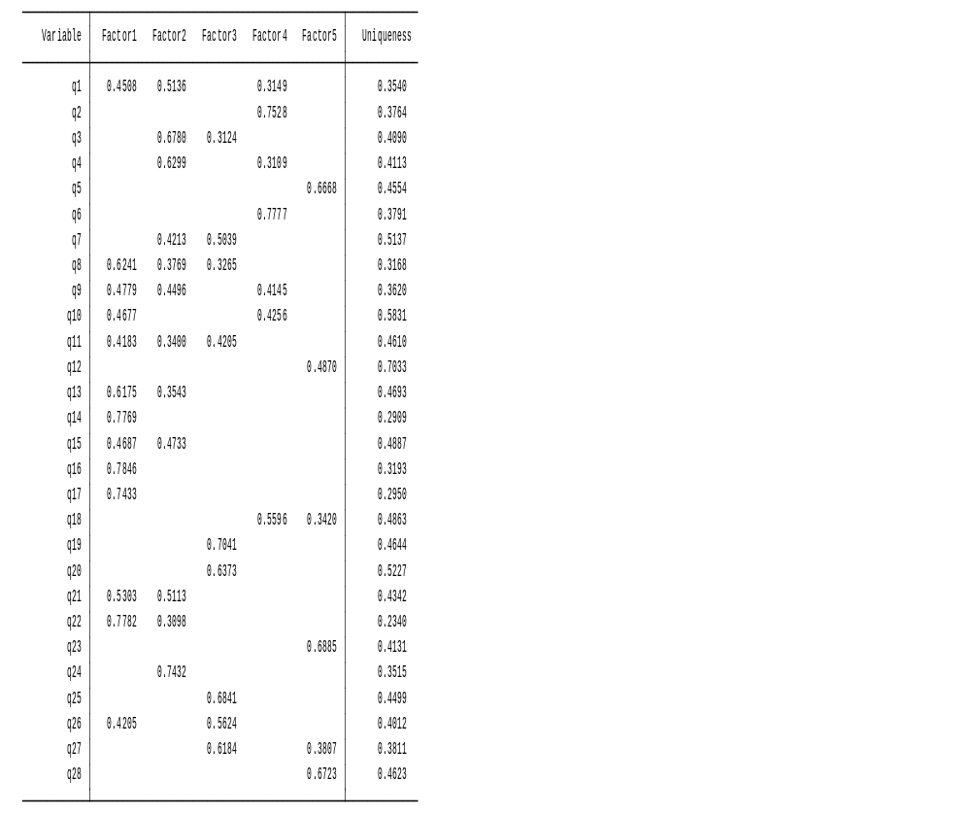

- Give the names and interpretations for the factors.
Factor 1 – experiment thinking people, enth8usiastic with experiment and how they doing
Factor 2 – the good at theory and statistics measurement
Factor 3 – helping teacher => positive to students
Factor 4 – negative to students
Factor 5 – shy and not social person

- Save the factors and recode them into ordinal variables with the same scale of measurement as the initial variables.

We do predict. If the value is +3 then it’s completely agree with the factor, -3 – completely disagree with the factor.

We decode as
Min -3 => 1
-3 -2 => 2
-2 -1 => 3
-1 0 => 4
0 1 => 5
1 2 => 6
2 max => 7

