2022.06.30 Ivanova Kseniya
How to install, compile, configure and run ICON
See Icon wiki page and tutorial here :
ICONIconModel - MODELS - C2SM Wiki (ethz.ch)
ICON Model Tutorial 2020 (dwd.de)
Icon grid can be downloaded here : ICON — Grid File Server (mpg.de)
DWD icontools are a repository on the C2SM github: https://github.com/C2SM/icontools

First, one clone Icon repository recursively (with all externals submodels, such as , for example, icon-art) from gitHub using SSH protocol:
git clone git@github.com:C2SM/icon.git

Execute
git submodule update --init
ICON needs to be configured before compilation. There is a configure-script for each compiler and/or machines located in config folder in the downloaded locally ICON source code. On daint I configure by running the following in the terminal in the icon source code folder:
./config/cscs/daint.cpu.pgi-20.1.1-eccodes
Often I got problems with eccodes root, you have to be sure that inside the configure file the provided link exists. For example, if in configure file you provide the following
ECCODES_ROOT='/project/g110/spack-install/daint/eccodes/2.19.0/pgi/6btxe4laukde6xhzonqnnczpz6tech7b'
Check that the directory
'/project/g110/spack-install/daint/eccodes/2.19.0/pgi/6btxe4laukde6xhzonqnnczpz6tech7b/share/eccodes/samples'
really exists and containing file GRIB2.tmpl.

Question: what is the difference between "01" configuration and "02" configuration for daint.pgi ?
Answer: this is the optimization level of the compiler

Optimization Levels - GNAT User's Guide (gnu.org)
02 Full optimization; generates highly optimized code and has the slowest compilation time
01 Moderate optimization; optimizes reasonably well but does not degrade compilation time significantly

After configuring, Makefile will be created. Compile with
make -j8
The exe file will be created in the /bin directory in the icon source code folder.
After that, if all steps were successful, you have to run requirenments file

python -m pip install -r requirements.txt

and finally you can run icon or icon-art through processing chain using the following command with preparing data

python run_chain.py icon-art-BRM 2018-12-21 0 24 -f -j prepare_data icon

or without preparing data :
python run_chain.py icon-art-BRM 2018-12-21 0 24 -f -j icon

All namelists one can find in the run file icon_runjob.cfg . One can change the output namelist as you wish (grib2 output format or netCDF, both are possible ) and add/remove output variables as you wish in (ml_varlist).

Grib2 output:
In order to write grb output, in configure file we need additional flag
EXTRA_CONFIG_ARGS+=' --disable-mpi-checks --enable-grib2 --without-external-cdi --enable-art'

This flag is also enable ART model from externals.

Here are some modificatios I did to run Icon with processing chain:
I commented in prepare_data.py
the following lines in order to avoid problems with lateral boundary conditions :

# tools.copy_file(cfg.lateral_boundary_grid,
# cfg.lateral_boundary_grid_scratch,
# output_log=True)

I also changed a bit the file config.py in /users/kivanova/processing-chain/cases/icon-art-BRM :
-created additional input root with meteoswiss data grid , dictionary etc
input_root2 = '/users/kivanova/icon1.config'
input_root = '/store/empa/em05/input_iconart_processing_chain_example/'

Icontool directory I used from Michael Steiner
icontools_dir = '/scratch/snx3000/msteiner/spack-stages/daint/spack-stage-icontools-master-t524rnfa5sfyn4rbvarypyzwae4jg46d/spack-src/icontools'

Also, I used the following :
radiation_grid_filename = os.path.join(input_root2,
"ICON-1E_DOM01.parent.nc")
dynamics_grid_filename = os.path.join(input_root2, "ICON-1E_DOM01.nc")
map_file_latbc = os.path.join(input_root_grid, "map_file.latbc")
extpar_filename = os.path.join(
input_root2, "external_parameter_mch_ICON_1E_R19B08_DOM1.nc")
lateral_boundary_grid = "/scratch/snx3000/kivanova/processing_chain/icon-art-BRM/2018122100_0_24/icon/input/grid/lateral_boundary.grid.grid.nc"

And

# ART settings----------------------------------------------------------------
input_root_tracers = os.path.join(input_root, 'XML')
chemtracer_xml_filename = os.path.join(input_root_tracers,
'tracers_BRM_pntsrc.xml')
pntSrc_xml_filename = os.path.join(input_root_tracers, 'pntSrc_BRM.xml')
art_input_folder = os.path.join(input_root, 'ART')

# SIMULATION =================================================================
# ICON -----------------------------------------------------------------------
# Executable
icon_bin ="/scratch/snx3000/kivanova/icon_src/bin/icon"
#os.path.join(exe_dir, "icon-kit-art_20211018")

# Namelists and slurm runscript templates
icon_runjob = os.path.join(case_dir, 'icon_runjob.cfg')

XML files one can find here :
/store/empa/em05/input_iconart_processing_chain_example/XML

In tracers_BRM_pntsrc.xml I changed the units :
mol mol-1 to kg kg-1

The tags "mol_weight" and "unit" are not required for passive tracers. And if they are provided, they have no influence on the tracer or output.
All tracers are treated as mass mixing ratios in the model. Passive tracers are also written out as MMR in the output. These 2 tags are used for chemical tracers in a conversion-routine such that the output is then in VMR, but passive tracers are skipped in this conversion-routine and are written out as MMR.
At the beginning of icon run script icon_runjob.cfg after SBATCH lines I added radiation input files coping it one by one
# Link radiation input files
# ----------------------------------------------------------------------------
ln -sf {cfg.art_input_folder}/runctrl_examples/photo_ctrl/* .
ln -sf {cfg.art_input_folder}/runctrl_examples/init_ctrl/* .
ln -sf /users/kivanova/icon1.config/ecrad_data/*
ln -sf /users/kivanova/icon1.config/ecrad_data/socrates_droplet_scattering_rrtm.nc
ln -sf /users/kivanova/icon1.config/ecrad_data/fu_ice_scattering_rrtm.nc
ln -sf /users/kivanova/icon1.config/ecrad_data/mcica_gamma.nc
ln -sf /users/kivanova/icon1.config/ecrad_data/RADRRTM
ln -sf /users/kivanova/icon1.config/ecrad_data/RADSRTM
ln -sf /users/kivanova/icon1.config/ecrad_data/slingo_droplet_scattering_rrtm.nc
ln -sf /users/kivanova/icon1.config/ecrad_data/yi_ice_scattering_rrtm.nc
ln -sf /users/kivanova/icon1.config/ecrad_data/baran_ice_scattering_rrtm.nc
ln -sf /users/kivanova/icon1.config/ecrad_data/es_droplet_scattering_rrtm.nc

Fieldextra
In fieldextra it is mandatory to remap variable hsurf since we use tag grid from this variable
&Process in_field = "HSURF", use_tag="GRID" /

&Process
in_file = "_tmp_u<DDHH>0000"
out_file = "IconPntSr<DDHH>0000", out_type = "GRIB2"
in_regrid_target = "GRID"
tstart = 0, tstop = 24, tincr = 1
/

I also changed the levels to 80, as in Meteoswiss
levmax = 80

and in icon_runjob.cfg in /users/kivanova/processing-chain/cases/icon-art-BRM
num_lev = 80 ! number of full levels (atm.) for each domain

To run new date with icon art we have to change XML file pntSrc_BRM.xml,config.py in processing chain (output_dir = os.path.join(work_root, casename, '2018041500_0_24', 'icon',
'output') and lateral_boundary_grid = "/scratch/snx3000/kivanova/processing_chain/icon-art-BRM/2018041500_0_24/icon/input/grid/lateral_boundary.grid.grid.nc" ), in icon_runjob.cfg name of outputfiles

for Flexpart files we have to change AVAILABLE, COMMAND.

Plot Icon unstructured mesh

To plot Icon unstructured, one can use Paraview with Reader plagin CDIReader
(available on ddm06 and on Daint), psyplot with python
import psyplot.project as psy
fN = '/project/ivme/MCH-1/icon-art-BRM/icon_output/ICON-ART-OEM_AllVarUnstr_DOM01_00130000.nc'
ncf = nc.Dataset(fN)
print(ncf)
print(ncf.variables.keys())
ds = xr.open_dataset(fN)
print(ds)
print(ds.t_2m.CDI_grid_type)
psy.rcParams['plotter.maps.xgrid'] = False
psy.rcParams['plotter.maps.ygrid'] = False
mpl.rcParams['figure.figsize'] = [10., 8.]
BRM = psy.plot.mapplot(fN, name="testtr12", load=True, maskleq=0,
levels=[80],
clabel="%(long_name)s",
title='%(time)s', cmap='Blues',
post="import cartopy.feature as cf; self.ax.add_feature(cf.BORDERS, color='red')",
post_timing="replot",
enable_post=True)
BRM.update(projection="moll")
BRM.show()

Or PolyCollection with python
from matplotlib.collections import PolyCollection

Icontools, problems:
Interpolation method 3 (RBF) with scaling factor 0.01 produce errors after running icon-art with processing-chain (100hPA level is not found).

Before running Icon, we have to prepare initial conditions, i.e. remap it. Before we were doing it with Icontools, which is produced the strange chess-like pattern for almost all ic variables, we also had unrealistic w_snow variable, this snow was not melting with time and that influenced on surface fluxes in Flexpart simulations. That is why we replaced the icontools by CDO for remappinf step for IC and BCs.

Below one can see the illustration of chess-like problems in IC and unrealistic values of W_snow.

Chess-like pattern in IC remapped with Icontools:
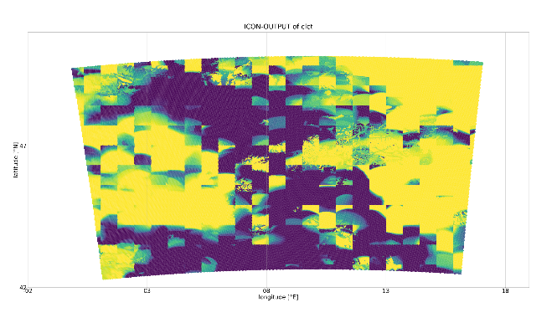

Icon and Icontools with spack
To install icontools with spack we need to run just 3 command (it didn’t work for me on Daint with icon from CSCS, but it worked for David Oschner with Icon from DWD):
module load cray-python
source /project/g110/spack/user/daint/spack/share/spack/setup-env.sh
spack install -v icontools@c2sm-master%gcc slave=daint

to install icon with spack we need git clone icon source code and run the following command

touch file_for_spack
spack dev-build -u build icon@dev-build%nvhpc \
icon_target=cpu \
+art +eccodes\
config_dir=/users/kivanova/icon
rm file_for_spack
touch file_for_spack
spack dev-build -u build icon@dev-build%pgi \
icon_target=cpu \
+art +eccodes\
config_dir=/users/kivanova/icon

rm file_for_spack

Icontools -> CDO for preprocessing step
Before running Icon, we have to prepare initial conditions, i.e. remap it. Before we were doing it with Icontools, which is produced the strange chess-like pattern for almost all ic variables, we also had unrealistic w_snow variable, this snow was not melting with time and that influenced on surface fluxes in Flexpart simulations. That is why we replaced the icontools by CDO for remappinf step for IC and BCs.

Below one can the script for remappimg ICs with CDO:

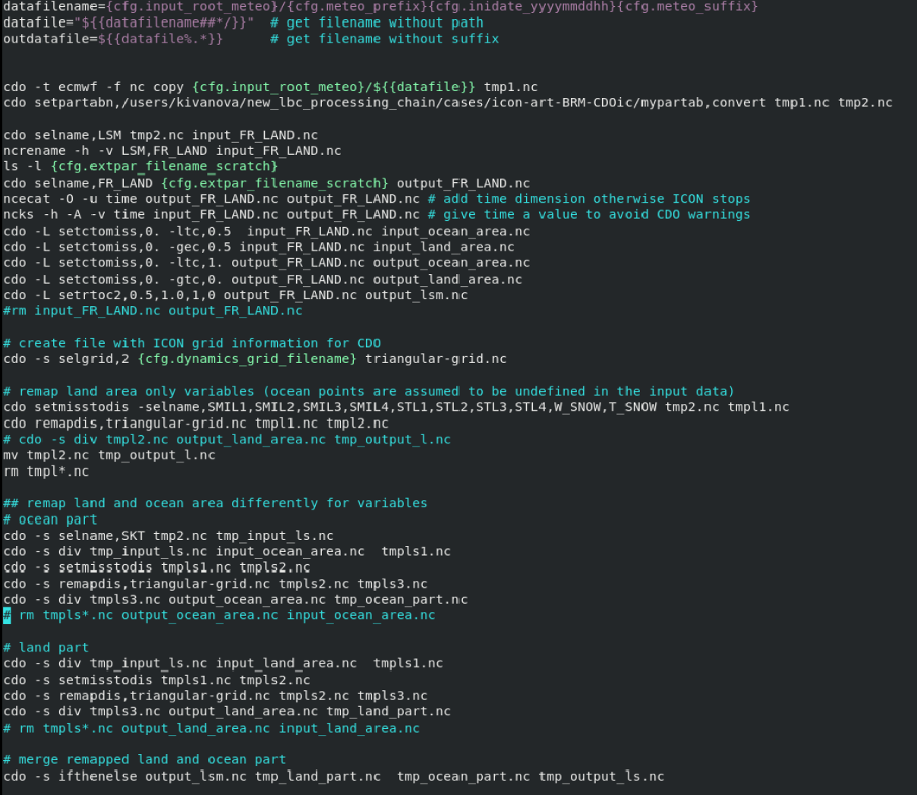

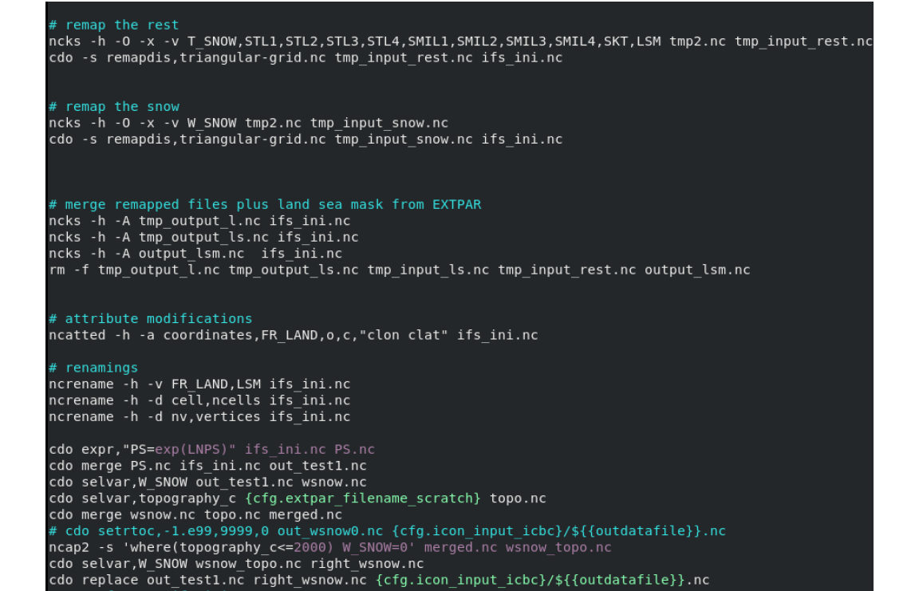

Below one can see the script to remap BCs with CDO.

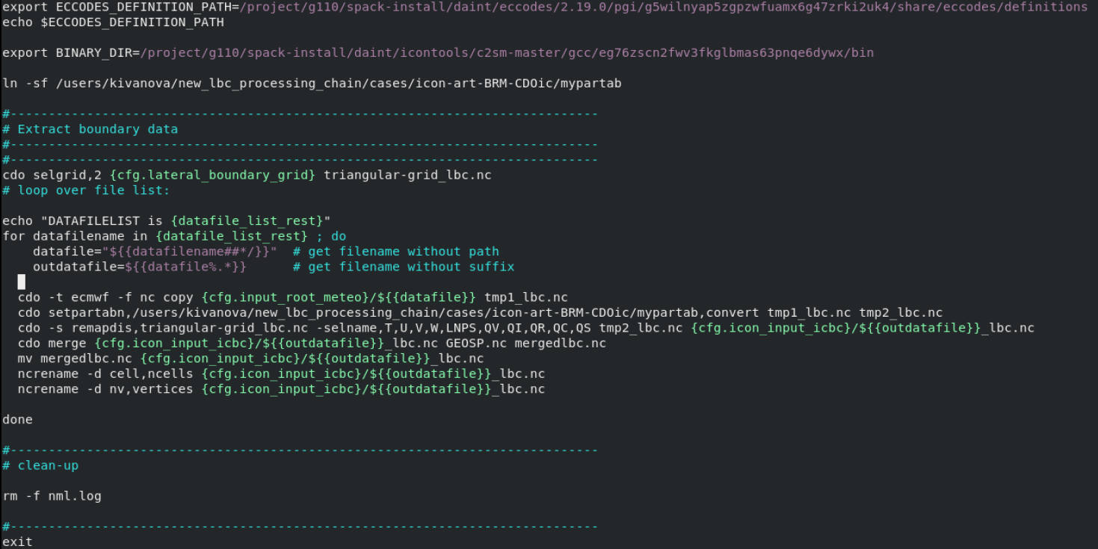

W_snow

LNPS initial condition remapped with CDO

