The name of the challenge is babyheap
hinting us that the challenge could be related to heap and use after free
And the title says:
You can't Use After Free if you never free, right

The checksec shows us that we have PIE enabled so we will need some address leak possibly:
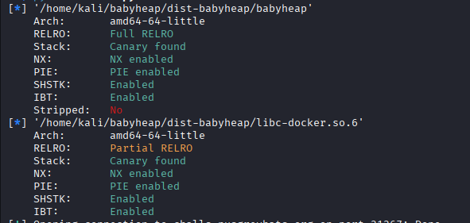

They have also given us the .cpp file for the binary so we have the code.
The program basically allows you to:
cout << "1. Create monkey" << endl;
cout << "2. Create greycat" << endl;
cout << "3. Make greycat talk" << endl;
So the monkey and greycat you create are saved in vectors:
vector<Monkey> monkeys;
vector<Greycat> greycats;

The Monkey class was not needed for the final exploit path.
what exactly is saved from your input is a name variable with 32 bytes
Then there is a function pointer named “speak”
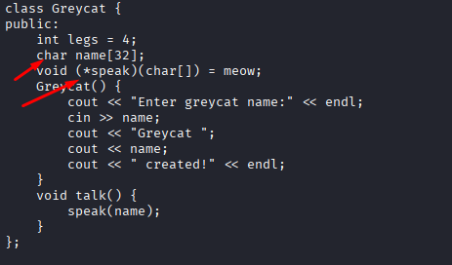
The Make greycat talk option
Calls that pointer and it runs this function:
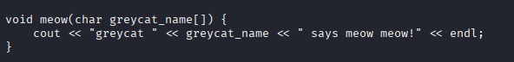

So if we change the pointer to point to system we can run code with the argument of “name”
So there is not heap manipulation or use after free, it is just missdirection.
But in order to find system we would need some leak
Luckily if you input 6767
The program givves you the runtime address of malloc:
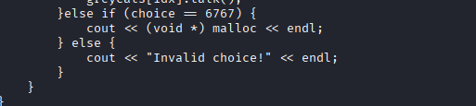
From there we can just calculate the libc base and combine it with the system offset to get the runtime system address
And here is how the final payload looks:
payload = b'cat<flag.txt\x00' + b"A" * 23 + p64(system)

So first we need to fill the name variable it is 32 bytes after that we need 4 bytes of padding since the program is calling a pointer we would need take account of struct alignment
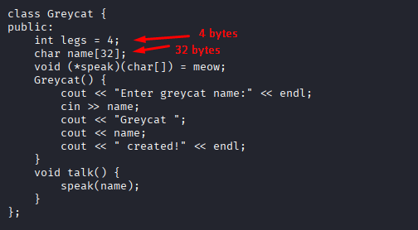

The program allocates 4 bytes before a pointer if the total sum of the bytes is not divisible by 8
before the pointer we have 36 bytes which is not dibvisible by 8 so the program allocates 4 more bytes before the pointer
which is *speak
So the payload is
32 bytes + 4 bytes padding + system address
Since the name variable itself is used as an argument, we will need to put our cat command in it
so we put
cat<flag.txt\x00 + 23 A’s (to fill the variable and padding) +the system address we calculated
After running the payload I have uploaded here as well, we get the flag

