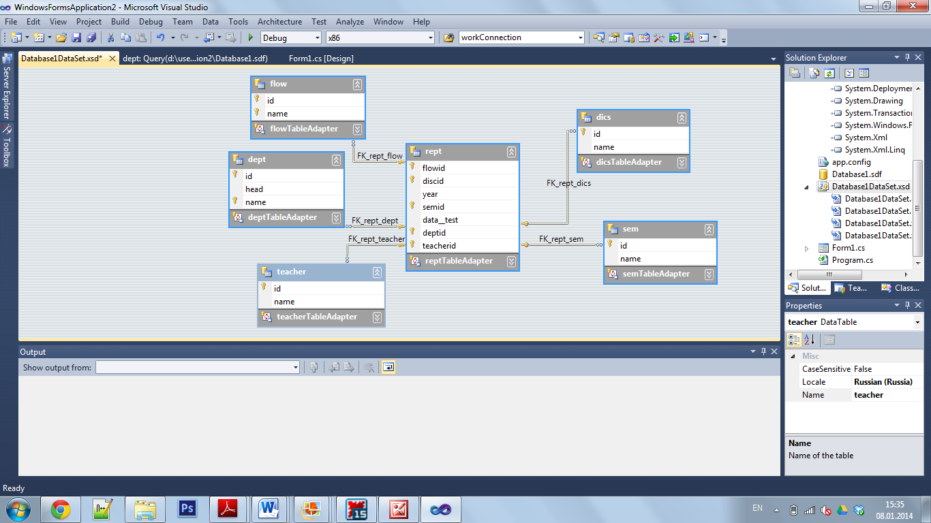

*-- Script Date: 09.01.2014 13:43*

*-- Database information:*

*-- locale identifier: 1033*

*-- encryption mode:*

*-- case sensitive: False*

*-- Database: Database1.sdf*

*-- ServerVersion: 3.5.8080.0*

*-- DatabaseSize: 148 KB*

*-- SpaceAvailable: 3,999 GB*

*-- Created: 08.01.2014 15:03*

*-- User Table information:*

*-- Number of tables: 6*

*-- dept: 0 row(s)*

*-- dics: 0 row(s)*

*-- flow: 0 row(s)*

*-- rept: -1 row(s)*

*-- sem: 0 row(s)*

*-- teacher: 0 row(s)*

**CREATE** **TABLE** [teacher] ( [id] int **IDENTITY** (1,1) **NOT** **NULL** , [name] nvarchar(100) **NULL**);

**CREATE** **TABLE** [sem] ( [id] int **IDENTITY** (1,1) **NOT** **NULL** , [name] nvarchar(100) **NULL**);

**CREATE** **TABLE** [rept] (

[flowid] int **NULL**

, [discid] int **NULL**

, [**year**] int **NULL**

, [semid] int **NULL**

, [data__test] int **NULL**

, [deptid] int **NULL**

, [teacherid] int **NULL**

);

**CREATE** **TABLE** [flow] ( [id] int **IDENTITY** (1,1) **NOT** **NULL** , [name] nvarchar(128) **NULL**);

**CREATE** **TABLE** [dics] ( [id] int **IDENTITY** (1,1) **NOT** **NULL** , [name] nvarchar(100) **NULL**);

**CREATE** **TABLE** [dept] ( [id] int **IDENTITY** (1,1) **NOT** **NULL** , [head] nvarchar(100) **NULL** , [name] nvarchar(100) **NULL**);

**SET** IDENTITY_INSERT [teacher] **OFF**;

**SET** IDENTITY_INSERT [sem] **OFF**;

**SET** IDENTITY_INSERT [flow] **OFF**;

**SET** IDENTITY_INSERT [dics] **OFF**;

**SET** IDENTITY_INSERT [dept] **OFF**;

**ALTER** **TABLE** [teacher] **ADD** **CONSTRAINT** [PK_teacher] **PRIMARY** **KEY** ([id]);

**ALTER** **TABLE** [sem] **ADD** **CONSTRAINT** [PK_sem] **PRIMARY** **KEY** ([id]);

**ALTER** **TABLE** [flow] **ADD** **CONSTRAINT** [PK_flow] **PRIMARY** **KEY** ([id]);

**ALTER** **TABLE** [dics] **ADD** **CONSTRAINT** [PK_dics] **PRIMARY** **KEY** ([id]);

**ALTER** **TABLE** [dept] **ADD** **CONSTRAINT** [PK_dept] **PRIMARY** **KEY** ([id]);

**CREATE** **UNIQUE** **INDEX** [UQ__teacher__0000000000000040] **ON** [teacher] ([id] **ASC**);

**CREATE** **UNIQUE** **INDEX** [UQ__sem__0000000000000032] **ON** [sem] ([id] **ASC**);

**CREATE** **UNIQUE** **INDEX** [UQ__flow__000000000000001F] **ON** [flow] ([id] **ASC**);

**CREATE** **UNIQUE** **INDEX** [UQ__flow__0000000000000024] **ON** [flow] ([name] **ASC**);

**CREATE** **UNIQUE** **INDEX** [UQ__dics__000000000000004E] **ON** [dics] ([id] **ASC**);

**CREATE** **UNIQUE** **INDEX** [UQ__dept__000000000000000C] **ON** [dept] ([id] **ASC**);

**CREATE** **UNIQUE** **INDEX** [UQ__dept__0000000000000011] **ON** [dept] ([name] **ASC**);