E-1608 DAQ Python Analog Ramping Controller Documentation & Manual

Ivan Bao, Aug 2022

# Installation & Setup

To setup the software, simply open the zip file and extract both “main” and “MCC” to the same folder anywhere in your computer.

Then click “main” to start the controller software

Make sure apps like DAQami (and other instances of this controller) are not sharing access to the same DAQ since the DAQ does not seem to accept multiple connections to it at the same time.

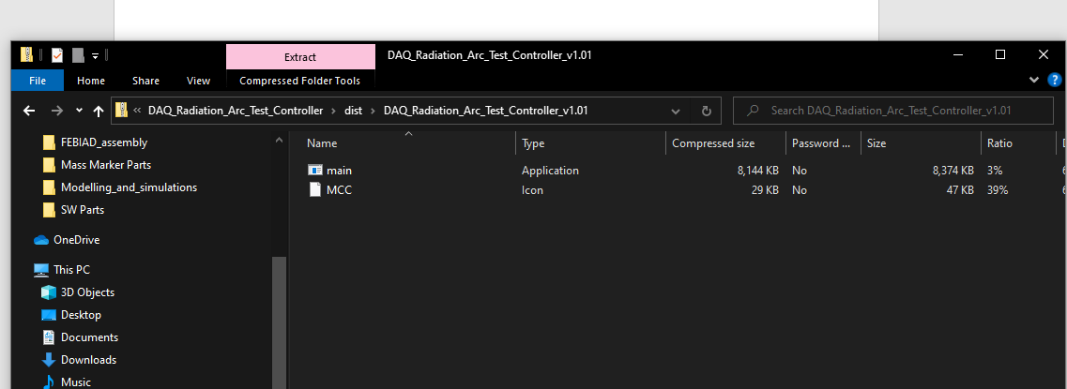

# Using the controller

To start, click on “Discover DAQ Devices” to search and choose the DAQ you want to use. The DAQ and computer should both be connected to TRIUMF Ethernet. Choose the DAQ under the “Discovered Devices” Drop-down menu.

Then enter the starting and final voltage of the desired ramp, as well as the ramp rate. This is the DAQ output voltage (0-10V range)

Note that the max ramp rate is 0.1V/s, limited by the execution speed of the ramping for loop.

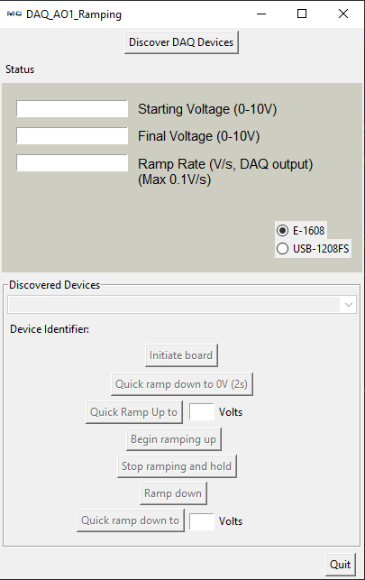

Then click “Initiate board” To load the voltage settings into the DAQ. Selecting the board type (E-1608 vs USB-1208FS) will also trigger the initiate board. These switches are only available when the boards are first connected, or when the output voltage of the DAQ is less than 0.1V, to avoid abrupt change being made to the HV power sources.

So if these buttons are greyed out, bring the voltage down to <0.1V to access them

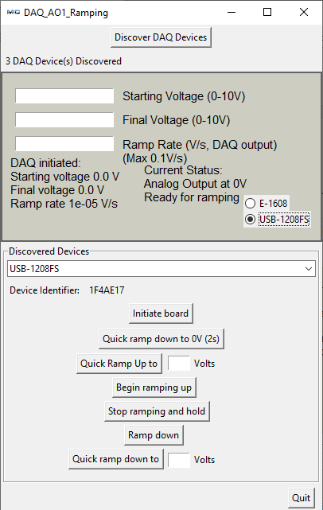

It should display the same values you entered. The controller computes the corresponding values for the DAQ analog output function based on the inputs above.

The controller defaults to output to analog output pin #1, as this is the only functional analog output pin on the DAQ we use.

When you are ready, you can click “Begin Ramping up” and it will start the voltage ramp, from starting voltage towards final voltage, at your chosen ramp rate.

You could also choose to quick ramp up to a desired starting voltage point, it will do the ramp up at a rate of about 0.1V/s .

You can choose to manually stop the ramping, once the ramping stopped, clicking “Begin Ramping Up” again will continue ramping up from where you paused. The same applies to “Ramp down”.

The Quick Ramp down will go straight to 0 in a few seconds, working as a quick yet smooth ramp down to de-energize the DAQ output pin. The “current status” will indicate that the ramping have stopped.

Alternatively you could choose “quick ramp down to” a desired voltage. Such as ramping it down to 0.8V after ramping up and hold at 1.0V

Upon pausing you can then click “Ramp down” to bring down the output voltage to starting voltage at the same rate.

The stop ramping and hold function will always be available, and you can pause the ramping and then ramp up/down from there (whether it’s quick ramp or normal ramp)

It is recommended to only energize the HV power supply after initializing the DAQ board.

# Known Glitches

* The controller may not close properly if it’s ramping up/down or holding a voltage, try close the program with task manager instead.
* If after closing the controller, opening it again fails to connect to the DAQ, go to task manager and look for any background programs called “main” and close them all. Then try open the controller again.