1. Problem Statement

* Part1. Write a program to do the following requirement.   
  (a) up-side-down lena.bmp   
  (b) right-side-left lena.bmp   
  (c) diagonally flip lena.bmp
* Part2. Write a program or use software to do the following requirement. (d) rotate lena.bmp 45 degrees clockwise   
  (e) shrink lena.bmp in half   
  (f) binarize lena.bmp at 128 to get a binary image

1. Programming Tools

* Programming language: Python 3.8.5
* Library: Numpy 1.19.1, OpenCV 4.0.1

1. Problem-Solving Process   
   First, I use the ‘cv2.imread()’ method to load ‘lena.bmp’ from the file.  
   Second, I process image with Numpy.  
   Finally, I save image by the ‘cv2.imwirte()’ method to the output file.
2. up-side-down lena.bmp  
   
3. right-side-left lena.bmp  
   
4. diagonally flip lena.bmp  
   
5. rotate lena.bmp 45 degrees clockwise  
   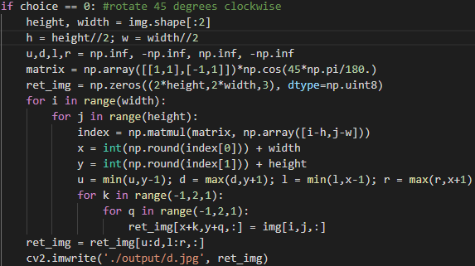
6. shrink lena.bmp in half  
   
7. binarize lena.bmp at 128 to get a binary image  
   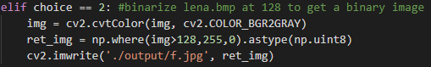
8. Results
9. up-side-down lena.bmp  
   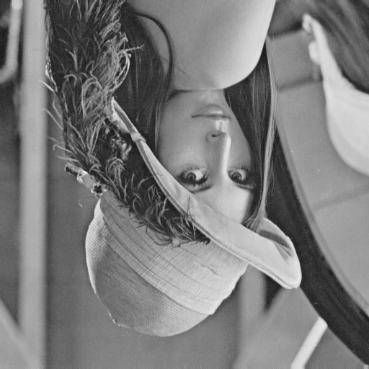
10. right-side-left lena.bmp

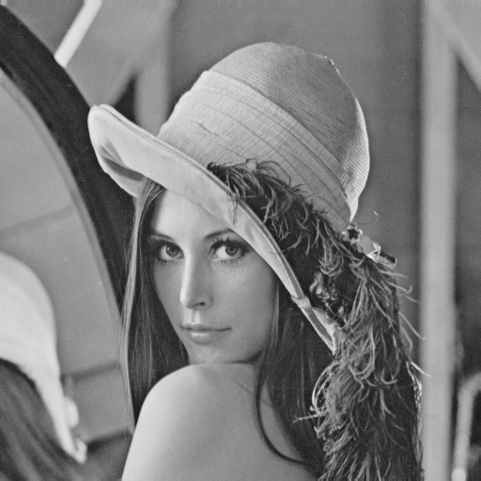

1. diagonally flip lena.bmp

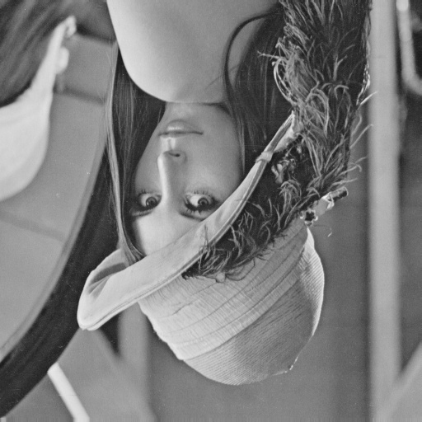

1. rotate lena.bmp 45 degrees clockwise

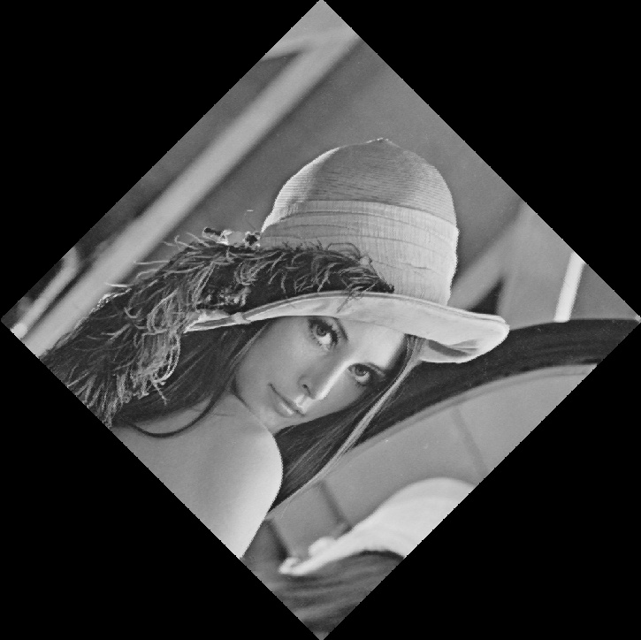

1. shrink lena.bmp in half

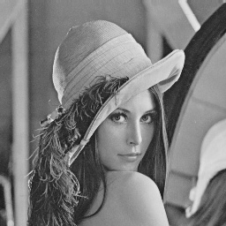

1. binarize lena.bmp at 128 to get a binary image

